The Mathematics Tower, Volume 4: The Penthouse
Storeys 38–50: From Category Theory to the Frontier
by Lothar J. Musiol

Copyright © 2026 Lothar J. Musiol. All rights reserved.

Table of Contents
Table of Contents 3
About This Volume 8
On Storeys and Rooms 9
Storey 38: Category Theory 10
Room 38.1: What Category Theory Actually Is 11
Room 38.2: Categories, Functors, and Natural Transformations 15
Room 38.3: Universal Properties and Representable Functors 20
Room 38.4: Limits and Colimits 24
Room 38.5: Adjoint Functors 28
Room 38.6: The Yoneda Lemma 32
Room 38.7: Monads and Algebras 36
Room 38.8: Abelian Categories and Homological Algebra 41
Room 38.9: Looking Ahead: From Categories to Higher Categories, Topoi, and Applied Category Theory 45
Storey 39: Information Theory 49
Room 39.1: What Information Theory Actually Is 50
Room 39.2: Entropy and Its Properties 54
Room 39.3: Typical Sets and the Asymptotic Equipartition Property 61
Room 39.4: Source Coding and Data Compression 66
Room 39.5: Mutual Information and Channel Capacity 71
Room 39.6: The Channel Coding Theorem 75
Room 39.7: Rate-Distortion Theory 79
Room 39.8: Continuous Channels and Gaussian Channels 83
Room 39.9: Looking Ahead: From Classical Information Theory to Networks, Quantum Information, and Learning 87
Storey 40: Wavelets & Signal Analysis 91
Room 40.1: What Wavelets and Signal Analysis Actually Are 92
Room 40.2: Time-Frequency Analysis and the Uncertainty Principle 96
Room 40.3: The Continuous Wavelet Transform 101
Room 40.4: Multiresolution Analysis 104
Room 40.5: Orthonormal Wavelet Bases 108
Room 40.6: The Discrete Wavelet Transform and Filter Banks 112
Room 40.7: Vanishing Moments, Approximation, and Compression 116
Room 40.8: Applications: Denoising, Images, and Beyond 119
Room 40.9: Looking Ahead: From Classical Wavelets to Frames, Shearlets, and Learned Representations 124
Storey 41: Game Theory & Decision Mathematics 129
Room 41.1: Decision Theory: Utility and Expected Utility 130
Room 41.2: Games in Normal Form 135
Room 41.3: Dominance, Best Responses, and Nash Equilibrium 139
Room 41.4: Mixed Strategies and Existence of Equilibrium 143
Room 41.5: Extensive-Form Games and Sequential Rationality 148
Room 41.6: Repeated Games and the Folk Theorems 152
Room 41.7: Cooperative Games and Bargaining 156
Room 41.8: Auctions and Mechanism Design 163
Room 41.9: Looking Ahead: From Classical Game Theory to Evolutionary, Algorithmic, and Behavioral Extensions 168
Storey 42: Statistics & Probability 175
Room 42.1: Probability Spaces and Random Variables 176
Room 42.2: Expectation, Variance, and Conditioning 180
Room 42.3: Independence and Classical Limit Theorems 184
Room 42.4: Parametric Models and Likelihood 188
Room 42.5: Estimation and Confidence Intervals 193
Room 42.6: Hypothesis Testing 198
Room 42.7: Linear Models and Regression 202
Room 42.8: Bayesian Inference 206
Room 42.9: Looking Ahead: From Classical Statistics to Modern Inference and Probability Theory 211
Storey 43: Probability Theory (Advanced) 215
Room 43.1: Probability Measures and Random Variables Revisited 216
Room 43.2: Independence, Product Spaces, and Kolmogorov's Extension 220
Room 43.3: Conditional Expectation 223
Room 43.4: Martingales in Discrete Time 226
Room 43.5: Convergence Theorems and the Strong Law 231
Room 43.6: Brownian Motion 235
Room 43.7: Continuous-Time Martingales and Stopping Times 239
Room 43.8: Markov Processes and Generators 243
Room 43.9: Looking Ahead: From Advanced Probability to Stochastic Calculus, SPDEs, and Ergodic Theory 247
Storey 44: Computational Geometry 251
Room 44.1: What Computational Geometry Actually Is 253
Room 44.2: Convex Hulls 258
Room 44.3: Line-Segment Intersection and Arrangements 262
Room 44.4: Polygon Triangulation and Art Galleries 265
Room 44.5: Voronoi Diagrams and Delaunay Triangulations 268
Room 44.6: Geometric Searching and Range Queries 271
Room 44.7: Arrangements of Lines and Hyperplanes 274
Room 44.8: Robustness, Degeneracies, and Exact Computation 277
Room 44.9: Looking Ahead: From Classical CG to Motion Planning, Meshing, and High-Dimensional Geometry 282
Storey 45: Control Theory 287
Room 45.1: What Control Theory Actually Is 288
Room 45.2: Linear State-Space Models 291
Room 45.3: Controllability and Observability 294
Room 45.4: Stability: Lyapunov and Input-Output 297
Room 45.5: State Feedback, Pole Placement, and Observers 300
Room 45.6: Optimal Control: LQR and the Maximum Principle 304
Room 45.7: Frequency-Domain Methods 307
Room 45.8: Nonlinear and Robust Control 311
Room 45.9: Looking Ahead: From Classical Control to Hybrid, Networked, and Learning-Based Control 315
Storey 46: Dynamical Systems & Chaos 319
Room 46.1: What Dynamical Systems Actually Are 320
Room 46.2: Flows, Maps, and Phase Portraits 324
Room 46.3: Linearization and Local Structure 328
Room 46.4: Periodic Orbits and Poincaré Maps 332
Room 46.5: Lyapunov Stability and Invariant Sets 335
Room 46.6: Chaos in One-Dimensional Maps 338
Room 46.7: Strange Attractors and Lyapunov Exponents 342
Room 46.8: Bifurcations 346
Room 46.9: Looking Ahead: From Classical Dynamics to Ergodic Theory, Hyperbolicity, and Applications 350
Storey 47: Mathematical Physics 354
Room 47.1: What Mathematical Physics Actually Is 355
Room 47.2: Lagrangian and Hamiltonian Mechanics 359
Room 47.3: Symplectic Geometry and Integrable Systems 363
Room 47.4: Continuum Mechanics and Classical Field Theories 368
Room 47.5: Electromagnetism and Maxwell's Equations 372
Room 47.6: Special Relativity and Minkowski Space 376
Room 47.7: General Relativity and Curved Spacetime 380
Room 47.8: Quantum Mechanics: Operators, Spectra, and States 384
Room 47.9: Looking Ahead: From Classical Mathematical Physics to Quantum Field Theory and Beyond 388
Storey 48: Optimization (Advanced) 392
Room 48.1: The Landscape of Nonconvex Optimization 394
Room 48.2: Critical Points, Saddles, and Landscape Geometry 398
Room 48.3: Stochastic Gradient Methods 401
Room 48.4: Variance Reduction and Adaptive Methods 404
Room 48.5: High-Dimensional and Structured Nonconvex Problems 408
Room 48.6: Minimax Optimization and GANs 412
Room 48.7: Complexity Lower Bounds and Optimal Rates 416
Room 48.8: Optimization for Statistical Learning 419
Room 48.9: Looking Ahead: From Advanced Optimization to Deep Learning, Distributed Methods, and Open Problems 423
Storey 49: Numerical Methods (Advanced) 425
Room 49.1: What Advanced Numerical Methods Actually Are 427
Room 49.2: Iterative Methods for Linear Systems 430
Room 49.3: Preconditioning and Multigrid 433
Room 49.4: Sparse Eigenvalue Problems and SVD 436
Room 49.5: Spectral and High-Order Methods 440
Room 49.6: Adaptive Finite Elements and Multilevel Methods 443
Room 49.7: Uncertainty Quantification 446
Room 49.8: Structure-Preserving and Geometric Integration 449
Room 49.9: Looking Ahead: From Advanced Numerics to Exascale, Machine Learning, and Verified Computation 452
Storey 50: Where the Tower Meets the World 456
Room 50.1: What Mathematical Modeling Actually Is 457
Room 50.2: The Modeling Process: From Phenomenon to Equation 460
Room 50.3: Scaling, Dimensional Analysis, and Dimensionless Models 463
Room 50.4: Discrete and Continuous Models 467
Room 50.5: Stochastic Models and Uncertainty 471
Room 50.6: Case Studies: Mechanics, Biology, and Epidemiology 475
Room 50.7: Data-Driven and Hybrid Modeling 479
Room 50.8: Validation, Falsification, and Model Selection 483
Room 50.9: Looking Back and Looking Ahead: The Tower and What Lies Beyond 486

About This Volume
This is Volume 4 of The Mathematics Tower, the last of four volumes and the top of the climb. Volume 1 (Storeys 1–12) begins at arithmetic and holds the Tower's full preface; Volume 2 (Storeys 13–25) generalizes into many variables and the foundations of mathematics; Volume 3 (Storeys 26–37) covers equations, geometry, and abstract structure. If you are arriving fresh at the penthouse, ‘On Storeys and Rooms’, immediately after this note, explains the building's vocabulary in brief.
This volume covers Storeys 38 through 50: category theory; information theory; wavelets and signal analysis; game theory and decision mathematics; statistics and probability, in both their standard and advanced forms; computational geometry; control theory; dynamical systems and chaos; mathematical physics; and, closing the Tower, advanced optimization, advanced numerical methods, and applied mathematics modelling. Thirteen storeys, from the most abstract structures in the whole book to the discipline that finally points all of it back at the physical world.
Behind you: abstract algebra, Volume 3's final storey. Ahead: nothing but the roof, the view, and whatever you decide to build with all of it. This is the last flight of stairs. Up we go, one final time.

On Storeys and Rooms
A brief note is owed on why perfectly good words like 'book' and 'chapter' have been evicted from this text and replaced with 'storey' and 'room', since I am aware this is the sort of decision that can look, from the outside, like whimsy that has got badly out of hand. The honest answer is that it has, rather, but let me at least make the case for the defence before you reach for a refund.
The trouble with 'book' is that this is no longer fifty of them; it is one, and a text that keeps referring to itself as 'this book' while also gesturing at 'the next book in the series' is not being quaint, it is being confused about its own word count. 'Storey' does the same job — a bounded, coherent stretch of related material — while also admitting, honestly, that the thing you are standing in only makes sense as one level of something larger. It is a small change of noun that happens to fix a structural lie, which is about as good a return as you ever get from renaming things.
'Room' replaces 'chapter' for similar reasons, but with the added benefit of matching the numbering to the metaphor rather than fighting it: Room 6.3 tells you, without further ceremony, that you are in the third room of the sixth storey, which is more information than 'Chapter 3' ever gave you and considerably more information than 'Chapter 3 of Book 6, one of a fifty-book series' gave you at roughly triple the word count. Efficiency, in the end, dressed up as a joke — which is, if I am honest, how most good jokes in mathematics arrive.
I will not pretend the metaphor is load-bearing in any technical sense; you cannot factor a polynomial faster for knowing it lives in a room rather than a chapter. But a reader climbing from arithmetic to category theory over fifty storeys deserves a mental image sturdier than 'a very long document', and a tower — with its floors resting on each other, its lift for the impatient, its occasional draughty landing — happens to be a much better description of how mathematical knowledge is actually built than a shelf of unrelated paperbacks ever was. So: storeys, rooms, and no further apology. Do come in.

Storey 38: Category Theory
Objects, Arrows, and the Art of Structure-Preserving Maps
The last storey left us surrounded by groups, rings, and fields, having learned the useful trick of stripping a mathematical object down to its axioms and discarding everything else. A group, we discovered, is not really a set of rotations of a triangle or a set of integers under addition; it is a set equipped with three unglamorous rules, and once you have the rules you can forget where you found them. That was, in its way, an exercise in tidying: fold up the specifics, keep the skeleton, label the box neatly and put it on the shelf. This storey performs the same manoeuvre one floor further up, and with considerably less mercy. We are going to strip away the axioms too, and keep only the arrows.
Category theory is what happens when a mathematician notices that groups, topological spaces, vector spaces, partially ordered sets, and a hundred other structures all obey the same four-part etiquette — a stock of objects, a stock of maps between them that preserve whatever there is to preserve, a way of composing those maps, and a do-nothing map at every object — and decides to study the etiquette itself, rather than any of the guests attending the party. The result is routinely accused of being abstract nonsense, an accusation its practitioners have long since stopped bothering to deny, because it is both true and beside the point: the nonsense turns out to have teeth. Once you can say precisely what a product, a free object, or a limit is without reference to any particular category, you can recognise the same construction wearing different disguises in algebra, topology, logic, and — as we shall not resist mentioning near the end — a fair slice of theoretical computer science.
This storey climbs from the bare definition of a category up to the Yoneda lemma, which has a strong claim to being the single most useful fact in the subject, and on past monads and abelian categories to a final room that gestures, with appropriate vertigo, at higher categories and topoi. Throughout, we keep our feet on recognisable ground: Set, Grp, Vect, and the humble poset make repeat appearances, not because category theory needs them, but because you do, and because every abstract claim in this storey is cashed out below in an example with actual numbers or an actual small structure you can hold in your hand and turn over.
One warning before we start climbing, delivered in the spirit of full disclosure rather than reassurance: mathematicians who spend long enough doing this eventually stop asking what an object is and start asking only how it behaves towards its neighbours, which is either a profound philosophical advance or a mild personality disorder, depending on how the department meeting goes. One storey from now, in Information Theory, the arrows will start carrying bits instead of abstract nonsense, and structure-preserving maps will turn into channels that try not to lose your message on the way through. For now, though, let us follow the arrows.

Room 38.1: What Category Theory Actually Is
In which we study almost nothing, extremely precisely
Category theory is the mathematical study of structures and of the maps that preserve them. That sentence sounds almost too modest to be a whole field, so it is worth being blunt about what it means in practice.
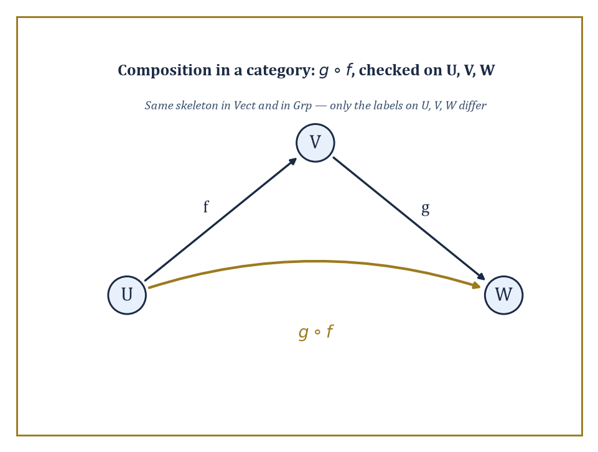
Strip the labels off U, V, W and the diagrams for Vect and Grp become identical — objects, arrows, composition, nothing more.
Abstract algebra, as the last storey demonstrated at some length, studies groups, rings, and fields, together with the homomorphisms between them that respect multiplication or addition. Topology studies spaces and the continuous maps between them. Linear algebra studies vector spaces and the linear maps between them. Each of these subjects, on its own, has a favourite kind of object and a favourite kind of map.
Category theory notices that in every case the same four ingredients are present — objects, maps (called morphisms or arrows), a rule for composing two compatible arrows into one, and a do-nothing arrow sitting at every object — and that these four ingredients obey exactly the same two laws in every case: composition is associative, and the do-nothing arrows really do nothing. A category is precisely that data, and nothing more.
Abstract example — Same skeleton, different flesh. Consider the category Vect of real vector spaces and linear maps, and the category Grp of groups and homomorphisms. On the face of it these have nothing in common: one is about scaling and adding vectors, the other about combining group elements. But look only at the skeleton.
In Vect, take three objects U, V, W (vector spaces), a linear map f: U → V, and a linear map g: V → W; composing gives a linear map g∘f: U → W, and every space V carries an identity map that does nothing:
id_V(v) = v
In Grp, take three groups A, B, C, a homomorphism f: A → B, and a homomorphism g: B → C; composing gives a homomorphism g∘f: A → C, and every group B carries an identity homomorphism that likewise does nothing:
id_B(b) = b
Strip the labels vector space and group off the objects, and homomorphism and linear map off the arrows, and the two pictures are identical: objects, arrows, composition, identity. That identical picture, and nothing about vectors or group elements specifically, is what a category theorist actually studies.
The subject did not spring from a desire to be difficult; it grew out of a very concrete headache in algebraic topology in the 1940s, when Samuel Eilenberg and Saunders Mac Lane needed a rigorous way to say that a certain isomorphism was natural, meaning it did not depend on any arbitrary choices, as opposed to one that merely happened to exist.
The distinction sounds pedantic until you meet a genuine example of it, at which point it becomes indispensable, because plenty of isomorphisms in mathematics exist but are, so to speak, dishonest: they only work once you have made a choice you cannot justify, and a different choice gives a different isomorphism.
Abstract example — An honest isomorphism versus a dishonest one. Let V be a finite-dimensional real vector space, say V = ℝ², and let V* be its dual space, the space of linear maps V → ℝ. It is a true fact that V is isomorphic to V*: both have dimension 2.
But to write down an actual isomorphism V ≅ V* you must first choose a basis of V, use it to build a dual basis of V*, and match vectors to the corresponding dual basis vectors — choose a different basis and you get a genuinely different isomorphism, with no way to prefer one over the other.
Contrast this with the double dual V**, the space of linear maps V* → ℝ. There is a map η_V: V → V** that needs no choices at all: send a vector v to the map ev_v that evaluates each linear functional at v, that is:
ev_v(f) = f(v)
Take v = (3, 5) in V = ℝ², with dual basis e₁*, e₂* dual to the standard basis e₁, e₂. Then:
ev_v(e₁*) = e₁*(3,5) = 3
ev_v(e₂*) = e₂*(3,5) = 5
— the same two numbers we started with, recovered without ever picking a basis to do it. This η_V is an isomorphism for finite-dimensional V, and it is natural: it is built the same way for every vector space, with no arbitrary decisions along the way. Making that difference — honest construction versus lucky coincidence — precise for arbitrary categories is exactly what natural transformations, met properly in the next room, were invented to do.
One should mention, in the interest of full disclosure, that letting objects be things like all sets invites a very old headache. The category Set has every set as an object, but the collection of all sets is too big to be a set itself — trying to assemble it runs straight into Russell's paradox, the same one that sank naive set theory further down the Tower.
Category theorists cope with this by drawing a line between small categories, whose objects and morphisms genuinely form sets, and large categories such as Set, Grp, and Top, whose objects only form a class, a well-behaved kind of too-big-to-be-a-set collection that set theorists have agreed to tolerate. Nothing in this storey collapses because of it, but it is worth knowing the fine print is filed away somewhere, rather like tenure in that respect: a great deal of quiet paperwork happened once so that nobody currently working the arrows has to think about the foundations giving way underneath them. Mostly.
Abstract example — Small enough to hold, too big to hold at all. The poset {1, 2, 4} under divisibility, met properly two rooms from now, is a small category: three objects, a handful of morphisms, the whole thing small enough to draw on a napkin and small enough that its objects genuinely form a set, namely {1,2,4}.
Set itself is not like this. Among the objects of Set are ℕ, ℝ, the power set of ℝ, the power set of that power set, and so on with no end in sight, growing through an unbounded hierarchy of ever-larger infinities; there is, provably, no set large enough to contain them all as elements, on pain of reconstructing Russell's paradox inside it.
So the objects of Set form a class rather than a set — a distinction invisible while working with any one small piece of Set, such as the napkin-sized example above, and unavoidable the moment you try to gather up the whole category and ask what kind of thing it is.
Because of this history, category theory is both a technical toolkit and a change of habit of mind. The technical toolkit is what fills the rest of this storey: definitions, universal properties, limits, adjoints, the Yoneda lemma.
The change of habit is simpler to state and harder to unlearn once acquired: stop asking what an object is, inside itself, and start asking how it relates to every other object via arrows. A group is not its elements; it is everything you can say about it using homomorphisms in and out.
This is either the most liberating idea in twentieth-century mathematics or a sign that the author has spent altogether too long around category theorists — the reader may form their own opinion over the course of the storey, and is warmly invited to change it more than once.

Room 38.2: Categories, Functors, and Natural Transformations
The three nouns that run the entire subject
Formally, a category C consists of: a collection of objects; for every pair of objects A, B, a set Hom(A, B) of morphisms (or arrows) from A to B, written f: A → B; a composition operation that takes f: A → B and g: B → C and produces g∘f: A → C; and for every object A an identity morphism id_A: A → A. Two laws are demanded.
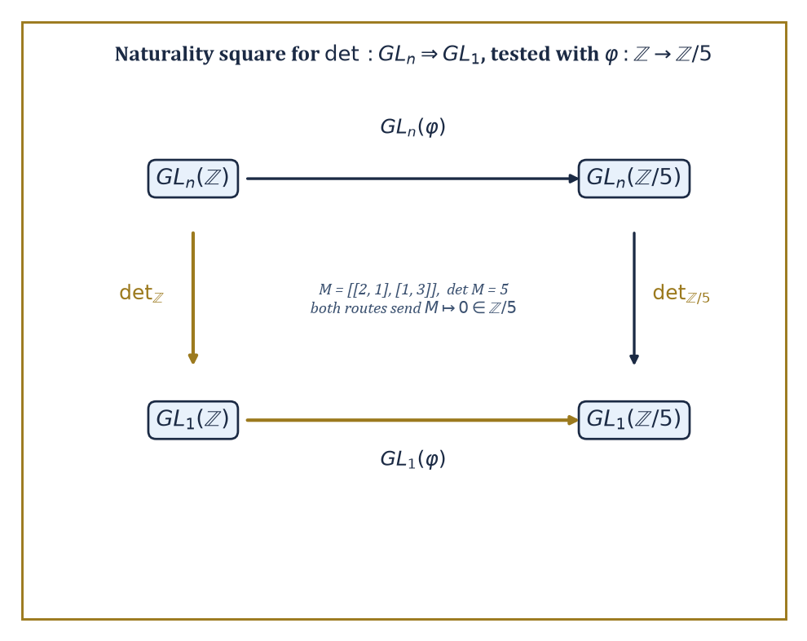
The naturality square for det, tested on an actual integer matrix reduced mod 5 — both routes land on 0, honestly.
Associativity: a chain of arrows composes to one answer regardless of how you bracket it, whenever the composites make sense.
(h∘g)∘f = h∘(g∘f)
Unit laws: the identity arrow really is a no-op under composition, for every f: A → B.
f∘id_A = f
id_B∘f = f
Familiar examples include Set (sets and functions), Grp (groups and homomorphisms), Top (topological spaces and continuous maps), Vect (vector spaces and linear maps), and Pos (posets and order-preserving maps); less obviously, any single group or monoid is a category with one object, and any preorder is a category in which there is at most one arrow between any two objects.
Numeric example — Composition and identity, checked by hand. Let A = {1, 2}, B = {a, b, c}, C = {x, y}, D = {α, β} be four finite sets, objects of Set. Define f: A → B by f(1) = a, f(2) = b; g: B → C by g(a) = x, g(b) = y, g(c) = x; h: C → D by h(x) = α, h(y) = β.
First, compose g and f:
(g∘f)(1) = g(a) = x
(g∘f)(2) = g(b) = y
So g∘f sends 1 ↦ x, 2 ↦ y. Now check associativity two ways.
Left path, h∘(g∘f): apply g∘f first, then h.
(h∘(g∘f))(1) = h(x) = α
(h∘(g∘f))(2) = h(y) = β
Right path, (h∘g)∘f: first compute h∘g.
(h∘g)(a) = h(x) = α
(h∘g)(b) = h(y) = β
(h∘g)(c) = h(x) = α
Then apply that to f.
((h∘g)∘f)(1) = (h∘g)(a) = α
((h∘g)∘f)(2) = (h∘g)(b) = β
Both paths give 1 ↦ α, 2 ↦ β: associativity holds, as it must for ordinary function composition, but now checked explicitly rather than taken on faith.
For the unit law:
id_A(1) = 1
id_A(2) = 2
And f∘id_A sends 1 ↦ f(1) = a and 2 ↦ f(2) = b, exactly f itself.
Numeric example — A category where the arrows are matrices. Not every category has sets as objects. Let Mat have as objects the natural numbers 0, 1, 2, …, and let a morphism n → m be an m×n real matrix, thought of as a linear map ℝⁿ → ℝᵐ; composition of f: n → m and g: m → p is ordinary matrix multiplication g·f, a p×n matrix, and id_n is the n×n identity matrix.
Take f: 2 → 3 given by the 3×2 matrix with rows (1,0), (0,1), (1,1), and g: 3 → 1 given by the 1×3 matrix (row vector) (2, 1, −1). The composite g∘f: 2 → 1 is the 1×2 matrix g·f. Its single row is computed entrywise:
first entry = 2·1 + 1·0 + (−1)·1 = 2 + 0 − 1 = 1
second entry = 2·0 + 1·1 + (−1)·1 = 0 + 1 − 1 = 0
g∘f = (1, 0)
Associativity of this composition is simply the associativity of matrix multiplication, which linear algebra already guarantees — category theory is not claiming anything new here, only pointing out that ℝⁿ-and-matrices was secretly a category all along.
A functor F: C → D is a structure-preserving map between categories: it sends each object A of C to an object F(A) of D, and each morphism f: A → B of C to a morphism F(f): F(A) → F(B) of D, in such a way that:
F(g∘f) = F(g)∘F(f)
F(id_A) = id_{F(A)}
Functors are to categories what homomorphisms are to groups, or continuous maps are to spaces — the maps that respect the relevant structure, except that here the structure being respected is the entire pattern of composition itself.
A single functor can forget structure (the forgetful functor U: Grp → Set simply remembers the underlying set of a group and forgets the multiplication), or it can freely generate structure (the free functor F: Set → Grp, met properly three rooms from now, builds the freest possible group on a set), or it can do something more elaborate still.
Numeric example — A forgetful functor, watched forgetting something. Let U: Grp → Set be the forgetful functor. Take the group G = ℤ/4 = {0, 1, 2, 3} under addition modulo 4. Then U(G) is just the four-element set {0, 1, 2, 3}, with no memory that 2+3=1 in G.
Now take the homomorphism φ: ℤ/4 → ℤ/2 given by φ(x) = x mod 2, so:
φ(0)=0, φ(1)=1, φ(2)=0, φ(3)=1
Check it really is a homomorphism on a couple of awkward-looking cases.
φ(3+3 mod 4) = φ(2) = 0
φ(3)+φ(3) mod 2 = 1+1 = 0
— matches.
φ(1+2 mod 4) = φ(3) = 1
φ(1)+φ(2) mod 2 = 1+0 = 1
— matches. The functor U sends this homomorphism to U(φ), which as a function {0,1,2,3} → {0,1} is described by exactly the same table of values — but U(φ) is now merely a function, with no obligation to respect any addition, because U has thrown the group structure away on both sides. Nothing about the four numbers changed; everything about what we are allowed to say about them did.
A natural transformation α: F ⇒ G between two functors F, G: C → D is a family of morphisms α_A: F(A) → G(A), one for every object A of C, chosen so that for every morphism f: A → B in C the square built from α_A, α_B, F(f), and G(f) commutes:
G(f)∘α_A = α_B∘F(f)
This single commuting-square condition, called naturality, is the formal replacement for the vague phrase the same construction, done the same way, for every object — exactly the property that separated the honest isomorphism V ≅ V** from the choice-dependent V ≅ V* two examples ago.
Numeric example — A naturality square that actually commutes. Let GL_n and GL_1 be functors from CRing (commutative rings and ring homomorphisms) to Grp, sending a ring R to the group of invertible n×n matrices over R, respectively the group of invertible 1×1 matrices over R (that is, the units of R). The determinant gives a natural transformation det: GL_n ⇒ GL_1:
det_R(M) = det(M)
Naturality says that for any ring homomorphism φ: R → S, applying φ entrywise to a matrix and then taking the determinant in S agrees with taking the determinant in R and then applying φ. Test it: let R = ℤ, S = ℤ/5, and φ: ℤ → ℤ/5 the reduction-mod-5 map. Take M = the 2×2 integer matrix with rows (2, 1) and (1, 3).
Its determinant is:
det(M) = 2·3 − 1·1 = 6 − 1 = 5
φ(det M) = φ(5) = 0 in ℤ/5
Now go the other way: φ(M) reduces every entry mod 5, but every entry of M is already below 5, so φ(M) has the same rows (2,1), (1,3), now read as a matrix over ℤ/5, and:
det(φ(M)) = 2·3 − 1·1 = 6 − 1 = 5 ≡ 0 (mod 5)
Both routes around the square land on 0 in ℤ/5: the square commutes, exactly as naturality demands, and not by luck — it would have commuted for any integer matrix and any reduction map, which is the entire content of calling det natural rather than merely true.
With these three words in hand — category, functor, natural transformation — the earlier promise starts to look concrete.
Any two constructions that can be phrased as functors, and any two functors that admit a natural transformation between them that is invertible at every object, are naturally isomorphic: identified not by an accident of counting, but by a uniform recipe that works the same way everywhere.
That is the precise meaning behind the informal claim, heard throughout mathematics, that two things are really the same construction in disguise.

Room 38.3: Universal Properties and Representable Functors
Defining a thing by what talks to it, rather than what it contains
An object is defined by a universal property when it is characterised, up to a unique isomorphism, by the morphisms into it or out of it, rather than by any description of its internal contents. This is a genuinely different style of definition from the ones met earlier in the Tower.
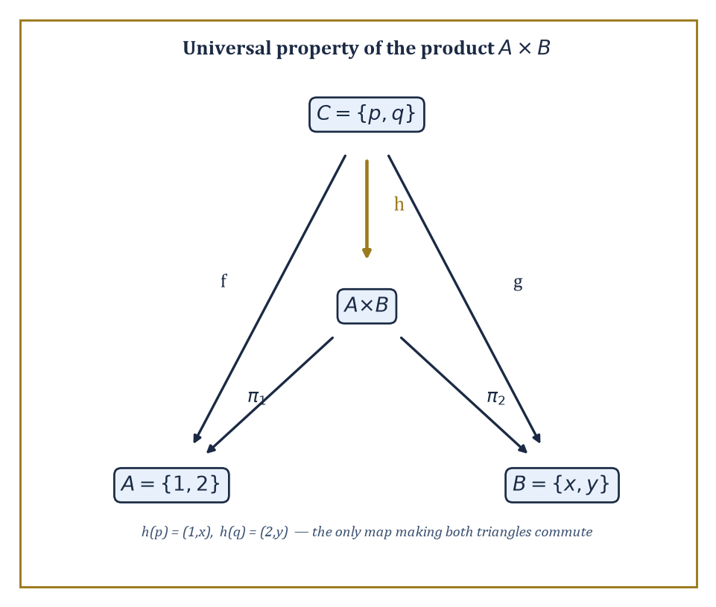
The universal property of the product, with the one map h that makes both triangles commute pinned down exactly.
Instead of building an object and then proving it has some property, you specify the property first — usually a formula stating that maps to or from some test object correspond exactly to maps to or from your object — and the object, if it exists at all, is pinned down uniquely by that specification alone. Products, coproducts, equalizers, free objects, and tensor products are all defined this way.
Numeric example — The product of two sets, built and verified. Let A = {1, 2} and B = {x, y}.
A × B = {(1,x), (1,y), (2,x), (2,y)}
The categorical product A × B in Set is this ordinary Cartesian product, equipped with projections π₁: A×B → A and π₂: A×B → B sending a pair to its first, respectively second, coordinate.
The universal property says: for any set C with a map f: C → A and a map g: C → B, there is exactly one map h: C → A×B with
π₁∘h = f and π₂∘h = g
Test it with C = {p, q}, where
f(p) = 1, f(q) = 2, g(p) = x, g(q) = y
The only candidate is
h(p) = (1,x), h(q) = (2,y)
since π₁(h(p)) must equal f(p)=1 and π₂(h(p)) must equal g(p)=x, forcing h(p)=(1,x); the same logic forces h(q)=(2,y). No other function C → A×B satisfies both projection conditions, which is exactly what unique means here — the pairing map is forced, not chosen:
h(c) = (f(c), g(c))
The coproduct is the mirror image: instead of maps into two objects, we ask about maps out of them.
The coproduct A ⊔ B comes with inclusions ι_A: A → A⊔B and ι_B: B → A⊔B, and its universal property says that a map out of A⊔B corresponds to a compatible pair of maps, one out of A and one out of B.
In Set, A ⊔ B is the disjoint union, formed by tagging elements so that copies from A never collide with copies from B even if the original sets overlapped.
Numeric example — A disjoint union, tags and all. Let A = {1, 2} and B = {3, 4}, which happen not to overlap already, but to see the general recipe we tag anyway.
A⊔B = {(1,A), (2,A), (3,B), (4,B)}
ι_A(1) = (1,A), ι_A(2) = (2,A)
and similarly for ι_B.
Had A and B instead both contained the element 1, the tags (1,A) and (1,B) would keep the two copies distinct — the whole point of the construction is that it never loses information by collision, unlike an ordinary set union.
Given any set D with maps p: A → D and q: B → D — say D = {•}, the one-point set, with p and q both the unique constant maps.
There is exactly one map A⊔B → D agreeing with p on the A-tagged elements and with q on the B-tagged elements, namely the constant map sending everything to •.
A third universal construction, the equalizer, is worth seeing because it looks less symmetric than a product or coproduct and is correspondingly more useful in practice: it is the universal way of forcing two parallel maps to agree.
Numeric example — The equalizer of two functions, found by inspection. Let f, g: {1, 2, 3} → {a, b} be given by
f(1)=a, f(2)=a, f(3)=b, and g(1)=a, g(2)=b, g(3)=b
The equalizer of f and g is the largest subset of {1,2,3} on which f and g agree, together with its inclusion map. Check each point:
at 1: f(1) = a = g(1) — they agree
at 2: f(2) = a, g(2) = b — they disagree
at 3: f(3) = b = g(3) — they agree
So the equalizer is {1, 3}, included into {1,2,3} in the obvious way.
The universal property says that any map h: D → {1,2,3} with f∘h = g∘h must land entirely inside {1,3} — which is obvious once you see it: if h(d)=2 for some d, then
f(h(d)) = a while g(h(d)) = b
contradicting f∘h = g∘h. So {1,3} is not merely a subset that happens to work; it is forced to be exactly the equalizer by the requirement itself.
A functor F: C → Set is representable when it is naturally isomorphic to a Hom-functor Hom(c, –) for some fixed object c of C — that is, F(A) looks, naturally in A, exactly like the set of morphisms c → A.
Representability is the categorical way of saying an entire functor, however defined, is secretly nothing more than probing objects with maps out of one fixed object c.
It turns questions about F into questions about morphisms into or out of c, which are usually far easier to get a grip on.
Numeric example — The identity functor on Set is representable. Let 1 = {*} be a one-element set, and consider Hom(1, –): Set → Set, sending a set X to the set of functions {*} → X.
Any such function is determined entirely by where it sends *, and it can send * to any element of X whatsoever — so Hom(1, X) is in natural bijection with X itself: the identity functor on Set is represented by the singleton set 1.
Check the count on X = {a, b, c}: there are exactly three functions {*} → X, one for each choice of image of *, matching |X| exactly:
|X| = 3
This is not a coincidence dressed up in fancy language; it is the precise statement that picking out an element of a set is the same activity as mapping a single point into it, which is obvious the moment it is said aloud and yet turns out, once generalised, to organise a remarkable amount of the rest of this storey.
The practical value of universal properties is that they replace an explicit, often fiddly construction with a characterising property that is frequently much easier to check.
If you can show two objects both satisfy the same universal property, a short formal argument — build the maps each way using the two universal properties, compose them, and note the composite must be an identity by uniqueness — proves they are isomorphic, without your ever having to compare their internal descriptions directly.
This is the trick that makes constructions functorial almost for free, and it is the trick that limits and colimits, in the next room, apply on an industrial scale.

Room 38.4: Limits and Colimits
One universal property to rule the products, equalizers, and their kin
Products and equalizers, from the previous room, turn out to be special cases of a single notion: the limit of a diagram.
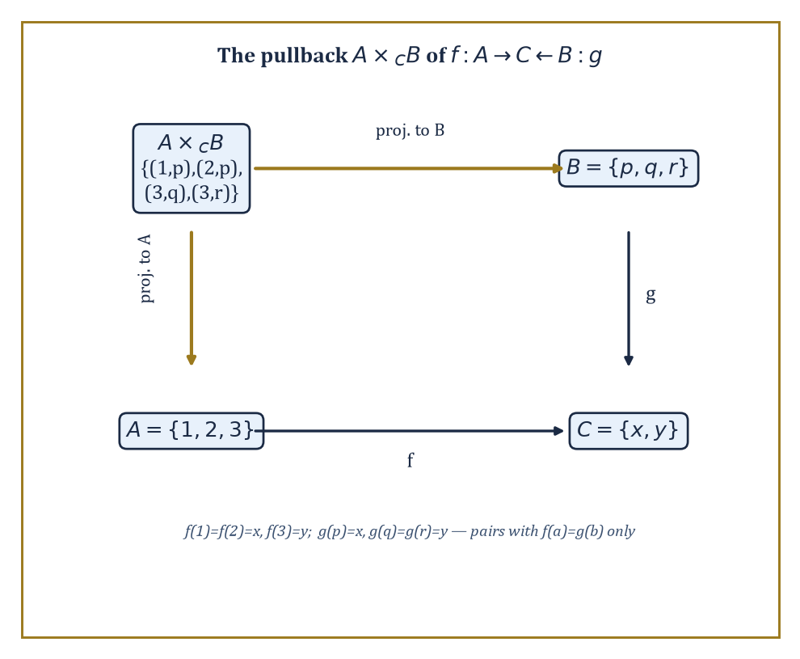
The pullback square, worked by brute force: only the pairs where f and g agree survive.
A diagram in a category C is just a collection of objects and morphisms among them, indexed by some shape; a cone over the diagram is an object with maps to every object of the diagram, compatible with the diagram's own arrows; and a limit is a universal cone — one through which every other cone factors uniquely.
Reverse every arrow and you get a cocone and a colimit, the universal object receiving maps from every object of the diagram.
Products, equalizers, and inverse limits are all limits of different diagram shapes; coproducts, coequalizers, and direct limits are all colimits.
Numeric example — A pullback, computed by brute force. The pullback of f: A → C and g: B → C is the limit of the diagram A → C ← B, and it is one of the most-used limits in all of mathematics.
A ×_C B = {(a,b) ∈ A×B : f(a) = g(b)}
Let A = {1,2,3}, B = {p,q,r}, C = {x,y}, with the maps f and g defined as follows:
f(1)=x, f(2)=x, f(3)=y
g(p)=x, g(q)=y, g(r)=y
Go through A element by element: for a=1, f(1)=x, so we need g(b)=x, which holds only for b=p, giving the pair (1,p); for a=2, f(2)=x also, giving (2,p); for a=3, f(3)=y, so we need g(b)=y, which holds for b=q and b=r, giving (3,q) and (3,r).
A ×_C B = {(1,p), (2,p), (3,q), (3,r)}
The pullback is this set — four pairs in total — together with the two projections down to A and B. This is exactly the universal cone: any set D mapping compatibly into A and B so that the two composites into C agree must factor uniquely through these four pairs.
Numeric example — A pushout, glued along a shared piece. Dually, the pushout of f: C → A and g: C → B is the colimit of A ← C → B, computed as the disjoint union A⊔B with f(c) glued to g(c) for every c in C.
Let A = {1,2,3}, B = {4,5,6}, C = {c₁,c₂}, with the maps defined as follows:
f(c₁)=1, f(c₂)=2, g(c₁)=4, g(c₂)=5
The disjoint union A⊔B has six tagged elements; the gluing relation identifies 1 with 4 (both images of c₁) and 2 with 5 (both images of c₂), and forces nothing else, since 3 and 6 are not in the image of either f or g.
The pushout therefore has four elements: the class {1,4}, the class {2,5}, the singleton class {3}, and the singleton class {6} — six elements minus two gluings, four classes, exactly as the universal property of a colimit demands: it is the smallest thing you can build by taking A and B and forcing them to agree wherever C tells them to.
A category is complete when every diagram indexed by a small (set-sized, as opposed to unmanageably large) shape has a limit, and cocomplete when every such diagram has a colimit.
Set, Grp, Top, and Vect are all complete and cocomplete; this single fact packages up the existence of arbitrary products, equalizers, intersections, inverse limits, coproducts, coequalizers, quotients, and direct limits in each of those categories into one theorem, rather than requiring a separate ad hoc construction for each.
Abstract example — The empty diagram, and the limit nobody expects. The empty diagram, with no objects and no arrows, still has a limit in any complete category: the limit over nothing at all is the terminal object, the object with exactly one map in from every other object.
In Set, the terminal object is any one-element set {*}, since for any set X there is exactly one function X → {*} — send everything to *.
Dually, the colimit over the empty diagram is the initial object; in Set this is the empty set ∅, since there is exactly one function ∅ → X for every set X (the empty function, vacuously well-defined, doing nothing because there is nothing to do it to).
It is a mildly delightful fact that completeness, a grand-sounding property, secretly guarantees the existence of the emptiest and loneliest objects in the category as a free consequence.
Not every functor gets on well with limits and colimits, and the ones that do are worth naming: a functor preserves limits if it sends limiting cones to limiting cones, and preserves colimits if it sends colimiting cocones to colimiting cocones.
Preservation is not automatic, and knowing which functors preserve which kind of construction is one of the main organising questions of the subject — indeed the whole of the next room is essentially an answer to it.
Numeric example — The forgetful functor preserves products. Let U: Grp → Set be the forgetful functor again, and let G = ℤ/2 = {0,1} and H = ℤ/3 = {0,1,2}.
The product G×H in Grp is the direct product group, with underlying set:
{(0,0),(0,1),(0,2),(1,0),(1,1),(1,2)}
That's six elements under componentwise addition — for example:
(1,1)+(1,2) = (0,0)
since 1+1=2≡0 mod 2 in the first coordinate and 1+2=3≡0 mod 3 in the second.
Apply U: U(G×H) is just this six-element set.
Compare with U(G)×U(H), the ordinary Cartesian product of the two-element set {0,1} and the three-element set {0,1,2}, which also has six elements, and in fact the identical six pairs.
U(G×H) = U(G)×U(H)
So this holds exactly: the forgetful functor preserves this particular product, and in fact preserves all limits — a general fact about forgetful functors into Set that makes them extremely convenient to compute with, precisely because they let you check a limit's size by simply counting elements.
The same forgetful functor is considerably less obliging about colimits, and the contrast is worth seeing, because it is the first hint of the general pattern the next room makes precise: functors that behave well with limits often behave badly with colimits, and vice versa.
A colimit in Grp need not have an underlying set that looks anything like the corresponding colimit of the underlying sets in Set.
Numeric example — The forgetful functor does not preserve coproducts. Let G = H = ℤ/2 = {0,1}, two separate copies of the two-element group.
In Set, U(G) ⊔ U(H) is the disjoint union of two two-element sets, which has exactly four elements.
But the coproduct in Grp, the free product G * H, is not the four-element group one might naively expect — it is the infinite dihedral group, generated by the two order-2 elements of G and H with no relation imposed between them beyond each individually squaring to the identity, so that products such as ab, abab, ababab and so on are all forced to be distinct, giving infinitely many elements.
So U(G*H) is infinite, while U(G) ⊔ U(H) has only four elements: the forgetful functor emphatically does not preserve this coproduct.
Since U is a right adjoint (to the free functor F of Room 38.5), this is no accident and no failure of the theorem — right adjoints are only ever guaranteed to preserve limits, and this is exactly the kind of colimit they are permitted, indeed expected, to mangle.

Room 38.5: Adjoint Functors
The closest thing category theory has to true love, requited on both sides
An adjunction between categories C and D is a pair of functors F: C → D and G: D → C, together with a natural bijection, for every object c of C and d of D.
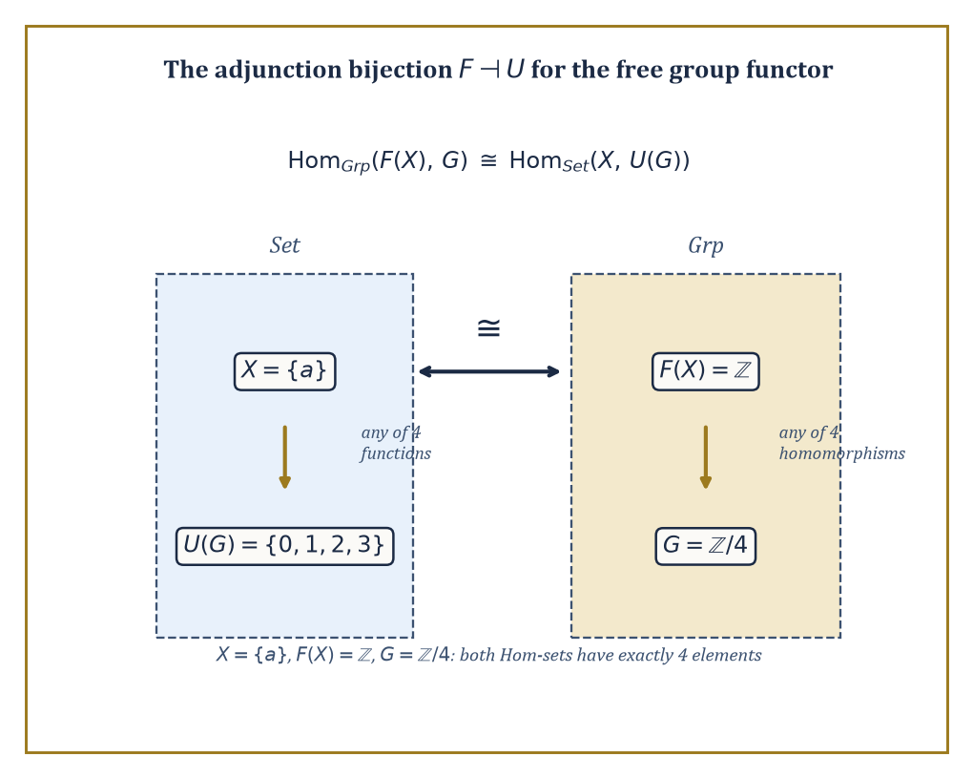
The adjunction bijection, made countable: four functions on one side, four homomorphisms on the other, matched exactly.
Hom_D(F(c), d) ≅ Hom_C(c, G(d))
F is called the left adjoint, G the right adjoint, and the relationship is written F ⊣ G. This single bijection is one of the most productive ideas in the whole of mathematics: an enormous number of pairs of constructions that look, on the surface, entirely unrelated — free objects and forgetful functors, tensor product and function space, existential quantifiers and substitution — turn out to be an adjoint pair once you look closely enough, and once you know that, a long list of formal consequences follows automatically, without further work.
Numeric example — Free group, forgetful functor, and a bijection you can count. Let F: Set → Grp send a set X to the free group on X, and let U: Grp → Set be the forgetful functor. The adjunction claims that the following holds naturally.
Hom_Grp(F(X), G) ≅ Hom_Set(X, U(G))
Take X = {a}, a single-element set. The free group on one generator is the infinite cyclic group, since with only one generator and no imposed relations, every element is just some integer power of a.
F({a}) = ℤ
Let G = ℤ/4 = {0,1,2,3}.
The right-hand side, Hom_Set({a}, U(G)), is the set of functions from a one-element set into the four-element set {0,1,2,3} — there are exactly four such functions, one for each choice of where a lands.
The left-hand side, Hom_Grp(ℤ, ℤ/4), is the set of group homomorphisms from ℤ to ℤ/4; since ℤ is generated freely by 1, such a homomorphism is entirely determined by the image of 1, and any of the four elements 0,1,2,3 may be chosen with no relation to violate (ℤ has none). That is again exactly four homomorphisms.
Both sides have four elements, and the adjunction's bijection matches them up in the obvious way: the function a ↦ k on the right corresponds to the homomorphism sending 1 ↦ k on the left. Freeness, in other words, is precisely the statement that choosing where generators go is the only choice you ever have to make.
Two structural facts about adjunctions are worth committing to memory, because they explain why adjoints are so useful rather than merely elegant: left adjoints preserve colimits, and right adjoints preserve limits.
A free construction, being a left adjoint, therefore automatically plays well with unions and gluings; a forgetful functor, being a right adjoint, automatically plays well with products and intersections — which is exactly the fact used two rooms ago to show the forgetful functor from Grp preserves products, now revealed not to be a lucky accident about groups specifically but a consequence of a general theorem about all right adjoints whatsoever.
Abstract example — Free functors turn disjoint unions into free products. Since F: Set → Grp is a left adjoint, it preserves colimits, and in particular sends the coproduct in Set (disjoint union) to the coproduct in Grp (free product, the group built by combining two groups with no relations imposed between their generators beyond what each already had internally).
Concretely, {a,b} is the coproduct of the singletons {a} and {b} in Set, so F({a,b}) must be the coproduct, in Grp, of F({a}) and F({b}) — that is, the free group on two generators is the free product of two copies of ℤ.
F({a,b}) ≅ ℤ * ℤ
This matches the direct definition of the free group on {a,b} exactly, but the adjunction handed us the fact without requiring a fresh construction — it fell out of a theorem that has nothing to do with groups in particular.
Every adjunction comes with two natural transformations that encode the bijection at its most basic level: the unit and the counit.
η: id_C ⇒ G∘F
ε: F∘G ⇒ id_D
These satisfy two triangle identities that essentially say applying the unit and then the counit, in either order, does nothing extra. The unit is usually the more intuitive of the two — it is the canonical way of feeding an object of C into the round trip C → D → C.
Numeric example — The unit of the free-forgetful adjunction, made explicit. For the adjunction F ⊣ U above, the unit at X = {a} is a function from {a} into the underlying set of the free group ℤ.
η_X: X → U(F(X))
It is simply the generator: the single element a is sent to the integer 1, which generates the free group F(X) = ℤ.
η_X(a) = 1
This looks almost too obvious to deserve a name, and that is rather the point — the unit is the officially sanctioned way of regarding a raw element as a generator of the freest possible group built from it, and the triangle identity guarantees that if you then apply U to any homomorphism out of F(X) and restrict along η_X, you recover exactly the function you started with, nothing gained, nothing lost, no accidental side effects.
A single functor is not limited to one adjoint on one side; some have a left adjoint and a right adjoint simultaneously, sitting on opposite sides of it like bookends, and comparing the two is instructive.
The forgetful functor U: Top → Set has both: a left adjoint that equips a set with the discrete topology (every subset declared open), and a right adjoint that equips it with the indiscrete topology (only the empty set and the whole space declared open).
Numeric example — Two adjoints, one set, two very different topologies. Let X = {1,2,3}. The discrete topology on X takes every one of the 2³ = 8 subsets of X to be open.
∅, {1}, {2}, {3}, {1,2}, {1,3}, {2,3}, {1,2,3}
The indiscrete topology on X takes only 2 of those subsets to be open, and declares nothing else open, however tempting.
∅, {1,2,3}
Both are genuine topologies on the same three-point set, sitting at opposite extremes of how much structure gets imposed, and the adjunctions say precisely why each deserves to be called canonical: the discrete topology is the freest possible topology making the identity function on X continuous when mapping out of it, and the indiscrete topology is the laziest possible topology making the identity function continuous when mapping into it.
Left adjoint gives you the most structure compatible with a universal property about maps out; right adjoint gives you the least structure compatible with a universal property about maps in — and the humble forgetful functor from topology to sets sits exactly in the middle, watching both extremes get generated automatically from nothing more than the two triangle identities.

Room 38.6: The Yoneda Lemma
Everything an object is, is what talks to it
The Yoneda lemma states: for any category C, any object c of C, and any functor F: C → Set, the natural transformations from the representable functor Hom(c, –) to F correspond exactly, and naturally, to the elements of F(c).
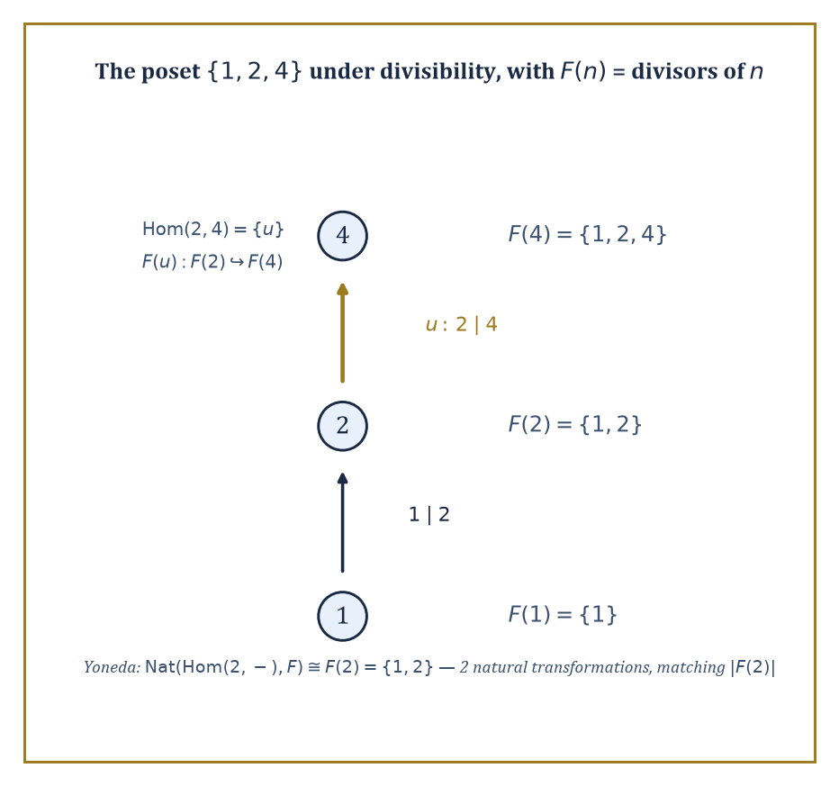
The three-object poset that makes the Yoneda lemma countable by hand: two natural transformations, matching |F(2)| on the nose.
Nat(Hom(c,–), F) ≅ F(c)
This is often introduced as the single most important theorem in category theory, a claim that sounds like hyperbole until you have watched it work on a genuine example, at which point the claim starts to look, if anything, understated: an entire set of natural transformations — potentially infinite, potentially fearsome to construct directly — collapses to something as simple as picking one element of one set.
Worked example — Yoneda, worked completely on a three-object category. Let C be the poset {1, 2, 4} ordered by divisibility, viewed as a category: there is exactly one morphism a → b when a divides b, and none otherwise.
Hom(2,1) = ∅, Hom(2,2) = {id₂}, Hom(2,4) = {u}
There is no morphism from 2 to 1, since 2 does not divide 1; there is exactly one morphism from 2 to 2, the identity id₂; and exactly one morphism from 2 to 4, the unique morphism u witnessing 2 | 4.
Let F: C → Set send each n to its set of divisors, and send a morphism a → b (i.e. a | b) to the inclusion of divisor-sets F(a) ⊆ F(b) — a genuine functor, since a | b implies every divisor of a is also a divisor of b.
F(1) = {1}, F(2) = {1,2}, F(4) = {1,2,4}
Yoneda predicts that the natural transformations from Hom(2,–) to F correspond exactly to the elements of F(2), a two-element set:
Nat(Hom(2,–), F) ≅ F(2) = {1,2}
Check this directly by hand. A natural transformation α assigns to each object n a function α_n: Hom(2,n) → F(n), compatibly.
At n=1, Hom(2,1) = ∅, so α₁ is the unique empty function — no freedom, no choice.
At n=2, Hom(2,2) = {id₂}, so α₂ is determined by the single value α₂(id₂), which may be any element of F(2) = {1,2} — two choices here.
At n=4, naturality forces the value of α₄(u), where F(u): F(2) → F(4) is the inclusion {1,2} ⊆ {1,2,4}:
α₄(u) = F(u)(α₂(id₂))
So if α₂(id₂) = 1 then α₄(u) = 1, and if α₂(id₂) = 2 then α₄(u) = 2 — no further freedom, entirely dictated by the earlier choice.
The upshot: the whole natural transformation, at every one of the three objects, is completely pinned down by the single choice of α₂(id₂) ∈ {1,2}. There are exactly two natural transformations Hom(2,–) ⇒ F, matching |F(2)| = 2 on the nose, and matching it for the structural reason Yoneda predicts, not by coincidence of counting.
A corollary follows almost immediately, and it is the corollary most often invoked in practice: the Yoneda embedding, sending an object c to the functor Hom(c,–), is full and faithful.
Applying the lemma itself with F = Hom(d,–) gives the following, where the right-hand side deserves a careful look at which way the arrow points:
Nat(Hom(c,–), Hom(d,–)) ≅ Hom(d,–)(c) = Hom(d,c)
A morphism d → c in C corresponds to a natural transformation Hom(c,–) ⇒ Hom(d,–), the direction having quietly reversed, exactly as it must once you notice that probing with maps out of c and probing with maps out of d have swapped roles.
Full and faithful then means precisely this: the collection of morphisms between two objects, however complicated the category, is recovered exactly, with nothing lost and nothing invented, as the collection of natural transformations between the two functors those objects represent — an object is determined, up to isomorphism, entirely by the maps other objects make into it and out of it.
Abstract example — Full faithfulness, checked in both directions on the same poset. Continue with C = {1,2,4} under divisibility. Take c = 4 and d = 2. There is a morphism d → c, namely 2 → 4, since 2 | 4; call it u. The corollary predicts exactly one natural transformation Hom(4,–) ⇒ Hom(2,–).
Check directly: such a transformation β assigns β_n: Hom(4,n) → Hom(2,n) for each n.
At n=1, Hom(4,1) = ∅ and Hom(2,1) = ∅, so β₁ is the unique empty function, no information gained.
At n=2, Hom(4,2) = ∅ (4 does not divide 2) and Hom(2,2) = {id₂}, so β₂ is again the unique empty function.
At n=4, Hom(4,4) = {id₄} and Hom(2,4) = {u}, so β₄(id₄) is forced to be u, the only available element — one choice, and it is not really a choice at all.
So there is exactly one such natural transformation, matching Hom(2,4) = {u} exactly, as the corollary demanded.
Now try the reverse: is there a morphism 4 → 2? No, since 4 does not divide 2, so Hom(4,2) = ∅, and the corollary predicts zero natural transformations Hom(2,–) ⇒ Hom(4,–).
Direct check confirms it: any such transformation would need a function Hom(2,2) → Hom(4,2), that is {id₂} → ∅, and no function exists from a nonempty set into the empty set.
Zero morphisms in, zero natural transformations out, on both sides, in both directions — the embedding never loses a morphism and never invents one that was not there.
It is worth pausing on one special case of the Yoneda embedding, because it turns out to be an old friend from several storeys ago wearing a new coat. Recall from Room 38.2 that a single group G can be viewed as a category BG with exactly one object, written *, whose morphisms Hom(*,*) are the elements of G, composed by the group operation.
Applying the Yoneda embedding here — there being only one object to embed — sends * to the functor Hom(*,–), which, since there is nowhere else to send it, is just the set G itself, with every element g of G acting on that set by post-composition, i.e. left multiplication by g.
Full faithfulness of the Yoneda embedding, in this one-object special case, says exactly that this action of G on itself by left multiplication is faithful — different group elements give different permutations of the underlying set of G.
That statement has a name from ordinary group theory, met long before this storey: it is Cayley's theorem, that every group embeds into the symmetric group on its own underlying set.
Numeric example — Yoneda recovers Cayley's theorem, verified on ℤ/3. Let G = ℤ/3 = {0,1,2} under addition modulo 3. The Yoneda-flavoured action of G on its own underlying set, by left multiplication (here, addition), sends each g to the permutation x ↦ x + g (mod 3).
g = 1: 0↦1, 1↦2, 2↦0
This is the 3-cycle (0 1 2).
g = 2: 0↦2, 1↦0, 2↦1
This is the 3-cycle (0 2 1), the inverse of the first. For g = 0, the result is the identity permutation.
These three permutations of {0,1,2} are pairwise distinct, exactly as faithfulness demands, and they form a subgroup of the symmetric group S₃ isomorphic to ℤ/3 itself — the familiar embedding ℤ/3 ↪ S₃ as the cyclic subgroup of rotations, arrived at here not by an ad hoc trick but as a direct instance of the Yoneda embedding applied to a one-object category.
What looked, several storeys back, like a clever standalone observation about permutations turns out to be the smallest possible case of a single unifying lemma.
Yoneda is often summarised, slightly flippantly but not inaccurately, as: an object is nothing but the collection of ways it relates to everything else.
That collapses a great deal of mathematical practice — recognising two constructions as isomorphic by checking they represent the same functor, computing an unfamiliar Hom-set by identifying it with a familiar one, proving a functor is representable at all — into applications of a single lemma whose proof, once you have done the bookkeeping exercise above by hand, is really just careful accounting and nothing more mysterious than that.

Room 38.7: Monads and Algebras
What an adjunction leaves behind when it goes home
A monad on a category C is an endofunctor T: C → C equipped with two natural transformations, a unit and a multiplication:
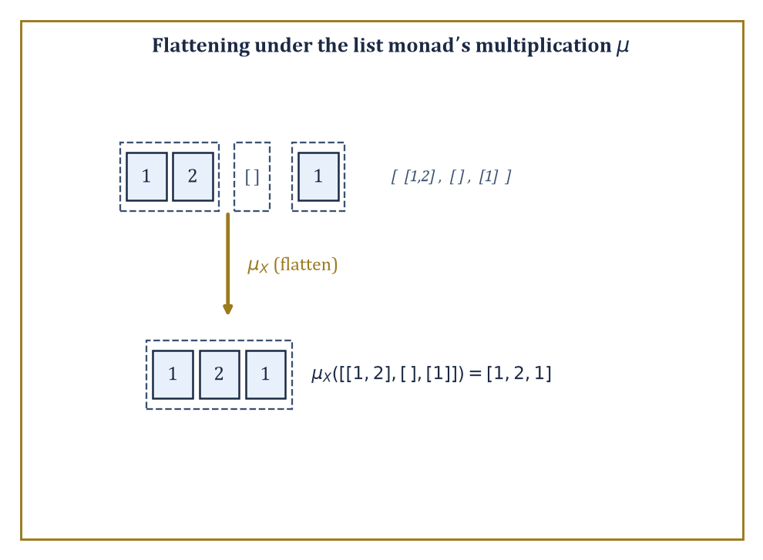
The list monad's multiplication, flattening three nested lists into one — no abstraction required, just concatenation.
η: id_C ⇒ T, μ: T² ⇒ T
These satisfy associativity and unit laws that mirror, almost word for word, the axioms of an ordinary monoid — which is exactly why a monad is often described as a monoid in the category of endofunctors of C, a description that sounds like a joke until you check it really is just that.
Every adjunction F ⊣ G produces a monad on C by setting
T = G∘F
with unit the adjunction's unit and multiplication built from the counit; conversely every monad arises this way from at least one adjunction, sometimes several.
Numeric example — The list monad, flattened by hand. Let T: Set → Set send a set X to List(X), the set of finite lists of elements of X.
The unit wraps an element as a one-item list:
η_X(x) = [x]
The multiplication μ_X: List(List(X)) → List(X) flattens a list of lists by concatenation.
Take X = {1,2}, and the list of lists [[1,2], [], [1]] ∈ List(List(X)) — three sub-lists, of lengths 2, 0, and 1. Concatenating in order: [1,2] followed by [] followed by [1] gives:
μ_X([[1,2],[],[1]]) = [1,2,1]
This is the monad multiplication computed on an actual example: three nested lists become one flat list of length
2+0+1 = 3
with the elements kept in the same left-to-right order they appeared in the nesting.
Every monad T gives rise to a category of T-algebras (the Eilenberg-Moore category), whose objects are pairs (A, α) with A an object of C and α: T(A) → A a structure map satisfying the evident associativity and unit laws. The unit law says:
α(η_A(a)) = a
and the associativity law says α applied after flattening equals α applied twice.
These algebras are exactly the categorical way of saying an algebraic theory such as group, or ring, or monoid, is secretly a monad on Set in disguise: the operations of the theory become the structure map, and the equational laws of the theory become the two algebra axioms.
Numeric example — Summation as an algebra for the list monad. Take A = ℕ, and let α: List(ℕ) → ℕ be the sum of a list (with the empty list summing to 0):
α([n₁,...,n_k]) = n₁+...+n_k
Check the unit law on n=7:
α(η_ℕ(7)) = α([7]) = 7
Correct. Check associativity on the nested list [[3,5],[2]] ∈ List(List(ℕ)) two ways. Direct route: flatten first with μ, giving [3,5,2], then sum:
α([3,5,2]) = 3+5+2 = 10
Indirect route: sum each inner list first (apply T(α), the functor T applied to the morphism α, meaning map α over the outer list), giving:
[α([3,5]), α([2])] = [8, 2]
Then sum that:
α([8,2]) = 8+2 = 10
Both routes give 10 — the associativity law for a monad algebra, checked with real numbers rather than merely asserted from the general theory.
What this is secretly saying is that ℕ, with addition and the number 0, is a monoid, and the list-algebra structure is precisely a repackaging of the monoid axioms: sum-then-sum equals sum-all-at-once, in whatever order you group the summation, which every schoolchild already knows and category theory now knows how to say for any algebraic theory whatsoever, not merely addition.
The Kleisli category of a monad T has the same objects as C, but a morphism X → Y in the Kleisli category is a morphism X → T(Y) in C, composed by feeding the output of one Kleisli map through T and then multiplying with μ.
This is the category of free algebras for T, and — outside pure mathematics — it is also precisely the structure that programming languages exploit to model computations that produce a value together with some side effect, such as possible failure, nondeterminism, or logging, without polluting ordinary function composition with the bookkeeping for that effect.
Numeric example — A Kleisli morphism for the list monad. In the Kleisli category of the list monad T = List, a Kleisli morphism f: {a} → {1,2,3} is an ordinary function {a} → List({1,2,3}), say:
f(a) = [1,2]
Read as: a produces two possible outputs, 1 and 2. Given a second Kleisli morphism g: {1,2,3} → {10,20}, say:
g(1)=[10,20], g(2)=[20], g(3)=[10]
The Kleisli composite g∘_K f sends a to the flattened concatenation of g applied to each element of f(a):
g(1)++g(2) = [10,20]++[20] = [10,20,20]
So the composite Kleisli morphism reports that a, via the intermediate nondeterministic choice of 1 or 2, can ultimately produce 10, 20, or 20 again — a computation that branches, tracked automatically by the monad's bookkeeping, with the underlying List structure doing all the work of collecting up the possibilities that an ordinary function could never represent.
The list monad tracks the effect of nondeterminism; a smaller and even more common monad tracks the effect of possible failure.
Let T(X) be the set X with one extra element ⊥ (read: none, or failure) bolted on:
T(X) = X ⊔ {⊥}
The unit wraps a value as a definite success:
η_X(x) = x
The multiplication μ_X: T(T(X)) → T(X) collapses any failure at either level down to the single failure ⊥ of the outer type.
Numeric example — Flattening nested failure, counted explicitly. Let X = {1,2}, so:
T(X) = {1, 2, ⊥}
three elements. Then T(T(X)) has four elements: three of the form just(y) for y ∈ T(X) = {1,2,⊥} — namely just(1), just(2), just(⊥) — plus one further outer failure, written ⊥ again but now living one level up.
Apply μ_X to each of the four.
μ_X(just(1)) = 1
A genuine success passed straight through.
μ_X(just(2)) = 2
Likewise.
μ_X(just(⊥)) = ⊥
An inner failure surfacing as an outer one.
μ_X(⊥) = ⊥
An outer failure that was never going to become anything else.
So μ_X sends the four elements to the following:
{just(1), just(2), just(⊥), ⊥} → {1, 2, ⊥, ⊥}
Two of the four inputs collapse onto the same output ⊥, which is exactly the desired behaviour: however failure arose, at whatever depth of nesting, there is only ever one flavour of it once you flatten, never two different kinds of nothing to keep track of.

Room 38.8: Abelian Categories and Homological Algebra
Where kernels and cokernels finally get the respect they deserve
An abelian category is a category that behaves, structurally, like the category of modules over a ring — the two running examples throughout this room will be abelian groups (ℤ-modules) and vector spaces.
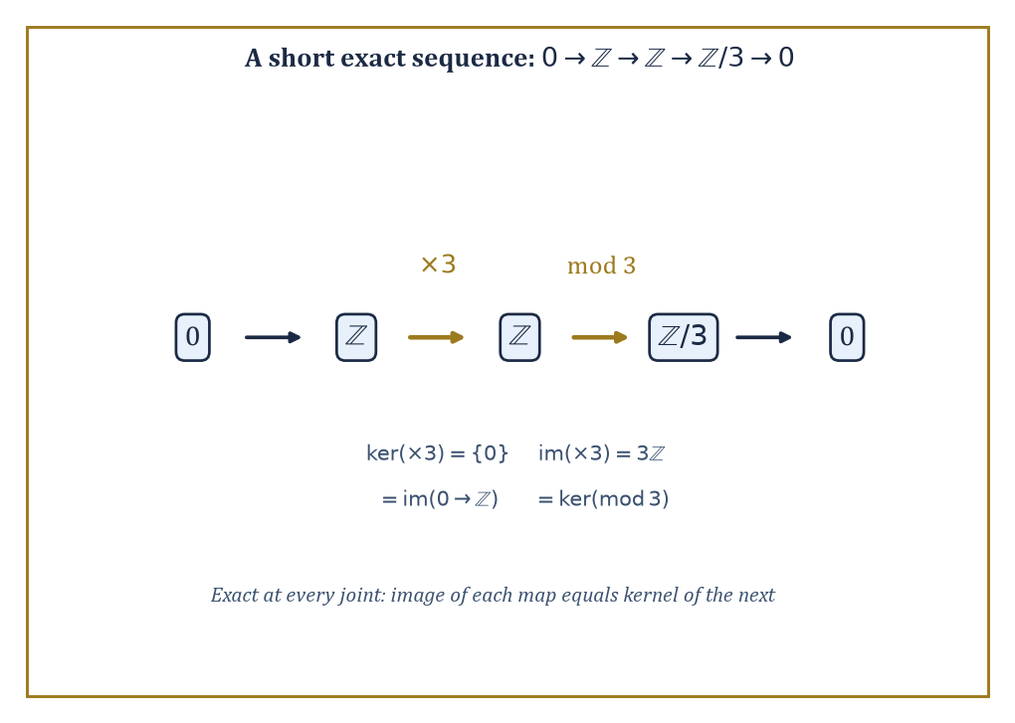
A short exact sequence, checked at every joint: image of each map lands exactly on the kernel of the next.
Formally, it has a zero object (both initial and terminal at once), every pair of objects has a biproduct, every morphism has a kernel and a cokernel, and every monomorphism arises as a kernel while every epimorphism arises as a cokernel.
Once these axioms hold, the entire apparatus of exact sequences and diagram-chasing lemmas familiar from a first course in module theory becomes available in any abelian category whatsoever, not merely in modules — a considerable saving of effort, since the same lemma no longer needs to be reproved from scratch in every new setting where it happens to apply.
Numeric example — A biproduct: product and coproduct, forced to coincide. In an abelian category, the product of two objects and their coproduct are always the same object, called the biproduct — a coincidence that fails badly outside the abelian world, as Room 38.4's infinite free product ℤ/2 * ℤ/2 already demonstrated for Grp.
Check it holds in Ab with A = ℤ/2 = {0,1} and B = ℤ/3 = {0,1,2}. The product A×B is the direct product group, with underlying set given by all ordered pairs, six elements in total, under componentwise addition:
A×B = {(0,0),(0,1),(0,2),(1,0),(1,1),(1,2)}
The coproduct in Ab of two abelian groups is also computed as the direct sum, which for finitely many finite groups is literally the same underlying set and operation as the direct product — so A⊕B has exactly the same six elements.
Moreover, since gcd(2,3) = 1, the Chinese Remainder Theorem identifies this six-element group with ℤ/6 directly, via n ↦ (n mod 2, n mod 3):
ℤ/6 = {0,1,2,3,4,5}
0↦(0,0), 1↦(1,1), 2↦(0,2), 3↦(1,0), 4↦(0,1), 5↦(1,2)
Each of the six elements of ℤ/6 lands on a distinct pair, so the map is a bijection, and it is easily checked to respect addition in both coordinates.
Either way, product and coproduct agree on the nose:
|A×B| = |A⊕B| = 6 = |ℤ/6|
This is in flat contradiction to what happened with two copies of ℤ/2 in the non-abelian category Grp two rooms ago.
Numeric example — Kernel and cokernel, computed for a genuine homomorphism. Work in Ab, the abelian category of abelian groups. Let φ: ℤ → ℤ/6 send n to n mod 6.
Its kernel is:
{n ∈ ℤ : φ(n) = 0} = {n : n ≡ 0 (mod 6)} = 6ℤ = {…,−12,−6,0,6,12,…}
the subgroup of multiples of 6 — a completely explicit computation, no abstraction required.
For a cokernel, let ψ: ℤ → ℤ send n to 3n, an injective homomorphism (multiplication by 3 never sends two different integers to the same place).
Its cokernel is the target modulo the image:
ℤ / 3ℤ
which has exactly three cosets, 0+3ℤ, 1+3ℤ, 2+3ℤ, so
coker(ψ) ≅ ℤ/3ℤ
a group of order 3 — the precise measure of how far ψ is from being surjective, expressed as an actual group you can write down.
Numeric example — A short exact sequence, checked at every joint. Consider the sequence:
0 → ℤ --(×3)--> ℤ --(mod 3)--> ℤ/3 → 0
Exactness at the first ℤ requires ker(×3) = image of the zero map, i.e.
ker(×3) = {0}
since ×3 is injective (3n=0 forces n=0), this holds.
Exactness at the middle ℤ requires image(×3) = ker(mod 3):
image(×3) = 3ℤ
ker(mod 3) = {n : n ≡ 0 (mod 3)} = 3ℤ
also — they match exactly.
Exactness at ℤ/3 requires image(mod 3) = ker(ℤ/3 → 0); the mod-3 map is surjective, so its image is all of ℤ/3, and the kernel of the map to the zero group is trivially all of ℤ/3 as well.
Every joint checks out: this is a genuine short exact sequence, the standard way of saying ℤ/3 is built from ℤ by killing exactly the multiples of 3.
Derived functors, and in particular Ext and Tor, are built by resolving an object with a chain of nicer (projective, or free) objects and then applying a functor to the resolution instead of to the object directly; the failure of the resulting sequence to stay exact measures something genuinely new about the object, invisible if you only ever apply the functor once.
This machinery is the working foundation of modern algebraic topology, algebraic geometry, and representation theory, and it is worth seeing run to completion on a small case rather than only described.
Numeric example — Ext¹(ℤ/5, ℤ), computed from a free resolution. The abelian group ℤ/5 has a short free resolution:
0 → ℤ --(×5)--> ℤ → ℤ/5 → 0
This means ℤ/5 = ℤ / 5ℤ, presented using two copies of the free module ℤ and the multiplication-by-5 map between them.
To compute Ext¹_ℤ(ℤ/5, ℤ), apply the contravariant functor Hom_ℤ(–, ℤ) to the resolution:
0 → ℤ --(×5)--> ℤ → 0
Since Hom_ℤ(ℤ, ℤ) ≅ ℤ, identifying a homomorphism with the image of 1, this turns into the cochain complex:
ℤ --(×5)--> ℤ
Precomposing with ×5 corresponds again to multiplying by 5, because for φ: ℤ → ℤ:
(φ∘(×5))(1) = φ(5) = 5·φ(1)
Ext⁰(ℤ/5, ℤ) is the kernel of this ×5 map, which is {0} since ×5 is injective on ℤ.
Ext¹(ℤ/5, ℤ) is the cokernel of the same ×5 map, which is ℤ / 5ℤ, a group of exactly five elements.
So:
Ext¹_ℤ(ℤ/5, ℤ) ≅ ℤ/5
This is computed, not merely quoted, and matches the general pattern Ext¹_ℤ(ℤ/n, ℤ) ≅ ℤ/n for any n, here made concrete with n = 5 and every arrow in the resolution written out.
The point of isolating the abelian category axioms, rather than just working inside Ab or a category of modules directly, is that the same kernel-cokernel-exact-sequence machinery, and the same Ext and Tor computations, then apply verbatim to sheaves of abelian groups, to chain complexes, to representations of a group, and to any other category that happens to satisfy the same short list of structural axioms — the exactness properties are what make homological algebra work, and they were there all along, independently of which particular category of modules you first learned them in.

Room 38.9: Looking Ahead: From Categories to Higher Categories, Topoi, and Applied Category Theory
The tower continues upward, and so, alarmingly, does the abstraction
We have now acquired the core of category theory: categories, functors, natural transformations, universal properties, limits and colimits, adjoint functors, the Yoneda lemma, monads, and abelian categories. Each of these is, on its own, already load-bearing throughout the rest of mathematics; together they form a language flexible enough to describe entire fields — algebraic topology, algebraic geometry, representation theory, and a growing share of theoretical computer science — as instances of the same handful of ideas, rather than as unrelated bodies of technique that happen to share some vocabulary by coincidence.
The most immediate direction beyond what we have covered is higher category theory, where the objects-and-arrows picture is extended by adding arrows between arrows, called 2-morphisms, and then arrows between those, and so on, potentially forever. A 2-category has objects, 1-morphisms between objects, and 2-morphisms between parallel 1-morphisms, composable both along the 1-morphisms and along the 2-morphisms, subject to a compatibility condition called the interchange law, which is exactly as fussy as it sounds and is enforced without exception.
Abstract example — Cat as a 2-category, using arrows we have already met. The category Cat, whose objects are (small) categories and whose morphisms are functors, is itself a 2-category: its 2-morphisms are natural transformations between parallel functors. Take the two functors GL_n and GL_1 from CRing to Grp met in Room 38.2, and the determinant natural transformation between them:
det: GL_n ⇒ GL_1
In the language of 2-categories, CRing and Grp are the 0-cells (objects of Cat), GL_n and GL_1 are 1-cells (functors, i.e. morphisms of Cat) from CRing to Grp, and det is a 2-cell, a natural transformation, sitting between those two parallel 1-cells.
The naturality square verified numerically in Room 38.2, with the matrix reducing mod 5, was in this light a direct, hands-on computation inside a 2-category, performed before the 2-category itself had even been named — which is rather the recurring experience of climbing this Tower: the general theory, once it finally arrives, usually turns out to have been quietly present in the examples all along.
A second direction is topos theory: a topos is a category that behaves, structurally, like the category of sheaves on a topological space, and in particular has enough internal structure — including its own internal notion of true and false — to serve as an alternative foundation for mathematics, competing with, and in some respects generalising, the usual set-theoretic foundation used throughout the rest of the Tower. The key extra piece of structure is a subobject classifier.
Numeric example — The subobject classifier in Set. In the topos Set, the subobject classifier is Ω, standing for the two truth values false and true:
Ω = {0, 1}
A subset A of a set X is classified by its characteristic function χ_A: X → Ω, defined by:
χ_A(x) = 1 if x ∈ A, and χ_A(x) = 0 otherwise
Take X = {1,2,3,4,5} and A = {1,3,5}. Then:
χ_A(1)=1, χ_A(2)=0, χ_A(3)=1, χ_A(4)=0, χ_A(5)=1
This is a completely explicit five-value table recovering A exactly from Ω-valued data.
The universal property is that A, together with its inclusion into X, is recovered as the pullback of the arrow {*} → Ω (picking out the value 1, true) along χ_A — every subset of every set, in other words, is secretly the answer to a yes-or-no question, and Ω is the object where all such answers live.
Richer topoi replace the two truth values 0 and 1 with more elaborate structures, encoding logics stranger than ordinary true-or-false, which is a substantial part of why topos theory has found use well outside pure mathematics, wherever a notion of partial or context-dependent truth is wanted.
A third direction, newer and still very much in motion, is applied category theory: using functors, monoidal categories, and string-diagram calculi to give compositional, checkable models of systems in computer science, physics, chemistry, biology, and even linguistics, in each case treating how the parts combine as the primary mathematical object rather than an afterthought. Modern algebraic geometry, via schemes and stacks, and modern homotopy theory are likewise now written natively in the language introduced in this storey, to the point where reading either subject without it is possible only in the sense that reading a novel is possible one unglossed foreign word at a time.
Numeric example — A monoidal category, sized up by hand. Applied category theory leans heavily on monoidal categories: categories equipped with a way of combining two objects into one, written ⊗, alongside ordinary composition — the extra structure needed to draw the string diagrams (boxes and wires) used to model circuits, processes, and resource flows compositionally.
The category Vect of real vector spaces is monoidal under the tensor product, with dimension given by:
dim(V ⊗ W) = dim(V) · dim(W)
Take V = ℝ² and W = ℝ³, so dim(V) = 2 and dim(W) = 3:
dim(V ⊗ W) = 2 · 3 = 6
meaning V ⊗ W ≅ ℝ⁶.
Composing two such combinations associatively — (U ⊗ V) ⊗ W against U ⊗ (V ⊗ W) — checks out immediately on dimensions alone:
(dim U · dim V) · dim W = dim U · (dim V · dim W)
This is ordinary multiplication being associative, which is the numerical shadow of the coherence isomorphisms a monoidal category is required to carry between the two ways of bracketing a triple tensor product.
The lesson to carry up the Tower is simple to state and, as promised at the start, genuinely does change how one reads mathematics afterwards: the maps between objects are frequently more informative than the objects themselves, and a systematic study of those maps — objects, arrows, composition, identity, and nothing more assumed — produces a language of remarkable unifying power, capable of noticing that a determinant, a divisor lattice, a free group, and a list of lists are, from a sufficient height, doing the same small number of things. Category theory is the mathematics of structure-preserving maps. We have learned to follow the arrows; the next storey hands them a payload of bits and asks how much of the message survives the trip.
We arrived at the top of this storey having thrown away rather a lot: no elements, no interiors, no privileged descriptions of what an object contains, only objects, arrows, composition, and identity, and the promise that anything worth saying can be said with those four ingredients alone. What we gained back was a single lens sharp enough to bring products in Set, free groups, matrix multiplication, determinants, and Ext groups into simultaneous focus, plus one lemma — Yoneda's — sturdy enough to hold the entire enterprise up. If that trade sounds suspiciously good, category theorists would be the first to agree it occasionally feels that way even from the inside, usually right up until the referee report arrives.
The next storey turns from structure-preserving maps in general to one very particular, very demanding kind: channels that carry a message from a sender to a receiver and are graded, ruthlessly, on how much of that message survives noise, compression, and the sheer cost of transmission. Information Theory measures exactly the kind of thing category theory prefers to leave unmeasured — not whether a structure-preserving map exists, but how many bits it costs you to describe one. The arrows are about to start counting.
Onward, then, and with the usual caution issued at every landing of this Tower: the view improves the higher you climb, but so, regrettably, does the drop.

Storey 39: Information Theory
Entropy, Codes, and the Art of Quantifying Uncertainty and Communication
After the vertiginous heights of Category Theory — where we stopped asking what mathematical objects are and started asking, with mounting existential unease, what they merely do to one another — the climber's legs may be glad of a storey with numbers in it again. Entropy still has an equals sign. It sits still long enough to be computed with a pencil, which is more than could be said for some of the commutative diagrams two storeys back, several of which required a small aircraft hangar and a strong nerve.
This storey belongs to Claude Shannon, who in 1948 did something almost indecent for an engineer: he wrote down a precise, provable, mathematically airtight answer to the question 'how much information is actually in this message?' — and then, having answered it, discovered the answer also told you the absolute fastest rate at which you could ever hope to send that message down a noisy wire without garbling it. Before Shannon, 'information' was a word people used the way they used 'vibes' — evocatively, and without units. After Shannon, it had units. Bits, to be precise, which is a pleasing pun that he did not, so far as history records, make on purpose.
We will climb through entropy (the measurement of uncertainty), the asymptotic equipartition property (a law of large numbers wearing a trench coat), source coding (how far you can squeeze a message before it screams), mutual information and channel capacity (how much a noisy channel will actually let through), the channel coding theorem (Shannon's two miracles: the achievable and the impossible, in the same breath), rate-distortion theory (compression when you're willing to lose a little), and finally continuous and Gaussian channels, home of the single most quoted formula in all of engineering.
It is worth flagging early that this storey's subject is unusually well-behaved for a mathematical theory: its central theorems are not just elegant, they are the numbers your internet connection is quietly trying to approach right now. The next storey, on Wavelets and Signal Analysis, will pick up more or less where we leave off — swapping Shannon's discrete symbols for continuous signals and asking not just how much information a signal carries, but where in time and frequency it is hiding. Onward, then, and let us quantify some uncertainty.

Room 39.1: What Information Theory Actually Is
In which we learn to put a number on surprise
Information theory is the mathematical study of how information can be quantified, stored, and communicated. Its founding insight — Shannon's, though the groundwork was prepared by Nyquist and Hartley in the 1920s — is that the 'amount of information' carried by an event is a function purely of how surprising that event is, which is to say, how improbable.
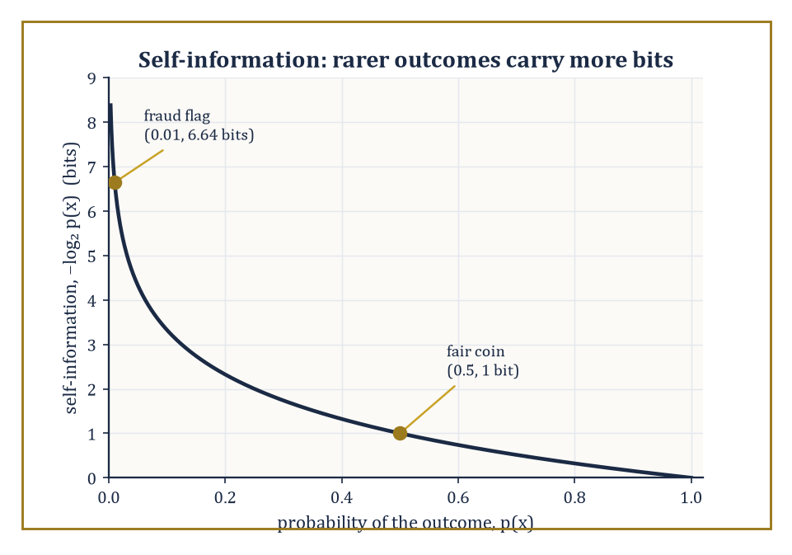
The self-information curve −log₂p(x): a fair coin's flip is worth one modest bit, a one-in-a-hundred fraud flag is worth nearly seven.
An event you were certain would happen (the sun rising, your college's endowment growing) tells you nothing when it occurs. An event you thought vanishingly unlikely (your college's endowment shrinking) tells you a great deal, purely by virtue of having defied expectation.
The formal quantity is the self-information of an outcome x with probability p(x), defined as follows, measured in bits.
−log₂ p(x)
Rare events have large self-information; certain events have none at all.
Numeric example — Worked example: surprise in bits. A fair coin lands heads with probability p = 0.5. Its self-information is:
−log₂(0.5) = −(−1) = 1 bit
That is exactly the amount of information needed to specify one of two equally likely outcomes, which is a satisfying place for the unit 'bit' to come from.
A fair six-sided die landing on any particular face has probability 1/6, so its self-information is:
−log₂(1/6) = log₂6 = ln6/ln2 ≈ 1.791759/0.693147 ≈ 2.585 bits
You need more than two but fewer than three bits to pin down which of six equally likely faces came up, which matches the intuition that six possibilities is 'more surprising' to resolve than two.
Now consider a rare event: a fraud-detection system flags a transaction with prior probability p = 0.01 (one in a hundred). Its self-information is:
−log₂(0.01) = −ln(0.01)/ln(2) = −(−4.60517)/0.693147 ≈ 6.644 bits
The rarer the event, the more bits it takes to say 'that just happened' — which is exactly why your insurer charges so little for a policy that almost never pays out, and so much for one that might.
Information theory answers two questions that sound like engineering but turn out to be pure mathematics wearing overalls. First: how far can a message be compressed before information is lost? Second: how fast can information be sent reliably down a channel that insists on corrupting some of it?
Both answers are asymptotic statements — they describe what happens as the length of the message (the 'block length') grows without bound, in the same spirit as the law of large numbers describing what happens to an average as the number of samples grows.
This is not a flaw in the theory; it is the theory's central discovery, that reliability and efficiency are only perfectly achievable in a limit, but that the limit can be approached as closely as engineering nerve and patience allow.
The two limiting quantities that answer these questions — entropy for compression, channel capacity for communication — are the subjects of the next several rooms.
Abstract example — Illustrative example: why frequent symbols deserve short codes. Suppose a source emits English text, where the letter 'e' occurs roughly 12.7% of the time and the letter 'z' occurs roughly 0.07% of the time (these are the standard frequency estimates used in cryptography and typography). Intuitively, a smart code should give 'e' a short codeword and 'z' a long one, because 'e' needs to be written down constantly and 'z' almost never.
This is exactly the intuition self-information formalises: 'e' has low self-information, it is not very surprising.
−log₂0.127 ≈ 2.98 bits
'z' has high self-information, it is a genuine event when it turns up.
−log₂0.0007 ≈ 10.48 bits
A code that assigns codeword lengths roughly proportional to self-information — short for 'e', long for 'z' — will, on average, use far fewer bits per letter than a code that gives every letter a flat 5 bits (needed to distinguish 26 letters uniformly). This intuition, made rigorous, is precisely the content of the source coding theorem in Room 39.4.
It is worth saying plainly that information theory is both a branch of pure mathematics — built on probability theory, with theorems and proofs exactly as rigorous as anything upstairs in this Tower — and the working theoretical foundation underneath every digital device the reader owns.
The compression ratio your phone achieves on a photograph, the error-correcting code protecting the bits on a hard drive, the maximum data rate advertised for a Wi-Fi router: these are not vague engineering folklore, they are numbers computed, or bounded, by the theorems in this storey.
Few branches of mathematics can claim their central theorem is checked, in practice, several billion times a second, somewhere on Earth, right now.
One further piece of vocabulary earns its place here before the formal machinery starts, because it will otherwise ambush the reader in Room 39.2: the base of the logarithm in every formula in this storey is a choice of unit, not a mathematical necessity.
Base 2 gives bits, the natural unit when the underlying question is 'how many binary yes/no questions does this take to pin down', which is why it dominates a subject born to serve digital circuits that only ever ask binary questions.
Base e gives nats, the natural choice when the surrounding mathematics is calculus-heavy (differentiating a natural logarithm is simply pleasanter than differentiating one in an arbitrary base), and base 10 gives the rarely-used hartleys, named for the Bell Labs engineer whose 1928 paper anticipated much of what follows.
Converting between them is nothing more than multiplying by a fixed constant, since the following holds for any base b.
log_b(x) = log₂(x)/log₂(b)
That is a fact so mechanically simple that it is easy to forget it is the only thing standing between 'bits' and 'nats' ever disagreeing about anything substantive.
Numeric example — Worked example: converting bits to nats. The self-information of the fraud-detection event above, p = 0.01, was computed as roughly 6.644 bits. To express the same quantity in nats (base e), use the conversion log_e(x) = log₂(x) × ln(2).
6.644 × 0.693147 ≈ 4.605 nats
Sanity check directly:
−ln(0.01) = −(−4.60517) = 4.60517 nats
That matches to four decimal places (the tiny discrepancy above is only rounding in the intermediate 6.644 figure). Every formula in this storey could equally well have been written with 'ln' in place of 'log₂' throughout — entropy, mutual information, capacity, all of it — and every inequality and every theorem would remain true, simply measured in nats instead of bits. The only reason this storey sticks doggedly to base 2 is that bits are the unit the reader's devices actually bill in, and a storey about quantifying information ought, where it can, to quantify it in units the reader recognises.

Room 39.2: Entropy and Its Properties
The single most overworked scalar in mathematics
The entropy of a discrete random variable X, written H(X), is the expected value of its self-information:
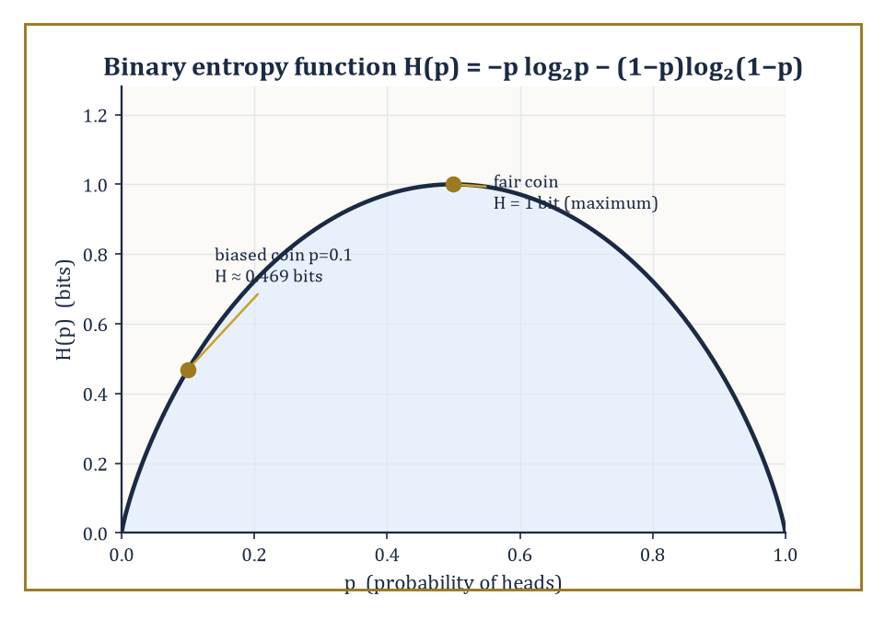
The binary entropy function H(p), peaking at 1 bit for a fair coin and dropping to about 0.469 bits for the room's p=0.1 example.
H(X) = E[−log₂ p(X)] = −Σₓ p(x) log₂ p(x)
The sum runs over all outcomes x with p(x) > 0 (by convention 0·log₂0 = 0, since an impossible outcome contributes neither surprise nor probability).
Entropy is the average number of bits of surprise a source generates per symbol — equivalently, and this is the operational meaning that makes the whole subject useful, it is the average number of bits needed to describe the outcome of X, once you're allowed to be clever about how you assign codewords.
It is always non-negative, since −log₂ p(x) ≥ 0 whenever 0 ≤ p(x) ≤ 1, and it is maximised, among all distributions on a fixed finite set of outcomes, by the uniform distribution — spreading your uncertainty as thin as possible maximises how surprised you are on average.
Numeric example — Worked example: entropy of a biased coin. Take a coin biased so that heads occurs with probability p = 0.1 and tails with probability 1 − p = 0.9. Its entropy is given by:
H(X) = −0.1·log₂0.1 − 0.9·log₂0.9
Computing each term:
log₂0.1 = ln(0.1)/ln(2) ≈ −2.302585/0.693147 ≈ −3.321928, so −0.1·(−3.321928) = 0.332193
log₂0.9 = ln(0.9)/ln(2) ≈ −0.105361/0.693147 ≈ −0.152003, so −0.9·(−0.152003) = 0.136803
Summing:
H(X) ≈ 0.332193 + 0.136803 = 0.468996, or about 0.469 bits
Compare this to a fair coin (p = 0.5), whose entropy is exactly 1 bit — the biased coin, being far more predictable (it is heads only one time in ten), carries under half a bit of genuine uncertainty per flip, roughly a fifth of what the fair coin carries. This 0.469-bit figure will recur throughout this storey; it is worth remembering.
Two structural facts about entropy are used constantly. First, additivity: if X and Y are independent random variables, then:
H(X, Y) = H(X) + H(Y)
— knowing two unrelated things is exactly as surprising as knowing each of them separately, no more, no less.
Second, the uniform-maximises-entropy fact mentioned above is not a coincidence but a consequence of the strict concavity of the function −p log₂ p, via Jensen's inequality; spreading probability mass more evenly always increases (or leaves unchanged) the entropy, and concentrating it always decreases entropy, all the way down to H = 0 for a variable that is certain (no surprise, no bits needed).
Numeric example — Worked example: additivity for independent coins. Let X and Y each be independent fair coin flips.
H(X) = H(Y) = 1 bit
The joint variable (X, Y) has four equally likely outcomes — (H,H), (H,T), (T,H), (T,T) — each with probability 0.25. Its entropy is:
H(X,Y) = −4 × (0.25 · log₂0.25) = −4 × (0.25 × (−2)) = −4 × (−0.5) = 2 bits
This exactly matches:
H(X) + H(Y) = 1 + 1 = 2
Contrast with the earlier biased coin: its entropy of 0.469 bits is strictly less than the fair coin's 1 bit, confirming that the uniform distribution really does carry the maximum possible uncertainty for a two-outcome variable — the biased coin has thrown away potential surprise by being predictable.
When two random variables are correlated rather than independent, the relevant quantities are the joint entropy and the conditional entropy H(Y|X), the average remaining uncertainty in Y once X is known. The joint entropy is defined as:
H(X,Y) = −Σₓ,ᵧ p(x,y) log₂ p(x,y)
These are linked by the chain rule:
H(X,Y) = H(X) + H(Y|X)
The joint uncertainty is the uncertainty in X, plus whatever uncertainty in Y is left over after X has been revealed. This is the entropy version of the elementary probability identity
p(x,y) = p(x)p(y|x)
and it is the workhorse identity of the entire subject.
Numeric example — Worked example: chain rule on a correlated pair. Let X and Y each be binary, with joint distribution:
p(0,0) = 0.5, p(0,1) = 0.1, p(1,0) = 0.1, p(1,1) = 0.3
This gives marginals p(X=0) = 0.6, p(X=1) = 0.4, and identically p(Y=0) = 0.6, p(Y=1) = 0.4 — check:
0.5+0.1 = 0.6 and 0.1+0.3 = 0.4 for X; 0.5+0.1 = 0.6 and 0.1+0.3 = 0.4 for Y
First, the joint entropy:
H(X,Y) = −[0.5log₂0.5 + 0.1log₂0.1 + 0.1log₂0.1 + 0.3log₂0.3]
We have:
log₂0.5 = −1, contributing 0.5
log₂0.1 ≈ −3.321928, contributing 0.1×3.321928 = 0.332193 twice, i.e. 0.664386
log₂0.3 = ln(0.3)/ln(2) ≈ −1.203973/0.693147 ≈ −1.736966, contributing 0.3×1.736966 ≈ 0.521090
Total:
H(X,Y) ≈ 0.5 + 0.664386 + 0.521090 = 1.685476 bits
Next, the marginal entropy:
H(X) = −[0.6log₂0.6 + 0.4log₂0.4]
log₂0.6 ≈ −0.736966, contributing 0.6×0.736966 ≈ 0.442180
log₂0.4 ≈ −1.321928, contributing 0.4×1.321928 ≈ 0.528771
So H(X) ≈ 0.970951 bits (and by symmetry H(Y) is the same). By the chain rule:
H(Y|X) = H(X,Y) − H(X) ≈ 1.685476 − 0.970951 ≈ 0.714525 bits
Knowing X still leaves about 0.71 bits of uncertainty about Y, less than Y's own marginal entropy of 0.971 bits, exactly as it should be — knowledge of a correlated variable can only reduce (or leave unchanged) uncertainty, never increase it.
A deeper structural fact, the data-processing inequality, says that if X, Y, Z form a Markov chain (written X → Y → Z, meaning Z depends on X only through Y — Z is computed from Y with no further peeking at X) then the mutual information satisfies:
I(X;Z) ≤ I(X;Y)
Processing can only destroy information about the original source, never manufacture more of it. This sounds obvious until you try to prove it (it follows from the chain rule and the non-negativity of conditional mutual information), and it is one of the two pillars — together with Fano's inequality below — on which every converse proof in this storey rests, including the impossibility half of the channel coding theorem in Room 39.6.
Worked example — Worked example: information degrading down a cascade of noisy channels. Let X be a uniformly random bit, sent through a binary symmetric channel (a channel that flips the bit with some fixed probability, defined properly in Room 39.5) with crossover probability 0.1 to produce Y, and then let Y be sent through a second, independent binary symmetric channel with crossover probability 0.2 to produce Z — so X → Y → Z is a genuine Markov chain, a cascade of two noisy links.
For a uniform input, the mutual information across a single binary symmetric channel with crossover ε is:
I = 1 − H(ε)
where H(ε) is the binary entropy function computed the same way as above. For the first link:
I(X;Y) = 1 − H(0.1) = 1 − 0.469 = 0.531 bits
(reusing the 0.469 figure from the worked example above). The cascade of two binary symmetric channels is itself a binary symmetric channel, with an effective crossover probability of:
ε_eff = 0.1(1−0.2) + 0.2(1−0.1) = 0.1×0.8 + 0.2×0.9 = 0.08 + 0.18 = 0.26
(a bit flips overall if exactly one of the two links flips it). So:
I(X;Z) = 1 − H(0.26)
Computing H(0.26):
log₂0.26 = ln(0.26)/ln(2) ≈ −1.347074/0.693147 ≈ −1.943416, contributing 0.26×1.943416 ≈ 0.505288
log₂0.74 = ln(0.74)/ln(2) ≈ −0.301105/0.693147 ≈ −0.434428, contributing 0.74×0.434428 ≈ 0.321477
So:
H(0.26) ≈ 0.826765, and I(X;Z) ≈ 1 − 0.826765 = 0.173235 bits
Indeed 0.173 ≤ 0.531: the second noisy link can only have thrown information away, never recovered it, exactly as the data-processing inequality demands.
Fano's inequality is the quantitative partner to the data-processing inequality. It bounds how much residual uncertainty H(X|Y) can remain about X given an observation Y, in terms of the probability Pₑ that a best guess of X from Y is simply wrong:
H(X|Y) ≤ H(Pₑ) + Pₑ log₂(M − 1)
where M is the number of possible values X can take. Intuitively: if your error probability is small, the leftover uncertainty about X must also be small, because a low-error guesser is basically telling you what X was.
Numeric example — Worked example: Fano's inequality with four messages. Suppose a receiver is trying to identify which of M = 4 equally likely messages was sent, and guesses wrong with probability Pₑ = 0.1. Fano's inequality bounds the leftover uncertainty:
H(X|Y) ≤ H(0.1) + 0.1 × log₂(4 − 1) = H(0.1) + 0.1 × log₂3
We already know H(0.1) ≈ 0.469 bits. And:
log₂3 = ln3/ln2 ≈ 1.098612/0.693147 ≈ 1.584963, so 0.1 × 1.584963 ≈ 0.158496
Adding:
H(X|Y) ≤ 0.469 + 0.158 = 0.627 bits
Since X itself, uniform over 4 messages, has entropy log₂4 = 2 bits, this says that a 10%-error guesser has left the receiver with at most 0.627 of the original 2 bits of uncertainty unresolved — most of the uncertainty about which message was sent has genuinely been eliminated by the observation. This is the exact inequality used, in reverse, to show that if the transmission rate exceeds channel capacity, Pₑ cannot be driven to zero — the converse half of the channel coding theorem in Room 39.6.
Finally, relative entropy — also called Kullback–Leibler divergence, written D(p‖q) — measures the cost, in bits, of believing a distribution q when the true distribution is p:
D(p‖q) = Σₓ p(x) log₂(p(x)/q(x))
It is always non-negative (Gibbs' inequality, itself a consequence of Jensen's inequality applied to the concave logarithm), and it is zero exactly when p = q. Crucially, D(p‖q) ≠ D(q‖p) in general — mis-specifying in one direction is not the same mistake as mis-specifying in the other — which is precisely why it is called a divergence and not a distance.
Relative entropy underlies large-deviations theory (how fast the probability of an atypical outcome decays) and reappears constantly as the currency of statistical inference and machine learning.
Numeric example — Worked example: KL divergence is not symmetric. Let p = (0.5, 0.5) be the true (fair-coin) distribution and q = (0.9, 0.1) be a mistaken model of it. Then:
D(p‖q) = 0.5·log₂(0.5/0.9) + 0.5·log₂(0.5/0.1)
The first term:
log₂(0.5/0.9) = log₂(0.5556) ≈ −0.848, contributing 0.5×(−0.848) = −0.424
The second:
log₂(0.5/0.1) = log₂5 ≈ 2.321928, contributing 0.5×2.321928 ≈ 1.160964
Summing:
D(p‖q) ≈ −0.424 + 1.161 = 0.737 bits
Now swap the roles:
D(q‖p) = 0.9·log₂(0.9/0.5) + 0.1·log₂(0.1/0.5)
log₂(0.9/0.5) = log₂1.8 ≈ 0.847997, contributing 0.9×0.847997 ≈ 0.763197
log₂(0.1/0.5) = log₂0.2 ≈ −2.321928, contributing 0.1×(−2.321928) ≈ −0.232193
Summing:
D(q‖p) ≈ 0.763197 − 0.232193 ≈ 0.531 bits
So D(p‖q) ≈ 0.737 bits while D(q‖p) ≈ 0.531 bits — visibly unequal, confirming that relative entropy genuinely cares which distribution is 'truth' and which is 'model'.
Entropy, then, is not one formula among many in this storey — it is the load-bearing wall. Every theorem that follows, from the asymptotic equipartition property to the channel coding theorem, is either a statement about entropy directly or an inequality that bounds something else in terms of it.

Room 39.3: Typical Sets and the Asymptotic Equipartition Property
A law of large numbers, wearing a trench coat
The asymptotic equipartition property, universally abbreviated AEP, is the observation that if X₁, X₂, …, Xₙ are drawn independently from the same distribution (i.i.d.), then a particular quantity converges, in probability, to H(X) as n grows large:
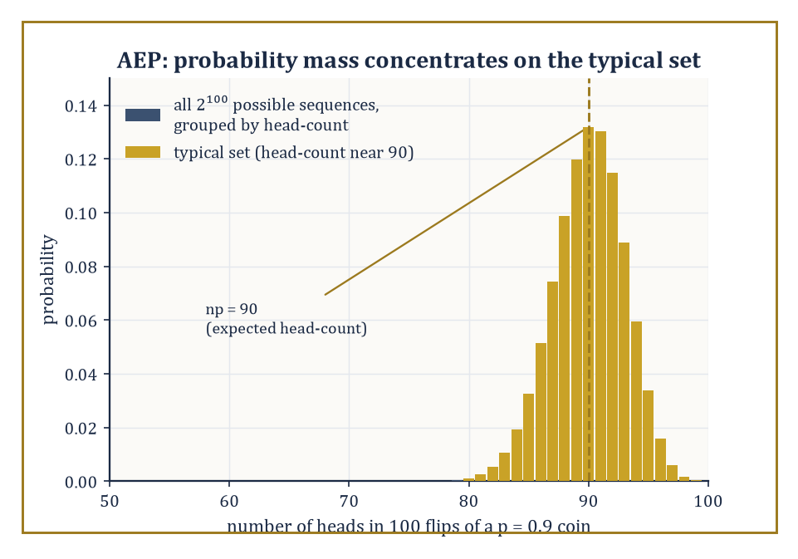
One hundred flips of the p=0.9 coin: almost all the probability crowds around the expected 90 heads, exactly the typical set the AEP describes.
−(1/n)log₂ p(X₁,…,Xₙ) → H(X)
This is genuinely nothing more exotic than the weak law of large numbers, applied to the random variables −log₂ p(Xᵢ), whose expected value is by definition H(X) — but its consequence is startling.
For large n, almost all of the probability mass concentrates on a set of sequences that are all roughly equally likely, each with probability close to 2^{−nH(X)}.
This set is called the typical set, Aₙ(ε), and it has two remarkable properties simultaneously: its total probability approaches 1, and yet it typically contains only a tiny fraction of all possible sequences.
It is rather as if, of the millions of ways a long sequence of coin flips could in principle come out, nature quietly agrees to use only a small, well-mannered subset of them, and everyone is too polite to mention the rest.
Worked example — Worked example: the probability of a typical sequence. Take a coin biased toward heads with p = 0.9, and flip it n = 100 times. Its entropy, computed the same way as the p = 0.1 case in Room 39.2 (binary entropy is symmetric, H(p) = H(1−p)), is H(0.9) ≈ 0.469 bits per flip.
Consider one specific sequence with exactly 90 heads and 10 tails (the 'typical' count, since 0.9×100 = 90). Its exact probability is:
p^{90}q^{10} = 0.9^{90} × 0.1^{10}
Taking logs is easier:
log₂(0.9^{90}×0.1^{10}) = 90log₂0.9 + 10log₂0.1 = 90×(−0.152003) + 10×(−3.321928) = −13.680 − 33.219 = −46.900
So the probability of this exact sequence is 2^{−46.9}. Notice this is exactly n×H(0.9):
n×H(0.9) = 100×0.469 = 46.9
For a sequence whose head-count exactly matches the expected count, the AEP estimate p(x) ≈ 2^{−nH} is not merely approximate but exact, since:
−log₂p(x) = −[np log₂p + nq log₂q] = nH(p)
This holds precisely whenever the counts land exactly on np and nq. Numerically, 2^{−46.9} ≈ 7.62×10⁻¹⁵ — a fantastically small number, but note that it is the same fantastically small number for every sequence with exactly 90 heads, which is the entire content of 'equipartition': typical sequences are not just probable in aggregate, they are all roughly equally probable individually.
The second half of the AEP concerns how many typical sequences there are.
Since each typical sequence has probability roughly 2^{−nH}, and their total probability is roughly 1, there must be roughly 2^{nH} of them — far fewer, for H < log₂|alphabet|, than the total number of possible length-n sequences, which is |alphabet|ⁿ.
This is the 'equipartition': nature has quietly discarded almost all conceivable sequences and concentrated attention on a comparatively small, roughly-equiprobable club.
Numeric example — Worked example: counting typical sequences. Continuing the n = 100, p = 0.9 example, the AEP estimate for the size of the typical set is roughly:
2^{nH} = 2^{46.9}
Computing this:
2^{46.9} = 2^{47} × 2^{−0.1}
Since 2^{47} ≈ 1.4074×10^{14} and 2^{−0.1} ≈ 0.9330, we get:
2^{46.9} ≈ 1.313×10^{14}
Compare this to the exact count of sequences with precisely 90 heads out of 100, which is the binomial coefficient C(100,10) (choosing the positions of the 10 tails):
C(100,10) = 17,310,309,456,440 ≈ 1.731×10^{13}
These are not equal — and should not be expected to be, since the AEP's '2^{nH} typical sequences' is an asymptotic estimate that includes all sequences whose empirical statistics are merely close to (90,10), not only the exact count — but they sit within the same order of magnitude, which is exactly the qualitative behaviour the AEP predicts and is enough to confirm the estimate is doing its job. As n grows larger still, the approximation (1/n)log₂|typical set| → H becomes exact in the limit.
This is the mechanism that turns entropy from an abstract expectation into an operational compression rate.
If nearly all the probability mass lives in a set of about 2^{nH} sequences, one need only assign a fixed-length index to each member of that set — requiring about nH bits total, or H bits per symbol — and assign nothing (or an error flag) to the negligible remainder.
As n → ∞, the probability of landing outside the typical set vanishes, so the scheme's failure probability vanishes too, while its rate approaches H exactly.
This single idea, sharpened, is the entire proof of the achievability half of the source coding theorem in the next room.
Numeric example — Worked example: compression via typicality. Returning once more to n = 100 flips of the p = 0.9 coin: naive fixed-length encoding of 100 independent bits (treating each flip as needing its own bit) would cost 100 bits.
But indexing only the typical sequences costs about:
⌈nH⌉ = ⌈46.9⌉ = 47 bits
This is because there are roughly 2^{46.9} ≈ 1.313×10^{14} of them, and ⌈log₂(1.313×10^{14})⌉ = 47 bits suffices to give each a distinct label.
The compression ratio achieved is:
47/100 = 0.47
This matches the entropy rate H(0.9) ≈ 0.469 almost exactly (the small gap is the ceiling function rounding up to a whole number of bits). This is a concrete instance of the general promise: a source with entropy H bits per symbol can be compressed to just over H bits per symbol, and — this is the content of the converse, proved by the same typicality argument run backwards — no scheme can reliably do any better.
The idea of typicality extends naturally from single sequences to pairs. If (X,Y) are drawn i.i.d. from a joint distribution, a pair of sequences (xⁿ, yⁿ) is jointly typical if each marginal sequence is typical for its own distribution and the pair, taken together, is typical for the joint distribution — meaning:
p(xⁿ,yⁿ) ≈ 2^{−nH(X,Y)}
This joint version of typicality is what makes channel coding possible: it lets a decoder search among roughly 2^{nH(X,Y)} plausible input-output pairs, out of a much larger space of 2^{nH(X)}·2^{nH(Y)} combinations if X and Y were treated as independent, and this gap between the two counts is precisely what gives mutual information its operational meaning as a communication rate in Room 39.5.
Abstract example — Illustrative example: joint typicality on a noisy link. Consider a uniformly random input bit X sent through a channel that flips it with probability 0.1 to produce output Y (a binary symmetric channel, formalised properly in the next room).
If a decoder receives a long output sequence yⁿ, it does not need to search among all 2ⁿ possible input sequences xⁿ for one that could plausibly have produced it — only among those jointly typical with yⁿ, of which there are roughly:
2^{nH(X|Y)} = 2^{n(H(X)−I(X;Y))}
Since I(X;Y) = 1 − H(0.1) ≈ 0.531 bits per use (computed in Room 39.2's cascade example) and H(X) = 1 bit (uniform input), the decoder's plausible-input search space shrinks to roughly:
2^{n(1−0.531)} = 2^{0.469n}
This is a dramatic reduction from the full 2ⁿ, and precisely the reduction that lets a decoder narrow down the true input reliably as n grows, which is the seed of the channel coding theorem's achievability proof.
Typicality, in short, is the technical engine hidden under the bonnet of nearly every asymptotic theorem in classical information theory.
It converts questions about expectations (entropy, mutual information) into questions about counting sets of roughly equal size, which is a far more tractable kind of mathematics — and it is why so many of Shannon's proofs, for all their conceptual audacity, ultimately reduce to a careful application of the law of large numbers.

Room 39.4: Source Coding and Data Compression
The first operational triumph, or: how to say less and mean the same
The source coding theorem is the formal promise implicit in the AEP argument of the previous room: a discrete memoryless source with entropy H can be compressed, with vanishing error probability, to any rate arbitrarily close to H bits per symbol — and it cannot be reliably compressed below H, no matter how ingenious the scheme.
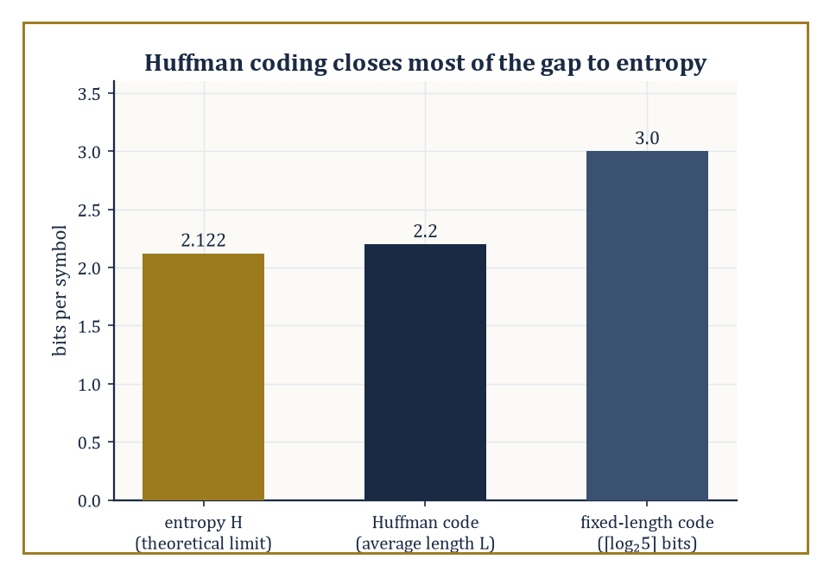
For the room's five-symbol source, Huffman coding lands within a tenth of a bit of the entropy limit, beating the naive fixed-length code by nearly a bit per symbol.
H is not merely a lower bound one hopes to approach; it is a wall.
Before reaching for Huffman coding or arithmetic coding, though, one needs the right vocabulary: a code assigns to each source symbol a string of bits (a codeword); it is uniquely decodable if no two symbol sequences ever produce the same bit string; and it is a prefix code (or instantaneous code) if no codeword is a prefix of another, which lets a decoder recognise the end of a codeword the instant it arrives, without needing to peek ahead.
The Kraft inequality characterises exactly which sets of codeword lengths admit a prefix code: lengths ℓ₁,…,ℓ_M admit one if and only if
Σᵢ 2^{−ℓᵢ} ≤ 1
Numeric example — Worked example: checking the Kraft inequality. Suppose a source has four symbols and a proposed code assigns codeword lengths 1, 2, 3, and 3 bits respectively. Checking the Kraft inequality:
Σ2^{−ℓᵢ} = 2^{−1} + 2^{−2} + 2^{−3} + 2^{−3} = 0.5 + 0.25 + 0.125 + 0.125 = 1.0
Since the sum equals exactly 1 (not merely ≤ 1), a prefix code with these lengths exists and is 'complete' — it uses the entire binary tree with no wasted leaves. A concrete instance: codewords 0, 10, 110, 111 have exactly these lengths (1,2,3,3) and one can check directly that none is a prefix of another.
Had the proposed lengths instead been 1, 1, 2, 2, the sum would be
0.5+0.5+0.25+0.25 = 1.5 > 1
and no prefix code with those lengths could exist — the Kraft inequality is doing real work, ruling out impossible code designs before anyone wastes an afternoon trying to build one.
Huffman coding is the classical algorithm that constructs an optimal prefix code — optimal meaning it achieves the minimum possible average codeword length among all prefix codes for a given symbol distribution.
The construction is a simple greedy recipe: repeatedly take the two least probable remaining symbols (or merged groups of symbols), merge them into a single node with combined probability, and repeat until one node — the root — remains; the resulting binary tree gives every symbol a codeword equal to the path from root to leaf.
Huffman's guarantee is a tight one: the resulting average length L satisfies
H ≤ L < H + 1
so a Huffman code is never more than one bit per symbol worse than the theoretical entropy limit, and is often much closer.
Numeric example — Worked example: building a Huffman code by hand. Consider five symbols A, B, C, D, E with probabilities 0.4, 0.2, 0.2, 0.1, 0.1.
Step 1: merge the two smallest, D and E (0.1 each), into a node 'DE' with probability 0.2. Remaining nodes:
A=0.4, B=0.2, C=0.2, DE=0.2
Step 2: merge the two smallest among these — say B and C (0.2 each) — into 'BC' with probability 0.4. Remaining:
A=0.4, DE=0.2, BC=0.4
Step 3: merge the two smallest, DE (0.2) and A (0.4), into 'ADE' with probability 0.6. Remaining:
BC=0.4, ADE=0.6
Step 4: merge these into the root, probability 1.0.
Reading off tree depths: B and C sit at depth 2 (under BC, itself a direct child of the root); A and DE sit at depth 2 as children of ADE (itself a child of the root); D and E sit at depth 3, as children of DE.
So codeword lengths are:
A=2, B=2, C=2, D=3, E=3
The average length is
L = 0.4×2 + 0.2×2 + 0.2×2 + 0.1×3 + 0.1×3 = 0.8+0.4+0.4+0.3+0.3 = 2.2 bits/symbol
The source's entropy is
H = −(0.4log₂0.4 + 0.2log₂0.2 + 0.2log₂0.2 + 0.1log₂0.1 + 0.1log₂0.1)
Computing:
0.4×1.321928 ≈ 0.528771
0.2×2.321928 ≈ 0.464386 (twice, for B and C, giving 0.928771)
0.1×3.321928 ≈ 0.332193 (twice, for D and E, giving 0.664386)
Total:
H ≈ 0.528771 + 0.928771 + 0.664386 = 2.121928 bits
Indeed
H ≈ 2.122 ≤ L = 2.2 < H+1 = 3.122
exactly as Huffman's guarantee promises — and compare this to the naive fixed-length code, which would need
⌈log₂5⌉ = 3
bits per symbol regardless of probabilities: Huffman's 2.2 bits/symbol is a 27% reduction, achieved purely by giving the frequent symbol A a short codeword and the rare symbols D, E longer ones, precisely the intuition previewed in Room 39.1.
Huffman coding is optimal among prefix codes for a source whose symbols arrive independently with a known, fixed distribution — but real sources (English text, images, audio) have memory: the next symbol's distribution depends on recent history.
Arithmetic coding and the Lempel–Ziv family of algorithms (LZ77, LZ78, and their many descendants) are designed to approach the entropy rate of such sources without needing to build an explicit codeword table for every possible context.
Arithmetic coding represents an entire message as a single high-precision fraction within [0,1), narrowing the interval at each symbol according to its (possibly context-dependent) probability; Lempel–Ziv methods instead build a dictionary of previously seen substrings on the fly and replace repeated substrings with short back-references.
Neither approach requires the source to hold still and be measured in advance, which is just as well, since English prose, unlike a fair coin, has never once in its history behaved itself.
Abstract example — Illustrative example: dictionary compression by hand. Consider the eight-character string 'ABABABAB', which is highly redundant.
An LZ77-style encoder scans left to right: it emits the literal 'A' (nothing to reference yet), then the literal 'B', and upon reaching the third character finds that the remaining six characters 'ABABAB' exactly match a substring starting two positions back — so it emits a single back-reference '(offset=2, length=6)' instead of six more literal characters.
The output is then just two literals plus one back-reference, rather than eight literals — a substantial saving that grows without bound as the repeated pattern is extended, which is exactly the behaviour Huffman coding (a symbol-by-symbol scheme with no memory of context) cannot exploit, since it would assign 'A' and 'B' fixed-length codewords regardless of the fact that they keep repeating in lockstep.
Every lossless codec in daily use — ZIP, PNG, FLAC, and the entropy-coding stage inside MP3 and modern video codecs — is, underneath its engineering, a sophisticated approximation to the entropy limit, constrained by real-world demands for speed, memory, and low delay that the pure mathematics is free to ignore.
Shannon himself estimated the entropy of written English at somewhere around one to one-and-a-half bits per character (based on how well human readers could guess the next letter), a striking contrast to the eight bits per character that a naive ASCII encoding uses, and roughly in line with the five-to-eightfold compression ratios general-purpose text compressors routinely achieve in practice.
Numeric example — Worked example: sanity-checking Shannon's English-entropy estimate. Take Shannon's estimate of one to one-and-a-half bits per character against the eight bits per character spent by naive fixed-width ASCII.
The implied compression ratio at the two ends of that range is
8/1 = 8-to-1
8/1.5 ≈ 5.33-to-1
which is exactly the 'five-to-eightfold' figure quoted above, not a rounded-off approximation to it.
Ordinary general-purpose compressors (ZIP-style tools on plain English prose) typically land around four- to sixfold in practice, comfortably inside that theoretical envelope once the gap between an idealised per-character entropy estimate and a real compressor's engineering overhead is allowed for.
It is a small but satisfying check that an entropy figure estimated from nothing more than letter frequencies and how well a human guesses the next character predicts, within a rounding error, the compression ratios that real software delivers on real text.
Lossless compression is, chronologically and conceptually, the first operational success of information theory: proof, sitting on every hard drive on Earth, that an abstract theorem about expected logarithms translates directly into engineering that works.

Room 39.5: Mutual Information and Channel Capacity
How much a noisy wire will actually let through
Mutual information I(X;Y) measures how much observing Y reduces uncertainty about X.
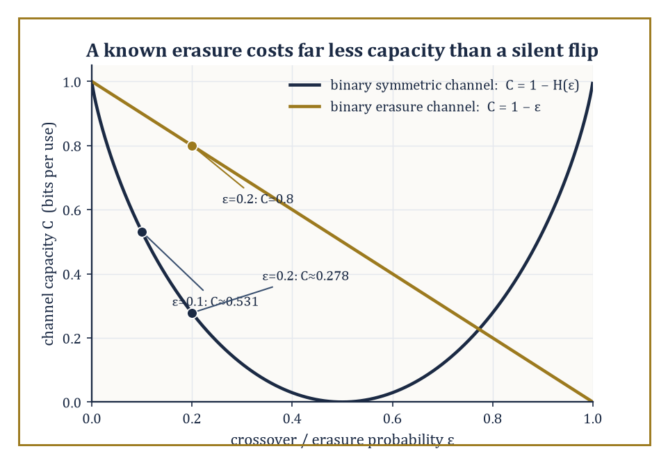
Capacity against noise level for the binary symmetric channel and the binary erasure channel: at the same 20% corruption rate, a known erasure costs far less capacity than a silent flip.
I(X;Y) = H(X) − H(X|Y) = H(Y) − H(Y|X) = H(X) + H(Y) − H(X,Y)
These are three equivalent formulas expressing the same quantity — a symmetric one, since I(X;Y) = I(Y;X) despite the asymmetric-looking definition, and a non-negative one, vanishing precisely when X and Y are independent (learning Y then tells you literally nothing new about X).
Numeric example — Worked example: mutual information of a correlated pair. Return to the joint distribution from Room 39.2: p(0,0)=0.5, p(0,1)=0.1, p(1,0)=0.1, p(1,1)=0.3, with marginal entropies H(X) = H(Y) ≈ 0.970951 bits and joint entropy H(X,Y) ≈ 1.685476 bits.
I(X;Y) = H(X) + H(Y) − H(X,Y) ≈ 0.970951 + 0.970951 − 1.685476 ≈ 0.256426 bits
So the mutual information is about 0.257 bits. This modest but positive figure says: observing Y reduces the average uncertainty about X by roughly a quarter of a bit — consistent with the earlier finding that H(Y|X) ≈ 0.715 bits, noticeably less than H(Y)'s own 0.971 bits, the difference between the two being exactly this 0.257-bit mutual information.
A discrete memoryless channel is specified by an input alphabet, an output alphabet, and a fixed set of transition probabilities p(y|x) — the probability the channel outputs y given that x was sent, with each use of the channel statistically independent of every other use.
This is an abstraction, but a remarkably productive one: it strips away every engineering detail (voltage levels, modulation schemes, physical noise sources) and leaves only the bare statistical relationship between what goes in and what comes out.
The channel's capacity is defined as the largest mutual information achievable by choosing the best possible input distribution:
C = max_{p(x)} I(X;Y)
This is a single number per channel, computed once and for all, independent of how long a message one intends to send.
Abstract example — Illustrative example: a channel as a stochastic matrix. The simplest non-trivial discrete memoryless channel is the binary symmetric channel (BSC): input and output alphabets are both {0,1}, and the channel flips the input bit with probability ε (the crossover probability), leaving it unchanged with probability 1−ε. Its transition probabilities form a 2×2 matrix:
p(0|0)=1−ε, p(1|0)=ε, p(0|1)=ε, p(1|1)=1−ε
This tiny stochastic matrix is the abstract skeleton underlying every noisy binary link — a copper wire with thermal noise, a disk sector with the occasional flipped bit, a wireless link with fading — and its capacity, derived below, is one of the two formulas every communications engineer knows by heart.
For the binary symmetric channel with crossover probability ε, the capacity has the closed form:
C = 1 − H(ε)
Here H is the same binary entropy function used throughout this storey. The intuition: a uniform input achieves
I(X;Y) = H(Y) − H(Y|X)
and H(Y|X) — the uncertainty in the output given the input, i.e. the uncertainty due purely to the channel's own noise — is exactly H(ε), the entropy of the flip itself. Since the best possible H(Y) is 1 bit (achieved by a uniform input, which also makes Y uniform by symmetry), the capacity is 1 − H(ε). Capacity, in this light, is simply the one bit you started with, minus whatever the channel insists on confiscating as its own private tax.
Numeric example — Worked example: BSC capacity at three noise levels. At ε = 0.1 (the crossover probability used throughout this storey):
C = 1 − H(0.1) = 1 − 0.469 = 0.531 bits per channel use
This is precisely the mutual-information figure computed in the cascade example of Room 39.2, now identified as this channel's capacity. At the noiseless extreme ε = 0, H(0) = 0 (no uncertainty in a flip that never happens), so:
C = 1 − 0 = 1 bit per use
An uncorrupted binary channel conveys exactly one bit per use, as it obviously should. At the maximally noisy point ε = 0.5, H(0.5) = 1 bit (a coin-flip's worth of uncertainty in every transmission), so:
C = 1 − 1 = 0
A channel that flips the bit with 50% probability is statistically indistinguishable from pure noise and can convey no information whatsoever, no matter how cleverly one codes for it — a coin flipped by the channel operator would serve the receiver just as well.
The binary erasure channel (BEC) offers an instructive contrast. Here the channel either passes the input bit through unchanged (probability 1−ε) or erases it, replacing it with a distinguishable 'erasure' symbol '?' that the receiver can plainly see is not a 0 or a 1 (probability ε) — crucially, it never lies by flipping a bit silently.
Its capacity turns out to be a much gentler formula, because the receiver always knows exactly which symbols were lost and which were received cleanly:
C = 1 − ε
Numeric example — Worked example: erasures are far less damaging than silent flips. Take erasure probability ε = 0.2 for the BEC: capacity is
C = 1 − 0.2 = 0.8 bits per use
Now compare a BSC with the same numerical error rate, ε = 0.2: its capacity is C = 1 − H(0.2). Computing H(0.2):
log₂0.2 ≈ −2.321928, contributing 0.2×2.321928 ≈ 0.464386
log₂0.8 = ln0.8/ln2 ≈ −0.223144/0.693147 ≈ −0.321928, contributing 0.8×0.321928 ≈ 0.257542
So:
H(0.2) ≈ 0.721928
C_BSC ≈ 1 − 0.722 = 0.278 bits per use
The erasure channel's capacity, 0.8 bits/use, dwarfs the symmetric channel's 0.278 bits/use, even though both corrupt exactly 20% of transmissions — because a known erasure carries almost no ambiguity (the receiver simply asks for a retransmission or leans on redundancy elsewhere), while a silent bit-flip is corrosive precisely because the receiver cannot tell it happened. This is why real systems go to considerable engineering lengths — checksums, parity, sequence numbers — to convert silent-failure channels into erasure-like ones wherever possible.
Capacity, in every case, is what information theorists call a single-letter quantity: it is computed entirely from the per-use transition probabilities, with no reference whatsoever to how long a codeword one intends to use.
That such a modest, per-symbol quantity should also be the ultimate, unbeatable ceiling on long-block communication rates is not obvious at all — it is the entire content of the channel coding theorem, to which the next room is devoted.

Room 39.6: The Channel Coding Theorem
Shannon's two miracles, delivered in the same breath
Shannon's channel coding theorem is arguably the single most surprising result in this storey, because it asserts two things that sound like they ought to contradict each other. For every rate R below the channel capacity C, there exist coding schemes — that is, ways of mapping messages to codewords and codewords back to guessed messages — whose probability of decoding error tends to zero as the block length n tends to infinity. And for every rate R above capacity C, no coding scheme, however clever, can drive the error probability to zero; it stays bounded away from zero no matter how long the blocks are allowed to grow. Capacity, in other words, is not merely a good target — it is a perfectly sharp threshold, with reliable communication possible on one side and categorically impossible on the other, and nothing in between.
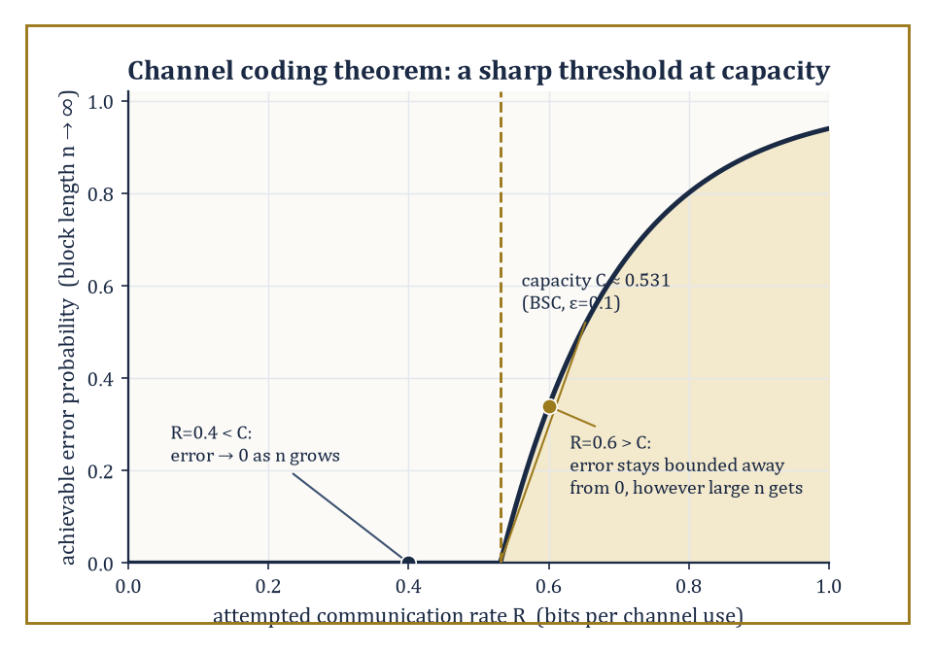
Schematic of the sharp threshold at capacity: reliable communication is asymptotically free below C, categorically impossible above it, for the BSC(0.1) of the room's own example.
Numeric example — Worked example: which side of the threshold. Take the binary symmetric channel with ε = 0.1 from Room 39.5, whose capacity is
C = 1 − H(0.1) ≈ 0.531 bits per use
A designer attempting to communicate at rate R = 0.4 bits/use is operating below capacity (0.4 < 0.531): the channel coding theorem guarantees that, with a sufficiently long and well-chosen code, the error probability can be made as small as desired — 10⁻⁶, 10⁻¹², anything one likes, simply by using a longer block. A designer attempting R = 0.6 bits/use is operating above capacity (0.6 > 0.531): no matter how ingenious the code, how long the block, or how much computing power is thrown at decoding, the error probability cannot be pushed below some fixed positive floor. The theorem does not merely say 'it gets harder above capacity' — it says the difficulty becomes an absolute wall.
The achievability half is proved by one of the most audacious arguments in mathematics: random coding. Rather than designing a clever code by hand, Shannon simply generated a codebook at random — each of the 2^{nR} codewords drawn independently according to the input distribution that achieves capacity — and then showed that, averaged over all such random codebooks, the probability of decoding error (using a decoder that looks for the unique codeword jointly typical with the received sequence, the joint-typicality idea from Room 39.3) vanishes as n → ∞, provided R < C. Since the average over all random codebooks is small, at least one specific codebook must perform at least as well as that average — so a good code is proved to exist, even though the proof gives no efficient recipe for finding it. This is achievability by pure existence proof, a style of argument that took the engineering world some decades to fully digest.
Abstract example — Worked example: a small repetition code and its error rate. A far cruder illustration of the coding idea, well below capacity but easy to compute exactly: send each message bit three times over the BSC(0.1) channel — a 'repetition code' of block length n=3, rate R = 1/3 ≈ 0.333 bits/use, comfortably below the channel's capacity of 0.531 bits/use. The decoder takes a majority vote of the three received bits. An error occurs only if two or three of the three transmissions are flipped.
P(exactly two flips) = C(3,2)×(0.1)²×(0.9) = 3×0.01×0.9 = 0.027
P(all three flip) = (0.1)³ = 0.001
Total error probability = 0.027 + 0.001 = 0.028
So a trivially simple code has already reduced the effective error rate from the channel's raw 0.1 (10%) down to 0.028 (2.8%) — a real, computable coding gain, though nowhere near the vanishing error rates the full theorem promises are achievable at rates just below 0.531 with sufficiently long, cleverly random codes. Repetition coding is a poor code (its rate is far below what capacity permits for a given error target) but it is an honest, hand-computable glimpse of the same underlying phenomenon that random coding exploits far more efficiently.
The converse half — that rates above capacity are hopeless — is proved by chaining together exactly the two tools built in Room 39.2: the data-processing inequality and Fano's inequality. Roughly: if a message of nR bits is sent, the mutual information between the message and the channel output can be at most nC (by the data-processing inequality, since the output can carry no more information about the input than the channel's own single-use capacity permits, summed over n independent uses). But if R > C, then nR bits of message entropy is being asked to survive a channel offering only nC bits of mutual information — a shortfall of n(R−C) bits that grows without bound as n increases. Fano's inequality then converts this growing entropy shortfall directly into a lower bound on the error probability that refuses to shrink to zero, however long the block.
Abstract example — Illustrative example: the converse argument in miniature. Recall the Fano's inequality worked example from Room 39.2: with M = 4 equally likely messages and observed error probability Pₑ = 0.1, the leftover uncertainty was bounded by
H(X|Y) ≤ 0.627 bits
well short of the full 2 bits of message entropy. The converse proof runs this logic in reverse and at scale: if the attempted rate R exceeds capacity C, then as block length n grows, the gap nR − nC (the entropy the channel physically cannot carry) grows linearly in n, while Fano's inequality caps the achievable H(X|Y) — and hence the tolerable error probability Pₑ — from becoming arbitrarily small; algebraically rearranging Fano's inequality to solve for Pₑ shows it must stay bounded below by a fixed positive number that depends only on R and C, never on how large n is allowed to grow. This is precisely why the theorem states a hard threshold rather than a merely diminishing-returns difficulty.
The channel coding theorem is the second operational triumph of this storey, after source coding, and arguably the more startling of the two: it says that noise, provided it is statistically well-behaved and known, is not an enemy that degrades communication gracefully as you push harder — it is an enemy with a precisely computable ceiling, below which perfect reliability is not just possible but asymptotically free. Everything in modern coding theory since 1948 — Reed–Solomon codes, turbo codes, low-density parity-check codes, the codes that let a spacecraft billions of kilometres away still be heard — is an attempt to find practical, efficiently decodable codes that get as close to this theoretical ceiling as engineering nerve allows.

Room 39.7: Rate-Distortion Theory
Compression, but you're allowed to lose a little
Lossless compression, the subject of Room 39.4, insists on perfect reconstruction — every bit of the original recovered exactly.
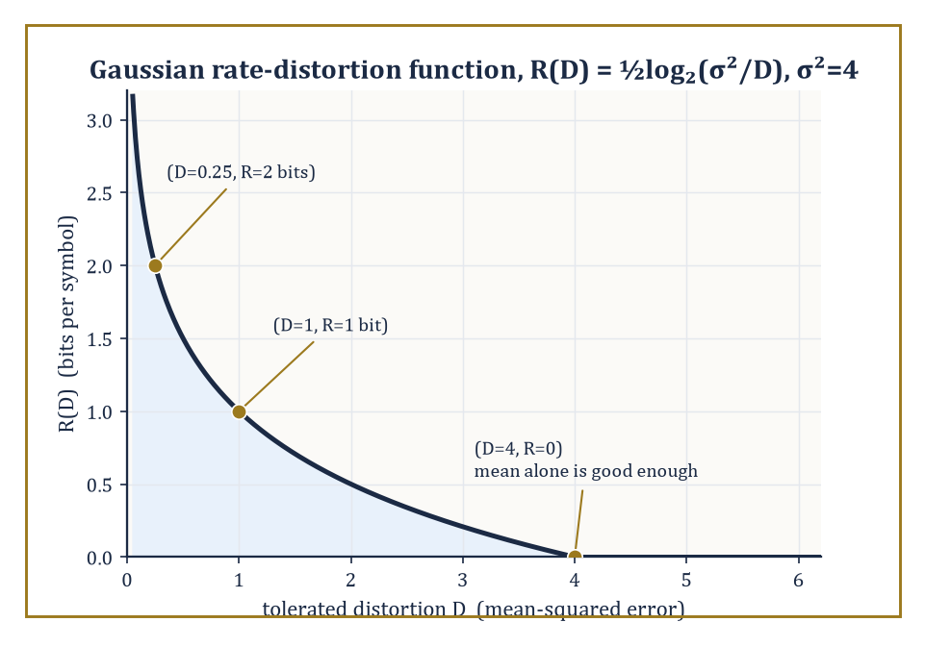
The Gaussian rate-distortion curve for σ²=4, tracing the room's three worked points: steep savings at first, logarithmic diminishing returns after.
Often this is neither possible (for a continuous source like an analogue audio signal, exact reconstruction from a finite number of bits is a category error) nor even desirable (a photograph compressed to half its file size at an imperceptible loss of quality is, for almost every practical purpose, strictly preferable to an uncompressed original twice the size).
Rate-distortion theory is the mathematics of this trade-off. Given a distortion measure d(x, x̂) — a number quantifying how bad it is to reconstruct the true value x as the approximation x̂ — the rate-distortion function R(D) is defined as the minimum mutual information I(X;X̂) over all conditional distributions p(x̂|x) whose expected distortion E[d(X,X̂)] does not exceed D:
R(D) = min_{p(x̂|x):\ E[d(X,X̂)] ≤ D}\ I(X;X̂)
It is, formally, a constrained convex optimisation problem, and the rate-distortion theorem asserts both that R(D) is achievable (a scheme exists using roughly R(D) bits per symbol that achieves average distortion at most D) and that it cannot be beaten (no scheme using fewer bits can achieve distortion D or better).
Abstract example — Illustrative example: the two boundary cases. Two limiting cases of R(D) are worth fixing firmly in mind before any formula appears, because they are checkable by pure common sense and any correct formula for R(D) must reduce to them.
At D = 0 (zero tolerated distortion, i.e. lossless reconstruction demanded), R(D) must equal H(X) exactly:
R(0) = H(X)
This is precisely the source coding theorem of Room 39.4, now revealed as the special case D=0 of the more general rate-distortion problem.
At the other extreme, once D is large enough that a receiver can achieve acceptable average distortion by simply ignoring the transmission entirely and always guessing some fixed default value (for instance, always guessing the source's mean, for squared-error distortion), R(D) drops to exactly 0:
R(D) = 0,\quad D ≥ D_{max}
No bits at all need be sent, because blind guessing already meets the distortion target. Every rate-distortion function in this room, plotted against D, starts at H(X) when D=0 and decreases monotonically to 0 at some finite D_max, and it is this decreasing curve — more tolerance for error buys a lower required rate — that the theory makes precise.
For a binary source X ~ Bernoulli(p) with Hamming distortion (d(x,x̂) = 0 if x = x̂, else 1 — you are simply penalised once for every bit reconstructed wrong), the rate-distortion function has the closed form:
R(D) = H(p) − H(D),\quad 0 ≤ D ≤ min(p, 1−p)
R(D) = 0,\quad D > min(p, 1−p)
It is a striking fact — not a coincidence, but a genuine structural echo — that this formula has exactly the same shape as the binary symmetric channel capacity formula from Room 39.5:
C = 1 − H(ε)
Both problems are, underneath, the same convex optimisation over binary conditional distributions, one maximising mutual information subject to a channel constraint, the other minimising mutual information subject to a distortion constraint, and the binary entropy function governs both.
Numeric example — Worked example: rate-distortion for a fair binary source. Take a fair binary source, p = 0.5, and a tolerated average bit-error rate (distortion) of D = 0.1. Then:
R(D) = H(0.5) − H(0.1) = 1 − 0.469 = 0.531 bits per symbol
This is the exact same numerical value, 0.531, computed for the BSC(0.1) channel capacity in Room 39.5.
This is the duality made concrete: a fair binary source willing to tolerate 10% bit errors can be compressed to 0.531 bits per symbol, precisely the rate a BSC with 10% crossover probability can reliably carry — describing a source lossily at distortion D and communicating over a channel with matched noise level D turn out, for the binary case with these parameters, to be mirror images of the same underlying mathematics.
For a continuous Gaussian source with variance σ² and squared-error distortion d(x,x̂) = (x−x̂)², the rate-distortion function is known exactly:
R(D) = ½log₂(σ²/D),\quad 0 ≤ D ≤ σ²
R(D) = 0,\quad D ≥ σ²
Beyond that point, simply outputting the mean, incurring distortion exactly σ², is as good as anything a positive bit rate could offer. This is one of the very few rate-distortion functions with a clean closed form, and it plays the same touchstone role for lossy compression that the AWGN capacity formula (next room) plays for channel capacity.
Numeric example — Worked example: the Gaussian rate-distortion curve. Let σ² = 4. At a tolerated distortion of D = 1:
R(D) = ½log₂(4/1) = ½×2 = 1 bit per symbol
At a stricter tolerance of D = 0.25 (a quarter of the previous distortion):
R(D) = ½log₂(4/0.25) = ½log₂16 = ½×4 = 2 bits per symbol
As expected, demanding four times less distortion costs exactly one extra bit per symbol. And at the boundary D = σ² = 4:
R(D) = ½log₂(4/4) = ½log₂1 = 0 bits per symbol
This confirms the boundary case discussed above: at this distortion level, always guessing the source mean already meets the target, so no transmitted bits are needed at all. These three points — (D=4, R=0), (D=1, R=1), (D=0.25, R=2) — trace out the characteristic downward-curving shape of every Gaussian rate-distortion function: steep savings in bits for the first bit of tolerated error, with diminishing (logarithmic) returns thereafter.
Every lossy codec encountered in ordinary life — JPEG for still images, MPEG and its descendants for video, MP3 and its heirs for audio — is an engineering approximation to a rate-distortion limit, operating under the additional practical constraints of computational complexity and encoding delay that the pure theory is free to ignore.
A JPEG encoder at a typical 'quality 80' setting, for instance, routinely achieves compression ratios in the region of ten-to-one on photographic images while remaining close to visually lossless, a rough but well-known illustration of how far practical engineering has learned to approach these theoretical limits.
Numeric example — Worked example: what ten-to-one actually costs in bits. An uncompressed colour photograph is typically stored at 24 bits per pixel — 8 bits each for red, green, and blue.
At the 'quality 80' ten-to-one ratio quoted above, a JPEG encoder is spending only:
24/10 = 2.4 bits per pixel
on average — roughly a tenth of the raw bit-depth — while staying close to visually lossless.
That such a small fraction of the original bit budget suffices is precisely the rate-distortion moral of this room: a real photograph, its neighbouring pixels heavily correlated in both space and colour, carries far less genuine per-pixel entropy than its raw 24-bit encoding implies, and a good codec's job is simply to stop paying for redundancy the eye was never going to miss.
Rate-distortion theory is, in short, the information-theoretic foundation underneath every 'lossy' file format the reader has ever opened — the mathematics that tells an engineer exactly how many bits are truly required to throw away just enough detail, and no more, to hit a chosen quality target.

Room 39.8: Continuous Channels and Gaussian Channels
Home of the most quoted formula in engineering
Every quantity so far has assumed a discrete alphabet — a finite (or countable) set of symbols. Real signals are often continuous, and extending entropy to continuous random variables requires a definition with a genuine subtlety attached: the differential entropy.
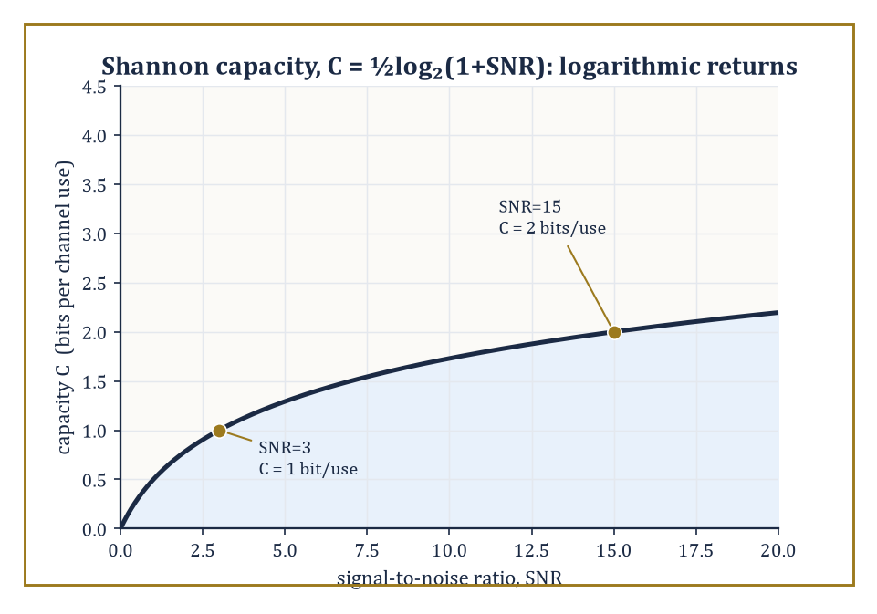
The Shannon capacity curve C = ½log₂(1+SNR), marking the room's SNR=3 and SNR=15 points — quadrupling the SNR buys only one more bit.
h(X) = −∫f(x)log₂f(x)dx
Here f is the probability density function of X. Unlike ordinary (discrete) entropy, differential entropy is not scale-invariant, is not bounded below by zero, and can in fact be negative — a fact that surprises newcomers every time, and which is worth demonstrating rather than merely asserting.
Numeric example — Worked example: differential entropy can be negative. Let X be uniformly distributed on the interval [0,4], with constant density f(x) = 1/4 there. Its differential entropy is:
h(X) = −∫₀⁴ (1/4)log₂(1/4)dx = −log₂(1/4) = log₂4 = 2 bits
This is a sensible, positive number, reflecting that X can land anywhere across a comparatively wide interval. In general, for X uniform on [a,b]:
h(X) = log₂(b−a)
Now shrink the interval to [0, 0.5]:
h(X) = log₂(0.5) = −1 bit
Negative! This is not a mistake — it simply reflects that once the interval is narrower than one unit, the density f = 1/(b−a) exceeds 1, and −log₂f becomes negative, dragging the (density-weighted) average below zero. Differential entropy, unlike its discrete cousin, measures something closer to 'spread relative to a fixed unit of length' than 'absolute uncertainty', and differences of differential entropies — rather than their raw values — are what carry the physically meaningful, unit-independent content.
For a Gaussian random variable with variance σ², the differential entropy has the closed form:
h(X) = ½log₂(2πeσ²)
This distribution occupies a privileged position: among all continuous distributions with a fixed variance σ², the Gaussian is the one that maximises differential entropy — the 'least predictable' shape a distribution can take once its spread is pinned down, which is precisely why Gaussian noise is the worst-case (and hence the standard, conservative) noise model in communications engineering.
Numeric example — Worked example: entropy of the standard normal. For a standard normal variable, σ² = 1:
h(X) = ½log₂(2πe)
Computing the constant:
2πe = 2 × 3.14159265 × 2.71828183 ≈ 17.07946
log₂(17.07946) = ln(17.07946)/ln(2) ≈ 2.837877/0.693147 ≈ 4.094282
h(X) ≈ 4.094282 / 2 ≈ 2.047 bits
This well-known figure — the differential entropy of the standard normal is about 2.047 bits — recurs throughout information-theoretic treatments of Gaussian noise, precisely because 'Gaussian with variance σ²' is the maximum-entropy, hence worst-case and most tractable, noise model available at that variance.
The single most famous formula in this entire storey — arguably in the whole of electrical engineering — is the capacity of the additive white Gaussian noise (AWGN) channel:
C = ½log₂(1 + SNR)
Here SNR is the signal-to-noise power ratio. Every Wi-Fi router, every satellite downlink, every fibre-optic repeater is, at bottom, an attempt to approach this one formula as closely as the laws of physics and the cost of engineering will allow, and it has held its position unshaken since Shannon derived it in 1948.
Numeric example — Worked example: Shannon capacity at two SNR levels. At a signal-to-noise ratio of SNR = 15 (the signal carries fifteen times the power of the noise, roughly 11.76 dB), capacity is:
C = ½log₂(1+15) = ½log₂16 = ½×4 = 2 bits per channel use
At a more modest SNR = 3:
C = ½log₂(1+3) = ½log₂4 = ½×2 = 1 bit per channel use
Notice that quadrupling the SNR (from 3 to roughly 12, say) only adds one further bit of capacity — this logarithmic law of diminishing returns is exactly why doubling a Wi-Fi router's transmit power never comes close to doubling its data rate, and why communications engineers obsess over reducing noise rather than merely brute-forcing more signal power.
When a communication resource is split across several parallel Gaussian sub-channels, each with its own noise level, and a total power budget must be divided among them, the optimal allocation is the elegant water-filling solution: imagine pouring a fixed total amount of 'water' (power) over a landscape whose ground level at each sub-channel equals its noise variance — power flows preferentially to the quietest (lowest-noise) sub-channels, and any sub-channel whose noise floor sits above the resulting water level receives no power at all. This is the same circle of ideas, generalised, that governs power allocation across the many parallel sub-carriers of a MIMO wireless system or an OFDM broadcast signal.
Numeric example — Worked example: water-filling across two sub-channels. Suppose two parallel Gaussian sub-channels have noise variances N₁ = 1 and N₂ = 4, and a total power budget of P = 10 must be split between them. Water-filling sets a common water level ν such that the power allocated to each active sub-channel is Pᵢ = ν − Nᵢ (whenever this is positive), with Σᵢ Pᵢ = P. Assuming both sub-channels are active:
(ν−1) + (ν−4) = 10 ⟹ 2ν − 5 = 10 ⟹ ν = 7.5
Then:
P₁ = 7.5 − 1 = 6.5, P₂ = 7.5 − 4 = 3.5
Both are positive, confirming both channels are indeed worth using, and P₁+P₂ = 10 checks out against the budget. The resulting total capacity is:
C = ½log₂(1+P₁/N₁) + ½log₂(1+P₂/N₂) = ½log₂(1+6.5) + ½log₂(1+0.875) = ½log₂7.5 + ½log₂1.875
Computing:
log₂7.5 = ln7.5/ln2 ≈ 2.014903/0.693147 ≈ 2.906891
log₂1.875 = ln1.875/ln2 ≈ 0.628609/0.693147 ≈ 0.906891
C ≈ ½×2.906891 + ½×0.906891 ≈ 1.453446 + 0.453446 ≈ 1.907 bits per pair of channel uses
Notice the quieter sub-channel (N₁=1) received nearly twice the power of the noisier one (N₂=4, receiving 3.5) — water-filling systematically favours quiet channels, precisely because a given watt of power buys more capacity where the competing noise is weaker.
Continuous information theory, in the end, retains every operational promise of the discrete theory — compression limits, capacity ceilings, achievability and converse — while adding a genuine layer of analytic subtlety around infinite alphabets and the peculiarities of differential entropy. It is the natural mathematical home for the wireless and fibre-optic engineering that carries most of the world's actual data traffic, and the natural bridge into the next storey's subject, where continuous signals are examined not just for how much information they carry, but for where in time and frequency that information is hiding.

Room 39.9: Looking Ahead: From Classical Information Theory to Networks, Quantum Information, and Learning
We have now climbed through the essential architecture of classical information theory: entropy as the measure of uncertainty, the asymptotic equipartition property as the technical mechanism that turns entropy into an operational rate, source coding and Huffman's construction as the answer to 'how far can this be squeezed', mutual information and channel capacity as the answer to 'how fast can this be sent reliably', the channel coding theorem as the sharp threshold separating the two, rate-distortion theory as the generalisation permitting controlled loss, and Gaussian channels as the continuous-alphabet setting in which Shannon's formula does its daily work.
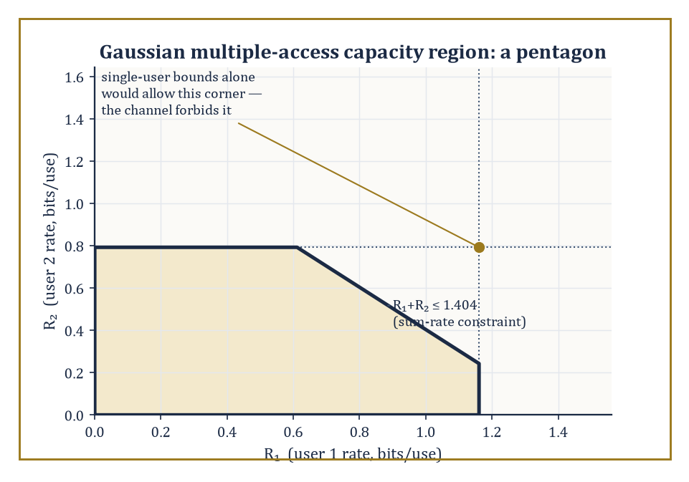
The Gaussian multiple-access capacity region is a pentagon, not the rectangle the two single-user bounds alone would suggest — the sum-rate constraint shaves off the far corner.
Every one of these ideas has an operational meaning checkable, in principle, with pencil, paper, and patience — which is more than can be said for some storeys of this Tower, and no shade intended toward Category Theory, which merely lives at a different altitude.
Classical (single-user, single-channel) information theory is, however, a special case of something considerably larger. Network information theory extends the entire apparatus to settings with multiple senders and receivers — the multiple-access channel (several transmitters sharing one receiver, as in a crowded cellular uplink), the broadcast channel (one transmitter, several receivers with different channel qualities), and the general problem of distributed compression, where correlated sources must be compressed separately but decoded jointly.
Remarkably, the capacity region of even the simplest genuinely multi-user channel is, in general, still an open problem — a humbling reminder that Shannon answered the single-user question completely in 1948, and the field has been chasing the multi-user generalisation ever since.
Abstract example — Illustrative example: a two-user capacity region. In the simplest tractable multi-user setting, the Gaussian multiple-access channel, two transmitters with powers P₁ and P₂ share a single receiver against background noise N. Unlike the single-user case, there is no single capacity number — instead there is a capacity region, a set of jointly achievable rate pairs (R₁,R₂).
Each user individually is capped by the single-user AWGN formula from Room 39.8:
R₁ ≤ ½log₂(1+P₁/N)
R₂ ≤ ½log₂(1+P₂/N)
But the two users jointly face a third, tighter constraint on their combined rate — the sum rate cannot exceed what a single user with their combined power could achieve alone, since from the receiver's point of view the two signals simply add:
R₁+R₂ ≤ ½log₂(1+(P₁+P₂)/N)
This three-constraint region, a pentagon rather than a rectangle when plotted, is the archetype of every richer network capacity region that follows — the geometry of 'sharing' made explicit.
A second and entirely different generalisation replaces bits with qubits. Quantum information theory studies entanglement, quantum channels, and quantum error-correcting codes, and finds that many classical intuitions bend or break: information encoded in quantum states cannot be copied (the no-cloning theorem), yet entangled pairs of qubits can be used to boost classical communication rates in ways with no classical analogue (superdense coding), and the quantum analogue of mutual information behaves in genuinely stranger ways than its classical namesake.
It is, in a real sense, the natural next storey up from this one for anyone drawn specifically to communication theory rather than to signal analysis — though this particular Tower, as noted, heads next toward wavelets.
A third generalisation runs not outward into networks or inward into quantum mechanics, but sideways into statistical learning theory. The information-theoretic analysis of generalisation asks: how much does a trained model's performance on new data depend on how much information its parameters retain about the specific training examples it saw?
A representative result, in the spirit of PAC-Bayes and mutual-information generalisation bounds, states that the expected gap between training and test performance is bounded by:
√(2σ²·I(W;S)/n)
Here I(W;S) is the mutual information between the learned parameters W and the training sample S, σ² bounds the variance of the loss, and n is the number of training examples — in plain words, a model that has 'memorised' more bits about its specific training data (higher I(W;S)) is provably more likely to generalise poorly, a precise, information-theoretic version of the folk wisdom that overfitting is a kind of over-remembering.
Numeric example — Worked example: a generalisation bound in numbers. Suppose a trained model's parameters retain I(W;S) = 10 bits of mutual information with the training sample (10 bits × ln2 ≈ 6.93 nats, since these bounds are typically stated in natural-log units), the loss function has variance bound σ² = 1, and the training sample has n = 1000 examples.
Plugging into the bound:
√(2×1×6.93/1000) = √(13.86/1000) = √0.01386 ≈ 0.1177
So the expected gap between training and test loss is bounded by roughly 0.118, in whatever units the loss is measured — a small number, reflecting that 10 bits of memorised information, spread thin over a thousand training examples, poses only a modest generalisation risk.
Note how the bound shrinks as n grows for fixed I(W;S): more training data dilutes the harm of any fixed amount of memorisation, exactly matching the empirical observation that overfitting is far more dangerous on small datasets than large ones.
A fourth thread — the algorithmic and practical side of coding theory — asks how to actually build codes that approach the Shannon limits proved abstractly in this storey, using decoders efficient enough to run in real time.
Low-density parity-check (LDPC) codes and turbo codes, both discovered decades after Shannon's original 1948 paper, come astonishingly close to capacity on real channels with practically implementable decoding algorithms, and are the workhorses inside modern Wi-Fi, satellite links, and mobile phone standards; their story is as much about clever engineering and iterative probabilistic decoding as about the pure mathematics developed here.
The deeper lesson of this entire storey, worth carrying forward past every one of these frontiers, is that information is a genuinely measurable quantity, with real physical and engineering units, and that the fundamental limits on how far it can be compressed and how fast it can be communicated are simultaneously mathematically exact and practically attainable — not asymptotic curiosities confined to a seminar room, but numbers that sit, quietly and precisely, inside every modem, every hard drive, and every fibre-optic cable on the planet.
Information theory is the mathematics of communication and uncertainty, and it is, without much competition, the branch of this Tower most likely to be running silently in the device the reader used to find this sentence.
We have learned to quantify information: to measure uncertainty in bits, to name the sharp threshold below which reliable communication is free and above which it is impossible, and to trade bits for tolerated error with rate-distortion theory's precise accounting. It is a rare corner of mathematics where the theorems are not merely beautiful but are, quite literally, the numbers an engineer designs toward on a Tuesday afternoon.
The tower continues upward, and the next storey turns from Shannon's discrete symbols to genuinely continuous signals, asking a question this storey deliberately set aside: not merely how much information a signal carries, but where — in time, in frequency, or in some cleverly chosen mixture of both — that information is actually hiding. Wavelets and signal analysis await, and they will feel less like a change of subject than a change of lens on exactly the same question.

Storey 40: Wavelets & Signal Analysis
Time-Frequency, Multiresolution, and the Art of Seeing Signals at Every Scale
One storey down, we spent our time weighing uncertainty in bits, discovering that a fair coin flipped once contains exactly one shannon of surprise and not a grain more. Information theory told us how much a signal has to say. It was scrupulously uninterested in when the signal said it. A message is a message, whether its entropy arrives all at once in a single dramatic spike or is doled out evenly like a disappointing allowance — Shannon's bookkeeping does not care, and frankly neither did we, at the time. We have some tidying up to do.
The tidying concerns an old friend from many storeys back: the Fourier transform, which decomposes a signal into pure frequencies with a thoroughness bordering on the obsessive. Its one great flaw, seldom advertised on the box, is that it is a hopeless gossip with no sense of chronology. Play it a single sharp click and a long, gentle, pure tone of exactly the same energy, and it will hand you back two spectra of comparable magnitude, because a click is (mathematically speaking) an extremely inclusive chord containing a little of every frequency there is. Ask the Fourier transform where the click happened, and it stares back blankly. It knows what. It has no idea when.
Wavelets are the fix, and a rather elegant one: instead of pure sinusoids that hum away identically from minus infinity to plus infinity — the mathematical equivalent of a dinner guest who never stops talking and never says anything about the room they're in — we build our basis out of small, localized waveforms that can be stretched (scaled) and slid along the time axis (translated). Correlate a signal against a whole family of these, and you get a time-scale portrait: not just what frequencies are present, but where, and at what magnification. It is, we will see, the mathematics of knowing both what a signal is doing and when it is doing it, which turns out to be exactly what nature, audio engineers, and radiologists all wanted from the beginning.
A confession before we start climbing: wavelets are one of the vanishingly few pieces of pure mathematics from the last fifty years that went from seminar-room curiosity to ubiquitous consumer technology within a single academic generation — most ideas take three generations merely to get a decent Wikipedia stub. The reason is unusually clean for mathematics: the very same construction that hands you a rigorous orthonormal basis of L² also hands you, for free, a fast, exactly invertible, multiscale algorithm that happens to compress ordinary photographs rather better than anything before it. Theorem and product shipped in the same box. If the Fourier transform taught us to see frequency, wavelets teach us to see frequency and location at once. Let's change the window size.

Room 40.1: What Wavelets and Signal Analysis Actually Are
In which a basis is finally permitted to have an address
A wavelet is a small waveform — a 'little wave', which is a slightly twee translation of the French ondelette but nobody involved in the 1980s renaming committee seems to have minded.
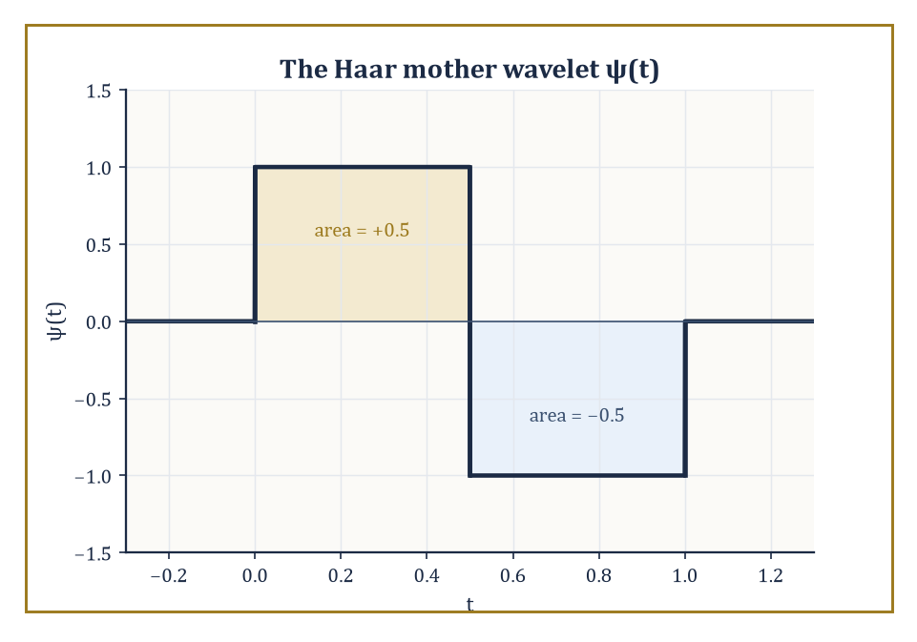
The Haar mother wavelet: one up-lobe, one down-lobe, and a mean of exactly zero.
It is localized: it lives on a bounded stretch of the time axis and is essentially zero elsewhere, unlike a sine wave, which lives everywhere with equal enthusiasm and no self-restraint.
From a single 'mother' wavelet ψ we generate a whole family by scaling (compressing or stretching it) and translating (sliding it left or right).
Signal analysis with wavelets means expanding a function, or a discrete signal, in a basis — or a looser structure called a frame, which we will meet properly in Room 40.9 — built from such waveforms, and then reading the resulting coefficients as a time-scale portrait: which scales are active, and where.
Numeric example — Worked example — the Haar wavelet, the simplest possible mother. The simplest mother wavelet of all is the Haar wavelet:
ψ(t) = +1 for t ∈ [0, 0.5), ψ(t) = −1 for t ∈ [0.5, 1), and ψ(t) = 0 everywhere else
It is a single up-down blip, roughly the mathematical equivalent of a doorbell. Check its mean:
∫₀¹ ψ(t) dt = ∫₀^0.5 (1) dt + ∫_0.5^1 (−1) dt = 0.5 − 0.5 = 0
Zero mean — we will see in Room 40.3 that this is not a coincidence but a requirement (admissibility) for any function that wants to call itself a wavelet.
Now scale it: ψ(2t) is the same blip compressed to live on [0, 0.5) instead of [0, 1) — squeeze the doorbell, and it rings twice as fast in half the space. Translate it: ψ(t − 1) is the identical blip, shifted to sit on [1, 2).
Scaling changes how fast it wiggles; translating changes where it wiggles. Together, scaled-and-translated copies ψ((t − b)/a) are the entire vocabulary of wavelet analysis.
The subject sits at a three-way junction: harmonic analysis (the Fourier tradition), approximation theory (how well can we represent a function using few pieces?), and signal processing (how do we actually compute any of this on a finite string of numbers?).
From Fourier analysis it inherits the central idea of expanding a function in an orthonormal basis and reading off coefficients.
Where it departs from Fourier analysis is in refusing to use basis functions that are spread thinly across the whole time axis; a wavelet basis insists that each basis function be localized in time as well as (to varying degrees) in frequency.
Abstract example — Abstract example — two basis elements, two addresses. Compare a single Fourier basis element on the circle, e^{i2πkt} for some fixed k, against a single wavelet basis element:
ψ_{1,3}(t) = √2·ψ(2t − 3)
The Fourier element has constant modulus 1 everywhere on [0,1) — ask it 'are you present near t = 0.05?' and the honest answer is 'I am present everywhere, equally, forever, thank you for asking.'
The wavelet element ψ_{1,3} is supported only on the interval where 2t − 3 ∈ [0,1), i.e. t ∈ [1.5, 2) — but that's outside [0,1), so shift the index: ψ_{1,0}(t) is supported on t ∈ [0, 0.5).
Ask the same question of ψ_{1,0} and it can honestly say 'yes, and nowhere else.' Both encode oscillation; only one comes with a return address.
The practical payoff of insisting on local basis functions is that the resulting expansion adapts to local regularity.
A smooth, slowly varying stretch of signal is captured efficiently by a handful of coarse, large-scale coefficients — you don't need fine detail to describe something that isn't doing anything interesting.
A singularity, a sharp edge, a sudden jump, produces large coefficients only at the fine scales and only at the locations where the misbehaviour actually occurs. Everywhere else, at fine scale, the coefficients are small or exactly zero.
This single fact — that wavelet coefficients are sparse for signals that are smooth except at a few places — is the mathematical seed from which essentially every application in this storey grows.
Numeric example — Worked example — a jump caught in the act. Take the 8-sample step signal s = [2, 2, 2, 2, 2, 6, 6, 6], flat except for one jump between positions 4 and 5 (0-indexed). Pair the samples and apply the (orthonormal) Haar transform to each pair, using the general formulas:
average a = (x₀+x₁)/√2, detail d = (x₀−x₁)/√2
Working through each pair in turn:
Pair (2,2): a₀ = 4/√2 ≈ 2.828, d₀ = 0/√2 = 0
Pair (2,2): a₁ ≈ 2.828, d₁ = 0
Pair (2,6): a₂ = 8/√2 ≈ 5.657, d₂ = (2−6)/√2 = −4/√2 ≈ −2.828
Pair (6,6): a₃ = 12/√2 ≈ 8.485, d₃ = 0
Three of the four detail coefficients are exactly zero — the constant stretches contribute nothing to detect — and the one non-zero detail coefficient, d₂ ≈ −2.828, sits precisely at the pair straddling the jump. The transform has, without being told where to look, pointed a finger at the discontinuity.
Two dialects will be spoken interchangeably throughout this storey, and it is worth naming them before they cause confusion.
The continuous dialect treats a signal as a function x ∈ L²(ℝ) — the space of square-integrable functions we met in earlier storeys, equipped with the energy norm:
‖x‖² = ∫|x(t)|² dt
The discrete dialect treats a signal as a sequence x ∈ ℓ²(ℤ), a doubly-infinite (or, in practice, finite) list of numbers with energy:
‖x‖² = Σₙ |xₙ|²
Continuous-time theorems (admissibility, the CWT) are proved in the first dialect; the algorithms you actually run on a laptop (the DWT, filter banks) live in the second.
The two are reconciled by sampling, and — this being mathematics done properly rather than hand-waved — the reconciliation is exact under the right conditions, not merely 'close enough'.
Numeric example — Worked example — energy survives the trip from continuous to discrete. Let x(t) = 1 for t ∈ [0, 4) and x(t) = 0 elsewhere — a continuous rectangular pulse of height 1 and width 4. Its continuous energy:
‖x‖² = ∫₀⁴ 1² dt = 4
Now sample it at spacing Δt = 1, landing exactly on the pulse's edges:
x₀ = x(0) = 1, x₁ = x(1) = 1, x₂ = x(2) = 1, x₃ = x(3) = 1, and every other sample is 0
Discrete energy, weighted by the sampling interval:
Σₙ |xₙ|²·Δt = (1+1+1+1)·1 = 4
The two energies agree exactly, 4 = 4, because the sampling grid happened to align perfectly with the pulse's boundaries. Shift the pulse to straddle a sample point instead, and the discrete sum would only approximate the continuous integral — a small foretaste of why boundary handling (Room 40.6) and the precise choice of sampling grid matter more than a first glance suggests.
That is the whole story in miniature, and everything from here to Room 40.8 is really an elaboration of it: build a family of localized, scaled, translated waveforms with the right mathematical properties (Rooms 40.2–40.5), turn the construction into a fast algorithm (Room 40.6), understand exactly how well it compresses smooth-but-occasionally-rude signals (Room 40.7), and then go and use it on things people actually care about (Room 40.8).
We start, as is traditional, by asking how badly the alternative — the fixed-window Fourier approach — fails, and by how much.

Room 40.2: Time-Frequency Analysis and the Uncertainty Principle
You may have a sharp watch or a good ear, but the universe will not sell you both
The most obvious patch for the Fourier transform's amnesia about location is the short-time Fourier transform (STFT): slide a fixed window g across the signal x, multiply, and Fourier-transform each windowed chunk separately.
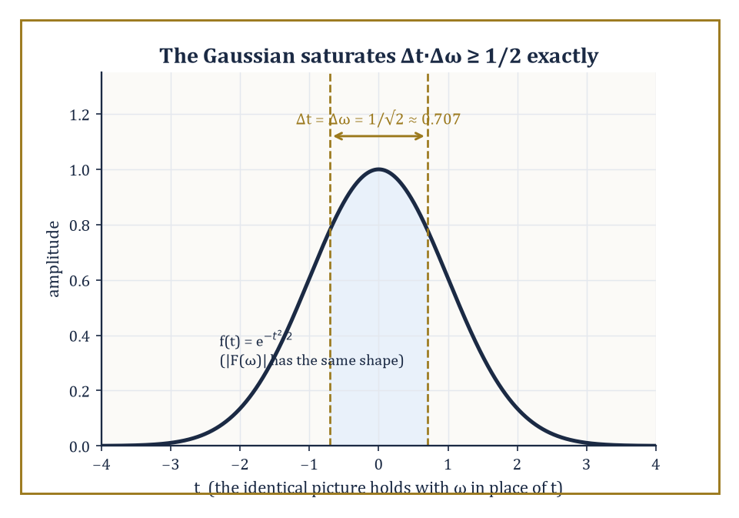
The Gaussian bump: the one shape for which time-spread and frequency-spread hit the Heisenberg floor with nothing left over.
STFT(t, ξ) = ∫ x(τ) g(τ − t) e^{−i2πξτ} dτ
The result is a genuine time-frequency portrait — a value for every combination of time t and frequency ξ — but its resolution is locked in by the width of the window g, chosen once, in advance, and applied uniformly to a signal that may have no intention of cooperating with a single fixed timescale.
Numeric example — Worked example — resolution bought and sold. A rough but standard rule of thumb relates window duration to frequency resolution:
Δf ≈ 1/T Hz
Choose T = 0.01 s (10 milliseconds, good for catching a drum hit):
Δf ≈ 1/0.01 = 100 Hz
Anything closer together than 100 Hz blurs into one smear. Choose T = 0.1 s (100 milliseconds, good for hearing a violin's pitch clearly):
Δf ≈ 1/0.1 = 10 Hz
That's ten times sharper in frequency. You cannot have both from the same window. Sharpen the clock, and the ear goes fuzzy; sharpen the ear, and the clock goes fuzzy. This is not an engineering shortcoming to be fixed by trying harder — it is the STFT's founding bargain.
That bargain is not an accident of poor design; it is forced by the Heisenberg uncertainty principle, imported wholesale from the Fourier analysis of earlier storeys.
For any function f in L²(ℝ) (normalized so it has a well-defined 'centre' and 'spread' in both time and frequency), the product of its time-spread Δt and its frequency-spread Δω obeys:
Δt·Δω ≥ 1/2
with equality if and only if f is a Gaussian bump. A function cannot be made arbitrarily narrow in time and arbitrarily narrow in frequency simultaneously — squeeze one, and the other balloons.
The same limit, applied to the analysis window g, caps how sharp the STFT's time-frequency picture can ever be.
Numeric example — Worked example — the Gaussian saturates the bound exactly. Take the function f, defined by:
f(t) = e^{−t²/2}
Its energy is a standard Gaussian integral:
∫e^{−t²} dt = √π
Its time-spread is:
Δt² = ∫t²e^{−t²}dt / ∫e^{−t²}dt = (√π/2)/√π = 1/2
Δt = 1/√2 ≈ 0.707
Its Fourier transform, using the convention:
F(ω)=∫f(t)e^{−iωt}dt
works out to:
F(ω) = √(2π)·e^{−ω²/2}
|F(ω)|² = 2π·e^{−ω²}
Its frequency-spread is:
Δω² = ∫ω²e^{−ω²}dω / ∫e^{−ω²}dω = (√π/2)/√π = 1/2
Δω = 1/√2 ≈ 0.707
The product is:
Δt·Δω = (1/√2)(1/√2) = 1/2
That is exactly the Heisenberg bound, met with no slack whatsoever. Nothing beats a Gaussian at this game; nothing ever will.
The energy of the STFT is displayed as a spectrogram — the workhorse image of every audio-analysis package, every birdsong study, every sound-editing app's waveform view. It shows time along one axis, frequency along the other, and brightness for energy.
Its Achilles' heel is precisely the fixed resolution just derived: a short window resolves a transient (a click, a consonant, a drum hit) crisply in time but blurs closely spaced tones together; a long window resolves closely spaced tones crisply but smears any transient out over its whole duration, turning a sharp click into a fuzzy, ambiguous smudge.
Abstract example — Abstract example — one signal, two failures. Consider a signal built from two events: a 5-millisecond click at t = 0, and two pure tones at 440 Hz and 460 Hz sustained throughout.
Using the 10 ms window from the earlier example (Δf ≈ 100 Hz): the click is well-timed but the two tones, only 20 Hz apart, are utterly indistinguishable — both fall inside the same 100 Hz smear.
Using the 100 ms window (Δf ≈ 10 Hz): the tones now separate cleanly, since a 20 Hz gap comfortably clears a 10 Hz resolution — but the 5 ms click gets smeared across the entire 100 ms window, its precise timing destroyed.
No single fixed window serves both halves of this rather ordinary signal well.
It is worth being honest about why the STFT cannot simply use a shorter window everywhere and call it a day. Musical pitch is perceived on a logarithmic (multiplicative) scale — the gap between 220 Hz and 440 Hz sounds like the same interval, an octave, as the gap between 440 Hz and 880 Hz — while the STFT's frequency resolution Δf ≈ 1/T is a fixed, additive quantity in Hz, the same size everywhere on the frequency axis.
A resolution fine enough to separate two close low notes is needlessly, wastefully fine when applied to two far-apart high notes, and a resolution coarse enough to be efficient at high notes is far too blunt to separate low ones.
Numeric example — Worked example — one resolution, two very different jobs. Take the window from the earlier example, with:
T = 0.1 s, giving Δf ≈ 10 Hz
Down at the bottom of the piano, the notes A2 (110 Hz) and A♯2 (about 116.5 Hz) are a semitone apart — a gap of only 6.5 Hz, smaller than the window's 10 Hz resolution, so the two notes blur together.
Up near the top of the piano, A6 (1760 Hz) and A♯6 (about 1864.7 Hz) are also exactly a semitone apart, but that is now a gap of roughly 105 Hz — more than ten times the window's resolution, comfortably separated with room to spare.
The same fixed window is simultaneously too coarse for the bass and needlessly over-precise for the treble; no single choice of T serves both octaves well, because the ear's sense of 'how far apart' two notes are does not match the STFT's flat, uniform notion of frequency distance.
Wavelets sidestep the impasse not by cheating the uncertainty principle — nobody cheats the uncertainty principle, tenure or no tenure — but by refusing to fix the window size at all. Instead the window scales with what it's looking for: narrow (short in time, wide in frequency) when hunting fine detail, wide (long in time, narrow in frequency) when hunting slow trends.
Picture the time-frequency plane tiled not by identical fixed boxes, as the STFT insists, but by boxes that are tall and narrow at high frequencies and short and wide at low frequencies — each box still obeying Heisenberg's minimum area, but no longer forced to be the same shape everywhere. That single change of habit is the entire content of the next room.

Room 40.3: The Continuous Wavelet Transform
A transform so redundant it could retire twice
The continuous wavelet transform (CWT) correlates a signal x with scaled and translated copies of a mother wavelet ψ:
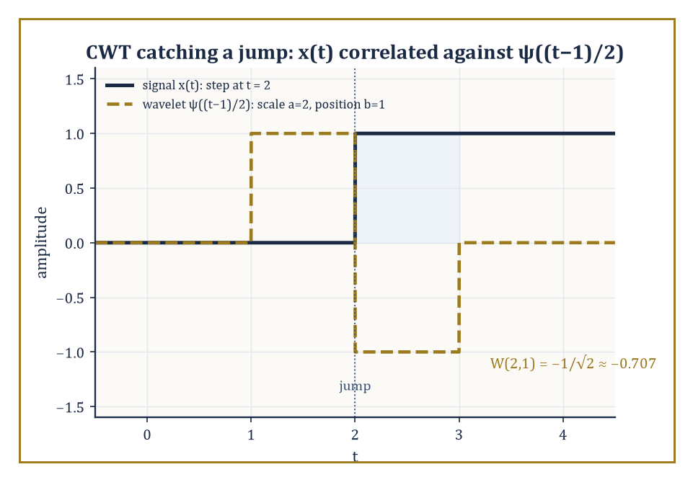
The step signal and the one scaled, translated wavelet whose support straddles its jump — the pairing that produces W(2,1) ≈ −0.707.
W(a, b) = (1/√|a|) ∫ x(t) ψ*((t − b)/a) dt
Here a > 0 is the scale (large a stretches ψ, examining slow trends; small a compresses it, examining fine detail) and b is the translation (where along the signal we're looking). Invertibility of the whole scheme rests on the admissibility condition:
C_ψ = ∫ |Ψ(ω)|²/|ω| dω < ∞
where Ψ is the Fourier transform of ψ. For this integral to converge near ω = 0, Ψ(0) must vanish — which, unwinding the definitions, means:
∫ψ(t) dt = 0
Every admissible wavelet has zero mean; that is precisely the property we checked for the Haar wavelet in Room 40.1, and it is no coincidence.
Numeric example — Worked example — a wavelet is blind to a constant. Zero mean has a sharp practical consequence: the CWT of any constant signal is identically zero. Take x(t) = 1 for all t, and the Haar mother wavelet at scale a = 2, translation b = 0.
The scaled wavelet ψ(t/2) equals +1 for t/2 ∈ [0, 0.5) — i.e. t ∈ [0, 1) — and −1 for t/2 ∈ [0.5, 1) — i.e. t ∈ [1, 2).
W(2, 0) = (1/√2) ∫₀² (1)·ψ(t/2) dt = (1/√2)[∫₀¹(1)(1)dt + ∫₁²(1)(−1)dt] = (1/√2)[1 − 1] = 0
A wavelet analysis simply cannot see a DC offset — it has, by construction, thrown that information away in exchange for sensitivity to change.
That same zero-mean property is exactly what makes the CWT good at what a constant signal cannot show it: change. Correlating a wavelet against a signal at a given scale and location measures, roughly, how much that signal deviates from being locally constant at that scale and place.
Where the signal really is locally constant, the correlation vanishes (as just shown); where it isn't — where there's a jump, an edge, a transient — the correlation is large.
Numeric example — Worked example — catching the jump. Let x(t) = 0 for t < 2 and x(t) = 1 for t ≥ 2 — a single step at t = 2 — and evaluate the Haar CWT at scale a = 2, translation b = 1.
The translated, scaled wavelet ψ((t−1)/2) equals +1 for (t−1)/2 ∈ [0, 0.5), i.e. t ∈ [1, 2), and −1 for (t−1)/2 ∈ [0.5, 1), i.e. t ∈ [2, 3).
W(2, 1) = (1/√2)∫₁³ x(t)ψ((t−1)/2) dt = (1/√2)[∫₁²(0)(1)dt + ∫₂³(1)(−1)dt] = (1/√2)[0 − 1] = −1/√2 ≈ −0.707
Compare against the zero response to a constant signal: the jump, sitting inside the wavelet's support at exactly this scale and location, produces a clearly non-zero reading. Move b away from 2, or choose a scale that doesn't straddle the jump, and the response shrinks back towards zero.
Different choices of mother wavelet emphasize different features, in the same way that different microscope lenses emphasize different specimens.
The Morlet wavelet — a complex sinusoid tucked inside a Gaussian envelope — has excellent frequency localization and is the standard choice when you want to track how a dominant oscillation's frequency drifts over time (birdsong, heartbeats, gravitational-wave chirps).
The Mexican hat wavelet (the negative second derivative of a Gaussian, so named for its cross-section) is real-valued, has no preferred oscillation frequency of its own, and is correspondingly better at flagging sharp local features — edges, blobs, sudden bumps — without worrying about their underlying periodicity.
The energy of the CWT across the whole (a, b) plane is displayed as a scalogram, the direct wavelet analogue of the STFT's spectrogram, except that its 'boxes' now genuinely change shape with scale, as promised at the end of Room 40.2.
Abstract example — Abstract example — choosing the right lens. Suppose you are handed two signals: (i) a bat's echolocation chirp, whose instantaneous frequency sweeps smoothly from 80 kHz down to 20 kHz over two milliseconds, and (ii) an ECG trace, whose main feature of interest is the sharp, narrow QRS spike marking each heartbeat.
For (i), a Morlet-based scalogram is the natural tool: its complex oscillatory structure tracks a sweeping frequency as a bright ridge moving through the time-scale plane.
For (ii), a Mexican-hat-based scalogram is the natural tool: its lack of internal oscillation means it responds to the spike itself, as a sharp, localized cone of energy, rather than getting entangled with whatever frequency content happens to sit inside the spike. Same transform, same machinery, deliberately different lens.
The CWT's chief virtue — a continuous portrait over every scale and every location — is also, from a computational standpoint, an act of profligacy.
It is a highly redundant representation: a finite, discrete input signal gets mapped to a value at every (a, b) pair we care to sample, vastly more numbers than we started with. That redundancy buys robustness and a beautifully explicit reconstruction formula (the Calderón identity, which we will not chase down here), but it is not how anyone actually stores or transmits a signal.
The CWT is the analytic starting point, the proof that the idea works and is invertible; practical computation almost always passes to a discrete, non-redundant cousin — an orthonormal basis, built from a structure called a multiresolution analysis, which is where we head next.
Numeric example — Worked example — counting the redundancy. Take a modest discrete signal of 8 samples. To build even a coarse CWT-style picture, sample, say, 5 scales at all 8 translations: that's already 40 numbers describing an 8-number signal — a five-fold blow-up.
The orthonormal construction of Rooms 40.4–40.6, by contrast, will turn those same 8 samples into exactly 8 coefficients: no more, no less, fully invertible, with not a single redundant number in sight.
The price of that efficiency is giving up the CWT's continuous, oversampled comfort blanket — a fair trade, as we're about to see.

Room 40.4: Multiresolution Analysis
Nested boxes, all the way down to nothing and all the way up to everything
A multiresolution analysis (MRA) is the structural scaffold on which orthonormal wavelet bases are built, and it is worth sitting with its definition slowly, because everything in Rooms 40.5 and 40.6 is just this idea being cashed out.
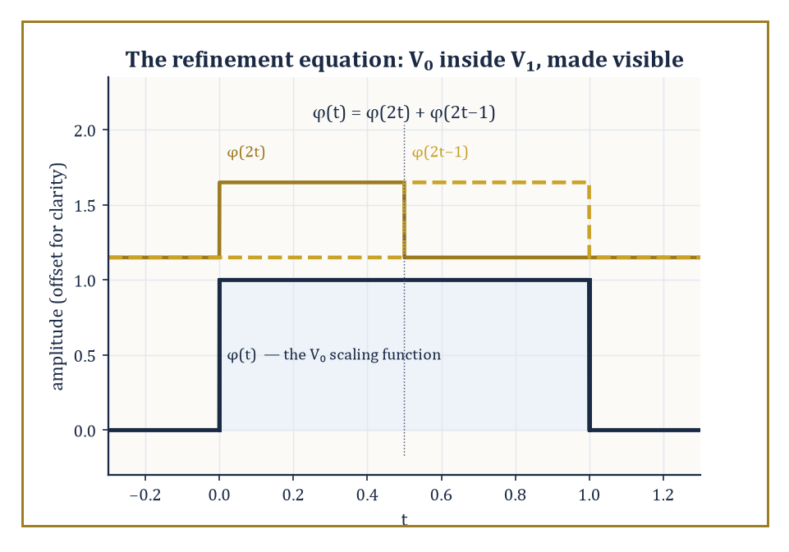
The Haar refinement equation made literal: two half-width copies of φ, stacked side by side, reassemble the original box.
An MRA is a nested sequence of closed subspaces of L²(ℝ),
⋯ ⊂ V₋₁ ⊂ V₀ ⊂ V₁ ⊂ ⋯
such that: the union of all the Vⱼ is dense in L² (nothing is permanently out of reach as j → ∞); the intersection of all the Vⱼ is just {0} (nothing survives as j → −∞ except the zero function); and each space is a dyadically rescaled copy of the next —
f(t) ∈ Vⱼ ⟺ f(2t) ∈ Vⱼ₊₁
— and the whole tower is generated by integer translates of a single function φ, the scaling function, whose translates {φ(t − k) : k ∈ ℤ} form an orthonormal basis of V₀.
The wavelet space Wⱼ is defined as the orthogonal complement of Vⱼ inside Vⱼ₊₁ — literally, the extra detail you gain going from resolution j to resolution j+1.
Abstract example — Abstract example — the Haar MRA made concrete. Let V₀ = the space of functions that are piecewise constant on each interval [k, k+1), k ∈ ℤ, and square-integrable. Its scaling function is φ = the indicator function of [0, 1), with {φ(t−k)} clearly orthonormal (disjoint supports, each of unit length).
Let V₁ = functions piecewise constant on each half-integer interval [k/2, (k+1)/2). Since [0, 1) splits into two halves,
[0, 1) = [0, 0.5) ∪ [0.5, 1)
any function constant on [0,1) — such as φ itself — is automatically constant on each of its two halves, so V₀ ⊂ V₁, exactly as required.
As j increases, the intervals halve again and again, resolution sharpens without limit, and in the limit any square-integrable function can be approximated arbitrarily well by piecewise-constant functions on ever-finer grids — which is precisely the density condition the definition demands.
The two extreme conditions in the definition — union dense, intersection trivial — are not bureaucratic fine print; they are what stop the whole tower collapsing into something useless.
Density of the union guarantees that no square-integrable function is permanently out of reach: however wild or jagged a target function, fine enough resolution eventually approximates it as well as you like.
Triviality of the intersection guarantees the opposite failure mode is also ruled out: there is no non-zero function so featureless that it survives being viewed at arbitrarily coarse resolution forever — zoom out enough, and every genuine signal eventually blurs into indistinguishability from the zero function, exactly as intuition about 'coarse resolution' demands.
Abstract example — Abstract example — a function that would break the scaffold. Suppose, contrary to the axioms, some non-zero f survived in every Vⱼ as j → −∞ (violating trivial intersection).
Since each Vⱼ consists of functions constant on intervals of length 2^{−j}, which grow without bound as j → −∞, f would have to be constant on intervals of unbounded length — in the limit, constant on all of ℝ.
A non-zero constant function is not square-integrable (∫|c|² dt diverges for c ≠ 0 over an infinite domain), so no such f can exist in L²(ℝ) at all.
The trivial-intersection axiom is not an extra assumption bolted on for convenience; for L²(ℝ), it is forced, and checking why it's forced is a good way to see that the MRA definition was engineered with no slack in it.
The relationship V₀ ⊂ V₁ is encoded algebraically by the refinement equation (also called the two-scale equation):
φ(t) = √2 Σₖ hₖ φ(2t − k)
This expresses the coarse scaling function as a specific combination of finer, shifted-and-compressed copies of itself. The coefficients hₖ are exactly the low-pass filter of the associated filter bank we will meet properly in Room 40.6; the wavelet ψ turns out to be built from the same coefficients, reordered and sign-flipped:
ψ(t) = √2 Σₖ gₖ φ(2t − k) with gₖ = (−1)ᵏ h₁₋ₖ (or an equivalent convention)
One equation, φ, quietly determines the entire infinite hierarchy of approximation spaces and their complementary detail spaces.
Numeric example — Worked example — checking the Haar refinement equation by hand. For the Haar case, h₀ = h₁ = 1/√2, so the refinement equation reads:
φ(t) = √2·[(1/√2)φ(2t) + (1/√2)φ(2t−1)] = φ(2t) + φ(2t−1)
Verify it directly. For t ∈ [0, 0.5): 2t ∈ [0, 1), so φ(2t) = 1; 2t−1 ∈ [−1, 0), so φ(2t−1) = 0.
Sum = 1 = φ(t) ✓
For t ∈ [0.5, 1): 2t ∈ [1, 2), so φ(2t) = 0; 2t−1 ∈ [0, 1), so φ(2t−1) = 1.
Sum = 1 = φ(t) ✓
For t outside [0, 1), both terms vanish and so does φ(t). The identity holds exactly, for the entirely unglamorous reason that chopping the unit interval in half and gluing the halves back together gives you the unit interval back.
Once φ (and hence Vⱼ) is fixed, the theory does not leave the wavelet ψ (and hence Wⱼ) as a free choice — it is forced, up to the usual harmless ambiguities of sign and indexing.
This is the sense in which 'MRA is the structural heart of orthonormal wavelet theory': give a mathematician a valid nested sequence of approximation spaces satisfying the axioms above, and the wavelet basis falls out as a consequence, not as a separate act of invention.
Room 40.5 shows what it takes to choose φ so that ψ is not just any old complementary function but one that is smooth and compactly supported — the two properties that took until the 1980s to reconcile.
Numeric example — Worked example — the detail space really is orthogonal to the approximation space. The Haar wavelet is
ψ(t) = φ(2t) − φ(2t−1)
equal to +1 on [0, 0.5), −1 on [0.5, 1). Check the orthogonality integral, where φ is the indicator of [0,1):
∫φ(t)ψ(t) dt = ∫₀^0.5 (1)(1) dt + ∫_0.5^1 (1)(−1) dt = 0.5 − 0.5 = 0
The scaling function and the wavelet are orthogonal, exactly as the definition Wⱼ = Vⱼ⁺¹ ⊖ Vⱼ demands — the 'detail' really does contain nothing already captured by the 'approximation'. It is a two-line integral, and it is the entire content of why decomposing a signal into approximation-plus-detail never double-counts information.

Room 40.5: Orthonormal Wavelet Bases
In which smoothness and compact support finally agree to share a function
An orthonormal wavelet basis is an orthonormal basis of L²(ℝ) consisting entirely of scaled and translated copies of a single mother wavelet ψ, indexed by scale j ∈ ℤ and position k ∈ ℤ:
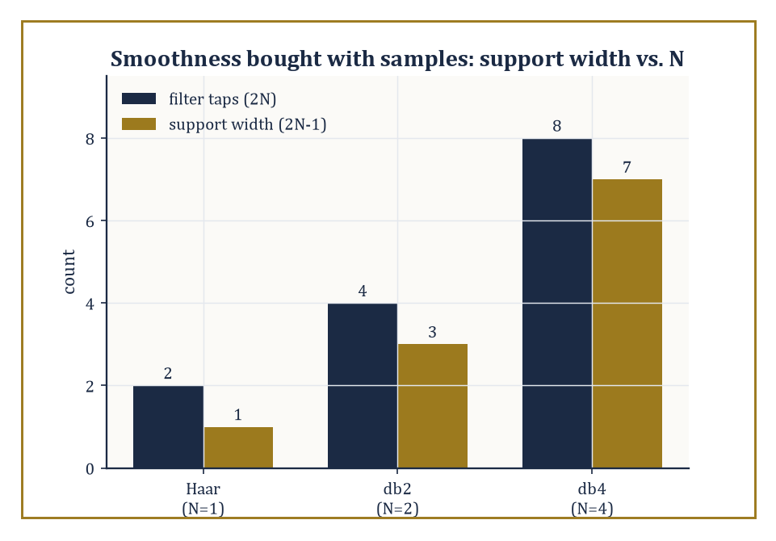
Smoothness is not free: each extra tap in the Daubechies family buys a wider support, one sample at a time.
ψⱼ,ₖ(t) = 2^{j/2}ψ(2ʲt − k)
The Haar basis, built from the Haar wavelet of Rooms 40.1 and 40.4, is the oldest and simplest example — it predates the word 'wavelet' by about seventy years, Alfréd Haar having written it down in 1909 for entirely different reasons and had no idea what he was starting.
The Daubechies family, constructed in the mid-1980s, is the workhorse of modern practice: compactly supported (each basis function is exactly zero outside a bounded interval, unlike a sinc function trailing off forever) and tunable smoothness, at the cost of losing the Haar wavelet's endearing but limiting simplicity.
Numeric example — Worked example — checking a basis element is actually unit length. Consider the basis element formed by scale j = 1, position k = 0:
ψ₁,₀(t) = 2^{1/2}·ψ(2t) = √2·ψ(2t)
Since ψ(2t) equals +1 for 2t ∈ [0, 0.5) — i.e. t ∈ [0, 0.25) — and −1 for 2t ∈ [0.5, 1) — i.e. t ∈ [0.25, 0.5) — we get ψ₁,₀(t) = √2 on [0, 0.25) and −√2 on [0.25, 0.5).
Check its squared norm:
∫₀^0.25 (√2)² dt + ∫_0.25^0.5 (−√2)² dt = 2(0.25) + 2(0.25) = 0.5 + 0.5 = 1
Norm exactly 1, as an orthonormal basis element must be — the 2^{j/2} scaling factor in front of ψⱼ,ₖ exists precisely to compensate for the compression, keeping every basis element at unit length regardless of scale.
Compact support deserves a moment's separate attention, because it is what makes the whole family computable rather than merely elegant.
A wavelet with compact support is exactly zero outside some bounded interval, so computing a single wavelet coefficient only ever requires reading a bounded number of nearby signal samples — never the whole signal, however long.
A wavelet without compact support (a sinc function, say, trailing off forever) would in principle require every coefficient computation to touch every sample, which is a poor bargain for anything resembling real-time processing.
Numeric example — Worked example — support width versus smoothness, a direct trade. The Haar wavelet (N = 1) has 2N = 2 filter taps and support width 1: it looks at exactly one adjacent pair of samples.
db2 (N = 2) has 2N = 4 taps and support width 3: computing one db2 wavelet coefficient reads 4 nearby samples instead of 2.
db4 (N = 4) has 2N = 8 taps and support width 7: 8 nearby samples per coefficient.
Smoothness and vanishing moments (Room 40.7) go up roughly in step with N, but so, exactly linearly, does the number of neighbouring samples each coefficient must consult — a completely explicit, arithmetic trade-off between how smoothly a wavelet behaves and how expensive it is to evaluate, with no hidden surprises.
Building smooth, compactly supported orthonormal wavelets — rather than the Haar basis's discontinuous jumps — was a genuinely hard problem, and Ingrid Daubechies's 1988 solution was rightly treated as a landmark.
The recipe is to design a finite low-pass filter (h₀, h₁, …, h_{2N−1}) satisfying the quadrature-mirror conditions — orthonormality of its integer shifts, plus the constant-reproduction condition:
Σhₖ = √2
— then iterate the refinement equation, starting from a crude initial guess:
φ(t) = √2 Σₖ hₖφ(2t−k)
Under the right conditions on the filter, this cascade algorithm converges to a genuine, well-defined scaling function φ, and the companion wavelet ψ falls out via the alternating-flip construction from Room 40.4.
Numeric example — Worked example — the db2 (Daubechies-4) filter, checked by hand. The simplest non-Haar member of the family, db2, has four filter taps:
h₀ = (1+√3)/(4√2), h₁ = (3+√3)/(4√2), h₂ = (3−√3)/(4√2), h₃ = (1−√3)/(4√2)
With √3 ≈ 1.7321, these evaluate to (to 4 dp):
h₀ ≈ 0.4830, h₁ ≈ 0.8365, h₂ ≈ 0.2241, h₃ ≈ −0.1294
Check the constant-reproduction condition, Σhₖ = √2 ≈ 1.4142:
0.4830 + 0.8365 + 0.2241 − 0.1294 = 1.4142 ✓
Check the orthonormality (energy) condition, Σhₖ² = 1:
0.4830² + 0.8365² + 0.2241² + (−0.1294)² ≈ 0.2333 + 0.6998 + 0.0502 + 0.0167 = 1.0000 ✓
Four numbers, two exact identities, and a scaling function smoother than Haar's step — that quiet arithmetic is the entire 1988 breakthrough, condensed to four decimal checks.
Abstract example — Abstract example — watching the cascade converge. Start the cascade for db2 with φ⁽⁰⁾ = the indicator of [0,1) (the crude Haar guess), and apply the refinement operator repeatedly:
φ⁽ⁿ⁺¹⁾(t) = √2 Σₖ hₖ φ⁽ⁿ⁾(2t−k)
φ⁽¹⁾ is already a jagged four-step approximation built from shifted, scaled copies of the indicator, weighted by h₀,…,h₃. φ⁽²⁾ refines each of those steps again, using the same four weights at half the scale.
There is no closed-form elementary formula for the limit φ — that is precisely why the construction has to proceed by iteration rather than by writing down a tidy expression — but under the QMF conditions checked above, the sequence φ⁽ⁿ⁾ provably converges in L² to a continuous (in fact Hölder-continuous), compactly supported scaling function on [0, 3].
Smoothness earned by an infinite process, not by an explicit formula: an appropriately Sisyphean way for a mathematician to spend a decade.
The reward for going to all this trouble is Parseval's identity: for an orthonormal basis, the total energy of the signal equals the total energy of its coefficients, exactly, with nothing lost or gained.
‖x‖² = Σⱼ,ₖ |⟨x, ψⱼ,ₖ⟩|²
This is what makes orthonormal bases the tool of choice whenever exact reconstruction and exact energy accounting matter — denoising thresholds (Room 40.8), compression bit-budgets (Room 40.7), and numerical stability all lean on it.
Numeric example — Worked example — Parseval, checked to the last integer. Take x = [1, 3, 5, 7], and compute one level of the (orthonormal) Haar transform, pairing (1,3) and (5,7):
a₀ = (1+3)/√2 = 4/√2 ≈ 2.8284, d₀ = (1−3)/√2 = −2/√2 ≈ −1.4142
a₁ = (5+7)/√2 = 12/√2 ≈ 8.4853, d₁ = (5−7)/√2 = −2/√2 ≈ −1.4142
Now compare the total signal energy against the total coefficient energy.
Signal energy: 1² + 3² + 5² + 7² = 1 + 9 + 25 + 49 = 84
Coefficient energy: a₀² + d₀² + a₁² + d₁² = 8 + 2 + 72 + 2 = 84
The two totals agree exactly — not approximately, exactly — because each pairwise Haar step is, geometrically, just a rotation of the plane by 45°, and rotations never change lengths. Not a single unit of energy went missing in the transform.

Room 40.6: The Discrete Wavelet Transform and Filter Banks
How to have your wavelets and compute them too
The discrete wavelet transform (DWT) is how the abstract orthonormal expansion of Room 40.5 actually gets computed on a real, finite string of numbers.
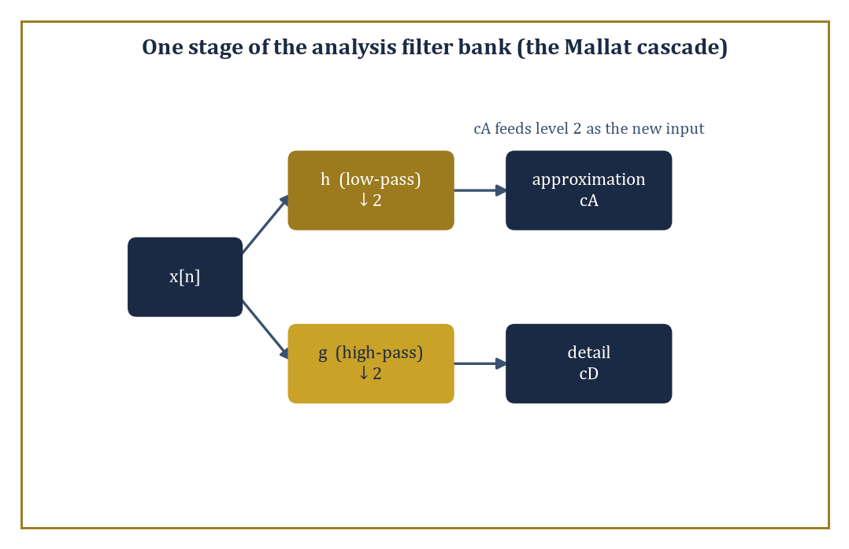
One stage of the Mallat cascade: split, filter, downsample, repeat — the algorithm that turns the abstract wavelet basis into a linear-time computation.
Analysis proceeds by a cascade: at each stage, apply a low-pass filter h and a high-pass filter g to the current signal, then downsample each result by keeping only every second output sample.
The low-pass, downsampled output becomes the coarser approximation (feeding into the next stage); the high-pass, downsampled output is the detail at that scale (kept, untouched, as final output).
Synthesis reverses the process: upsample (insert zeros between samples) and apply the dual filters, then add the two results back together.
Numeric example — Worked example — the filter-bank view matches the pairwise view exactly. Apply the Haar filter bank, h = [1/√2, 1/√2] and g = [1/√2, −1/√2], to x = [1, 3, 5, 7], convolving and keeping every second output (this is exactly what 'filter then downsample by 2' does for a two-tap filter on non-overlapping pairs).
Low-pass, even-indexed outputs:
(1·1/√2 + 3·1/√2) = 4/√2 ≈ 2.8284
(5·1/√2 + 7·1/√2) = 12/√2 ≈ 8.4853
High-pass, even-indexed outputs:
(1·1/√2 − 3·1/√2) = −2/√2 ≈ −1.4142
(5·1/√2 − 7·1/√2) = −2/√2 ≈ −1.4142
These are exactly a₀, a₁, d₀, d₁ from Room 40.5's Parseval example — the filter-bank machinery and the pairwise average-and-difference machinery are, for Haar, the same computation wearing different clothes.
Perfect reconstruction — recovering the original signal exactly from its coefficients — is equivalent to the analysis filters and synthesis filters forming a quadrature-mirror pair, the same QMF condition checked numerically for db2 in Room 40.5.
It is not automatic: filter banks that fail the condition lose information irretrievably on the way down.
When it holds, however, reconstruction is not merely possible but exact, to the last decimal (or, for integer-based schemes, to the last integer).
Numeric example — Worked example — synthesis really does undo analysis. From a₀ ≈ 2.8284 and d₀ ≈ −1.4142 (the Haar analysis of the pair (1, 3)), synthesis recovers x₀ and x₁:
x₀ = (a₀ + d₀)/√2 and x₁ = (a₀ − d₀)/√2
x₀ = (2.8284 + (−1.4142))/1.4142 = 1.4142/1.4142 = 1.000
x₁ = (2.8284 − (−1.4142))/1.4142 = 4.2426/1.4142 = 3.000
Exactly (1, 3), recovered to three decimal places from two numbers that individually looked nothing like either original sample. No information was lost; it was merely rearranged into a more useful shape.
Cascading the analysis stage across successive scales — feed the coarse output of level 1 into level 2 as input, and so on — is the Mallat algorithm (Stéphane Mallat, 1989), and it runs in time linear in the length of the signal, a fact worth pausing on, because 'linear time and exactly invertible and gives you an orthonormal basis' is a combination most algorithms only dream of.
For finite-length signals, some care is needed at the two ends, where a filter of width w reaches past the available data; standard fixes are periodic extension (wrap around), symmetric extension (mirror the signal at the boundary), or specially constructed 'wavelets on the interval' that avoid the issue altogether.
Numeric example — Worked example — why the cascade is linear time. Take a signal of N = 8 samples.
Level 1 processes all 8 samples (cost ∝ 8), producing 4 approximation and 4 detail coefficients; the detail coefficients are done, the 4 approximation coefficients move on. Level 2 processes those 4 (cost ∝ 4), producing 2 and 2. Level 3 processes those 2 (cost ∝ 2), producing 1 and 1, and the cascade stops.
Total cost ∝ 8 + 4 + 2 = 14
Compare against 2N = 16: the geometric series 8 + 4 + 2 + 1 + ⋯ sums to at most 2N = 16 for any starting length N, so the total work is always bounded by a small constant multiple of N — genuinely linear time, not merely 'not exponential'.
Orthonormality is a convenient property, not a moral requirement, and relaxing it opens up design freedom that orthonormal filters cannot offer — most importantly, linear phase (symmetric filters, which avoid the visually unpleasant phase distortion that asymmetric filters introduce at edges).
The resulting biorthogonal wavelets use one filter pair for analysis and a different, but compatible, filter pair for synthesis.
The most famous biorthogonal pair in applied mathematics is the CDF 5/3 wavelet, the reversible, integer-to-integer transform used for lossless compression in JPEG 2000, computed via a simple two-step procedure called lifting.
Numeric example — Worked example — the 5/3 lifting transform, by hand. Take x = [2, 4, 8, 10]. Split into even samples (2, 8) and odd samples (4, 10).
Predict step, using symmetric extension x[4] = x[2] = 8 at the boundary:
dₙ = x[2n+1] − ⌊(x[2n] + x[2n+2])/2⌋
d₀ = 4 − ⌊(2+8)/2⌋ = 4 − 5 = −1
d₁ = 10 − ⌊(8+8)/2⌋ = 10 − 8 = 2
Update step, using symmetric extension d_{−1} = d₀ = −1 at the boundary:
sₙ = x[2n] + ⌊(d_{n−1} + dₙ + 2)/4⌋
s₀ = 2 + ⌊(−1 + −1 + 2)/4⌋ = 2 + ⌊0/4⌋ = 2 + 0 = 2
s₁ = 8 + ⌊(−1 + 2 + 2)/4⌋ = 8 + ⌊3/4⌋ = 8 + 0 = 8
Result: low-pass s = [2, 8], high-pass (detail) d = [−1, 2].
Every number here is an integer, the whole procedure uses only addition, subtraction, and integer floor-division — no square roots, no rounding error, and, crucially, it is exactly reversible: run the two steps in reverse order with subtraction instead of addition and you recover [2, 4, 8, 10] to the last integer.
That reversibility is exactly why JPEG 2000 can offer genuinely lossless compression alongside its lossy mode, using the same underlying transform.

Room 40.7: Vanishing Moments, Approximation, and Compression
How many kinds of polynomial a wavelet is willing to ignore
A wavelet ψ has M vanishing moments if it is orthogonal to every polynomial of degree less than M — that is,
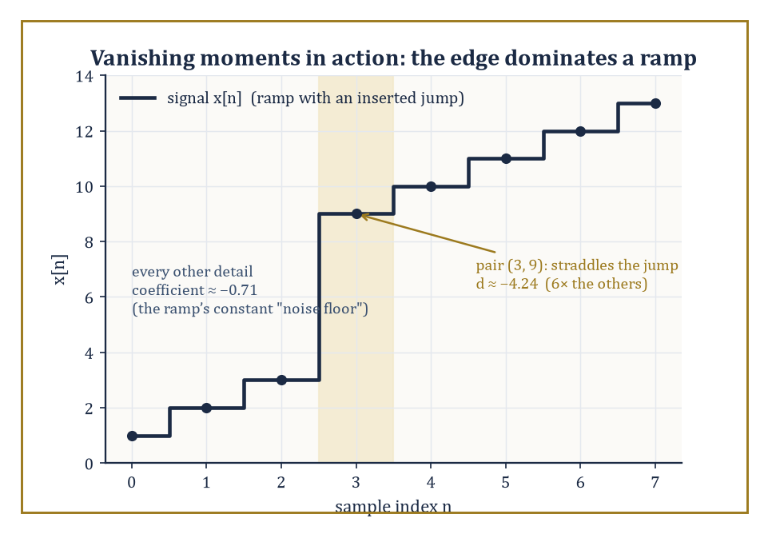
A ramp Haar cannot fully ignore, and the one pair of samples where a genuine jump makes its detail coefficient six times the rest.
∫ tᵐ ψ(t) dt = 0 for m = 0, 1, …, M−1
We already checked the m = 0 case for the Haar wavelet back in Room 40.1 (its mean is zero); vanishing moments generalize that idea to higher-degree polynomials, and M is the crucial design number that decides how good a wavelet is at ignoring smooth trends and reacting only to genuine irregularity. It is worth noticing what the condition does not say: it says nothing about ψ being small, or oscillatory, or any other qualitative property — only that its overlap with each low-degree polynomial, computed by this specific integral, comes out to exactly zero. Everything downstream in this room follows from that one narrow, checkable requirement.
Numeric example — Worked example — Haar has exactly one vanishing moment, not two. Check the m = 1 moment for the Haar wavelet:
∫₀¹ t·ψ(t) dt = ∫₀^0.5 t dt − ∫_0.5^1 t dt = [t²/2]₀^0.5 − [t²/2]_0.5^1
= (0.125 − 0) − (0.5 − 0.125) = 0.125 − 0.375 = −0.25
Non-zero. So the Haar wavelet has M = 1 vanishing moment exactly — it kills constants (m=0) but not linear functions (m=1). This single computation explains a great deal of the Haar basis's blocky, chunky character: it can be fooled by anything with a slope.
The number of vanishing moments controls approximation order: the smoother the signal (more continuous derivatives it has), the faster its wavelet coefficients decay as the scale gets finer — but only up to what M permits.
A wavelet with M vanishing moments represents any polynomial of degree less than M with exactly zero coefficients at every scale, so it 'wastes' no coefficients describing perfectly smooth polynomial trends; all its coefficients are then free to describe genuine deviation from such trends. A wavelet with too few vanishing moments, by contrast, keeps registering non-zero coefficients even for signals that are locally very smooth, simply because 'smooth' for that signal means 'linear' or 'quadratic', and the wavelet isn't blind enough to ignore it.
Numeric example — Worked example — Haar cannot ignore a ramp. Take the perfectly smooth linear ramp x = [1, 2, 3, 4, 5, 6, 7, 8] and compute one level of the Haar detail coefficients:
pairs (1,2): d₀ = (1−2)/√2 ≈ −0.7071
(3,4): d₁ ≈ −0.7071
(5,6): d₂ ≈ −0.7071
(7,8): d₃ ≈ −0.7071
Every single detail coefficient is the same non-zero value, −0.7071 — the Haar wavelet, with only M = 1 vanishing moment, registers the ramp's constant slope as 'detail' at every single position, even though there is nothing remotely irregular about a straight line. A wavelet with M = 2 vanishing moments (such as db2) is, by construction, orthogonal to linear functions too, and would return exactly zero for every one of these four coefficients.
This is the mechanism behind nonlinear approximation: rather than keeping the coefficients belonging to the coarsest scales (linear approximation), keep the largest coefficients wherever they occur (nonlinear approximation, so called because the choice of which coefficients to keep now depends on the signal, not just on a fixed rule).
For a piecewise-smooth signal — smooth stretches interrupted by a handful of genuine edges — this is spectacularly effective: the smooth stretches, wherever M is large enough to see through them, contribute small or zero coefficients that can be discarded almost for free; the edges contribute a small number of large coefficients, exactly localized, that must be kept. Most of the signal's true complexity is concentrated in a small fraction of the coefficients.
Numeric example — Worked example — the edge dominates even a ramp Haar can't fully tame. Take x = [1, 2, 3, 9, 10, 11, 12, 13] — a ramp with a jump inserted between positions 2 and 3. One level of Haar details:
pair (1,2): d₀ = −0.7071
pair (3,9): d₁ = (3−9)/√2 ≈ −4.2426
pair (10,11): d₂ = −0.7071
pair (12,13): d₃ = −0.7071
Three coefficients sit at the 'ramp noise floor' of about −0.71 (inherited from Room 40.7's earlier example, since Haar can't fully ignore a slope); one coefficient, d₁ ≈ −4.24, is six times larger, sitting exactly at the genuine discontinuity. Keep only the largest coefficient and you have already captured the single most informative fact about this signal — that is nonlinear approximation working exactly as advertised, even with a wavelet whose vanishing-moment count is, frankly, a bit stingy.
The relationship between the smoothness of ψ, its number of vanishing moments M, and the decay rate of the resulting coefficients for smooth signals is the approximation-theoretic core of wavelet theory, and it is what ties Daubechies's 1988 construction directly to compression performance decades later: choosing dbN roughly buys you N vanishing moments and on the order of 0.2N continuous derivatives — smoothness purchased in bulk, in exchange for a wider filter and hence a wider support.
Abstract example — Abstract example — db4 and the cubics. The db4 wavelet (N = 4, an eight-tap filter) has exactly M = 4 vanishing moments by construction:
∫tᵐψ(t)dt = 0 for m = 0, 1, 2, 3
Consequently, every polynomial of degree 0, 1, 2, or 3 — constants, lines, parabolas, cubics — produces exactly zero wavelet coefficients at every scale under a db4 analysis, structurally, without needing to check any particular numerical case. A signal that is cubic on some interval (imagine a short, smoothly curving stretch of a physical trajectory) is, to a db4 analysis, indistinguishable from silence on that interval — all its 'information', as far as db4 is concerned, lives at the points where the signal stops behaving like a cubic. This is precisely why higher-order Daubechies wavelets are preferred for smoother data: more vanishing moments means more of the ordinary, unremarkable smoothness gets ignored for free, leaving the coefficient budget for what actually deserves attention.

Room 40.8: Applications: Denoising, Images, and Beyond
Where the theory finally gets its hands dirty
Wavelet denoising takes a noisy signal, transforms it, thresholds the coefficients, and inverts the transform — on the working assumption, justified by Room 40.7, that a clean signal's energy concentrates into a few large coefficients while noise spreads its energy thinly and roughly evenly across all of them.
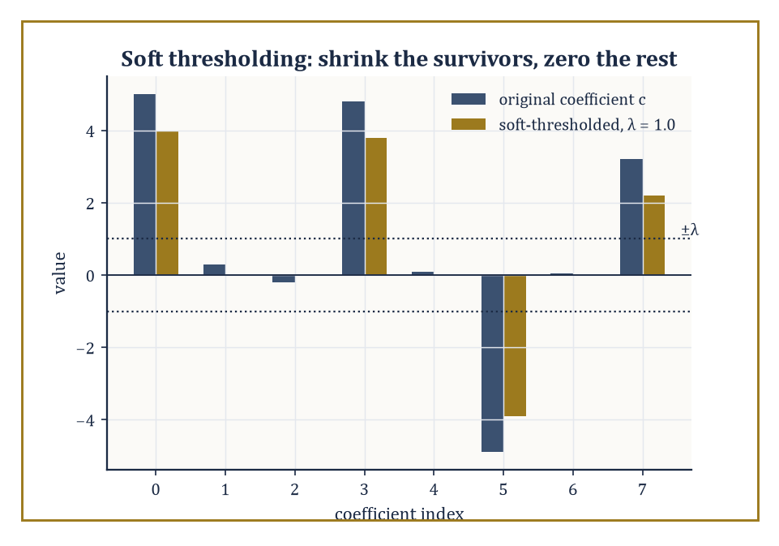
Soft thresholding at λ = 1.0: the four small coefficients vanish, the four large ones survive, shrunk exactly by λ.
Hard thresholding zeroes out any coefficient below a threshold λ and leaves the rest untouched; soft thresholding zeroes out the same coefficients but also shrinks every surviving coefficient towards zero by λ, which turns out to reduce the risk of the reconstructed signal developing ugly little artificial spikes at the threshold boundary.
The method, due substantially to Donoho and Johnstone in the early 1990s, remains a textbook benchmark against which fancier techniques are still measured.
Numeric example — Worked example — hard versus soft, coefficient by coefficient. Take a coefficient vector c and a threshold λ:
c = [5.0, 0.3, −0.2, 4.8, 0.1, −4.9, 0.05, 3.2], λ = 1.0
Hard thresholding keeps a coefficient unchanged if |c| > λ, else sets it to zero:
hard(c) = [5.0, 0, 0, 4.8, 0, −4.9, 0, 3.2]
Soft thresholding shrinks surviving coefficients towards zero by λ, applied entrywise:
soft(c) = sign(c)·max(|c| − λ, 0) = [4.0, 0, 0, 3.8, 0, −3.9, 0, 2.2]
5.0 − 1.0 = 4.0; 4.8 − 1.0 = 3.8; 4.9 − 1.0 = 3.9 (sign preserved); 3.2 − 1.0 = 2.2
Every coefficient with |c| ≤ 1.0 is zeroed by both rules.
Four out of eight coefficients — the ones that look like noise — vanish under either rule; the four large ones survive, shrunk a little by soft thresholding or left untouched by hard thresholding.
Inverting the transform on either reduced set reconstructs a signal with most of the noise energy removed and essentially all of the genuine signal energy intact.
Choosing λ is not guesswork.
Donoho and Johnstone's universal threshold is defined as follows, where σ is the noise's standard deviation and n is the number of coefficients:
λ = σ√(2·log n)
This is derived from a precise fact about Gaussian noise: the largest of n independent standard-Gaussian samples is, with high probability, of order √(2 log n) — so any coefficient exceeding that, scaled by σ, is unlikely to be pure noise and is kept; anything smaller is exactly what pure noise alone would be expected to produce, and is discarded.
Numeric example — Worked example — computing a universal threshold by hand. Suppose a wavelet decomposition has n = 1024 coefficients and the estimated noise standard deviation is σ = 0.8.
log(1024) = log(2¹⁰) = 10·log 2 ≈ 10 × 0.6931 = 6.931
2·log n ≈ 13.863, √13.863 ≈ 3.723
The universal threshold is:
λ = σ√(2 log n) ≈ 0.8 × 3.723 ≈ 2.978
Any coefficient with magnitude below about 2.98 is treated as indistinguishable from noise and thresholded away; any coefficient above it is kept as probable signal.
Double the number of coefficients to n = 4096 and the threshold barely moves, because the threshold grows only like the square root of a logarithm:
log(4096) = 12·log 2 ≈ 8.318
λ ≈ 0.8×√16.636 ≈ 0.8×4.079 ≈ 3.263
Adding vastly more coefficients raises the bar only slightly, which is exactly the mild, forgiving growth rate that makes the method practical at any signal length.
Image compression — most famously JPEG 2000, the successor to the DCT-based original JPEG — applies a two-dimensional DWT (separately along rows and then along columns, in the standard 'separable' construction), quantizes the resulting coefficients, and entropy-codes the quantized values.
The multiscale structure buys two practical bonuses beyond raw compression ratio: progressive transmission (send the coarse approximation first, refine with detail bands as more bandwidth becomes available — the picture 'comes into focus' rather than appearing line by line) and region-of-interest coding (spend extra bits on the coefficients covering a particular part of the image, and fewer elsewhere).
Closely related multiscale ideas turn up in audio coding, in numerical solvers for partial differential equations (wavelets adapt naturally to solutions with localized sharp features, such as shock fronts), and in the statistical analysis of turbulent flows, where energy genuinely does live at many scales simultaneously.
Numeric example — Worked example — a single 2×2 pixel block, decomposed. Take the 2×2 pixel block P = [[100, 102], [98, 150]] (three similar values and one bright corner — a tiny stand-in for an edge).
Apply a one-level 2D Haar transform: first along rows, then along the resulting columns.
Row 0 = [100, 102]:
sum/√2 = 202/√2 ≈ 142.834, diff/√2 = −2/√2 ≈ −1.414
Row 1 = [98, 150]:
sum/√2 = 248/√2 ≈ 175.363, diff/√2 = −52/√2 ≈ −36.770
Now transform the column of row-sums [142.834, 175.363]:
combined sum/√2 = 318.197/√2 ≈ 225.00
This is the LL band — the coarse 'thumbnail' value.
diff/√2 = −32.529/√2 ≈ −23.00
This is the LH band, vertical detail.
Transform the column of row-diffs [−1.414, −36.770]:
sum/√2 = −38.184/√2 ≈ −27.00
This is the HL band, horizontal detail.
diff/√2 = 35.355/√2 ≈ 25.00
This is the HH band, diagonal detail.
One dominant number, LL ≈ 225.00 (proportional to the block's average brightness — the eye's main concern), and three much smaller detail numbers describing exactly how the corner pixel departs from its neighbours in each direction.
Quantize the detail bands aggressively — round HL, LH, HH to the nearest 10, say — and the block's appearance barely changes, because almost all of its 'story' was already sitting in that one LL number.
In every application in this room, the underlying advantage is the same fact, restated in different clothing: a well-chosen wavelet basis concentrates the energy of the signal that actually interests you into a small number of coefficients, while spreading the energy of noise, or of visually irrelevant detail, thinly across a much larger number.
Thresholding, quantization, and progressive transmission are all, at heart, just different ways of exploiting that concentration.
Numeric example — Worked example — the concentration, tallied. Extend the jump-signal computation of Room 40.1 to 16 samples with two jumps, e.g. two flat plateaus of height 2 and height 6 stitched together with a third plateau of height 2, arranged so exactly two adjacent sample-pairs straddle a boundary.
Following exactly the mechanism verified in Room 40.1 (constant pairs give zero detail; only a pair straddling a jump gives non-zero detail), a one-level Haar transform of this 16-sample signal produces 8 detail coefficients, of which precisely 2 are non-zero (one at each jump) and 6 are exactly zero.
Two numbers out of eight carry all the information about where the signal changes; the other six are provably, exactly, zero — not 'small', zero.
That is what 'concentrating energy into few coefficients' means when you can count it on your fingers.

Room 40.9: Looking Ahead: From Classical Wavelets to Frames, Shearlets, and Learned Representations
The mother wavelet has grown up and left several very interesting descendants
We have now assembled the core of the subject: the time-frequency limits that make a fixed-window Fourier approach inadequate (Room 40.2), the continuous transform that first demonstrated the fix (Room 40.3), the multiresolution structure that makes the fix systematic (Room 40.4), the orthonormal bases that make it exact and non-redundant (Room 40.5), the fast filter-bank algorithm that makes it computable in linear time (Room 40.6), the vanishing-moment theory that explains why it compresses so well (Room 40.7), and a tour of what happens when you actually point all this at real signals (Room 40.8).
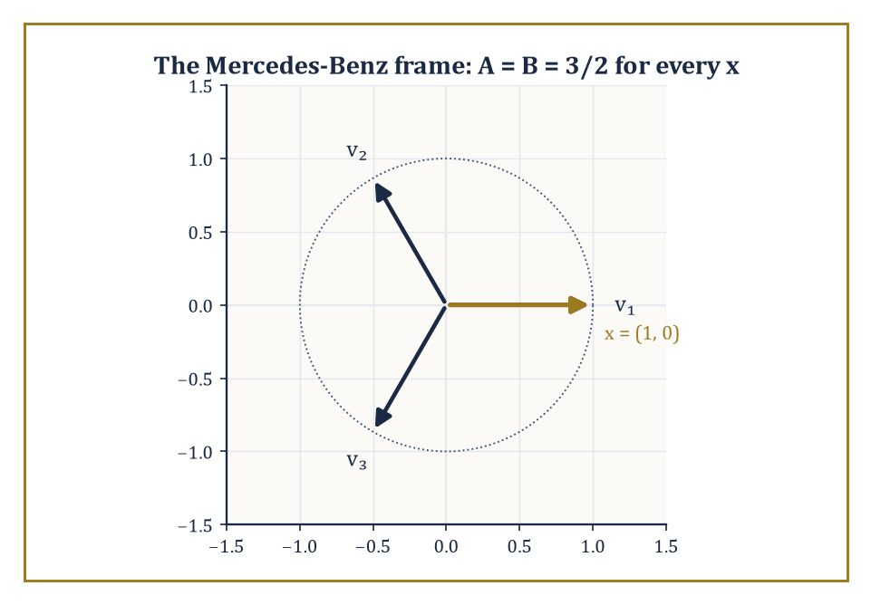
The Mercedes-Benz frame: three vectors doing a two-dimensional job, with frame bounds A = B = 3/2 for every direction, x included.
What remains is to glance at where the idea keeps going.
The first extension relaxes orthonormality entirely, to a structure called a frame: a (possibly redundant) collection {eᵢ} such that the following holds for all x, for some fixed constants 0 < A ≤ B < ∞ called the frame bounds:
A‖x‖² ≤ Σᵢ |⟨x, eᵢ⟩|² ≤ B‖x‖²
When A = B, the frame is called tight, and it behaves almost exactly like an orthonormal basis for the purposes of reconstruction — despite having more vectors than strictly necessary.
Redundancy of this kind buys robustness (losing one or two coefficients to transmission error or quantization noise no longer destroys information the way it would in a minimal orthonormal basis) at the cost of storing more numbers than the signal's dimension strictly requires.
Numeric example — Worked example — a tight frame with three vectors in a two-dimensional world. Take three unit vectors in ℝ² spaced 120° apart (the 'Mercedes-Benz frame').
v₁ = (1, 0), v₂ = (−0.5, √3/2) ≈ (−0.5, 0.866), v₃ = (−0.5, −√3/2) ≈ (−0.5, −0.866)
For x = (1, 0), compute the inner product with each of the three frame vectors.
⟨x, v₁⟩ = 1, ⟨x, v₂⟩ = −0.5, ⟨x, v₃⟩ = −0.5
Sum the squares of these inner products.
1² + (−0.5)² + (−0.5)² = 1 + 0.25 + 0.25 = 1.5
‖x‖² = 1² + 0² = 1
So the ratio is 1.5 — exactly 3/2.
Try x = (0, 1) instead.
⟨x, v₁⟩ = 0, ⟨x, v₂⟩ = 0.866, ⟨x, v₃⟩ = −0.866
sum of squares = 0 + 0.75 + 0.75 = 1.5
And ‖x‖² = 1, so the ratio is again exactly 3/2.
Three vectors describing a two-dimensional space, one vector more than an orthonormal basis would need, and yet the frame bounds A = B = 3/2 hold exactly for every direction — a small, fully verifiable instance of the redundant-but-stable expansions that dominate modern frame theory.
The second extension addresses a genuine blind spot of separable wavelets: a two-dimensional wavelet basis, built by tensoring one-dimensional wavelets along rows and columns, is superb at isolated point-like singularities but comparatively wasteful at representing smooth curved edges, because it can only 'zoom' isotropically — the same amount in every direction.
Curvelets, shearlets, and contourlets fix this by scaling anisotropically: stretching the analyzing waveform more in one direction than another, so that a single atom can hug a curved edge over a much longer stretch before needing to be replaced by its neighbour.
Shearlets, in particular, achieve the needed directionality with a shearing matrix rather than a rotation, which keeps the underlying grid structure — and hence the fast algorithms — intact.
Numeric example — Worked example — what a shear actually does to a square. Apply the shear matrix S = [[1, 1], [0, 1]] to the four corners of the unit square.
(0,0) ↦ (0·1+0·1, 0·0+0·1) = (0, 0)
(1,0) ↦ (1, 0)
(0,1) ↦ (0+1, 0+1) = (1, 1)
(1,1) ↦ (1+1, 1) = (2, 1)
The square has become a parallelogram elongated along the diagonal direction, its corners now at (0,0), (1,0), (2,1), (1,1) — same area (the shear matrix has determinant 1), but a very different shape, stretched precisely along one direction.
A shearlet built on this sheared support can lie flush against a diagonal edge over a much longer run than an isotropically scaled wavelet ever could, which is exactly why directional systems outperform separable wavelets on images rich in curved contours.
The third extension is the increasingly porous border with machine learning: instead of hand-designing the filter coefficients hₖ to satisfy QMF conditions, learn them from data, subject to whatever constraints (orthogonality, sparsity, invariance) the application demands.
The scattering transform, an idea due to Mallat again, cascades fixed wavelet filters through alternating convolution and modulus (absolute-value) nonlinearities, producing representations that are provably stable to small deformations of the input — a property that ordinary trained neural networks have to learn from scratch, at considerable expense in data, but which a scattering network gets for free from the underlying wavelet mathematics.
Wavelet networks and learned filter banks sit somewhere between the two extremes, borrowing the multiscale skeleton and letting data fill in the details.
Abstract example — Abstract example — the first layer of a scattering transform. Take a toy signal with a single spike and a single Haar-type detail filter ψ at the finest scale.
x = [0, 0, 0, 5, 0, 0, 0, 0]
ψ = [1, −1]/√2
Convolving ψ against x near the spike and taking the modulus produces a small burst of activity concentrated at the two positions straddling the spike, made positive by the modulus, and zero everywhere else — this modulus-of-a-wavelet-coefficient is the first-layer scattering coefficient.
±5/√2 ≈ ±3.54
Average-pooling that burst over a short window produces a single number summarizing 'there is high-frequency energy near here', robust to the spike shifting slightly left or right within the pooling window — which is exactly the local translation-invariance a scattering network is built to provide, using nothing more exotic than a wavelet filter, an absolute value, and an average.
The deeper lesson, running underneath every room in this storey, is that the right basis — or the right frame — can make a stubborn signal simple, and that finding that basis is simultaneously a mathematical problem (does it exist? is it orthonormal? how many vanishing moments does it have?) and an engineering one (can we compute it in linear time? does it compress real photographs? does it fit in a chip small enough to put in a phone?).
Wavelets are the mathematics of multiscale signal representation, and the multiscale idea, once seen clearly here, keeps reappearing — in hierarchical statistical models, in the analysis of data living on graphs and manifolds, and now in the architecture of learned representations themselves.
We arrived complaining that the Fourier transform, for all its brilliance, could not tell us when. We leave having built an entire apparatus — admissible mother wavelets, nested approximation spaces, quadrature-mirror filters, vanishing moments, lifting schemes — whose sole purpose is to answer exactly that question, and to do so with an algorithm that runs in time proportional to the length of the signal and loses not a single unit of energy along the way. Not every branch of mathematics gets to ship its central theorem inside a billion telephones within a decade of proving it. Wavelets did, and it is worth pausing on the stairwell to admire that, before the vertigo of the next flight sets in.
What remains open is not whether the idea works — that argument closed sometime around the release of JPEG 2000 — but how far the idea can be stretched: redundant frames that trade efficiency for robustness, shearlets that learn to bend around a curve rather than merely zoom in on a point, and scattering networks that borrow a wavelet's provable stability and hand it to a learning algorithm as a head start rather than a homework assignment. The mother wavelet, having spent this storey being scaled and translated in every direction we could think of, has evidently decided that motherhood suits her, and is not finished having descendants.
The next storey abandons signals for strategies. Where wavelets found the basis that makes a stubborn function simple, game theory and decision mathematics go looking for the strategy that makes a stubborn opponent's life difficult — a rather more adversarial kind of optimization, in which the other player, unlike Gaussian noise, is actively trying to outwit you back. Mind the discontinuity as you go up; some of what follows will, appropriately enough, arrive rather suddenly.

Storey 41: Game Theory & Decision Mathematics
Strategies, Equilibria, and the Art of Rational Choice in Conflict and Cooperation
The previous storey left you taking a single signal apart wavelet by wavelet — a lone violin solo dissected wobble by wobble, coefficient by coefficient, with no other musician anywhere in the concert hall. That was, if you look back on it, a rather solitary way to spend a storey. The signal sat there and let itself be decomposed. It did not object, negotiate, bluff, or attempt to anticipate which mother wavelet you were about to apply to it and adjust its frequency content accordingly out of spite. Reality, alas, is rarely so obliging once other minds get involved.
This storey is about what happens the moment a second decision-maker walks into the room — one who also has preferences, also has options, and also, worse luck, is capable of reasoning about what you are likely to do. The mathematics of a single agent optimizing against a fixed, indifferent world is decision theory, and we will spend our first room getting that in order, because it is the one-player skeleton on which everything else hangs its coat. But the main event is game theory: several agents, whose outcomes depend jointly on everyone's choices, each trying to out-think the others while knowing the others are trying to out-think them right back. It is optimization with the added indignity that the landscape you are climbing is also trying to guess where you'll step.
A word of warning before we start, because this is one of the few corners of pure mathematics that escaped into the wild and now roams the opinion pages unsupervised. 'Nash equilibrium', 'zero-sum', and 'dominant strategy' get deployed at dinner parties and on cable news with a confidence wildly disproportionate to how carefully anyone involved has actually defined their terms. This is flattering, in its way — it is nice to be famous — but it also means the popular version of the subject is thinner and looser than the real one. We are going to do the real one: games in normal and extensive form, Nash equilibria in pure and mixed strategies, sequential rationality, the folk theorems of repeated play, cooperative solutions to the bargaining problem, and a first pass at auctions and mechanism design, which is game theory practised in reverse — designing the game so that self-interested play produces the outcome you actually wanted.
If optimization, several storeys back, taught us to choose the best action, this storey teaches us to choose the best action when the very meaning of 'best' depends on what somebody else, who is thinking exactly the same thought about you, decides to do. It is a small step in the sentence and a large step in the mathematics. Let's reason about reasoning.

Room 41.1: Decision Theory: Utility and Expected Utility
The one-player warm-up, in which the only opponent is arithmetic
A decision problem under certainty — you know exactly what each option delivers — is simply an optimization problem: list the options, evaluate them, pick the best. Nothing in this storey's title has entered the room yet; you are merely choosing among known quantities, the way you chose the cheapest of three identical kettles a great many storeys ago.
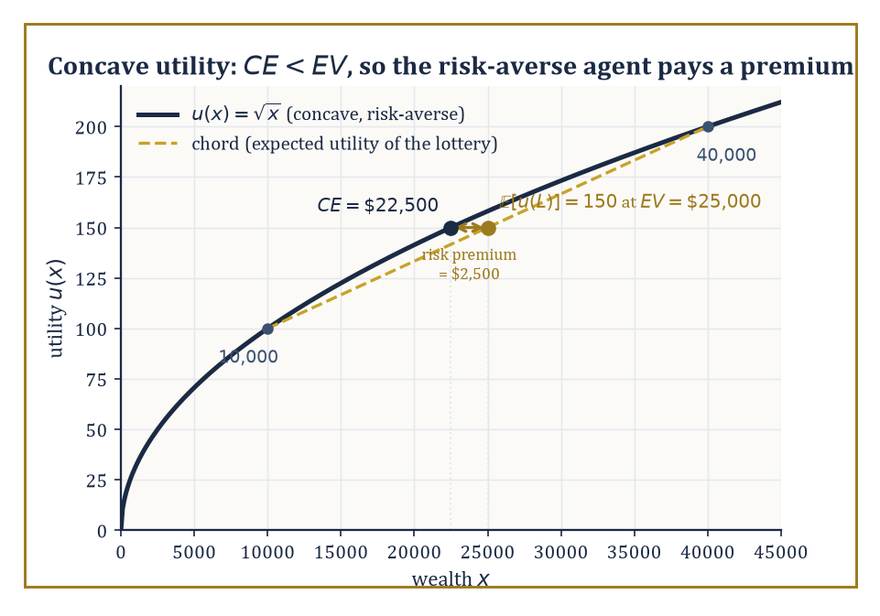
A concave utility curve: the certainty equivalent falls short of the expected value, and that shortfall is the risk premium.
The interesting mathematics begins under risk, meaning you know the probabilities of the possible outcomes but not which one will occur, and it begins in earnest with a theorem that quietly underwrites almost everything that follows: the von Neumann–Morgenstern (vNM) expected utility theorem.
The theorem starts from a handful of axioms about how a rational agent's preferences over lotteries — gambles with known probabilities over prizes — ought to behave: completeness (you can always say which of two lotteries you prefer, or that you're indifferent), transitivity (no cycles of preference), continuity (no lottery is infinitely better or worse than another, so small probability shifts produce small preference shifts), and independence (mixing two lotteries with a third, common one, in the same proportions, should not reverse your preference between them).
Von Neumann and Morgenstern proved that any preference relation satisfying these axioms can be represented by a utility function u on prizes such that lottery L is preferred to lottery M exactly when the expected utility of L exceeds that of M, where the expected utility is written:
𝔼[u(L)] = Σ p(x)·u(x)
This is a representation theorem, not a moral claim: it says rational preference of this specific kind is equivalent to maximizing an expectation, not that maximizing an expectation is the only sane way to live.
The utility function itself is pinned down only up to a positive affine transformation — you may rescale it as a·u + b for any a > 0 — because doubling every utility number and adding ten to each leaves every expected-utility comparison unchanged.
And crucially, the shape of u encodes attitude to risk: a concave u (curving downward, like a square root) means an agent who prefers a certain amount to a fair gamble of the same expected value — a risk-averse agent — while a convex u describes risk-seeking, and a straight line describes risk-neutrality, the rare soul who cares only about expected value and nothing about spread.
Numeric example — Worked example: pricing a gamble with a concave utility. Suppose an agent's utility for wealth x is given by:
u(x) = √x
This function is concave, hence risk-averse. Consider a lottery L offering a 50% chance of $10,000 and a 50% chance of $40,000. Its expected monetary value is:
EV = 0.5 × 10,000 + 0.5 × 40,000 = $25,000
But the agent doesn't eat expected value; they eat expected utility:
𝔼[u(L)] = 0.5 × √10,000 + 0.5 × √40,000 = 0.5 × 100 + 0.5 × 200 = 50 + 100 = 150
Now ask: what certain amount CE (the 'certainty equivalent') would give this same utility? Solve u(CE) = 150:
√CE = 150, so CE = 150² = 22,500
The agent is precisely indifferent between the gamble and a guaranteed $22,500 — they would happily pay up to:
$25,000 − $22,500 = $2,500
(the risk premium) just to make the uncertainty go away. Note this is not a small effect: a fair coin flip worth $25,000 on average is, to this agent, worth exactly the same as a cheque for $2,500 less. Concavity is expensive.
Risk, in the sense above, means the probabilities are known — you know it's a fair coin. Uncertainty is the murkier cousin: you don't even know the odds.
Subjective expected utility theory, due independently to Savage and to Anscombe and Aumann, extends the vNM framework by deriving both a utility function and a subjective probability distribution — the agent's beliefs — from axioms on preferences over acts (functions from states of the world to outcomes) rather than over ready-made lotteries.
The upshot is the same expected-utility formula, except now the probabilities are not handed to you by nature but inferred from the agent's own choices: you discover what someone believes by watching what they're willing to bet on. This is elegant, and it is also the point at which real human behaviour begins to misbehave.
The Allais paradox, devised by Maurice Allais in 1953, is the classic demonstration that people routinely violate the independence axiom even in problems designed to make the violation glaring. It works by presenting the same underlying trade-off twice, dressed differently, and showing that popular choices in the two dressings cannot both be expected-utility maximizing under any utility function whatsoever.
Numeric example — Worked example: the Allais paradox, done in cold arithmetic. Situation 1 — choose between A: $1,000,000 for certain, or B: 10% chance of $5,000,000, 89% chance of $1,000,000, 1% chance of $0. Most people choose A; the 1% risk of walking away with nothing feels like a poor trade for a shot at more money you already, in some sense, have.
Situation 2 — choose between C: 11% chance of $1,000,000, 89% chance of $0, or D: 10% chance of $5,000,000, 90% chance of $0. Most people now choose D — with the 1,000,000 no longer 'safe' in either option, why not go for the bigger prize on roughly the same odds?
Normalize a utility function with u($0) = 0 and u($1,000,000) = 1, and let u($5,000,000) = k.
Preferring A to B means:
1 > 0.10k + 0.89(1) + 0.01(0)
which simplifies to:
0.11 > 0.10k
so:
k < 1.1
Preferring D to C means:
0.10k + 0.90(0) > 0.11(1) + 0.89(0)
which simplifies to:
0.10k > 0.11
so:
k > 1.1
The same number k is required to be both less than 1.1 and greater than 1.1 — a flat contradiction. No utility function reproduces the popular pair of choices; the independence axiom has been violated in the wild, by ordinary sensible people, not by anyone being stupid. That is precisely what makes it a paradox rather than a mistake.
The Ellsberg paradox, from Daniel Ellsberg in 1961 (yes, that Ellsberg, some years before the Pentagon Papers — a man clearly fond of releasing damning information), targets ambiguity rather than risk itself.
Offer a bet on drawing a red ball from an urn of 90 balls: 30 known red, and 60 that are black or yellow in an unknown split. People typically prefer betting on red (a known 1-in-3 chance) over betting on black (an ambiguous chance somewhere between 0 and 60-in-90) — ambiguity aversion.
But offered the complementary bet, on 'red-or-yellow' versus 'black-or-yellow', most of the same people now prefer betting on black-or-yellow, even though consistency under any fixed subjective probability for the black/yellow split would require the opposite ranking to hold throughout.
People, it turns out, don't merely dislike bad odds; they dislike not knowing the odds at all, and no single subjective probability distribution captures that discomfort.
Prospect theory (Kahneman and Tversky) and various ambiguity-averse decision models were built afterwards to accommodate findings like these, replacing raw probabilities with distorted 'decision weights' and utility with gains-and-losses measured from a reference point rather than from absolute wealth — psychologically richer, mathematically messier, and a proper subject for a later storey on its own.
Numeric example — Worked example: the Ellsberg paradox, formalized. Formalize the two choices using a single subjective probability distribution over the urn's contents: let r = 1/3 be the known, certain probability of drawing red, and let b and y be the agent's subjective probabilities for black and yellow, whatever they happen to be, subject only to the constraint:
b + y = 2/3
(since exactly 60 of the 90 balls are black-or-yellow, even though the individual split is unknown). Preferring the bet on Red over the bet on Black means the agent's subjective P(red) exceeds their subjective P(black):
1/3 > b, i.e. b < 1/3
Preferring the bet on 'Black-or-Yellow' over 'Red-or-Yellow' means P(black) + P(yellow) exceeds P(red) + P(yellow):
b + y > 1/3 + y
and since y appears identically on both sides it cancels straight out, leaving:
b > 1/3
The same number b is required to be simultaneously less than 1/3 and greater than 1/3 — exactly the flat contradiction the Allais paradox produced a few paragraphs ago, and for the identical structural reason: no single subjective probability distribution, fed into the ordinary expected-utility formula, reproduces both popular preferences at once. The elegance of the argument is that y, the genuinely unknown quantity, never gets pinned down and never needs to be — it cancels out of the comparison entirely, which is exactly why the contradiction holds no matter what the agent actually believes about the black/yellow split.
None of this dents the theorem so much as it marks its boundary: expected utility remains the normative benchmark — what a coherent, axiom-respecting agent does — even where descriptive accounts of actual human choice must diverge from it.
And it is this one-player scaffolding, warts and paradoxes included, that game theory now bolts a second player onto: a player's payoff in a game is a utility in exactly this sense, and rational play means maximizing expected utility given beliefs about what the other players — who are doing the same calculation about you — are going to do.

Room 41.2: Games in Normal Form
Writing down conflict as a spreadsheet
A game in normal form (also called strategic form) is specified by three ingredients: a finite set of players, a strategy set S_i for each player i listing every action available to them, and a payoff function u_i, one per player, mapping every possible profile of strategies — one choice from each player, simultaneously — to a real-valued utility for that player.
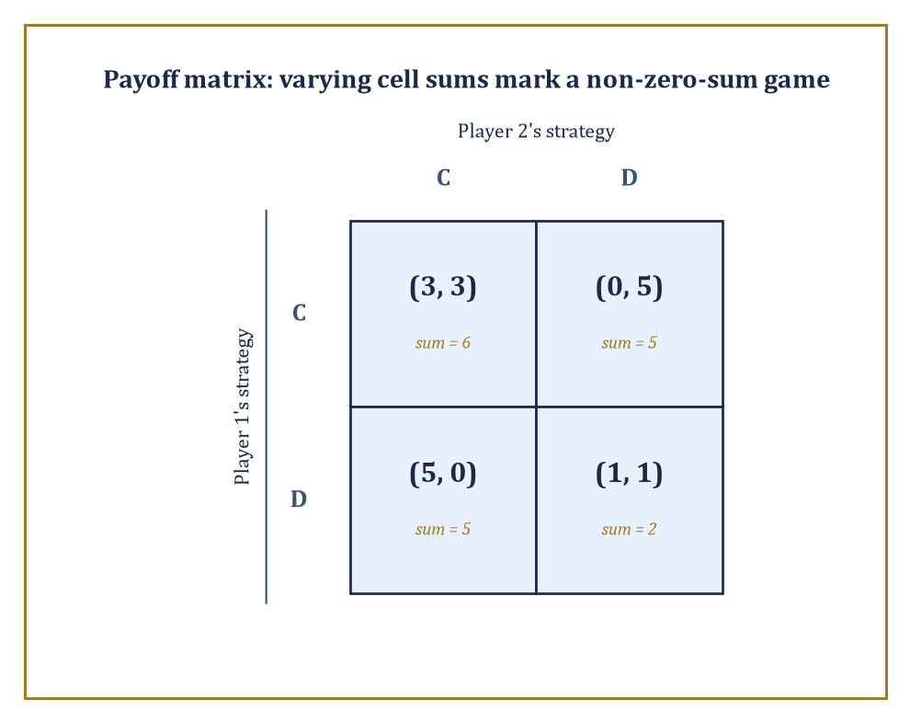
The Prisoner's Dilemma's payoff matrix, cell sums included: a non-zero-sum game wears its varying sums on its sleeve.
For two players with finitely many strategies each, this is most naturally drawn as a payoff matrix: rows indexed by player 1's strategies, columns by player 2's, and each cell holding an ordered pair (u_1, u_2) of the payoffs both players receive if that row and that column are chosen together.
For three or more players the matrix becomes a tensor — a matrix with an extra dimension for each additional player — which is why textbook examples stop politely at two players and everyone else is left to imagine the three-dimensional spreadsheet.
Numeric example — Worked example: reading a payoff matrix — the Prisoner's Dilemma. Two suspects, interrogated separately, each choose to Cooperate (stay silent, i.e. cooperate with each other) or Defect (betray the other).
The classic payoff matrix, in years of freedom converted to utility points (higher is better), reads:
(Cooperate, Cooperate) → (3, 3); (Cooperate, Defect) → (0, 5); (Defect, Cooperate) → (5, 0); (Defect, Defect) → (1, 1)
Reading this is entirely mechanical once you know the convention: if player 1 plays Cooperate and player 2 plays Defect, look up the cell (Cooperate, Defect) and read off (0, 5) — player 1 gets 0, player 2 gets 5.
Notice the payoff sums across the four cells are 6, 5, 5, and 2 respectively — not constant.
That single observation is enough to classify the game, which is the next thing we need to do.
A zero-sum game is one in which the payoffs in every cell sum to the same constant (conventionally zero, by simply subtracting that constant from everyone) — one player's gain is exactly the other's loss, and the game models pure, undiluted conflict: chess, tic-tac-toe, dividing a fixed pie with nothing left over.
A non-zero-sum (or general-sum) game, like the Prisoner's Dilemma above, has payoff sums that vary across cells, meaning some outcomes are jointly better or worse than others — there is room for both conflict and cooperation to matter simultaneously, which is why the Prisoner's Dilemma is philosophically far more interesting than a coin-matching contest: the players aren't just fighting over a fixed pie, they're deciding, without being able to talk about it, whether to bake a bigger one.
Numeric example — Worked example: a genuinely zero-sum game — Matching Pennies. Two players each secretly show a coin as Heads or Tails.
Player 1 wins (+1) if the coins match; player 2 wins (+1) if they differ, and the loser in each case pays −1.
The payoff matrix:
(H, H) → (1, −1); (H, T) → (−1, 1); (T, H) → (−1, 1); (T, T) → (1, −1)
Check every cell:
1 + (−1) = 0
(−1) + 1 = 0
(−1) + 1 = 0
1 + (−1) = 0
Every single cell sums to exactly zero — this is a zero-sum game in the strictest sense, one player's fortune is the other's misfortune to the penny, and there is nothing here resembling the Prisoner's Dilemma's shared temptation to defect: there is no joint outcome either player would rather steer toward, only a pure contest of guessing.
Several classes of games carry extra structure worth naming because it buys tractability later.
A symmetric game is one where all players have the same strategy set and payoffs depend only on one's own strategy and the multiset of others' strategies, not on who specifically played what — Rock-Paper-Scissors is symmetric; a labour negotiation between a unique employer and a unique union is not.
A potential game (Monderer and Shapley) is one admitting a single real-valued potential function Φ over strategy profiles such that any player's change in payoff from unilaterally switching strategies exactly equals the resulting change in Φ — meaning every player, in effect, is secretly climbing the same shared hill, which guarantees a pure-strategy Nash equilibrium exists (at any local maximum of Φ) and that better-response dynamics converge to one.
A supermodular game is one where strategies are complements — if I raise my strategy, your best response weakly rises too — which also guarantees pure equilibria and gives them a lattice structure amenable to comparative-statics arguments.
All three properties are, in essence, promises that the game's equilibria won't be some pathological needle in a haystack, and a working game theorist checks for them the way a working analyst checks for convexity before reaching for calculus.
Abstract example — Abstract example: a potential game — congestion on two roads. Consider two commuters, each independently choosing Road A or Road B to get to work, where each road's travel-time cost to a driver depends only on how many drivers (0, 1, or 2) use that road: a road with 1 driver costs that driver 1 (in time units), a road with 2 drivers costs each driver 3 (congestion), and payoffs are the negative of cost, since drivers want to minimize travel time, not maximize it.
Define the potential function:
Φ(profile) = −Σ, over each road, of the running total [cost paid by that road's 1st driver, plus cost paid by its 2nd driver, ...]
This is the standard Rosenthal congestion-game potential, with a minus sign attached so it rises exactly when payoff rises, rather than when raw cost does.
If both drivers pick Road A: the road carries a '1st' driver (cost 1) and a '2nd' driver (cost 3), so:
Φ = −(1+3) + 0 = −4
If they split, one on each road: each road carries only a '1st' driver (cost 1), so:
Φ = −1 + −1 = −2
Now check the potential-game property directly: starting from both-on-A (Φ = −4), suppose driver 2 switches to Road B.
Their actual payoff (negative cost) changes from −3 (on crowded A) to −1 (alone on B), a gain of +2.
The potential changes from −4 to −2, also a gain of +2 — the two changes agree exactly, precisely as the definition promises.
And the practical payoff of the theory is that pure equilibria — here, one driver on each road, since abandoning it to join the other driver would trade a cost of 1 for a cost of 3 — always exist and can be found simply by locally optimizing Φ (the split outcome, Φ = −2, is a strict local maximum, beating both-on-one-road's Φ = −4), rather than searching the whole strategy space for a fixed point.
One structural feature the normal form deliberately throws away is time: it records only which strategies were chosen, not the order in which anyone moved or what they knew at each stage.
That abstraction is often exactly what you want — a great many real interactions genuinely are simultaneous, or might as well be — but chess is not one of them, and neither is a used-car negotiation with an opening offer and a counter-offer.
The extensive form, several rooms from now, puts the clock back on the wall.

Room 41.3: Dominance, Best Responses, and Nash Equilibrium
In which nobody wants to move first, second, or at all
A strategy is strictly dominated for player i if some other strategy of theirs yields a strictly higher payoff no matter what every other player does — dominance is a promise that holds against the entire field of possible opposition, not merely against what you happen to expect.
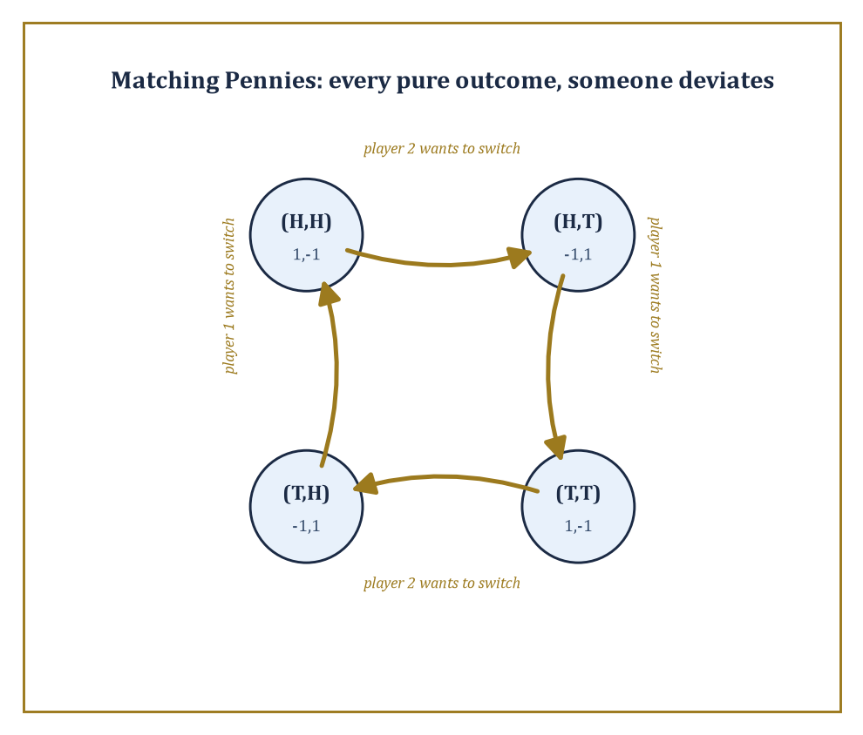
Matching Pennies chased around its own outcomes: at every pure profile, somebody has a gold arrow pointing away from it.
A rational player, by definition, never plays a strictly dominated strategy, since some other option does better in literally every contingency; there is no story under which the dominated choice was the right call.
This licenses a solution procedure called iterative elimination of strictly dominated strategies (IESDS): delete any strictly dominated strategy from the game, recompute, and repeat, since removing an option from your opponent's repertoire can create new dominance relations that weren't there before.
Weak dominance — where the alternative is at least as good everywhere and strictly better somewhere — licenses a similar but more delicate procedure, delicate because, unlike the strict version, the order in which you eliminate weakly dominated strategies can change which equilibria survive; strict elimination, reassuringly, always arrives at the same reduced game no matter the order.
Numeric example — Worked example: solving a game by iterated elimination. Player 1 chooses row U or D; player 2 chooses column L, M, or R. The payoffs (u₁, u₂) are as follows.
U-L = (4, 3), U-M = (5, 1), U-R = (6, 2); D-L = (2, 1), D-M = (8, 4), D-R = (3, 6)
Compare player 2's columns M and R directly, holding player 1's row fixed each time.
If player 1 plays U, M gives player 2 a payoff of 1 while R gives 2 — R is better; if player 1 plays D, M gives 4 while R gives 6 — R is better again.
Column R strictly dominates column M for player 2 in every contingency, so M is eliminated, leaving a 2×2 game.
U-L = (4,3), U-R = (6,2); D-L = (2,1), D-R = (3,6)
Now compare player 1's rows: against L, U gives 4 versus D's 2 — U better; against R, U gives 6 versus D's 3 — U better again.
Row U strictly dominates row D, so D is eliminated, leaving player 1 committed to U and player 2 choosing only between L (payoff 3) and R (payoff 2). Player 2 picks L.
The game has been solved down to the single outcome (U, L), with payoffs (4, 3) — and, worth checking, this survivor is automatically a Nash equilibrium, since it survived elimination against every alternative at every stage.
A best response is a strategy for player i that maximizes i's payoff given some fixed profile of strategies for everyone else.
A Nash equilibrium, the central solution concept of the entire subject, is a strategy profile in which every player's strategy is simultaneously a best response to everyone else's — no exceptions, no player left wishing they'd chosen differently once they see what actually happened.
This is what makes equilibrium self-enforcing rather than merely predicted: nobody needs to be forced, threatened, or morally persuaded to stay put, because unilateral deviation strictly does not pay.
It is worth dwelling on how modest this notion actually is — a Nash equilibrium says nothing about fairness, efficiency, or how the players got there; it says only that, once arrived at, no individual regrets their own choice given what everyone else did.
Two people can be jointly miserable in a perfectly good Nash equilibrium, as the Prisoner's Dilemma is about to demonstrate.
Numeric example — Worked example: finding the Nash equilibrium of the Prisoner's Dilemma. Recall the payoffs.
(C,C) = (3,3), (C,D) = (0,5), (D,C) = (5,0), (D,D) = (1,1)
Compute player 1's best response to each of player 2's choices: if player 2 plays C, player 1 gets 3 from C and 5 from D — D is the best response; if player 2 plays D, player 1 gets 0 from C and 1 from D — D is again the best response.
Player 1's best response is D regardless of what player 2 does; by the identical calculation (the game is symmetric) player 2's best response is also D regardless.
The only profile in which both strategies are simultaneously best responses is (D, D), giving payoffs (1, 1) — a Nash equilibrium, and the unique one in pure strategies.
The bitter joke, of course, is that (C, C) gives both players 3, strictly better for everyone than the (1, 1) they're actually stuck with; the equilibrium is self-enforcing but not remotely optimal, which is precisely why this two-line game launched a thousand papers on cooperation, trust, and the difference between individual and collective rationality.
Existence, however, is not automatic.
A pure-strategy Nash equilibrium — one where each player commits deterministically to a single strategy — can simply fail to exist, and Matching Pennies, introduced last room, is the standard minimal counterexample: it has no stable deterministic outcome at all.
Numeric example — Worked example: Matching Pennies has no pure Nash equilibrium. Recall the payoffs.
(H,H) = (1,−1), (H,T) = (−1,1), (T,H) = (−1,1), (T,T) = (1,−1)
Check all four candidate profiles exhaustively.
At (H,H): player 2 currently gets −1; switching to T moves the outcome to (H,T) = (−1, 1), improving player 2's payoff to 1 — player 2 wants to deviate, so (H,H) is not an equilibrium.
At (H,T): player 1 currently gets −1; switching to T moves to (T,T) = (1,−1), improving player 1 to 1 — not an equilibrium.
At (T,H): player 1 currently gets −1; switching to H moves to (H,H) = (1,−1), improving player 1 — not an equilibrium.
At (T,T): player 2 currently gets −1; switching to H moves to (T,H) = (−1,1), improving player 2 — not an equilibrium.
Every one of the four possible deterministic outcomes leaves somebody itching to switch.
There is, quite literally, no way to stand still in this game — which is exactly the intuition behind why it's called Matching Pennies rather than Sitting-Still Pennies, and exactly the gap that mixed strategies, the subject of the next room, are built to fill.

Room 41.4: Mixed Strategies and Existence of Equilibrium
Rational players learn to shrug convincingly
A mixed strategy for player i is a probability distribution over i's pure strategies — instead of committing to Heads, the player commits to 'Heads with probability p, Tails with probability 1 − p', and then, crucially, actually randomizes, rather than merely picking whichever one they secretly prefer and calling it random.
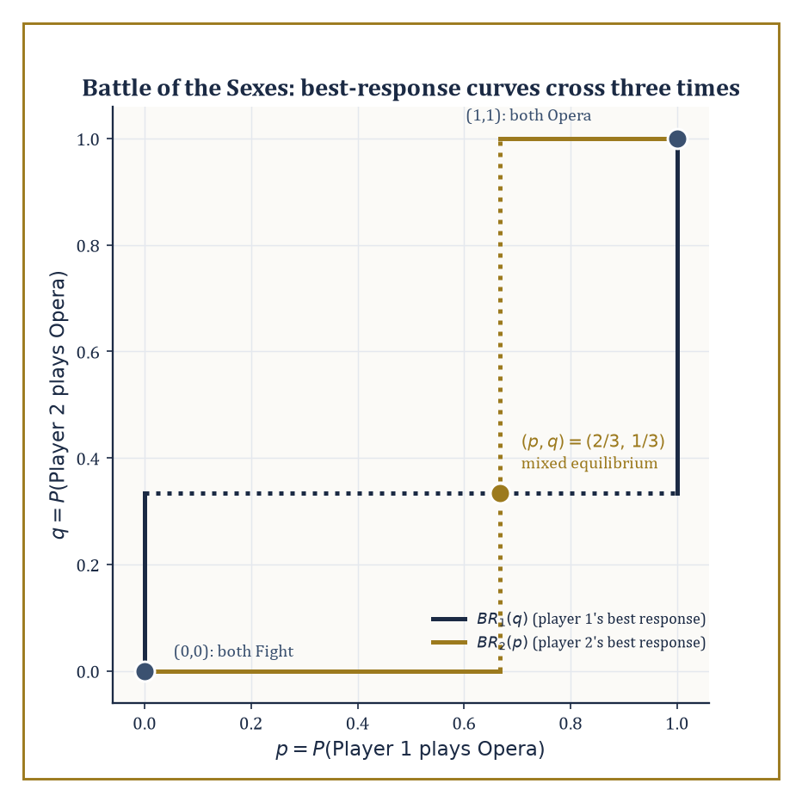
Best-response curves for the Battle of the Sexes, crossing three times: two corners of agreement and one uneasy compromise in the middle.
Payoffs extend to mixed strategy profiles bilinearly: the expected payoff is simply the probability-weighted average over all combinations of pure strategies, one term per cell of the payoff matrix, weighted by the product of the probabilities that put the players there.
John Nash's 1950 theorem is the existence result the whole apparatus has been building toward: every finite game — finitely many players, each with finitely many pure strategies — possesses at least one Nash equilibrium in mixed strategies, even when, as with Matching Pennies, no pure equilibrium exists at all.
The proof is not constructive in the useful sense; it applies a fixed-point theorem (Brouwer's, or the more general Kakutani's for the multi-player, correspondence-valued case) to the best-response correspondence, showing that some mixed profile must map to itself under 'everybody best-responds to everybody else'. It guarantees an equilibrium exists; it does not tell you, free of charge, what it is.
Finding the equilibrium by hand relies on the indifference principle: if player i is genuinely willing to randomize between two pure strategies, both must yield i exactly the same expected payoff against the other players' mixture — otherwise i would strictly prefer one and would not be randomizing at all. Setting the two expected payoffs equal and solving is, in small games, entirely mechanical.
Numeric example — Worked example: the mixed equilibrium of Matching Pennies. Let player 1 play H with probability p, T with probability 1 − p.
Player 2's expected payoff from playing H outright: p·(−1) + (1−p)·(1) = 1 − 2p
Player 2's expected payoff from playing T: p·(1) + (1−p)·(−1) = 2p − 1
For player 2 to be willing to randomize, these must be equal:
1 − 2p = 2p − 1
4p = 2, so p = 1/2
By the symmetric argument on player 1's side, player 2 must also play H with probability q = 1/2. So the unique Nash equilibrium is p = q = 1/2 for both players — flip honestly.
The expected payoff to player 1 at this equilibrium, averaging over all four cells with weight 1/4 each, is:
1/4(1) + 1/4(−1) + 1/4(−1) + 1/4(1) = 0
A fair coin against a fair coin is worth precisely nothing to anybody, which is reassuring, since the game was symmetric and zero-sum and any other answer would have been a sign something had gone wrong.
Numeric example — Worked example: mixed equilibrium in the Battle of the Sexes. Two players want to spend the evening together but disagree on where: player 1 prefers the Opera, player 2 prefers a Fight (a boxing match, in the traditional if slightly baffling telling). The payoffs are:
(Opera,Opera) = (2,1), (Opera,Fight) = (0,0), (Fight,Opera) = (0,0), (Fight,Fight) = (1,2)
There are two pure equilibria (both go to Opera, or both go to the Fight) but also a mixed one, worth finding for what it reveals. Let player 1 play Opera with probability p, Fight with 1−p; player 2 play Opera with probability q, Fight with 1−q.
Player 2's indifference condition compares the expected payoff from each pure strategy.
Expected payoff from Opera: p·1 + (1−p)·0 = p
Expected payoff from Fight: p·0 + (1−p)·2 = 2 − 2p
Setting equal: p = 2 − 2p, so 3p = 2, p = 2/3
Player 1's indifference condition works the same way.
Expected payoff from Opera: q·2 + (1−q)·0 = 2q
Expected payoff from Fight: q·0 + (1−q)·1 = 1 − q
Setting equal: 2q = 1 − q, so 3q = 1, q = 1/3
So player 1 (who prefers Opera) goes to Opera with probability 2/3, while player 2 (who prefers the Fight) goes to Opera with only probability 1/3 — each leans toward their own favourite, exactly as you'd hope, while still leaving the other indifferent.
But check the payoffs this equilibrium actually delivers:
Player 1's expected payoff: 2q = 2/3; player 2's expected payoff: p = 2/3 (matching the Fight-branch value 2 − 2p = 2 − 4/3 = 2/3)
Both players get 2/3 — worse than the 1 or 2 either would get from successfully coordinating on either pure equilibrium. Mixing solves the existence problem; it does not solve the coordination problem, and the players pay a tangible price, in expectation, for not being able to simply ring each other up beforehand.
Two-player zero-sum games are the special case where the theory sharpens considerably: the equilibrium payoff is unique across all equilibria and is called the value of the game, and the equilibrium mixed strategies are exactly the maximin strategy for the maximizing player (guaranteeing the best worst-case payoff) and the minimax strategy for the minimizing player.
This coincidence of maximin and minimax — von Neumann's minimax theorem, which predates Nash by two decades and is really the zero-sum special case of the same fixed-point idea — means the value and the optimal mixed strategies can be computed exactly by linear programming, no fixed-point machinery required, because the problem of finding your own best worst-case guarantee turns out to be the dual of your opponent's identical problem.
Numeric example — Worked example: computing the value of a zero-sum game. Player 1 (rows A, B) plays against Player 2 (columns C, D) in a zero-sum game with player 1's payoff given below (player 2's payoff is the negative of each):
A-C = 4, A-D = 1, B-C = 2, B-D = 3
First check for a pure saddle point.
Row minima: min(4,1) = 1 for row A, min(2,3) = 2 for row B, so maximin = max(1,2) = 2
Column maxima: max(4,2) = 4 for column C, max(1,3) = 3 for column D, so minimax = min(4,3) = 3
Since maximin (2) ≠ minimax (3), there is no pure saddle point, and mixed strategies are required. Let player 1 play A with probability p.
Player 2's payoff from column C: 4p + 2(1−p) = 2p + 2
Player 2's payoff from column D: 1p + 3(1−p) = 3 − 2p
Indifference requires these be equal:
2p + 2 = 3 − 2p, so 4p = 1, p = 1/4
Player 1 plays A a quarter of the time, B three-quarters.
Value at this point: 2(1/4) + 2 = 2.5 (check the other branch: 3 − 2(1/4) = 2.5, matches)
Now let player 2 play C with probability q.
Player 1's payoff from A: 4q + 1(1−q) = 3q + 1
Player 1's payoff from B: 2q + 3(1−q) = 3 − q
Indifference: 3q + 1 = 3 − q, so 4q = 2, q = 1/2
Value: 3(0.5) + 1 = 2.5, matching exactly
The game has value 2.5: player 1 can guarantee an expected payoff of at least 2.5 by mixing (1/4, 3/4), and player 2 can guarantee holding player 1 to at most 2.5 by mixing (1/2, 1/2), and neither can do any better against a competent opponent.
In general-sum games, this uniqueness collapses: multiple equilibria with genuinely different payoffs for the players can and do coexist, as the Battle of the Sexes just demonstrated with its two pure equilibria and one mixed one — three equilibria, three different outcomes, and the theory itself is silent on which one the players will actually reach.
Equilibrium selection — refinements, focal points, evolutionary or learning-based justifications for one equilibrium over another — remains a genuinely open conceptual problem, not merely a computational one.
And computation has its own bad news to deliver: finding a Nash equilibrium of a general finite game is PPAD-complete, a complexity class believed (though, tediously, not proven) to sit strictly between polynomial-time solvable problems and NP-complete ones — hard in a specific, well-understood, mathematically respectable way, rather than merely hard because nobody's been clever enough yet.
Special structure rescues tractability: zero-sum games reduce to linear programming, as above; potential games and congestion games reduce, essentially, to local search on the potential function. It is a running theme of applied mathematics that the general case is intractable and the useful special cases are exactly the ones somebody eventually names after themselves.

Room 41.5: Extensive-Form Games and Sequential Rationality
Threats you would never actually carry out
An extensive-form game restores what the normal form threw away: order and information. It is drawn as a tree — a root node where the game begins, branches labelled by the actions available at each decision point, further nodes at the end of each branch, and payoffs sitting at the leaves, one number per player per leaf.
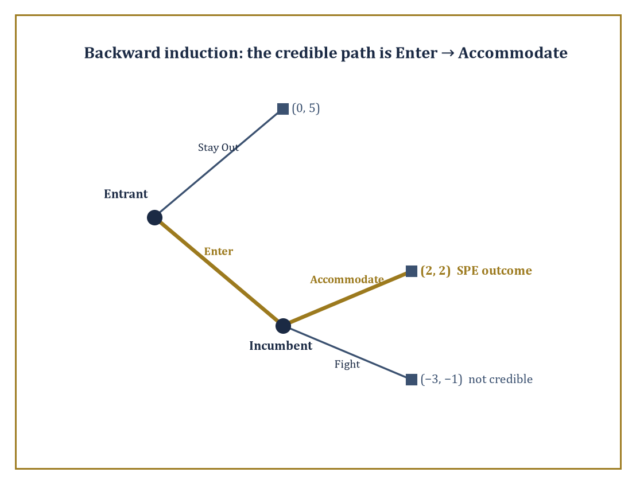
The entry-deterrence tree, folded backward: the credible path runs Enter, then Accommodate, leaving Fight an empty threat.
Nodes are grouped into information sets: a set of nodes a player cannot tell apart when it is their turn to move, because they don't yet know which one of them the game has actually reached.
A strategy in the extensive form is not merely 'what I do' but a complete contingency plan — an action specified at every information set where that player might ever be called on to move, including ones that, given how the game actually unfolds, are never reached. This is a stricter, more demanding object than a normal-form strategy, and it is exactly this extra structure that lets the theory distinguish threats a player would actually carry out from threats that are pure bluster.
When every information set is a single node — every player, at every point, knows exactly where they are in the tree, which is called perfect information — the game can be solved by backward induction: work out the optimal action at each final decision node first (where the payoffs are immediately visible), fold those choices back into the payoffs one level up as if they were already fixed, and repeat toward the root.
The resulting equilibrium, playing optimally at every node including ones off the path actually taken, is called subgame-perfect (Selten), because it remains a Nash equilibrium not merely of the whole game but of every subgame — every smaller tree hanging off any node — considered on its own.
Numeric example — Worked example: backward induction in an entry-deterrence game. An Entrant first decides whether to Enter a market or Stay Out. If the Entrant Stays Out, the game ends with payoffs (Entrant, Incumbent):
(Entrant, Incumbent) = (0, 5)
If the Entrant Enters, the Incumbent then decides whether to Fight (a price war) or Accommodate (share the market), giving payoffs:
(Enter, Fight) = (−3, −1)
(Enter, Accommodate) = (2, 2)
Backward induction starts at the last decision, the Incumbent's: comparing Fight (−1) against Accommodate (2), Accommodate is strictly better for the Incumbent, so a rational Incumbent, if the game ever reaches that node, accommodates.
Folding this back: the Entrant, anticipating that Entering leads to Accommodate rather than Fight, compares Stay Out (payoff 0) against Enter (which now effectively delivers 2, the Accommodate outcome), and Enter is strictly better.
The subgame-perfect equilibrium is (Enter, Accommodate), with payoffs:
(2, 2)
The Incumbent's capacity to fight, however menacing it sounds beforehand, is simply not credible once the moment to actually pay its cost arrives, and a rational Entrant sees straight through it.
This is worth contrasting directly with plain Nash equilibrium, because the extensive form exposes a gap that the normal form quietly papers over: a threat can be part of a perfectly good Nash equilibrium of the game's normal form while being utterly incredible the moment you actually ask whether the threatener would carry it out.
Numeric example — Worked example: a non-credible threat surviving as a Nash equilibrium. Consider the strategy profile where the Entrant Stays Out and the Incumbent's strategy is 'Fight if Entry occurs' — i.e. the Incumbent commits, in advance, to a policy of fighting. Is this a Nash equilibrium of the normal form?
Check the Entrant's best response to 'Incumbent will Fight': entering yields (−3), staying out yields 0, so Staying Out is indeed the Entrant's best response — no incentive to deviate.
Check the Incumbent's best response to 'Entrant Stays Out': whatever the Incumbent's strategy says to do if entry occurred, that branch of the tree is never actually visited, so the Incumbent's realized payoff is 5 regardless of whether their stated policy is Fight or Accommodate — they are indifferent, and 'Fight' is technically a best response (weakly, by not being strictly worse) to a threat that never gets tested.
So (Stay Out, Fight) is a bona fide Nash equilibrium of the normal form. But it fails to be subgame-perfect, because the Incumbent's strategy prescribes Fight at the one node where it actually matters — should entry occur — and there, as the previous example showed, Fight (−1) is strictly worse than Accommodate (2).
The threat is Nash-equilibrium-compatible precisely because it is never called upon; subgame perfection is the requirement that a strategy remain optimal even off the path actually played, and it is the tool that rules this equilibrium out as an empty bluff rather than a genuine deterrent.
Real information sets are rarely singletons, of course — usually you move without knowing exactly which node you're at, because an earlier player's action was hidden from you. Under such imperfect information, backward induction as stated doesn't directly apply (there's no single 'the' payoff to work backward from at a multi-node information set), and the relevant refinements are sequential equilibrium (Kreps and Wilson) and perfect Bayesian equilibrium: each player's strategy must be optimal given a system of beliefs — a probability distribution over which node in their current information set they're actually at — and those beliefs must, wherever Bayes' rule applies, be genuinely derived from the other players' strategies rather than plucked from thin air.
The chief applications are signaling games, where an informed player (a job applicant who knows their own ability) takes a costly, visible action (getting a degree) partly to credibly reveal that information to an uninformed party (an employer who cannot directly observe ability); screening games, the mirror image, where the uninformed party designs a menu of options to induce the informed party to self-sort by type; and the broader reputation literature, where a long-run player's history of past actions substitutes, however imperfectly, for information the short-run players who observe them can't access directly.
Abstract example — Abstract example: the skeleton of a signaling game. A worker is privately either High-ability or Low-ability, each with prior probability 1/2 — the employer cannot see this directly.
The worker first chooses an education level (say, Degree or No Degree), which costs a High-ability worker less effort to obtain than a Low-ability one (the standard Spence single-crossing condition). The employer, observing only the education choice — not the underlying ability — then offers a wage, updating their belief about the worker's type via Bayes' rule based on which education level was chosen.
A separating equilibrium is one where High- and Low-ability workers choose different education levels, so the employer's Bayesian belief becomes degenerate (certain) after observing the signal, and wages fully reveal ability even though ability itself was never directly observed — education here has no productive value whatsoever in the model; its entire function is to be a hard-to-fake billboard, credible only because it costs the two types differently.
A pooling equilibrium, by contrast, is one where both types choose the same education level, the employer's belief stays at the 1/2-1/2 prior, and the signal conveys nothing at all — which of the two the game settles into depends on the specific cost and wage numbers chosen, but the qualitative machinery (beliefs updated by Bayes' rule wherever possible, strategies optimal given those beliefs) is exactly what perfect Bayesian equilibrium was built to formalize.

Room 41.6: Repeated Games and the Folk Theorems
Cooperation, purchased on an instalment plan
A repeated game takes a single stage game — the Prisoner's Dilemma will do nicely, since it has been sitting there being tragic for three rooms now — and plays it over and over, either infinitely often or for a long but finite number of rounds, with the crucial twist that a strategy in the repeated game may condition its action in round t on the entire history of play in rounds 1 through t−1.
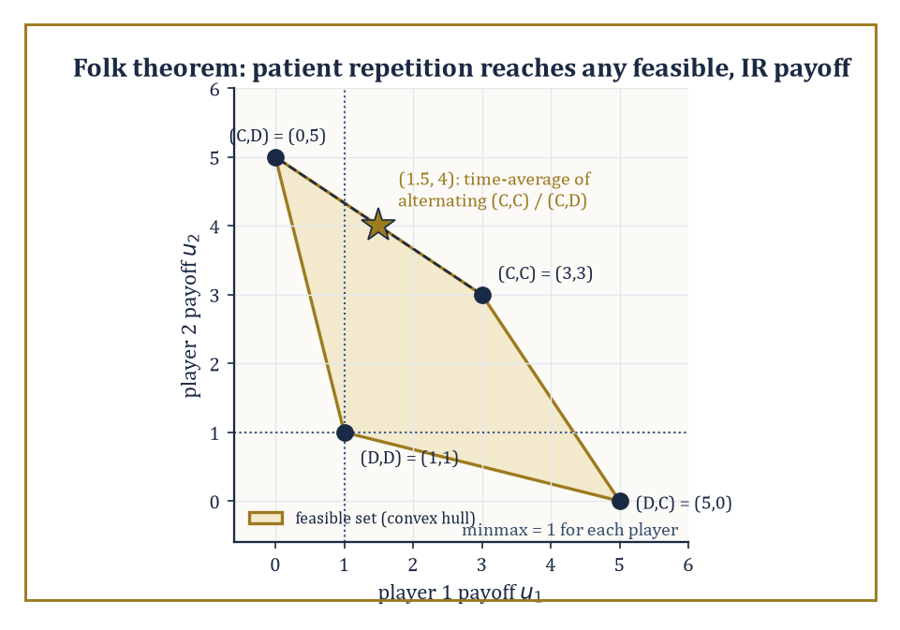
The feasible payoff set of the repeated Prisoner's Dilemma, with a patient pair reaching (1.5, 4) by alternating outcomes no single round could offer.
This extra memory is what makes repeated games interesting: an outcome that is not a Nash equilibrium of the one-shot stage game — mutual cooperation in the Prisoner's Dilemma, for instance — can become sustainable as an equilibrium of the repeated game, enforced by the credible threat of future punishment for deviation.
Future payoffs are discounted by a factor δ ∈ (0,1) per period (δ close to 1 means the players are patient, weighting the future almost as heavily as the present; δ close to 0 means they barely care what happens tomorrow), and how patient the players are turns out to be exactly the knob that determines how much cooperation is achievable.
The folk theorems — so called because their essential content was informally 'known in the folklore' among game theorists well before anyone bothered to write down a careful proof — characterize precisely which payoff vectors can arise as equilibrium outcomes of the infinitely repeated game.
The rough statement: for sufficiently patient players (δ close enough to 1), essentially any feasible payoff vector (one achievable by some combination, including time-averaging or randomizing over, the stage game's outcomes) that is also individually rational (giving each player at least their minmax payoff — the most a player can be held down to by the others, if that player then plays their own best response) can be supported as a subgame-perfect equilibrium outcome of the repeated game.
This is a strikingly permissive result — it says the set of sustainable outcomes is enormous, not that any particular one is inevitable — and the mechanism that makes it work is the trigger strategy: cooperate as long as everyone else has cooperated so far; the instant anyone deviates, switch to permanent (or temporary, in gentler variants) punishment.
Numeric example — Worked example: how patient must you be to cooperate forever?. Take the Prisoner's Dilemma payoffs, and consider the grim trigger strategy: both players cooperate every round until either defects, at which point both defect forever after (the harshest available punishment, since (D,D) gives each player their minmax payoff of 1 — neither can be pushed below 1, since defecting is always available as a fallback).
(C,C) = (3,3), (C,D) = (0,5), (D,C) = (5,0), (D,D) = (1,1)
Is mutual cooperation, sustained by this threat, a subgame-perfect equilibrium for a given discount factor δ? Compare the value of cooperating forever against the value of deviating once — grabbing 5 this round by defecting while the opponent still cooperates — and then suffering the punishment payoff of 1 every round after.
3 + 3δ + 3δ² + ... = 3/(1−δ)
5 + δ·1 + δ²·1 + ... = 5 + δ/(1−δ)
Cooperation is sustainable exactly when the first is at least the second:
3/(1−δ) ≥ 5 + δ/(1−δ)
Multiply both sides by (1−δ), which is positive:
3 ≥ 5(1−δ) + δ = 5 − 5δ + δ = 5 − 4δ
Rearranging:
4δ ≥ 2
δ ≥ 1/2
Cooperation, backed by the threat of eternal mutual defection, is a subgame-perfect equilibrium precisely when the players discount the future by no more than a factor of 1/2 per round — put plainly, when they value next round's payoff at least half as much as this round's. Below that threshold, the one-off temptation of grabbing 5 instead of 3 outweighs any amount of future punishment, patient posturing notwithstanding, and defection wins.
Grim trigger is the blunt instrument of the family — a single slip and the relationship never recovers, which is both maximally deterrent and maximally unforgiving, since it also punishes honest mistakes as harshly as calculated betrayal.
Tit-for-tat — cooperate first, then simply mirror whatever the opponent did last round — is gentler, self-correcting after a single mutual slip, and famously did rather well in Robert Axelrod's repeated-tournament experiments precisely because it is 'nice' (never defects first), 'retaliatory' (punishes defection immediately), and 'forgiving' (returns to cooperation the instant the opponent does).
Real applications complicate the clean theory in three ways worth flagging: discounting captures impatience, as above; imperfect monitoring — where players observe only a noisy signal of what others actually did, rather than the action itself — forces punishment to sometimes trigger by mistake, and the theory of repeated games with imperfect monitoring is largely about designing strategies robust to that noise; and finite horizons, where the game is known to end at a fixed round T, unravel cooperation entirely by backward induction in the pure Prisoner's Dilemma case (nobody cooperates in round T, since there's no future to protect; anticipating that, nobody cooperates in T−1 either, and so on back to round 1) — a sharp reminder that it is the shadow of an uncertain, sufficiently long future, not repetition for its own sake, that is doing the actual work of sustaining cooperation.
Numeric example — Worked example: the folk theorem's feasible payoff set, made concrete. The four stage-game outcomes of the Prisoner's Dilemma give payoff pairs (3,3), (0,5), (5,0), (1,1); the feasible set is (roughly) the convex hull of these points, since patient players can approximate any point in that hull by alternating or randomizing among the pure outcomes over time and averaging the results.
Each player's minmax payoff is 1 (achieved when the opponent defects and the player best-responds by defecting too), so the individually rational region is every feasible pair with both coordinates at least 1.
Take the target payoff (1.5, 4): is it in this region? It lies on the segment between (3,3) and (0,5) — specifically, alternate cooperation-cooperation and cooperation-defection every other round: half the rounds give (3,3), half give (0,5), and the long-run time-average is:
((3+0)/2, (3+5)/2) = (1.5, 4)
Both coordinates, 1.5 and 4, exceed the individually-rational floor of 1, so by the folk theorem this payoff pair is achievable as a subgame-perfect equilibrium outcome for δ close enough to 1, using an appropriately constructed punishment scheme (any deviation from the prescribed alternation collapses play to the mutual-defection payoff of (1,1) forever, the same disciplining device as before).
Notice how far outside the four original stage-game outcomes this lands: patient repetition doesn't just make (3,3) achievable, it opens up an entire continuum of payoff splits nobody could reach in a single round of the underlying game at all.
Repeated games are, in this sense, the formal backbone of every long-run relationship economics or biology cares to model — supplier and buyer, employer and employee, two firms tacitly colluding on price, or two organisms locked in an evolutionary arms race — anywhere cooperation that looks individually irrational in a single encounter becomes rational once the encounter is understood to recur, and where reputation, memory, and the shadow of the future do the enforcement work that no external referee is available to provide.

Room 41.7: Cooperative Games and Bargaining
Splitting the pie without pretending it wasn't a fight to bake it
Everything so far has been non-cooperative game theory: players choose strategies individually, and any cooperation that emerges must be self-enforcing, arising from the incentive structure itself rather than from an outside authority.
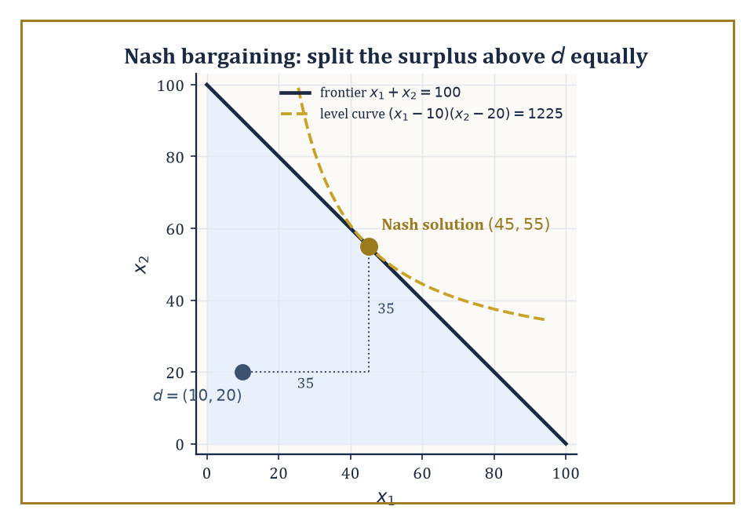
The Nash bargaining solution: the highest reachable product-of-gains curve, tangent to the frontier at a fifty-fifty split of the surplus above disagreement.
Cooperative game theory takes a different starting point: it assumes coalitions can form and make binding agreements, and asks how the value those coalitions jointly create ought to be divided.
The basic object is the characteristic function v, which assigns to every possible coalition S of players (every subset of the full player set N, including the empty coalition and the grand coalition N itself) a single number v(S) — the total value that coalition can guarantee itself, regardless of what the players outside S do.
The question the theory then asks is not 'what will happen?' but 'what division of v(N) — the value of everyone cooperating together — is stable, or fair, or both, according to some explicit set of axioms?'
Three solution concepts dominate the landscape, each formalizing a different notion of a 'good' division.
The core is the set of allocations (x_1, ..., x_n) summing to v(N) such that no coalition S can do better by breaking away and splitting v(S) among just its own members.
Σ_{i∈S} x_i ≥ v(S), for every coalition S
An allocation in the core is stable in the strongest sense: absolutely no subgroup has both the incentive and the capacity to defect.
The Shapley value (Lloyd Shapley, 1953) instead asks a fairness question, defining each player's share as their average marginal contribution to the coalition, computed over every possible order in which the grand coalition could be assembled one player at a time — a single number for each player, always summing exactly to v(N), and uniquely characterized by a small set of fairness axioms (symmetry, efficiency, additivity, and a null-player condition).
The nucleolus, a third and more computationally intricate concept, picks out the allocation that lexicographically minimizes the worst-case dissatisfaction (the largest shortfall v(S) − Σ_{i∈S} x_i, over all coalitions S) — it exists and is unique even in games where the core is empty, which the core-based approach, by construction, cannot promise.
Numeric example — Worked example: the Shapley value of the glove game. Players 1 and 2 each own a left-hand glove; player 3 owns a right-hand glove. A matched pair (one left, one right) sells for $10; unmatched gloves are worthless, and only one pair can ever be sold no matter how many spare gloves are lying around.
The characteristic function assigns 0 to any coalition without player 3, or with player 3 alone, since no pair can form.
v(∅) = v({1}) = v({2}) = v({3}) = v({1,2}) = 0
Any coalition containing player 3 and at least one left-glove owner can sell exactly one pair, for $10.
v({1,3}) = v({2,3}) = v({1,2,3}) = 10
Compute the Shapley value by averaging marginal contributions over all 3! = 6 orderings in which the grand coalition could be built up one player at a time.
Order (1,2,3): player 1 joins ∅, then player 2 joins {1}, then player 3 joins {1,2}.
v({1}) − v(∅) = 0
v({1,2}) − v({1}) = 0
v({1,2,3}) − v({1,2}) = 10 − 0 = 10
This ordering assigns contributions of 0, 0, and 10 to players 1, 2, and 3 respectively.
Order (1,3,2): player 1 joins first, contributing nothing; then player 3 joins {1}; then player 2 joins {1,3}.
v({1}) − v(∅) = 0
v({1,3}) − v({1}) = 10
v({1,2,3}) − v({1,3}) = 10 − 10 = 0
Order (2,1,3) is symmetric to the first, giving 0, 0, 10 to players 2, 1, 3 respectively.
Order (2,3,1): player 2 joins first, contributing 0; player 3 joining {2} contributes 10; player 1 joining {2,3} contributes 0.
v({2}) − v(∅) = 0
v({2,3}) − v({2}) = 10
v({1,2,3}) − v({2,3}) = 10 − 10 = 0
Order (3,1,2): player 3 joins ∅, contributing 0; player 1 joining {3} contributes 10; player 2 joining {1,3} contributes 0.
v({3}) − v(∅) = 0
v({1,3}) − v({3}) = 10
v({1,2,3}) − v({1,3}) = 10 − 10 = 0
Order (3,2,1) is symmetric, giving player 3 a contribution of 0, player 2 a contribution of 10, player 1 a contribution of 0.
Summing each player's contributions across all six orderings and dividing by 6 gives the Shapley value. Player 1 gets:
(0+0+0+0+10+0)/6 = 10/6 = 5/3 ≈ 1.67
Player 2 gets, by the same symmetric calculation, the identical figure:
5/3 ≈ 1.67
Player 3 gets:
(10+10+10+10+0+0)/6 = 40/6 = 20/3 ≈ 6.67
Check the total:
5/3 + 5/3 + 20/3 = 30/3 = 10 = v(N)
Exactly as it must. Player 3, the sole owner of the scarce right glove, walks away with four times either left-glove owner's share — a clean illustration of how scarcity, not effort or ownership count, drives the Shapley division.
Numeric example — Worked example: the core of the same game, and why it disagrees with Shapley. Is the Shapley allocation (5/3, 5/3, 20/3) actually in the core? Check the coalition {1,3}: its members receive, between them:
5/3 + 20/3 = 25/3 ≈ 8.33
But v({1,3}) = 10 — the coalition {1,3} could break away, sell their own pair, and split $10 among just the two of them, strictly better than the 8.33 the Shapley value gives them jointly. The Shapley allocation is not in the core of this game.
So what is? The core requires the total to equal v(N), together with the following coalition constraints (the {1,2} constraint, x_1+x_2 ≥ 0, is automatic since payoffs are non-negative).
x_1 + x_2 + x_3 = 10
x_1 + x_3 ≥ 10
x_2 + x_3 ≥ 10
From x_1+x_3 ≥ 10 and the total being exactly 10, we get x_2 ≤ 0, and since x_2 ≥ v({2}) = 0 also holds, x_2 = 0 exactly.
The identical argument on x_2+x_3 ≥ 10 forces x_1 = 0. That leaves x_3 = 10.
The core of this game is the single point (0, 0, 10) — the scarce player takes everything, and any allocation giving either left-glove owner so much as a cent leaves the coalition {the other left-glove owner, player 3} with an incentive to defect and undercut them.
This divergence is entirely typical, not a mistake in either concept: the Shapley value always exists and always treats symmetric players symmetrically (both left-glove owners here get equal shares, matching the fact that they are interchangeable), while the core can be a single razor's-edge point, empty altogether in other games, or a large region — it answers 'what's stable', not 'what's fair', and the two questions, as this example shows starkly, need not have the same answer.
Bargaining theory narrows the cooperative question to the cleanest possible case: two (or more) parties dividing a surplus, with a specified disagreement point — what each gets if talks collapse entirely.
The Nash bargaining solution (a different, earlier contribution of John Nash's, not to be confused with the equilibrium concept bearing his name) is the unique division satisfying four axioms — Pareto optimality (no surplus left needlessly on the table), symmetry (identical bargaining power if the underlying problem is symmetric), invariance to affine rescaling of utilities, and independence of irrelevant alternatives (shrinking the set of available deals, without removing the eventual agreement itself, shouldn't change what's agreed).
It turns out to be exactly the division that maximizes the product of the two parties' gains over their disagreement point, subject to feasibility:
(x_1 − d_1)(x_2 − d_2)
Strategic models of alternating-offer bargaining (Rubinstein, 1982) — where players take turns proposing splits, each round discounted, with the threat of talks dragging on forever looming over both — independently justify this same solution as the limit of subgame-perfect equilibrium outcomes as the time between offers shrinks to zero, which is a satisfying place for the axiomatic and the strategic to meet.
Numeric example — Worked example: the Nash bargaining solution. Two parties bargain over a $100 pie, with disagreement payoffs d_1 = $10 and d_2 = $20 — what each party could secure by walking away (perhaps by suing, or by taking their business elsewhere).
The Nash solution maximizes the following product subject to feasibility:
(x_1 − 10)(x_2 − 20), subject to x_1 + x_2 = 100
Substitute x_1 = 100 − x_2 to reduce this to a single-variable maximization:
f(x_2) = (90 − x_2)(x_2 − 20) = −x_2² + 110x_2 − 1800
Differentiate and set to zero:
f′(x_2) = −2x_2 + 110 = 0
x_2 = 55, so x_1 = 100 − 55 = 45
(The second derivative is −2, confirming a maximum, not a minimum.) So the Nash bargaining solution is x_1 = $45, x_2 = $55.
There's a shortcut worth noting for next time: the solution always splits the surplus above the disagreement point equally — here the surplus is:
100 − 10 − 20 = 70, split as 35 each
x_1 = 10 + 35 = 45, x_2 = 20 + 35 = 55
Matching exactly. Both parties end up better off than their disagreement payoffs (45 > 10, 55 > 20, satisfying individual rationality) despite party 2's better fallback position translating directly into a larger absolute share — a formal version of the folk wisdom that your bargaining power is exactly as strong as your best alternative to agreement, no stronger.
The Nash program, finally, is less a theorem than a research agenda: it holds that every cooperative solution concept ought to be realizable — reconstructible, payoff for payoff — as the equilibrium outcome of some suitably designed non-cooperative game, so that binding agreements and unenforceable enlightened self-interest turn out, on sufficiently careful inspection, to be two descriptions of the same underlying incentive structure rather than two genuinely different phenomena.
The Rubinstein bargaining result above, recovering the axiomatically-defined Nash solution as the limit of an explicit non-cooperative negotiation protocol, is the program's flagship success story.

Room 41.8: Auctions and Mechanism Design
Game theory practised backwards, on purpose
An auction is a game in which bidders submit bids according to some publicly known rule, and that rule — together with the bids actually submitted — determines both who wins whatever is being sold and how much everyone pays.
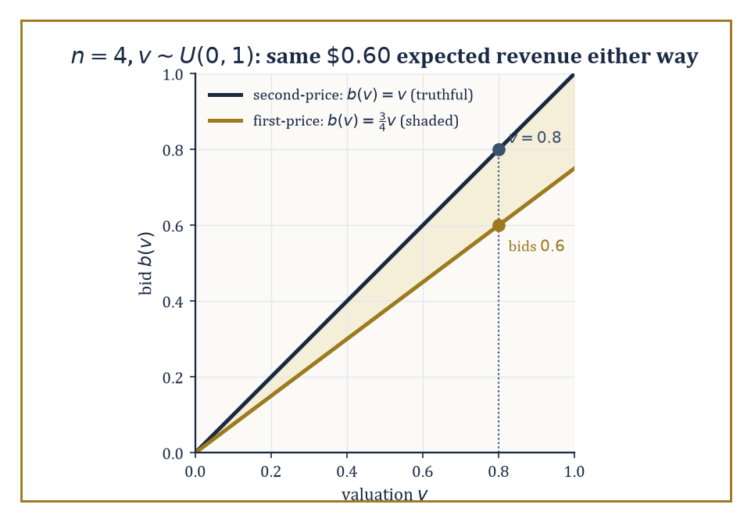
First-price shading against second-price honesty for four uniform bidders: different lines, identical sixty-cent expected revenue.
Different rules define different games: in a first-price sealed-bid auction the highest bidder wins and pays their own bid; in a second-price sealed-bid auction (Vickrey, 1961) the highest bidder wins but pays only the second-highest bid; in an ascending (English) auction the price rises openly until only one bidder remains; in a descending (Dutch) auction the price falls from a high starting point until someone accepts.
The revenue equivalence theorem is the startling unifying fact underneath all of this variety: under standard assumptions — bidders' valuations are independently and identically drawn from a common distribution, bidders are risk-neutral, and the object always goes to the highest-value bidder in equilibrium — a very wide class of auction formats, first-price and second-price included, yield exactly the same expected revenue for the seller.
The formats look utterly different in procedure and feel; in expectation, they are financially indistinguishable.
The Vickrey second-price auction has a property that makes it a favourite teaching example and, increasingly, a favourite real-world mechanism (variants power a good deal of online advertising auction infrastructure): bidding one's true valuation is a weakly dominant strategy.
That means it is a best response regardless of what anyone else bids, with no need to guess opponents' behaviour, model the distribution of their valuations, or engage in any strategic second-guessing whatsoever.
Numeric example — Worked example: why truthful bidding dominates in a second-price auction. A bidder values the item at v = $10, and let b* denote the highest bid submitted by everyone else — unknown to this bidder in advance, but fixed for the purposes of the argument. Consider Case 1, where the highest rival bid falls short of this bidder's value:
b* < 10
Bidding exactly v = 10 wins (ties broken however the rules specify) and pays b*, for a profit of:
10 − b* > 0
Bidding higher than 10 still wins, still pays b* (the price is set by the second-highest bid, not the winner's own bid), so the profit is identical: no gain from overbidding. Bidding below b* loses the auction, earning 0 — strictly worse whenever 10 − b* > 0.
Now consider Case 2, the reverse situation:
b* > 10
Bidding v = 10 loses, earning 0. Bidding anything between 10 and b* still loses. Bidding above b* wins but pays b*, giving a profit of:
10 − b* < 0
which is strictly worse than the 0 from losing. Bidding exactly v = 10 is therefore never worse, and sometimes strictly better, than any other bid, for every possible value of b* — precisely what 'weakly dominant' means.
The elegant consequence: this bidder never needs to think about what anyone else is likely to bid at all. The strategic problem simply evaporates, replaced by pure honesty, which is not a phrase auction theory gets to use very often.
First-price auctions offer no such free lunch: since the winner pays their own bid rather than the second-highest, bidding one's true value guarantees zero profit whenever you win (you'd have paid exactly what the item is worth to you), so rational bidders shade their bids downward, trading a lower chance of winning against a larger profit conditional on winning.
The equilibrium amount of shading depends on the number of competing bidders and the distribution their values are drawn from — more bidders means fiercer competition means less room to shade.
Numeric example — Worked example: revenue equivalence, checked with actual numbers. Take n = 4 bidders, each with a valuation drawn independently from a Uniform(0,1) distribution. A classical result gives the symmetric equilibrium bidding function in the first-price auction as:
b(v) = ((n−1)/n)·v
Here that is:
b(v) = (3/4)v
so a bidder valuing the item at 0.8 optimally bids 0.6, shading down by a quarter. To compare expected revenue across formats, recall a fact about order statistics of n iid Uniform(0,1) draws: the expected value of the k-th smallest of n draws is
k/(n+1)
The largest of 4 draws (k = 4) has expectation:
4/5 = 0.8
and the second-largest (k = 3) has expectation:
3/5 = 0.6
In the second-price auction, truthful bidding (from the earlier dominance argument) means the seller's revenue equals the second-highest valuation, so expected revenue is exactly:
3/5 = 0.6
In the first-price auction, the winner is whoever has the highest valuation, and they pay:
b(v_max) = (3/4)·v_max
so expected revenue is:
(3/4)·𝔼[v_max] = (3/4)·(4/5) = 3/5 = 0.6
— identical, to the exact fraction, to the second-price figure. Two auctions that look, run, and feel completely different — one truthful and transparent, one requiring careful strategic shading — hand the seller the same $0.60 in expectation, out of a maximum possible $1.00. Revenue equivalence, confirmed in cold arithmetic rather than merely asserted.
Mechanism design inverts the entire question the rest of this storey has been asking. Instead of starting from a fixed game and working out what equilibrium play looks like, it starts from a desired social outcome — the item should go to whoever values it most, say, or a public good should be built exactly when its total benefit exceeds its cost — and asks what game (what mechanism: what messages players may send, and what allocation and payment rule turns those messages into an outcome) will make self-interested equilibrium behaviour produce that outcome.
The revelation principle is the tool that makes this search tractable: it states that for any mechanism and any equilibrium of it, there exists an equivalent direct mechanism — one where players simply report their private information (their true valuation, say) directly — in which truthful reporting is itself an equilibrium and produces exactly the same outcomes.
This collapses an unbounded search over conceivable game forms down to a search over truthful direct mechanisms alone, subject to two basic constraints: incentive compatibility (no player can gain by lying about their private information) and individual rationality (no player is made worse off by participating than by staying out entirely).
The Vickrey auction, not coincidentally, is the simplest possible illustration of a direct, incentive-compatible, individually rational mechanism, since 'report your value' and 'bid your value' are, for that particular design, one and the same instruction.
Abstract example — Abstract example: the revelation principle in miniature. Suppose some indirect mechanism — a complicated multi-round bidding procedure, say — has an equilibrium in which a bidder with true value v strategically submits some transformed bid β(v) rather than v itself, and this produces outcome (allocation, payment) pair O(β(v)) for that bidder.
Define a new, direct mechanism: ask each bidder to report a value directly, and when a bidder reports r, run them through the transformation β and then through the original outcome rule, i.e. give them O(β(r)) exactly as the indirect mechanism would have.
In this constructed direct mechanism, reporting truthfully (r = v) delivers precisely the outcome O(β(v)) that the bidder was already getting by playing their equilibrium strategy β(v) in the original indirect game — and since β(v) was optimal there, r = v is optimal here, because the two mechanisms are, by construction, delivering identical outcomes for identical true values.
Nothing about the bidder's incentives has changed; only the label on what they're asked to submit has.
This is the entire content of the revelation principle: it is a change of variables, not a discovery about strategic behaviour, but it is a change of variables that turns an intractable search over all possible mechanisms into a tractable search over the comparatively small, well-behaved space of truthful ones.
Auctions and mechanism design are, fittingly, the point where this storey's mathematics turns from description to engineering: rather than merely predicting how self-interested agents will behave in a given game, the theory tells you how to build the game itself so that the behaviour it predicts is the behaviour you actually wanted all along.
Spectrum auctions, matching markets for school places and kidney exchanges, and the ad-auction infrastructure quietly running behind a great many web pages are this theory, deployed.

Room 41.9: Looking Ahead: From Classical Game Theory to Evolutionary, Algorithmic, and Behavioral Extensions
The tower continues, and so, alarmingly, does everyone else's reasoning about it
We have, over eight rooms, assembled the classical core of the subject: utility and expected utility as the one-player foundation; games in normal and extensive form as the two languages for describing strategic situations, one abstracting time away and one restoring it; dominance and best response as the basic solution tools; Nash equilibrium, in pure and mixed strategies, as the central self-enforcing solution concept, guaranteed to exist by Nash's theorem even where pure equilibria fail outright; subgame perfection as the refinement that separates credible strategies from empty threats; the folk theorems as the account of how repetition and patience manufacture cooperation that a single encounter could never sustain; cooperative solutions — the core, the Shapley value, Nash bargaining — as the mathematics of dividing jointly created value; and mechanism design as game theory reversed, engineering the rules so that self-interest does the designer's work.
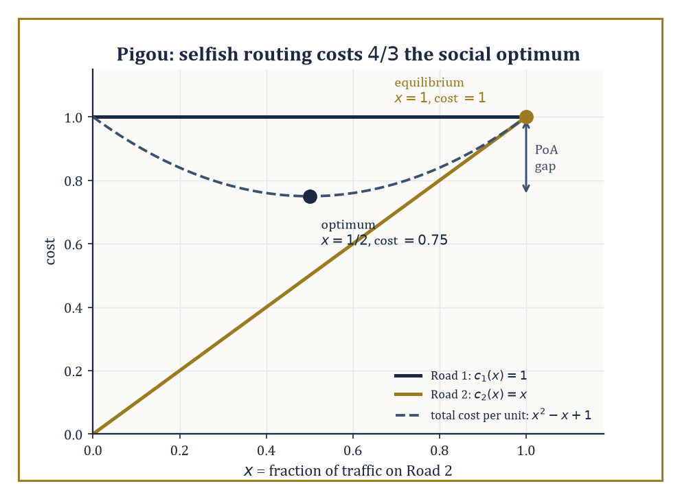
Pigou's two roads: selfish routing settles at cost 1 where a planner could have had 0.75 — the price of anarchy, drawn as a gap.
It is, by any reasonable standard, already a formidable toolkit.
It is also, this final room exists to insist, very much not the end of the story.
Evolutionary game theory (Maynard Smith and Price, 1973) drops the assumption that players are calculating, forward-looking reasoners at all, and replaces it with populations of agents playing fixed strategies, whose relative numbers change over time according to how well each strategy currently performs — strategies that do well multiply, strategies that do badly die out, no cognition required anywhere in the model.
The central solution concept is the evolutionarily stable strategy (ESS): a strategy that, once it dominates a population, cannot be successfully invaded by any rare mutant strategy, because the mutant does no better against the resident population than residents already do against each other.
Remarkably, this biological, non-rational notion of stability turns out to coincide, in the relevant technical sense, with a refinement of Nash equilibrium — evolution, with no reasoning involved anywhere, discovers the same equilibria that careful strategic calculation does, which either says something profound about the universality of the mathematics or something faintly deflating about how much credit strategic reasoning deserves, depending on your mood that afternoon.
Numeric example — Worked example: the evolutionarily stable strategy in Hawk-Dove. In the classic Hawk-Dove game, individuals compete for a resource worth V; Hawks always fight, Doves always retreat. Two Hawks meeting split the cost of a fight C evenly, each netting (V − C)/2; a Hawk meeting a Dove takes the whole resource (V) while the Dove gets 0; two Doves meeting share peacefully, each getting V/2.
Take the following values (fighting is expensive relative to the prize — a biologically realistic regime):
V = 2, C = 6
If Hawks are rare in a population and cost of conflict is high, an all-Dove population is unstable (a Hawk mutant does very well against passive Doves), but an all-Hawk population is also unstable, since C > V here means fighting is a net loss on average against other Hawks.
The mixed ESS is the Hawk-frequency p* at which a Hawk and a Dove earn exactly the same expected payoff against the population, so neither strategy can invade the other.
A Hawk's expected payoff against a population playing Hawk with probability p is:
p·(V−C)/2 + (1−p)·V
A Dove's expected payoff is:
p·0 + (1−p)·V/2
Setting these equal:
p(V−C)/2 + (1−p)V = (1−p)V/2
Substitute V = 2, C = 6:
p(−4)/2 + 2(1−p) = (1−p)(1)
−2p + 2 − 2p = 1 − p
−4p + 2 = 1 − p
−3p = −1
p = 1/3
This matches the well-known closed form exactly:
p* = V/C = 2/6 = 1/3
At this mixture — a population that is one-third Hawk, two-thirds Dove (or, equivalently, every individual playing Hawk with probability 1/3) — no mutant strategy, Hawk or Dove or anything in between, can achieve a higher average payoff, and the population sits in a stable evolutionary equilibrium that no individual organism ever had to reason its way into.
Algorithmic game theory asks the computer-science question that classical theory tends to wave past: how hard is it, computationally, to actually find these equilibria, and what happens to overall system efficiency when everyone plays selfishly rather than being centrally coordinated?
We have already met the first strand — PPAD-completeness of general Nash equilibrium computation, back in the mixed-strategy room.
The second strand asks about the price of anarchy: the ratio between the worst-case total welfare under selfish equilibrium play and the welfare achievable under a centrally-imposed social optimum, and it turns out this price can be substantial even in strikingly simple settings.
Numeric example — Worked example: the price of anarchy in Pigou's traffic example. One unit of traffic must travel from A to B via one of two roads. Road 1 has a constant travel cost of 1 regardless of how much traffic uses it; Road 2 has a cost equal to the fraction x of total traffic using it:
c₂(x) = x
Selfish drivers each choose whichever road is currently cheaper. At equilibrium, traffic keeps piling onto Road 2 until its cost rises to match Road 1's, since
c₂(0) = 0 < c₁ = 1
This happens exactly at x = 1, i.e. all traffic uses Road 2 (any driver peeling off to Road 1 would incur cost 1, identical to staying, so nobody has incentive to move first, and any earlier point with x < 1 still has c₂(x) = x < 1 pulling more traffic in).
Total cost at equilibrium:
1 unit of traffic × cost 1 each = 1
Now find the social optimum: a planner chooses the split x on Road 2 (and 1−x on Road 1) to minimize total cost:
x·c₂(x) + (1−x)·c₁ = x² + (1−x) = x² − x + 1
Differentiate:
d/dx(x² − x + 1) = 2x − 1 = 0
x = 1/2
(and the second derivative, 2, confirms a minimum). Total cost at the optimum:
(1/2)² + (1 − 1/2) = 0.25 + 0.5 = 0.75
The price of anarchy is the ratio of selfish cost to optimal cost:
1 / 0.75 = 4/3 ≈ 1.33
Selfish routing makes everyone worse off by a full third compared to what a benevolent traffic planner could achieve, purely because Road 2's cheap early capacity lures in more traffic than is collectively sensible, and no individual driver, choosing selfishly, has any reason to hold back. This is the mathematical seed of Braess's paradox, in which adding an additional road to a network can, astonishingly, make every driver's commute longer — a possibility that sounds like nonsense until you've sat with exactly this calculation.
Behavioral game theory folds the descriptive lessons of decision theory's paradoxes — Allais, Ellsberg, and their many relatives — back into strategic settings, replacing perfect best-response with models like quantal response equilibrium (players best-respond only probabilistically, with better responses more likely but not certain, capturing the reality that people err), level-k reasoning (players reason only a finite number of steps deep — 'I think you think I think...' stopping after k iterations rather than reaching a fully self-consistent equilibrium), and explicit fairness or inequity-aversion preferences (players' utilities depend not just on their own payoff but on how it compares to others', which alone explains a great deal of experimentally observed behaviour in bargaining and public-goods games that pure self-interest cannot).
Beyond these three extensions, the theory continues to grow outward into mean-field games (Lasry and Lions), which handle populations so large that no single player's action meaningfully affects any other individually, only through the aggregate distribution of behaviour — a genuinely different mathematical regime, closer to a partial differential equation than to a payoff matrix — and continuous-time stochastic games, where the state of the world evolves randomly between decision points and strategies must account for both the other players and the uncertainty of the environment itself.
The deeper lesson of the whole storey, stripped of its many payoff matrices, is this: rational choice in the presence of other rational choosers is not a mushy, case-by-case affair to be settled by intuition or negotiation seminars — it has genuine mathematical structure, precise solution concepts, known existence guarantees, known computational limits, and known failure modes, and that same body of mathematics turns out to be exactly what's needed to design the institutions — auctions, voting rules, matching markets, traffic networks — within which future choices will be made.
Game theory is the mathematics of strategic interaction: not merely a description of conflict and cooperation after the fact, but, in its mechanism-design guise, a set of tools for engineering better versions of both.
We arrived at this storey already able to optimize; we leave it able to optimize while somebody else optimizes back at us, which is a genuinely different and considerably more paranoid skill. Utility and expected utility gave us the one-player scaffolding; Nash equilibrium, in its pure, mixed, and sequential varieties, gave us the self-enforcing notion of a stable outcome; repeated play and cooperative solutions gave us cooperation without a referee; and mechanism design gave us the closing trick of building the game itself around the outcome we actually wanted. If you take only one habit of mind up the stairwell from here, let it be this: before asking what you should do, ask what everyone else, doing the same arithmetic about you, is rationally going to do first.
Notice, too, how much of this storey quietly leaned on probability without ever stopping to justify it — mixed strategies are probability distributions, expected utility is an expectation, the folk theorems traffic in discounted sums, ESS computations balance expected payoffs against a resident population. We borrowed the machinery and paid none of the intellectual rent. The next storey collects the debt properly: Statistics & Probability builds the theory of chance and inference from first principles — the very apparatus this storey spent nine rooms cheerfully assuming was already in the room.
It is, in its way, a fitting sequel. Game theory asks what a rational agent should do when the world includes other rational agents; probability and statistics ask what a rational agent should believe, and how confidently, when the world simply refuses to hold still and tell you the truth. Between the two, not much of decision-making under any form of uncertainty is left unaddressed. The tower continues upward. We have learned to reason about reasoning; next, we learn to reason about not knowing.

Storey 42: Statistics & Probability
Randomness, Inference, and the Art of Learning from Data
The previous storey left us in the company of game theorists, who build magnificent structures on a foundation of two convenient fictions: that the players are rational, and that they already know the probabilities of everything that might happen to them. It is a wonderful piece of scaffolding, and we leaned on it happily for an entire storey. But somebody, eventually, has to build the probabilities those payoff matrices were resting on, and somebody else has to go out into the world, collect a horribly small and horribly noisy pile of data, and try to reconstruct which of those probabilities is actually true. That is this storey's job. Game theory assumed the numbers; we now supply them, and then, with slightly less confidence, estimate them from evidence.
Probability and statistics are really one subject wearing two coats. Probability starts from a fully specified chance mechanism — a fair die, a biased coin, a population with a known distribution of heights — and computes what is likely to happen. Statistics runs the film backwards: it starts from what did happen, a stubborn little dataset sitting on a hard drive, and tries to infer what chance mechanism could plausibly have produced it. Every statistical method is only as good as the probability theory used to evaluate it, and every serious probability calculation eventually has to answer to data. Neither coat fits well without the other.
This storey builds the machinery of both from the ground up: random variables, expectation, conditioning, the great limit theorems that make large samples behave predictably, and then the statistical apparatus built on top of them — likelihood, estimation, hypothesis testing, regression, and a first, honest look at the Bayesian alternative to all of it. We keep things applied in spirit — real numbers, real computations, no measure-theoretic throat-clearing beyond what is strictly needed — while being honest about where the rigour is presently hiding, since Storey 43 is where we go back and do probability properly, with σ-algebras and all the trimmings, once you've seen why anyone would bother.
A confession, before we start: statistics is the branch of mathematics where elegance most visibly collides with compromise. The estimator you want does not exist; the test you want has no power; the model you fitted is, strictly speaking, wrong, because all models are, strictly speaking, wrong. Good statistical practice is not the pursuit of the perfect procedure — it is the art of choosing a procedure that keeps working when your assumptions turn out to be only approximately true, which is the only kind of assumption the universe ever actually grants you. With that cheerful disclaimer lodged, let us quantify some uncertainty.

Room 42.1: Probability Spaces and Random Variables
In which chance acquires a filing system
A probability space is nothing more exotic than a measure space whose total mass has been rationed to exactly one — a budget of certainty that every possible outcome must share. Formally it is a triple (Ω, ℱ, P): Ω is the sample space, the set of everything that could conceivably happen; ℱ is a collection of subsets of Ω called events, chosen so that the usual set operations (complement, countable union, countable intersection) never take you outside the collection; and P is a measure on ℱ satisfying the following normalisation.
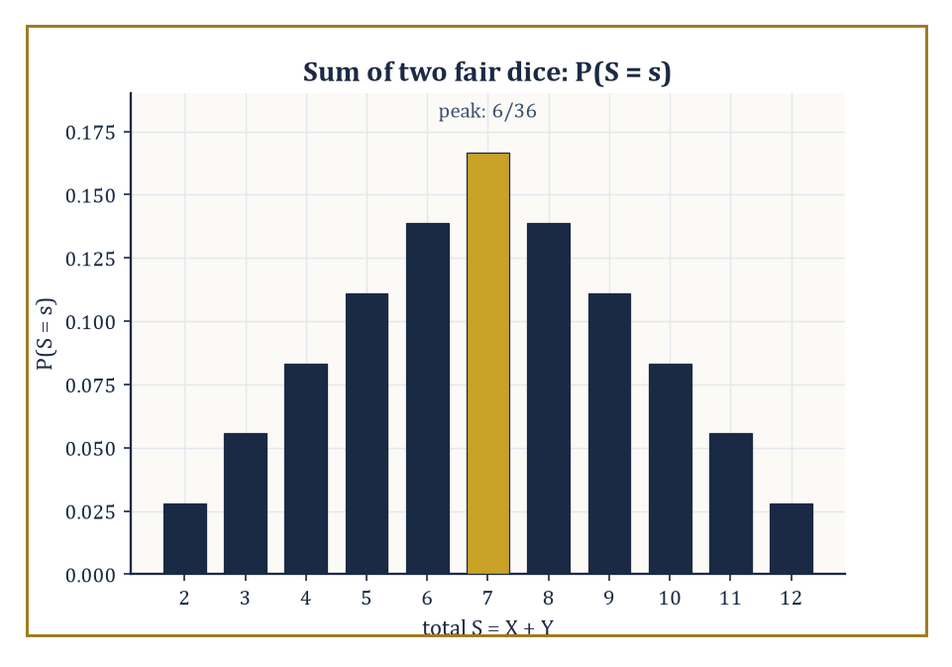
The probability mass function of the sum of two fair dice — a tent pitched squarely on 7, exactly as thirty-six equally likely outcomes demand.
P(Ω) = 1
An event's probability is simply its measure. This is the entire metaphysical commitment of the subject: uncertainty is mass, and mass of one unit is spread across all the ways the world might turn out.
Numeric example — Worked example — a single fair die. Let Ω = {1, 2, 3, 4, 5, 6}, one outcome per face. Take ℱ to be every subset of Ω (sixty-four of them, including the empty set and Ω itself — with a finite Ω you never need to be fussy about which sets are 'measurable'). Define the probability of each subset A as follows.
P(A) = |A|/6
Check the budget.
P(Ω) = 6/6 = 1
as required. The event 'the roll is even' is A = {2, 4, 6}, which has probability:
P(A) = 3/6 = 1/2
The event 'the roll exceeds 4' is B = {5, 6}, which has probability:
P(B) = 2/6 = 1/3
Nothing here is deep, but it is worth seeing the formalism close its jaws on something this simple before we ask it to bite into anything harder.
A random variable is not, despite the name, random or a variable in any sense a first-year algebra course would recognise — it is a measurable function X: Ω → ℝ, a rule that reads off a number from each outcome. Measurability just means that for every real number x, the following set is an event in ℱ.
{ω : X(ω) ≤ x} ∈ ℱ
so that we are always permitted to ask for the probability that X falls below some threshold. The distribution of X is the push-forward of P along X: a new measure on ℝ that records how the original mass of one lands once you view it through X's eyes. If X takes finitely or countably many values, the distribution is described by a probability mass function; if it takes a continuum of values smoothly, by a density. The cumulative distribution function is defined as follows.
F(x) = P(X ≤ x)
This is the universal translator that describes discrete, continuous, and even hybrid distributions in one formula, which is precisely why it is the object probabilists reach for first and abandon last.
Numeric example — Worked example — the sum of two dice. Roll two fair dice and let S = X + Y, the total. There are 36 equally likely ordered outcomes, each with probability 1/36. Counting the ways to make each total gives the probability mass function.
P(S=2)=1/36, P(S=3)=2/36, P(S=4)=3/36, P(S=5)=4/36, P(S=6)=5/36, P(S=7)=6/36, P(S=8)=5/36, P(S=9)=4/36, P(S=10)=3/36, P(S=11)=2/36, P(S=12)=1/36
This is a little tent shape peaking at 7, and the sceptical reader is invited to check that these eleven numbers sum to 36/36 = 1. The cumulative distribution function at 7 is:
F(7) = P(S≤7) = (1+2+3+4+5+6)/36 = 21/36 = 7/12 ≈ 0.583
This means that in slightly under three rolls out of five, two dice will total 7 or less. Compare a continuous cousin: if U is uniform on [0,1], its density and CDF on that interval are simple.
f(u) = 1, F(u) = u
so that:
P(0.2 < U ≤ 0.7) = F(0.7) − F(0.2) = 0.5
exactly — no counting required, because the mass is spread evenly rather than lumped at integers.
When several random variables live on the same sample space, their joint distribution is a measure on the product space of their possible values — a full account of how they behave together, not merely separately. From the joint distribution you can always recover each variable's marginal distribution (its behaviour ignoring the others, obtained by summing or integrating the joint over the variables you don't care about) and its conditional distributions (its behaviour once you've been told the value of the others). Independence is the special case in which conditioning teaches you nothing: the joint measure factors as a product of the marginals.
P(X∈A, Y∈B) = P(X∈A)·P(Y∈B) for all events A and B
It is the mathematical way of saying that two pieces of information genuinely have nothing to do with each other, a state of affairs statisticians spend a suspicious amount of energy both assuming and then testing for.
Numeric example — Worked example — checking independence directly. In the two-dice setup, let X be the first die and Y the second. Their joint distribution assigns probability 1/36 to each pair (i,j) with i,j ∈ {1,...,6}. The marginal of X is found by summing over all six values of Y for a fixed X=3.
P(X=3) = 6/36 = 1/6
and likewise P(Y=5) = 1/6. The joint probability is:
P(X=3, Y=5) = 1/36
and indeed the product rule holds exactly.
(1/6)×(1/6) = 1/36
confirming what physical common sense already told you: one die has no idea what the other one is doing. Contrast this with S = X+Y and X itself.
P(X=3, S=7) = P(X=3, Y=4) = 1/36
P(X=3)·P(S=7) = (1/6)(6/36) = 1/36
as well here — no contradiction yet, and checking a second case finds another exact match.
P(X=6,S=7)=1/36 against P(X=6)P(S=7)=(1/6)(1/6)=1/36
a quirk of the value 7 specifically (every X-value pairs with exactly one Y to make S=7, so X is, unusually, independent of the single event 'S=7'). The dependence is not hiding, though: try P(X=1,S=2) against P(X=1)P(S=2).
P(X=1,S=2)=1/36 vs. P(X=1)P(S=2)=(1/6)(1/36)=1/216
wildly unequal, so X and S are dependent overall, exactly as it should be, since S is built out of X.

Room 42.2: Expectation, Variance, and Conditioning
Averages, spreads, and the art of updating your beliefs when someone tells you something
Expectation is simply integration against the probability measure.
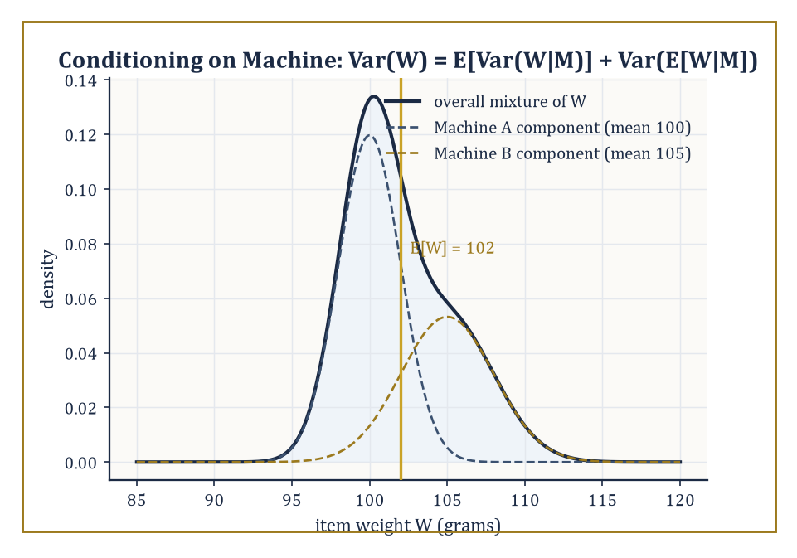
The two machine-conditional weight distributions blend into the overall mixture — the law of total variance is this picture, quantified.
E[X] = ∫ X dP
which for a discrete variable collapses to the familiar sum.
E[X] = Σ x·P(X=x)
It inherits linearity from the Lebesgue integral for free and without needing independence.
E[X+Y] = E[X] + E[Y]
always, whether or not X and Y have ever heard of each other, which surprises almost everyone the first time they see it proved. Positivity and the monotone and dominated convergence theorems likewise transfer over unchanged; expectation is Lebesgue integration wearing a probabilist's hat. Variance measures how far a variable typically strays from its own average.
Var(X) = E[(X−E[X])²]
and covariance measures the extent to which two variables stray together rather than independently.
Cov(X,Y) = E[(X−E[X])(Y−E[Y])]
Numeric example — Worked example — mean and variance of a die. For a fair die, the mean is:
E[X] = (1+2+3+4+5+6)/6 = 21/6 = 3.5
To get the variance, first compute E[X²].
E[X²] = (1²+2²+3²+4²+5²+6²)/6 = (1+4+9+16+25+36)/6 = 91/6 ≈ 15.1667
Then:
Var(X) = E[X²] − (E[X])² = 91/6 − 3.5² = 15.1667 − 12.25 = 2.9167
i.e. exactly 35/12. Now use linearity, which cost us nothing: for S = X+Y, the sum of two independent dice:
E[S] = E[X]+E[Y] = 3.5+3.5 = 7
the peak of the tent shape from the previous room, reassuringly. Because X and Y are independent, variances also add — a fact linearity alone does not give you; you need Cov(X,Y)=0 as well — so:
Var(S) = Var(X)+Var(Y) = 35/12+35/12 = 35/6 ≈ 5.833
Conditional expectation is the single most important construction in this room, and arguably in the entire subject. Given a σ-algebra 𝒢 (informally, a record of 'what you currently know'), E[X∣𝒢] is the 𝒢-measurable random variable that best approximates X in the least-squares sense — literally the orthogonal projection of X onto the subspace of 𝒢-measurable functions inside L². It is a random variable, not a number, because your best guess at X generally depends on which piece of the sample space you've landed in. The law of total expectation says that averaging your conditional best-guesses over all the ways 𝒢 could have turned out recovers the unconditional average.
E[X] = E[E[X∣𝒢]]
no information is lost or gained by conditioning and then un-conditioning. The law of total variance splits the total spread of X into an 'average within-group spread' term and a 'spread of the group averages' term.
Var(X) = E[Var(X∣𝒢)] + Var(E[X∣𝒢])
and is one of the most useful two-line theorems a working statistician owns.
Numeric example — Worked example — a factory with two machines. A factory's Machine A produces 60% of its output with a 2% defect rate; Machine B produces the remaining 40% with a 5% defect rate. Let D be the indicator that a randomly chosen item is defective, and let M record which machine made it — this M is exactly the 'σ-algebra' of the previous paragraph, dressed in overalls. The law of total expectation gives the overall defect probability.
E[D] = E[E[D∣M]] = P(M=A)·0.02 + P(M=B)·0.05 = 0.6×0.02 + 0.4×0.05 = 0.012 + 0.020 = 0.032
a 3.2% defect rate overall — and E[D∣M] is literally the step function taking the value 0.02 on every item from Machine A and 0.05 on every item from Machine B, which is exactly the L²-projection description: it is the simplest possible function that still respects what you know (the machine) while discarding everything you don't (which specific item). Now extend to a continuous quantity, item weight W in grams: given Machine A, W has mean 100 and variance 4; given Machine B, mean 105 and variance 9. The law of total variance gives:
Var(W) = E[Var(W∣M)] + Var(E[W∣M])
The first term is:
E[Var(W∣M)] = 0.6×4 + 0.4×9 = 2.4+3.6 = 6.0
For the second term, E[W∣M] equals 100 with probability 0.6 and 105 with probability 0.4, so:
E[E[W∣M]] = 0.6×100+0.4×105 = 60+42 = 102
and:
Var(E[W∣M]) = 0.6×100² + 0.4×105² − 102² = 6000 + 4410 − 10404 = 6.0
Total:
Var(W) = 6.0 + 6.0 = 12.0
a suspiciously tidy number, included here purely because it is more satisfying to check arithmetic that comes out clean.
Generating functions repackage a whole distribution as a single function chosen precisely so that a difficult operation on random variables — convolution, the way the distribution of a sum is built from the distributions of the parts — becomes easy multiplication of functions. The probability generating function of a variable X taking non-negative integer values is:
G(s) = E[s^X]
the characteristic function does the same job for arbitrary real-valued variables and always exists, which is its chief virtue over the more fragile moment generating function.
φ(t) = E[e^{itX}]
If X and Y are independent, the generating function of X+Y is simply:
G_{X+Y}(s) = G_X(s)·G_Y(s)
the messy sum-over-all-ways-to-make-a-total calculation from the two-dice example becomes ordinary polynomial multiplication.
Worked example — Worked example — recovering the dice-sum probabilities by multiplication. A single fair die has probability generating function:
G(s) = (s+s²+s³+s⁴+s⁵+s⁶)/6 = s(1+s+s²+s³+s⁴+s⁵)/6
For two independent dice, the PGF of the sum S is:
G(s)² = s²(1+s+s²+s³+s⁴+s⁵)²/36
Expand (1+s+s²+s³+s⁴+s⁵)² just far enough to check one coefficient: the s⁵ term (which, multiplied by the leading s², gives the coefficient of s⁷ in G(s)², matching P(S=7)) arises from pairs of exponents (0,5),(1,4),(2,3),(3,2),(4,1),(5,0) in the product — six pairs, each contributing coefficient 1×1, so the s⁵ coefficient is 6. Hence the s⁷ coefficient of G(s)² is:
6/36 = 1/6
exactly matching P(S=7) = 6/36 computed by brute-force counting in Room 42.1. The generating function did not know it was rolling dice; it multiplied two polynomials and produced the right answer anyway, which is either reassuring or slightly eerie, depending on how much sleep you've had.

Room 42.3: Independence and Classical Limit Theorems
Why averaging things makes chaos behave, eventually, mostly
Independence extends naturally from events to whole σ-algebras: two σ-algebras 𝒢 and ℋ are independent if every event in 𝒢 is independent of every event in ℋ, and a sequence of random variables is independent if the σ-algebras they generate are jointly independent.
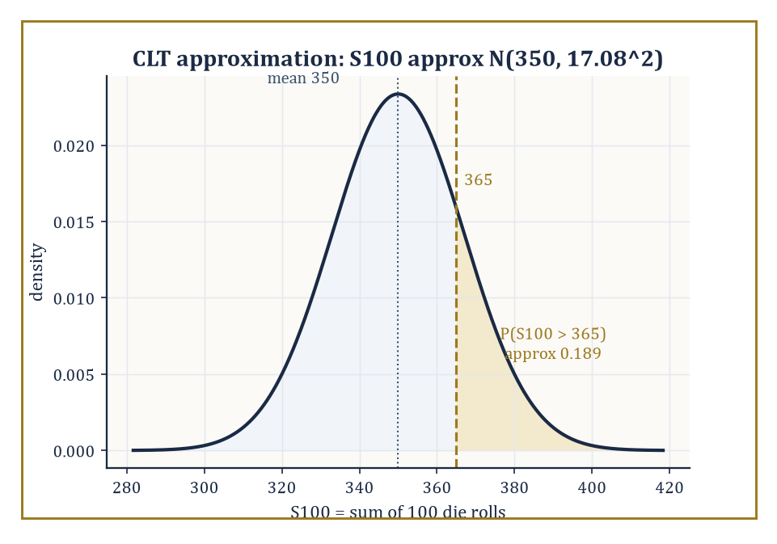
The CLT's Gaussian stand-in for the sum of 100 dice, with the tail P(S100 > 365) shaded in gold.
A sequence that is both independent and identically distributed — i.i.d., the two most-abused initials in the subject — is the setting for the two theorems that make classical statistics possible at all. The law of large numbers (LLN) says that the sample average of n i.i.d. variables with finite mean μ converges to μ as n grows — informally, that random noise averages itself away.
The central limit theorem (CLT) says something sharper and stranger: rescale the deviation of that average from μ by √n and, regardless of the shape of the original distribution — lumpy, skewed, bimodal, whatever — the rescaled deviation converges in distribution to a Gaussian. Chaos, viewed through the correct rescaling, turns out to have a fixed, universal shape.
Numeric example — Worked example — the law of large numbers as shrinking variance. For the fair die, Var(X) = 35/12 ≈ 2.9167 (Room 42.2). The sample mean of n independent rolls has the following variance, since averaging n independent copies divides the variance by n — a direct consequence of Var(X+Y)=Var(X)+Var(Y) for independent variables, plus the scaling rule Var(cX)=c²Var(X).
Var(X̄ₙ) = Var(X)/n
At n=10:
Var(X̄₁₀) = 2.9167/10 = 0.2917, standard deviation ≈ 0.540
a typical run of ten rolls might plausibly average anywhere from about 3.0 to 4.0. At n=1000:
Var(X̄₁₀₀₀) = 2.9167/1000 = 0.0029, standard deviation ≈ 0.054
now the average is essentially pinned to 3.5 ± 0.11 or so. This is the LLN made visible without needing to actually roll a thousand dice: the theoretical spread of the sample mean shrinks like 1/√n, squeezing the average toward the true mean of 3.5 as n grows, exactly as advertised, and entirely mechanically.
Numeric example — Worked example — the CLT approximating a dice-sum tail probability. Let S₁₀₀ be the sum of 100 independent fair-die rolls. By linearity:
E[S₁₀₀] = 100×3.5 = 350
and by independence:
Var(S₁₀₀) = 100×(35/12) = 291.67, standard deviation = √291.67 ≈ 17.08
The exact distribution of S₁₀₀ is a nightmare of a sum over an enormous number of dice-outcome combinations; the CLT lets us skip it entirely by approximating:
S₁₀₀ ≈ N(350, 17.08²)
To estimate P(S₁₀₀ > 365), standardise:
z = (365−350)/17.08 = 15/17.08 ≈ 0.88
and read off the standard normal tail Φ(0.88) ≈ 0.8106, giving:
P(S₁₀₀ > 365) ≈ 1 − 0.8106 = 0.1894
or about 19%. The honest reader should note this is an approximation — the true sum is discrete and bounded between 100 and 600 — but for n this large the approximation is excellent, which is precisely the CLT's promise and precisely why it underwrites so much of classical statistics: sums and averages of almost anything look Gaussian once you have enough of them.
There is more than one way for a sequence of random variables to 'converge', and the differences matter. Convergence in probability means that for every ε>0, the following holds.
P(|Xₙ−X|>ε) → 0
the variable is eventually almost certainly close to its limit, though it may occasionally misbehave. Almost-sure convergence is stronger: it says that, with probability one, the entire sequence of outcomes (not just the probability of a single deviation) settles down and stays close to the limit forever after some point. Convergence in distribution is weaker still — only the distributions need to converge, not the variables themselves, which may not even live on a comparable sample space.
The implications run as follows, and none of the reverse implications hold in general — a fact best appreciated through a genuine counterexample rather than taken on faith.
a.s. ⇒ in probability ⇒ in distribution
Abstract example — Abstract example — convergence in probability without almost-sure convergence. Let U be uniform on [0,1]. Enumerate the sequence of intervals I₁=[0,1], I₂=[0,½], I₃=[½,1], I₄=[0,⅓], I₅=[⅓,⅔], I₆=[⅔,1], and so on: at 'level k' the interval [0,1] is chopped into 2^k equal pieces, and the pieces are listed in order, one after another — the classic 'typewriter sequence'. Define Xₙ = 1 if U falls in the n-th interval on this list, and 0 otherwise.
Since the n-th interval at level k has length 1/2^k, and level k is reached once n exceeds roughly 2^k, we get the following.
P(Xₙ=1) = 1/2^k → 0 as n→∞
so Xₙ → 0 in probability: the chance of a false alarm shrinks to nothing. But almost-sure convergence fails completely: because every level's intervals tile the whole of [0,1], every single point U=u lies in exactly one interval at each level k, meaning Xₙ(u)=1 for infinitely many n, no matter which u you picked. So for every outcome, the sequence Xₙ(u) equals 1 infinitely often and never settles down — it does not converge to 0, or to anything, at any single point. Convergence in probability tolerates this kind of persistent, shrinking, but never-vanishing misbehaviour; almost-sure convergence does not.
Two workhorse theorems let us transfer limiting behaviour through further computation without redoing the analysis from scratch. The continuous mapping theorem says that if Xₙ converges (in any of the above senses) to X, and g is a continuous function, then g(Xₙ) converges to g(X) in the same sense — limits pass through continuous transformations for free.
Slutsky's theorem handles the common situation where you have one sequence converging in distribution and a second converging in probability to a constant: if Xₙ→ᵈ X and Yₙ→ᵖ c, then the following both hold.
Xₙ+Yₙ →ᵈ X+c and Xₙ·Yₙ →ᵈ cX
This innocuous-looking pair of results is what justifies, among other things, replacing an unknown standard deviation by its sample estimate inside a test statistic and still trusting the resulting distribution — the very trick that makes the t-statistic of Room 42.6 legitimate.
Abstract example — Abstract example — why Slutsky legitimises the t-statistic. Suppose the following holds by the CLT, where σ is the true (unknown) standard deviation.
√n(X̄ₙ−μ)/σ →ᵈ N(0,1)
In practice we don't know σ, so we substitute the sample standard deviation Sₙ, which by the law of large numbers satisfies the following — a consistency fact, not a distributional one, since it converges to a constant.
Sₙ →ᵖ σ
Write the statistic as a product of two brackets.
√n(X̄ₙ−μ)/Sₙ = [√n(X̄ₙ−μ)/σ] × [σ/Sₙ]
The first bracket converges in distribution to N(0,1); the second converges in probability to the constant 1 (since Sₙ→ᵖσ). Slutsky's theorem then licenses multiplying these together and concludes the following as well.
√n(X̄ₙ−μ)/Sₙ →ᵈ N(0,1)
the swap of the true σ for the estimated Sₙ costs nothing in the limit. This one abstract move, entirely mechanical once you trust the theorem, is what allows every introductory-statistics t-test to pretend it knows the population standard deviation when it manifestly does not.

Room 42.4: Parametric Models and Likelihood
Turning the model around and asking which parameter it likes best
A parametric model is a family of distributions {P_θ : θ ∈ Θ} indexed by a finite-dimensional parameter θ, ranging over some parameter space Θ — a Bernoulli(p) model indexed by p ∈ [0,1], say, or a Normal(μ,σ²) model indexed by (μ,σ²) ∈ ℝ×(0,∞).
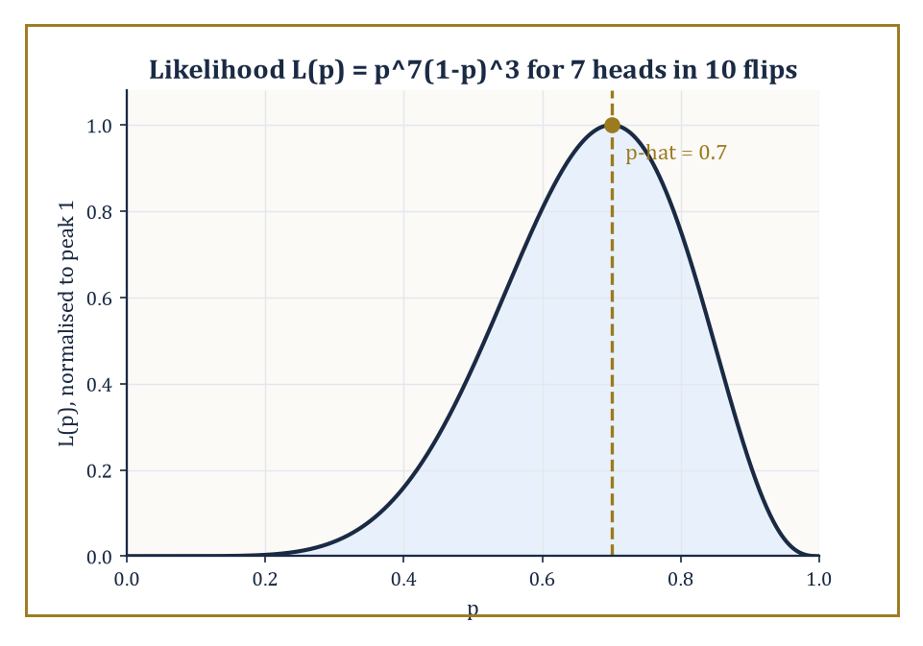
The likelihood curve for 7 heads in 10 flips, peaking obediently at p-hat = 0.7.
The likelihood function performs a small act of conceptual jujitsu: it takes the same density or mass function f(x;θ) used to compute probabilities of data given a parameter, and, once the data x are fixed at their observed values, reinterprets it as a function of θ instead.
L(θ) = f(x;θ)
The maximum-likelihood estimator (MLE), θ̂, is whichever value of θ makes the observed data look as probable as possible.
Under mild regularity conditions the MLE is consistent (it converges to the true θ as sample size grows), asymptotically normal (its sampling distribution becomes Gaussian for large samples, courtesy of the CLT machinery of the previous room), and asymptotically efficient (no competing consistent estimator can beat its large-sample variance).
Numeric example — Worked example — MLE for a coin. Flip a coin 10 times and observe 7 heads. Modelling each flip as Bernoulli(p), the likelihood of this data is the following (seven factors of p for the heads, three of (1−p) for the tails; the binomial coefficient C(10,7) is a constant that doesn't affect where the maximum sits, so it's usually dropped).
L(p) = p⁷(1−p)³
It's easier to maximise the log-likelihood.
ℓ(p) = 7 ln p + 3 ln(1−p)
Differentiating and setting to zero:
ℓ'(p) = 7/p − 3/(1−p) = 0
so 7(1−p) = 3p, giving 7 − 7p = 3p, hence 7 = 10p, so:
p̂ = 0.7
exactly the sample proportion of heads, as the theory predicts for a Bernoulli model.
The Fisher information I(θ) measures how sharply the log-likelihood curves near the true parameter — a sharp, narrow peak means the data pin θ down tightly; a broad, flat peak means the data are nearly indifferent to θ. Formally, it is the expected curvature of the log-likelihood.
I(θ) = E[−∂²/∂θ² ln f(X;θ)]
The Cramér–Rao bound then states that no unbiased estimator of θ can have variance smaller than the following.
Var(θ̂) ≥ 1/I(θ)
The information sets a hard floor under how precisely you are ever allowed to know the parameter, however cleverly you build your estimator. An estimator that actually achieves this floor is called efficient.
Numeric example — Worked example — the Cramér–Rao bound for the coin. For a single Bernoulli(p) observation, one can show the Fisher information is 1/(p(1−p)); for n independent flips it is:
Iₙ(p) = n/(p(1−p))
With n=10 and p=0.7:
p(1−p) = 0.7×0.3 = 0.21, I₁₀(0.7) = 10/0.21 ≈ 47.62
The Cramér–Rao bound is then:
Var(p̂) ≥ 1/I₁₀(0.7) = 0.21/10 = 0.021
Compare this to the actual variance of the sample proportion, a standard fact about Bernoulli trials.
Var(p̂) = p(1−p)/n = 0.21/10 = 0.021
the two numbers coincide exactly. The sample proportion doesn't just satisfy the Cramér–Rao bound; it sits precisely on it, meaning it wastes not one drop of the information the data contain. Few estimators in this life are so honestly efficient; treasure this one while you can.
Exponential families are the distributions whose density can be written in the following form, for some functions h, η, T, A.
f(x;θ) = h(x)·exp(η(θ)·T(x) − A(θ))
A rather forbidding formula that buys a remarkably clean payoff: the log-likelihood is linear in the statistic T(x), meaning that however large your sample, all the information relevant to estimating θ compresses losslessly into the single (or finite-dimensional) quantity T(x), called a sufficient statistic.
The Bernoulli, Poisson, exponential, normal, and gamma families are all exponential families, which is why maximum-likelihood estimation for them so often reduces to computing one simple summary of the data — a sample mean, a sample proportion, a sum — rather than requiring the entire dataset to be retained.
Numeric example — Worked example — sufficiency and MLE for a Poisson model. Suppose five independent counts are observed from a Poisson(λ) model: x = (2, 4, 3, 5, 1). The Poisson family is exponential with sufficient statistic T(x) = Σxᵢ, so the entire dataset compresses to a single number.
Σxᵢ = 2+4+3+5+1 = 15
The log-likelihood, with n=5, is:
ℓ(λ) = Σ(−λ + xᵢ ln λ − ln xᵢ!) = −nλ + (Σxᵢ) ln λ + constant
Setting ℓ'(λ) = −n + (Σxᵢ)/λ = 0 gives:
λ̂ = (Σxᵢ)/n = 15/5 = 3
the sample mean, exactly as sufficiency predicted — the individual values 2, 4, 3, 5, 1 were never needed beyond their sum. The Fisher information for a single Poisson observation is 1/λ, so for n=5 at λ=3:
I₅(3) = 5/3 ≈ 1.667
giving a Cramér–Rao bound of:
1/I₅(3) = 3/5 = 0.6
And since Var(Xᵢ)=λ for a Poisson variable, the true variance of the sample mean is:
Var(λ̂) = λ/n = 3/5 = 0.6
the bound is met exactly again. Two for two: both the Bernoulli and Poisson MLEs turn out to be efficient, though the reader should be warned this happy coincidence is a feature of exponential families specifically, not a universal law of the mathematical universe.
That phrase 'under mild regularity conditions' has been doing a great deal of quiet work throughout this room, and it is worth showing what happens when the conditions are withdrawn. Regularity essentially demands that the support of the model — the set of x-values that have positive probability — does not itself depend on θ, so that the likelihood is smooth in θ everywhere it matters.
When the support does depend on the parameter, both the Cramér–Rao bound and the usual √n-rate asymptotic normality can fail outright, and the MLE can behave in a completely different, and often better, way.
Numeric example — Worked example — a non-regular model, Uniform(0,θ). Let X₁,…,Xₙ be i.i.d. Uniform(0,θ), so the density is f(x;θ)=1/θ for 0≤x≤θ and 0 otherwise — the support [0,θ] depends on θ itself, immediately breaking the regularity assumption.
The likelihood is L(θ)=1/θⁿ for θ ≥ max(x₁,…,xₙ), and 0 for any smaller θ, since a smaller θ would make some observed xᵢ impossible. Because 1/θⁿ is decreasing in θ, the likelihood is maximised by taking θ as small as the data will allow, giving the MLE:
θ̂ = max(X₁,…,Xₙ)
Take a concrete sample of n=5 draws from a true θ=10: x = (3.1, 7.8, 9.6, 2.4, 6.0). The MLE is:
θ̂ = max(x) = 9.6
a perfectly sensible-looking estimate, but a biased one: one can show that:
E[max(X₁,…,Xₙ)] = (n/(n+1))θ
so here:
E[θ̂] = (5/6)×10 ≈ 8.333, bias = 8.333−10 = −1.667
Worse (or rather, more interestingly) for the asymptotics: because the maximum of n uniforms converges to θ at rate n rather than the usual √n, the estimator's error shrinks far faster than regularity theory promises, and its limiting distribution is exponential, not Gaussian. The MLE recipe still hands you an answer here — it simply refuses to obey the standard-issue asymptotic normality and Cramér–Rao machinery this room otherwise leans on so heavily, a useful reminder to check the fine print before trusting a general theorem.

Room 42.5: Estimation and Confidence Intervals
How wrong you're willing to admit you might be, quantified
A point estimator is judged by three related quantities. Its bias measures systematic error — does it aim at the right target on average?
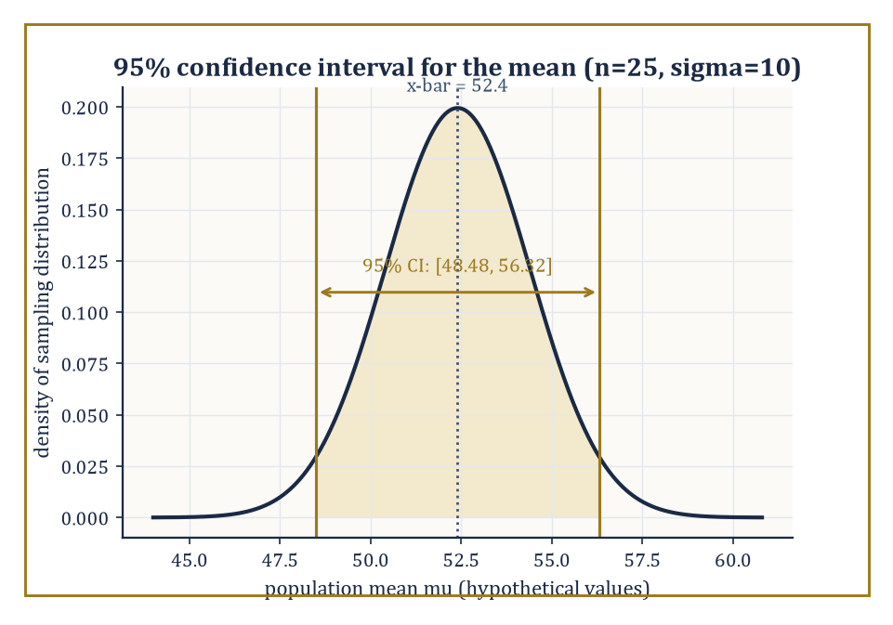
The sampling distribution behind a 95% confidence interval — a statement about the manufacturing process, not about this one interval.
Bias(θ̂) = E[θ̂] − θ
Its variance measures how much it wobbles from sample to sample around wherever it is aiming. And its mean squared error combines both into a single number, via a short algebraic identity worth memorising.
MSE(θ̂) = E[(θ̂−θ)²] = Var(θ̂) + Bias(θ̂)²
An estimator can trade a little bias for a large reduction in variance and come out ahead on MSE, which is precisely the philosophical justification behind an enormous amount of modern regularised statistics and machine learning.
Numeric example — Worked example — the bias of the maximum-likelihood variance estimator. Given n i.i.d. observations with true variance σ², the maximum-likelihood estimator of variance is:
S²_MLE = (1/n)Σ(Xᵢ−X̄)²
which has expectation — a standard, if slightly fiddly, calculation traceable to the fact that X̄ itself is estimated from the same data, using up one degree of freedom.
E[S²_MLE] = ((n−1)/n)σ²
Take n=5 and suppose the true variance is σ²=16. Then:
E[S²_MLE] = (4/5)×16 = 12.8, bias = 12.8 − 16 = −3.2
the MLE systematically underestimates the variance by 3.2 on average, for this sample size. This is exactly why the 'unbiased' sample variance divides by n−1 rather than n — it corrects precisely this deficit, at the cost of being (very slightly) less efficient in mean-squared-error terms for some models. Nobody said this subject would stop making you choose between two imperfect options.
Bias and variance are only the ingredients; how they get combined into a verdict depends on a loss function chosen up front, and different loss functions can crown different estimators as 'best'.
Squared-error loss is minimised in expectation by the mean, and its associated risk is exactly the MSE already discussed.
(θ̂−θ)²
Absolute-error loss is instead minimised by the median, which cares only about which side of the truth an estimate falls on, not by how far — a property that makes median-based estimators far more forgiving of the occasional wild outlier.
|θ̂−θ|
Numeric example — Worked example — mean versus median under an outlier. Consider the small dataset {1, 2, 2, 3, 50} — four ordinary-looking measurements and one that looks like a typo or a genuine rare event. The sample mean is:
(1+2+2+3+50)/5 = 58/5 = 11.6
dragged far from where four of the five points actually sit, because squared-error loss punishes the single large deviation so heavily that the estimator is forced to chase it.
(50−11.6)² = 1474.56
The sample median, sorting to (1,2,2,3,50) and taking the middle value, is 2 — untouched by the outlier's exact magnitude, since absolute-error loss only 'sees' that 50 is on the high side, not how astronomically high. Neither estimator is objectively correct; which one is 'best' depends entirely on whether the loss function governing the decision genuinely penalises large errors quadratically (squared-error, favouring the mean) or merely linearly (absolute-error, favouring the median) — a choice statistics cannot make for you, only illuminate the consequences of.
An interval estimator attaches an honest admission of uncertainty to a point estimate. A 95% confidence interval is constructed by a procedure that, applied to repeated independent samples, would contain the true (fixed, non-random) parameter in 95% of those repetitions — a statement about the reliability of the procedure across hypothetical repeated sampling, not a probability statement about the one interval you happen to be holding, however much everyone (including, on a bad day, the author) is tempted to say the latter.
For many exponential-family models exact intervals are available in closed form; more generally, one leans on the CLT-driven asymptotic normality of the MLE from Room 42.4 to build an approximate interval, where SE is the estimated standard error and z is a quantile of the standard normal (1.96 for 95% coverage, since Φ(1.96)≈0.975 leaves 2.5% in each tail).
θ̂ ± z·SE(θ̂)
Numeric example — Worked example — a confidence interval for a mean. Suppose a sample of n=25 measurements has sample mean X̄=52.4, and the population standard deviation is known to be σ=10 (a slightly artificial but pedagogically forgivable assumption). The standard error of the mean is:
SE = σ/√n = 10/5 = 2
A 95% confidence interval is:
X̄ ± 1.96×SE = 52.4 ± 1.96×2 = 52.4 ± 3.92 = [48.48, 56.32]
The correct reading: if this sampling-and-interval-building procedure were repeated many times on fresh samples of size 25, about 95% of the resulting intervals would contain the true population mean. This particular interval either contains the true mean or it does not — the 95% describes the manufacturing process, not this one unit off the line.
When the sampling distribution of an estimator has no clean closed form — which, in the untidy world outside textbook exponential families, is most of the time — the bootstrap offers a computational escape hatch. It approximates the sampling distribution of a statistic by resampling the observed data with replacement, recomputing the statistic on each resample, and using the spread of those recomputed values as a stand-in for the true (unknown) sampling variability.
It costs computation rather than mathematical cleverness, which is precisely why it only became routine once computers became cheap.
Numeric example — Worked example — bootstrap resampling by hand. Take the tiny dataset {2, 5, 9}, with sample mean:
(2+5+9)/3 = 16/3 ≈ 5.333
A bootstrap resample draws 3 values from {2,5,9} with replacement — so any value may appear zero, one, two, or three times. A few illustrative resamples, drawn to show the mechanics rather than a full simulation, give the following means.
{2,2,9}: (2+2+9)/3 = 13/3 ≈ 4.333
{5,5,5}: mean = 5
{9,9,2}: (9+9+2)/3 = 20/3 ≈ 6.667
and {2,5,9} itself (the original sample, which is one of the 27 equally likely ordered resamples for n=3) recovers the original mean 16/3. Collecting many such resample means — in practice, thousands of them, generated by a computer rather than a patient human — builds up an approximate distribution for the sample mean, from which a bootstrap confidence interval can be read off directly, without ever invoking the CLT or assuming a particular parametric family. The price is that you need a machine and a few thousand repetitions rather than a formula; the reward is that the method barely cares what the underlying distribution actually is.

Room 42.6: Hypothesis Testing
Formalised scepticism, with a strict word limit on how wrong you're allowed to be
A hypothesis test adjudicates between a null hypothesis H₀ (the sceptical default, usually 'nothing interesting is going on') and an alternative H₁, using the observed data as evidence.
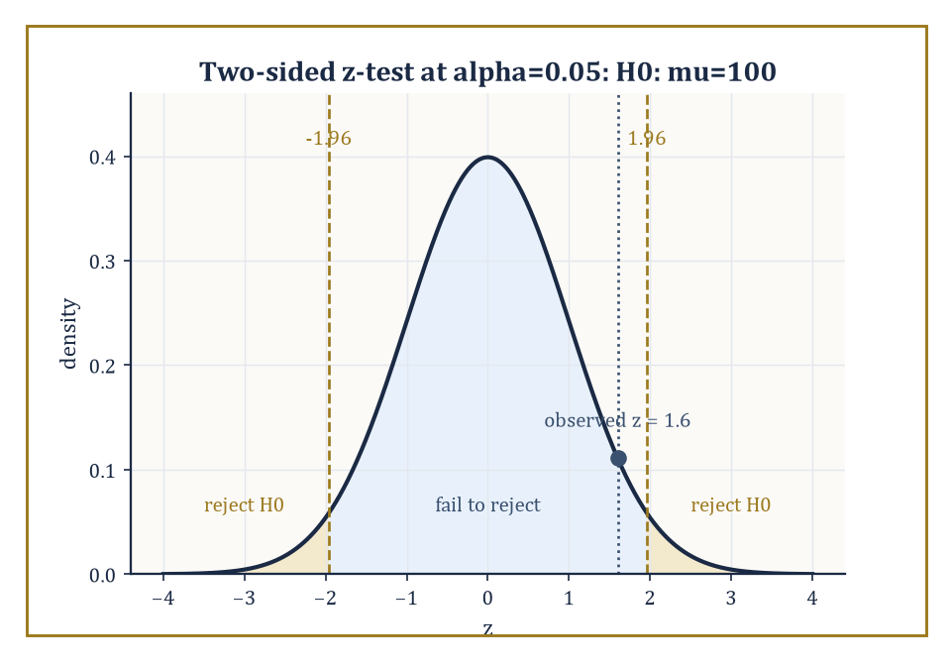
The two-sided z-test's rejection regions, with the observed z = 1.6 landing safely — if narrowly — inside 'fail to reject'.
The Neyman–Pearson framework fixes in advance the probability of a Type I error — rejecting H₀ when it is in fact true — at some small level α, called the size of the test (conventionally 0.05, a number chosen by historical accident and defended ever since by force of habit), and then, among all tests with that size, seeks the one with maximal power: the highest probability of correctly rejecting H₀ when the alternative is in fact true.
For composite hypotheses — where H₀ or H₁ specify a whole range of parameter values rather than one exact value — the likelihood-ratio test, which rejects when the likelihood under the best-fitting null parameter is much smaller than under the best-fitting unrestricted parameter, is the generic, essentially always-sensible choice under regularity conditions.
Numeric example — Worked example — a z-test for a mean. Test H₀: μ=100 against H₁: μ≠100, with known population standard deviation σ=15 and a sample of n=36 giving X̄=104. The test statistic is:
z = (X̄−μ₀)/(σ/√n) = (104−100)/(15/6) = 4/2.5 = 1.6
At significance level α=0.05, the two-sided rejection region is |z|>1.96; since 1.6<1.96, we fail to reject H₀ — the data are not surprising enough under the null to overturn it. The p-value quantifies precisely how unsurprising.
p = 2×P(Z>1.6) = 2×(1−Φ(1.6)) = 2×(1−0.9452) = 2×0.0548 = 0.1096
Since 0.1096 > 0.05, the conclusion matches the rejection-region approach, as it always must — the p-value and the fixed-α test are two descriptions of the same comparison.
The p-value is the probability, computed under the null hypothesis, of observing data at least as extreme as what was actually seen.
It is not the probability that the null hypothesis is true, it is not the probability that the result is 'due to chance' in some vague philosophical sense, and it does not measure the size or importance of an effect — three misreadings so common and so persistent that entire journal editorial policies have been rewritten to fight them, with only partial success. It is a statement about the data, conditional on the null, full stop.
Power, meanwhile, is the mirror-image quantity: the probability of correctly rejecting H₀ when a specific alternative is true, and it depends on the sample size, the significance level, and how far the true parameter actually sits from the null value.
Numeric example — Worked example — computing power against a specific alternative. Continue the previous test (H₀: μ=100, σ=15, n=36, α=0.05, two-sided, so SE=2.5), whose rejection region is the following.
X̄ > 100+1.96×2.5 = 104.9 or X̄ < 100−1.96×2.5 = 95.1
Suppose the true mean is actually μ=108 — how often would this test catch it? Under the true μ=108, X̄ ~ N(108, 2.5²). The probability of landing in the upper rejection region is:
P(X̄>104.9) = P(Z > (104.9−108)/2.5) = P(Z > −1.24) = Φ(1.24) ≈ 0.8925
using the symmetry Φ(−z)=1−Φ(z). The probability of landing in the lower rejection region, P(X̄<95.1), is astronomically small under a true mean of 108 (over five standard deviations away) and safely ignored. So the power against the alternative μ=108 is approximately 0.8925 — this test would correctly flag the shift about 89% of the time, and miss it, embarrassingly, the other 11%.
Run enough tests and some will reject purely by chance, however true every null hypothesis actually is — this is the multiple-testing problem, and ignoring it is one of the most common ways good data becomes a bad paper.
The Bonferroni correction is the crude but reliable fix: to keep the overall (family-wise) probability of at least one false rejection at or below α across m independent tests, run each individual test at level α/m instead of α; the union bound guarantees the total error stays controlled.
The false-discovery-rate approach is a subtler, less conservative alternative, controlling the expected proportion of false rejections among all rejections rather than the probability of any false rejection at all — appropriate when you expect to make some discoveries and can tolerate a controlled fraction of them being wrong, which describes most of genomics and a distressing amount of the social sciences.
Numeric example — Worked example — the cost of not correcting for multiple tests. Suppose 20 independent hypothesis tests are each run at the nominal level α=0.05, and every single null hypothesis happens to be true (nothing real is going on anywhere). The probability that at least one test rejects anyway is:
1 − (0.95)²⁰
Computing (0.95)²⁰ by repeated squaring:
(0.95)²=0.9025, (0.95)⁴=0.9025²≈0.8145, (0.95)⁸≈0.8145²≈0.6634, (0.95)¹⁶≈0.6634²≈0.4401, (0.95)²⁰=(0.95)¹⁶×(0.95)⁴≈0.4401×0.8145≈0.3585
So the family-wise error rate is approximately:
1−0.3585=0.6415
a 64% chance of at least one spurious 'significant' result out of twenty tests on pure noise, despite each individual test looking perfectly respectable at the 5% level. Applying the Bonferroni correction, each test is instead run at α/20 = 0.0025; the union bound then guarantees the family-wise error rate is at most:
20×0.0025=0.05
restoring the 5% guarantee for the collection as a whole, at the cost of making each individual test considerably harder to pass.
Every test considered so far has fixed its sample size n in advance and looked at the data exactly once.
Sequential analysis instead lets the sample size itself be a random, data-driven quantity: after each new observation, a running likelihood ratio is compared against two thresholds, and sampling stops the moment the evidence is decisive enough in either direction — often letting a clear-cut case be settled with far fewer observations than a fixed-n design would have required, which matters enormously when each additional observation is expensive, slow, or (in a clinical trial) ethically fraught.
Numeric example — Worked example — Wald's sequential probability ratio test. Test H₀: p=0.5 against H₁: p=0.7 for a stream of coin flips, at Type I error α=0.05 and Type II error β=0.05. Wald's sequential probability ratio test (SPRT) tracks the cumulative likelihood ratio and stops as soon as it leaves the interval (B, A).
Λₙ = L₁(x₁,…,xₙ)/L₀(x₁,…,xₙ), A = (1−β)/α, B = β/(1−α)
Here:
A = 0.95/0.05 = 19, B = 0.05/0.95 ≈ 0.0526
if Λₙ climbs to 19 or beyond, stop and reject H₀ (the data are 19 times more consistent with p=0.7 than p=0.5); if Λₙ falls to 0.0526 or below, stop and fail to reject H₀; otherwise, flip again. Each observed head multiplies Λₙ by 0.7/0.5=1.4, and each tail multiplies it by 0.3/0.5=0.6. Starting from Λ₀=1, four heads in a row would give:
Λ₄=1.4⁴≈3.84
not yet decisive — while seven heads in a row give:
Λ₇=1.4⁷≈10.54
still short of 19, and eight heads give:
Λ₈≈14.76
still short; a ninth head pushes it to:
Λ₉≈20.66
crossing 19 and triggering a stop-and-reject after just nine observations, something a fixed-sample z-test of comparable error rates would typically need several times as many flips to achieve, precisely because the sequential design keeps spending observations only for as long as the evidence remains genuinely ambiguous.

Room 42.7: Linear Models and Regression
Drawing the straight line that data least objects to
The linear model expresses a response Y as a linear function of covariates plus noise.
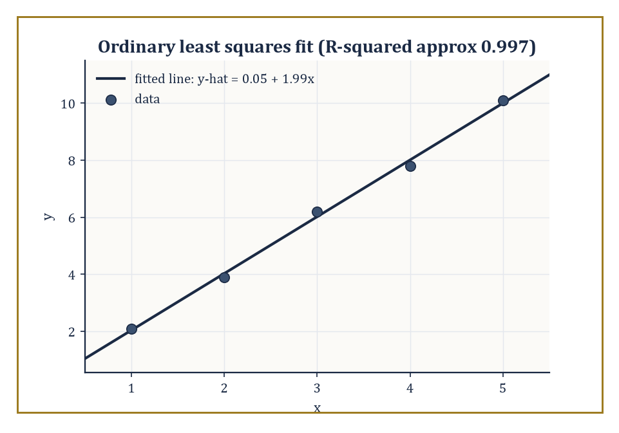
The hand-fitted line y-hat = 0.05 + 1.99x against its five data points, with residuals drawn in as short gold verticals.
Y = Xβ + ε
where X is a matrix of predictors, β the vector of coefficients to be estimated, and ε random error, conventionally assumed to have mean zero. Ordinary least squares (OLS) chooses β̂ to minimise the sum of squared residuals.
Σ(yᵢ−ŷᵢ)²
Geometrically, this is the orthogonal projection of the response vector onto the column space spanned by the covariates. When the errors are Gaussian, OLS coincides exactly with the maximum-likelihood estimator of Room 42.4; even without Gaussian errors, the Gauss–Markov theorem guarantees OLS is the best linear unbiased estimator (BLUE) — the minimum-variance choice among all linear, unbiased estimators — provided only that the errors have mean zero, constant variance, and are uncorrelated.
Numeric example — Worked example — fitting a line by hand. Data: x = (1,2,3,4,5), y = (2.1, 3.9, 6.2, 7.8, 10.1). The means are x̄=3 and ȳ=30.1/5=6.02. The deviations from the mean are as follows.
(x−x̄) = (−2,−1,0,1,2); (y−ȳ) = (−3.92,−2.12,0.18,1.78,4.08)
The slope is b = Σ(x−x̄)(y−ȳ) / Σ(x−x̄)²: the numerator and denominator work out to the following.
numerator = (−2)(−3.92)+(−1)(−2.12)+0(0.18)+1(1.78)+2(4.08) = 7.84+2.12+0+1.78+8.16 = 19.9
denominator = 4+1+0+1+4 = 10
giving:
b = 19.9/10 = 1.99
The intercept is:
a = ȳ − b·x̄ = 6.02 − 1.99×3 = 6.02−5.97 = 0.05
So the fitted line is:
ŷ = 0.05 + 1.99x
very close to the tidy relationship y=2x with a little noise stirred in, which is exactly how this dataset was cooked up.
The total variability in the response splits cleanly into a part explained by the model and a part left over as residual, a decomposition called the partition of sums of squares.
SST = SSR + SSE
where SST is the total variation, SSR is the variation explained by the regression, and SSE is the leftover, unexplained residual variation.
SST = Σ(yᵢ−ȳ)², SSR = Σ(ŷᵢ−ȳ)², SSE = Σ(yᵢ−ŷᵢ)²
The ratio R² = SSR/SST reports the proportion of variability the model accounts for, running from 0 (useless) to 1 (perfect fit, and therefore slightly suspicious). The t-test on an individual coefficient and the F-test on the whole model are both, at bottom, comparisons of explained to unexplained variation, calibrated against the appropriate reference distribution.
Numeric example — Worked example — sums of squares, R², and a t-test on the slope. Continuing the fit above, the predicted values are ŷ = (2.04, 4.03, 6.02, 8.01, 10.00), giving residuals (0.06, −0.13, 0.18, −0.21, 0.10), which sum to zero as they must.
SSE = 0.06²+0.13²+0.18²+0.21²+0.10² = 0.0036+0.0169+0.0324+0.0441+0.0100 = 0.107
SST = 3.92²+2.12²+0.18²+1.78²+4.08² = 15.3664+4.4944+0.0324+3.1684+16.6464 = 39.708
So:
SSR = 39.708−0.107 = 39.601, R² = 39.601/39.708 ≈ 0.9973
the line explains 99.7% of the variation in y, which is what near-perfect linear data with a small amount of noise looks like. For the t-test on the slope: the residual mean square is MSE = SSE/(n−2) (n−2=3 degrees of freedom, since two parameters — slope and intercept — were estimated from 5 points).
MSE = 0.107/3 ≈ 0.03567
The standard error of the slope is:
SE(b) = √(MSE/Sxx) = √(0.03567/10) = √0.003567 ≈ 0.0597
and the t-statistic is:
t = b/SE(b) = 1.99/0.0597 ≈ 33.3
enormously larger than the critical value of about 3.18 (3 degrees of freedom, α=0.05, two-sided), so the slope is overwhelmingly statistically significant. It would be alarming if it weren't, given the data was practically shouting y≈2x.
Generalised linear models (GLMs) free the framework from the assumption that the response is Gaussian and additive. A link function g relates the linear predictor η=Xβ to the mean response.
g(E[Y]) = η
and a variance function specifies how the response's variance depends on its mean — logistic regression (binary response, logit link) and Poisson regression (count response, log link) are the two most common examples encountered outside the safety of continuous, symmetric data.
Beyond the fit itself, responsible practice examines the residuals for patterns the model missed, checks for individual points exerting outsized influence on the fitted coefficients, and uses model-selection criteria such as AIC (which penalises added complexity against improved fit) or cross-validation (which directly tests predictive performance on held-out data) to choose among competing specifications rather than trusting R² alone, which increases automatically with every added predictor whether or not that predictor means anything.
Numeric example — Worked example — the logistic link in action. In a logistic regression predicting the probability p of some binary outcome from a covariate x, suppose the fitted coefficients are β₀=−2 and β₁=0.05. The linear predictor at x=40 is:
η = β₀+β₁x = −2+0.05×40 = −2+2 = 0
The logit link inverts as p = 1/(1+e^{−η}); at η=0:
p = 1/(1+e⁰) = 1/(1+1) = 1/2 = 0.5
So a covariate value of x=40 is exactly the point at which the model predicts a 50–50 outcome — the link function's whole job is performed here in one line: it took an unbounded linear predictor (which could stray to −∞ or +∞ as x varies) and squeezed it, via the logistic curve, into the legal range [0,1] that a probability is required to occupy.
Numeric example — Worked example — AIC prefers the model that earns its extra parameter. Using the AIC formula (dropping an additive constant common to every model being compared, since only differences matter):
AIC ≈ n·ln(SSE/n) + 2k
compare the fitted line from above (k=2 parameters: slope and intercept, SSE=0.107, n=5) against a null model that predicts the sample mean ȳ=6.02 for every point regardless of x (k=1 parameter, so its SSE is simply SST=39.708, since a constant-mean model explains nothing). For the fitted line:
n·ln(SSE/n) = 5·ln(0.107/5) = 5·ln(0.0214) ≈ 5×(−3.844) = −19.22, AIC ≈ −19.22 + 4 = −15.22
For the null model:
5·ln(39.708/5) = 5·ln(7.9416) ≈ 5×2.072 = 10.36, AIC ≈ 10.36 + 2 = 12.36
Lower AIC is preferred, and −15.22 is dramatically lower than 12.36 — AIC agrees emphatically with the R²≈0.997 finding from before that x is doing real explanatory work, while also being the more principled comparison, since it is exactly the sort of criterion that would correctly refuse to reward a third, fourth, or fifth predictor added purely to shave a few more decimal places off SSE without actually improving genuine predictive power.

Room 42.8: Bayesian Inference
Treating the unknown parameter as one more random variable, and being honest about it
The Bayesian approach makes a philosophical move the frequentist framework of the previous rooms refuses to make: it treats the unknown parameter θ itself as a random variable, equipped with a prior distribution π(θ) that encodes what you believed before seeing any data.
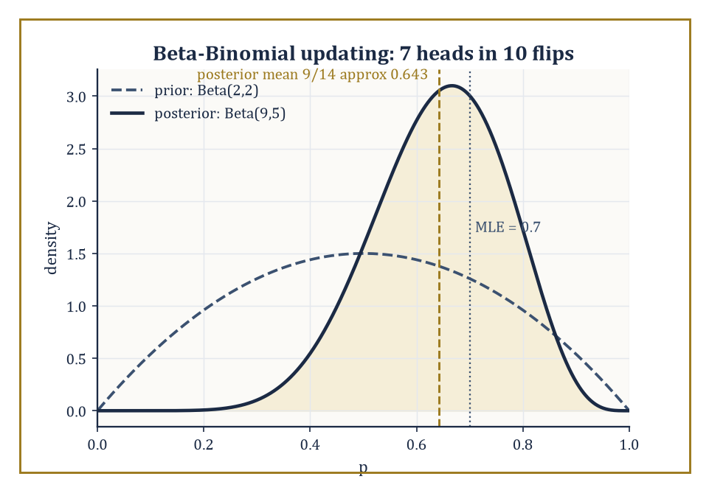
The flat Beta(2,2) prior sharpens into the Beta(9,5) posterior once 7 heads out of 10 flips are taken into account — the MLE sits a little to its right, still slightly unshrunk.
Bayes' theorem then converts this prior, together with the likelihood of the observed data, into a posterior distribution.
π(θ∣x) ∝ L(θ)·π(θ)
This is the complete, updated description of your uncertainty about θ once the evidence has been taken into account. Everything downstream — point estimates (the posterior mean, median, or mode), and credible intervals (ranges containing, say, 95% of the posterior probability) — is read directly off this one object, with none of the repeated-sampling gymnastics that confidence intervals require.
Numeric example — Worked example — Beta-Binomial conjugacy. Return to the coin from Room 42.4: 7 heads out of 10 flips. Suppose the prior belief about p is Beta(2,2) — a symmetric prior centred at 0.5, mildly favouring middling values of p over extreme ones. The Beta distribution is conjugate to the Binomial likelihood, meaning the posterior is again a Beta distribution, with parameters simply updated by adding the observed successes and failures.
posterior = Beta(2+7, 2+3) = Beta(9,5)
The posterior mean is:
9/(9+5) = 9/14 ≈ 0.643
noticeably pulled down from the raw MLE of 0.7 toward the prior's centre of 0.5, a phenomenon called shrinkage, and the price (or the benefit, depending on your priors about priors) of bringing prior belief to bear at all. The posterior mode, for a Beta(a,b) with a,b>1, is (a−1)/(a+b−2):
(9−1)/(9+5−2) = 8/12 ≈ 0.667
For a credible interval, use the Beta variance formula.
Var = ab/[(a+b)²(a+b+1)] = (9×5)/(14²×15) = 45/2940 ≈ 0.0153
giving a standard deviation of about 0.124; a normal approximation to the posterior then gives an approximate 95% credible interval:
0.643 ± 1.96×0.124 ≈ [0.400, 0.885]
an interval that, unlike its frequentist cousin, really does mean 'there is a 95% probability the true p lies in here, given the prior and the data', because in the Bayesian framework p genuinely is being treated as random.
Conjugate priors, of which the Beta-Binomial pair is the most famous, yield posteriors in closed form and make Bayesian arithmetic as clean as the exponential-family likelihood arithmetic of Room 42.4 — indeed the two facts are the same fact, since conjugacy is exactly the exponential-family sufficiency structure applied to the prior as well as the likelihood.
Outside these tidy special cases, the posterior generally has no closed form, and one resorts to numerical integration for low-dimensional problems, Markov chain Monte Carlo (MCMC) — which builds a random walk whose long-run behaviour reproduces the posterior without ever writing its formula down — for higher-dimensional ones, or variational approximation, which trades some accuracy for enormous speed by fitting the closest tractable distribution to the true posterior.
Hierarchical models extend the whole apparatus to problems with natural grouping structure — many related but not identical experiments — by placing a prior not on a single parameter but on a shared distribution from which each group's parameter is drawn, letting information flow between groups automatically.
Numeric example — Worked example — hierarchical shrinkage across two coins. Suppose two coins are each flipped 10 times: Coin A gives 8 heads (raw MLE 0.8), Coin B gives 3 heads (raw MLE 0.3). Taken in isolation, these look like two very different coins. A hierarchical (or simply shared-prior) Bayesian treats both as drawn from a common family of 'coins like these', represented by a shared Beta(3,3) prior (centred at 0.5, expressing mild scepticism that any single coin is wildly biased).
Coin A posterior = Beta(3+8, 3+2) = Beta(11,5), mean = 11/16 = 0.6875
Coin B posterior = Beta(3+3, 3+7) = Beta(6,10), mean = 6/16 = 0.375
Notice what happened: Coin A's estimate was pulled down from 0.8 to 0.6875, and Coin B's was pulled up from 0.3 to 0.375 — both nudged toward the shared centre of 0.5, and both nudged by the same proportion (37.5%) of their original distance from that centre, because that proportion depends only on the strength of the shared prior relative to the (here, equal) amount of data behind each coin, not on how far off-centre the raw estimate happened to be.
0.375×(0.5−0.8) = −0.1125, 0.375×(0.5−0.3) = +0.075
matching both shifts exactly. This is the essence of empirical-Bayes and hierarchical reasoning: individually noisy estimates borrow strength from each other via the shared prior, typically improving overall accuracy even though no individual coin's true bias is known with certainty.
Room 42.5 showed that the choice of loss function determines which point estimate is 'best' among frequentist candidates; the Bayesian posterior makes that same choice explicit and almost mechanical, because once you have a full distribution over θ rather than just a point guess, the optimal action under any given loss function is simply whichever summary of the posterior minimises expected loss under that posterior.
Numeric example — Worked example — different Bayes estimators from one posterior. Return to the Beta(9,5) posterior from earlier in this room. Under squared-error loss, the Bayes estimator is the posterior mean.
9/14 ≈ 0.643
Under absolute-error loss, it is the posterior median (not computed in closed form for the Beta in general, but numerically close to 0.649 for Beta(9,5) — slightly above the mean here, since the distribution has a modest left skew). Under 0–1 loss (rewarding an exact hit and penalising any miss equally, however small), the Bayes estimator is the posterior mode.
(9−1)/(9+5−2) = 8/12 ≈ 0.667
Three different, defensible summaries of the same evidence — 0.643, roughly 0.649, and 0.667 — quietly disagreeing by a few hundredths, purely because they are answering three subtly different questions about what 'best' means. The frequentist mean-versus-median tension from Room 42.5 has not been resolved by going Bayesian; it has simply been relocated to a single, honestly displayed posterior distribution instead of two separate, competing estimators.
The Bayesian machinery supplies a fully coherent calculus of uncertainty — every quantity of interest, from a single parameter to a prediction for tomorrow's data, is simply another distribution to be computed from the posterior — and it slots naturally into decision theory, since a posterior distribution over states of the world is exactly the input a rational decision-maker needs to minimise expected loss.
Whether one is a Bayesian by temperament or a frequentist by training (or, like most working statisticians, both depending on the day and the deadline), the two frameworks agree on an enormous amount in the large-sample limit — the CLT and its cousins from Room 42.3 ensure that with enough data, the choice of prior fades and posterior and confidence intervals converge to much the same numbers, which is either a deeply reassuring unification or a sign that both camps have simply been arguing about the same mountain from different, equally steep sides.
Numeric example — Worked example — the prior fading with more data. Return once more to the Beta(2,2) prior on the coin, but suppose the same 70% heads rate is now observed over n=1000 flips instead of 10, i.e. 700 heads and 300 tails. The posterior is:
Beta(2+700, 2+300) = Beta(702,302), mean = 702/1004 ≈ 0.6992
a shift of only 0.7−0.6992 = 0.0008 from the raw MLE, compared with the shift of 0.7−0.643 = 0.057 seen back at n=10: the same prior, applied to fifty times more data, now moves the estimate by roughly one-seventieth as much. The posterior standard deviation is:
√(702×302/(1004²×1005)) ≈ 0.01447
giving a 95% credible interval:
0.6992 ± 1.96×0.01447 ≈ [0.671, 0.727]
Compare the frequentist 95% confidence interval built from the MLE alone.
SE = √(0.7×0.3/1000) ≈ 0.01449, 0.7 ± 1.96×0.01449 ≈ [0.672, 0.728]
the two intervals, built from philosophically opposite starting points, now sit almost exactly on top of each other. This is the CLT-driven convergence promised above, made visible: with 10 flips the prior was doing real work; with 1000 it has been quietly outvoted by the data.

Room 42.9: Looking Ahead: From Classical Statistics to Modern Inference and Probability Theory
In which the practical toolkit sends the bill upstairs for the foundations it never paid for
We now hold the core toolkit of classical probability and statistics: random variables and their distributions, expectation and conditioning, the law of large numbers and the central limit theorem, likelihood and the maximum-likelihood estimator, point and interval estimation, hypothesis testing, linear regression, and a first honest look at the Bayesian alternative. Every one of these tools was built to answer one question in two directions — given a chance mechanism, what will the data look like; given the data, what was the chance mechanism — and every worked example in this storey was, in the end, one small demonstration of that same back-and-forth.
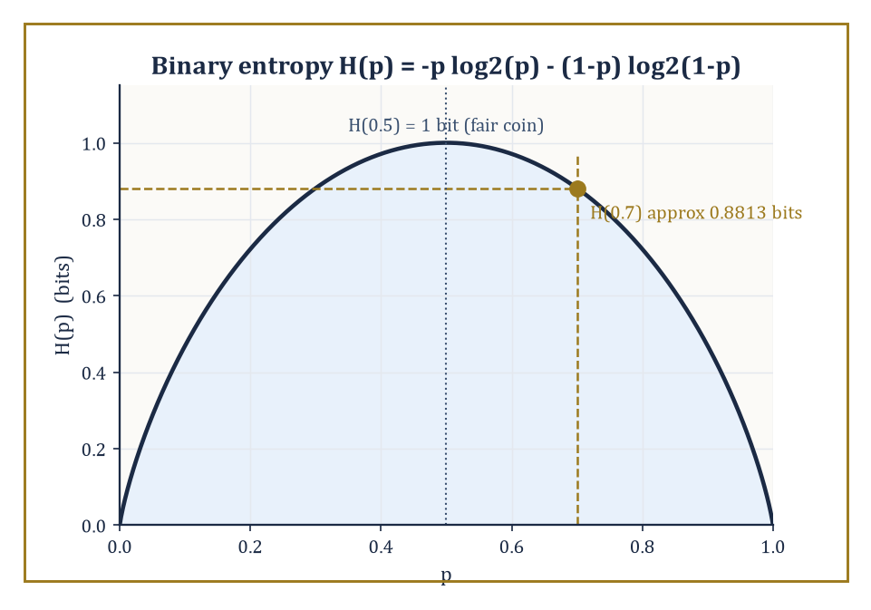
The binary entropy curve, with the storey's recurring 70%-biased coin marked at just under 0.9 bits of genuine surprise per flip.
These tools open directly onto the next storey's measure-theoretic probability, where the informal 'total mass of one' of Room 42.1 gets its full Lebesgue-integral treatment, conditional expectation is properly constructed as a Radon–Nikodym derivative rather than gestured at as a projection, and stochastic processes — sequences and continuous-time families of random variables evolving together, martingales prominent among them — take centre stage.
They also open onto modern high-dimensional statistics (where the number of parameters can rival or exceed the number of observations, breaking many classical guarantees), nonparametric methods (which estimate whole functions rather than finite parameter vectors), causal inference (which asks not merely what is correlated but what would happen under intervention), and the statistical foundations quietly underneath most of machine learning, which is, when the marketing is peeled away, mostly very large parametric and nonparametric models fitted by maximum likelihood or its close relatives.
Numeric example — Worked example — a first taste of a stochastic process. Everything in this storey treated each observation as independent of the others, or at most conditionally related through a fixed grouping variable like 'which machine' or 'which coin'. A Markov chain, the simplest genuinely dynamic stochastic process and a fixture of Storey 43, instead lets today's state directly determine tomorrow's probabilities. Take a two-state weather chain with states {Sunny, Rainy} and the following transition probabilities.
P(Sunny→Sunny)=0.9, P(Sunny→Rainy)=0.1, P(Rainy→Sunny)=0.5, P(Rainy→Rainy)=0.5
The long-run, or stationary, distribution (π_S, π_R) is the one that reproduces itself after one more step.
π_S = 0.9π_S + 0.5π_R, π_R = 0.1π_S + 0.5π_R, π_S+π_R=1
The first equation rearranges to 0.1π_S = 0.5π_R, so π_S = 5π_R; substituting into π_S+π_R=1 gives:
5π_R+π_R=6π_R=1, so π_R=1/6, π_S=5/6
In the long run, regardless of today's weather, this chain spends five-sixths of its days sunny and one-sixth rainy — a clean, computable limit reached by solving two linear equations, and a small preview of how this storey's expectation, conditioning, and limiting arguments extend, with a little more machinery, to systems that unfold through time rather than sitting still.
Computational statistics — the bootstrap of Room 42.5, the MCMC of Room 42.8, and their many descendants — has made previously intractable calculations routine, trading mathematical cleverness for raw computation in a bargain that would have seemed almost like cheating to earlier generations of statisticians armed with nothing but tables and patience.
And the same probabilistic vocabulary built here resurfaces, essentially unchanged in spirit, in information theory's account of how much a message or a dataset can possibly tell you.
Numeric example — Worked example — a glimpse forward into information theory. The entropy of a Bernoulli(p) distribution measures in bits how much genuine uncertainty remains in a single flip of a coin with bias p — the same quantity, not coincidentally, that governs how compactly a long sequence of such flips can be encoded.
H(p) = −p log₂p − (1−p) log₂(1−p)
For the coin from Rooms 42.4 and 42.8, with p=0.7:
log₂(0.7) = ln(0.7)/ln(2) ≈ (−0.3567)/0.6931 ≈ −0.5146, log₂(0.3) = ln(0.3)/ln(2) ≈ (−1.2040)/0.6931 ≈ −1.7370
So:
H(0.7) = −0.7×(−0.5146) − 0.3×(−1.7370) = 0.3602 + 0.5211 = 0.8813 bits
noticeably less than the full 1 bit of a fair coin, because a coin known to favour heads 70% of the time carries a little less genuine surprise per flip than one that is perfectly balanced. The same p=0.7 that maximised our likelihood in Room 42.4 and anchored our posterior in Room 42.8 reappears here as the input to an entirely different calculation, in an entirely different storey of mathematics, which is as good an illustration as any that probability is not a subject with borders — it is closer to a common currency the rest of mathematics keeps finding reasons to spend.
The deeper lesson of this storey, if it must be compressed into a single sentence, is that uncertainty is not a confession of mathematical failure but an object with its own precise, learnable structure — one that data can reduce in principled, quantifiable ways, and whose reduction is exactly what all of estimation, testing, and Bayesian updating are for. It is not a small thing to have built a mathematics of not-quite-knowing.
The next storey climbs back down into the foundations we borrowed from without properly repaying — measure-theoretic probability, stochastic processes, and the machinery that lets 'random variable' mean something rigorous even when time itself becomes a continuous parameter. Consider this storey the practitioner's tour; the one above is where the plumbing gets inspected. The tower continues upward, and it is, as ever, considerably taller than it looks from here.
We came up from a storey of game theorists who assumed their probabilities and went straight to computing equilibria; we leave having built those probabilities from the ground up, and having learned, at some length, how to recover them honestly from data that never cooperates quite as fully as one would like. Random variables, expectation, the limit theorems, likelihood, estimation, testing, regression, and the Bayesian posterior — nine rooms, one continuous argument: uncertainty can be measured, data can shrink it, and the mathematics that describes how much and how reliably is neither a bolt-on to the rest of the Tower nor a mere practical afterthought, but one of its load-bearing walls.
It has also, if the author may say so without too much immodesty, been a storey where practically nothing needed to be taken on faith — every claim came with a number attached, checked twice, because a statistics book that gets its own arithmetic wrong has no business lecturing anyone about the perils of unchecked inference.
Ahead lies Storey 43, where probability theory sheds its applied clothing and puts on the full measure-theoretic uniform: σ-algebras taken seriously, conditional expectation built rather than merely described, and stochastic processes unfolding through continuous time. Everything learned here survives the transition intact — it simply gets a rigorous floor poured underneath it. Onward and, as always in this Tower, upward.

Storey 43: Probability Theory (Advanced)
Measure, Martingales, and the Art of Randomness at the Foundations
The previous storey taught you to compute with randomness: distributions, densities, the central limit theorem wheeled out like a reliable but slightly overworked family car. That was probability as most of the world meets it, and it is not wrong, merely provisional — built on a sample space that is politely assumed to behave, on random variables that are politely assumed to have nice densities, and on limit theorems whose proofs, if you look closely, tend to wave their hands exactly at the moment things get interesting. This storey removes the politeness. We rebuild probability from the measure theory laid down many storeys below, and in exchange for the extra rigour we get a theory that works on any measurable space whatsoever, handles continuous time without flinching, and turns a dozen classical theorems that used to require separate, ad-hoc proofs into corollaries of one idea.
That one idea, roughly, is information. A σ-algebra is not merely bureaucratic apparatus for deciding which sets are measurable; once you have a probability measure sitting on top of it, a σ-algebra is what you know. Conditional expectation given that σ-algebra is your best possible guess given what you know. A martingale is a process whose best guess about tomorrow, given everything you know today, is simply today's value — a fair game, formalised until it squeaks. Once these three notions are in place, filtrations track the flow of information through time, stopping times encode decisions that cannot see the future, and a startling number of classical results — the strong law, the central limit theorem, the existence of Brownian motion — turn out to be the same theorem wearing different coats.
We will build the core of this machinery in nine rooms: probability measures and random variables done properly, independence and the construction of infinite product spaces, conditional expectation, discrete-time martingales, the great convergence theorems, Brownian motion, continuous-time martingales, Markov processes and their generators, and finally a look at what lies just beyond — stochastic calculus, stochastic PDEs, and ergodic theory, none of which we will attempt to close-read, all of which will look considerably less alarming once you have this storey behind you.
A small confession before we start climbing: advanced probability is the subject in which the phrase 'almost surely' quietly does most of the moral labour, in which null sets are cheerfully ignored, and in which the underlying sample space — supposedly the whole point of the enterprise — is very often never mentioned again once we have proven it exists. This is not evasion; it is the price admission to a theory that can handle continuous time, infinite dimensions, and the mild vertigo of a stopping time that cannot see next Tuesday. Let's build on measure, and then let it run.

Room 43.1: Probability Measures and Random Variables Revisited
In which coin flips turn out to have been a special case all along
Recall from the measure-theory storeys that a measure space is a triple (Ω, F, μ), where F is a σ-algebra of subsets of Ω and μ assigns a countably additive, non-negative number to each set in F. A probability measure P is nothing more exotic than a measure satisfying a single extra condition — the whole of chance, dignified by a normalisation constant.
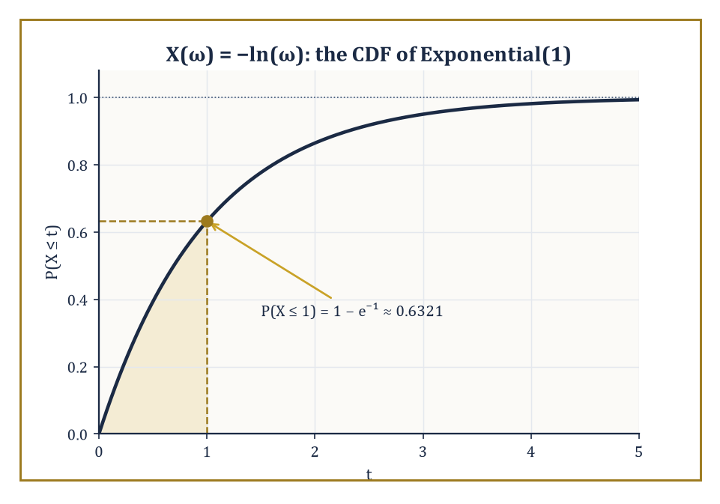
The CDF of X(ω) = −ln(ω): a probability space this humble, and it already knows how to be exponential.
P(Ω) = 1
We call (Ω, F, P) a probability space, we call sets in F events, and we call elements ω of Ω outcomes, though after this room you will rarely be asked to look at one directly.
A random variable X is simply a measurable function X : Ω → ℝ, meaning the following condition holds.
X⁻¹(B) ∈ F for every Borel set B ⊆ ℝ
This technical condition exists precisely so that questions like 'what is the probability that X is at most t' are meaningful, since that probability is P(X⁻¹((-∞, t])), which requires X⁻¹((-∞, t]) to be an event.
The distribution (or law) of X, written P_X or μ_X, is the push-forward measure on ℝ defined as follows.
μ_X(B) = P(X⁻¹(B))
It is the only feature of X that most calculations ever care about, which is why this single measure-theoretic definition quietly subsumes both the discrete probability mass functions and the continuous densities of the previous storey, without needing two separate theories to do it.
Numeric example — Worked example: building an exponential random variable from a uniform one. Take Ω = [0, 1], F the Borel sets, and P Lebesgue measure — the uniform distribution on the unit interval, the humblest probability space there is. Define X as follows.
X(ω) = −ln(ω)
We compute the distribution of X directly from the definition, with no appeal to any pre-packaged 'exponential density' formula. For t ≥ 0, consider the event {ω : X(ω) ≤ t}, which unwinds by a chain of equivalent descriptions.
{ω : X(ω) ≤ t} = {ω : −ln ω ≤ t} = {ω : ln ω ≥ −t} = {ω : ω ≥ e^(−t)}
This last set is the interval [e^(−t), 1]. Since P is Lebesgue measure, its length is the answer.
P(X ≤ t) = 1 − e^(−t)
Two sanity checks confirm this is right. At t = 0 the formula gives the following.
P(X ≤ 0) = 0
This must be true since ω ∈ (0, 1] forces −ln ω ≥ 0, so X can never be negative; and as t → ∞ the formula tends to 1, as any honest cumulative distribution function must.
Plugging in a concrete value:
P(X ≤ 1) = 1 − e^(−1) ≈ 1 − 0.3679 = 0.6321
We have just derived, from first principles, that X is Exponential(1) distributed — and in doing so reconstructed the inverse-transform method that every random-number generator on your computer uses to turn a uniform sample into an exponential one.
When the underlying space is not just ℝ but a metric space, the natural σ-algebra is the Borel σ-algebra generated by the open sets, and once a probability measure P is fixed it is common (and harmless) to complete F by throwing in every subset of every P-null set, so that 'measurable' and 'negligible' interact politely.
The theory becomes especially well-behaved when the state space is Polish — complete, separable, and metrisable — which is the standing assumption for essentially everything from here to the end of the storey.
On Polish spaces one gets two regularity properties that classical probability rarely needed to name but that become indispensable once we start taking limits of entire probability measures rather than limits of numbers: tightness, which says a family of measures does not let its mass leak off to infinity, and weak convergence, where μ_n ⇒ μ means the following.
∫ f dμ_n → ∫ f dμ for every bounded continuous f
Prokhorov's theorem says a family of measures is relatively compact for weak convergence exactly when it is tight, and the portmanteau theorem gives half a dozen equivalent ways to check weak convergence (via open sets, closed sets, or sets whose boundary the limit measure ignores). These are the tools that will let us talk sensibly, several rooms from now, about a sequence of random walks converging to Brownian motion.
Abstract example — Worked example: tight versus non-tight families of measures. Consider two families of Gaussian measures on ℝ. First, take the family with mean zero and shrinking variance.
μ_n = N(0, 1/n)
Given ε > 0, choose the following radius.
M = 1/√ε
By Chebyshev's inequality, for every n ≥ 1, the following bound holds, since the variance 1/n never exceeds 1.
P(|X| > M) ≤ Var(X)/M² ≤ 1/M² = ε
So the compact interval [−M, M] captures at least 1 − ε of the mass of every μ_n simultaneously: the family is tight, and indeed the Gaussians converge weakly as follows, collapsing onto the origin.
μ_n ⇒ δ₀
Here δ₀ is the point mass at zero. Now consider the second family — fixed variance, but a mean marching off to infinity.
ν_n = N(n, 1)
For any fixed compact set K = [−M, M], the following holds, because the entire bell curve is sailing past M and never coming back.
ν_n(K) → 0 as n → ∞
No single compact set can trap uniform mass 1 − ε from every ν_n, so the family is not tight — and correspondingly there is no weak limit on ℝ at all; the mass has genuinely escaped.
This is the whole content of tightness in one illustrative pair: shrinking variance keeps a family corralled, a runaway mean lets it escape — and a growing variance with a fixed mean would escape too, by exactly the same mechanism, spread rather than shift.
Prokhorov's theorem is simply the abstract guarantee built to catch every version of this escape at once: a family is relatively compact for weak convergence precisely when no such leak, however it happens, is occurring.

Room 43.2: Independence, Product Spaces, and Kolmogorov's Extension
How to build infinitely many coins without flipping a single one
Two sub-σ-algebras G₁, G₂ ⊆ F are independent if the following product property holds for every A₁ ∈ G₁ and A₂ ∈ G₂, and finitely many σ-algebras are independent if the product property holds for every choice of one set from each.
P(A₁ ∩ A₂) = P(A₁)P(A₂)
Random variables are independent precisely when the σ-algebras they generate are independent, which unpacks to the familiar statement that their joint distribution is the product of their marginal distributions.
It is worth stating plainly, because it trips up even careful people: independence of every pair in a collection — pairwise independence — does not imply independence of the whole collection.
Genuine (mutual) independence is a strictly stronger, and strictly more useful, condition; it is the hypothesis under which the classical limit theorems of the next few rooms actually hold.
Numeric example — Worked example: pairwise independence is not enough. Let X and Y be independent fair coin flips, each taking values 0 or 1 with probability 1/2, and let Z = X XOR Y (so Z = 1 exactly when X and Y differ). First check pairwise independence of X and Z.
P(X=1, Z=1) = P(X=1, Y=0) = 1/4
P(X=1)P(Z=1) = (1/2)(1/2) = 1/4
They match, and by symmetry Y and Z are pairwise independent too, alongside the given independence of X and Y. So every pair in {X, Y, Z} is independent. But check the triple: the event {X=1, Y=1, Z=1} is impossible, because if X = Y = 1 then Z = X XOR Y = 0, not 1; hence
P(X=1, Y=1, Z=1) = 0
Yet the product of the marginals is
P(X=1)P(Y=1)P(Z=1) = (1/2)(1/2)(1/2) = 1/8 ≠ 0
The three variables are pairwise independent but not mutually independent — a standard cautionary tale, and the reason every serious statement of independence in this storey insists on the full product property for every finite subcollection, not merely for pairs.
None of this is useful, of course, unless infinite collections of independent random variables actually exist as honest measurable functions on some probability space, rather than as a comforting story about flipping a coin forever.
The Kolmogorov extension theorem supplies them: given, for every n, a probability measure on ℝⁿ, such that the family is consistent (the measure on ℝⁿ, marginalised down to ℝᵐ for m < n, agrees with the given measure on ℝᵐ), there exists a single probability measure on the infinite product space ℝ^∞ whose finite-dimensional marginals are exactly the given ones.
This is how one rigorously builds an infinite sequence of i.i.d. random variables with any prescribed common distribution, and — far more importantly for what follows — it is how one builds a stochastic process from nothing but a consistent specification of its finite-dimensional distributions, which is exactly the strategy we will use to construct Brownian motion in Room 43.6.
The Ionescu–Tulcea theorem is the companion result for processes specified not by fixed finite-dimensional laws but by a consistent chain of transition kernels, and it is the existence theorem behind Markov chains with arbitrarily prescribed transition probabilities.
Abstract example — Worked example: checking consistency for a Gaussian random walk. Suppose we want to build an infinite sequence (X₁, X₂, X₃, …) by declaring that, for every n, the vector (X₁, …, Xₙ) is multivariate Gaussian with mean zero and covariance given by the following.
Cov(Xᵢ, Xⱼ) = min(i, j)
This is not an arbitrary choice: it is exactly the covariance structure of the partial sums Sᵢ = ξ₁ + ⋯ + ξᵢ of independent, mean-zero, unit-variance increments, since for i ≤ j:
Cov(Sᵢ, Sⱼ) = Cov(Sᵢ, Sᵢ + (Sⱼ − Sᵢ)) = Var(Sᵢ) + Cov(Sᵢ, Sⱼ − Sᵢ) = i + 0 = i = min(i, j)
The cross term vanishes by independence of Sᵢ and the later increment. To apply Kolmogorov's theorem we must check consistency: does marginalising the 5-dimensional law down to its first 3 coordinates recover the 3-dimensional law we specified directly?
Since any subvector of a multivariate Gaussian is again Gaussian, with covariance given by the corresponding submatrix, the marginal of (X₁, X₂, X₃) taken from the 5-dimensional specification has covariance the 3×3 submatrix [min(i,j)]ᵢ,ⱼ≤3 — precisely the 3-dimensional law we specified.
Consistency holds automatically, for every n and every choice of subset, and Kolmogorov's theorem hands us a single probability space carrying the entire infinite sequence at once. We have just constructed, rigorously and without simulating a single step, the discrete-time random walk sampled at every integer time — the exact skeleton on which Brownian motion will later be draped.
Independence, seen this way, is probability's precise model of 'learning nothing': knowing the value of one variable leaves your belief about the others completely unmoved.
And the extension theorems are what let us stop worrying, once and for all, whether 'infinitely many independent trials' is secretly nonsense dressed up in probabilistic language. It is not. Kolmogorov checked, and the receipt is the theorem bearing his name.

Room 43.3: Conditional Expectation
The best guess you can make, formalised until it hurts
Let G be a sub-σ-algebra of F, thought of as 'the information currently available' — some events are decidable from G, others are not yet.
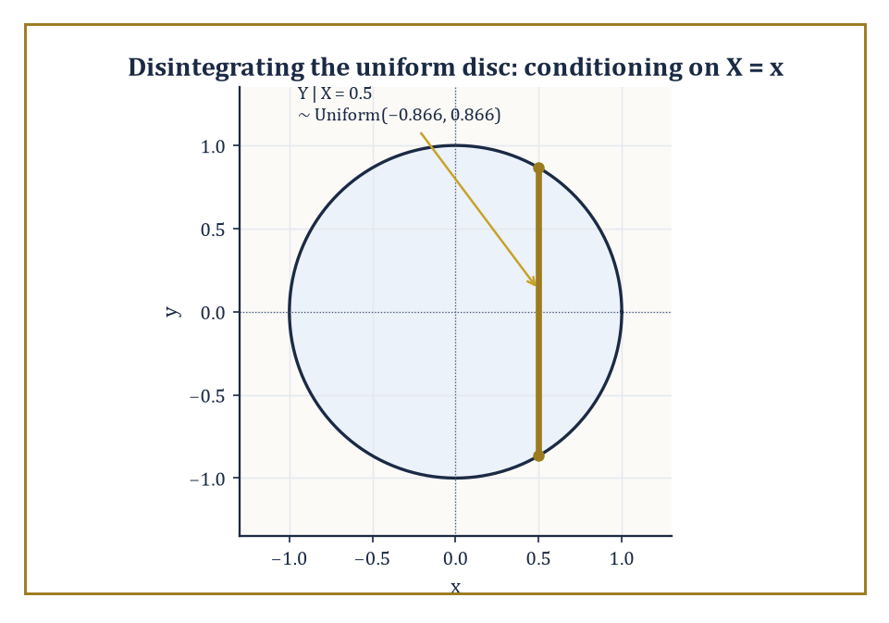
Conditioning on X = x slices the disc into a single vertical chord, uniform along its own length and nothing more.
The conditional expectation E[X | G] is defined as the (essentially unique) G-measurable random variable Y satisfying, for every A ∈ G, the relation:
∫_A Y dP = ∫_A X dP
Existence follows from the Radon–Nikodym theorem applied to the signed measure A ↦ ∫_A X dP restricted to G.
Read the defining property carefully: it says Y agrees with X on average over every G-measurable event, while being forced to be constant on the 'atoms' of G — it is the best approximation to X that can be computed using only the information in G.
When X has a finite second moment, this coincides exactly with the orthogonal projection of X onto the closed subspace L²(G) of the Hilbert space L²(F, P), which is the cleanest possible way to think about it: conditional expectation is projection, full stop.
It is linear, positive, preserves constants, and satisfies the following identity (take A = Ω):
E[E[X|G]] = E[X]
It also satisfies the tower property, valid whenever G₂ ⊆ G₁ — more information can always be thrown away, never conjured:
E[E[X|G₁] | G₂] = E[X|G₂]
and Jensen's inequality, for convex φ:
φ(E[X|G]) ≤ E[φ(X)|G]
Conditional probability P(A|G) is simply the special case:
X = 1_A
Numeric example — Worked example: conditioning on one die out of two. Roll two independent fair dice and let X be their sum, with G = σ(D₁) — the information consisting of the first die's value alone:
X = D₁ + D₂
Since D₂ is independent of D₁, with expected value:
E[D₂] = 3.5
we claim:
E[X | G] = D₁ + 3.5
Verify this directly on the event A = {D₁ = 3} ∈ G, where X = 3 + D₂. Averaging over the six equally likely values of D₂ gives an average value of X on A equal to:
3 + 3.5 = 6.5
The claimed conditional expectation D₁ + 3.5 also equals, on A:
3 + 3.5 = 6.5
The two sides of the defining integral equation agree, and the same check works for every value D₁ can take, so the formula holds.
Now confirm the tower property: E[E[X|G]] should equal E[X]. The left side is:
E[D₁ + 3.5] = 3.5 + 3.5 = 7
The right side, the expected sum of two dice, is famously also 7.
The two-dice example is small enough to check by hand and general enough to show exactly what conditional expectation does: it replaces the unknown D₂ by its unconditional average, while leaving the known quantity D₁ untouched.
For Polish state spaces, one can go further and construct a regular conditional distribution: for (almost) every value x, an honest probability measure describing 'the law of Y given X = x', not merely an equivalence class of functions defined up to null sets.
This is the rigorous version of disintegration — slicing a joint measure into a family of conditional measures glued together by the marginal law of X — and it is what allows statements like 'conditional on X = x, Y is distributed as…' (the daily bread of Bayesian statistics, back in the previous storey) to be honest mathematics rather than convenient shorthand.
It is also the technical backbone of the Markov property we meet in Room 43.8, where the future given the present is exactly a regular conditional distribution.
Abstract example — Worked example: disintegrating the uniform measure on a disc. Let (X, Y) be uniformly distributed on the unit disc {x² + y² ≤ 1} ⊂ ℝ², with the following joint density on the disc:
f(x,y) = 1/π
The marginal density of X is obtained by integrating out y over the vertical chord at height x, for x ∈ (−1, 1):
f_X(x) = ∫_{−√(1−x²)}^{√(1−x²)} (1/π) dy = 2√(1−x²)/π
The conditional density of Y given X = x, for y ∈ (−√(1−x²), √(1−x²)), is then:
f(y|x) = f(x,y)/f_X(x) = (1/π) / (2√(1−x²)/π) = 1/(2√(1−x²))
This is exactly the uniform density on that interval, since its value times the interval's length 2√(1−x²) equals 1, confirming it is a genuine probability density for every fixed x.
So the regular conditional distribution of Y given X = x is:
Uniform(−√(1−x²), √(1−x²))
Geometrically, the conditional law at each x is simply 'uniform along the vertical slice of the disc at that x', and integrating these honest slice-measures against the marginal law of X reconstructs the original uniform measure on the whole disc exactly.
Conditional expectation, in this picture, is nothing more mysterious than averaging over one particular slice.
This operator is the single load-bearing wall of the entire storey. Martingales are defined by it, the Markov property is a special case of it, and the theory of filtering and estimation is built entirely out of it, relabelled and reintroduced under a fresh name every few storeys — so it is worth having the two pictures (best-guess-given-information, and orthogonal projection) both firmly in hand before we go any further.

Room 43.4: Martingales in Discrete Time
Fair games, formalised, with no house edge permitted
A filtration (F_n)_{n≥0} is an increasing sequence of σ-algebras,
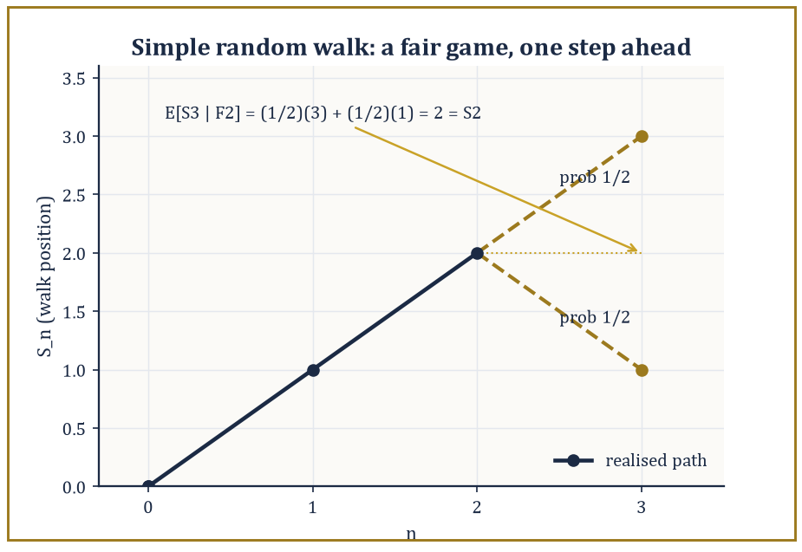
Two equally likely futures from S₂ = 2, and the honest average of them is exactly S₂ — no edge, house or otherwise.
F₀ ⊆ F₁ ⊆ F₂ ⊆ …
representing information accumulating over time: F_n is everything knowable by time n. A process (X_n) is adapted to the filtration if X_n is F_n-measurable for every n — you are not allowed to know the future.
The process is a martingale if it is adapted, integrable, and satisfies:
E[X_{n+1} | F_n] = X_n
almost surely: your best guess of tomorrow's value, given everything you know today, is exactly today's value. This is the formal content of 'fair game' — no systematic drift in either direction.
A submartingale satisfies:
E[X_{n+1}|F_n] ≥ X_n
(a favourable game, or at least one that never actively cheats you), and a supermartingale satisfies the reverse inequality (a casino, essentially, dressed in stochastic-process clothing).
Numeric example — Worked example: the simple random walk is a martingale. Let ξ₁, ξ₂, … be i.i.d. with P(ξᵢ = 1) = P(ξᵢ = −1) = 1/2, let S₀ = 0, S_n = ξ₁ + ⋯ + ξ_n, and F_n = σ(ξ₁, …, ξ_n).
Then, using that S_n is F_n-measurable and ξ_{n+1} is independent of F_n:
E[S_{n+1} | F_n] = E[S_n + ξ_{n+1} | F_n] = S_n + E[ξ_{n+1} | F_n] = S_n + E[ξ_{n+1}] = S_n + 0 = S_n
Concretely, suppose the first two steps were (ξ₁, ξ₂) = (+1, +1), so S₂ = 2.
Given this history, S₃ is either 3 (if ξ₃ = +1, probability 1/2) or 1 (if ξ₃ = −1, probability 1/2), so:
E[S₃ | F₂] = (1/2)(3) + (1/2)(1) = 2 = S₂
This holds exactly, as the martingale property demands.
A stopping time τ is a random time such that {τ = n} ∈ F_n for every n: the decision to stop by time n may use only information available by time n, never a peek ahead.
The optional stopping theorem states that, under suitable integrability conditions (τ bounded, or the stopped process uniformly integrable, are the standard sufficient hypotheses):
E[X_τ] = E[X₀]
The fair-game property survives being evaluated at a well-behaved random time, not merely a fixed one.
Doob's maximal inequality bounds the running maximum of a non-negative submartingale:
P(max_{k≤n} X_k ≥ λ) ≤ E[X_n]/λ
And the upcrossing inequality, which controls how many times a martingale can cross back and forth over an interval, is the engine behind the almost-sure convergence theorem of the next room.
Numeric example — Worked example: optional stopping, applied correctly and applied incorrectly. First, the trap. Let τ be the first time the simple random walk from S₀ = 0 hits the level +1. Since the walk is recurrent, τ is finite almost surely, and S_τ = 1 always, so:
E[S_τ] = 1
But:
E[S₀] = 0
And 1 ≠ 0, so the optional stopping theorem has failed here. It fails because its hypotheses fail — one can show:
E[τ] = ∞
And the stopped martingale is not uniformly integrable, even though it converges (trivially) almost surely. A finite stopping time is not enough; the theorem needs genuine integrability control.
Now the legitimate case: gambler's ruin with two absorbing barriers, −a and b (integers a, b > 0), and τ = the first time the walk hits either barrier. Here τ has finite expectation and the walk is bounded between −a and b before stopping, so optional stopping applies cleanly:
E[S_τ] = 0
Writing p = P(hit b before −a), this expectation expands as:
E[S_τ] = b·p + (−a)·(1−p) = 0
Which rearranges to:
p = a/(a+b)
Taking a = 2, b = 3 (ruin at −2, win at 3, starting at 0):
p = 2/5 = 0.4
Check directly:
bp − a(1−p) = 3(0.4) − 2(0.6) = 1.2 − 1.2 = 0
Exactly as required.
Numeric example — Worked example: Doob's maximal inequality, applied to the random walk. Since S_n is a martingale, S_n² is a submartingale (Jensen's inequality applied to the convex function x², using the martingale property of S_n). Doob's maximal inequality for a non-negative submartingale gives:
P(max_{k≤n} S_k² ≥ λ) ≤ E[S_n²]/λ
Take n = 9: since Var(S_n) = n for the simple random walk (each of the nine independent ±1 steps contributes variance 1):
E[S_9²] = 9
Choosing λ = 36 (i.e. asking about the event max_{k≤9} S_k² ≥ 36, equivalently max_{k≤9} |S_k| ≥ 6) gives:
P(max_{k≤9} |S_k| ≥ 6) ≤ 9/36 = 0.25
This is a genuine, non-trivial bound obtained without knowing the exact distribution of the running maximum at all — a single moment computation on the endpoint S_9 controls the entire path's excursions, which is precisely the point of maximal inequalities: they trade exact distributional knowledge for a cheap, universally applicable bound.
Martingales quietly unify a surprising range of classical probability: sums of independent random variables (of which the random walk above is the simplest instance), branching processes, optimal stopping problems (when should you sell the stock, stop the search, accept the offer?), and the online-updating algorithms — stochastic gradient descent, reinforcement learning value estimates — that are, when you look closely, martingale-difference sequences with a modern job title.
Numeric example — Worked example: the martingale hiding inside a branching process. Consider a Galton–Watson branching process: Z₀ = 1 individual, and each individual independently produces a random number of offspring according to a fixed distribution with mean m, the generations Z_n evolving accordingly. Take the offspring distribution to be 0 with probability 1/2 and 4 with probability 1/2, so:
m = (1/2)(0) + (1/2)(4) = 2
The normalised population size W_n = Z_n/mⁿ is always a martingale, regardless of the offspring distribution's details. Here is the n = 0 to n = 1 step checked by hand: Z₁ is 0 (probability 1/2, if the single ancestor has no offspring) or 4 (probability 1/2), so W₁ = Z₁/2 is 0 or 2, each with probability 1/2.
E[W₁] = (1/2)(0) + (1/2)(2) = 1 = W₀
This confirms the martingale property for this first step. Since W_n ≥ 0, it is automatically a supermartingale-turned-honest-martingale bounded below, and the martingale convergence theorem of the next room guarantees W_n converges almost surely — the rigorous starting point for the classical theory of branching-process extinction probabilities, where the fate of an entire family tree is read off from the limiting behaviour of a single martingale.
The next room shows why this unification is not merely aesthetic: the strong law of large numbers and the central limit theorem, once proved by separate and rather laborious arguments, both fall out of the martingale convergence theorem almost for free.

Room 43.5: Convergence Theorems and the Strong Law
In which averages finally stop wobbling, almost surely
The martingale convergence theorem is the payoff of the upcrossing inequality mentioned in the last room: if (X_n) is a martingale that is L¹-bounded, meaning
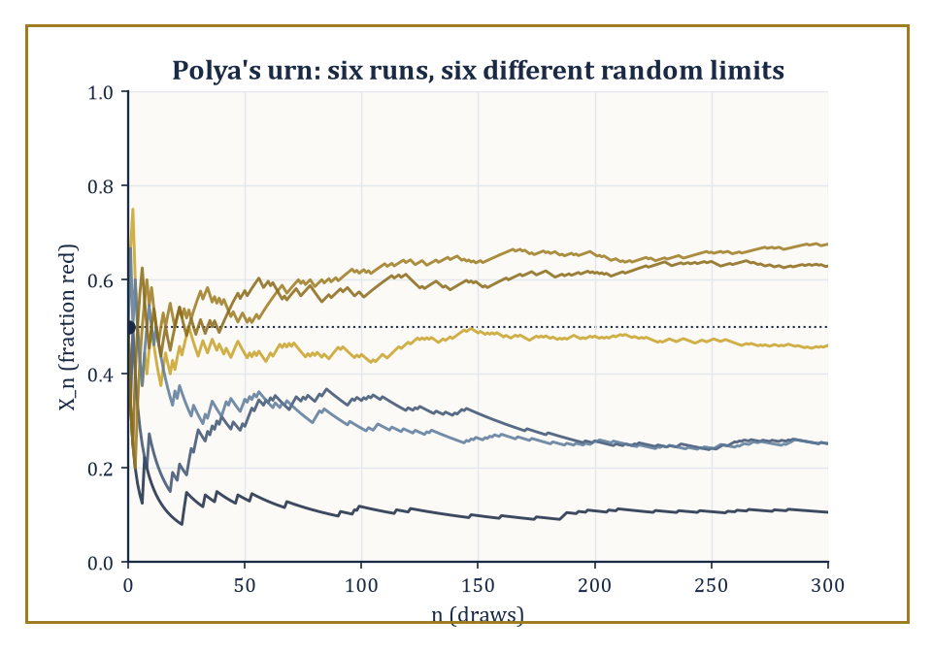
Six runs of Pólya's urn, six different destinies — each one a martingale that stopped wobbling and committed.
sup_n E|X_n| < ∞
then X_n converges almost surely to an integrable limit X_∞.
The intuition behind the proof is worth keeping, even without the details: if a martingale kept crossing back and forth over some interval [a, b] infinitely often, it would have to accumulate an unbounded amount of expected 'wasted motion' — up past b, back down past a, up again — which the L¹ bound forbids.
So for every rational interval, the number of crossings must eventually stay finite, which forces the sequence to settle down on one side or the other for every such interval simultaneously, which forces convergence.
Numeric example — Worked example: Pólya's urn and its random limit. Start an urn with 1 red ball and 1 blue ball. At each step, draw a ball uniformly at random, then return it to the urn along with one additional ball of the same colour. Let X_n be the fraction of red balls after n draws, so
X₀ = 1/2
Compute one step by hand: from the 2-ball urn, drawing red (probability 1/2) produces an urn with 2 red, 1 blue, so
X₁ = 2/3
drawing blue (probability 1/2) produces 1 red, 2 blue, so
X₁ = 1/3
Check the martingale property:
E[X₁ | F₀] = (1/2)(2/3) + (1/2)(1/3) = (1/2)(1) = 1/2 = X₀
exactly as required — the urn 'knows' the future draw is unbiased by the past composition in exactly the right way. Since X_n is always trapped in [0, 1], it is automatically L¹-bounded, so the martingale convergence theorem guarantees X_n → X_∞ almost surely for some random limit X_∞.
The classical (and rather charming) further fact — not proved here, but worth knowing as the punchline — is that X_∞ is Uniform(0, 1) distributed: the urn's eventual colour proportion is itself a uniformly random number, generated entirely by its own history.
The strong law of large numbers holds for i.i.d. integrable X_i with mean μ:
(1/n)Σᵢ₌₁ⁿ Xᵢ → μ almost surely
This is now recoverable as an instance of this general machinery, either by building a suitable reverse martingale from the partial sums, or by the classical two-step route: Kolmogorov's three-series theorem, which reduces almost-sure convergence of a series of independent (not necessarily identical) terms to the convergence of three auxiliary numerical series built from truncated means, variances, and tail probabilities; followed by Kronecker's lemma, a purely deterministic fact converting convergence of a series Σaₙ/n into convergence of the Cesàro-type average (1/n)Σaₙ to zero.
Almost-sure convergence alone does not hand you convergence of expectations — dominated convergence needs an actual dominating function — so one further ingredient, uniform integrability, is what upgrades almost-sure (or in-probability) convergence to convergence in L¹: it is precisely the 'just enough domination, on average, uniformly across the sequence' condition.
Numeric example — Worked example: the strong law's fluctuations, in numbers. Let X_i be i.i.d. Bernoulli(0.3), so
Var(X_i) = 0.3 × 0.7 = 0.21
The strong law says
(1/n)ΣXᵢ → 0.3 almost surely
but it says nothing about the rate — for that we need the standard deviation of the average, σ/√n.
At n = 10,
σ/√n = √(0.21/10) = √0.021 ≈ 0.145
two standard deviations is about 0.29, so a run of just 10 flips could easily land anywhere from roughly 0 to 6 successes (a sample fraction of 0 to 0.6) without contradicting anything.
At n = 1000,
σ/√n = √(0.21/1000) = √0.00021 ≈ 0.0145
ten times smaller, so the sample average is now typically pinned to within about ±0.03 of the true value 0.3.
This is the strong law's convergence made visible: the fluctuation shrinks like 1/√n, so no fixed finite sample ever proves the limit, but every larger sample squeezes the plausible range tighter around it — exactly the qualitative picture 'almost surely' is quietly promising to deliver in the limit.
The central limit theorem admits at least three genuinely different proofs, each illuminating a different part of the theory: via characteristic functions and Lévy's continuity theorem (convergence of characteristic functions implies weak convergence of laws); via Lindeberg's replacement method, which swaps the summands for independent Gaussians one at a time while controlling the damage using a third-moment condition; and via a martingale central limit theorem for triangular arrays of martingale differences satisfying a conditional Lindeberg condition, which is what lets the CLT extend far beyond the i.i.d. case — to Markov chains, to regression residuals, to any process whose increments are 'unpredictable given the past' in the martingale sense even if they are not literally independent or identical.
The Berry–Esseen theorem makes the rate of convergence in the classical CLT completely explicit:
sup_x |P((Sₙ − nμ)/(σ√n) ≤ x) − Φ(x)| ≤ Cρ/(σ³√n)
where ρ = E|X₁ − μ|³ and C is an absolute constant (the best known value, due to Shevtsova, is C ≈ 0.4748).
Numeric example — Worked example: an explicit Berry–Esseen bound. Continue with X_i i.i.d. Bernoulli(0.3), so
μ = 0.3, σ² = 0.21, σ = √0.21 ≈ 0.45826
and
ρ = E|X − 0.3|³ = 0.3 × (0.7)³ + 0.7 × (0.3)³ = 0.3 × 0.343 + 0.7 × 0.027 = 0.1029 + 0.0189 = 0.1218
Since σ² = 0.21 exactly,
σ³ = σ² × σ = 0.21 × 0.45826 ≈ 0.09623
At n = 100, √n = 10, so the denominator is
σ³√n ≈ 0.9623
and the numerator is
Cρ ≈ 0.4748 × 0.1218 ≈ 0.05783
The bound is therefore about
0.05783 / 0.9623 ≈ 0.0601
for a sample of 100 Bernoulli(0.3) trials, the standardised sum's cumulative distribution function is guaranteed to be within about 0.06 of the standard normal CDF, uniformly over every threshold — a completely explicit, non-asymptotic guarantee, in contrast to the bare central limit theorem, which only promises the gap vanishes eventually without saying how fast.
Seen from here, the classical limit theorems of elementary probability — once proved by separate and often quite delicate ad hoc arguments — are simply the martingale convergence theorem, applied to cleverly chosen martingales, wearing their nineteenth- and twentieth-century names.

Room 43.6: Brownian Motion
The drunkard's walk, taken to the continuous limit, and still no soberer for it
A standard Brownian motion (or Wiener process) (B_t)_{t≥0} is a stochastic process with B₀ = 0, independent increments (B_t − B_s is independent of the past for t > s), and continuous sample paths almost surely. Its increments are Gaussian:
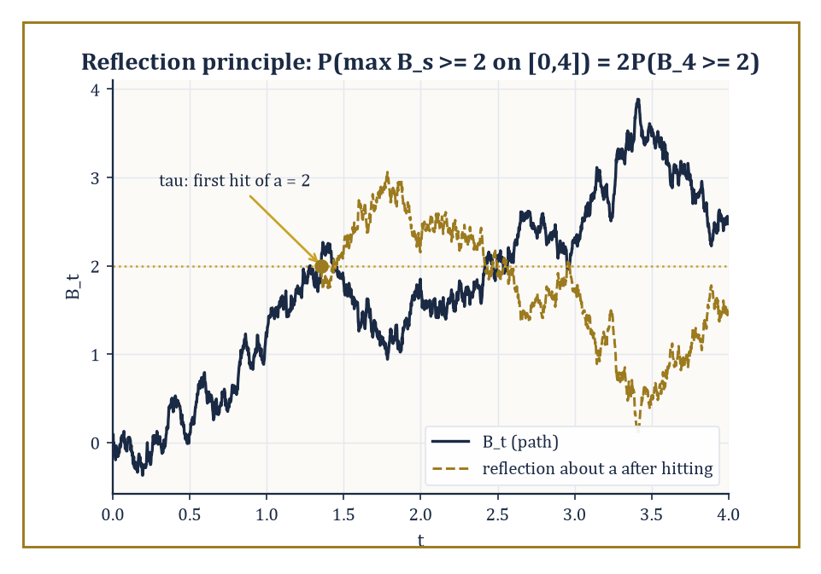
Reflect the path about the level it first touches, and the maximum's whole distribution falls out for free.
B_t − B_s ~ N(0, t − s)
That such a process exists at all is not obvious — a naive construction from the prescribed finite-dimensional (Gaussian) distributions via Kolmogorov's extension theorem gives a process, but says nothing about whether its paths can be chosen continuous. Kolmogorov's continuity criterion closes this gap: if a moment bound of the following form holds for some p, C, α > 0, then a continuous modification of the process exists.
E|B_t − B_s|^p ≤ C|t − s|^{1+α}
For Brownian motion's Gaussian increments this moment bound is easy to check directly. An equally illuminating existence route is Donsker's invariance principle, which builds Brownian motion as the limit, as n → ∞, of a suitably rescaled simple random walk.
Numeric example — Worked example: Donsker scaling, checked at one point. Let S_k be the simple random walk with i.i.d. ±1 steps, and define the rescaled process
W_n(t) = S_⌊nt⌋/√n, for t ∈ [0, 1]
Take n = 100 and t = 0.25, so ⌊nt⌋ = 25. Since each step has variance 1 and the steps are independent,
Var(S₂₅) = 25
so
Var(W₁₀₀(0.25)) = Var(S₂₅)/100 = 25/100 = 0.25
which matches, exactly,
Var(B_{0.25}) = 0.25
for standard Brownian motion. In general,
Var(W_n(t)) = ⌊nt⌋/n → t as n → ∞
for every fixed t, which is the numerical heart of Donsker's theorem: the rescaled random walk's variance converges pointwise to Brownian motion's, and (with considerably more work) so do all its finite-dimensional distributions and its path behaviour.
Brownian motion's quadratic variation is one of its most consequential features: for a partition of [0, t] with mesh going to zero, the sum of squared increments converges (in probability, and in L²) to t itself.
Σ(B_{t_{i+1}} − B_{t_i})² → t
Compare this to any smooth function, whose quadratic variation over any interval is zero — Brownian paths, despite being continuous, are almost surely nowhere differentiable and have infinite total variation on every interval, a fact that scandalised nineteenth-century analysts and merely irritates first-year probabilists now.
Numeric example — Worked example: quadratic variation, checked in expectation. Partition [0, 1] into n equal pieces, each of length 1/n. Each increment B_{i/n} − B_{(i−1)/n} has variance 1/n, since Brownian increments over an interval of length h have variance h. There are n such increments, so:
E[Σᵢ₌₁ⁿ (B_{i/n} − B_{(i−1)/n})²] = n × (1/n) = 1
exactly, for every single n — not merely in the limit. This is a much weaker statement than the true quadratic-variation theorem (which shows the sum itself, not merely its expectation, converges to 1 as the partition refines), but it already shows why the answer has to be t = 1 and not, say, 0: the expected value of the sum of squared increments is pinned to 1 at every level of partition refinement, so whatever the limit turns out to be, it cannot be anything other than 1. Refining the partition (larger n) does not change this expectation at all — it only shrinks the fluctuation of the sum around it, which is exactly the extra ingredient (a variance computation, then Chebyshev) needed to upgrade 'correct on average' to 'converges in probability'.
The strong Markov property says that Brownian motion, restarted at a stopping time, is again a Brownian motion independent of everything that came before — a fact used constantly, for instance in the reflection principle, obtained by reflecting the path about a level a after the first time it is hit (which, by the strong Markov property, is a legitimate fresh Brownian motion to reflect):
P(max_{s≤t} B_s ≥ a) = 2P(B_t ≥ a), for a > 0
A tidy corollary worth remembering is that the running maximum has the same distribution as |B_t| itself:
M_t = max_{s≤t} B_s has the same distribution as |B_t|
Reflection turns 'the maximum exceeded a' into 'the endpoint, possibly reflected, exceeded a', and the two events have exactly matching probability for every a. The law of the iterated logarithm pins down the almost-sure envelope of oscillation with remarkable precision:
limsup_{t→∞} B_t/√(2t ln ln t) = 1 almost surely
This is a growth rate slower than any fixed power of t, but faster than any fixed multiple of √t, sitting in the narrow gap between the two with an exactness that still looks like a magic trick on first meeting it.
Numeric example — Worked example: the reflection principle, in numbers. Take t = 4 and a = 2. Since B₄ ~ N(0, 4), standardise:
Z = B₄/2 ~ N(0, 1)
so
P(B₄ ≥ 2) = P(Z ≥ 1) = 1 − Φ(1) ≈ 1 − 0.8413 = 0.1587
By the reflection principle:
P(max_{s≤4} B_s ≥ 2) = 2 × 0.1587 = 0.3174
This must exceed P(B₄ ≥ 2) alone — reaching level 2 at some point during [0,4] is strictly easier than being at or above 2 exactly at time 4 — and indeed 0.3174 > 0.1587, as required; it must also stay below 1, which it comfortably does.
Brownian motion is simultaneously a martingale (Room 43.4) and a Markov process (Room 43.8) with continuous paths — the meeting point of every idea this storey has built so far.
It is the object from which essentially every continuous-time process of real interest is constructed, by time-change, by conditioning, or by the stochastic integration that lies just past this storey's summit, in the neighbourhood usually called stochastic calculus.

Room 43.7: Continuous-Time Martingales and Stopping Times
Doob's theory, now with an uncountable index set (apologies in advance)
Moving from discrete to continuous time introduces a genuine technical hazard: with uncountably many time points, naive definitions can silently break.
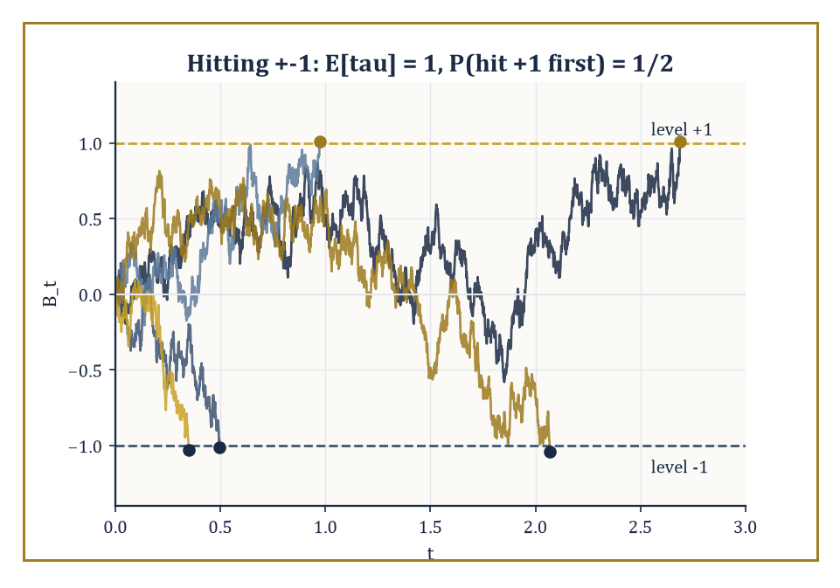
Five paths, two barriers, and a coin flip's worth of suspense about which one gets hit first.
The standard fix is to require the filtration (F_t)_{t≥0} to satisfy the 'usual conditions' — right-continuity, meaning information cannot jump discontinuously into existence, plus completeness with respect to null sets. Right-continuity is the requirement that:
F_t = ∩_{s>t} F_s
Under mild conditions a submartingale has a càdlàg version (right-continuous with left limits — the French acronym has simply stuck in English usage), which is the standard choice of representative path.
An optional time is the continuous-time analogue of a stopping time:
{τ ≤ t} ∈ F_t for every t
The optional sampling theorem extends Doob's discrete result: for a right-continuous martingale with the right integrability (bounded τ, or a uniformly integrable stopped process, are the usual sufficient conditions),
E[X_τ] = E[X₀]
Doob's maximal inequality likewise extends:
P(sup_{s≤t} |X_s| ≥ λ) ≤ E|X_t|/λ
Numeric example — Worked example: hitting probabilities via optional sampling. Let τ be the first time standard Brownian motion, started at 0, hits either level +1 or level −1. This τ is a legitimate case for optional sampling, unlike the cautionary example in Room 43.4: it is a classical fact that E[τ] = 1 (in general, for symmetric barriers at ±a, E[τ] = a²), so the integrability hypothesis genuinely holds, and B is bounded by 1 throughout [0, τ].
Optional sampling therefore applies directly:
E[B_τ] = E[B₀] = 0
Writing p = P(hit +1 first), B_τ equals +1 with probability p and −1 with probability 1 − p, so:
E[B_τ] = p(1) + (1−p)(−1) = 2p − 1 = 0
giving:
p = 1/2
This is exactly the continuous-time mirror of the discrete gambler's-ruin computation from Room 43.4 with a = b = 1, which also gave:
p = a/(a+b) = 1/2
— the discrete and continuous theories agreeing precisely, as any sensible theory built on the same intuitions ought to.
Quadratic variation ⟨X⟩_t, already met for Brownian motion in the last room (where ⟨B⟩_t = t), is defined in general as the increasing process making the following a local martingale:
X_t² − ⟨X⟩_t
'Local martingale' relaxes the martingale property to hold only up to a localising sequence of stopping times — an accommodation needed because several important continuous-time processes are fair games only in this weaker, local sense: their true martingale property can fail globally purely because an integrability condition blows up, even though every finite piece of the path looks perfectly fair.
A semimartingale is a local martingale plus a finite-variation process, and semimartingales are exactly the class of integrators against which the Itô stochastic integral — the subject waiting just past this storey's horizon — can be defined.
The Doob–Meyer decomposition writes any (sufficiently regular) submartingale uniquely as:
X_t = M_t + A_t
with M_t a local martingale and A_t a predictable increasing process: the continuous-time way of saying 'fair game plus a systematic, foreseeable upward drift'.
Abstract example — Worked example: the Doob–Meyer decomposition of a Poisson process. Let N_t be a Poisson process of rate λ — a counting process whose increments N_t − N_s (t > s) are Poisson(λ(t−s)) and independent of the past. It is a submartingale:
E[N_t | F_s] = N_s + λ(t − s) ≥ N_s
Its Doob–Meyer decomposition is:
N_t = M_t + λt
where M_t := N_t − λt is the compensated Poisson process. Verify M_t is a genuine martingale:
E[M_t | F_s] = E[N_t − N_s | F_s] + N_s − λt = λ(t−s) + N_s − λt = N_s − λs = M_s
exactly the martingale property. Here the increasing process A_t = λt is even deterministic, hence trivially predictable — the simplest possible instance of Doob–Meyer, and precisely the manoeuvre queueing theorists and actuaries use to convert a raw arrival count into a fair-game process suitable for martingale-based estimation and central limit arguments.
Numeric example — Worked example: Doob's continuous-time maximal inequality, and how loose it is. Doob's L² maximal inequality states:
E[(sup_{s≤t} |X_s|)²] ≤ 4 E[X_t²]
for a martingale X. Apply it to standard Brownian motion at t = 9:
E[B₉²] = 9
(Room 43.6), so the inequality gives:
E[(sup_{s≤9} |B_s|)²] ≤ 4 × 9 = 36
But for Brownian motion the running maximum M_t = max_{s≤t} B_s has the same distribution as |B_t| (the reflection-principle corollary from Room 43.6), so:
E[M_t²] = E[B_t²] = t
exactly — meaning the true value at t = 9 is:
E[M₉²] = 9
not 36. Doob's inequality, in this instance, is correct but loose by a factor of 4, which is entirely typical: maximal inequalities are prized for holding in complete generality, for every martingale whatsoever, and that generality is paid for in tightness.
When you have extra structure — as Brownian motion's reflection principle supplies here — you can usually do much better than the universal bound, but the universal bound is what you reach for first, on a process about which you know nothing else.
This continuous-time apparatus — right-continuous filtrations, optional times, quadratic variation, local martingales, Doob–Meyer — is not an end in itself.
It is the load-bearing scaffolding on which the stochastic calculus of the next mathematical neighbourhood is built, and a first taste of that calculus is exactly where this storey's final room is headed.

Room 43.8: Markov Processes and Generators
Amnesia as an organising principle
A stochastic process (X_t) is Markov if its future depends on its past only through its present value, for every s, t ≥ 0 and every event A:
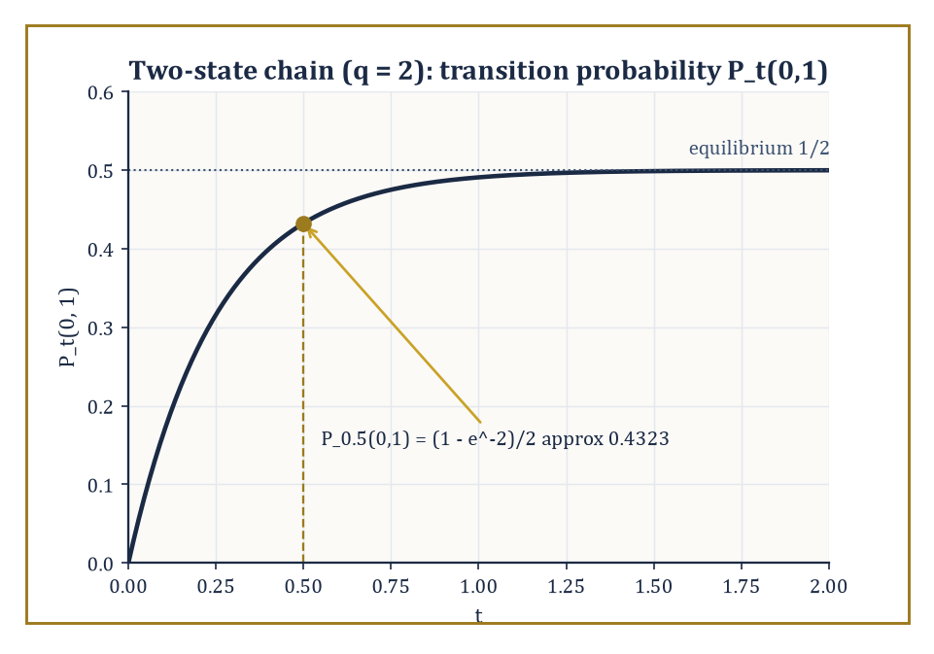
The two-state chain forgets which state it started in at rate 2q, settling into its equilibrium coin flip.
P(X_{t+s} ∈ A | F_t) = P(X_{t+s} ∈ A | X_t) almost surely
The transition semigroup (P_t)_{t≥0} encodes the law of the future given the present:
P_t(x, A) = P(X_t ∈ A | X₀ = x)
The semigroup property — the Chapman–Kolmogorov equation —
P_{t+s} = P_t P_s
is just the statement that going partway and then the rest of the way gives the same distribution as going straight there.
The infinitesimal generator L is defined on a suitable domain of functions f by
Lf = lim_{t→0} (P_t f − f)/t
it captures the instantaneous drift and diffusion of the process.
Kolmogorov's backward equation describes how expectations evolve, with u(t,x) = E_x[f(X_t)]:
∂_t u = Lu
The forward (Fokker–Planck) equation describes how the probability mass itself evolves, for the transition density p:
∂_t p = L*p
The same physics, viewed from two ends of the same telescope.
Numeric example — Worked example: a two-state continuous-time Markov chain. Consider a chain on states {0, 1} that jumps from 0 to 1 at rate q and from 1 to 0 at rate q (a symmetric telegraph-type process), with generator matrix
L = [[−q, q], [q, −q]]
Diagonalising L: the vector (1,1) is an eigenvector with eigenvalue 0, and (1,−1) is an eigenvector with eigenvalue −2q. Exponentiating gives the standard closed form
P_t(0,1) = (1 − e^{−2qt})/2
Take q = 2 and t = 0.5, so
2qt = 2 × 2 × 0.5 = 2
and e^{−2} ≈ 0.1353:
P_t(0,1) = (1 − 0.1353)/2 = 0.8647/2 ≈ 0.4324
Two sanity checks confirm the formula: as t → 0,
2qt → 0 and P_t(0,1) → (1−1)/2 = 0
correctly saying there is no time to jump; as t → ∞,
P_t(0,1) → (1−0)/2 = 0.5
correctly converging to the symmetric chain's equilibrium of spending half its time in each state.
Numeric example — Worked example: Chapman–Kolmogorov, checked directly. The semigroup property should hold for the two-state chain above with q = 2:
P_{t+s} = P_t P_s
Split t = 0.5 as t = 0.3 + 0.2 and check both routes agree. Direct, this was computed earlier:
P_{0.5}(0,1) = (1 − e^{−2})/2 ≈ 0.4324
Via the split, first compute the two intermediate transition probabilities:
P_{0.3}(0,1) = (1 − e^{−1.2})/2 ≈ (1 − 0.3012)/2 ≈ 0.3494, so P_{0.3}(0,0) ≈ 0.6506
P_{0.2}(0,1) = (1 − e^{−0.8})/2 ≈ (1 − 0.4493)/2 ≈ 0.2753, so P_{0.2}(1,1) = P_{0.2}(0,0) ≈ 0.7247 by the chain's symmetry
Chapman–Kolmogorov says:
P_{0.5}(0,1) = P_{0.3}(0,0) P_{0.2}(0,1) + P_{0.3}(0,1) P_{0.2}(1,1)
Substituting the numbers:
0.6506 × 0.2753 + 0.3494 × 0.7247 ≈ 0.1791 + 0.2532 ≈ 0.4323
This matches the direct computation of 0.4324 up to rounding. The semigroup property is not a formal abstraction here; it is an ordinary law-of-total-probability statement (condition on where the chain is at the intermediate time 0.3), and the matrix exponential formula for P_t is simply the bookkeeping device that makes it automatic for every split of every t.
Diffusion processes are Markov processes with continuous paths whose generators are second-order differential operators — literally the advection–diffusion operator of classical physics, now interpreted probabilistically, with b the drift and σ² the diffusion coefficient. In one dimension:
Lf(x) = ½σ²(x) f''(x) + b(x) f'(x)
Brownian motion is the case b = 0, σ = 1, giving
L = ½ d²/dx²
Geometric Brownian motion, the standard Black–Scholes model of a stock price, has generator
Lf(x) = ½σ²x² f''(x) + μx f'(x)
The Ornstein–Uhlenbeck process, the standard model of mean reversion (interest rates, physical systems relaxing to equilibrium), has generator
Lf(x) = ½σ² f''(x) − θx f'(x)
with the term −θx pulling the process back toward zero at rate θ. Jump processes — the Poisson process, and more generally Lévy processes, defined by stationary independent increments, of which Brownian motion and the Poisson process are the two purest examples — extend the Markov class beyond continuous paths entirely. Notice that all three named diffusions above are, at bottom, the same generator ½σ²f'' with a different drift term bolted on — a small, respectable menagerie built from one recycled idea, which is rather how most of applied mathematics gets done.
Abstract example — Worked example: the Ornstein–Uhlenbeck generator explains its own mean reversion. Take the Ornstein–Uhlenbeck generator
Lf(x) = ½σ² f''(x) − θx f'(x)
and test it on the simple function f(x) = x, so that f'(x) = 1 and f''(x) = 0:
Lf(x) = ½σ²(0) − θx(1) = −θx = −θf(x)
The identity function is an eigenfunction of L with eigenvalue −θ. This single computation is the generator-level explanation for exponential mean reversion: solving the backward equation ∂_t u = Lu with initial condition u(0,x) = f(x) = x, and using that f is an eigenfunction, gives
u(t,x) = e^{Lt}f(x) = e^{−θt}f(x) = e^{−θt}x
that is,
E_x[X_t] = e^{−θt}x
the mean decaying exponentially back to zero at rate θ, exactly the 'spring pulling toward zero' intuition one draws for this process, now derived rather than merely asserted.
The Markov property is the probabilistic expression of memorylessness, and it is the organising principle behind a genuinely enormous swathe of applied probability — queueing theory, population genetics, mathematical finance, statistical mechanics — precisely because 'forget everything except where you are right now' is, remarkably often, close enough to true to be worth building an entire theory on.

Room 43.9: Looking Ahead: From Advanced Probability to Stochastic Calculus, SPDEs, and Ergodic Theory
Onward, upward, and increasingly stochastic
We have now assembled the core of advanced probability: measure-theoretic foundations for probability spaces and random variables; independence and the extension theorems that let infinite collections of them exist; conditional expectation as the operator underlying everything else; martingales in discrete time and the convergence theorems built from them; Brownian motion as the canonical continuous-time process; the continuous-time martingale theory of quadratic variation, local martingales, and Doob–Meyer; and Markov processes with their generators.
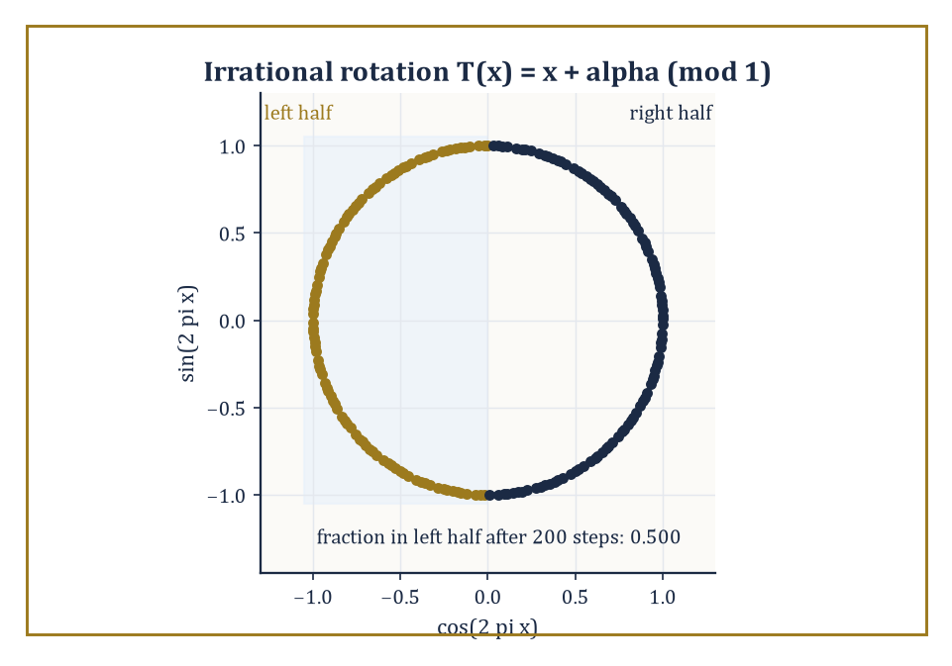
Two hundred steps of an irrational rotation, and the orbit has already split the circle exactly down the middle.
Each of these pieces was, in its own room, a destination; together, they are also a staging ground.
The most immediate neighbourhood beyond this storey is stochastic calculus: the Itô integral, which makes sense of 'integrating against' a martingale of unbounded variation like Brownian motion, and Itô's formula, the corrected chain rule that accounts for the fact that Brownian motion's quadratic variation is not zero. Where ordinary calculus says
df(B_t) = f'(B_t) dB_t
Itô's formula adds a second term,
df(B_t) = f'(B_t) dB_t + ½f''(B_t) dt
a correction that is, in effect, the tax levied for differentiating a function of a path that is continuous but nowhere smooth.
Numeric example — Worked example: Itô's formula recovers a fact we already knew. Take f(x) = x², so f'(x) = 2x and f''(x) = 2. Itô's formula gives
d(B_t²) = 2B_t dB_t + ½(2) dt = 2B_t dB_t + dt
The term 2B_t dB_t is (the differential of) an Itô integral, which is itself a martingale started at 0, so its expectation is 0 for every t; taking expectations of both sides therefore gives
d E[B_t²] = dt
and integrating from 0 with E[B₀²] = 0 gives
E[B_t²] = t
This matches Var(B_t) = t exactly, a fact we already established directly from the definition of Brownian motion back in Room 43.6 — two entirely different routes, the defining Gaussian property and the machinery of Itô's formula, landing on the identical answer. That agreement is not a coincidence to be shrugged off; it is exactly the kind of cross-check that makes stochastic calculus trustworthy rather than merely clever, and it is the first genuine computation in a toolkit the next mathematical neighbourhood will use constantly.
Past stochastic calculus lie stochastic partial differential equations, where the noise driving the equation is itself an infinite-dimensional (space-time) object; the general theory of stochastic processes, which sharpens the distinction between predictable information ('can see it coming one instant ahead') and merely optional information ('knows it the moment it happens'), a distinction this storey's Doob–Meyer decomposition already leaned on without quite naming it; and ergodic theory, whose Birkhoff almost-everywhere convergence theorem for measure-preserving transformations is the deterministic-dynamics cousin of the strong law of large numbers from Room 43.5 — time averages along a single trajectory converging to space averages, the same phenomenon this storey proved for independent randomness, now proved for deterministic systems with just enough mixing to behave, statistically, as if they were random.
Abstract example — Worked example: Birkhoff's theorem for an irrational rotation. Let T : [0,1) → [0,1) be rotation by an irrational angle α,
T(x) = x + α (mod 1)
which preserves Lebesgue measure (rotating the circle does not distort lengths) and is ergodic precisely because α is irrational (a rational rotation would instead break the circle into finitely many invariant arcs, and ergodicity — the deterministic analogue of 'no non-trivial invariant information', echoing the independence discussion of Room 43.2 — would fail). Take f to be the indicator function of the interval [0, 0.5). Birkhoff's theorem guarantees that for almost every starting point x₀, the time average converges to the space average:
(1/n)Σ_{k=0}^{n−1} f(Tᵏx₀) → ∫₀¹ f dx = 0.5
the Lebesgue measure of the interval. Concretely: this says that the orbit x₀, x₀+α, x₀+2α, … (mod 1) visits the left half of the circle exactly half the time in the long run, for almost every starting point — the equidistribution of irrational rotations, which number theorists knew and proved by other means well before ergodic theory existed, now recovered as a single instance of the same time-average-equals-space-average phenomenon that gave us the strong law of large numbers for coin flips. Deterministic dynamics and independent randomness, in the end, obey the identical limit law.
Applications of this whole apparatus range from mathematical finance and signal filtering to statistical physics and the probabilistic analysis of algorithms — anywhere a system evolves under genuine uncertainty and someone, eventually, needs a guarantee sharper than a shrug.
The deeper lesson of this storey is not any single theorem but the shift in vocabulary: once probability is built on measure theory, information, fairness, and continuous-time evolution stop being metaphors and become precise mathematical objects, with a coherent theory connecting them.
Advanced probability, in the end, is the measure-theoretic theory of randomness and information — and having built it, we are now equipped to let it run.
We have spent this storey turning informal certainties into provable ones, at the cost of a prose style in which 'almost surely' quietly carries most of the moral weight and the sample space itself, once its existence is secured, is rarely spoken of again. That trade — rigour for a certain deliberate austerity — is the going rate for a theory that can handle continuous time and infinite dimensions without blinking, and it is, on the whole, a fair exchange; certainly fairer than most martingales one meets in practice.
The next storey descends, or perhaps ascends sideways, into computational geometry: convex hulls, Voronoi diagrams, triangulations, the combinatorics of points and lines in the plane and beyond — a subject that looks, on first approach, like the driest and most deterministic corner of the entire Tower. It will not stay that way for long. The fastest known algorithms for building convex hulls and Delaunay triangulations are randomised, and their expected-running-time analyses lean on exactly the independence, conditional expectation, and martingale bookkeeping this storey just built — so the randomness we have spent nine rooms taming will turn out to be, a storey from now, someone else's favourite algorithmic trick.
The tower continues upward. We have learned to build probability on measure, and to let it run — and, mercifully, it appears to know where it is going even when we, its architects, occasionally do not.

Storey 44: Computational Geometry
Algorithms, Data Structures, and the Art of Computing with Shapes
The previous storey closed with a promise, tossed off almost as an afterthought at the end of a discussion of martingale convergence: that the machinery just built there — independence, conditional expectation, the whole disciplined apparatus for reasoning rigorously about randomness — would turn out, one storey later, to be somebody else's favourite algorithmic trick. That somebody is this storey. The trick is this: the fastest convex hull algorithm known to humanity works by throwing the input points in at random and hoping, and the hoping is not naïve optimism, it is a theorem, with an expected-running-time proof that leans directly on the conditional-expectation bookkeeping we spent nine rooms assembling. Computational geometry, encountered cold, looks like the most bloodlessly deterministic subject in the entire Tower — points, lines, polygons, a Euclidean world with the straightedge and compass replaced by a machine that does not appreciate elegance and must be told, with tedious precision, exactly what to do. It does not stay that way for long, and we shall watch the randomness sneak back in by Room 44.2.
Classical geometry, the kind Euclid practised and the kind several early storeys of this Tower revisited, reasons about individual configurations: this triangle, that circle, prove the claim once and for all with a diagram and a chain of deductions. Computational geometry asks a different question, and it is a question Euclid never had to face because he never had ten million points to process before lunch. Given a finite set of points, segments, or polygons — as input, on a computer, with no diagram to squint at — how quickly, and how reliably, can an algorithm compute their convex hull, their pairwise intersections, a triangulation, a nearest-neighbour structure, a decomposition into cells? The objects are the same ones geometry has always studied. The demand for a procedure that terminates in a predictable and provably small number of steps, on inputs of a size no human draughtsman would attempt, is new, and it is the demand this entire storey exists to satisfy.
The plan of ascent: Room 44.2 builds the convex hull, the first genuinely nontrivial computation in the subject and the building block for most of what follows. Room 44.3 sweeps a line across the plane to find every crossing among a bundle of segments, and introduces the arrangement those segments cut the plane into. Room 44.4 cuts simple polygons into triangles and asks how few security guards a nervous museum director can get away with hiring. Room 44.5 studies the two most beautiful structures in the subject — Voronoi diagrams and Delaunay triangulations — which turn out to be the same structure viewed from two directions. Room 44.6 builds data structures that answer geometric questions about a fixed point set without re-examining every point each time. Room 44.7 studies what happens when the segments of Room 44.3 are extended into full lines, an innocuous-sounding change that multiplies the complexity of the picture by roughly a factor of n. Room 44.8 confronts the fact that computers do arithmetic in floating point, and floating point does not know what convexity is, which turns out to matter enormously. Room 44.9 looks up the staircase toward motion planning, mesh generation, computational topology, and geometry in more dimensions than any of us can comfortably picture.
If Euclidean geometry taught us the properties of shapes, computational geometry teaches us to compute those properties at scale, under a clock, without cheating. Let's compute with shapes.

Room 44.1: What Computational Geometry Actually Is
In Which Euclid Meets a Compiler and Is Not Amused
Computational geometry is the study of algorithms and data structures for solving geometric problems on finite, explicitly given input.
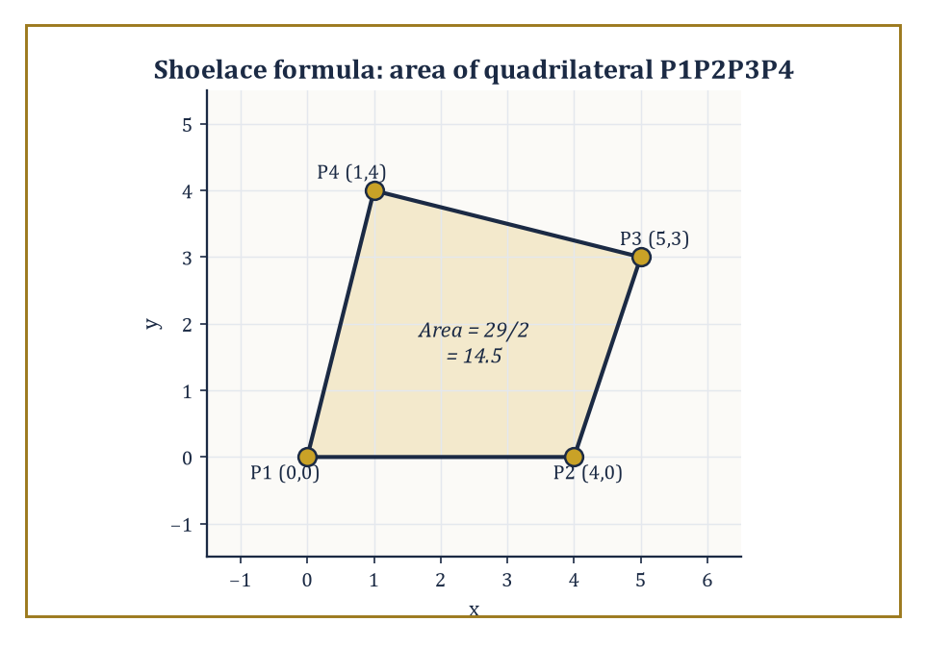
The shoelace formula turns four pairs of coordinates into the exact area 14.5, no protractor required.
The inputs are typically finite sets of points, line segments, or polygons, living in the plane or in some higher-dimensional space; the outputs are either combinatorial structures — a convex hull, a triangulation, a partition of the plane into cells — or numeric quantities computed from the input, such as an area, a distance, or a count of intersections.
What makes the subject distinctively computational, rather than merely another branch of geometry, is that every claim must come with a bound on how long it takes to compute and how much space it takes to store, stated as a function of the input size n and, crucially, of the ambient dimension d.
A theorem in classical geometry says a fact is true. A theorem in computational geometry says a fact is true, and here is a machine that discovers it in at most c·n log n steps, and here is a proof that no machine can do it faster.
Numeric example — Worked example — the shoelace formula. The most basic move in the entire subject is turning a list of coordinates into a number, and the area of a simple polygon is the cleanest instance. Take the quadrilateral with vertices, listed counterclockwise, P1=(0,0), P2=(4,0), P3=(5,3), P4=(1,4).
The shoelace formula computes twice the signed area as a sum over consecutive pairs, with the list wrapping around:
Σ(xᵢyᵢ₊₁ − xᵢ₊₁yᵢ)
(P1,P2): 0·0 − 4·0 = 0
(P2,P3): 4·3 − 5·0 = 12
(P3,P4): 5·4 − 1·3 = 20 − 3 = 17
(P4,P1): 1·0 − 0·4 = 0
Summing gives:
0 + 12 + 17 + 0 = 29
and the area is half the absolute value:
29/2 = 14.5 square units
No diagram was drawn, no protractor was consulted; four pairs of numbers went in, one number came out, and it is exact and correct for any simple polygon, however many vertices it has and however irregular its shape. That is the entire spirit of the subject in miniature: geometric meaning, reduced to arithmetic that a machine can execute a billion times a second without ever once feeling the pull of visual intuition.
Almost every algorithm in this storey is built, ultimately, out of one microscopic decision, repeated enormously many times: given three points P, Q, R, does the path P→Q→R turn left, turn right, or go straight? This is the orientation test, and it is computed without a single trigonometric function, using only the sign of a 2×2 determinant:
orient(P,Q,R) = (Qₓ−Pₓ)(R_y−P_y) − (Q_y−P_y)(Rₓ−Pₓ)
A positive value means the turn is counterclockwise (R lies to the left of the directed line P→Q); negative means clockwise (R to the right); zero means the three points are collinear.
It costs two subtractions and two multiplications and a subtraction — no square roots, no angles, no ambiguity about which quadrant anything is in — which is precisely why it can be evaluated billions of times inside a hull or intersection algorithm without ruining the running time, and precisely why, in Room 44.8, it turns out to be the single predicate whose sign floating-point arithmetic is most likely to get catastrophically wrong.
Numeric example — Worked example — the orientation test. Take P=(1,1), Q=(4,2), R=(2,5). Compute:
orient(P,Q,R) = (4−1)(5−1) − (2−1)(2−1) = (3)(4) − (1)(1) = 12 − 1 = 11
The result is positive, so the path P→Q→R turns left (counterclockwise) — and indeed, sketching it mentally, the first leg moves mostly rightward and slightly up, while the second leg swings sharply up and back to the left, which is exactly what a left turn looks like.
Now test P'=(0,0), Q'=(4,0), R'=(2,−3):
orient = (4−0)(−3−0) − (0−0)(2−0) = (4)(−3) − 0 = −12
Negative, a right turn — R' sits below the line through P' and Q', consistent with a clockwise bend. This one formula, and the sign of its output, is doing all the geometric work; everything else in this storey is bookkeeping around it.
The field is a marriage of two older habits of mind.
Combinatorial geometry contributes the study of the discrete structure of geometric configurations: how many vertices can a convex hull have, how many cells can an arrangement of lines create, how does that count grow with n and with d.
Algorithm design contributes the toolkit for exploiting that structure efficiently: divide-and-conquer (solve two halves, merge), the sweep line (process the plane one coordinate at a time, as if dragging a ruler across it), randomized incremental construction (add the input in a random order and let the expected cost work out small), and range searching (organise data so that a query only touches the part of it that matters).
Every room from here on is an application of one or two of these paradigms to one geometric problem, and the dependence on dimension d is the theme that recurs most stubbornly: an algorithm that is embarrassingly fast in the plane can become embarrassingly slow, or combinatorially explosive, the moment d climbs past three or four — a phenomenon with its own name, the curse of dimensionality, that will follow us all the way to Room 44.9.
Numeric example — Worked example — the curse of dimensionality in round numbers. To put a number on the phrase before meeting its formal source in Room 44.2: an algorithm whose cost scales as n^⌊d/2⌋ — precisely the bound convex hull complexity turns out to obey — costs, for a modest n=100 points:
d=2: 100¹ = 100 operations
d=4: 100² = 10,000 operations
d=6: 100³ = 1,000,000 operations
d=10: 100⁵ = 10,000,000,000 operations
Four small, entirely reasonable-looking increases to the dimension — from 2 up to 10 — turn a computation done on the back of an envelope into one needing ten billion steps, and not one single point was added to the input the whole time.
That is the curse of dimensionality reduced to a table: not that high-dimensional geometry is impossible, but that the exponent in its running-time bounds is the dimension itself, or half of it, and exponents are considerably less forgiving than the constants everybody spends their afternoons optimising instead.
One further confession, inherited from the source material and worth stating in cold numbers before we go any further: in this subject, the gap between O(n²) and O(n log n) is not an aesthetic preference for theorists with time on their hands, it is the difference between a program that finishes and a program that does not.
Applications drive the choice of which geometric problems get studied — computer graphics, geographic information systems, robotics, computer-aided design, mesh generation for numerical simulation — and the theory's job is to supply both the fastest known algorithm and a matching lower bound proving nobody will ever do better, so that engineers can stop looking for a speedup that provably does not exist.
Numeric example — Worked example — why the exponent matters. Take n = 1,000,000 points, a modest dataset by modern standards (a city's worth of GPS pings, say).
An O(n²) algorithm performs roughly n² elementary operations:
n² = 10¹² elementary operations
An O(n log n) algorithm performs roughly n·log₂n operations; since log₂(10⁶) ≈ 19.93, that is about:
10⁶ × 19.93 ≈ 1.99×10⁷ operations — call it 2×10⁷
The ratio between the two is:
10¹²/(2×10⁷) = 5×10⁴, a factor of fifty thousand
On a processor doing a generous one billion elementary operations per second, the O(n log n) algorithm finishes in about 0.02 seconds — you would not have time to glance away from the screen.
The O(n²) algorithm needs about:
10¹²/10⁹ = 1,000 seconds
That is the better part of seventeen minutes, for the same input. Scale n up by a further factor of ten, to ten million points, and the O(n log n) algorithm is still comfortably under a second, while the O(n²) algorithm now needs on the order of a full day.
This is why the subject cares, with an intensity that can look excessive from the outside, about whether an algorithm's exponent is 1, or 1 with a logarithm attached, or 2.

Room 44.2: Convex Hulls
The Shrink-Wrap Theorem
The convex hull of a finite set of points is the smallest convex set containing them all — imagine stretching a rubber band around a scattering of nails hammered into a board and letting it snap tight; the shape it settles into is the hull.
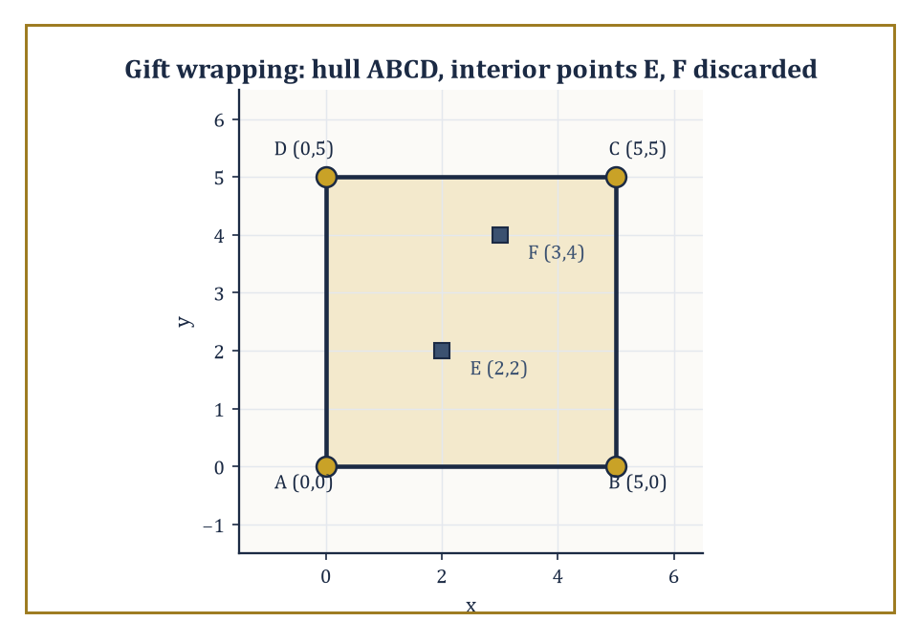
Gift wrapping finds the square ABCD and correctly ignores the interior points E and F, which never win a single left-of-everything test.
In the plane, the hull is always a convex polygon, and its vertices are always a subset of the original points (the rubber band only ever touches the outermost nails; the ones in the middle are irrelevant to it, however many of them there are).
Three classical algorithms compute the planar hull in O(n log n) time: gift wrapping (Jarvis march), which walks around the outside picking the next most extreme point at each step; Graham scan, which sorts the points by angle around a fixed pivot and then sweeps, discarding any point that would create a right turn; and Andrew's monotone chain, which sorts by x-coordinate and builds the upper and lower chains of the hull independently.
All three lean on the orientation test from Room 44.1 for every decision about which points to keep.
Numeric example — Worked example — gift wrapping by hand. Take the six points A(0,0), B(5,0), C(5,5), D(0,5), E(2,2), F(3,4).
Gift wrapping starts at a point guaranteed to be on the hull — here the lowest point, A — and repeatedly finds the next hull vertex by testing, via the orientation test, whether every other point lies to the left of the current candidate edge. From A, try candidate edge A→B: for each remaining point r, check orient(A,B,r).
r=C=(5,5): orient = (5−0)(5−0) − (0−0)(5−0) = 25 − 0 = 25 > 0, left
r=D=(0,5): orient = (5)(5) − (0)(0) = 25 > 0, left
r=E=(2,2): orient = (5)(2) − (0)(2) = 10 > 0, left
r=F=(3,4): orient = (5)(4) − (0)(3) = 20 > 0, left
Every remaining point lies to the left of A→B, so B is confirmed as the next hull vertex — no other candidate edge from A could have this property, since any edge with a point to its right is disqualified.
Repeating the same test from B finds C next, then D, then back to A, closing the hull as the square A→B→C→D. The interior points E and F never once win the left-of-everything test, and are correctly discarded — the algorithm has, without ever computing an area or drawing a picture, identified exactly the four extreme points and ignored the two that contribute nothing to the shape.
That O(n log n) is not merely the best anyone has managed; it is provably optimal, and the proof is a small piece of intellectual jujitsu: the hull problem can be made to sort.
Given any n real numbers, place the point (xᵢ, xᵢ²) for each one on the parabola y = x². Because the parabola is strictly convex, every one of these points lies on the convex hull — none is ever interior to the others — and the hull's vertices occur in exactly the same left-to-right order as the sorted xᵢ values.
So an algorithm that computed convex hulls faster than O(n log n) would sort faster than O(n log n) too, by disguising the numbers as points on a parabola; since comparison-based sorting has a proven Ω(n log n) lower bound, convex hull computation inherits the same floor.
It is a rare and satisfying situation in which a geometric problem and a purely combinatorial one turn out to be, computationally, the very same problem wearing different coats.
Worked example — Worked example — hiding a sorting problem inside a hull. Take the five numbers 3, 1, 4, 2, 5 and lift each onto the parabola y = x²:
(3,9), (1,1), (4,16), (2,4), (5,25)
Because y = x² is convex, all five points already sit in convex position — none is inside the hull of the others — so the convex hull is the entire set, and its boundary, traced from left to right, visits the points in order of increasing x-coordinate:
(1,1), (2,4), (3,9), (4,16), (5,25)
Read off the x-coordinates in that order — 1, 2, 3, 4, 5 — and the original list has been sorted, entirely as a side effect of computing a convex hull.
Any hull algorithm faster than O(n log n) could therefore be repurposed as a sorting algorithm faster than O(n log n), which the Ω(n log n) comparison-sorting lower bound forbids; hence no hull algorithm can be faster than O(n log n) either. This is the whole lower-bound argument, run on five numbers instead of an abstract n, and it generalises without changing a single idea.
Move to three dimensions and the hull becomes a convex polyhedron; the two-dimensional algorithms do not generalise gracefully, but randomized incremental construction (add the points one at a time in random order, updating the hull as each new point either lies inside the current hull, in which case ignore it, or outside, in which case patch the hull to include it) achieves optimal O(n log n) expected time.
Timothy Chan's algorithm achieves the same bound deterministically, in the worst case, with no randomness required at all — a small triumph, since derandomizing a randomized algorithm without losing its speed is usually much harder than it sounds.
In three dimensions the hull's combinatorial complexity (its number of vertices, edges, and faces) is always O(n), by Euler's formula for polyhedra.
The surprise arrives in higher dimensions, where the hull of n points in general position in ℝᵈ can have as many as Θ(n^⌊d/2⌋) faces — a bound that is quadratic already at d=4 and grows without any comfortable limit as d increases, a first hint of the curse of dimensionality that will recur through the rest of this storey.
Numeric example — Sanity check — Euler's formula in three dimensions. Take the simplest possible 3-D hull, a tetrahedron: 4 vertices, 6 edges, 4 faces. Euler's formula for a convex polyhedron states:
V − E + F = 2
4 − 6 + 4 = 2 — correct
Now take a triangular bipyramid formed by gluing two tetrahedra together on a shared face: it has 5 vertices, 9 edges, 6 (triangular) faces.
5 − 9 + 6 = 2 — correct again
Both examples confirm the general fact underlying the O(n) bound on 3-D hull complexity: for any convex polyhedron, the edge and face counts are pinned to the vertex count by a single linear relation, so however many vertices the hull has, its total combinatorial size stays proportional to that number — no quadratic blow-up is possible in three dimensions, however the points are arranged.
It is precisely this comfortable linear relationship that fails once the ambient dimension climbs to four and beyond.
Convex hulls are the first genuinely nontrivial computation in the subject, and very far from the last time we shall use one: hull computations sit inside collision-detection routines in physics engines, inside the first step of many triangulation and mesh-generation algorithms, and — as the arrangement of Room 44.7 will reveal — inside the very lower-bound arguments the field uses to prove itself optimal elsewhere.
Treat the hull, from here on, as a building block rather than a destination.

Room 44.3: Line-Segment Intersection and Arrangements
Where Everybody Crosses Everybody, Politely
Given n line segments in the plane, how quickly can every pair of crossings among them be found and reported? A naive approach checks all C(n,2) pairs, costing O(n²) time regardless of how few intersections actually occur — wasteful when the segments barely cross at all, and precisely the kind of quadratic blowup Room 44.1 warned against.
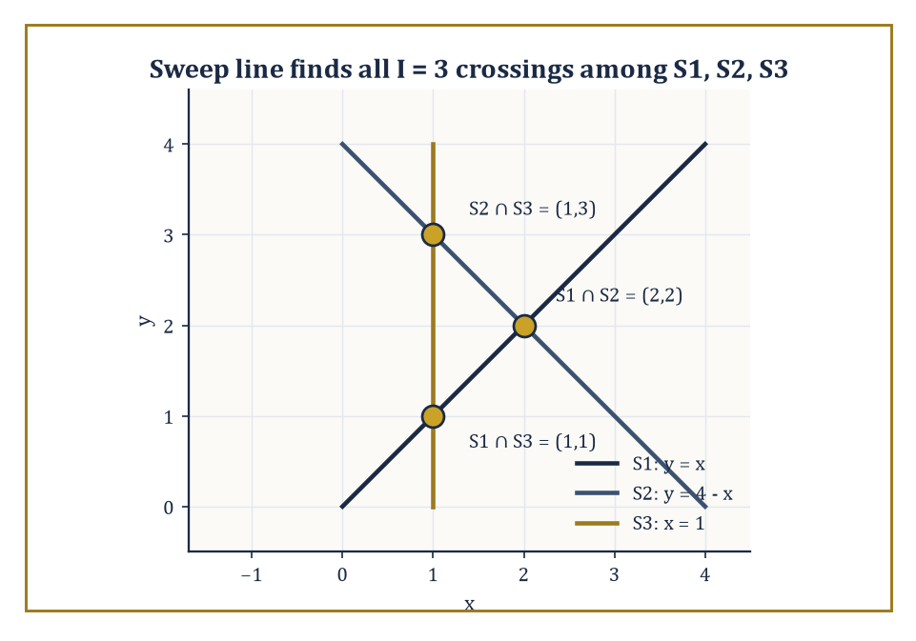
Three segments, three crossings — exactly the I = 3 a sweep line would report, and no more.
The Bentley–Ottmann sweep-line algorithm does better: it drags an imaginary vertical line across the plane from left to right, pausing at a sequence of events (segment endpoints, and intersection points as they are discovered), and maintains a status structure recording the top-to-bottom order of the segments currently crossed by the sweep line.
Two segments can only intersect if they become adjacent in this order at some point during the sweep, which lets the algorithm find every crossing in O(n log n + I) time, where I is the number of intersection points actually reported — the running time adapts to how cluttered the picture actually is, rather than pessimistically assuming the worst.
Numeric example — Worked example — three segments, three crossings. Take three segments: S1 from (0,0) to (4,4) (the line y = x); S2 from (0,4) to (4,0) (the line y = 4 − x); S3 the vertical segment from (1,0) to (1,4) (the line x = 1).
Compute S1 ∩ S2 by writing both as points-plus-parameter, for t, s ∈ [0,1]:
S1(t) = (4t, 4t), S2(s) = (4s, 4 − 4s)
Setting the x-coordinates equal gives:
4t = 4s, so t = s
Setting the y-coordinates equal gives:
4t = 4 − 4s = 4 − 4t, so 8t = 4, t = 0.5
Substituting back, the intersection point is:
(4·0.5, 4·0.5) = (2, 2)
and t = s = 0.5 both lie in [0,1], so the crossing is genuinely on both segments (not merely on their infinite extensions). A quick check of the other two pairs confirms the pattern: S1 meets S3 (x=1 on y=x) at (1,1); S2 meets S3 (x=1 on y=4−x) at (1,3). So I = 3 for this instance.
A sweep line moving left to right would process, in order of x-coordinate, the left endpoints of S1 and S2 (both at x=0), then the crossing S1∩S3 and S2∩S3 at x=1 (with S3 itself starting there too), then the crossing S1∩S2 at x=2, then the remaining right endpoints at x=4 — six endpoint events and three intersection events, nine events total, each handled in O(log n) time to update the status structure.
A naive method here would simply test all C(3,2) = 3 pairs of segments directly, which for an instance this tiny is obviously cheaper than running an event queue with nine entries in it — nobody sane deploys a sweep line to intersect three segments, and this example is not a demonstration of speed but a demonstration of mechanism.
The saving the sweep line is actually built for is asymptotic: with n segments and I crossings, sweeping costs O((n+I)log n) against a naive method's C(n,2), which grows like n²/2, and it is only once n climbs into the thousands, exactly as in the O(n²) versus O(n log n) comparison of Room 44.1, that the sweep's per-event overhead stops being the dominant cost and its refusal to examine irrelevant pairs starts to pay for itself.
The same sweep, run to completion rather than merely to report crossings, produces the arrangement of the segments: the subdivision of the plane into vertices (segment endpoints and crossings), edges (the pieces of segments between consecutive vertices), and faces (the regions the segments cut the plane into), each face bounded by a constant number of edges.
Arrangements generalise readily from segments to full lines or curves, and Room 44.7 is devoted to the case of full lines, where the complexity explodes in an instructive way.
The key structural fact used throughout the subject is the zone theorem: the total complexity — counted in edges — of all the faces that a single additional curve passes through, as it crosses an existing arrangement of n lines or segments, is only O(n), even though the arrangement as a whole can have complexity Θ(n²).
A curve threading its way through a crowded arrangement only ever disturbs a linear-sized neighbourhood of its own path.
Abstract example — Worked example — counting faces in an arrangement. An arrangement of n lines in general position (no two parallel, no three meeting at a point) has exactly C(n,2) vertices, and divides the plane into exactly 1 + n + C(n,2) faces — a formula worth checking on small cases before trusting it on large ones.
For n=2, two crossing lines have C(2,2)=1 vertex:
1 + 2 + 1 = 4 faces
The familiar four quadrants an X-shape cuts the plane into. Correct.
For n=3 lines in general position (forming a small triangle in the middle), C(3,2)=3 vertices:
1 + 3 + 3 = 7 faces
The central triangle, three regions adjacent to its edges, and three unbounded regions beyond its corners, seven in total. Correct, and a pleasant thing to verify by sketching three lines on paper and counting.
The face count grows as Θ(n²) — for n=20 lines it is already:
1 + 20 + 190 = 211 faces
Yet the zone theorem says that if a twenty-first line is added to this arrangement of 20, it crosses each of the 20 existing lines at most once (general position again), so it is cut into at most 21 pieces by those crossings, and each piece lies in a single face of the original arrangement — meaning the new line passes through at most 21 faces, not 211.
This gap between the linear cost of touching an arrangement and the quadratic cost of the whole arrangement is precisely why algorithms that build an n-line arrangement by inserting the lines one at a time can do so in optimal O(n²) total time: each of the n insertions costs only O(n), and n insertions at O(n) apiece sum to O(n²), matching the size of the final answer with no wasted work.

Room 44.4: Polygon Triangulation and Art Galleries
Cutting Up Rooms, Guarding Museums
Every simple polygon with n vertices — simple meaning its boundary does not cross itself, however wildly it wanders — can be cut into triangles using only diagonals that lie entirely inside the polygon, and any such triangulation always uses exactly n − 3 diagonals and produces exactly n − 2 triangles, regardless of the polygon's shape or how the diagonals are chosen.
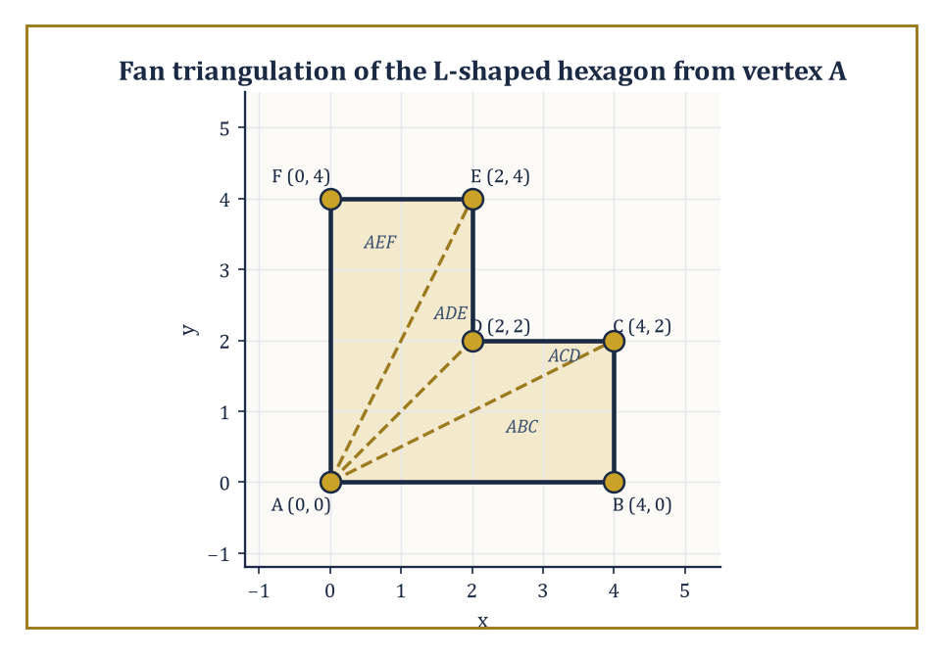
Fanning three diagonals out from vertex A cuts the L-shaped hexagon into exactly n-2 = 4 triangles, areas summing to the whole.
Bernard Chazelle's algorithm computes such a triangulation in O(n) time, genuinely linear, after a linear-time partition of the polygon into simpler pieces — a landmark result, and one of the more technically demanding optimal algorithms in the field.
Polygons that happen to be monotone (meaning every vertical line crosses the boundary at most twice, so the polygon has a well-defined top chain and bottom chain) are far easier: a simple stack-based sweep triangulates a monotone polygon in O(n) time using nothing more sophisticated than the orientation test from Room 44.1, and turning an arbitrary simple polygon into a handful of monotone pieces first is the standard route to a triangulation in practice, even when Chazelle's fully linear method is overkill.
Numeric example — Worked example — triangulating an L-shaped hexagon. Take the L-shaped hexagon with vertices, in order, A(0,0), B(4,0), C(4,2), D(2,2), E(2,4), F(0,4) — the union of a wide rectangle [0,4]×[0,2] and a tall rectangle [0,2]×[2,4] sharing an edge, with a reflex (inward-pointing) vertex at D.
With n=6, any triangulation must use n−2=4 triangles and n−3=3 diagonals.
Fan the triangulation out from vertex A, using diagonals A–C, A–D, and A–E; checking each diagonal stays inside the polygon (A–C runs entirely within the wide rectangle; A–D runs along y=x from (0,0) to (2,2), staying inside the wide rectangle the whole way; A–E runs from (0,0) to (2,4), staying inside the wide rectangle for the first half and the tall rectangle for the second) confirms all three are legal. This produces triangles ABC, ACD, ADE, AEF.
As a check on the whole construction, compute each triangle's area by the shoelace formula and confirm they sum to the polygon's true area. The shoelace area of a triangle (P,Q,R) is:
½|Pₓ(Q_y−R_y) + Qₓ(R_y−P_y) + Rₓ(P_y−Q_y)|
Triangle ABC = A(0,0),B(4,0),C(4,2): ½|0(0−2)+4(2−0)+4(0−0)| = ½|0+8+0| = 4
Triangle ACD = A(0,0),C(4,2),D(2,2): ½|0(2−2)+4(2−0)+2(0−2)| = ½|0+8−4| = 2
Triangle ADE = A(0,0),D(2,2),E(2,4): ½|0(2−4)+2(4−0)+2(0−2)| = ½|0+8−4| = 2
Triangle AEF = A(0,0),E(2,4),F(0,4): ½|0(4−4)+2(4−0)+0(0−4)| = ½|0+8+0| = 4
Summing:
4 + 2 + 2 + 4 = 12
Independently, the polygon's own area is the sum of the two rectangles:
(4×2) + (2×2) = 8 + 4 = 12
The two totals agree exactly, confirming both that the triangulation is valid and that no arithmetic slipped along the way.
The art-gallery theorem, due to Václav Chvátal, asks a question a security consultant might actually ask: how many stationary guards, each with an unlimited 360° field of view, are always sufficient to see every point inside an arbitrary simple polygon with n walls, and how many are sometimes necessary?
The answer is a clean ⌊n/3⌋: that many guards always suffice for any simple polygon, and there exist polygons — comb-shaped ones, with deep narrow prongs — for which ⌊n/3⌋ guards are also necessary, so the bound cannot be improved in general.
The proof that ⌊n/3⌋ always suffices runs through triangulation: triangulate the polygon, three-colour the vertices of the resulting triangulation so that every triangle has one vertex of each colour (always possible, by an inductive argument on the triangulation's dual tree), and place a guard at every vertex of whichever colour class is smallest — since the three colour classes partition the n vertices, the smallest is at most ⌊n/3⌋ vertices, and because every triangle has a vertex of that colour, every triangle (and hence the whole polygon) is seen by some guard standing on one of its own corners.
Abstract example — Worked example — a comb polygon needs its guards. To see that ⌊n/3⌋ is sometimes genuinely necessary and not merely a lazy upper bound, picture a comb with k prongs: a long rectangular base with k narrow, deep triangular teeth sawn into one long side, each tooth separated from its neighbours by a deep narrow notch.
Such a polygon can be built with exactly:
n = 3k vertices
Three vertices per prong, roughly speaking: the tip and the two notch-corners flanking it. The crucial feature is that the interior of each notch can only be seen from very close to the tip of its own prong; no single guard, wherever placed, can see into two different notches at once, because the deep narrow walls of the intervening teeth block the line of sight between them.
Guarding all k notches therefore requires at least k separate guards, one per prong, and:
k = n/3
Matching the ⌊n/3⌋ upper bound exactly and showing it is tight. This is the standard reason computational geometers reach for a comb whenever they need to prove a guarding bound cannot be beaten: it is the geometric equivalent of a worst-case adversary, purpose-built to make every guard as short-sighted as the theorem allows.
The computational problem of finding the true minimum number of guards for a given polygon — rather than the worst-case bound over all polygons — is NP-hard in general, though efficient exact and approximation algorithms exist for restricted classes such as monotone or orthogonal (rectilinear) polygons.

Room 44.5: Voronoi Diagrams and Delaunay Triangulations
Everybody Gets Their Own Postcode
Given a finite set of sites in the plane, the Voronoi diagram partitions the plane into cells, one per site, where the cell belonging to site s consists of every point closer to s than to any other site — the mathematical formalisation of catchment areas, postcodes, and the territory a mobile-phone mast actually covers.
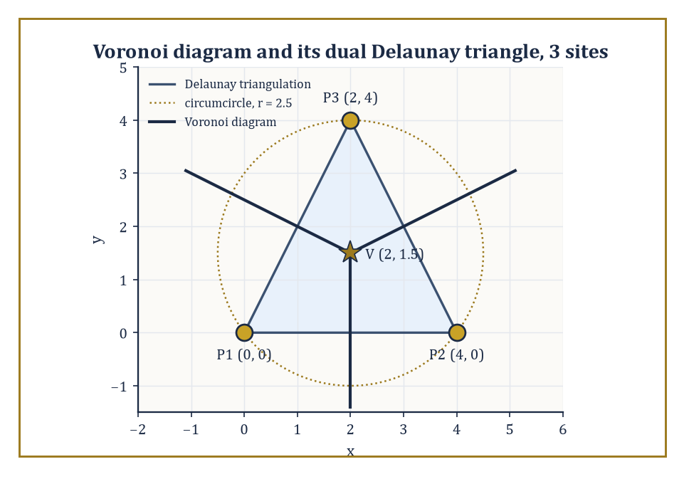
The same three points, viewed two ways: Voronoi cells meeting at V, and the Delaunay triangle they are dual to, both governed by the circumcircle of radius 2.5.
Each cell is a convex polygon (possibly unbounded, for sites on the outer edge of the set), bounded by segments of the perpendicular bisectors between pairs of sites, and the whole diagram has only O(n) total complexity and can be built in O(n log n) time by a sweep or by randomized incremental construction, despite there being, in principle, O(n²) pairs of sites whose bisectors might have contributed an edge — most bisectors, it turns out, never make it into the final diagram at all, because some closer site always renders them irrelevant.
Numeric example — Worked example — the Voronoi vertex of three sites. Take three sites P1=(0,0), P2=(4,0), P3=(2,4). Their three Voronoi cells meet at the circumcenter of the triangle P1P2P3 — the unique point equidistant from all three.
The perpendicular bisector of P1P2 passes through the midpoint (2,0) and, since P1P2 is horizontal, is the vertical line:
x = 2
The perpendicular bisector of P1P3 passes through the midpoint (1,2); since P1P3 has direction (2,4) and hence slope 2, the bisector has slope −1/2, giving the line:
y − 2 = −½(x − 1)
Substituting x=2 from the first bisector:
y − 2 = −½(2−1) = −0.5, so y = 1.5
The two bisectors meet at (2, 1.5). Check this point is indeed equidistant from all three sites:
distance to P1 = √(2²+1.5²) = √(4+2.25) = √6.25 = 2.5
distance to P2 = √((2−4)²+1.5²) = √(4+2.25) = 2.5
distance to P3 = √((2−2)²+(1.5−4)²) = √(0+6.25) = 2.5
All three distances equal 2.5 exactly, confirming (2,1.5) is the common Voronoi vertex where the three cells meet — a disc of radius 2.5 centred there passes through all three sites and contains no other site (there are no others), which is exactly the empty-circle property that characterises Delaunay triangulations.
Joining the three sites directly, P1–P2, P2–P3, P3–P1, gives the Delaunay triangulation dual to this diagram: an edge appears in the Delaunay triangulation precisely when the two sites' Voronoi cells share a boundary edge, and here all three pairs do, meeting at the single vertex just computed.
Among all the possible triangulations of a given point set, the Delaunay triangulation is distinguished by an elegant optimality property: it maximizes the minimum angle appearing anywhere in the triangulation, over all possible ways of choosing the diagonals.
This is not a cosmetic preference — triangles with very small angles (slivers) cause numerical instability in the finite-element and finite-difference methods that triangulations are so often built to feed, so a triangulation that provably avoids slivers wherever the point set allows it is a mesh generator's favourite structure, and it is why the Delaunay triangulation, rather than some arbitrary alternative, is the default choice throughout computational science.
Numeric example — Worked example — an edge flip, and the angle that improves. Take the convex quadrilateral A(0,0), B(2,0), C(2,2), D(0,2.5), and consider its two possible triangulations, split by either diagonal AC or diagonal BD.
Diagonal AC gives triangles ABC and ACD. Triangle ABC is right-angled at B (legs AB=2, BC=2), giving angles:
90°, 45°, 45°
Triangle ACD, with AC=√8≈2.828, AD=2.5, CD=√(2²+0.5²)=√4.25≈2.062, has angle at A exactly 45° (since AC lies at 45° to the x-axis and AD lies along the y-axis, at 90°, a 45° difference); its three angles are:
angle A ≈ 45°, angle C ≈ 59°, angle D ≈ 76° (summing to 180°)
The minimum angle across this triangulation is 45°.
Diagonal BD instead gives triangles ABD and BCD. Triangle ABD is right-angled at A (legs AB=2, AD=2.5), giving:
angle A = 90°, angle B = arctan(2.5/2) ≈ 51.3°, angle D ≈ 38.7°
Triangle BCD, with BC=2, BD=√(2²+2.5²)=√10.25≈3.202, CD≈2.062, works out via the dot-product form of the cosine rule to:
angle C ≈ 104.0°, angle B ≈ 38.7°, angle D ≈ 37.3° (summing to 180°)
The minimum angle across this triangulation is 37.3°.
Comparing the two: the AC-diagonal triangulation has minimum angle 45°, the BD-diagonal triangulation has minimum angle only 37.3°. Since 45° > 37.3°, the AC diagonal is the Delaunay choice — exactly the diagonal that the empty-circle test would also select, since it avoids creating the thinner, more sliver-prone triangles that the BD diagonal produces.
Flipping from the worse diagonal to the better one, whenever a local test like this one detects an improvement, is precisely the local operation that incremental Delaunay algorithms repeat until no more flips help.
Beyond meshing, the Voronoi diagram is the natural data structure for nearest-neighbour queries (find which site a query point falls closest to — just locate which cell it lands in), for facility-location problems (where should a new depot go to be as far as possible from every existing depot's territory — look at the diagram's vertices, which are the locally most-distant points from their nearest sites), and for the classical post-office problem this whole line of research is sometimes named after: given a set of post offices, which one is closest to an arbitrary address?
Once the diagram is built, each such query is answered by a single O(log n) point-location step, the subject of Room 44.6.

Room 44.6: Geometric Searching and Range Queries
Finding a Needle Without Reading the Whole Haystack
Point location asks: given a planar subdivision fixed in advance — the faces of a Voronoi diagram, say, or of any arrangement — and given a query point that arrives afterwards, which face contains it?
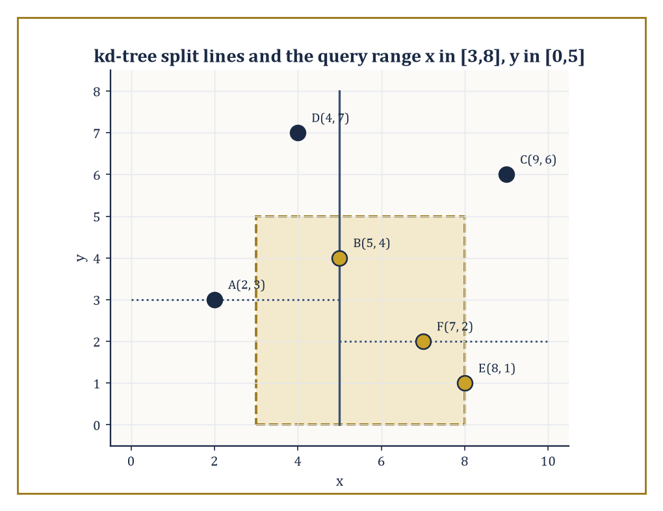
The kd-tree's alternating split lines let the query rectangle skip straight to B, E, and F without ever touching A, C, or D.
Preprocessing the subdivision into a trapezoidal map (extend a vertical segment upward and downward from every vertex until it hits another edge, cutting every face into trapezoids) and a corresponding search structure (a directed acyclic graph whose internal nodes each test the query point against a single x-coordinate or a single edge) allows any subsequent query to be answered in O(log n) expected time, using only O(n) space, built by randomized incremental construction in O(n log n) expected time — one query touches only a handful of trapezoids, however large n is, because each internal test halves (in expectation) the remaining candidates.
Numeric example — Worked example — locating a point among Voronoi cells. Reuse the three sites from Room 44.5's Voronoi example: P1=(0,0), P2=(4,0), P3=(2,4), whose bisectors were x=2 (separating P1 from P2), y=−½x+2.5 (separating P1 from P3), and y=½x+0.5 (separating P2 from P3), meeting at the Voronoi vertex (2,1.5). Locate the query point Q=(1,1) without computing a single distance.
Test 1: compare Q against the P1/P2 bisector x=2.
Qₓ = 1 < 2, so Q sits on P1's side
Test 2: compare Q against the P1/P3 bisector; at x=1 the bisector sits at:
y = −½(1)+2.5 = 2
And Q_y=1<2, so Q again sits on P1's side (P1 itself, at y=0, also lies below this line). Two tests, both pointing to P1, and the search structure can stop — no need to consult the P2/P3 bisector at all, since P1's cell has already been identified.
Check the answer the slow way, by direct distance:
d(Q,P1) = √(1+1) = √2 ≈ 1.414
d(Q,P2) = √(9+1) = √10 ≈ 3.162
d(Q,P3) = √(1+9) = √10 ≈ 3.162
P1 is indeed nearest. Two comparisons settled a question that three distance computations (each requiring a square root) would otherwise have answered — and with log₂3≈1.58, two is exactly the ⌈log₂ n⌉ the O(log n) bound promises for three cells, a saving that stays at O(log n) however many sites are added, rather than growing with n the way a distance-by-distance scan would.
Range searching asks a related but distinct question: given a fixed set of n points, preprocessed once, report (or merely count) all the points lying inside an arbitrary query rectangle, half-plane, or simplex, presented later.
A kd-tree answers axis-aligned rectangle queries by recursively splitting the point set with alternating vertical and horizontal lines (split by x-coordinate at the root, by y-coordinate at depth one, back to x at depth two, and so on), using O(n) space and O(n log n) preprocessing time, at the cost of O(√n + k) query time for reporting k points — slower per query than a range tree, which achieves O(log n + k) query time at the price of O(n log n) space instead of O(n); partition trees offer yet another point on this space–time trade-off curve, and lower bounds derived from partition theorems in combinatorial geometry prove that no data structure can do better on every axis of the trade-off simultaneously — you may pick your poison, but you may not avoid poison altogether.
Numeric example — Worked example — building and querying a kd-tree. Take six points A(2,3), B(5,4), C(9,6), D(4,7), E(8,1), F(7,2). Build a kd-tree by splitting on x at the root: sorted by x, the points are A(2), D(4), B(5), F(7), E(8), C(9), and the median is B(5,4), which becomes the root with a vertical split at x=5.
The remaining points split into {A,D} (x<5) and {F,E,C} (x≥5). Within {A,D}, split on y: A(2,3) becomes the node (y=3 split), with D(4,7) as its child (y=7 ≥ 3).
Within {F,E,C}, split on y: sorted by y, E(1), F(2), C(6), so the median F(7,2) becomes the node, with E(8,1) as its left child (y=1<2) and C(9,6) as its right child (y=6≥2). The tree: root B, left child A (with right grandchild D), right child F (with children E and C).
Now query the rectangle x∈[3,8], y∈[0,5]. Ground truth by direct inspection: A(x=2) fails the x-test, excluded. B(5,4): both coordinates pass, included. C(9,6): x fails, excluded. D(4,7): y fails, excluded. E(8,1): both pass, included. F(7,2): both pass, included. So the true answer is {B, E, F}.
Tracing the tree: at root B, the x-range [3,8] straddles the split at 5, so both children must be explored; B itself is tested and passes (report B).
In the left subtree (region x<5), the query range [3,8] overlaps [−∞,5), so it must be explored; A itself fails the x-test (2∉[3,8]), and its only child D fails the y-test (7∉[0,5]) — nothing reported from this side.
In the right subtree (region x≥5), the query overlaps, so explore; F itself passes both tests (report F); F's left child E, in the region x≥5, y<2, overlaps the query and is explored — E passes both tests (report E); F's right child C, in the region x≥5, y≥2, also overlaps and must be explored, but C itself fails the x-test (9∉[3,8]) and has no children.
Total reported: {B, F, E} — exactly matching the ground truth, and obtained by examining every node of a six-point tree rather than the full brute-force scan, a saving that becomes dramatic once n runs into the millions rather than six.
The common thread linking point location and range searching is that both trade preprocessing time and storage, paid once, for query time paid repeatedly — the right trade to make whenever a fixed dataset will be queried far more often than it is built, which describes the overwhelming majority of interactive geometric applications, from a map application locating your tap on the correct building to a physics engine deciding, sixty times a second, which objects are close enough to warrant a full collision check.

Room 44.7: Arrangements of Lines and Hyperplanes
The Plane, Thoroughly Gridlocked
Extend the segments of Room 44.3 into full, infinite lines, and the picture changes character sharply: an arrangement of n lines in the plane, in general position, has exactly C(n,2) vertices, n² edges, and 1 + n + C(n,2) faces — all Θ(n²), and all computable in optimal O(n²) time by incremental construction, adding the lines one at a time and updating the arrangement's affected zone at each step (the O(n) zone-theorem cost from Room 44.3, paid once per line, n times over).
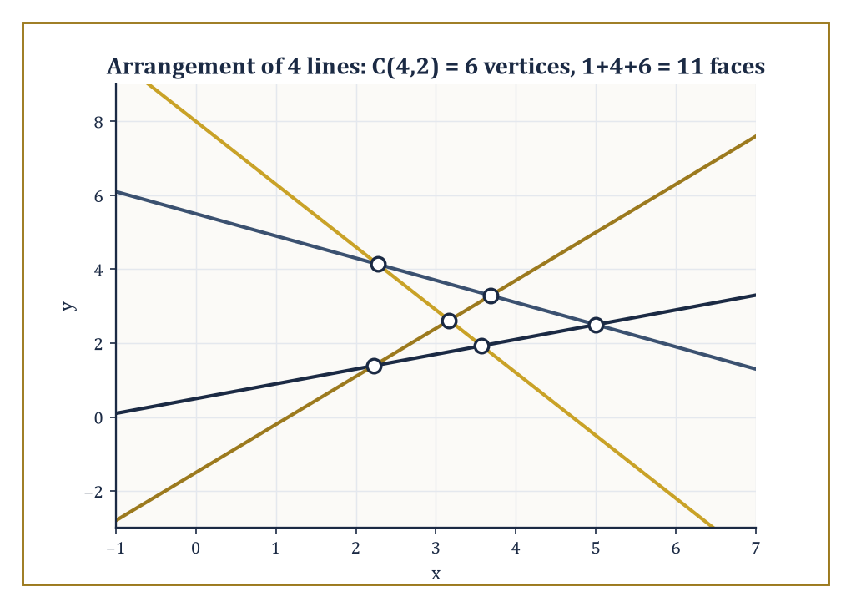
Four lines in general position produce exactly C(4,2) = 6 vertices and 1+4+6 = 11 faces, the Θ(n²) arithmetic made visible.
Higher-dimensional arrangements of n hyperplanes in ℝᵈ have complexity Θ(n^d) — a still hungrier exponent than the Θ(n^⌊d/2⌋) that bounded convex hull complexity back in Room 44.2, and for a related, not coincidental, reason: a hyperplane arrangement's vertices are simply all the ways of choosing d of the n hyperplanes to intersect, C(n,d) of them, which already grows like n^d before a single edge or face is counted, and it is exactly the same combinatorial counting — how many subsets of the input can simultaneously determine a feature of the output — that drives the hull's Θ(n^⌊d/2⌋) bound as well.
The two exponents differ, but the mechanism generating both is the same one, and the point-line duality below makes the kinship precise rather than merely rhetorical.
Numeric example — Worked example — point-line duality preserves incidence. The standard point-line duality sends a point (a,b) to the line y = ax − b, and a line y = mx + c to the point (m, −c); applying the transform twice recovers the original object (dual of the dual is the identity), which is why the map is called a duality rather than merely a trick.
It also preserves incidence: a point lies on a line if and only if the dual point lies on the dual line. Check this concretely. Take point P=(2,3) and line ℓ: y=4x−5. Does P lie on ℓ? Substitute x=2:
4(2)−5 = 8−5 = 3
This matches P's y-coordinate, so yes, P lies on ℓ. The dual of P=(2,3) is the line y=2x−3. The dual of ℓ (with m=4, c=−5) is the point:
(4, −(−5)) = (4,5)
Now check whether the dual point (4,5) lies on the dual line y=2x−3: substitute x=4:
2(4)−3 = 8−3 = 5
This matches the dual point's y-coordinate exactly. The incidence has been faithfully preserved across the transform, in both directions, on real numbers, with nothing hand-waved.
This is more than a curiosity: it means any theorem about points lying on lines (or below them, since the transform also respects above/below relations with a consistent sign convention) automatically yields a theorem about lines passing through points, simply by dualizing every statement — a two-for-one deal that combinatorial geometers exploit constantly, and it is the formal underpinning of the claim that hull complexity in high dimensions and arrangement complexity in high dimensions are, at bottom, the same phenomenon.
Because the full Θ(n²) arrangement is expensive to build and store whenever only part of it is actually needed, the subject singles out substructures of lower complexity that suffice for many applications: the zone of a curve (the faces it passes through, O(n) total complexity, as established in Room 44.3), the k-level (the set of edges with exactly k lines of the arrangement passing below them, whose worst-case complexity is a long-standing open problem, currently bounded only slightly below the trivial O(n²)), and the envelope (the boundary of the region above, or below, all n lines simultaneously, closely related to the k=0 level and computable via the same divide-and-conquer machinery used for convex hulls).
Incremental algorithms and topological sweeps — sweeps that follow the combinatorial structure of the arrangement rather than a literal geometric coordinate — compute these substructures without ever materialising the full arrangement, which is exactly the saving that makes many downstream algorithms, motion planning among them (a preview of Room 44.9), practical at all.
Abstract example — Worked example — the zone theorem, elementarily. Here is the zone theorem's core mechanism, provable in three lines without any heavy machinery. Suppose an arrangement of n lines, in general position, already exists, and one further line ℓ is added.
Because the configuration is in general position, ℓ is not parallel to any of the n existing lines, so it crosses each of them exactly once, at n distinct points along its own length.
Those n crossing points divide ℓ itself into at most n+1 pieces (n interior segments plus two unbounded rays, or however the count falls depending on where ℓ's own crossings land — but never more than n+1 pieces total).
Each of these pieces, lying strictly between two consecutive crossings, cannot cross any line of the arrangement partway through, so it must lie entirely within a single face of the existing arrangement.
Since ℓ has at most n+1 pieces, it can visit at most n+1 distinct faces — a genuinely linear bound, obtained with nothing more than a counting argument, even though the arrangement those n+1 faces sit inside can itself have as many as 1+n+C(n,2) faces in total, a quantity that is quadratic in n rather than linear.
For n=20, the arrangement has 211 faces (as computed in Room 44.3), yet any single new line added to it can touch at most 21 of them — a concrete illustration of exactly how much smaller a curve's own footprint is than the arrangement it passes through.

Room 44.8: Robustness, Degeneracies, and Exact Computation
When the Computer's Idea of a Straight Line Disagrees With Reality's
Every algorithm in this storey has been described as though arithmetic were exact — as though the orientation test's sign, or the circumcenter's coordinates, were computed with infinite precision and no rounding whatsoever.
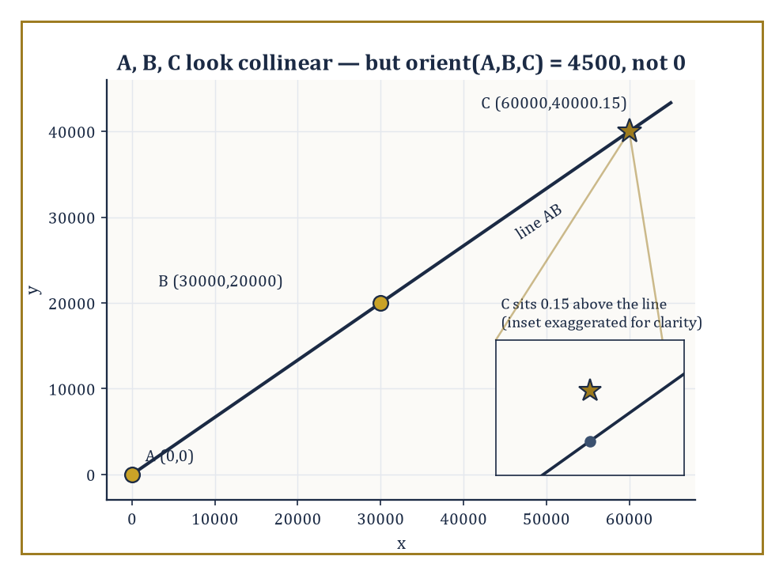
A, B, and C look perfectly collinear at this scale — the inset reveals the 0.15 that catastrophic cancellation rounds away.
Real computers, running floating-point arithmetic, offer no such guarantee, and the gap between the two is not a minor footnote: it is capable of making a convex hull algorithm output a polygon that is not, in fact, convex, or making a Delaunay triangulation contain an edge that should not be there, because the orientation test or the in-circle test returned the wrong sign on points that were close to the boundary case.
The field's response is exact geometric computation: evaluate the predicates — orientation, in-circle, and their relatives — with just enough precision, dynamically, to guarantee the sign returned is correct, using filtered arithmetic (try fast floating point first, and only fall back to slow, exact arbitrary-precision arithmetic when the floating-point result is too close to zero to trust) and adaptive precision (increase the working precision only as far as the specific inputs actually require, rather than paying the cost of full exactness on every single evaluation).
Numeric example — Worked example — catastrophic cancellation in the orientation test. To see the failure mode concretely, without needing real IEEE double-precision hardware to demonstrate it, work with a deliberately coarse toy arithmetic that keeps only 3 significant figures per multiplication — a stand-in for the same phenomenon that afflicts real floating point, just triggered here with smaller numbers for legibility.
Take A=(0,0), B=(30000,20000), C=(60000, 40000.15) — C sits just 0.15 above the point (60000,40000), which lies exactly on the line through A and B (since B has slope 20000/30000 = 2/3, and 40000/60000 = 2/3 also).
The exact orientation test is:
orient(A,B,C) = (Bₓ)(C_y) − (B_y)(Cₓ) = 30000×40000.15 − 20000×60000 = 1,200,004,500 − 1,200,000,000 = 4,500
A small but definitely positive number, correctly signalling that C sits very slightly to the left of the line AB (counterclockwise turn).
Now recompute using the toy 3-significant-figure arithmetic: 30000×40000.15 rounds to 3 sig figs as 1,200,000,000 (the true value 1,200,004,500 rounds down, since the fourth significant figure is the first to be dropped), and 20000×60000 = 1,200,000,000 exactly already. The rounded orientation value is:
1,200,000,000 − 1,200,000,000 = 0
The coarse computation reports the three points as exactly collinear, when the true answer is a small but definite positive number.
This is catastrophic cancellation: two large, nearly equal numbers were subtracted, and the small but meaningful difference between them was swallowed entirely by the rounding error in computing the large numbers themselves.
Real IEEE double precision carries about fifteen to sixteen significant decimal digits rather than three, so it takes correspondingly larger or more closely-spaced coordinates to trigger the same failure — but the mechanism is identical, and it is exactly the mechanism that exact geometric computation is built to defeat, by detecting when a floating-point result is too close to the cancellation danger zone to be trusted and falling back to arbitrary-precision arithmetic only then.
A second, distinct hazard is degeneracy: configurations that are combinatorially ambiguous even under perfectly exact arithmetic, such as four points lying exactly on a common circle (so the in-circle test used by Delaunay triangulation returns exactly zero, and it is unclear which of two triangulations to prefer) or three lines meeting at exactly one common point (so an arrangement algorithm cannot decide whether to treat it as one triple-intersection vertex or three separate crossings).
Symbolic perturbation, and its most famous instance, Simulation of Simplicity (Edelsbrunner and Mücke), resolve these by replacing every input coordinate with a formal symbol perturbed by an infinitesimal amount, in a fixed and consistent order — small enough, conceptually, to be smaller than any actual real number, yet large enough to break every tie — so that the algorithm always sees a generic, non-degenerate configuration, and the perturbation is chosen so that as it shrinks to zero the answer converges consistently to a single well-defined combinatorial structure, decided once and for all rather than by whichever way the rounding happens to fall on a given run.
Abstract example — Worked example — perturbing away a three-line degeneracy. Take three lines, all passing through the origin — a textbook degenerate concurrency:
ℓ1: x=0, ℓ2: y=0, ℓ3: x+y=0
Perturb each by an infinitesimal ε, using a fixed convention that assigns line i the perturbation εⁱ:
ℓ1′: x=ε, ℓ2′: y=ε², ℓ3′: x+y=ε³
Find the three pairwise intersections of the perturbed lines.
ℓ1′∩ℓ2′: x=ε, y=ε², giving the point (ε, ε²)
For ℓ1′∩ℓ3′: x=ε, so y = ε³−ε, giving:
ℓ1′∩ℓ3′ = (ε, ε³−ε)
Since ε is infinitesimal, ε³ is negligible next to ε, so this point behaves, to leading order, like (ε, −ε).
For ℓ2′∩ℓ3′: y=ε², so x = ε³−ε², giving:
ℓ2′∩ℓ3′ = (ε³−ε², ε²)
Since ε³ is negligible next to ε², this behaves, to leading order, like (−ε², ε²).
As ε shrinks toward zero, all three intersection points converge to the origin, recovering the original degenerate picture in the limit — but for any fixed, however tiny, positive ε, the three points (ε,ε²), (ε,−ε), and (−ε²,ε²) are genuinely distinct, forming a small, well-defined triangle rather than a single ambiguous vertex.
Because the perturbation order ε³ ≪ ε² ≪ ε was fixed once, in advance — ε itself infinitesimal but still the largest of the three, since raising a number already less than 1 to a higher power only shrinks it further — every algorithm applying the same convention to the same degenerate input arrives at the same triangle, the same combinatorial structure, every single time — the ambiguity has not been avoided by luck, it has been resolved by a deterministic rule agreed in advance, which is precisely what Simulation of Simplicity provides.
Controlled perturbation offers a randomized alternative to this fully symbolic approach — perturb the actual input coordinates by a small random amount, run ordinary floating-point arithmetic, and use probabilistic bounds to guarantee the resulting combinatorial structure is correct with high probability — trading the deterministic guarantee of the symbolic method for the considerably lower implementation cost of not needing arbitrary-precision arithmetic at all.
Robustness is, in the end, the difference between an algorithm that is correct in the algebraic decision-tree model — the idealised world every complexity bound in this storey has been stated in — and a program that is correct on the actual floating-point hardware it will be compiled and run on.
A great many published, peer-reviewed, theoretically optimal geometric algorithms have shipped in production code that occasionally crashes, loops forever, or silently produces nonsense on real data, purely because this last, unglamorous step was skipped.
It is not an exaggeration to say that robustness engineering is where a sizeable fraction of the actual professional labour in computational geometry goes, however little of it makes it into the textbooks — including, one must admit with the appropriate degree of sheepishness, this one until just now.

Room 44.9: Looking Ahead: From Classical CG to Motion Planning, Meshing, and High-Dimensional Geometry
The View From the Top of This Particular Staircase
We have now acquired the core of computational geometry: convex hulls (Room 44.2), line-segment intersection and arrangements (Room 44.3), polygon triangulation and the art-gallery theorem (Room 44.4), Voronoi diagrams and Delaunay triangulations (Room 44.5), geometric searching and range queries (Room 44.6), arrangements of lines and hyperplanes (Room 44.7), and the practical machinery of robustness, degeneracy handling, and exact computation that keeps all of the above honest on real hardware (Room 44.8).
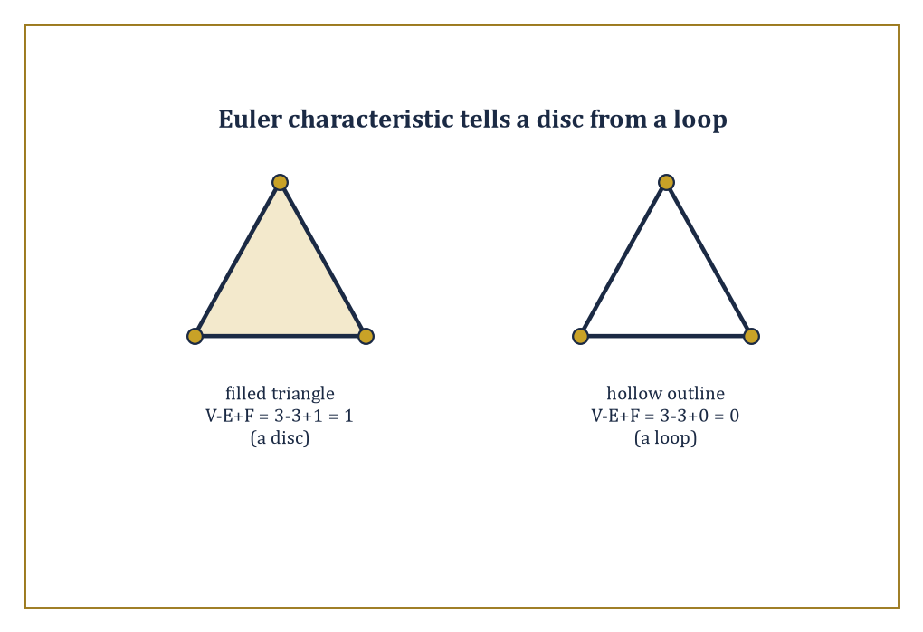
Same vertex and edge count, different fate: a filled triangle has χ = 1 like a disc, its hollow outline χ = 0 like a loop.
Every subsequent tool in the field either combines these directly or generalises one of them to a setting classical computational geometry was not originally built for.
Motion planning takes a robot with some number of independently movable joints and asks how it can get from a start configuration to a goal configuration without any part of it colliding with an obstacle, at any moment along the way.
The natural setting is the configuration space: not the physical room the robot sits in, but an abstract space in which each point represents one complete configuration of every joint simultaneously, and the robot's motion becomes a single point tracing a continuous path through that space, which must avoid a region — the union of all configurations that cause a collision — computed, at bottom, using arrangement and intersection algorithms exactly like those of Rooms 44.3 and 44.7.
Sampling-based planners (build a roadmap by scattering random configuration-space points and connecting the nearby ones that have a collision-free straight path between them, an unmistakable cousin of the randomized incremental constructions of Rooms 44.2 and 44.5) now dominate practical robotics, precisely because computing the collision region exactly, for a robot with many joints, runs straight into the Θ(n^d) high-dimensional blow-up first met with convex hulls back in Room 44.2.
Abstract example — Worked example — configuration space grows with every joint. A single point-robot moving freely in a two-dimensional room with polygonal obstacles has a configuration space that is just the room itself, minus the obstacles — two-dimensional, and the arrangement and triangulation tools of this storey apply directly and without modification.
Now replace the point-robot with a rigid car-like robot that also has an orientation θ, free to point any direction as it moves: a single configuration is now a triple (x, y, θ), and the configuration space is three-dimensional even though the physical room the robot drives around in is still flat and two-dimensional — an obstacle that was a single polygon in the physical room becomes, in configuration space, a more complicated three-dimensional region, swept out by all the orientations at which the car-shaped robot would collide with that obstacle at each position.
Add a second robot arm with two independently rotating joints, and the configuration space climbs to two more dimensions on top of whatever the base already contributed.
This is the mechanism, entirely elementary once stated, by which motion-planning problems that look almost identical to the flat polygonal picture of Rooms 44.3 and 44.4 quietly become five- or six- or twenty-dimensional arrangement problems, and it is exactly why the Θ(n^d) complexity bound from Room 44.2 is not an abstract curiosity to a robotics engineer but the reason their exact planner has been running since Tuesday.
Mesh generation refines the triangulations of Room 44.4 and Room 44.5 for use in numerical simulation: Delaunay refinement inserts additional points, chosen carefully, until every triangle in the mesh meets a prescribed quality bound (no angle too small, no triangle too large relative to its neighbours), while advancing-front methods grow a mesh inward from the boundary of a region, one layer of well-shaped elements at a time.
Computational topology asks coarser questions that triangulation and Voronoi machinery turn out to answer well: persistent homology tracks how the connectivity of a shape built from noisy data — how many connected pieces it has, how many loops, how many enclosed voids — changes as a scale parameter is varied, and Morse theory organises a shape by the critical points of a function defined on it, in a discretized, algorithmic form direct descended from the continuous Morse theory of earlier, more analytic storeys.
Numeric example — Worked example — a first taste of the Euler characteristic. The Euler characteristic, already used to check hull complexity in Room 44.2, is also computational topology's simplest invariant, and it distinguishes shapes that triangulation alone cannot tell apart by vertex count:
χ = V − E + F
Take a filled triangle: V=3 vertices, E=3 edges, and F=1 (counting the solid triangular face itself).
χ = 3 − 3 + 1 = 1
This matches the Euler characteristic of a topological disc — any shape that can be continuously squashed down to a single point has χ=1.
Now take only the triangle's boundary, the hollow outline with no interior face filled in: V=3, E=3, F=0 (there is no 2-dimensional face to count, only the loop).
χ = 3 − 3 + 0 = 0
This matches the Euler characteristic of a circle — a loop, unlike a disc, cannot be squashed to a point without tearing it, and χ=0 is topology's way of recording that difference using nothing but a vertex count, an edge count, and a face count, the same three quantities Room 44.2's polyhedra were built from.
Persistent homology, several storeys of mathematical machinery beyond this one's remit, generalises exactly this idea — count holes of every dimension, not just this one crude alternating sum — and does so robustly enough to apply to noisy real-world data rather than only to clean triangulated shapes.
High-dimensional geometric algorithms confront the curse of dimensionality directly rather than working around it: approximate nearest-neighbour search abandons the promise of finding the exact closest point (impossibly expensive once d grows large) in exchange for a point provably within a small factor of the true nearest, found in time that no longer explodes with dimension.
Dimension reduction techniques, such as the Johnson–Lindenstrauss lemma, prove that n points in an arbitrarily high-dimensional space can be projected down into a space of dimension only O(log n) while distorting all pairwise distances by at most a small controlled factor — a genuinely startling fact, since it says the relevant dimension of a geometric problem is often not the number of coordinates the data happens to arrive in, but something closer to the logarithm of how many points there are.
Numeric example — Worked example — Johnson–Lindenstrauss in round numbers. Take n=1,000,000 points living in some enormous ambient space, d=10,000 coordinates, however they arrived there. A commonly cited sufficient form of the Johnson–Lindenstrauss bound says a target dimension of about:
k ≈ (8/ε²)·ln n
suffices to preserve every pairwise distance to within a factor of (1±ε). Fix a modest distortion tolerance ε=0.5:
ln(1,000,000) = 6·ln10 ≈ 6×2.3026 = 13.82
k ≈ (8/0.25)×13.82 = 32×13.82 ≈ 442
Round up, and about 450 dimensions suffice — a reduction from ten thousand coordinates down to a few hundred, at a distance-distortion cost of only 50%.
Notice what did not appear anywhere in that calculation: d. Had the ambient space been 10,000,000-dimensional instead of 10,000-dimensional, k would not have moved by a single unit, because the bound depends only on n and ε, never on d.
This is the startling part of the lemma made concrete: it is the number of points, not the number of coordinates describing them, that decides how far the data can be compressed.
The same circle of ideas, applied to smooth rather than combinatorial shapes, reappears in discrete differential geometry and throughout the modern analysis of geometric data more broadly.
The deeper lesson of this storey is that geometry, once discretized and combinatorialized — reduced to finite point sets, orientation tests, and cell counts — becomes an algorithmic subject with its own complexity landscape, its own optimal algorithms, and its own matching lower bounds, every bit as rigorous as the classical geometry it grew out of, and considerably more useful to anyone who needs an answer before the heat death of the universe.
Computational geometry is the algorithmic theory of shape. We have learned to compute with shapes.
It is worth pausing, before the staircase turns, on how remarkably calm the objects of this storey have been throughout. A convex hull, once computed, simply sits there, being convex, with no further opinions on the matter. A Voronoi diagram tiles the plane and stops. A Delaunay triangulation maximizes its minimum angle once, permanently, and does not need to be reminded to keep doing so. Even the arrangement of Room 44.7, for all its Θ(n²) exuberance, is a static picture the moment the last line has been added. This is not a criticism — it is precisely what allows the subject's algorithms to be provably optimal, since a target that holds still is enormously easier to hit exactly than one that keeps moving.
That stillness, though, was purchased at a cost we spent all of Room 44.8 confessing to: real machines compute with floating-point arithmetic, not the exact real numbers the theory pretends is available, and the gap between the two is not a rounding error to be politely ignored but an active adversary that has, in practice, turned theoretically optimal algorithms into programs that crash. Robustness earns its keep as the least glamorous and most indispensable room in the storey — the discipline of taking a beautiful, provably correct algorithm and making sure it survives contact with a computer that has never heard of convexity and does not much care.
The tower continues upward, and its next storey trades our static shapes for objects that will not hold still no matter how firmly asked: dynamical systems, evolving under differential equations, that someone or something must actively steer. Control theory awaits, with feedback loops standing in for the diagonals and bisectors of this storey, and stability replacing convexity as the property everyone is desperately trying to guarantee. We have learned to compute with shapes; the tower is about to ask us to keep them moving in the right direction instead.

Storey 45: Control Theory
Feedback, Stability, and the Art of Making Systems Behave
The previous storey left us surrounded by static shapes: convex hulls wrapped snugly around point clouds, Voronoi cells tiling the plane with geometric indifference, Delaunay triangulations sitting there being optimal and not going anywhere in particular. It was, if we are honest, a rather calm neighbourhood of the Tower. This storey is not calm. Here the objects move, drift, oscillate, and occasionally blow up in finite time if left entirely to their own devices — and, this being the point of the whole enterprise, someone or something is expected to stop them doing that. Welcome to control theory: the branch of mathematics devoted to the modest ambition of making the universe behave.
A dynamical system, recall from several storeys back, evolves according to a differential or difference equation: give it a starting point and the rules of motion, and it will dutifully trace out a trajectory whether or not you approve of where it is going. Control theory asks a sharper question: can we choose an input — a rudder angle, a voltage, a drug dose, an interest rate — so that the trajectory does what we actually want? Stays near a setpoint. Tracks a moving target. Shrugs off the wind, the sensor noise, the well-meaning colleague leaning on the accelerator. That input can be a fixed function of time, decided in advance and never revisited (open-loop), or it can watch the system's actual behaviour and correct on the fly (closed-loop, or feedback). Feedback is the idea this entire storey is built around, so it is worth saying now what makes it remarkable: a feedback loop can turn a system that is uncertain, disturbed, or outright unstable into one that behaves reliably — without the controller ever needing to know exactly what is wrong. It only needs to notice that something is wrong, and push back.
The mathematical scaffolding should feel familiar, since we assembled most of it many storeys ago: ordinary differential equations for the dynamics, linear algebra for the state-space bookkeeping, and complex analysis for the frequency-domain half of the subject, where stability becomes a question about where certain functions are impolite enough to have poles. What is new is the purpose to which all this machinery is put. Where an earlier storey asked what a system does, control theory asks what we can make it do, and how much we are allowed to cheat. A confession, before we start climbing: control theory is unusually candid about the gap between the linear theory one teaches — complete, elegant, almost suspiciously well-behaved — and the nonlinear world one actually has to engineer, which is none of those things. The linear methods work far more often than the underlying mathematics has any strict right to promise. Knowing when to trust that luck, and when the linearization is a flattering lie rather than a faithful portrait, is most of what separates a control engineer from someone who has merely read a book about control engineering. We shall try, over the next nine rooms, to become the former.
If differential equations taught us how systems evolve, control theory teaches us how to make them evolve as we would like. Let's close the loop.

Room 45.1: What Control Theory Actually Is
Or: the thermostat as a philosophical statement
Control theory studies how to influence the behaviour of a dynamical system — called the plant, in a nod to the process-control factories where much of this language was coined, though today's plant is as likely to be a satellite, an insulin pump, or a national power grid. The influence comes through an input, and the three goals worth naming up front are stability (the system doesn't fly apart), performance (it tracks what you asked it to track, and shrugs off disturbances it wasn't asked to tolerate), and robustness (it keeps doing both even though your model of the plant is, to some degree, a polite fiction). Almost everything in this storey is an elaboration of those three words.
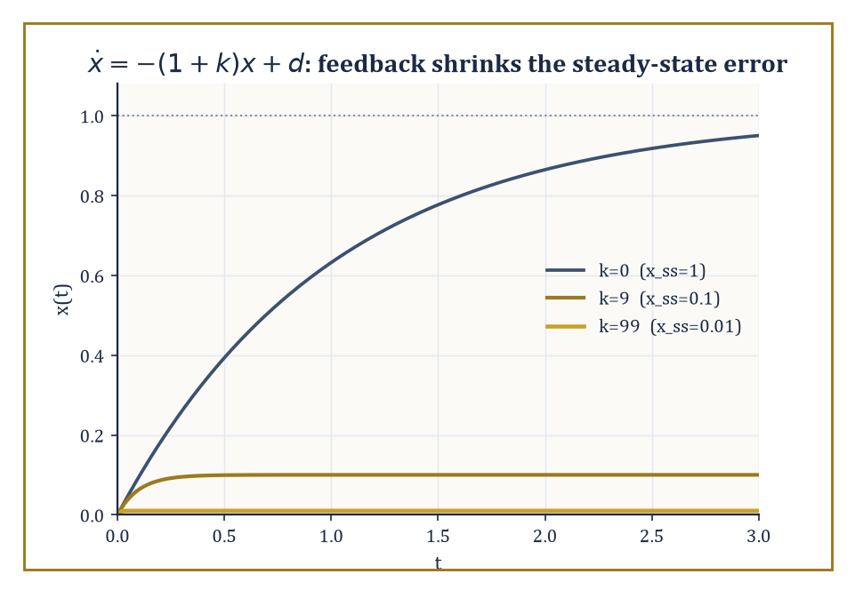
The same disturbance, the same plant, three gains: feedback buys accuracy without ever measuring what it's correcting for.
Numeric example — Worked example — what feedback actually buys you. Take the simplest plant imaginable: a scalar system ẋ = −x + u + d, where x is the quantity we care about, u is our control input, and d is a constant disturbance we did not ask for and cannot measure — say d = 1.
With no control at all (u = 0), the system settles to a steady state where ẋ = 0, i.e. −x + d = 0, giving
x_ss = d = 1
The disturbance leaves its full mark. Now apply proportional feedback: u = −k·x, pushing back harder the further x drifts from zero. The closed-loop equation becomes
ẋ = −x − kx + d = −(1+k)x + d
with steady state
x_ss = d/(1+k)
Set k = 0 (no feedback) and you recover x_ss = 1, as before. Set k = 9 and x_ss = 1/10 = 0.1 — the disturbance's effect has been cut by a factor of ten using nothing but a measurement of x and a dial. Set k = 99 and x_ss = 0.01. Nothing about the disturbance changed; we never even measured it. The controller simply refused, ten times a second if need be, to let x sit anywhere but very close to zero. That is the entire miracle of feedback, in one line of algebra: it buys accuracy by spending correction, and it does so without needing to know what it's correcting for.
The open-loop/closed-loop distinction is worth dwelling on because it is genuinely a difference in kind, not just in cleverness. An open-loop input is a piano roll: composed in advance, played back regardless of whether the piano is in tune. A closed-loop input is a driver: watching the road, the speedometer, the errant cyclist, and adjusting continuously.
The first working feedback controller most historians point to is James Watt's centrifugal governor of 1788 — a pair of spinning weights on a steam engine that flew outward as the engine sped up, and via simple linkage throttled the steam valve in response. Nobody involved knew a differential equation from a bread recipe; the mathematics of why it worked (and why, tuned wrong, it could oscillate itself to pieces) had to wait for James Clerk Maxwell in 1868, arguably the first paper in the modern theory of stability of feedback systems.
Abstract example — Abstract example — feedback older than the mathematics. Biology got there first, of course. The human pupillary reflex is a textbook closed loop: photoreceptors in the retina sense light intensity, signal the brain, and the iris sphincter muscle contracts or relaxes to change pupil diameter — which changes the light hitting the retina, closing the loop.
Too much light narrows the pupil, which reduces the light, which stops the narrowing: negative feedback, self-limiting, no central planner required. The controller here is a few milliseconds of neural circuitry; the plant is an optical aperture; the disturbance is whatever the sun is doing. It is, structurally, identical to Watt's governor and to the thermostat on your wall, and it evolved roughly four hundred million years before anyone wrote
ẋ = Ax + Bu
The field then fans out along several independent axes, and it helps to see them laid out before we start filling in each one. Linear versus nonlinear: whether the plant's response to input is proportional and superimposable, or whether it does something more interesting (and harder). Time-domain versus frequency-domain: whether we reason about trajectories x(t) directly, or about how the system responds to oscillations of each frequency ω — the same plant, interrogated in two different languages, neither of which it is under any obligation to answer in.
And a further split by design philosophy — optimal control (find the provably best input by some cost measure), robust control (find an input that survives the worst plausible model error), adaptive control (find an input that learns the model error as it goes), and geometric control (understand what's reachable at all, using the tools of differential geometry). Applications range from aerospace guidance and chemical-process control to robotic manipulation, power-grid frequency regulation, and — as the pupil already showed us — the oldest control systems of all, running quietly inside every living thing.
Strip away the applications and the mathematical core is single and sharp: the analysis and design of feedback maps that turn an open-loop plant — uncertain, possibly unstable, doing whatever differential equations do when left alone — into a closed-loop system with properties we actually specified. The next eight rooms build that core in order: a language for describing plants precisely (state-space models), a pair of structural questions about what such a description can and cannot do (controllability and observability), a rigorous notion of good behaviour (stability), the two main levers for enforcing it (state feedback and observers), a way to do all this optimally rather than merely adequately (LQR and the maximum principle), an older and still-thriving parallel language (frequency-domain methods), and finally an honest look at what happens once we admit the plant was never quite linear to begin with (nonlinear and robust control).

Room 45.2: Linear State-Space Models
In which the state of the system is finally given somewhere to live
A linear time-invariant (LTI) system is written
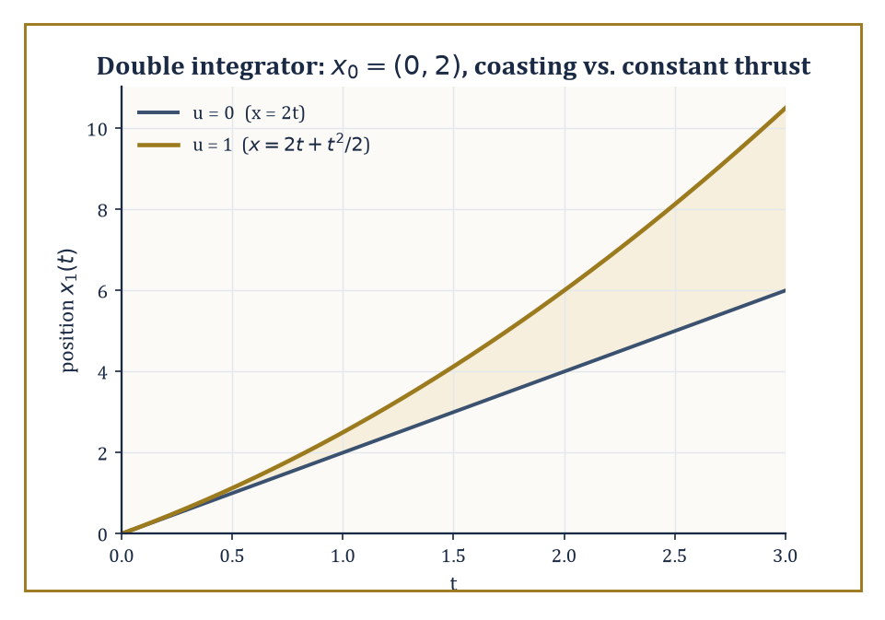
The matrix exponential quietly reproducing first-year kinematics: coasting versus constant thrust from the same starting velocity.
ẋ = Ax + Bu, y = Cx + Du
Here x is the state vector — a snapshot, at each instant, of everything you need to know about the system to predict its future given the future inputs; u is the input (what we get to choose); y is the output (what we actually get to measure, which is often less than the whole state); and A, B, C, D are constant matrices doing four distinct jobs.
A encodes the internal dynamics — how the state evolves on its own, with no input. B encodes actuation — how the input pushes on the state. C encodes sensing — which combinations of the state we can see. D encodes direct feedthrough — the rare case where the input leaks straight into the output without passing through the state at all (most physical systems have D = 0, since instantaneous influence without any dynamics in between is usually a modelling shortcut rather than physics).
The exact solution, for constant A, is
x(t) = e^{At} x(0) + ∫₀ᵗ e^{A(t−s)} B u(s) ds
the matrix-exponential analogue of the scalar formula you met storeys ago for ẋ = ax + u, now correctly accounting for the fact that A's various components can rotate into and feed off one another.
Numeric example — Worked example — the double integrator, solved exactly. Let x₁ be position and x₂ be velocity of a unit mass under a force u (Newton's second law, F = ma with a = 1):
ẋ₁ = x₂, ẋ₂ = u
In matrix form, A = [0 1; 0 0], B = [0; 1]. Notice
A² = [0 1; 0 0]·[0 1; 0 0] = [0 0; 0 0]
A is nilpotent, so the matrix exponential series e^{At} = I + At + (At)²/2! + ⋯ truncates after two terms:
e^{At} = [1 t; 0 1]
With no force (u = 0) and initial condition x(0) = [0; 2] (starting position 0, starting velocity 2):
x(t) = e^{At}x(0) = [1 t; 0 1]·[0; 2] = [2t; 2]
Position grows linearly at the constant velocity, exactly as Newton would insist. Now switch on a constant unit force u(s) = 1 for s ≥ 0. The forced term is ∫₀ᵗ e^{A(t−s)}B·1 ds. Compute
e^{A(t−s)}B = [1 (t−s); 0 1]·[0; 1] = [t−s; 1]
then integrate componentwise:
∫₀ᵗ(t−s)ds = t²/2 and ∫₀ᵗ1ds = t
So the forced contribution is [t²/2; t], and the total solution is
x(t) = [2t + t²/2; 2 + t]
That is precisely x = x₀ + v₀t + ½at² and v = v₀ + at with x₀=0, v₀=2, a=1 — the matrix exponential has, correctly and automatically, reproduced first-year kinematics.
The transfer function
G(s) = C(sI−A)⁻¹B + D
is the same system described from outside: an input-output map that hides the internal state entirely, obtained by Laplace-transforming the state equations. Two systems with wildly different state-space descriptions can have identical transfer functions, because the transfer function only sees the part of the state that is both reachable from the input and visible at the output — a preview of the controllability and observability distinction the next room makes precise.
A realization is any state-space model (A,B,C,D) reproducing a given G(s); realizations are never unique, but a minimal realization — one that is both controllable and observable, in the sense the next room defines — has the smallest possible state dimension, and is unique up to a change of coordinates (a similarity transform x → Tx).
Abstract example — Abstract example — two realizations, one transfer function. Realization 1 (minimal): A = −1, B = 1, C = 1, D = 0, a scalar system. Its transfer function is
C(s−A)⁻¹B = 1·(s+1)⁻¹·1 = 1/(s+1)
Realization 2 (non-minimal): A = [−1 0; 0 −2], B = [1; 0], C = [1 0], D = 0 — a two-dimensional system with an extra decaying mode at −2. Its transfer function is
C(sI−A)⁻¹B = [1 0]·diag(1/(s+1), 1/(s+2))·[1; 0] = 1/(s+1) + 0 = 1/(s+1)
Identical to Realization 1, despite carrying an entire extra state. The −2 mode contributes nothing to the input-output behaviour because B's second entry is zero — the input never reaches it — so it decays away in total obscurity, present in the equations but invisible from outside. We shall meet this exact mode again in the next room, where it will get the recognition (or lack thereof) it deserves.
Why does the linear case get such complete treatment while the general nonlinear case remains, several rooms from now, a collection of special techniques rather than one theory? Partly because linear systems are exactly the ones for which the tools of linear algebra apply without approximation. But mostly because linear models are the natural first approximation to nonlinear ones: near an equilibrium, a nonlinear system ẋ = f(x,u) behaves, to leading order, like the linear system
ẋ = Ax + Bu, with A = ∂f/∂x, B = ∂f/∂u
evaluated at that equilibrium — the Jacobian linearization. Everything built in this storey's early rooms is therefore not merely a toy theory for toy systems; it is the local theory that governs every nonlinear plant near wherever we've chosen to balance it.
Numeric example — Worked example — linearizing a pendulum. A pendulum of length L = 1 m obeys
θ̈ + (g/L)sinθ = u, g ≈ 9.8 m/s²
Writing x₁ = θ, x₂ = θ̇, this is
ẋ₁ = x₂, ẋ₂ = −(g/L)sinx₁ + u
manifestly nonlinear, thanks to sinx₁. Near the downward equilibrium x₁ = 0, sinx₁ ≈ x₁ for small angles, giving the linearized model
ẋ₁ = x₂, ẋ₂ = −9.8x₁ + u, i.e. A = [0 1; −9.8 0], B = [0; 1]
This is the linear pendulum equation from the storey on ordinary differential equations, recovered here as the A-matrix of a control problem — and every pole-placement or LQR calculation later in this storey that uses a system 'like a spring' is secretly reasoning about a system exactly like this one, valid as long as θ stays small enough that sinθ ≈ θ hasn't started lying to us.

Room 45.3: Controllability and Observability
Can you get there from here, and can you tell where 'there' was
A system is controllable if, for any two states, there exists a control input that drives the system from the first to the second in finite time. This is a purely structural question — it says nothing about how large the input needs to be, how long it takes, or how sensible the resulting trajectory looks, only whether it is possible at all.
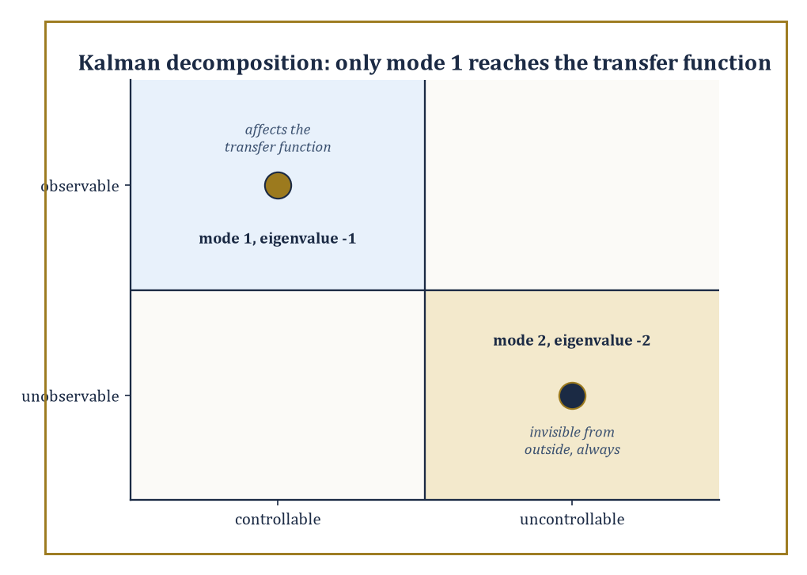
Only the controllable-and-observable quadrant ever shows up outside the equations; the other three modes keep their secrets.
Kalman's rank test turns this into linear algebra: form the controllability matrix
𝒞 = [B AB A²B ⋯ Aⁿ⁻¹B]
(n being the state dimension); the system is controllable if and only if 𝒞 has full rank n. The intuition is that B tells you which directions the input can push immediately, AB tells you which directions it can push one differentiation later (by first pushing, then letting the dynamics carry that push somewhere new), and so on — if these directions together span the whole state space, nowhere is permanently out of reach.
Numeric example — Worked example — the double integrator is controllable. Return to A = [0 1; 0 0], B = [0; 1] from the previous room (force controlling a mass's position and velocity). Compute
AB = [0 1; 0 0]·[0; 1] = [1; 0]
The controllability matrix is 𝒞 = [B AB] = [0 1; 1 0] (first column [0;1], second column [1;0]). Its determinant is
det(𝒞) = 0·0 − 1·1 = −1 ≠ 0
so 𝒞 has full rank 2: the system is controllable. This matches physical common sense — a force applied to a free mass can, given enough time, steer it to any position with any velocity you like.
Contrast this with the realization from the previous room, A = diag(−1,−2), B = [1; 0]: there,
AB = diag(−1,−2)·[1;0] = [−1; 0]
giving 𝒞 = [1 −1; 0 0] — a matrix whose second row is entirely zero, hence rank 1, not full rank. That system is not controllable: the input, having zero effect on the second state's equation, can never reach it. This is precisely the mode that vanished from the transfer function two rooms ago; that was not a coincidence, and the next paragraph explains why.
Dual to controllability is observability: the ability to reconstruct the full internal state from a history of inputs and outputs, even though the output y = Cx + Du may reveal only a partial, blurred combination of the state at each instant. The observability matrix stacks
𝒪 = [C; CA; CA²; ⋯; CAⁿ⁻¹]
(each block a row, or several rows, of the output map applied after successive rounds of dynamics); the system is observable exactly when 𝒪 has full rank n. The intuition mirrors controllability exactly, with time reversed: C tells you what you can see right now, CA tells you what you can infer about the state one time-derivative back by watching how the visible part changes, and so on.
Numeric example — Worked example — position alone reveals velocity. Take the same double integrator, but suppose we can only measure position, not velocity: y = x₁, i.e. C = [1 0]. Then
CA = [1 0]·[0 1; 0 0] = [0 1]
The observability matrix is 𝒪 = [1 0; 0 1] = the identity matrix, of full rank 2. So the system is observable: watching position alone over time is enough, in principle, to reconstruct velocity as well — which is exactly what differentiating a position sensor's reading does, and exactly what an observer (built in Room 45.5) will do far more gracefully than raw differentiation ever could.
Kalman's decomposition puts these two structural facts together: any linear system splits (via a suitable change of coordinates) into up to four subsystems — controllable-and-observable, controllable-but-unobservable, uncontrollable-but-observable, and uncontrollable-and-unobservable. Only the first piece, controllable and observable, affects the transfer function and hence the input-output behaviour that anyone outside the system can ever detect; the other three pieces are, from the outside, undetectable ghosts, however dramatic their internal dynamics.
Abstract example — Abstract example — the ghost mode, formally introduced. In the realization A = diag(−1,−2), B = [1;0], C = [1 0] from the previous two rooms, mode 1 (eigenvalue −1) has B's first entry nonzero (controllable) and C's first entry nonzero (observable): it is the controllable-and-observable part, and it alone survives into the transfer function 1/(s+1).
Mode 2 (eigenvalue −2) has both entries zero: uncontrollable, because the input never reaches it, and unobservable, because the output never sees it. It sits in Kalman's fourth, most thoroughly ignored quadrant — the uncontrollable-and-unobservable part — decaying away at its own pace, affected by nothing we do and noticed by no one watching. If one wanted an unkind analogy for the state of mode 2 in the university sense, one need not look terribly far.
These tests extend, with real effort, beyond the linear time-invariant case. For linear time-varying systems the controllability and observability matrices become time-dependent Gramians rather than fixed-rank tests. For nonlinear systems the questions become genuinely differential-geometric: controllability is governed by the Lie brackets of the vector fields that describe how each control direction pushes the state (an idea we shall put to concrete use, and considerable delight, when Room 45.8 parallel-parks a car), and observability by the codistribution generated by successive Lie derivatives of the output map. The rank conditions of this room are, in that sense, the linear shadow of a much richer geometric story — but they are also, happily, the version an engineer reaches for first, because most plants near their operating point are well approximated by exactly the linear systems this room has been testing.
It is tempting, having just watched two clean rank conditions settle two clean questions, to assume controllability and observability are permanent properties of a physical device — that a car either is or isn't steerable, full stop. They are properties of the model at a particular operating point, and can change as that point changes: a system linearized near one equilibrium may be perfectly controllable, while the same physical device linearized near a different equilibrium develops a direction the input genuinely cannot reach (a control surface that goes aerodynamically limp at a certain angle of attack is the classic aerospace nightmare version of this). The rank tests of this room, in other words, are not once-and-for-all facts about a machine; they are facts about a linear approximation, valid exactly where that approximation is valid, and worth re-checking whenever the operating point moves far enough for the Jacobian from Room 45.2 to have changed its mind.

Room 45.4: Stability: Lyapunov and Input-Output
Not falling over, mathematically speaking
Lyapunov's second method certifies stability of an equilibrium without ever solving the differential equation — a considerable relief, since most nonlinear equations refuse to be solved in closed form at all. The idea: find a scalar function V(x), positive everywhere except at the equilibrium (V(0)=0, V(x)>0 otherwise), that acts as a generalized energy. If V̇(x), the rate of change of V along the system's own trajectories, is negative everywhere except at the equilibrium, then V is strictly decreasing along every trajectory, is bounded below by zero, and therefore the state must be converging toward the one place where V bottoms out. No formula for x(t) is needed; only a single well-chosen function and some careful differentiation.
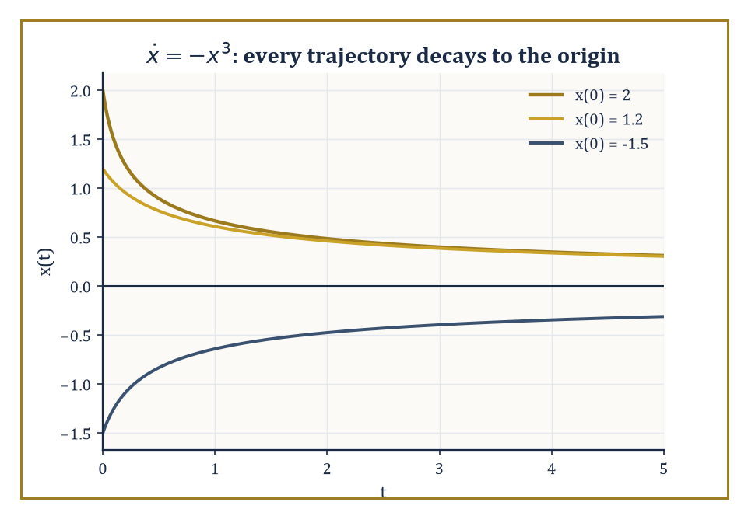
No formula for x(t) was needed to prove this convergence — only that V=x²/2 keeps going downhill.
Numeric example — Worked example — a nonlinear system stabilized by inspection. Consider the scalar nonlinear system ẋ = −x³. Try the natural energy-like candidate V(x) = x²/2, positive for all x ≠ 0. Then
V̇ = (dV/dx)·ẋ = x·(−x³) = −x⁴
This is negative for every x ≠ 0 and zero only at x = 0. Lyapunov's theorem therefore certifies that the origin is (globally) asymptotically stable — every trajectory, wherever it starts, decays to zero — despite the fact that we never wrote down x(t) explicitly (it happens to be x(t) = x₀/√(1+2x₀²t), but Lyapunov's method didn't need to know that, and for most nonlinear systems no such formula exists at all).
For linear systems ẋ = Ax, this machinery collapses to a single matrix equation. Try the quadratic candidate V(x) = xᵀPx for a symmetric positive-definite matrix P; its derivative along trajectories is
V̇ = xᵀ(AᵀP + PA)x
Choosing any symmetric positive-definite Q and solving the Lyapunov equation
AᵀP + PA = −Q
for P then guarantees V̇ = −xᵀQx < 0 automatically. The remarkable fact, due to Lyapunov, is the converse too: A is stable (all eigenvalues in the open left half-plane) if and only if this equation has a positive-definite solution P for every positive-definite Q — turning a question about eigenvalues into a question about solving one linear matrix equation, which is often easier in high dimensions.
Numeric example — Worked example — solving the Lyapunov equation directly. Scalar case first: A = −2, Q = 1. The Lyapunov equation Aᵀ P + PA = −Q becomes
(−2)P + P(−2) = −4P = −1, so P = 1/4 > 0
confirming, via a route that never mentions eigenvalues, that ẋ = −2x is stable (which we already knew, since −2 < 0, but the method scales to cases where 'already knowing' is not an option).
Now a 2×2 case: A = diag(−1,−2), Q = I. Try P diagonal, P = diag(p₁,p₂); for diagonal matrices,
AᵀP + PA = diag(−2p₁, −4p₂)
Setting this equal to −I = diag(−1,−1) gives p₁ = 1/2 and p₂ = 1/4, both positive, so P = diag(0.5, 0.25) is positive-definite and certifies stability — again correctly, since A's eigenvalues −1 and −2 are both negative.
Lyapunov stability concerns behaviour near an equilibrium; input-output (or BIBO, bounded-input-bounded-output) stability concerns the system as a black box, asking only that bounded inputs never produce unbounded outputs. For LTI systems this is equivalent to the impulse response g(t) being absolutely integrable,
∫₀^∞|g(t)|dt < ∞
which in turn is equivalent to every pole of the transfer function lying strictly in the open left half-plane — the same condition as Lyapunov stability of A, seen from the frequency-domain side of the house, which is reassuring, since it would be alarming if the two main notions of stability in this room disagreed with each other.
Numeric example — Worked example — a stable pole and an unstable one. G(s) = 1/(s+3) has impulse response g(t) = e^{−3t} for t ≥ 0. Then
∫₀^∞ e^{−3t}dt = [−(1/3)e^{−3t}]₀^∞ = 0 − (−1/3) = 1/3
finite — absolutely integrable, so BIBO stable, and indeed its single pole s = −3 sits in the open left half-plane. Compare G(s) = 1/(s−1), impulse response e^{t}, for which ∫₀^∞ e^{t}dt diverges: not BIBO stable, and its pole s = 1 sits in the right half-plane, exactly where the theorem said trouble would be.
Neither Lyapunov's method nor the transfer-function pole test says anything, on its own, about what happens when stable systems are wired together — and almost nothing useful is ever built from a single isolated system. The small-gain theorem fills the gap: if two systems are interconnected in a feedback loop and each has an input-output gain (formally, an induced L₂ norm) of γ₁ and γ₂ respectively, the closed loop is guaranteed stable whenever
γ₁γ₂ < 1
regardless of the internal details of either system, linear or not. Passivity theorems offer a related, energy-based sufficient condition for stability of interconnections, particularly suited to physical systems that cannot manufacture energy from nothing.
Numeric example — Worked example — small-gain in one line. Two subsystems in a feedback loop have gains γ₁ = 0.5 and γ₂ = 1.5. Their product is
γ₁γ₂ = 0.75 < 1
so the small-gain theorem certifies stability of the interconnection — a guarantee obtained without ever examining either subsystem's internal equations, linear, nonlinear, or otherwise, which is precisely the theorem's appeal when the internals are unknown or too unpleasant to inspect.
Stability is deliberately treated first among the design requirements, because it is a precondition rather than a preference: a controller that stabilizes badly is a starting point for improvement, while a controller that fails to stabilize at all has nothing further worth discussing. Performance — how quickly, how accurately, how gracefully the system behaves — and robustness — how much of that performance survives contact with a plant that isn't quite the one on paper — are the subjects of the next several rooms, and both presuppose that this room's business has already been settled.

Room 45.5: State Feedback, Pole Placement, and Observers
Moving the poles, and guessing what you cannot see
If a system is controllable, the pole-placement theorem guarantees something remarkably strong: state feedback of the form u = −Kx can move the closed-loop poles — the eigenvalues of A − BK, which govern the closed-loop system's transient behaviour and stability — to any locations we like (subject only to complex poles coming in conjugate pairs, since the physical system has to stay real-valued). For a single-input system, the gain K achieving a desired set of poles is unique, and Ackermann's formula computes it directly from the controllability matrix and the desired characteristic polynomial; for multi-input systems, modern 'place' algorithms do the same job numerically, with extra freedom to choose the K that is best-conditioned or otherwise best-behaved among the many that work.
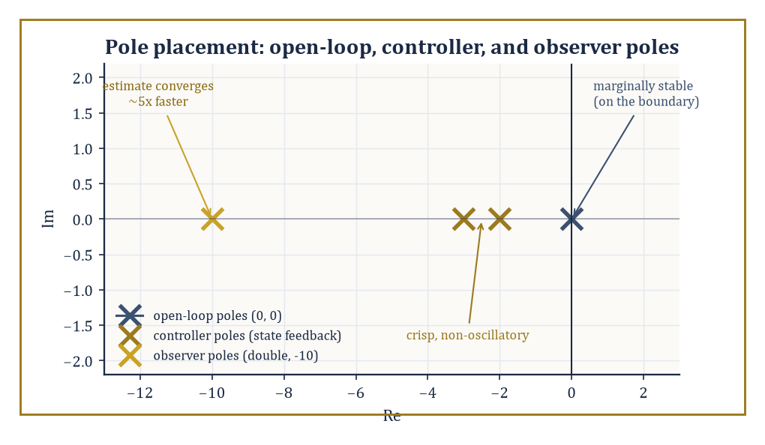
Two poles marginally stable at the origin get relocated by feedback, while the observer poles are placed well to their left so the estimate never lags behind.
Numeric example — Worked example — placing the poles of the double integrator. Take our recurring double integrator, A = [0 1; 0 0], B = [0; 1], and feedback u = −Kx with K = [k₁ k₂]. Then BK = [0;1]·[k₁ k₂] = [0 0; k₁ k₂], and the closed-loop matrix is A − BK = [0 1; −k₁ −k₂]. Its characteristic polynomial is
det(λI − (A−BK)) = det([λ −1; k₁ λ+k₂]) = λ(λ+k₂) + k₁ = λ² + k₂λ + k₁
Suppose we want closed-loop poles at −2 and −3 (both stable, giving a reasonably crisp, non-oscillatory response). The desired polynomial is
(λ+2)(λ+3) = λ² + 5λ + 6
Matching coefficients: k₂ = 5, k₁ = 6, so K = [6 5]. Check: trace(A−BK) = 0 + (−5) = −5, which should equal the sum of the poles, −2 + (−3) = −5 — correct. And det(A−BK) = 0·(−5) − 1·(−6) = 6, which should equal the product of the poles, (−2)(−3) = 6 — correct. A single line of feedback, u = −6x₁ − 5x₂, has converted a system with two poles sitting right on the stability boundary (the open-loop double integrator has both poles at the origin — marginally stable at best) into one with two comfortably stable, well-separated poles.
Pole placement assumes the full state x is available for feedback, which is often wishful thinking — many systems can only be measured through a handful of sensors, not read off in full. When the state is not directly measured, an observer reconstructs an estimate x̂ from the input and the actual output, using a copy of the plant's own dynamics plus a correction term driven by the prediction error:
x̂̇ = Ax̂ + Bu + L(y − Cx̂)
The observer gain L is chosen — again by a pole-placement calculation, this time on the error dynamics — to make the estimation error e = x − x̂ decay quickly. The classical version for deterministic systems is the Luenberger observer; its stochastic cousin, tuned to minimize estimation error variance in the presence of measurement and process noise, is the Kalman filter.
Numeric example — Worked example — an observer for the same system. Suppose we can only measure position, y = x₁, so C = [1 0], and we want the estimation error to decay fast — say, both observer poles at −10 (faster than the controller poles at −2, −3, on the sound principle that a guess should converge well before the control law starts trusting it). Set L = [l₁; l₂]. Then LC = [l₁; l₂]·[1 0] = [l₁ 0; l₂ 0], and A − LC = [−l₁ 1; −l₂ 0]. Its characteristic polynomial is
det(λI−(A−LC)) = det([λ+l₁ −1; l₂ λ]) = λ(λ+l₁) + l₂ = λ² + l₁λ + l₂
The desired polynomial for a double pole at −10 is
(λ+10)² = λ² + 20λ + 100
giving l₁ = 20, l₂ = 100. Check: trace(A−LC) = −20 = −10 + −10, and det(A−LC) = l₂ = 100 = (−10)(−10) — both correct. This observer reconstructs both position and velocity from position measurements alone, converging roughly five times faster than the controller designed around it needs it to.
The separation principle is the elegant theorem that makes this two-step design legitimate rather than merely convenient: for a controllable and observable linear system, the feedback gain K and the observer gain L may be designed entirely independently, using the plant model alone, and the resulting combined closed-loop system (controller acting on the estimate x̂, observer fed by the actual output y) has closed-loop eigenvalues exactly equal to the union of the two sets designed separately —
eigenvalues(A−BK) ∪ eigenvalues(A−LC)
There is no cross-term, no interaction to worry about, no coupled higher-order eigenvalue problem to solve by hand.
Abstract example — Abstract example — the separation principle cashed out. Combining the two designs above: the full closed-loop system — controller plus observer, four states in total (two plant states, two estimation-error states) — has closed-loop poles exactly
{−2, −3} ∪ {−10, −10} = {−2, −3, −10, −10}
Nobody needed to write down, let alone diagonalize, the resulting 4×4 matrix; two clean 2×2 pole-placement calculations, done in isolation and without reference to each other, are provably sufficient. It is one of the few moments in this storey where the mathematics hands the engineer a genuine, no-strings-attached shortcut — a rare enough event in this line of work to be worth pausing to enjoy.
It is worth being precise about what static output feedback — control laws of the form u = −Ky using only the measured output y directly, with no observer in between — can and cannot do: it is, in general, not powerful enough to place closed-loop poles arbitrarily, even for systems that are fully controllable and observable, because y typically carries less information than x. Dynamic output feedback — precisely the observer-plus-state-feedback architecture just built — recovers the full pole-placement power of state feedback for any controllable and observable system, at the modest cost of doubling the state dimension (the observer's estimation error is itself a dynamical system riding along). State feedback and observers, used together via the separation principle, are the two basic components from which the great majority of modern linear controllers are actually built.

Room 45.6: Optimal Control: LQR and the Maximum Principle
Doing it not just well, but provably as well as possible
Pole placement asks for a specific closed-loop behaviour; optimal control asks for the best closed-loop behaviour, according to a stated cost. The linear-quadratic regulator (LQR) minimizes
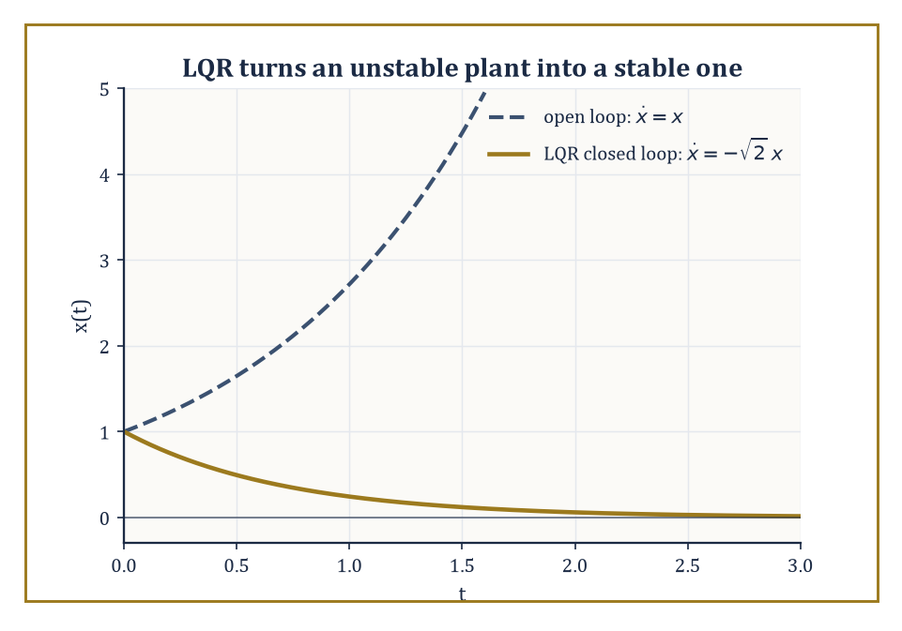
Same plant, same starting point, one Riccati equation later: exponential blow-up becomes exponential decay.
J = ∫₀^∞ (xᵀQx + uᵀRu) dt
for a linear system ẋ = Ax + Bu, where Q ≥ 0 penalizes deviation of the state from zero and R > 0 penalizes control effort — a formalization of the entirely reasonable desire to get the job done without either wandering off or slamming the actuators.
The remarkable result, and the reason LQR remains a default choice decades after its discovery, is that the optimal control is linear state feedback,
u = −Kx, K = R⁻¹BᵀP
where P is the unique positive-definite solution of the algebraic Riccati equation (ARE):
AᵀP + PA − PBR⁻¹BᵀP + Q = 0
The optimization problem, infinite-dimensional in principle (a whole function u(t) to choose), collapses to solving one matrix quadratic equation.
Numeric example — Worked example — LQR stabilizes an unstable plant. Take a scalar system ẋ = ax + bu with a = 1 (unstable — without control, x(t) = x(0)e^{t} grows without bound) and b = 1, with equal weighting Q = 1, R = 1. The scalar Riccati equation is 2aP − (b²/R)P² + Q = 0, i.e.
2P − P² + 1 = 0, or P² − 2P − 1 = 0
The quadratic formula gives
P = [2 ± √(4+4)]/2 = 1 ± √2
taking the positive root (required for P > 0), P = 1 + √2 ≈ 2.4142. The gain is
K = R⁻¹bP = 1·1·(1+√2) = 1+√2 ≈ 2.4142
The closed-loop system is
ẋ = (a−bK)x = (1 − (1+√2))x = −√2·x ≈ −1.4142x
asymptotically stable, with decay rate √2, despite starting from a plant that was unstable on its own. Notice the closed-loop pole −√2 is exactly −√(a² + b²Q/R) = −√(1+1) = −√2, the general scalar-LQR closed-loop pole formula; LQR has done more than merely stabilize, it has done so while explicitly balancing the cost of state deviation against the cost of the control effort spent correcting it.
The version above is the infinite-horizon LQR, appropriate when the control runs indefinitely; a finite-horizon version instead solves a Riccati differential equation backward from a terminal condition, and under standard conditions (controllability, observability of √Q) its solution converges to the algebraic Riccati equation's solution as the horizon lengthens — reassuring evidence that the two formulations agree when they overlap.
Pairing LQR's optimal state feedback with the Kalman filter — the optimal observer for systems disturbed by Gaussian process and measurement noise — gives the LQG (linear-quadratic-Gaussian) design methodology, and the separation principle from the previous room extends here too: the two problems may be solved independently and combined, with the Kalman filter gain solving a Riccati equation that is structurally the dual of the LQR one, with (A,B,Q,R) replaced by (Aᵀ,Cᵀ, process noise covariance, measurement noise covariance).
Abstract example — Abstract example — the LQR/Kalman duality. LQR takes (A,B,Q,R) and produces a state-feedback gain K minimizing a cost on future state and control. The Kalman filter takes the transposed, role-swapped data (Aᵀ,Cᵀ,Q_noise,R_noise) — where C now plays the part B played, and the noise covariances play the part the cost weights played — and produces an observer gain Lᵀ minimizing estimation-error variance. Solve one Riccati equation, relabel the symbols, and you have solved the other: control and estimation, so often taught as separate subjects, turn out to be the same piece of mathematics wearing two different sets of matrix labels — arguably the single most elegant fact in this entire storey.
LQR presupposes a linear system and a quadratic cost; for nonlinear dynamics or more general costs, the Pontryagin maximum principle (PMP) supplies necessary conditions that any optimal trajectory must satisfy, without requiring the problem to be solved in closed form. Define the Hamiltonian
H(x,u,p) = L(x,u) + pᵀf(x,u)
where L is the running cost, f is the dynamics ẋ = f(x,u), and p(t) is an adjoint (costate) variable — a Lagrange multiplier that evolves in time, satisfying ṗ = −∂H/∂x. The principle states that an optimal control u*(t) minimizes (or maximizes, by sign convention) the Hamiltonian pointwise over admissible controls at each instant. This is a direct generalization of the Euler–Lagrange equations from the calculus of variations, extended to handle explicit control inputs and constraints on them — the costate p is, in effect, the shadow price of the state constraint ẋ = f(x,u), exactly as a Lagrange multiplier is the shadow price of an ordinary constrained optimum.
Numeric example — Worked example — minimum-energy control via the maximum principle. Minimize
J = ∫₀¹ ½u² dt subject to ẋ = u, x(0) = 0, x(1) = 1
— steer a point from 0 to 1 in one unit of time, spending as little control energy as possible. The Hamiltonian (minimization convention) is H = ½u² + pu. Minimizing over u: ∂H/∂u = u + p = 0, so u*(t) = −p(t). The costate equation is ṗ = −∂H/∂x = 0 (H does not depend on x here), so p(t) is constant, p(t) ≡ p₀, and hence u(t) is constant too, u(t) ≡ u₀ = −p₀. Then x(t) = ∫₀ᵗ u₀ ds = u₀t, and the boundary condition x(1) = 1 forces u₀ = 1. So the optimal control is simply
u(t) = 1 for all t ∈ [0,1], giving x(t) = t
check: x(0)=0, x(1)=1, both satisfied. The minimum cost is J = ∫₀¹ ½(1)²dt = 1/2. The maximum principle has told us, correctly and with no wasted effort, that the cheapest way to cover a fixed displacement in a fixed time is to push at a constant, steady rate — exactly the instinct any sensible driver already has, now derived from first principles rather than habit.
LQR and the maximum principle are best understood as complementary rather than competing: LQR is a design method, handing back an explicit, implementable feedback law whenever the problem happens to be linear-quadratic; the maximum principle is a set of necessary conditions, characterizing what any optimal trajectory must look like for a far wider class of nonlinear problems, at the cost of usually requiring a two-point boundary-value problem (in x and p together) to be solved numerically rather than in closed form. Between them, they supply both the everyday workhorse and the theoretical ceiling against which every other design method in this storey is, implicitly, being measured.

Room 45.7: Frequency-Domain Methods
The same story, told in Hertz
Classical control design largely ignores the state altogether and works directly with the transfer function G(s), read off along the imaginary axis s = jω to see how the system responds to sinusoids of each frequency ω. A Bode plot displays the magnitude |G(jω)| (usually in decibels, 20log₁₀|G(jω)|) and the phase ∠G(jω) as functions of ω, on logarithmic frequency axes; a Nyquist plot traces G(jω) as a curve in the complex plane as ω sweeps from −∞ to ∞; a root-locus diagram tracks how the closed-loop poles migrate as a single gain is varied. None of these require ever forming a state-space model, which is precisely their appeal to an engineer handed only a measured frequency response and no equations at all.
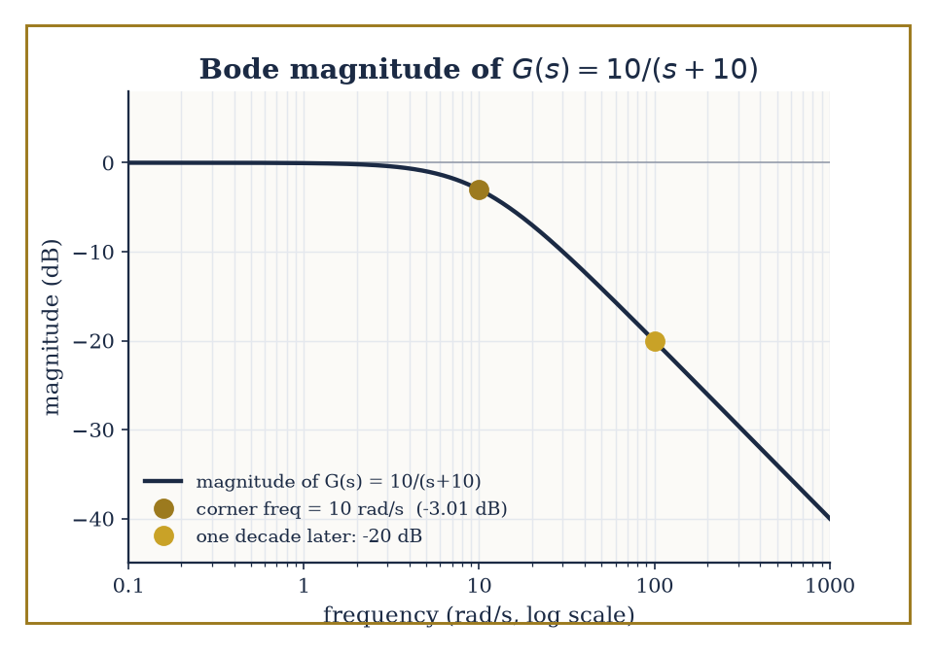
The corner frequency, the -3 dB point, and the -20 dB/decade roll-off, all readable off the same curve without sketching a single asymptote.
Numeric example — Worked example — reading a Bode plot by hand. Take the first-order system G(s) = 10/(s+10), a simple low-pass filter with a pole at s = −10. Its magnitude at real frequency ω is
|G(jω)| = 10/√(ω²+100)
At ω = 0: |G| = 10/10 = 1, i.e. 20log₁₀(1) = 0 dB — full gain at DC. At ω = 10 (the 'corner frequency', where ω equals the pole magnitude):
|G| = 10/√(100+100) = 10/√200 ≈ 0.7071, 20log₁₀(0.7071) ≈ −3.01 dB
the famous '−3 dB point'. The phase there is
∠G(j10) = −arctan(10/10) = −arctan(1) = −45°
exactly halfway to the eventual −90° a first-order lag approaches at high frequency. At ω = 100, one decade above the corner:
|G| = 10/√(10000+100) = 10/√10100 ≈ 10/100.499 ≈ 0.0995, 20log₁₀(0.0995) ≈ −20.04 dB
a drop of almost exactly 20 dB from the corner, confirming the standard −20 dB/decade roll-off rate of a single pole past its corner frequency, without needing to sketch a single asymptote.
Stability margins quantify how close a nominally stable closed loop sits to instability, using nothing but the open-loop frequency response L(jω) (open loop = plant times controller, before the loop is closed). The phase margin is 180° plus the phase of L(jω) at the frequency where |L(jω)| first crosses 0 dB (unity gain); the gain margin is how many decibels of extra gain could be added before |L(jω)| reaches 0 dB at the frequency where the phase first crosses −180°. Rules of thumb (phase margin ≥ 45°, gain margin ≥ 6 dB or so) are the classical engineer's proxy for the more rigorous — but harder to build intuition for — robustness guarantees of later, modern methods.
Numeric example — Worked example — margins from two numbers. Suppose the open loop crosses 0 dB at some frequency ω_c where the measured phase is −130°. Phase margin =
180° − 130° = 50°
comfortably above the 45° rule of thumb. Suppose separately that at the frequency where the phase crosses −180°, the measured gain is −8 dB. The gain margin is 8 dB, meaning the loop gain could be multiplied by
10^(8/20) = 10^0.4 ≈ 2.512
before the system reaches the brink of instability — a healthy safety factor of roughly 2.5×, obtained from two single-number readings off a Bode plot and no further calculation.
The Nyquist stability criterion goes further than a margin: it decides closed-loop stability outright from the open-loop frequency response, by counting how many times the Nyquist plot of L(jω) encircles the critical point −1. Precisely, the number of clockwise encirclements N equals Z − P, where P is the number of open-loop unstable poles and Z the number of closed-loop unstable poles; for an open-loop stable system (P=0), the closed loop is stable exactly when the plot does not encircle −1 at all. This is the frequency-domain machinery that ultimately explains why the gain and phase margins of the previous example mean anything — they measure, in two convenient numbers, how far the Nyquist plot sits from the one point it is forbidden to touch.
Numeric example — Worked example — a critical gain, found by Routh–Hurwitz. Take the classic triple-pole plant L(s) = K/[(s+1)(s+2)(s+3)], stable in open loop (P = 0), with gain K > 0 to be chosen. The closed-loop characteristic equation is (s+1)(s+2)(s+3) + K = 0. Expanding:
(s+1)(s+2) = s²+3s+2
(s²+3s+2)(s+3) = s³ + 3s² + 3s² + 9s + 2s + 6 = s³ + 6s² + 11s + 6
So the closed-loop characteristic polynomial is s³ + 6s² + 11s + (6+K). Build the Routh array: row s³ holds coefficients 1 and 11; row s² holds 6 and (6+K); row s¹ holds (6·11 − 1·(6+K))/6 = (60−K)/6; row s⁰ holds (6+K). Stability requires every entry in the first column — 1, 6, (60−K)/6, (6+K) — to be positive, which requires K < 60 and K > −6.
For physically sensible K > 0, the closed loop is stable for 0 < K < 60, marginally stable (a pair of poles exactly on the imaginary axis, sustained oscillation) at K = 60, and unstable beyond. This K = 60 is the same number the Nyquist plot would show swallowing the −1 point as K increases past it, and — as the next example shows — it is not merely a number we compute and discard.
Proportional-integral-derivative (PID) control remains the overwhelming industrial default, not because it is theoretically optimal but because it is cheap, transparent, and tunable by operators who have never seen a Riccati equation and never need to. The Ziegler–Nichols ultimate-gain method is the classical tuning recipe: increase a purely proportional gain until the closed loop first sustains steady oscillation, record that critical gain K_u and the oscillation period T_u, then set Kp = 0.6K_u, integral time Tᵢ = T_u/2 (giving integral gain Kᵢ = Kp/Tᵢ), and derivative time T_d = T_u/8 (giving derivative gain K_d = Kp·T_d).
Numeric example — Worked example — Ziegler–Nichols tuning, continuing the plant above. The triple-pole plant just analyzed sustains oscillation exactly at K_u = 60 — precisely the K where the Routh test found a marginally stable pole pair, the same critical gain a Nyquist plot would flag as touching −1. Suppose the resulting sustained oscillation is measured to have period T_u = 2 s. Ziegler–Nichols then prescribes
Kp = 0.6×60 = 36
Tᵢ = 2/2 = 1 s (so Kᵢ = 36/1 = 36)
T_d = 2/8 = 0.25 s (so K_d = 36×0.25 = 9)
A full PID controller, three numbers, obtained from a plant we never needed to model beyond finding the single gain at which it starts to sing.
Modern frequency-domain design extends this classical toolkit to systems with many inputs and outputs, and to uncertainty that isn't just 'the gain might be a bit off' but structured — different actuators, sensors, or subsystems each with their own, possibly correlated, error bars. H∞ loop shaping designs a controller minimizing the worst-case gain, over all frequencies, from disturbance to error — the H∞ norm
‖T‖∞ = sup_ω σ̄(T(jω))
the peak of the largest singular value of the closed-loop transfer function, generalizing the scalar peak |T(jω)| to the multivariable case. μ-synthesis refines this further to account explicitly for the structure of the uncertainty, rather than treating it as an undifferentiated blob. For all their machinery, both methods are answering exactly the question a Bode plot was already asking — how big can the response get, and at what frequency — just for systems too large and too uncertain for a hand sketch to settle.

Room 45.8: Nonlinear and Robust Control
When the straight line stops being a kindness
Every technique so far has, at some point, leaned on linearity — superposition, eigenvalues, transfer functions, quadratic Lyapunov functions solved by a matrix equation. Real plants are rarely so obliging over their full operating range, and nonlinear control supplies a toolkit for the cases where the straight-line approximation from Room 45.2 has been stretched past its useful life. Feedback linearization is the most direct idea: if the nonlinearity enters the dynamics in a way we can identify and algebraically cancel using the very input we're free to choose, we can manufacture linear closed-loop behaviour from a genuinely nonlinear plant, rather than merely approximating one.
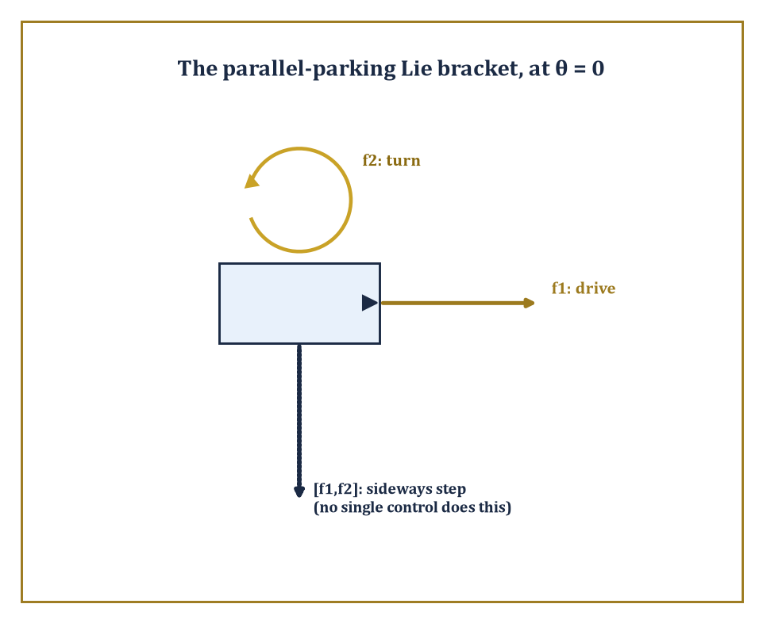
Neither drive nor turn moves the car sideways; their Lie bracket does — every parallel-parking driver implements this arrow by hand.
Numeric example — Worked example — cancelling a cubic nonlinearity. Take ẋ = −x + x³ + u — stable for small x thanks to the −x term, but the x³ term threatens to dominate and destabilize for larger x. Choose u = −x³ + v, exactly cancelling the troublesome term: the closed loop becomes
ẋ = −x + x³ + (−x³ + v) = −x + v
now perfectly linear in the new input v, regardless of how large x gets. Design v as ordinary linear feedback, v = −4x (so the effective gain, combined with the existing −x, gives decay rate 5):
ẋ = −x − 4x = −5x, x(t) = x(0)e^{−5t}
Starting from x(0) = 2, at t = 0.2:
x(0.2) = 2e^{−1} = 2 × 0.367879 ≈ 0.7358
The cubic term has been surgically removed from the closed-loop dynamics, not merely tolerated for being small; this is a genuinely nonlinear technique, valid for all x, not just x near an equilibrium.
Sliding mode control trades the elegance of exact cancellation for outright robustness to disturbances we cannot cancel because we don't know their exact size — only a bound on it. Choose a sliding surface s(x) = 0 (here, for simplicity, just s = x) and a discontinuous control law that switches sign depending on which side of the surface the state currently sits, with a switching gain large enough to overpower the worst-case disturbance. The state is driven onto the surface in finite time and, once there, held on it despite the disturbance — at the cost of chattering, rapid switching near the surface, which is the well-known practical nuisance of the method.
Numeric example — Worked example — robustness against a bounded disturbance. Take ẋ = f(x) + u + d(t), where d(t) is an unknown disturbance satisfying only |d(t)| ≤ D = 3 (bound known, exact value not). Choose u = −f(x) − K·sign(x) with K = 5 > D. The sliding variable is s = x, and
ṡ = ẋ = f(x) + u + d = −K·sign(s) + d
Using the Lyapunov function V = s²/2:
V̇ = s·ṡ = s(−K·sign(s) + d) = −K|s| + sd ≤ −K|s| + |s|·D = −(K−D)|s| = −(5−3)|s| = −2|s|
Since V̇ ≤ −2|s| < 0 whenever s ≠ 0, regardless of the disturbance's exact behaviour (only its bound D=3 was ever used), the state reaches s = 0 in finite time and stays there — a robustness guarantee obtained without ever needing to know, or estimate, what d(t) actually was doing.
Some questions of controllability cannot even be asked in linear language, because the system's controls only ever push in a handful of instantaneous directions, and yet the full state space turns out to be reachable anyway — a phenomenon linear algebra alone cannot explain, but Lie brackets can. The Lie bracket [f₁,f₂] of two vector fields (control directions) measures the net motion produced by wiggling first along f₁, then f₂, then back along f₁, then back along f₂ — a motion in a genuinely new direction, unavailable from f₁ or f₂ alone, that emerges purely from the order in which the two motions fail to commute.
Abstract example — Abstract example — the parallel-parking Lie bracket. The kinematic car (unicycle model) has state (x,y,θ) — position and heading — and two controls: drive forward, f₁ = (cosθ, sinθ, 0), or turn in place, f₂ = (0,0,1). Neither control alone moves the car sideways. Computing the Lie bracket [f₁,f₂] = Df₂·f₁ − Df₁·f₂: since f₂ is constant, Df₂ = 0; the Jacobian of f₁ with respect to (x,y,θ) is Df₁ = [0 0 −sinθ; 0 0 cosθ; 0 0 0], so Df₁·f₂ = Df₁·(0,0,1)ᵀ = (−sinθ, cosθ, 0)ᵀ, giving
[f₁,f₂] = −(−sinθ,cosθ,0)ᵀ = (sinθ, −cosθ, 0)ᵀ
At θ = 0 (car facing along the x-axis), this bracket direction is (0, −1, 0) — pure sideways motion, in the y-direction, exactly perpendicular to the heading. No single control produces this motion, but alternating drive-turn-reverse-turn, in the pattern the bracket encodes, produces a net sideways step over one full cycle. This is, quite literally, the mathematics of parallel parking: the car cannot move sideways directly, but the Lie bracket of its two available motions can, and every driver who has ever inched a car into a tight space has been implementing this bracket by hand, entirely without noticing.
Robust control accepts, as a starting premise, that the model is wrong by some amount, and designs for the worst case that amount allows. H∞ control chooses the controller minimizing the worst-case closed-loop gain from disturbance to error across all frequencies (the same H∞ norm introduced in the previous room, now used as a direct design objective rather than a passive measurement); μ-synthesis extends this to structured uncertainty, where different parts of the model are wrong in different, possibly correlated ways, rather than treating all uncertainty as one undifferentiated blob. Adaptive control takes a different tack again: rather than designing once for the worst case, it estimates the unknown parameters online and adjusts the controller as better information arrives — appropriate when the uncertainty is parametric (a mass, a friction coefficient, a gain, unknown but constant) rather than an arbitrary disturbance.
Abstract example — Abstract example — an adaptive law verified by Lyapunov, not by solving the trajectory. Consider ẋ = θ*x + u, with true parameter θ* unknown and constant, and control u = −kx − αx, where α is an online estimate of θ* and k > 0 is a fixed, known robustifying gain. Writing the estimation error φ = α − θ*, the closed loop is
ẋ = θ*x + u = θ*x − kx − αx = −kx + (θ*−α)x = −kx − φx
Choose the adaptive update law α̇ = γx² for some fixed γ > 0 (note φ̇ = α̇, since θ* is constant). Try the Lyapunov function V = x²/2 + φ²/(2γ):
V̇ = xẋ + φφ̇/γ = x(−kx−φx) + φ(γx²)/γ = −kx² − φx² + φx² = −kx²
With, say, k = 2, this gives V̇ = −2x² ≤ 0 for every value of the unknown θ*, every value of γ > 0, and every trajectory of α — a stability guarantee established without ever solving the coupled nonlinear equations for x(t) and α(t) explicitly, which in general cannot be done in closed form. This is the defining move of Lyapunov-based adaptive control: choose the update law specifically so that the awkward cross-term in V̇ cancels, and let the sign of what remains do all the remaining work.
Nonlinear and robust methods do not replace the linear theory built in Rooms 45.2 through 45.6; they extend its reach into territory where a single linearization, a single fixed model, or a single worst-case-free assumption would quietly fail. The goals — stability, performance, robustness — are unchanged from Room 45.1's opening sentence. Only the honesty required to pursue them has increased.

Room 45.9: Looking Ahead: From Classical Control to Hybrid, Networked, and Learning-Based Control
From the loop to the network, the switch, and the machine that learns
We have now assembled the core of control theory: linear state-space models as the common language, controllability and observability as the structural prerequisites for design, Lyapunov and input-output stability as the non-negotiable first requirement, state feedback and observers as the two basic levers (united by the separation principle), LQR and the Pontryagin maximum principle as the optimal versions of those levers, frequency-domain methods as an older and still-thriving parallel dialect, and the beginnings of nonlinear and robust control for when the linear dialect starts to strain. Every later development in the field builds directly on this list, rather than replacing any part of it.
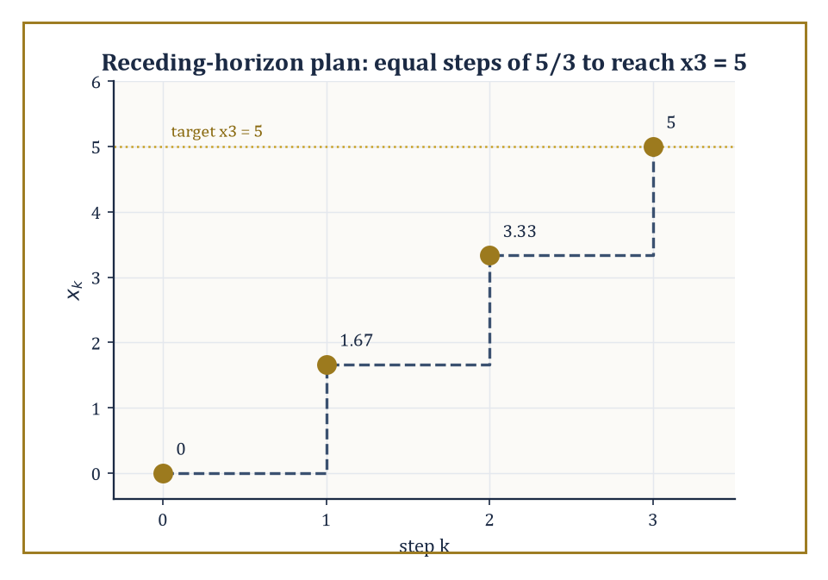
A one-shot optimal plan would apply all three moves; MPC applies only the first, then re-solves from wherever reality actually put it.
Hybrid systems combine continuous dynamics with discrete switches — a thermostat that is a linear heat-transfer equation almost everywhere, except at the instants it flips the furnace on or off; a bouncing ball, whose height obeys ordinary Newtonian free-fall except at the instant of impact, when velocity is reset (with a coefficient of restitution) rather than merely continuous. Networked control confronts the fact that, outside the classroom, sensors and actuators rarely sit in the same box as the controller: communication delays, dropped packets, and — increasingly — the coordination of many controllers and many plants at once (a fleet of drones, a smart grid) as a genuinely multi-agent problem, rather than one loop closed in isolation.
Model-predictive control (MPC) takes the finite-horizon optimal control idea from Room 45.6 and runs it on a rolling basis: at each time step, solve a finite-horizon optimal control problem (explicitly incorporating constraints on state and input that LQR's unconstrained framework cannot handle directly) from the currently measured state, apply only the first control move of the resulting plan, then measure the actual resulting state and re-solve the whole problem from scratch. The controller never trusts its own multi-step plan beyond the very next instant — a philosophy summarized, not unfairly, as never fully believing a forecast beyond the next step, and re-checking constantly.
Numeric example — Worked example — a receding-horizon plan, and its first move. Take a discrete-time integrator x_{k+1} = x_k + u_k, starting at x₀ = 0, with the goal of reaching x₃ = 5 after three steps while minimizing the control energy Σ_{k=0}^{2} u_k². This is the discrete cousin of Room 45.6's minimum-energy problem, and the same logic applies: minimizing a sum of squares subject to a fixed total (here u₀+u₁+u₂ = 5, from the constraint x₃−x₀=5) is minimized, by symmetry (or a one-line Lagrange-multiplier argument), by splitting the total evenly,
u₀ = u₁ = u₂ = 5/3 ≈ 1.667
A one-shot optimal controller would simply apply all three moves in sequence. An MPC controller applies only the first, u₀ ≈ 1.667, then measures the actual x₁ (which may differ from the planned 1.667, if reality disagreed with the model), and re-solves the two-step problem from whatever x₁ turned out to be — repeating the same minimum-energy logic on a shrinking, continually re-grounded horizon, rather than trusting a three-step plan made before anything had actually happened yet.
Learning-based control replaces some or all of the model itself with data: system identification learns A, B (or their nonlinear generalizations) from observed trajectories rather than first-principles physics; reinforcement learning for continuous control learns a feedback policy directly by trial, reward, and correction, without ever writing down an explicit model at all — a strategy control theorists view with a mixture of professional interest and a certain territorial unease, since it frequently works rather well on problems the classical theory finds awkward, while offering markedly weaker stability guarantees than a hand-derived Lyapunov certificate. The two communities are, at the time of writing, still negotiating how much of each other's furniture to borrow.
The negotiation is not merely academic turf-guarding: it is a genuine trade-off, and this storey has equipped us to state it precisely. A Room 45.6 LQR controller comes with a certificate — the Riccati equation's solution is a Lyapunov function, in the sense of Room 45.4, and its existence proves stability, not merely observes it in simulation. A learned policy, however capable it looks in a million training episodes, comes with no such certificate by default; it has been tested, not proved. The most promising current work in learning-based control is, tellingly, work that tries to have both — learning a policy or a model from data, then handing the result back to exactly the Lyapunov and small-gain machinery built in Room 45.4 to certify it after the fact, rather than trusting the training curve alone. The classical theory, in other words, is not being replaced so much as relocated: from the design phase to the verification phase, still doing the same job of separating behaviour that is guaranteed from behaviour that merely happened to work on the examples tried so far.
What is easy to lose, amid switches, networks, and learned policies, is how far the same underlying mathematical ideas travel. A robot arm's joint controllers are pole-placement and observer design from Rooms 45.2 through 45.5, wearing overalls. A power grid's frequency regulation is a large-scale, networked instance of exactly the stability and disturbance-rejection questions Room 45.4 asked of a scalar toy system. And the pupillary reflex from Room 45.1 — negative feedback, self-limiting, no central planner — is structurally the same object as the thermostat, the cruise control, and the Kalman filter humming quietly inside a modern aircraft's autopilot: the same loop, closed, over and over, at every scale biology and engineering have found a use for it.
The deeper lesson of this storey is that feedback is a genuinely universal mechanism for converting uncertainty and instability into reliable behaviour — and that the mathematics required to use it correctly, rather than merely hopefully, is both elegant and, in any system anyone actually depends on, indispensable. Control theory is the mathematics of steering dynamical systems. We have learned to close the loop.
Stand back and look at what this storey handed us: a way to describe a moving system precisely (state space), two structural questions about what such a description can and cannot do (controllability, observability), a rigorous meaning for 'behaving' (Lyapunov and input-output stability), two levers for enforcing it (state feedback and observers, married by the separation principle), a way to do all of this not just adequately but provably optimally (LQR and the maximum principle), a parallel and still-thriving frequency-domain dialect for saying much the same things in Hertz, and a first, honest look at what happens once the plant stops being linear or the model stops being trustworthy. Every one of those pieces reduces, in the end, to the same single idea from Room 45.1: measure what is actually happening, and push back.
It is worth sitting with how strange that idea is, mathematically speaking. Nothing in this storey required the controller to know the disturbance, or to have correctly identified every parameter of the plant, or to have anticipated the specific way things would go wrong. Feedback does not need to be right about the future; it only needs to notice, continuously, that the present has drifted from where it should be, and correct. That a mechanism this modest can stabilize an inverted pendulum, land a rocket booster on a barge, or keep a pupil the right size in changing light, is either a minor miracle or an extremely good argument that the universe rewards persistence over prescience. Possibly both.
Every system in this storey, however, was a system we were allowed to touch — a plant with a B matrix, an input channel, a standing invitation to intervene. The next storey withdraws that invitation entirely. Dynamical Systems and Chaos asks what these same differential equations do when left completely alone: unforced, unfed, un-Kalman-filtered, with nobody minding the loop. Room 45.4 spent considerable effort teaching us to recognize and enforce stability; the next storey goes looking, quite deliberately, for equations that provably refuse it — trajectories that never settle to an equilibrium, never repeat, and depend so sensitively on their starting point that two initial conditions indistinguishable to twenty decimal places diverge into entirely different futures. It is, in a sense, this storey's mirror image: control theory is the art of making a system predictable; chaos theory studies what a system does when nobody has bothered, or nobody is able, to make it behave.
The tower continues upward. We have learned to close the loop; next, we find out what happens when we don't.

Storey 46: Dynamical Systems & Chaos
Flows, Maps, Attractors, and the Art of Long-Term Behavior
Control theory left us with the comforting idea that if you observe a system well enough and design the right feedback, you can force it to do roughly what you want — steer it, stabilise it, apologise to it if necessary. Dynamical systems now asks the ruder question underneath: left entirely to itself, with no engineer fiddling with the dials, what does a system do? The answer, we shall see, ranges from 'settles down and has a nice little rest at an equilibrium' to 'wanders forever through an infinitely detailed cloud of its own making, never once repeating itself, while remaining perfectly, insultingly deterministic.'
This is the storey in which the word 'chaos' finally earns its formal mathematics rather than its Hollywood soundtrack. We will define it properly — no butterflies required, though one insists on making a cameo — and discover that chaos is not the absence of law but an excess of it: a rule so faithfully obeyed, iterated so relentlessly, that its outputs become as unpredictable in practice as a coin toss, while remaining as fixed in principle as 2 + 2 = 4.
The tools are geometric: phase space, trajectories, linearization near equilibria, Poincaré maps that turn continuous flows into countable clicks, Lyapunov functions that behave like an ever-so-slightly disapproving energy, and eventually strange attractors, whose geometry is so intricate that 'dimension' itself has to be redefined to keep up with them. None of it requires more machinery than we already possess from earlier storeys — differential equations, linear algebra, a smattering of topology — but the way these tools combine produces some of the most startling pictures in all of mathematics, and a fair amount of quiet despair for anyone who was hoping long-term forecasting would eventually get easier.
Ahead lies Mathematical Physics, where these same flows turn out to be the equations of motion of the universe itself, and where the question 'does this system behave predictably' becomes rather more pressing than an academic curiosity. But first, let us learn to distrust our intuition about 'simple rule, simple outcome' — because it is about to be thoroughly, gleefully demolished.

Room 46.1: What Dynamical Systems Actually Are
In which a state learns to move, and immediately regrets it
A dynamical system consists of two ingredients: a phase space — the set of every state the system could conceivably be in — and a rule for how a state changes as time passes. If time flows continuously, the rule is a differential equation, and the resulting motion is called a flow.
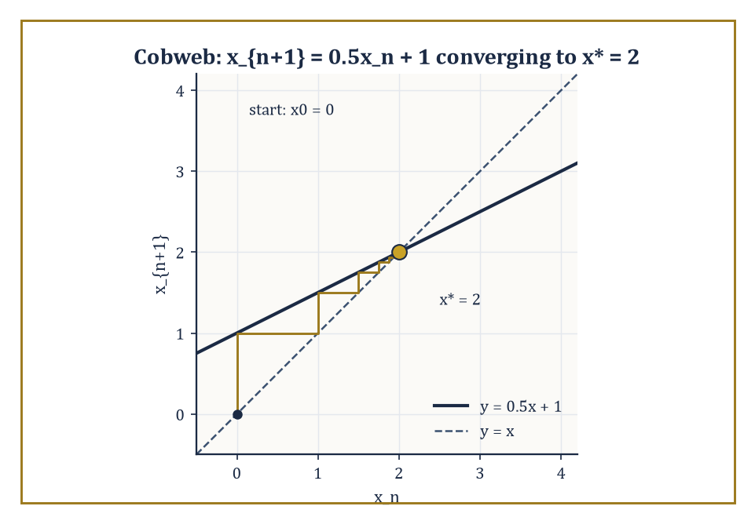
A cobweb diagram for x_{n+1} = 0.5x_n + 1, spiralling obediently into the fixed point x* = 2.
ẋ = f(x)
If time ticks in discrete steps (year one, year two, year three, with nothing in between), the rule is an iterated map.
x_{n+1} = f(x_n)
Either way, the trajectory (or orbit) of a starting point x₀ is the full sequence of states it passes through as time runs forward — the curve traced by a flow, or the list of iterates produced by a map. Everything in this storey is really one question dressed up in different clothes: given the rule, and given enough time, where does the state end up?
Numeric example — Worked example — iterating a map by hand. Take the discrete rule x_{n+1} = 0.5x_n + 1, starting from x₀ = 0. Compute the orbit:
x₁ = 0.5(0) + 1 = 1
x₂ = 0.5(1) + 1 = 1.5
x₃ = 0.5(1.5) + 1 = 1.75
x₄ = 0.5(1.75) + 1 = 1.875
x₅ = 1.9375
The values are creeping toward a number that satisfies x = 0.5x + 1, i.e. 0.5x = 1, i.e. x* = 2 — an equilibrium (or fixed point): a state the rule maps to itself. The orbit never quite arrives, but it gets there in the limit. This is dynamical systems in miniature: a rule, an orbit, and a long-term destination.
Not every orbit settles at a single point. The principal types of recurrent long-term behaviour are: equilibria (states that never move), periodic orbits (states that return exactly to where they started after a fixed time or fixed number of steps), invariant tori (motion that combines two or more independent, generally incommensurate frequencies, so the state wanders over a doughnut-shaped surface without ever exactly repeating), and — the star of this storey — chaotic attractors, where the orbit is confined to a bounded region forever but never settles, never repeats, and depends with terrifying sensitivity on where it started.
Numeric example — Worked example — periodic versus quasi-periodic on a circle. Consider the circle map x_{n+1} = x_n + α (mod 1), which nudges a point around a circle of circumference 1 by a fixed amount α each step. With α = 1/3:
x₀ = 0, x₁ = 1/3, x₂ = 2/3, x₃ = 1 mod 1 = 0
The orbit is exactly periodic with period 3, revisiting {0, 1/3, 2/3} forever. Now take α irrational, say α = √2 − 1 ≈ 0.41421. The orbit
x_n = n α (mod 1)
never returns exactly to 0, because n α = integer would force α to be rational — a contradiction. Instead the orbit is quasi-periodic: it fills the circle densely without ever repeating a point, a fact known since Weyl's equidistribution theorem. Same map, same formula; whether α is a fraction or an irrational decides the entire character of the long-term behaviour, which ought to be a small early warning about how much rides on the fine print.
A dynamical system is called structurally stable if its qualitative phase portrait — which regions flow where, how many equilibria there are and of what type — survives small perturbations of the rule f itself (not just small perturbations of the starting point). A bifurcation is precisely a parameter value at which this fails: an infinitesimal nudge to the rule changes the picture qualitatively, not just quantitatively. We will spend an entire room on this later (Room 46.8), but it is worth meeting the idea now, since it explains why dynamical systems is a subject about families of rules, not single rules in isolation.
Numeric example — Worked example — a bifurcation you can watch happen. Take the linear map x_{n+1} = a x_n with starting point x₀ = 1, for two nearby values of the parameter a. At a = 0.9:
x₁ = 0.9, x₂ = 0.81, x₃ = 0.729, x₄ = 0.6561
— decaying steadily to the equilibrium 0. At a = 1.1:
x₁ = 1.1, x₂ = 1.21, x₃ = 1.331, x₄ = 1.4641
— growing without bound. Nothing violent happens to the formula as a crosses 1; the coefficient just ticks past a threshold. But the qualitative fate of every orbit flips from 'converges' to 'diverges'. That crossing, at a = 1, is a bifurcation — the simplest possible one, and the ancestor of every richer bifurcation we will meet later.
One more piece of vocabulary earns its place immediately, because it recurs at every later stage of this storey: two dynamical systems are topologically conjugate if there exists a homeomorphism h (a continuous, continuously invertible change of coordinates) carrying every orbit of one system exactly onto an orbit of the other, respecting the direction of time. Conjugate systems are, for every qualitative purpose, the same dynamical system dressed in different coordinates — the precise notion of sameness that structural stability is defending, and the exact relationship the Hartman–Grobman theorem asserts between a nonlinear flow and its linearization near a hyperbolic equilibrium (Room 46.3).
Numeric example — Worked example — two very different-looking maps, secretly the same. The logistic map at r = 4, x_{n+1} = 4x_n(1 − x_n), and the doubling map θ_{n+1} = 2θ_n (mod 1) look nothing alike, yet are conjugate via h(θ) = sin²(πθ). To check:
h(2θ) = sin²(2πθ) = [2 sin(πθ)cos(πθ)]² = 4 sin²(πθ) cos²(πθ) = 4 sin²(πθ)(1 − sin²(πθ)) = 4h(θ)(1 − h(θ))
— exactly the logistic formula applied to h(θ). So doubling θ and then applying h gives the same result as applying h and then applying the logistic map: the diagram commutes. Numerically, take θ₀ = 0.1:
h(θ₀) = sin²(18°) = (0.309017)² ≈ 0.095492
Doubling first:
θ₁ = 0.2, h(θ₁) = sin²(36°) = (0.587785)² ≈ 0.345492
Logistic first:
x₁ = 4(0.095492)(1 − 0.095492) = 4(0.095492)(0.904508) ≈ 0.345493
The two routes agree (to rounding error) — confirming that the wild, fractal-looking logistic map at r = 4 is, underneath a smooth change of coordinates, nothing but the doubling map from Room 46.1 in disguise, binary-digit shift and all.

Room 46.2: Flows, Maps, and Phase Portraits
Portraiture without a sitter
Formally, a flow is a family of maps φ_t : M → M, one for each time t ∈ ℝ, satisfying φ₀ = identity and the group law:
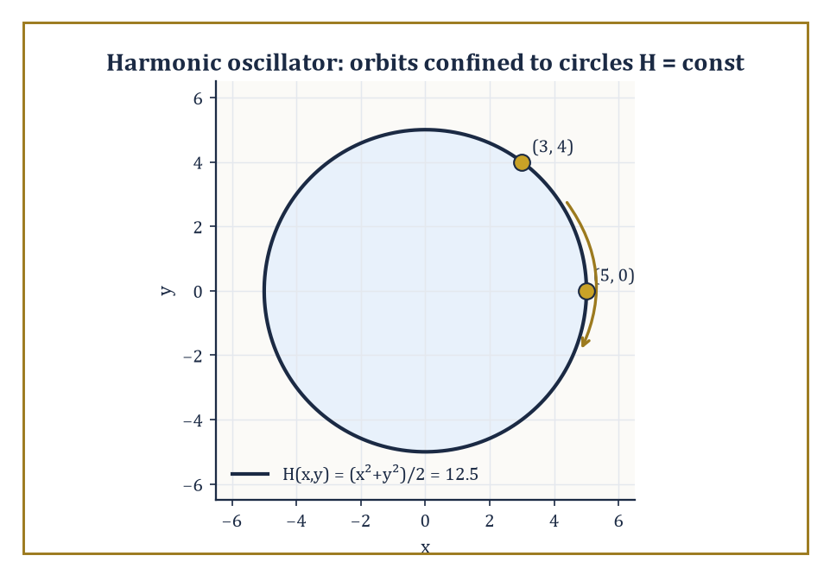
The harmonic oscillator's orbits, pinned by conservation of H to circles of constant radius — no differential equation required.
φ_t(φ_s(x)) = φ_{t+s}(x)
Flowing for s time units and then t more is the same as flowing for s + t all at once. A flow is generated by a vector field f via the differential equation:
ẋ = f(x)
Here φ_t(x₀) is simply the solution starting at x₀, evaluated at time t. A discrete dynamical system dispenses with the group law's continuity and just iterates a single map f : M → M directly.
The phase portrait is the picture you get by drawing enough orbits to see the whole qualitative structure — which regions spiral in, which flow past, where the equilibria and periodic orbits sit. It is the cartography of the rule's long-term behaviour, and like all cartography it involves a certain amount of tasteful omission.
Numeric example — Worked example — checking the group law by hand. The flow of ẋ = x on ℝ is given by the explicit solution:
φ_t(x₀) = x₀ e^t
Take x₀ = 2, and check φ_t(φ_s(x₀)) = φ_{t+s}(x₀) for s = t = 1. First route: flow by 1, then flow by 1 again.
φ_1(2) = 2e ≈ 5.4366
φ_1(2e) = 2e · e = 2e² ≈ 14.7781
Second route: flow by 2 directly.
φ_2(2) = 2e² ≈ 14.7781
The two routes agree exactly, as the group law demands — flowing for one unit twice is indistinguishable from flowing for two units once, which is a statement about time itself being additive, not a coincidence of this particular equation.
Existence, uniqueness, and continuous dependence on initial conditions for ẋ = f(x) follow from the standard ODE theorems already met in an earlier storey, provided f is Lipschitz continuous.
But local existence — a solution defined for a little while near t = 0 — is not the same as completeness, which is global existence for all time. Some perfectly smooth, perfectly well-behaved vector fields generate solutions that reach infinity in finite time, at which point the flow simply has nothing left to say.
Numeric example — Worked example — a smooth equation with no future. Take ẋ = x², x(0) = 1 — about as innocent-looking an equation as one could write. Separating variables gives:
dx/x² = dt
Integrating:
−1/x = t + C
At t = 0, x = 1 gives C = −1, so:
−1/x = t − 1, i.e. x(t) = 1/(1 − t)
This solution is perfectly well defined and smooth for t < 1 — but as t → 1⁻, x(t) → +∞. The trajectory reaches infinity at the finite time t = 1 and the solution simply ceases to exist afterward, despite f(x) = x² being Lipschitz on every bounded set and about as tame-looking a formula as you could ask for. Completeness is not automatic; growth conditions (typically, f growing no faster than linearly at infinity) are needed to rule this out.
Continuous dependence on initial conditions is the standard guarantee, valid whenever f is Lipschitz with constant L, that two solutions starting a distance δ apart stay within δe^{L|t|} of one another for as long as both remain defined — a precise, quantitative version of 'a small change at the start produces a small change later.'
Read casually this sounds entirely reassuring; read carefully, the sting is already visible. The very same exponential bound that guarantees closeness over any fixed finite stretch of time also permits — indeed, in the worst case, predicts — arbitrarily large separation over long stretches of time.
This is not a flaw in the theorem; it is the crack through which sensitive dependence and chaos will later climb.
Numeric example — Worked example — a rigorous bound that still allows enormous drift. For ẋ = x (so L = 1, the Lipschitz constant is exactly the coefficient), take two starting points x₀ = 1 and x₀′ = 1.01, a gap of δ = 0.01. The explicit solutions are:
x(t) = e^t and x′(t) = 1.01e^t
So their gap at time t is exactly:
gap(t) = 0.01e^t
This matches the general bound δe^{Lt} with equality, since the system is linear and the bound is tight here. At t = 0 the gap is a modest 0.01.
gap(5) = 0.01 × e^5 ≈ 0.01 × 148.41 ≈ 1.484
That is a roughly 148-fold amplification of a tiny initial discrepancy, achieved by a flow that is perfectly smooth, perfectly deterministic, and in full compliance with the continuous-dependence theorem the entire time. Continuity of dependence was never a promise that errors stay small forever; it was only ever a promise about how fast, and by exactly what factor, they are allowed to grow.
Conserved quantities and Lyapunov functions constrain the possible phase portrait dramatically. A conserved quantity is a function H(x) that stays exactly constant along every trajectory:
Ḣ = 0
This means the entire flow is confined to move along the level sets of H — the portrait is foliated by these invariant surfaces before you have solved a single equation of motion. This is often the fastest route to understanding global behaviour: find the conserved quantity, and the geometry does the rest.
Numeric example — Worked example — energy conservation confines the orbit to a circle. For the harmonic oscillator ẋ = y, ẏ = −x, try the candidate conserved quantity:
H(x, y) = (x² + y²)/2
Differentiating along trajectories:
Ḣ = x ẋ + y ẏ = x·y + y·(−x) = xy − xy = 0
So H is exactly conserved, and every orbit lies on a circle x² + y² = constant. Concretely: starting at (x, y) = (3, 4):
H = (9 + 16)/2 = 12.5, so √(x²+y²) = 5
That radius holds for the whole orbit thereafter. Checking a later point on the same trajectory, say (5, 0):
H = (25 + 0)/2 = 12.5, and √(25+0) = 5
Both match exactly, confirming the same radius. The orbit never needed to be solved explicitly (though it is easy enough: (x(t), y(t)) = (5 cos t, 5 sin t) up to a phase) — the conservation law alone pinned it to a circle.

Room 46.3: Linearization and Local Structure
Zooming in until the curve looks straight, then hoping it stays that way
Near an equilibrium x₀ (where f(x₀) = 0), the nonlinear flow ẋ = f(x) is approximated by its linearization,
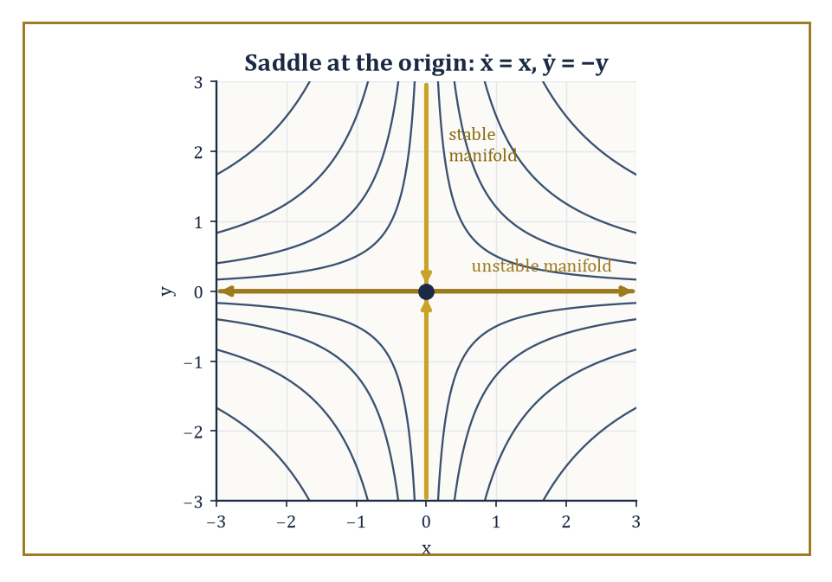
The saddle ẋ = x, ẏ = −y made literal: hyperbolas of constant xy, with the two axes standing in as the stable and unstable manifolds.
ẋ = Df(x₀)(x − x₀)
where Df(x₀) is the Jacobian matrix of partial derivatives evaluated at the equilibrium. An equilibrium is called hyperbolic if no eigenvalue of Df(x₀) has zero real part — none of them sit exactly on the knife-edge between growth and decay.
The Hartman–Grobman theorem then guarantees that near a hyperbolic equilibrium, the true nonlinear flow is topologically conjugate to its linearization: there is a continuous, continuously invertible change of coordinates turning one into the other, so the qualitative local picture (sink, source, saddle) is entirely decided by the linear algebra, and the nonlinear terms only distort the picture, never its topology.
Numeric example — Worked example — linearizing a genuinely nonlinear system. Take the system:
ẋ = −x + y², ẏ = −2y
At the origin, f(0,0) = (0,0), confirming it is an equilibrium. The Jacobian is
Df(x,y) = [[−1, 2y], [0, −2]]
so
Df(0,0) = [[−1, 0], [0, −2]]
which is already diagonal with eigenvalues −1 and −2 — both real and negative, neither zero, so the origin is hyperbolic (a stable node, or 'sink'). Check the approximation at a nearby point (0.1, 0.1): the true vector field gives
f(0.1, 0.1) = (−0.1 + 0.01, −0.2) = (−0.09, −0.2)
The linear approximation gives
Df(0,0)·(0.1, 0.1) = (−0.1, −0.2)
The two agree to within 0.01 in the x-component (the discrepancy is entirely the quadratic y² term, which is second-order small near the origin) and exactly in the y-component. Both point inward toward the origin, confirming the local picture the eigenvalues predicted.
Real eigenvalues give straight-line approach or departure along the eigendirections, as in the sink just examined.
A complex-conjugate pair of eigenvalues a ± bi (with b ≠ 0) gives a qualitatively different picture: trajectories wind around the equilibrium infinitely often as they approach it (if a < 0) or flee it (if a > 0), tracing logarithmic spirals rather than straight paths.
Hyperbolicity only demands a nonzero real part and has nothing to say about the imaginary part, so Hartman–Grobman applies here exactly as before: a stable spiral is still topologically conjugate to its linearization, spiral and all.
Numeric example — Worked example — a stable spiral, verified by its own radius. Take the system:
ẋ = −x − y, ẏ = x − y
The Jacobian is constant, [[−1, −1], [1, −1]], with characteristic equation
(−1 − λ)² + 1 = 0
that is,
(λ + 1)² = −1
giving
λ = −1 ± i
a complex-conjugate pair with negative real part −1: a stable spiral. This can be confirmed without ever solving for x(t) and y(t) explicitly, by tracking r² = x² + y² instead:
d(r²)/dt = 2xẋ + 2yẏ = 2x(−x−y) + 2y(x−y) = −2x² − 2xy + 2xy − 2y² = −2x² − 2y² = −2r²
This is a clean exponential decay equation for r² alone, with solution
r²(t) = r²(0)e^{−2t}
and the rate, 2, is exactly twice the real part of the eigenvalues (2 × 1 = 2), exactly as the general theory predicts. Numerically: start at (x₀,y₀) = (1,0), so r²(0) = 1. At t = 1:
r²(1) = e^{−2} ≈ 0.1353
so
r(1) ≈ 0.368
the trajectory has spiralled from radius 1 down to about a third of that in one time unit, while simultaneously rotating (the imaginary part ±1 sets the angular speed), exactly the spiral behaviour the complex eigenvalues foretold.
At a hyperbolic equilibrium, the tangent space splits into a stable subspace (eigenvalues with negative real part, along which nearby solutions are drawn in) and an unstable subspace (positive real part, along which they are flung out).
The corresponding curved objects in the full nonlinear system — the stable and unstable manifolds — are invariant surfaces tangent to these subspaces at the equilibrium.
When an eigenvalue does sit exactly on the boundary (zero real part), its direction is called a center direction, and the linear theory falls silent: whether that direction is attracting, repelling, or neither depends on the nonlinear terms, which is precisely what center-manifold reduction and normal-form theory are built to sort out.
Abstract example — Worked example — a saddle, made completely explicit. Consider the system:
ẋ = x, ẏ = −y
The origin is an equilibrium; the Jacobian is already [[1, 0], [0, −1]], with eigenvalues +1 (unstable direction, the x-axis) and −1 (stable direction, the y-axis) — a hyperbolic saddle. The system solves exactly:
x(t) = x₀e^t, y(t) = y₀e^{−t}
Multiplying,
x(t)y(t) = x₀y₀ e^t e^{−t} = x₀y₀
a constant for each orbit — so every orbit lies on a hyperbola xy = constant, except the two axes themselves, which are exactly the stable manifold (x₀ = 0, so y decays to 0 while x stays 0) and the unstable manifold (y₀ = 0, so x grows while y stays 0). The abstract classification (stable manifold = span of negative-eigenvalue eigenvectors) here becomes two literal, drawable lines.
Exactly the same machinery governs fixed points of discrete maps, with one change of vocabulary: instead of asking whether eigenvalues have negative or positive real part, one asks whether they lie inside or outside the unit circle in the complex plane.
An eigenvalue of magnitude less than 1 means perturbations shrink with each iteration (stable); greater than 1, they grow (unstable); exactly 1 is the non-hyperbolic borderline where center-manifold and normal-form techniques again take over.
Numeric example — Worked example — inside versus outside the unit circle. Compare two linear maps near their fixed point at 0. First,
x_{n+1} = 2x_n
with derivative (eigenvalue) 2, outside the unit circle. Starting at x₀ = 0.01:
x₁ = 0.02, x₂ = 0.04, x₃ = 0.08
doubling each step, clearly repelled from 0. Second,
x_{n+1} = 0.5x_n
with eigenvalue 0.5, inside the unit circle. Starting at x₀ = 1:
x₁ = 0.5, x₂ = 0.25, x₃ = 0.125
converging geometrically to 0. The magnitude of the single eigenvalue — 2 in one case, 0.5 in the other — completely decides the fate of every nearby orbit, exactly mirroring the flow case where it was the sign of the real part rather than the size relative to 1.

Room 46.4: Periodic Orbits and Poincaré Maps
Turning an eternal loop into a single, judgeable click
A periodic orbit is a trajectory γ(t) satisfying the periodicity condition below, for some minimal period T > 0 — the state returns exactly to a previous value and then repeats forever.
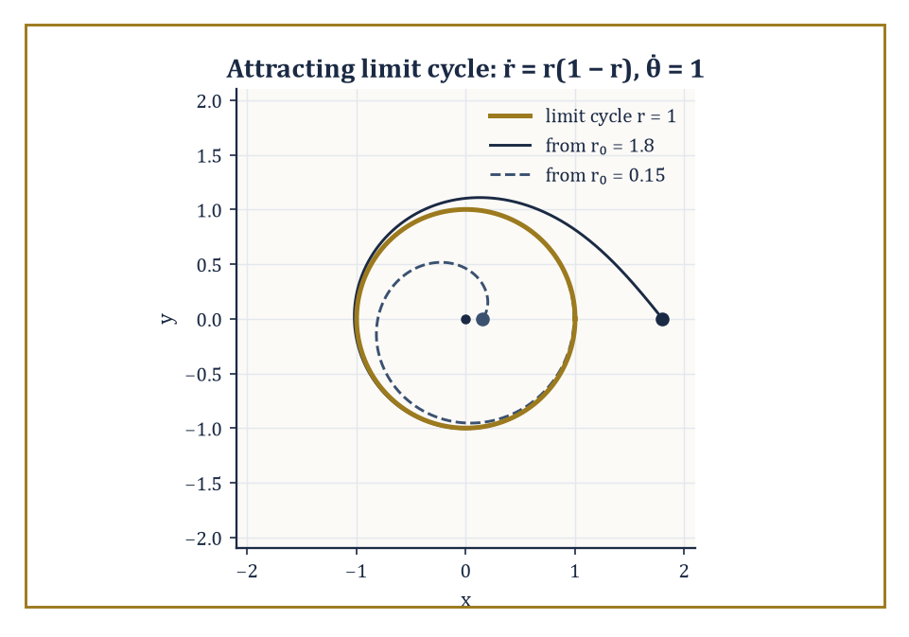
The attracting limit cycle r = 1, with trajectories spiralling onto it from both outside and inside — exactly as its negative Floquet multiplier promises.
γ(t + T) = γ(t) for all t
To study its stability, pick a section Σ transverse to the orbit (a small surface the orbit crosses, rather than runs along) and follow the flow starting from a nearby point on Σ until it first returns to Σ. This defines the Poincaré return map P : Σ → Σ, and the periodic orbit itself corresponds to a fixed point of P.
Crucially, this converts a question about a continuous-time loop into a question about a discrete-time fixed point — exactly the linearization toolkit from Room 46.3 applies, and the eigenvalues of DP at the fixed point (called Floquet multipliers) decide stability: inside the unit circle means the periodic orbit attracts nearby trajectories, outside means it repels them.
Numeric example — Worked example — a limit cycle and its exact Floquet multiplier. Consider the planar system written in polar coordinates:
ṙ = r(1 − r), θ̇ = 1
Since θ increases at a constant unit rate, the point sweeps around the origin at constant angular speed regardless of r; since ṙ = 0 exactly at r = 1, the unit circle is a periodic orbit of period T = 2π.
To find its stability, linearize the r-equation about r = 1: writing u = r − 1, consider the function g(r) = r(1 − r), whose derivative is:
g′(r) = 1 − 2r
Evaluating at the fixed point:
g′(1) = −1
This gives u̇ ≈ −u near the orbit, hence:
u(t) ≈ u(0)e^{−t}
Over one full period T = 2π, a perturbation shrinks by the exact factor:
e^{−2π} ≈ 0.001867
this is the Floquet multiplier, and its magnitude is far below 1, so the orbit is strongly stable.
Concretely: start at r₀ = 1.1, so u₀ = 0.1. After one full loop:
u(2π) ≈ 0.1 × 0.001867 ≈ 0.0001867
i.e. r ≈ 1.000187 — a trajectory that started 10% off the cycle is within 0.02% of it after a single revolution. That is what 'attracting periodic orbit' looks like in numbers.
The Poincaré–Bendixson theorem is the reason chaos cannot occur in continuous flows confined to the plane: if a trajectory stays forever inside a compact trapping region containing no equilibria, its long-term (ω-limit) behaviour must be a periodic orbit — nothing more exotic is available.
The intuitive reason is topological: a planar trajectory cannot cross itself (that would violate uniqueness of solutions), so it behaves like a single car stuck on a one-lane road with no exits — it can only settle at a point or loop around. Add a third dimension, however, and trajectories gain room to pass 'over' or 'under' each other without literally crossing, and the theorem's guarantee evaporates — which is precisely why every strange attractor in this storey lives in three dimensions or more.
Abstract example — Worked example — Poincaré–Bendixson caught in the act. Return to the system:
ṙ = r(1 − r), θ̇ = 1
Take the annulus 0.5 ≤ r ≤ 1.5 as the trapping region: since θ̇ = 1 is never zero, there are no equilibria anywhere in the annulus (an equilibrium would need both ṙ = 0 and θ̇ = 0 simultaneously).
By Poincaré–Bendixson, every trajectory entering this annulus must have a periodic orbit as its long-term fate — and we already found it by direct calculation: the unit circle r = 1. The theorem, in this case, could have told us a periodic orbit existed even before we solved anything; the explicit solution merely confirmed which one.
Floquet theory generalizes the eigenvalue calculation above to the case of a periodic orbit in any number of dimensions, where the linearization along the orbit is a matrix A(t) that is itself periodic rather than constant:
A(t+T) = A(t)
The fundamental solution of this linear time-varying system, evaluated over one full period, is called the monodromy matrix; its eigenvalues are exactly the Floquet multipliers, generalizing the single number computed above to a full spectrum.
Abstract example — Worked example — a monodromy matrix computed by hand. Take the constant matrix:
A = [[0, 1], [−1, 0]]
This is the generator of pure rotation, formally periodic with any period since it never changes. Its flow is e^{At}, a rotation by angle t; at t = 2π this is a full rotation, so the fundamental matrix over one period is:
Φ(2π) = e^{A·2π} = the identity matrix
The monodromy matrix is therefore I, with both Floquet multipliers equal to 1 — neither attracting nor repelling, but neutral.
This matches the earlier finding (Room 46.2) for the pure-rotation system:
ẋ = y, ẏ = −x
whose orbits are an entire continuum of concentric circles, each one exactly as stable (or unstable) as its neighbours: a whole family of periodic orbits sharing the same neutral multiplier, rather than one isolated orbit standing out from the crowd.

Room 46.5: Lyapunov Stability and Invariant Sets
Proving convergence without ever solving the equation
Lyapunov's direct method proves stability without ever solving the differential equation, by exhibiting an auxiliary function V(x) — positive everywhere except at the equilibrium, where V = 0 — that never increases along trajectories.
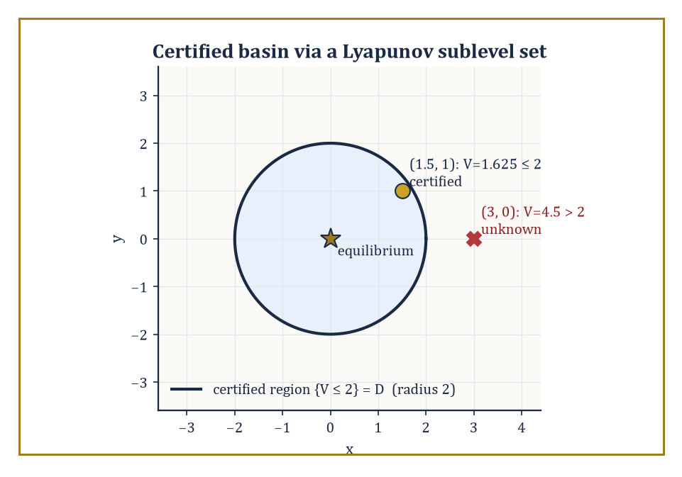
A Lyapunov sublevel set certifying a chunk of the true basin of attraction — one point provably converges, its neighbour is merely unproven.
V̇ = ∇V · f ≤ 0
Think of V as a generalized energy: if it can only fall or stay level, the state can never wander arbitrarily far from where V is small, which is exactly the definition of stability. If V̇ is strictly negative away from the equilibrium, the state is squeezed all the way down to it — asymptotic stability.
Numeric example — Worked example — an energy function that only ever falls. Take the damped oscillator ẋ = y, ẏ = −x − y, and try V(x, y) = (x² + y²)/2.
V̇ = x ẋ + y ẏ = x·y + y·(−x − y) = xy − xy − y² = −y²
This is always ≤ 0 — confirming stability immediately, without solving anything. But notice V̇ is exactly 0 whenever y = 0, even if x ≠ 0, so this test alone does not yet prove the state is pulled all the way to the origin.
at (x, y) = (1, 0): V = 0.5, V̇ = 0
But ẏ = −1 − 0 = −1 ≠ 0, so y is immediately about to become nonzero, and V̇ will immediately become strictly negative again.
at (x, y) = (2, 1): V = 2.5, V̇ = −1² = −1
A genuine decrease. The energy is not monotonically decreasing at every single instant along every direction, but it never increases, which is already enough to certify stability.
LaSalle's invariance principle finishes the job Lyapunov's method left open: when V̇ ≤ 0 but is not strictly negative everywhere, trajectories are guaranteed to converge not to the whole equilibrium set but to the largest invariant subset contained inside {V̇ = 0} — the set of points where equality holds and that the dynamics cannot escape from once entered.
Numeric example — Worked example — LaSalle closes the gap. Continuing the damped oscillator above, {V̇ = 0} is the entire x-axis (y = 0). Is the x-axis itself invariant — can a trajectory stay on it forever?
on y = 0: ẋ = 0, ẏ = −x − 0 = −x
ẋ = 0 is fine — x is momentarily frozen — but ẏ = −x is nonzero whenever x ≠ 0. So any point on the x-axis other than the origin immediately leaves it. The largest invariant subset of {V̇ = 0} is therefore just the single point (0, 0). By LaSalle's principle, every trajectory converges to the origin — full asymptotic stability, recovered even though the raw Lyapunov derivative was only ever ≤ 0 rather than < 0.
An attracting set is a closed invariant set A with a neighbourhood U such that every trajectory starting in U converges to A; the basin of attraction is the union of all such neighbourhoods — every initial condition that eventually ends up at A, however circuitous the route. An attractor, more precisely, is an attracting set that cannot be split into smaller closed invariant pieces each independently attracting a full neighbourhood on its own — it is, so to speak, attracting as one indivisible unit. The global structure of a dynamical system is then simply the partition of the whole phase space into basins, and the attractors sitting at the bottom of each one.
Numeric example — Worked example — two attractors and the knife-edge between their basins. Take the bistable system ẋ = x − x³. Its equilibria solve:
x − x³ = x(1 − x²) = 0, giving x = 0, +1, −1
The derivative is f′(x) = 1 − 3x².
at x = 0: f′ = 1 > 0 (unstable); at x = ±1: f′ = 1 − 3 = −2 < 0 (stable)
So there are two attractors, {+1} and {−1}, each a single stable equilibrium. Their basins are (0, ∞) and (−∞, 0) respectively, separated by the unstable equilibrium at x = 0, whose own 'basin' is the single point 0 — a set of measure zero, meaning a randomly chosen starting point will, with probability one, end up at +1 or −1 and never balance forever on the ridge between them.
checking numerically: at x₀ = 0.1, f(0.1) = 0.1 − 0.001 = 0.099 > 0
So x increases — heading toward +1, exactly as the basin (0, ∞) predicts.
A Lyapunov function rarely certifies stability across the whole of phase space in one go; more often V̇ < 0 can only be verified within some bounded region D surrounding the equilibrium, since the argument that produced it — a Taylor expansion, an inequality that only held for moderate values — quietly stopped being valid further out. In that common case, the largest sublevel set {x : V(x) ≤ c} that still fits entirely inside D gives an explicit, computable underestimate of the true basin of attraction: a region the analyst can certify by arithmetic, even without knowing the real basin's exact — and usually far more generous — shape.
Numeric example — Worked example — certifying a basin you can actually compute. Suppose, for some system with equilibrium at the origin, the energy-like function V(x, y) = (x² + y²)/2 can only be shown to satisfy V̇ < 0 within the disc x² + y² < 4 (beyond that radius the nonlinear terms are no longer dominated, and the sign of V̇ is simply unknown). The largest sublevel set of V fitting inside that disc is found by matching radii: {V ≤ c} is the disc of radius √(2c), so setting:
√(2c) = 2 gives c = 2
The certified region is therefore {(x,y) : x² + y² ≤ 4} — which happens to coincide with D here.
at (1.5, 1): V = (2.25 + 1)/2 = 1.625 ≤ 2
So this point is certified to converge to the origin.
at (3, 0): V = 9/2 = 4.5 > 2
This point lies outside the certified region — it may well still converge (the true basin is very often larger than any sublevel-set estimate), but the Lyapunov argument, applied honestly, is simply silent about it. Knowing the boundary of what one has actually proved, as opposed to what is merely probably true, is most of the discipline in applied stability theory.

Room 46.6: Chaos in One-Dimensional Maps
Where a single multiplication table learns to misbehave
The logistic map is, astonishingly, complicated enough to contain the entire mechanism of chaos, despite being a single quadratic formula with one parameter r.
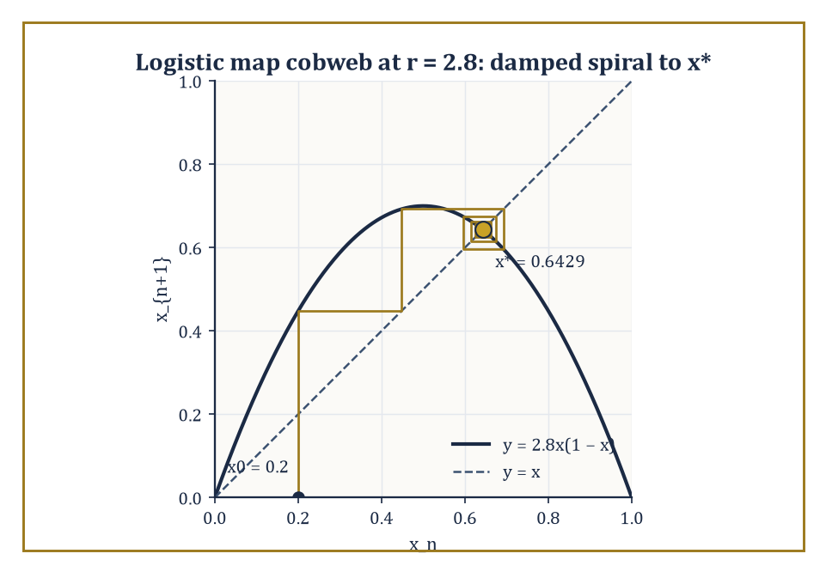
The logistic map at r = 2.8, cobwebbing its way in a damped spiral toward x* ≈ 0.6429 — the alternating convergence a negative derivative always produces.
x_{n+1} = r x_n(1 − x_n)
For small r, every orbit converges to a fixed point. As r increases, that fixed point loses stability and is replaced by a stable period-2 orbit, then period 4, period 8, and so on — a period-doubling cascade — culminating, beyond a critical value, in a regime with sensitive dependence on initial conditions, densely many periodic orbits of every period, and a positive Lyapunov exponent (defined properly in Room 46.7).
The tent map, a simpler piecewise-linear cousin, exhibits the same phenomena with arithmetic simple enough to do by hand, which is why it is the textbook's favourite training wheel.
Numeric example — Worked example — converging to a fixed point at r = 2.8. For the logistic map with r = 2.8, the nonzero fixed point solves for x*.
x* = 2.8x*(1 − x*)
Solving gives x* explicitly.
x* = 1 − 1/2.8 = 0.642857
Its derivative is f′(x) = r(1 − 2x), which simplifies at the fixed point to the following.
f′(x*) = 2 − r = 2 − 2.8 = −0.8
This value is comfortably inside the unit circle, so x* is stable. Iterating from x₀ = 0.2 gives the sequence of values below.
x₁ = 2.8(0.2)(0.8) = 0.448
x₂ = 2.8(0.448)(0.552) ≈ 0.6924
x₃ = 2.8(0.6924)(0.3076) ≈ 0.5963
x₄ = 2.8(0.5963)(0.4037) ≈ 0.6740
x₅ ≈ 0.6152
x₆ ≈ 0.6628
The values oscillate back and forth while creeping toward x* ≈ 0.6429 — exactly the damped, alternating convergence a negative derivative of magnitude 0.8 predicts.
Increase r past 3 and the fixed point's derivative crosses −1, the threshold beyond which even the smallest oscillation is amplified rather than damped: the fixed point ejects a stable period-2 orbit in its place. Further increases repeat the trick — period 2 destabilizes into period 4, then 8, then 16 — with the bifurcations accumulating at r∞ ≈ 3.569946, beyond which lies a tangled zone of chaos interrupted by narrow periodic windows.
Remarkably, the ratio of successive parameter gaps between bifurcations tends to a universal constant, δ ≈ 4.6692 (Feigenbaum's constant), that reappears in an enormous range of unrelated one-parameter families of maps sharing only a single smooth quadratic-like maximum — a piece of order lurking directly inside the onset of disorder.
Numeric example — Worked example — catching the exact bifurcation point. At r = 3, the fixed point formula gives x* explicitly.
x* = 1 − 1/3 = 2/3
Its derivative is the following.
f′(x*) = 2 − r = 2 − 3 = −1
This sits precisely on the boundary between stability and instability, confirming by direct hand calculation that r = 3 is exactly the threshold at which the period-1 fixed point hands off to a period-2 orbit. No numerical search was needed; the formula 2 − r = −1 pins the transition down to the decimal.
Sharkovskii's theorem orders all the positive integers into a single, strange total order — 3, then 5, 7, 9, ... (all odd numbers beyond 1), then 2·3, 2·5, 2·7, ..., then 4·3, 4·5, ..., then higher and higher powers of 2 times odd numbers, and only at the very end, 2ⁿ, ..., 8, 4, 2, 1 — such that if a continuous map of an interval has a periodic orbit of period p, it is guaranteed to have periodic orbits of every period q that comes later than p in this order.
Since 3 sits right at the front, the existence of a period-3 orbit forces periodic orbits of every possible period simultaneously — the celebrated 'period three implies chaos' theorem of Li and Yorke, which further guarantees uncountably many aperiodic orbits alongside them.
Abstract example — Worked example — the period-3 window forces everything else. In the logistic map's bifurcation diagram, a visually striking period-3 window opens near r ≈ 3.83, in the middle of the otherwise chaotic region beyond r∞.
By Sharkovskii's theorem, the mere presence of that period-3 orbit at r ≈ 3.83 forces the coexistence of periodic orbits of every other period — 1, 2, 4, 5, 6, 7, and so on, all present at once inside the same map — together with uncountably many orbits that never repeat at all.
A single observed period-3 cycle is, in this precise sense, a certificate of total combinatorial chaos, without needing to hunt down any of the other periods individually.
Symbolic dynamics makes this combinatorial richness explicit by conjugating a chaotic map to the shift map on sequences of symbols: record, at each iterate, which region of the interval the point currently occupies (say, symbol 0 for the left half, symbol 1 for the right), and the resulting infinite sequence of symbols evolves under iteration exactly the way the shift map evolves an infinite sequence — by deleting the first symbol and moving everything else one place to the left.
The doubling map, and the logistic map at r = 4 (related to it by a smooth change of variables), are the cleanest possible illustrations, since their symbolic itinerary is literally the binary expansion of the starting point.
Numeric example — Worked example — the shift map made completely literal. The doubling map on [0, 1) is exactly the shift map on binary digits.
θ_{n+1} = 2θ_n (mod 1)
Take θ₀ = 5/8, whose binary expansion is 0.101 (since 1/2 + 1/8 = 0.625).
θ₀ = 5/8 = 0.625
Iterating gives the following steps.
θ₁ = 2(0.625) mod 1 = 1.25 mod 1 = 0.25
This is 0.01 in binary — precisely the digits of 0.101 with the leading 1 deleted and everything shifted left.
θ₂ = 2(0.25) = 0.5
That's binary 0.1 — again the leading digit of 0.01 dropped.
θ₃ = 2(0.5) mod 1 = 0
Binary 0.000... — the last digit dropped, leaving nothing.
5/8 → 1/4 → 1/2 → 0 → 0 → ...
The whole orbit is nothing but the binary digits of the starting point being read off and discarded one at a time. A rational starting point like 5/8 has a finite (or eventually repeating) binary expansion and so gives an eventually periodic orbit; an irrational starting point has a binary expansion that never repeats, and its orbit under the doubling map is correspondingly non-repeating and, in the technical sense of this room, chaotic.

Room 46.7: Strange Attractors and Lyapunov Exponents
Measuring exactly how fast the universe forgets your starting guess
A strange attractor is an attracting invariant set that is neither a finite collection of equilibria nor a periodic orbit (nor a finite union of tori) — it is a genuinely new kind of long-term destination, typically possessing a fractal, non-integer geometry and exhibiting sensitive dependence on initial conditions within it.
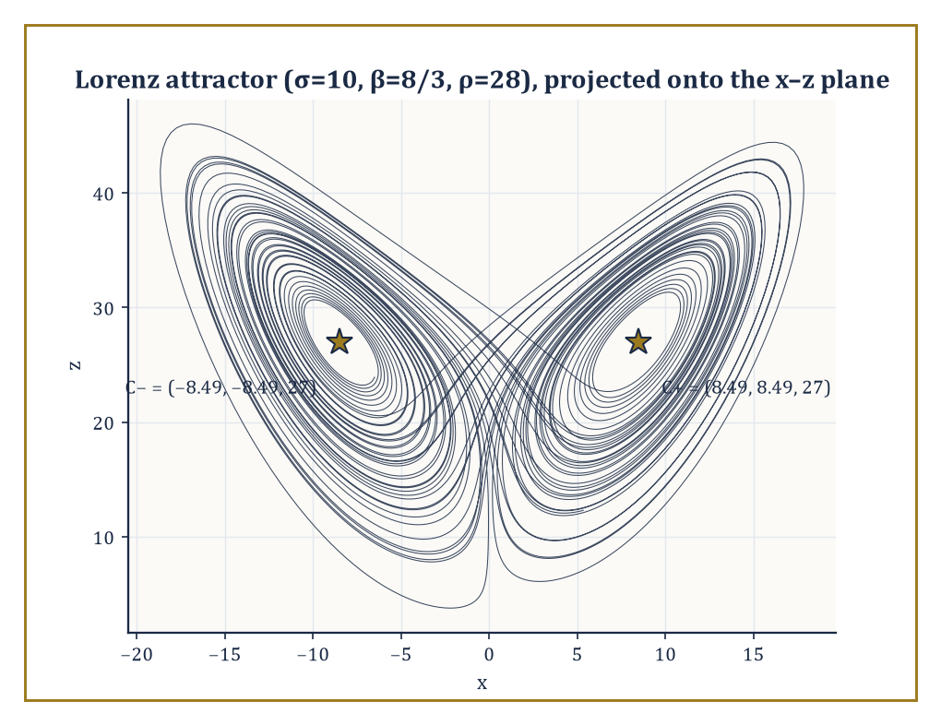
The Lorenz attractor at the classic parameters, winding forever around its two ghost equilibria without ever once repeating a loop.
The Lorenz attractor, born from a drastically simplified three-variable model of atmospheric convection, and the Hénon attractor, its two-dimensional discrete-map cousin, are the two classic exhibits — objects one can stare at for years and never see repeat a single loop.
Abstract example — Worked example — locating the Lorenz equilibria. The Lorenz system is given by the following equations, with the classic parameters σ = 10, β = 8/3, ρ = 28.
ẋ = σ(y − x)
ẏ = x(ρ − z) − y
ż = xy − βz
Setting all derivatives to zero, the first equation gives:
σ(y − x) = 0 gives y = x
Substituting y = x into the second equation gives:
x(ρ − z) − y = 0 with y = x gives x(ρ − z − 1) = 0
So either x = 0 or z = ρ − 1 = 27. Substituting y = x into the third equation gives:
xy − βz = 0 with y = x gives x² = βz
Taking the nonzero branch z = 27:
x² = β(27) = (8/3)(27) = 72
x = ±√72 = ±6√2 ≈ ±8.485
This gives two symmetric equilibria C± = (±8.485, ±8.485, 27) alongside the origin.
At ρ = 28, both C± have already turned unstable (through a subcritical bifurcation), and it is around this pair of ghost equilibria that the famous butterfly-shaped attractor winds, switching between the two wings in a pattern that never exactly repeats despite the equations themselves containing not one grain of randomness.
The Lyapunov exponent measures the average exponential rate at which two initially close trajectories separate: for a small perturbation δx(0) evolved under the linearized (variational) flow,
λ = lim_{t→∞} (1/t) ln(|δx(t)| / |δx(0)|)
A positive largest exponent, λ₁ > 0, is the precise quantitative signature of chaos: it means nearby states, no matter how close, are pulled apart exponentially fast, so that any uncertainty in the initial measurement — however tiny — grows to swamp the whole system within a predictable 'horizon time' of roughly 1/λ₁, after which the two trajectories are, for practical purposes, unrelated strangers.
Numeric example — Worked example — an exactly computable Lyapunov exponent. The doubling map θ ↦ 2θ (mod 1) has derivative exactly 2 at every point (away from the measure-zero set of boundary points).
So after n iterations a small initial perturbation δθ₀ has grown, by the chain rule, to:
2ⁿ δθ₀
The Lyapunov exponent is therefore:
λ = lim_{n→∞} (1/n) ln(2ⁿ) = ln 2 ≈ 0.6931
This is a positive number computed exactly, no approximation required.
This gives a concrete predictability horizon: losing one decimal digit of accuracy takes about the following number of iterations.
ln 10 / ln 2 ≈ 3.32
Concretely, perturb θ₀ = 0.5 by δ = 10⁻⁶.
After 20 iterations the perturbation has grown by a factor of:
2²⁰ = 1,048,576
So the two orbits — which started closer together than a millionth of the interval — now differ by roughly:
10⁻⁶ × 1,048,576 ≈ 1.05
That is, they are completely decorrelated, anywhere on the unit interval relative to each other. That is sensitive dependence, stated as an arithmetic fact rather than a meteorological metaphor.
For an n-dimensional flow there is a full spectrum of exponents λ₁ ≥ λ₂ ≥ ... ≥ λ_n, one for each independent direction, and the Kaplan–Yorke conjecture converts this spectrum into an estimate of the attractor's fractal (Lyapunov) dimension:
D_KY = k + (λ₁ + ... + λ_k)/|λ_{k+1}|
Here k is the largest number of leading exponents whose sum is still non-negative.
This sidesteps the famously painful business of literally trying to count boxes over a fractal shape, replacing it with an ordinary sum of numbers already computed for other reasons.
Numeric example — Worked example — the fractal dimension of the Lorenz attractor. At the classic Lorenz parameters, the numerically established Lyapunov spectrum is approximately λ₁ ≈ 0.906, λ₂ ≈ 0 (the flow direction along any non-equilibrium trajectory always contributes exactly one zero exponent), and λ₃ ≈ −14.57.
As a sanity check, the sum of all three exponents should equal the average divergence of the vector field, which for the Lorenz system is the constant:
−(σ + 1 + β) = −(10 + 1 + 8/3) ≈ −13.667
Indeed:
0.906 + 0 − 14.57 = −13.664
This matches closely.
Taking k = 2 (since λ₁ + λ₂ ≈ 0.906 ≥ 0, but adding λ₃ would make the running sum negative):
D_KY = 2 + (0.906 + 0)/14.57 ≈ 2 + 0.0622 ≈ 2.062
This is the widely quoted fractal dimension of the Lorenz attractor — a set with 'more structure than a surface but nowhere near the bulk of a solid,' which is exactly the kind of object the word 'strange' was coined to describe, and exactly the kind of number ('two point oh-six dimensions') that makes geometry teachers reach for the sherry.

Room 46.8: Bifurcations
The calculus of a phase portrait changing its mind
A bifurcation is a qualitative change in the phase portrait as a parameter is varied — not just a shift in where an equilibrium sits, but a change in how many equilibria there are, or what type they are.
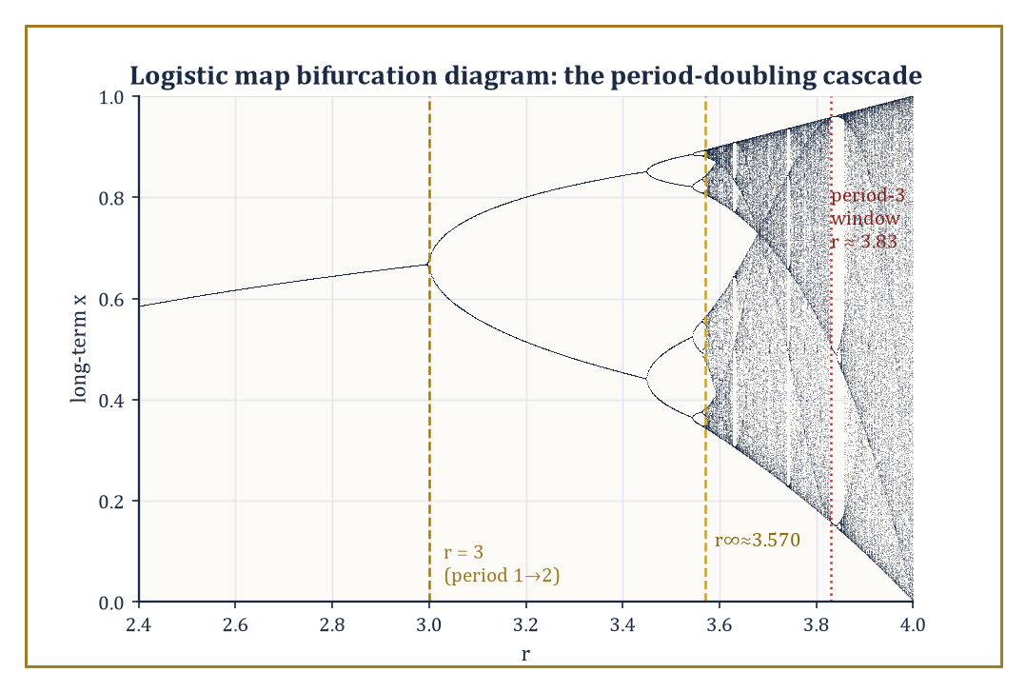
The single most reproduced picture in nonlinear dynamics: the logistic map's period-doubling cascade, accumulating at r∞ and thinning briefly at the period-3 window.
The codimension-one local bifurcations of equilibria (meaning: generic, requiring only one parameter to tune) come in four standard flavours: saddle-node (a pair of equilibria, one stable and one unstable, collide and annihilate each other, or are born together from nothing), transcritical (two equilibria pass through one another, trading stability as they cross), pitchfork (occurring in systems with a symmetry, where one equilibrium splits into three), and Hopf (an equilibrium loses stability by ejecting a small periodic orbit, as a complex-conjugate pair of eigenvalues crosses the imaginary axis).
Numeric example — Worked example — a saddle-node bifurcation, equilibria appearing and vanishing. Take the canonical normal form:
ẋ = μ + x²
For μ < 0, equilibria solve
x² = −μ
x = ±√(−μ)
At μ = −1, this gives
x = ±1
The derivative is
f′(x) = 2x
so at each equilibrium:
f′(+1) = 2 > 0 (unstable)
f′(−1) = −2 < 0 (stable)
— one stable, one unstable equilibrium, as promised.
At μ = 0, the two equilibria have merged into a single non-hyperbolic point at x = 0, since
f′(0) = 0
At μ = +1, the equation
ẋ = 1 + x²
is strictly positive for every real x, so there is no equilibrium anywhere — the pair has collided and annihilated completely, and the flow simply sweeps every point rightward, forever. Watching μ go from −1 to 0 to +1 is watching two equilibria approach, merge, and vanish, in three lines of arithmetic.
The pitchfork bifurcation is the symmetric cousin, appearing when the governing equation is odd in x (unchanged, up to sign, under x ↦ −x) — the same symmetry that produced the two-attractor bistable example back in Room 46.5, now with the splitting parameter made explicit.
Numeric example — Worked example — a pitchfork opening as the parameter grows. Take the normal form:
ẋ = μx − x³
The equilibria are x = 0 always, together with
x² = μ, so x = ±√μ, whenever μ > 0
The derivative is
f′(x) = μ − 3x²
so at the origin:
f′(0) = μ
meaning the origin is stable for μ < 0 and unstable for μ > 0.
At μ = 4, the two new equilibria sit at x = ±2, and
f′(±2) = 4 − 3(4) = 4 − 12 = −8 < 0
confirming both are stable. So as μ crosses 0, the single stable equilibrium at the origin turns unstable and simultaneously spawns two new stable equilibria straddling it symmetrically — exactly the μ = 1 case of this same family (equilibria 0 and ±1) already examined as a bistable system in Room 46.5, now recognisable as one snapshot of a whole bifurcating family rather than an isolated curiosity.
Global bifurcations involve the collision of invariant sets that are not confined to a single neighbourhood, and so cannot be seen by linearizing at any one equilibrium.
A homoclinic tangency occurs when a trajectory leaving a saddle equilibrium loops around and returns to that very same saddle; as a parameter varies, such loops can develop tangencies that, on crossing, create or destroy entire chaotic invariant sets (horseshoes) in one stroke.
A blue-sky catastrophe is the equally dramatic case where a periodic orbit's period stretches to infinity as it collides with a homoclinic loop, and the orbit itself disappears — from the perspective of anyone watching only a bounded region, apparently into empty air.
Bifurcation diagrams — the parameter plotted horizontally, the long-term values (equilibria, periodic points, or chaotic bands) plotted vertically for each parameter value — compress an entire family's worth of qualitative behaviour into a single image, and are the field's principal computational and expository tool.
Abstract example — Worked example — one picture, the whole cascade. The logistic map's bifurcation diagram (r along the horizontal axis from 0 to 4, the long-term iterates plotted vertically for each r) is precisely the period-doubling cascade of Room 46.6 rendered as a single image: a single stable branch splits into two at r = 3, splits again at the next threshold, then again, the splittings accumulating at r∞ ≈ 3.569946, after which the picture dissolves into a chaotic haze.
This chaotic haze is interrupted by clean, narrow periodic windows, the period-3 window near r ≈ 3.83 chief among them, visible as a sudden thinning of the haze into three sharp branches before it thickens back into chaos.
It is, at once, a bifurcation diagram, a portable chaos detector, and very probably the single most reproduced picture in the whole of nonlinear dynamics — which is either a great compliment to the logistic map or a damning indictment of how few pictures the rest of us have bothered to draw.

Room 46.9: Looking Ahead: From Classical Dynamics to Ergodic Theory, Hyperbolicity, and Applications
Packing for the rest of the journey
We have now acquired the working core of dynamical systems and chaos: flows and maps as the two grammars of time evolution, linearization and the Hartman–Grobman theorem for the local picture near an equilibrium, Poincaré maps and Floquet multipliers for periodic orbits, Lyapunov's method and LaSalle's principle for certifying long-term convergence, one-dimensional maps as the cleanest laboratory for chaos itself, strange attractors and Lyapunov exponents as its geometric and quantitative signatures, and bifurcation theory as the calculus of how all of the above can change discontinuously as a parameter is tuned.
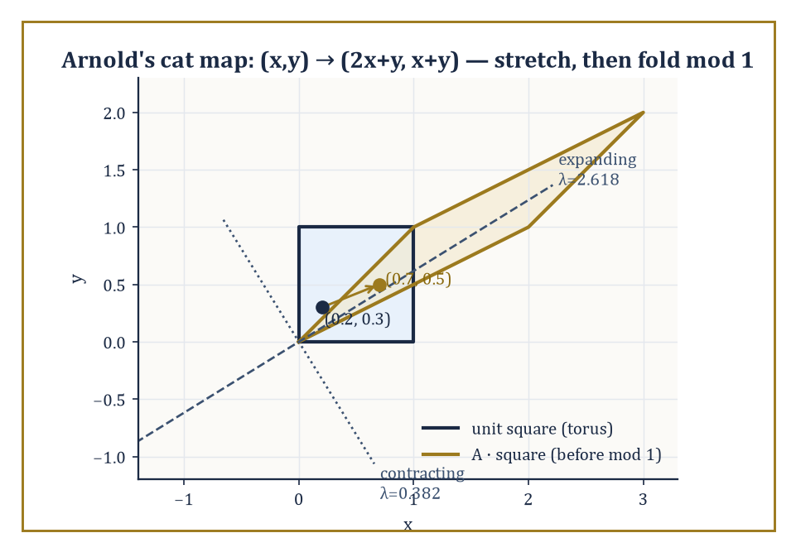
Arnold's cat map stretching the unit square along its expanding eigendirection before the mod-1 fold sends it back onto the torus — hyperbolicity at every single point, taken completely literally.
That is a respectable amount of luggage for one storey, and rather more than most of us manage to pack for a fortnight abroad.
These tools open directly onto hyperbolic theory, which asks what happens when the local hyperbolicity of Room 46.3 (stable and unstable directions, no lingering center directions) holds not just at isolated equilibria but at every single point of the phase space simultaneously — a condition called being Anosov, or, in a slightly relaxed form allowing periodic orbits and equilibria too, Axiom A.
Such systems are the best-behaved chaotic systems known: provably structurally stable (their qualitative picture survives perturbation, unlike the fragile bifurcation points of Room 46.8) despite being chaotic everywhere at once.
Numeric example — Worked example — Arnold's cat map, hyperbolic at every point simultaneously. Consider the map on the unit torus,
(x, y) ↦ (2x + y, x + y) (mod 1)
with matrix
A = [[2, 1], [1, 1]]
Its determinant is
2(1) − 1(1) = 1
(so the map preserves area exactly), and its trace is
2 + 1 = 3
giving the characteristic equation
λ² − 3λ + 1 = 0
with roots
λ = (3 ± √5)/2 ≈ 2.618 and 0.382
— one eigenvalue expanding, one contracting, their product exactly 1 as the determinant demands. Because the matrix is constant, these same two eigenvalues govern the map at every single point of the torus: this is Anosov hyperbolicity taken completely literally.
Watching a point move: starting at (0.2, 0.3), one iteration gives
(2(0.2)+0.3, 0.2+0.3) = (0.7, 0.5)
a second iteration gives
(2(0.7)+0.5, 0.7+0.5) mod 1 = (1.9, 1.2) mod 1 = (0.9, 0.2)
The 'mod 1' wraparound folds the torus back onto itself at every step, and it is this folding — combined with the underlying stretching by a factor of 2.618 — that produces genuine chaos out of a map that is, underneath the wraparound, entirely linear.
Ergodic theory, meanwhile, gives up on tracking individual orbits altogether and instead asks statistical questions: is there an invariant probability measure μ on phase space — one left completely unchanged by the dynamics — with respect to which one can speak of the 'typical' long-term behaviour of almost every orbit?
Birkhoff's ergodic theorem is the payoff: for such a measure, the time average of a quantity along almost every individual trajectory equals its space average against μ, converting an impossibly complicated infinite orbit into a single computable number.
Entropy then quantifies how fast the system generates new, unpredictable information with each step — a statistical cousin of the Lyapunov exponent from Room 46.7, viewed through the lens of probability rather than geometry.
Numeric example — Worked example — checking measure invariance directly. The doubling map
θ ↦ 2θ (mod 1)
preserves ordinary Lebesgue measure — length, in other words — which can be checked directly rather than taken on faith.
Take the interval [0, 0.3); its preimage under the doubling map consists of every θ mapping into it, namely θ ∈ [0, 0.15) (which doubles, without wraparound, straight into [0, 0.3)) together with θ ∈ [0.5, 0.65) (which doubles to [1, 1.3), and mod 1 lands exactly back in [0, 0.3)).
The total length of the preimage is
0.15 + 0.15 = 0.3
exactly matching the length of the original interval [0, 0.3) — confirming, by one concrete computation, that the map neither inflates nor deflates length on average, which is exactly what 'Lebesgue measure is invariant' means in practice.
From here the subject fans out in every direction: the thermodynamic formalism recasts ergodic theory in the language of statistical mechanics; physics contributes turbulence and celestial mechanics (the three-body problem that started much of this field in the first place); biology contributes population dynamics and neuroscience; engineering contributes vibration analysis and climate modelling; and delay equations, partial differential equations, and other infinite-dimensional systems extend the entire framework to phase spaces that are no longer merely high-dimensional but properly infinite.
The deeper lesson of this storey is not that the universe is secretly random — it manifestly is not, not in any of the systems we have examined — but that simple deterministic rules, iterated patiently enough, can generate behaviour so intricate that it is, for every practical purpose, indistinguishable from randomness, while still admitting a precise geometric and statistical description for anyone willing to do the bookkeeping.
So: deterministic rules can produce unpredictable futures, and we now know precisely what that sentence is allowed to mean. Not 'anything could happen' — the trajectory is still pinned down exactly, for all time, by its starting point and the rule — but 'no finite amount of measurement precision will let you say what happens next, past a horizon set by a number (the Lyapunov exponent) you can, with sufficient patience, actually compute.' It is one of the tidier ironies available in mathematics: total lawfulness and total unpredictability turn out to be entirely compatible, and the proof fits in a phase portrait.
There is, inevitably, a small existential moral lurking underneath the fractals: most systems worth caring about — the weather, an ecosystem, an economy, several of the author's own attempts at long-term planning — sit somewhere on this spectrum between 'boringly predictable' and 'chaotically unknowable,' and the mathematics developed here is precisely the toolkit for finding out which. It will not make the forecast come true. It will, at least, tell you honestly how far ahead you are allowed to trust yourself, which is more than most forecasting can promise.
Ahead lies Mathematical Physics, and the flows we have spent this storey drawing as abstract arrows in an abstract phase space are about to be revealed as nothing less than the equations of motion of the physical world itself — planets, pendulums, fields, and the occasional genuinely cosmic-scale strange attractor. The geometry stays exactly the same; only the stakes go up.
The tower continues upward.

Storey 47: Mathematical Physics
From Classical Mechanics to Quantum Theory, and the Art of Modeling the Physical World
The last storey left the Tower in a slightly undignified state: watching a system with no randomness whatsoever — no dice, no noise, nothing but a differential equation and an honest initial condition — generate behaviour so sensitive to its own starting point that predicting it became, for practical purposes, as hopeless as reading tea leaves. Lorenz's attractor, the Lyapunov exponents totting up how fast your ignorance compounds, the whole cheerful business of chaos: it was a masterclass in humility, administered by mathematics to anyone who ever thought 'deterministic' was a synonym for 'predictable'.
This storey turns that humility to a rather different use. If dynamical systems taught us what can go wrong once you've written down an equation of motion, mathematical physics is the discipline that had the nerve to write the equation down in the first place — to look at the actual universe (planets wheeling about the sun, electrons refusing to have a definite position, spacetime bending under the weight of stars) and assert, calmly, that it obeys laws precise enough to state as mathematics and rich enough to reward the effort of solving them. It is not experimental physics, which measures; it is not pure mathematics, which is under no obligation to describe anything real. It is the bridge between the two, built out of the analytic, geometric, algebraic, and probabilistic machinery assembled in every storey below this one.
The route runs from the variational principles of classical mechanics, through the intrinsic geometry of phase space, through continuum theories of matter and the four deceptively short equations that govern electricity and magnetism, out into the four-dimensional geometry of relativity — special first, then the considerably more demanding general theory — and finally down into the operator-theoretic strangeness of quantum mechanics, where tools built for spectral theory turn out to have been, all along, a theory of measurement. A small confession, worth stating plainly before we begin: mathematical physics is the one subject in the Tower where the line between 'mathematics motivated by physics' and 'physics expressed as mathematics' is deliberately, permanently smudged. The same symplectic manifold is a phase space to a physicist and a geometric object to a mathematician; the same self-adjoint operator is an observable to one and a spectral problem to the other. Nobody here is trying to resolve the ambiguity. The ambiguity is the point.
Once the laws of nature are written down, of course, somebody eventually wants to use them — to find the trajectory that costs least fuel, the shape that costs least material, the decision that costs least regret. That is a problem for the next storey, which turns from describing the world to improving our choices within it. But that is optimisation's job, not physics's. Ours, for now, is simply to write the laws of nature in mathematical form, and to mean it.

Room 47.1: What Mathematical Physics Actually Is
Or: the discipline that refuses to pick a side
Mathematical physics is the discipline that formulates physical laws in precise mathematical language and then extracts their consequences by mathematical reasoning — not by squinting at an apparatus, and not by intuition alone, but by proof, or at least by argument sufficiently careful to deserve the name.
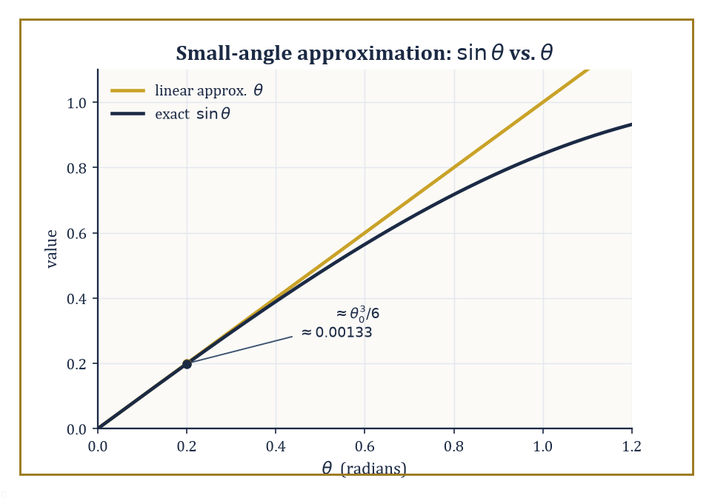
The bold simplification (θ) and the honest function (sin θ), with Taylor's theorem keeping score of exactly how far apart they are.
It is neither pure mathematics, which cares not a jot whether its objects correspond to anything you could drop on your foot, nor experimental physics, which cares about little else.
It occupies the increasingly crowded middle ground: the belief, which is either wildly optimistic or the only sane position available, that the universe runs on rules simple enough to write down and precise enough to compute with.
The subject spans a startling range of rigour. At one end sits the fully proved: the spectral theorem for self-adjoint operators, the classification of Lie groups underlying gauge symmetry, the existence and uniqueness theory for well-behaved wave equations.
At the other end sits the pragmatically rigorous — formal calculations, performed by physicists with an excellent nose for which manipulations are safe, that produce correct and testable predictions long before a mathematician manages to justify them fully.
The existence and smoothness of solutions to the Navier–Stokes equations in three dimensions remains open — one of the seven Clay Millennium Prize Problems, and arguably the only one you could, in principle, disprove by watching a kettle boil in a sufficiently pathological way. The mathematical foundations of quantum field theory are, at the time of writing, still incomplete, which has not stopped that theory from predicting the electron's magnetic moment to ten significant figures.
Both styles have a place in this storey; the formal calculation and the existence proof are not rivals so much as colleagues who occasionally turn up to the same seminar in rather different degrees of dress.
Numeric example — A pragmatic approximation, made rigorous. Consider a simple pendulum of length L = 1 metre, swinging under gravity g = 9.8 m/s². Its exact equation of motion is:
θ'' + (g/L) sin θ = 0
a perfectly respectable nonlinear ODE with no closed-form solution in elementary functions (its solutions are elliptic integrals, which is mathematics's polite way of saying 'go away').
The physicist's instinct, for small swings, is to replace sin θ by θ, giving the linear equation:
θ'' + (g/L) θ = 0
with angular frequency:
ω = √(g/L) = √9.8 ≈ 3.1305 rad/s
and period:
T = 2π/ω ≈ 2.007 seconds
Is this legitimate? Taylor's theorem says yes, and tells you exactly how legitimate. Since:
sin θ = θ − θ³/6 + O(θ⁵)
the error introduced at amplitude θ₀ = 0.2 radians (about 11.5°) is θ₀ − sin θ₀, which is approximately:
θ₀³/6 = (0.2)³/6 = 0.008/6 ≈ 0.00133 radians
a relative error of about θ₀²/6 ≈ 0.0067, roughly two-thirds of one percent.
Direct computation confirms it:
sin(0.2) = 0.19867, and 0.2 − 0.19867 = 0.00133
exactly as promised. That is the whole method of 'pragmatic' mathematical physics in miniature: make the bold simplification first, because it's the equation you can actually solve, then let a rigorous remainder estimate tell you, afterwards, precisely how much you were allowed to get away with.
Every earlier storey of this Tower supplied a tool; mathematical physics is where the tools finally get used in anger.
Real and complex analysis furnish the differential equations. Differential geometry furnishes the curved spaces on which those equations live.
Functional analysis — Hilbert spaces, spectral theory, operator theory — furnishes almost the entire apparatus of quantum mechanics, largely unchanged from its pure-mathematical form. Group theory furnishes the symmetries that Noether's theorem converts into conservation laws.
None of these connections is superficial; each is load-bearing, in the sense that removing it collapses the storey built on top of it.
Abstract example — Where the machinery comes from. Take one thread and follow it end to end. An earlier storey on functional analysis proved the spectral theorem: every self-adjoint operator A on a Hilbert space H admits a spectral decomposition:
A = ∫ λ dE(λ)
where E is a projection-valued measure supported on the real spectrum of A. At the time it was proved, this was a statement purely about operators — abstract, elegant, and to all appearances physics-free.
Room 47.8 of this storey will hand you the postulates of quantum mechanics, and the very first one reads: every physical observable is represented by a self-adjoint operator, and the possible outcomes of measuring it are exactly the points of that operator's spectrum.
The spectral theorem, proved with no physical intention whatsoever, turns out to be the precise mathematical reason measured quantities in quantum mechanics come out real, and why repeated measurement of the same quantity on the same state is statistically well-defined.
Nobody designed it that way. It was simply waiting.
There is a famous phrase for this state of affairs, coined by the physicist Eugene Wigner in 1960: 'the unreasonable effectiveness of mathematics in the natural sciences.' Wigner's puzzle was precisely why mathematical structures developed with no thought of physical application — complex numbers, matrix algebra, non-Euclidean geometry — turn out again and again to be exactly the right language for a physical theory decades or centuries later.
Mathematical physics does not resolve Wigner's puzzle so much as live inside it permanently, treating the coincidence as a working method rather than a mystery to be settled before proceeding.
Abstract example — A structure invented for algebra, later needed for physics. Complex numbers were introduced in the sixteenth century purely to make Cardano's formula for solving cubic equations work in cases where it produced square roots of negative numbers even though the final answer was a perfectly ordinary real number — a piece of algebraic bookkeeping that mathematicians of the time treated with open suspicion (Descartes coined the term 'imaginary' as an insult, and it stuck).
Three centuries later, Schrödinger's equation has an i sitting in it that cannot be removed by any change of variables:
iħ ∂ψ/∂t = Ĥψ
Quantum mechanics is not merely convenient to write with complex numbers, it is false without them, since a real-valued wavefunction cannot reproduce the interference and probability-conservation properties actually observed in experiment.
A tool built to tidy up cubic equations turned out, entirely unrequested, to be load-bearing for the whole of quantum theory.
With the philosophical throat-clearing out of the way, we can begin building. The natural starting point — the one every physicist meets first and never quite gets over — is the variational principle: the striking claim that a particle moving from A to B chooses, among all conceivable paths, the one that makes a certain integral stationary.
That is the subject of the next room.

Room 47.2: Lagrangian and Hamiltonian Mechanics
Two ways of being right about the same ball
Classical mechanics, in its Newtonian form, tells you to write down forces and solve:
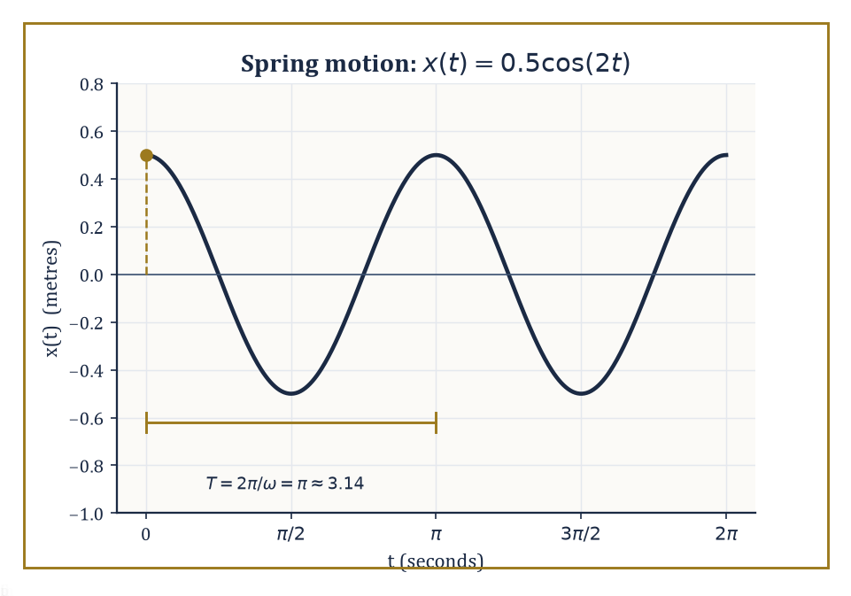
The mass-on-a-spring's motion, x(t) = 0.5 cos(2t), recovered from the Euler–Lagrange equation without ever mentioning a force.
F = ma
The Lagrangian formulation asks a stranger question: among all the paths a system could conceivably take from its state at time t₁ to its state at time t₂, which one does it actually take?
The answer, due to Euler, Lagrange, and (in its full generality) Hamilton, is that nature chooses the path making the action stationary:
S = ∫[t₁,t₂] L(q, q̇, t) dt
Here L = T − V is the Lagrangian — kinetic energy minus potential energy, expressed in generalized coordinates q and generalized velocities q̇. 'Stationary' does not mean 'minimal', despite the traditional name 'principle of least action'; saddle points are allowed, and in several standard examples the true path is a saddle, not a minimum, of the action.
Applying the calculus of variations (built in an earlier storey) to this stationarity condition produces the Euler–Lagrange equations, one for each coordinate:
d/dt(∂L/∂q̇) − ∂L/∂q = 0
These are exactly equivalent to Newton's equations of motion — but written in a form that survives a change of coordinates unscathed, incorporates constraints gracefully, and generalizes without modification to fields, relativity, and quantum theory in ways F = ma never could.
Numeric example — The Lagrangian of a spring. Take a mass m = 2 kg on a spring of stiffness k = 8 N/m, sliding on a frictionless line, with position x.
Kinetic energy is T = ½mẋ² and potential energy is V = ½kx², so the Lagrangian is, after substituting the numbers:
L = ½mẋ² − ½kx² = ẋ² − 4x²
Compute the two pieces of the Euler–Lagrange equation. First:
∂L/∂ẋ = mẋ = 2ẋ, so d/dt(∂L/∂ẋ) = 2ẍ
And second:
∂L/∂x = −kx = −8x
The equation d/dt(∂L/∂ẋ) − ∂L/∂x = 0 then gives:
2ẍ − (−8x) = 0, i.e. 2ẍ + 8x = 0, i.e. ẍ = −4x
That is exactly Newton's second law for a spring, F = −kx = ma, recovered without ever writing down a force.
Solving ẍ = −4x with initial conditions x(0) = 0.5 m and ẋ(0) = 0 gives angular frequency:
ω = √(k/m) = √4 = 2 rad/s
and solution:
x(t) = 0.5 cos(2t)
Check the solution by differentiating twice:
x'(t) = −1·sin(2t), so x''(t) = −2cos(2t)
and comparing against −4x(t):
−4x(t) = −4(0.5cos 2t) = −2cos(2t)
They agree, confirming the solution.
The Lagrangian lives on velocity space; the Hamiltonian formulation moves house to phase space, coordinatized by positions q and momenta p, where the momentum conjugate to q is defined as:
p = ∂L/∂q̇
The transition — replacing q̇ by p as the independent variable — is a Legendre transform, the same operation that turns a convex function's graph into the graph of its dual, familiar from thermodynamics and convex analysis.
The Hamiltonian itself is, re-expressed entirely in q and p:
H(q,p) = pq̇ − L
For the ordinary mechanical systems met in this room it works out to be simply the total energy, T + V, written in momentum rather than velocity.
The payoff is Hamilton's equations — a first-order system, twice the dimension of the Lagrangian's second-order one:
q̇ = ∂H/∂p and ṗ = −∂H/∂q
These are strikingly symmetric, and, as the next room will show, the natural flow of a geometric structure on phase space in its own right.
Numeric example — The same spring, in phase space. Continuing the spring above, the conjugate momentum is:
p = ∂L/∂ẋ = mẋ = 2ẋ, so ẋ = p/2
The Legendre transform then gives:
H = pẋ − L = p(p/2) − [½(2)(p/2)² − 4x²] = p²/2 − p²/4 + 4x² = p²/4 + 4x²
In general form this is H = p²/(2m) + ½kx², which for m = 2, k = 8 gives exactly p²/4 + 4x², as computed.
Check that Hamilton's equations reproduce the same motion. First:
q̇ = ∂H/∂p = p/2
matching ẋ = p/2 above. Second:
ṗ = −∂H/∂q = −8x
while p = 2ẋ means ṗ = 2ẍ, giving:
2ẍ = −8x, i.e. ẍ = −4x
the identical equation of motion, arrived at from the opposite direction.
Now track the energy. At t = 0: x = 0.5, ẋ = 0, so p = 0, and:
H(0) = 0²/4 + 4(0.5)² = 1 joule
At t = π/4 (a quarter period later), x(π/4) = 0.5cos(π/2) = 0, and p(π/4) = 2ẋ(π/4) = 2(−1·sin(π/2)) = −2, so:
H(π/4) = (−2)²/4 + 4(0)² = 1 joule
The energy agrees at both instants, as it must, since H has no explicit time dependence and Hamilton's equations guarantee dH/dt = 0 along any trajectory.
Phase space carries an algebraic structure beyond simply being a space of pairs (q,p): the Poisson bracket, defined for functions f and g on phase space as:
{f,g} = ∂f/∂q · ∂g/∂p − ∂f/∂p · ∂g/∂q
Hamilton's equations can be rewritten compactly using this bracket:
q̇ = {q,H} and ṗ = {p,H}
More generally, the time evolution of any observable f along the flow is ḟ = {f,H}.
Canonical transformations are exactly the changes of coordinates on phase space that preserve every Poisson bracket — the symmetries of the Hamiltonian formalism, in the same sense isometries are the symmetries of a metric space.
This bracket is not decorative: it is the classical shadow of the commutator that governs quantum mechanics, and the resemblance is not a coincidence, as Room 47.8 will make embarrassingly explicit.
Abstract example — The fundamental bracket. Compute {x,p} directly from the definition, treating x and p as the two functions on phase space:
{x,p} = ∂x/∂x · ∂p/∂p − ∂x/∂p · ∂p/∂x = (1)(1) − (0)(0) = 1
This single number, {x,p} = 1, is the entire algebraic content of classical mechanics' phase space — every other bracket among polynomials in q and p can be built from it using bilinearity, antisymmetry, and the Leibniz rule.
Remember it for when it resurfaces in Room 47.8, dressed up as the commutation relation:
[x̂,p̂] = iħ
The classical bracket, multiplied by iħ, becomes the quantum one. This procedure, taking Poisson brackets to (1/iħ) times commutators, is literally called 'canonical quantization', and it is close to the most direct bridge between classical and quantum mechanics that exists.
Lagrangian and Hamiltonian mechanics are equivalent whenever the Lagrangian is regular — meaning the map from velocities to momenta is invertible, so the Legendre transform doesn't get stuck.
Between them they are the foundation of essentially everything downstream: the geometric structure of phase space (next room), the field theories obtained by promoting q to a field (two rooms from now), and the entire operator formalism of quantum theory, which is best understood as what happens when you take the Poisson bracket seriously as an algebra and represent it on a Hilbert space instead of a phase space.

Room 47.3: Symplectic Geometry and Integrable Systems
The geometry nobody told you phase space had
Phase space is not merely a set of pairs (q,p); it carries a geometric structure, and once you see it, Hamilton's equations stop looking like an arbitrary recipe and start looking inevitable.
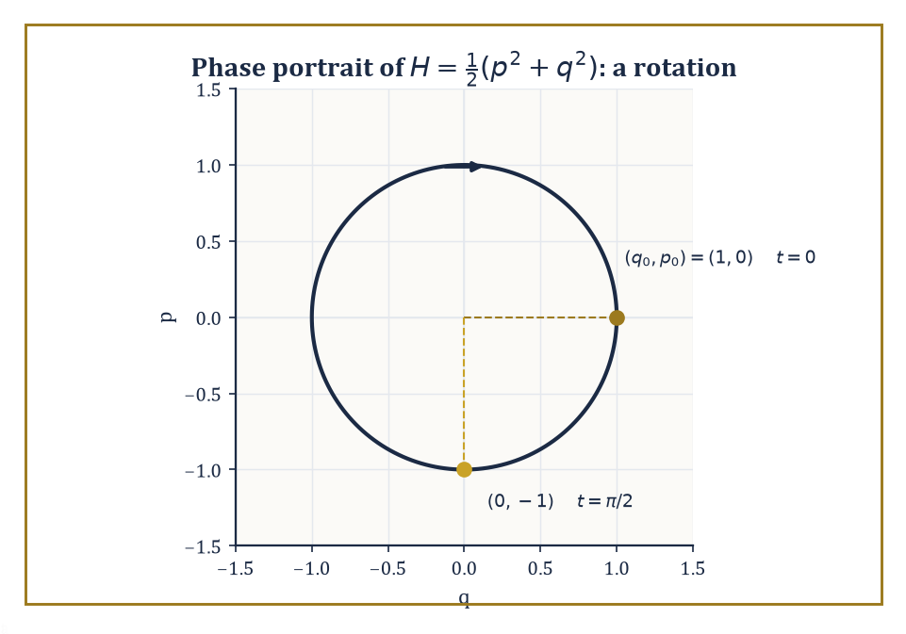
The oscillator's phase-space flow is a rotation: a quarter turn carries (1,0) to (0,−1), and Liouville's theorem is just det R(t)=1 in disguise.
The structure is a symplectic form: a differential 2-form ω that is closed (dω = 0) and non-degenerate (ω(v,·) = 0 forces v = 0). On the standard phase space ℝ²ⁿ with coordinates (q¹,...,qⁿ,p₁,...,pₙ), the canonical symplectic form is:
ω = Σᵢ dpᵢ ∧ dqᵢ
Given a Hamiltonian function H, the Hamiltonian vector field X_H is defined by:
ι_{X_H}ω = dH
In words: plug X_H into the first slot of ω and you get the differential of H out — and the integral curves of X_H are, when unwound in coordinates, exactly the solutions of Hamilton's equations.
Symplectic geometry is what phase space looks like once you stop thinking of it as a mere coordinate system and start thinking of it as the intrinsic object classical mechanics actually lives on.
Numeric example — The flow of the oscillator is a rotation. Take the simplest possible Hamiltonian, a unit-mass, unit-frequency oscillator:
H(q,p) = ½(p² + q²)
Hamilton's equations are:
q̇ = ∂H/∂p = p and ṗ = −∂H/∂q = −q
giving the general solution:
q(t) = q₀cos t + p₀sin t and p(t) = −q₀sin t + p₀cos t
Direct differentiation confirms q̇ = −q₀sin t + p₀cos t = p(t) and ṗ = −q₀cos t − p₀sin t = −q(t), so both equations hold. This flow is the linear map (q₀,p₀) ↦ (q(t),p(t)) given by the rotation matrix:
R(t) = [[cos t, sin t],[−sin t, cos t]]
Take t = π/2 and starting point (q₀,p₀) = (1,0):
q(π/2) = cos(π/2)·1 + sin(π/2)·0 = 0, and p(π/2) = −sin(π/2)·1 + cos(π/2)·0 = −1
So (1,0) is carried to (0,−1), a quarter-turn clockwise, exactly as a rotation should behave.
Now check whether the flow preserves the symplectic form — equivalently, area, in this two-dimensional case. The Jacobian of the flow at any time is R(t) itself, and:
det R(t) = cos²t + sin²t = 1
for every t. This is Liouville's theorem in miniature: Hamiltonian flows always preserve symplectic volume, no matter how complicated H gets, and this two-line calculation is the whole reason a gas of a million billion billion classical particles cannot, whatever else it does, spontaneously shrink the volume it occupies in phase space.
Most Hamiltonian systems cannot be solved in closed form — this is the generic situation, and the reason the previous storey needed an entire theory of chaos to handle it. A special class, the completely integrable systems, can be solved.
A system with n degrees of freedom is completely integrable if it possesses n independent conserved quantities (including H itself) that Poisson-commute with each other:
{Fᵢ,Fⱼ} = 0 for all i,j
The Liouville–Arnold theorem then guarantees that, under mild compactness and non-degeneracy hypotheses, the common level sets of the Fᵢ are n-dimensional tori, and the motion on each torus is a straight-line, quasi-periodic flow when expressed in the right coordinates: the action-angle variables (I,θ), in which the angles θᵢ wind around the torus at constant rates and the actions Iᵢ — essentially the area enclosed by one cycle of the motion — are the conserved labels picking out which torus you're on.
Integrable systems are the exactly solvable models of classical mechanics — the harmonic oscillator, the Kepler problem, the free rigid body — and everything the previous storey called 'chaos' is what happens when you perturb an integrable system just enough that KAM theory's guarantee of surviving tori starts to fail.
Worked example — Two independent clocks, and the tori they trace out. Take two decoupled unit-mass oscillators with frequencies ω₁ = 1 and ω₂ = 2, total Hamiltonian H = H₁ + H₂ where Hᵢ = ½(pᵢ² + ωᵢ²qᵢ²).
Each Hᵢ is separately conserved (they Poisson-commute trivially, since they depend on disjoint coordinates), so this is a completely integrable system with two degrees of freedom. For a single such oscillator, the standard action-angle computation gives:
Iᵢ = Eᵢ/ωᵢ
where Eᵢ is the energy stored in that oscillator. Suppose the first oscillator carries E₁ = 3 joules and the second E₂ = 8 joules. Then:
I₁ = E₁/ω₁ = 3/1 = 3, and I₂ = E₂/ω₂ = 8/2 = 4
The invariant torus for this motion is the set {I₁ = 3, I₂ = 4} — a genuine two-dimensional torus sitting inside the four-dimensional phase space (q₁,p₁,q₂,p₂). The motion on it is:
θ₁(t) = θ₁(0) + t and θ₂(t) = θ₂(0) + 2t
Two independent clocks, one running twice as fast as the other. Because ω₁/ω₂ = 1/2 is rational here, the combined motion actually closes up (after time 2π); for a generic, irrational frequency ratio it would wind around the torus forever without ever exactly repeating — quasi-periodic in the strict sense.
KAM theory (Kolmogorov–Arnold–Moser) answers the natural next question: what happens to these invariant tori when the Hamiltonian is perturbed slightly,
H = H₀ + εH₁
away from perfect integrability?
The naive expectation — that a small perturbation produces a small, controllable change in the motion — turns out to be catastrophically wrong for many individual tori, because of the small-divisor problem: perturbation theory produces correction terms with denominators like (m·ω) for integer vectors m, and when the unperturbed torus's frequency ratios are close to rational, these denominators come arbitrarily close to zero, blowing the correction up.
KAM theory's remarkable rescue is that tori whose frequency ratios are sufficiently irrational — in a precise Diophantine sense, badly approximable by rationals — survive small perturbations largely intact, merely deformed, while tori with rational or near-rational frequency ratios are generically destroyed, dissolving into the chaotic layers explored in the previous storey.
'Most' tori, in a measure-theoretic sense, survive for small enough ε; the destroyed ones are exactly where chaos gets its foothold.
Numeric example — The small divisor, made concrete. Fix ω₁ = 1 and compare two choices of ω₂: a value deliberately chosen close to the rational 3/2, namely ω₂ = 1.4995, and the golden ratio:
ω₂ = φ = (1+√5)/2 ≈ 1.618034
famous among number theorists as the real number hardest to approximate well by rationals. Perturbation theory for the resonance associated with the integer vector m = (3,−2) needs the quantity m·ω = 3ω₁ − 2ω₂ sitting in a denominator.
For the near-resonant frequency:
m·ω = 3(1) − 2(1.4995) = 3 − 2.999 = 0.001
a denominator of one-thousandth, so any correction term of the form (something)/(m·ω) gets amplified a thousandfold, and the perturbation series is in real danger of diverging.
For the golden ratio:
m·ω = 3(1) − 2(1.618034) = 3 − 3.236068 = −0.236068
more than two hundred times larger in magnitude, even though φ is irrational and 1.4995 is not.
This is the small-divisor problem in miniature: it is not irrationality alone that protects a torus, but how badly the frequency ratio resists approximation by rationals — and the golden ratio, whose continued fraction [1;1,1,1,...] converges more slowly than that of any other number, is essentially the best-protected frequency ratio there is, which is why it turns up disproportionately often in KAM-theoretic examples.
This is where the previous storey's chaos and this storey's order meet: an integrable system's tori are the scaffolding, and KAM theory tells you how many of them survive a small perturbation of H before the scaffolding collapses into the strange attractors and sensitive dependence explored two storeys ago.
Continuum physics, next, generalizes all of this from finitely many degrees of freedom to infinitely many — from a handful of (q,p) pairs to a field defined at every point of space.

Room 47.4: Continuum Mechanics and Classical Field Theories
Matter, smoothed out for your convenience
Continuum mechanics treats matter not as a swarm of point particles but as a continuous medium — a simplification that is technically false at the atomic scale and enormously useful at every scale a bridge engineer or a meteorologist actually cares about.
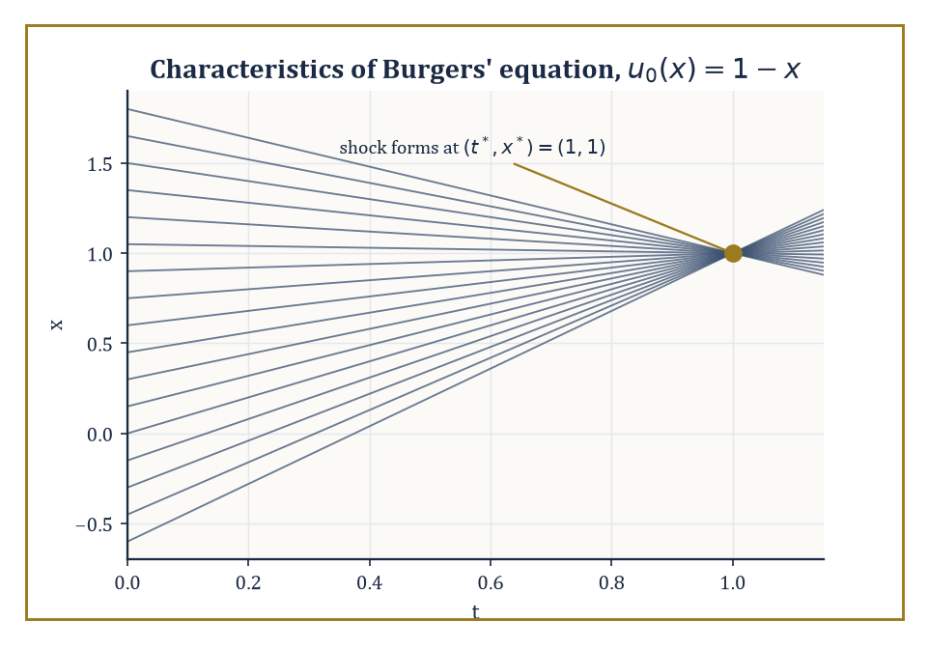
Every characteristic of u₀(x)=1−x, however far apart it started, arrives at exactly the same instant — which is what a shock actually is.
The governing equations come from three balance laws — conservation of mass, momentum, and energy — applied to an arbitrary chunk of material, combined with a constitutive relation encoding what the material is actually made of (how stress relates to strain, or to rate of strain).
For an inviscid fluid this produces the Euler equations; adding viscosity produces the Navier–Stokes equations; applied to a deformable solid instead of a fluid, the same balance-law logic produces the equations of elasticity.
When these equations are nonlinear and hyperbolic — which the compressible Euler equations emphatically are — smooth initial data can develop genuine discontinuities in finite time: shock waves, the mathematical signature of a sonic boom or a traffic jam forming out of nothing but smoothly varying density.
Numeric example — Watching a shock form, one equation at a time. The simplest nonlinear hyperbolic equation that still shows shock formation is Burgers' equation:
u_t + u·u_x = 0
a drastically simplified stand-in for momentum balance in the Euler equations, sharing their essential nonlinear pathology. Its solutions are constant along characteristic lines: if a point x₀ carries initial value u₀(x₀), u stays equal to u₀(x₀) forever along the line x(t) = x₀ + u₀(x₀)·t.
Take initial condition u₀(x) = 1 − x, a straight line sloping downward. The characteristic starting at x₀ is:
x(t) = x₀ + (1 − x₀)t
Take two nearby starting points, x₀ and x₀ + ε. They collide when:
x₀ + (1−x₀)t = (x₀+ε) + (1−x₀−ε)t
Expanding the right side gives x₀ + ε + (1−x₀)t − εt; setting the two sides equal:
(1−x₀)t = ε + (1−x₀)t − εt, which simplifies to 0 = ε − εt, i.e. t = 1
independent of both x₀ and ε. Every pair of characteristics collides at exactly the same instant, t* = 1. Substituting t = 1 into the characteristic formula gives:
x(1) = x₀ + (1−x₀)(1) = 1
again independent of x₀: every characteristic line, wherever it started, passes through the single point (t,x) = (1,1). At that instant the smooth solution must be replaced by a discontinuous one governed by a jump (Rankine–Hugoniot) condition — a shock forms.
(This particular initial condition is unusually tidy: a linear velocity profile makes every characteristic collide at one shared point, chosen here because the arithmetic comes out exactly, not because real shocks are typically this obliging.)
Once a shock has formed, the classical, differentiable notion of 'solving the PDE' breaks down, and the equation must be reinterpreted in a weak sense: an integral identity, tested against smooth functions, that no longer requires u itself to be differentiable across the discontinuity.
Weak solutions are not unique, however — infinitely many discontinuous functions can satisfy the weak formulation of Burgers' equation with the same initial data, and only one of them is physically correct.
Selecting the right one requires an extra admissibility condition, the entropy condition (so named by analogy with the second law of thermodynamics, which likewise picks out the physically realized direction among mathematically permitted ones): characteristics must run into a shock from both sides, never emerge from one.
This is the same logic, transplanted into pure analysis, that rules out a traffic jam spontaneously un-forming itself for no reason.
Numeric example — A shock that is allowed, and one that isn't. Consider the Riemann problem for Burgers' equation: a single jump at x = 0 at time zero, with u(x,0) = u_L for x < 0 and u(x,0) = u_R for x > 0.
The Rankine–Hugoniot condition fixes the speed of any propagating discontinuity, with flux f(u) = ½u²:
s = [f(u_L) − f(u_R)]/(u_L − u_R), which simplifies to s = (u_L + u_R)/2
Take u_L = 2, u_R = 0: the shock speed is:
s = (2+0)/2 = 1
Check the entropy condition, u_L > s > u_R:
2 > 1 > 0
This holds, so this jump is admissible — characteristics carrying value 2 travel at speed 2 and catch the shock from the left, characteristics carrying value 0 sit still and get caught by the shock from the right, and both families feed into the discontinuity, exactly as required.
Now swap the states: u_L = 0, u_R = 2. The same formula gives the same-looking jump, speed:
s = (0+2)/2 = 1
but the entropy condition u_L > s now reads 0 > 1, which is false. This discontinuity satisfies the jump condition but is not the physically correct solution, because no characteristics run into it — the left state's characteristics (speed 0) and the right state's (speed 2) both move away from x = 0 as t increases.
The genuine solution here has no shock at all: it is the continuous rarefaction fan:
u(x,t) = x/t for 0 ≤ x/t ≤ 2
smoothly interpolating between the two states as the initial jump fans out rather than propagating.
Classical field theories generalize continuum mechanics one step further: instead of a displacement field defined on a lump of matter, a field φ(x,t) is defined at every point of spacetime itself, and the Lagrangian becomes a Lagrangian density ℒ(φ, ∂φ), integrated over spacetime to give the action:
S = ∫ ℒ d⁴x
Extremizing S with respect to variations of φ produces the Euler–Lagrange equation for fields:
∂ℒ/∂φ − ∂_μ(∂ℒ/∂(∂_μφ)) = 0
This is the direct field-theoretic descendant of the particle Euler–Lagrange equation from Room 47.2, with the time derivative now joined by the spatial ones.
Scalar fields, the electromagnetic field, and (much further up the tower of difficulty) Yang–Mills gauge fields are all continuum theories of exactly this shape, differing only in what φ is and what ℒ looks like.
Abstract example — A symmetry, quietly enforcing a conservation law. Noether's theorem states that every continuous symmetry of the action corresponds to a conserved quantity. Take the simplest instance: a free particle with Lagrangian L = ½mẋ², and the symmetry x → x + ε for constant infinitesimal ε — translating the whole trajectory sideways changes nothing about L, since L doesn't depend on x at all, only on ẋ.
Noether's construction gives the conserved quantity as:
Q = (∂L/∂ẋ)·(δx/δε)
and since δx/δε = 1 here:
Q = ∂L/∂ẋ = mẋ = p
the ordinary linear momentum.
Check directly that Q is conserved along the actual motion: for a free particle the Euler–Lagrange equation reads:
d/dt(mẋ) − 0 = 0
so mẋ is constant in time — precisely Q, precisely conserved.
Translation symmetry of space, run through Noether's machine, produces conservation of momentum; the same argument applied to time-translation symmetry produces conservation of energy, and to rotational symmetry produces conservation of angular momentum. Three of Newtonian mechanics' oldest conservation laws turn out to be one theorem, applied three times.
Electromagnetism, the next room, is simply the best-known and most consequential example of exactly this field-theoretic pattern: a Lagrangian density, an Euler–Lagrange equation, and — because the theory has an enormous symmetry group — a correspondingly enormous supply of conserved and geometrically meaningful structure.

Room 47.5: Electromagnetism and Maxwell's Equations
Four equations, one universe, rather too much notation
Maxwell's equations are four statements — two structural, two dynamical — that between them determine the entire classical behaviour of electric and magnetic fields. In vector-calculus notation, they read:
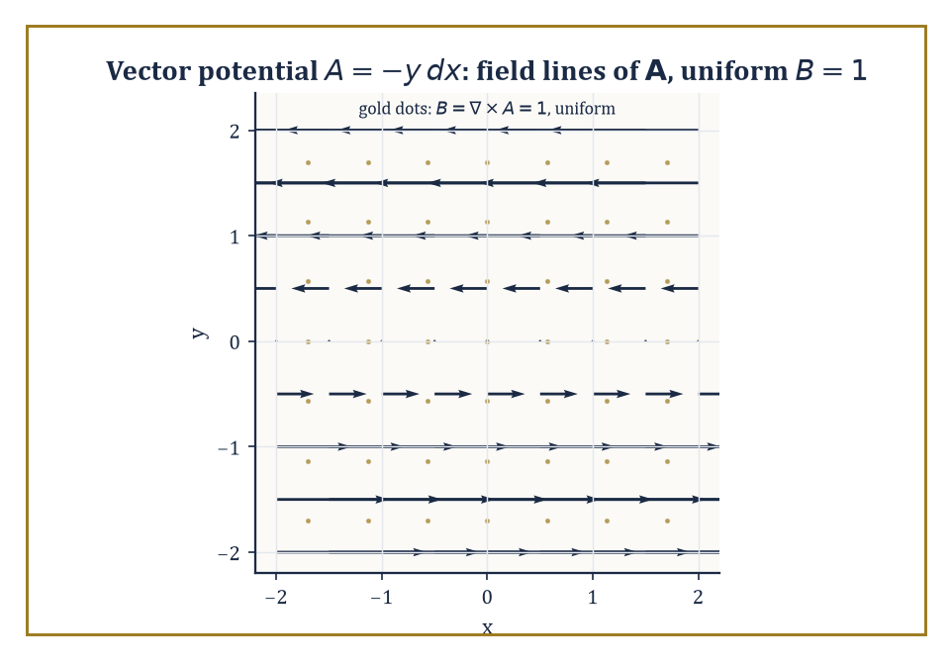
The vector potential A = −y dx, drawn as arrows, generates a perfectly uniform magnetic field — the only thing anyone could actually measure.
∇·E = ρ/ε₀ (Gauss's law)
∇·B = 0 (no magnetic monopoles)
∇×E = −∂B/∂t (Faraday's law)
∇×B = μ₀J + μ₀ε₀∂E/∂t (the Ampère–Maxwell law, with Maxwell's own crucial addition of the displacement current term)
In vacuum, with no charges or currents, taking the curl of Faraday's law and substituting the Ampère–Maxwell law produces a wave equation for E (and symmetrically for B):
∂²E/∂t² = c²∇²E, where c = 1/√(ε₀μ₀)
Maxwell noticed, in 1861, that this quantity — built entirely out of two constants measured in static electricity and magnetism experiments, with no reference to light whatsoever — came out equal to the known speed of light, and correctly concluded that light itself is an electromagnetic wave.
It remains one of the most startling unifications in the history of science, and it happened by pure calculation, before a single new experiment was performed.
Numeric example — Deriving the speed of light from two unrelated constants. The vacuum permittivity is ε₀ ≈ 8.854×10⁻¹² F/m and the vacuum permeability is μ₀ ≈ 1.2566×10⁻⁶ N/A² (equal to 4π×10⁻⁷ in the older SI convention). Multiply them:
ε₀μ₀ ≈ 8.854×10⁻¹² × 1.2566×10⁻⁶ ≈ 11.127×10⁻¹⁸ = 1.1127×10⁻¹⁷ (units of s²/m²)
Take the square root:
√(1.1127×10⁻¹⁷) = √(11.127×10⁻¹⁸) = √11.127 × 10⁻⁹ ≈ 3.336×10⁻⁹ s/m
Invert:
c = 1/(3.336×10⁻⁹) ≈ 2.998×10⁸ m/s
This matches the measured speed of light, 299,792,458 m/s, to the precision of the constants used — and neither ε₀ nor μ₀ was measured by anyone looking at light.
Two entirely electrostatic and magnetostatic experiments, multiplied and square-rooted, hand you the speed of light. This is the calculation that told Maxwell, and tells every student since, that light is electromagnetism.
Rewritten in the language of differential forms (built in an earlier storey), the whole theory collapses to two lines and becomes manifestly coordinate-free. The electric and magnetic fields combine into a single field-strength 2-form F on spacetime.
The two source-free equations (no monopoles, Faraday's law) become:
dF = 0
meaning F is closed. The two equations with sources become:
d★F = J
relating the Hodge dual of F to the current 3-form J.
Because dF = 0 and spacetime (locally, or globally if it is topologically simple) has no interesting closed-but-not-exact 2-forms, F = dA for some 1-form A, the vector potential.
But A is not unique: replacing A by A + dχ for any function χ leaves F unchanged, since d(dχ) = 0 always (the exterior derivative squared vanishes — this is the differential-forms reason 'curl of a gradient is zero').
This freedom to shift A without changing any physically measurable field is gauge freedom, the prototype of every gauge symmetry in modern physics, up to and including the Standard Model.
Abstract example — Changing the potential without changing the physics. Work in the plane, with coordinates x,y, and take the 1-form A = −y dx. Compute its exterior derivative:
dA = d(−y)∧dx = −dy∧dx = dx∧dy (using dy∧dx = −dx∧dy)
So F = dA = dx∧dy, corresponding to a uniform magnetic field:
B = ∂A_y/∂x − ∂A_x/∂y = 0 − (−1) = 1
in suitable units. Now perform a gauge transformation with χ = xy:
dχ = y dx + x dy
The new potential is:
A′ = A + dχ = (−y dx) + (y dx + x dy) = x dy
a completely different-looking expression, with A′_x = 0 and A′_y = x instead of A_x = −y and A_y = 0. Compute the field it produces:
B′ = ∂A′_y/∂x − ∂A′_x/∂y = ∂(x)/∂x − 0 = 1
Exactly the same magnetic field as before, despite the potential having changed completely. Equivalently:
dA′ = d(x dy) = dx∧dy = dA
the same F, confirmed directly. This is gauge invariance in its smallest possible example: the potential is a bookkeeping device with genuine freedom in it; the field is the only thing anyone can actually measure.
The electromagnetic field also carries its own energy and momentum, encoded in a stress-energy tensor built from F, with energy density:
u = ½ε₀E² + B²/(2μ₀)
and energy flux given by the Poynting vector:
S = E×B/μ₀
This is the mechanism by which sunlight, having travelled 150 million kilometres through the vacuum carrying no matter whatsoever, nonetheless arrives carrying enough energy to warm a face.
Numeric example — The energy hiding in an electric field. For a plane electromagnetic wave in vacuum, B = E/c at every instant, so the magnetic contribution to the energy density can be rewritten entirely in terms of E:
B²/(2μ₀) = E²/(2μ₀c²)
and since c² = 1/(ε₀μ₀), this equals ε₀E²/2 — exactly the same as the electric contribution.
The two halves are equal, so the total energy density simplifies to:
u = ½ε₀E² + ½ε₀E² = ε₀E²
Take E = 300 V/m, a typical peak field strength for bright midday sunlight. Then:
u = ε₀E² = 8.854×10⁻¹² × (300)² = 8.854×10⁻¹² × 90,000 = 7.969×10⁻⁷ J/m³
a very small number per cubic metre, which is exactly why it takes an enormous cross-sectional area (such as the disc of the Earth, or a large solar panel) sweeping through this energy density at the speed of light to add up to a noticeable warming effect.
Electromagnetism was also the first classical theory to insist, quietly but unavoidably, that Newtonian absolute time could not be right — because the wave equation predicts that light travels at a fixed speed c regardless of the observer's motion, and reconciling that with Newtonian kinematics is simply impossible.
Sorting out the consequences is the next room's entire job.

Room 47.6: Special Relativity and Minkowski Space
Time loses its absoluteness and nobody gets a refund
Special relativity begins by taking Maxwell's inconvenient prediction — that light travels at the same speed c for every inertial observer — completely at face value, and working out what geometry makes that consistent.
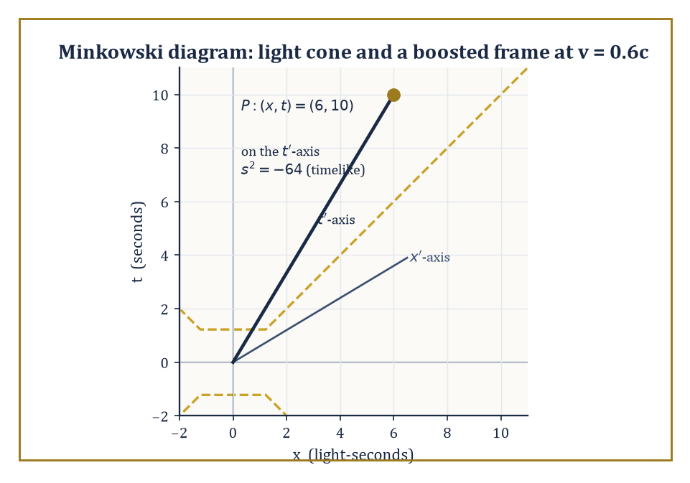
Event P sits on the boosted observer's own t′-axis; the light cone and the interval s²=−64 look the same to everyone, which is the whole point.
The answer is Minkowski spacetime: ℝ⁴, with coordinates (t,x,y,z), equipped not with the ordinary Euclidean distance but with the Minkowski metric:
ds² = −c²dt² + dx² + dy² + dz²
(signature (−,+,+,+); some authors use the opposite sign convention, and mathematical physicists have never quite forgiven each other for it.)
The crucial novelty is that ds² can be negative, zero, or positive, and each case means something physically distinct: a timelike interval (ds² < 0) connects events that could be cause and effect; a null interval (ds² = 0) connects events joinable only by light; a spacelike interval (ds² > 0) connects events too far apart in space, relative to the time between them, for any signal to travel between them at all.
Newtonian absolute simultaneity — the idea that 'at the same time' means the same thing to every observer — simply does not survive; it is replaced by this causal structure, which every observer agrees on even though they disagree about almost everything else.
Numeric example — A clock and a ruler, both misbehaving at 0.6c. Take an observer moving at v = 0.6c relative to you. The Lorentz factor is:
γ = 1/√(1 − v²/c²) = 1/√(1 − 0.36) = 1/√0.64 = 1/0.8 = 1.25
Time dilation: if the moving observer's own clock ticks off a proper time Δτ = 1 second between two events on their worldline, you measure the time between those same two events as:
Δt = γΔτ = 1.25 × 1 = 1.25 seconds
their clock, from your point of view, runs slow.
Length contraction: if the moving observer carries a ruler measuring L₀ = 10 metres in their own rest frame, you measure its length as:
L = L₀/γ = 10/1.25 = 8 metres
Nothing physical has happened to the ruler; different observers simply disagree about simultaneity, and 'the length of a moving object' secretly means 'the distance between its two ends measured at the same time in my frame' — and 'the same time in my frame' is not the same set of events as 'the same time in their frame'.
The transformations relating the coordinates used by two inertial observers in relative motion are the Lorentz transformations — the linear maps preserving the Minkowski metric, forming the Lorentz group O(3,1); adding spacetime translations gives the full Poincaré group, the complete symmetry group of special relativity.
Physical quantities that were separate three-dimensional vectors and scalars in Newtonian physics get bundled into four-vectors and tensors that transform properly under this group: energy and three-momentum combine into a single energy-momentum four-vector; the electric and magnetic fields combine, as seen in the previous room, into the single field-strength tensor F.
Maxwell's equations, written in four-dimensional form, turn out to have been secretly Lorentz-invariant the entire time — special relativity was hiding inside electromagnetism since 1865, waiting for 1905.
Numeric example — The spacetime interval, computed by two disagreeing observers. Work in units where c = 1 (time measured in the same units as distance, e.g. light-seconds), with the same relative velocity as above, v = 0.6, γ = 1.25. Take an event with coordinates (t,x) = (10, 6) in your frame — 10 seconds and 6 light-seconds from the origin.
The Minkowski interval in your frame is:
s² = −t² + x² = −(10)² + (6)² = −100 + 36 = −64
timelike since it's negative (check: x/t = 0.6 < 1, consistent with a sub-light-speed signal).
Now transform to the moving observer's coordinates using x′ = γ(x − vt) and t′ = γ(t − vx):
x′ = 1.25×(6 − 0.6×10) = 1.25×(6 − 6) = 0
t′ = 1.25×(10 − 0.6×6) = 1.25×(10 − 3.6) = 1.25×6.4 = 8
Compute the interval again in the moving observer's own coordinates:
s′² = −t′² + x′² = −(8)² + 0² = −64 + 0 = −64
exactly the same number as before, despite t and x individually changing completely (10 became 8; 6 became 0).
This is what it means for the metric to be invariant: individual coordinates are observer-dependent opinions, but the interval ds² is a fact every observer computes identically, and it is the closest thing special relativity has to an absolute quantity.
Special relativity also forces a reconsideration of energy and momentum themselves. The energy of a particle of rest mass m moving with momentum p satisfies the relativistic energy-momentum relation:
E² = (pc)² + (mc²)²
which reduces to the familiar Newtonian approximation at low speeds (a binomial expansion left as a pleasant exercise):
E ≈ mc² + p²/(2m)
and collapses to the single most quoted equation in physics, when the particle is at rest and p = 0:
E = mc²
Numeric example — The energy locked in an electron at rest. Take an electron, rest mass m = 9.109×10⁻³¹ kg, and compute its rest energy using E = mc² with c = 2.998×10⁸ m/s. First:
c² = (2.998×10⁸)² ≈ 8.988×10¹⁶ m²/s²
Then:
E = mc² = 9.109×10⁻³¹ × 8.988×10¹⁶ ≈ 8.187×10⁻¹⁴ joules
(multiplying the leading digits, 9.109 × 8.988 ≈ 81.87, gives E ≈ 81.87×10⁻¹⁵ = 8.187×10⁻¹⁴ joules).
Converting to the units particle physicists actually use — dividing by 1.602×10⁻¹³ joules per MeV:
E ≈ 8.187×10⁻¹⁴ / 1.602×10⁻¹³ ≈ 0.5111 MeV
This is the electron's rest energy, a number that appears constantly in particle physics (it sets, for instance, the minimum photon energy needed for electron-positron pair production, 2×0.511 = 1.022 MeV) and is recovered here from nothing but the electron's mass and the speed of light, with no reference to any experiment beyond those two measurements.
Special relativity handles inertial observers moving at constant velocity relative to each other; it says nothing about acceleration, and nothing at all about gravity.
Extending the theory to cover both turns out to require abandoning flat Minkowski spacetime altogether and letting the geometry itself become dynamical — which is exactly the escalation the next room makes.

Room 47.7: General Relativity and Curved Spacetime
Gravity is what happens when geometry won't behave
General relativity's central claim is audacious even by the standards of this storey: gravity is not a force at all, but a manifestation of the curvature of spacetime itself. Matter and energy tell spacetime how to curve; curved spacetime tells matter how to move.
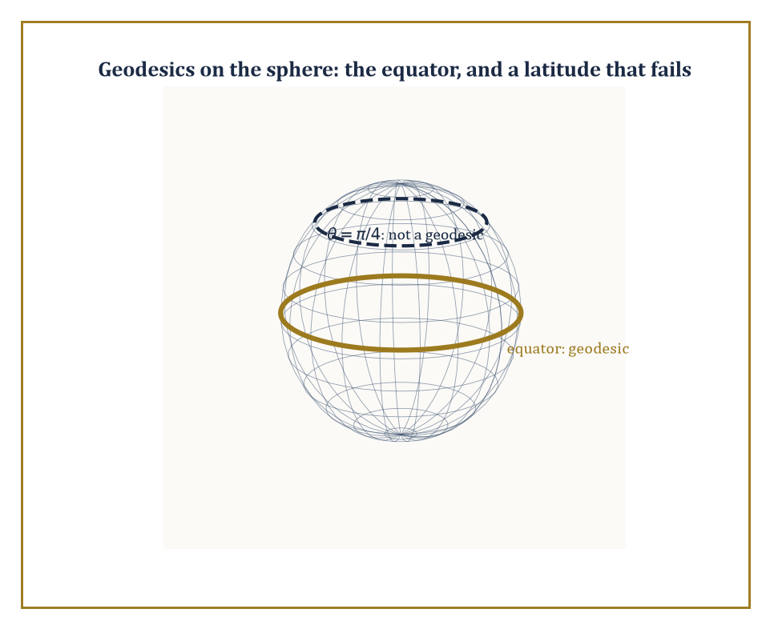
On the sphere, the equator solves the geodesic equation and a random latitude circle does not — curvature's opinion on what counts as 'straight'.
Specifically, free particles (subject to no force except gravity) move along geodesics, the curved-space generalization of straight lines, satisfying:
d²xᵘ/dτ² + Γᵘ_{αβ}(dxᵅ/dτ)(dxᵝ/dτ) = 0
where the Christoffel symbols Γᵘ_{αβ} encode how the metric — and hence the notion of 'straight' — varies from point to point.
The precise relationship between curvature and matter is the Einstein field equation:
Gᵘᵛ = 8πG/c⁴ · Tᵘᵛ
equating the Einstein tensor Gᵘᵛ (a specific contraction of the Riemann curvature tensor, built from second derivatives of the metric) to the stress-energy tensor Tᵘᵛ, which encodes the density and flow of energy, momentum, and stress.
Spacetime is now a Lorentzian manifold — the metric g varies from point to point, and flat Minkowski space from the previous room is recovered only in the total absence of matter and energy.
Abstract example — Geodesics on a sphere, as a warm-up. Before tackling the four-dimensional Schwarzschild geometry, it helps to see curvature bend a geodesic in a space simple enough to visualize completely: the ordinary 2-sphere, with metric:
ds² = dθ² + sin²θ dφ² (θ = colatitude, φ = longitude)
Its nonzero Christoffel symbols are:
Γᶿ_{φφ} = −sinθcosθ and Γᵠ_{θφ} = Γᵠ_{φθ} = cotθ
The geodesic equations become:
θ'' − sinθcosθ (φ′)² = 0 and φ'' + 2cotθ θ′φ′ = 0
Try the equator, θ(t) ≡ π/2 constant, and check whether it is a valid solution. Since θ is constant, θ′ = 0 and θ'' = 0.
The first equation becomes:
0 − sin(π/2)cos(π/2)(φ′)² = 0 − (1)(0)(φ′)² = 0
satisfied automatically for any φ′, since cos(π/2) = 0.
The second equation becomes:
φ'' + 2cot(π/2)·0·φ′ = φ''
and since cot(π/2) = 0 this reduces to φ'' = 0, so φ′ is constant and φ(t) = φ(0) + ωt for some constant ω.
Both geodesic equations are satisfied: the equator, traversed at constant angular speed, is a genuine geodesic — a great circle, exactly the 'straight line' intuition demands on a sphere. The same machinery, applied to the considerably more complicated Schwarzschild metric instead of the round sphere, is what produces the actual orbits of planets and photons around a gravitating mass.
Schwarzschild found, within weeks of Einstein publishing the field equations in 1915, the exact solution describing the spacetime geometry outside a static, spherically symmetric mass.
It predicts three things Newtonian gravity gets subtly wrong: an extra precession of planetary orbits (famously resolving a long-standing discrepancy in Mercury's orbit), the bending of starlight passing near the sun (confirmed in the 1919 eclipse expedition that made Einstein famous overnight), and — pushed to its extreme, where the metric develops a genuine singularity in its causal structure rather than just a coordinate artifact — black holes.
Cosmological solutions of the same field equations, the Friedmann–Lemaître family, describe a spacetime that is homogeneous and isotropic but whose overall scale expands or contracts with time, and form the mathematical backbone of the expanding-universe picture.
Numeric example — How compact does the Sun have to get?. The Schwarzschild radius of a mass M is:
r_s = 2GM/c²
the radius within which the escape velocity from the mass would, in a Newtonian-flavoured but essentially correct heuristic, exceed the speed of light.
Take the Sun: M = 1.989×10³⁰ kg, G = 6.674×10⁻¹¹ m³ kg⁻¹ s⁻², c = 2.998×10⁸ m/s. Compute 2GM:
2GM = 2 × 6.674×10⁻¹¹ × 1.989×10³⁰ ≈ 2 × 13.275×10¹⁹ = 26.55×10¹⁹ = 2.655×10²⁰
Compute c²:
c² = (2.998×10⁸)² ≈ 8.988×10¹⁶
Divide:
r_s = 2.655×10²⁰ / 8.988×10¹⁶ ≈ 0.2954×10⁴ = 2954 m ≈ 2.95 km
The Sun, whose actual radius is about 696,000 km, would need to be compressed into a sphere less than 3 kilometres across before it stopped being merely a very hot ball of plasma and became a black hole.
It cannot do this on its own — stellar collapse to a black hole requires a mass considerably larger than the Sun's, since smaller stars are rescued from this fate by electron or neutron degeneracy pressure — but the number itself is a clean, checkable consequence of a formula with no free parameters, worth confirming by hand exactly once in a mathematical physicist's life.
The perihelion precession mentioned above is not just a qualitative prediction; general relativity supplies an explicit formula for it:
Δφ = 6πGM/(c²a(1−e²)) radians per orbit
where a is the orbit's semi-major axis and e its eccentricity — a formula with no adjustable parameters, depending only on the central mass and the shape of the orbit.
Numeric example — Mercury's orbit, precessing exactly as much as it should. Mercury has semi-major axis a = 5.79×10¹⁰ m and eccentricity e = 0.2056, orbiting the Sun (M = 1.989×10³⁰ kg). Using G = 6.674×10⁻¹¹ and c = 2.998×10⁸ m/s:
GM = 6.674×10⁻¹¹ × 1.989×10³⁰ ≈ 1.3275×10²⁰ m³/s²
so:
6πGM = 18.850 × 1.3275×10²⁰ ≈ 2.502×10²¹
Next:
e² = 0.2056² ≈ 0.04227, so 1 − e² ≈ 0.95773
and:
a(1−e²) ≈ 5.79×10¹⁰ × 0.95773 ≈ 5.544×10¹⁰ m
Then:
c²·a(1−e²) ≈ 8.988×10¹⁶ × 5.544×10¹⁰ ≈ 4.983×10²⁷
Dividing:
Δφ ≈ 2.502×10²¹ / 4.983×10²⁷ ≈ 5.021×10⁻⁷ radians per orbit
Converting to arcseconds (1 radian = 206,265 arcsec):
Δφ ≈ 5.021×10⁻⁷ × 206,265 ≈ 0.1036 arcsec per orbit
Mercury completes an orbit every 87.969 days ≈ 0.2408 years, so in a century it completes about 100/0.2408 ≈ 415.2 orbits, giving a total precession of about:
0.1036 × 415.2 ≈ 43.0 arcseconds per century
the exact figure, long unexplained by Newtonian gravity alone, that convinced astronomers in 1915 that Einstein's theory, and not some undiscovered planet named Vulcan, was the correct explanation for Mercury's stubbornly anomalous orbit.
General relativity is where mathematical physics and differential geometry become, for long stretches, simply the same subject wearing different hats.
What it does not touch — deliberately, and for very good reason — is the atomic and subatomic scale, where classical fields and classical geodesics give way entirely to a different kind of mathematics. That is where this storey now, at last, must go.

Room 47.8: Quantum Mechanics: Operators, Spectra, and States
The universe, now with uncertainty built in
Quantum mechanics performs, on the classical framework built over the last seven rooms, one of the strangest substitutions in the history of physics: phase space is replaced by a Hilbert space H of states (a complex vector space with an inner product, complete in the norm it induces — precisely the object built in an earlier storey on functional analysis), and observables — position, momentum, energy, spin — are replaced by self-adjoint operators on H.
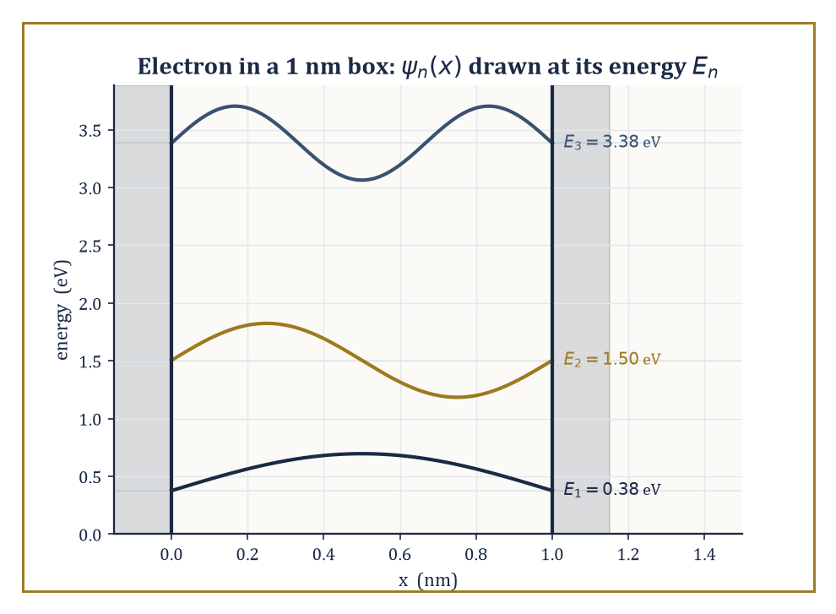
An electron in a 1 nm box, confined to three discrete energies instead of a continuum — quantization made visible, not just asserted.
A measurement of an observable A can only yield a value in A's spectrum, and the Born rule gives the probability of each outcome in terms of the state vector's overlap with A's eigenspaces.
Time evolution is governed by the Schrödinger equation:
iħ ∂ψ/∂t = Ĥψ
where Ĥ is the Hamiltonian operator — the direct quantum descendant of the classical Hamiltonian function from Room 47.2, now acting on states rather than being evaluated on points of phase space.
Numeric example — An electron confined to a one-nanometre box. The simplest genuinely quantum system is a particle confined to an infinite square well (a 'particle in a box') of width L, where the Schrödinger equation forces the wavefunction to vanish at both walls. Solving it gives discrete, quantized energy levels:
E_n = n²π²ħ²/(2mL²), n = 1, 2, 3, ...
already a striking departure from classical mechanics, where a confined particle can have any energy at all.
Take an electron (m = 9.109×10⁻³¹ kg) confined to a box of width L = 1 nanometre = 1×10⁻⁹ m, roughly the scale of a small molecule. With ħ = 1.0546×10⁻³⁴ J·s, compute the ground-state energy E₁ = π²ħ²/(2mL²). The numerator is:
ħ² = (1.0546×10⁻³⁴)² ≈ 1.1122×10⁻⁶⁸; multiplying by π² ≈ 9.8696 gives π²ħ² ≈ 1.0977×10⁻⁶⁷
The denominator is:
2mL² = 2 × 9.109×10⁻³¹ × (1×10⁻⁹)² = 2 × 9.109×10⁻³¹ × 1×10⁻¹⁸ ≈ 1.8218×10⁻⁴⁸
Divide:
E₁ ≈ 1.0977×10⁻⁶⁷ / 1.8218×10⁻⁴⁸ ≈ 6.026×10⁻²⁰ joules
Converting to electron-volts (divide by 1.602×10⁻¹⁹ J/eV) gives:
E₁ ≈ 0.376 eV
comparable to typical chemical bond energies, which is exactly why quantum confinement effects of this kind matter for real molecules and nanostructures.
The second level scales as n² and comes out at E₂ = 4E₁ ≈ 1.50 eV, the third at E₃ = 9E₁ ≈ 3.39 eV: the spacing between levels grows, rather than staying constant as it would for a classical oscillator, itself a diagnostic fingerprint distinguishing a 'box' potential from a harmonic one in real spectroscopy.
Most operators of physical interest — position and momentum chief among them — are unbounded, which introduces genuine technical difficulty: they cannot be defined on the whole Hilbert space, only on a dense domain, and 'self-adjoint' becomes a considerably more delicate condition than 'symmetric'.
The reward for getting this right is Stone's theorem: every strongly continuous one-parameter group of unitary operators U(t) (such as the time evolution generated by the Schrödinger equation) arises as:
U(t) = e^{−iĤt/ħ}
for a unique self-adjoint Ĥ, and conversely.
Uncertainty principles — the fact that position and momentum cannot both be measured with unlimited precision on the same state — follow directly from the non-commutativity of the corresponding operators, via a short Cauchy–Schwarz argument that turns 'these two operators don't commute' into 'the product of their measurement uncertainties has a hard lower bound.'
Abstract example — Deriving the fundamental commutator. Represent position as multiplication by x and momentum as the differential operator p̂ = −iħ d/dx, acting on differentiable wavefunctions ψ(x). Compute the commutator [x̂,p̂]ψ = x̂p̂ψ − p̂x̂ψ directly, for a general ψ.
First term:
x̂p̂ψ = x·(−iħψ′) = −iħxψ′
Second term, by the product rule:
p̂x̂ψ = −iħ d/dx(xψ) = −iħ(ψ + xψ′)
Subtract:
[x̂,p̂]ψ = −iħxψ′ − [−iħ(ψ + xψ′)] = −iħxψ′ + iħψ + iħxψ′ = iħψ
The xψ′ terms cancel exactly, leaving [x̂,p̂] = iħ as an operator identity, holding for every ψ in the domain.
This is precisely the classical Poisson bracket {x,p} = 1, computed in Room 47.2, multiplied by iħ — canonical quantization, promised two rooms ago, delivered explicitly.
Every classical Poisson bracket of observables becomes, on passing to quantum mechanics, (1/iħ) times the corresponding operator commutator, and the entire uncertainty-principle machinery of quantum theory is downstream of this one non-vanishing bracket refusing to be zero.
The general form of the uncertainty relation, for any two observables A and B, is:
ΔA·ΔB ≥ ½|⟨[Â,B̂]⟩|
the spread in one measurement times the spread in the other is bounded below by half the expectation value of their commutator.
Substituting the result just derived, [x̂,p̂] = iħ, gives the specific and famous case, Heisenberg's uncertainty principle:
Δx·Δp ≥ ħ/2
This is not a statement about the clumsiness of measuring instruments, but a hard mathematical consequence of position and momentum being represented by non-commuting operators on the same Hilbert space.
Abstract example — A state that saturates the bound exactly. The inequality Δx·Δp ≥ ħ/2 is achieved with equality only for Gaussian wavepackets. Take:
ψ(x) = (2πσ²)^(−1/4) exp(−x²/(4σ²))
for some width parameter σ > 0, normalized so that ∫|ψ|²dx = 1 and centred so ⟨x⟩ = 0.
Since |ψ(x)|² is a normal distribution with variance σ², the position spread is Δx = σ, directly by inspection.
The Fourier transform of a Gaussian is again a Gaussian, and the standard calculation for the free Schrödinger equation shows the momentum-space wavefunction has variance in wavenumber k equal to 1/(4σ²), so the momentum spread is:
Δp = ħ·Δk = ħ/(2σ)
Multiplying the two:
Δx·Δp = σ · ħ/(2σ) = ħ/2
exactly the lower bound, with no slack whatsoever.
Any other shape of wavepacket (a top-hat, an exponential, or the particle-in-a-box ground state from the earlier example in this room) gives a strictly larger product; the Gaussian is the uncertainty principle's unique 'best case', which is part of why Gaussian wavepackets are the standard starting point for building coherent states and semiclassical approximations throughout quantum theory.
That is the mathematical skeleton of nonrelativistic quantum mechanics: a Hilbert space, a spectral theorem doing quiet, essential work, and a commutator inherited from classical phase space.
What it does not yet do is fit together with special relativity, or say anything about particles being created and destroyed — problems that belong to quantum field theory, and to the final room of this storey, which looks ahead rather than solving anything new.

Room 47.9: Looking Ahead: From Classical Mathematical Physics to Quantum Field Theory and Beyond
Or: everything above was the easy part
We have, over eight rooms, assembled the mathematical core of classical and early-quantum physics: the variational principles of Lagrangian and Hamiltonian mechanics; the symplectic geometry that makes phase space more than just a set of coordinates; the continuum theories of matter and the field-theoretic pattern — Lagrangian density, Euler–Lagrange equations, Noether currents — recurring everywhere from elasticity to electromagnetism; the geometry of electromagnetism itself and its forced marriage with relativity; the curved-spacetime formulation of gravity; and the operator-theoretic reformulation of mechanics that is quantum theory.
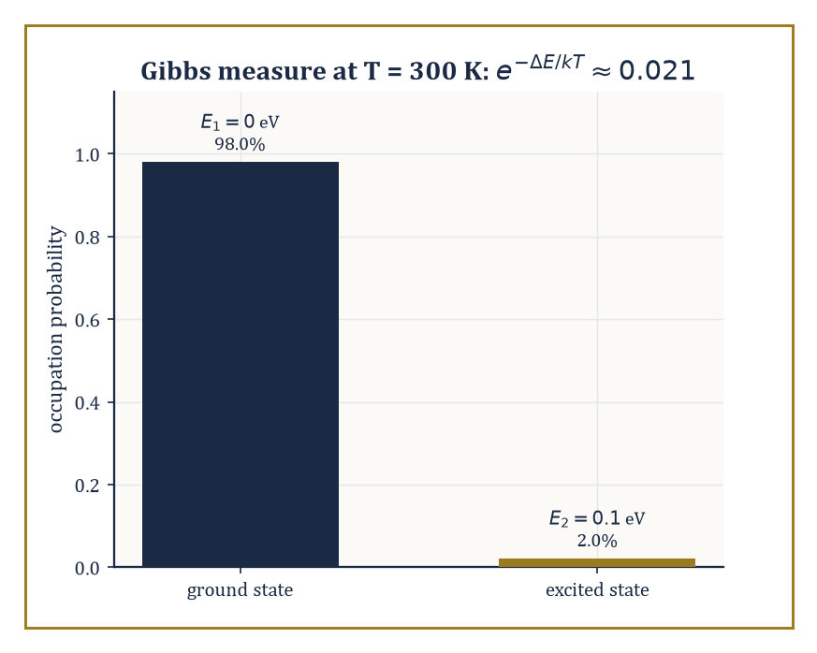
At room temperature, a 0.1 eV energy gap is almost never bridged: the Gibbs measure leaves the excited state occupied about 2% of the time.
It is, by any reasonable standard, an enormous amount of physics — and it is also, by the standards of what remains, only the classical half of the subject.
The immediately next step, quantum field theory, is the synthesis this storey's structure has been quietly pointing toward the entire time: take the field-theoretic pattern from Room 47.4, apply the canonical quantization procedure from Room 47.8 (Poisson brackets become commutators) not to a handful of particle coordinates but to a field defined at every point of space, and the result is a theory in which particles themselves become quantized excitations of an underlying field, capable of being created and destroyed.
Beyond QFT lie statistical mechanics and the still largely unrigorous mathematics of phase transitions, the infinite-dimensional dynamical systems governing fluid turbulence and kinetic theory (a direct descendant of the previous storey's dynamical systems, now with a Hilbert space of degrees of freedom instead of a handful), and the geometric and topological methods — bundles, characteristic classes, moduli spaces — appearing throughout modern gauge theory and string theory.
Abstract example — From two oscillators to a field, in one paragraph of algebra. Recall the two decoupled oscillators of Room 47.3, with Hamiltonian H = H₁ + H₂, each Hᵢ = ½(pᵢ² + ωᵢ²qᵢ²).
Quantum field theory is, at a first and genuinely illuminating approximation, exactly this idea run to its logical extreme: a free field can be decomposed, by Fourier analysis, into infinitely many independent normal modes, indexed by wavenumber k instead of by i = 1,2, each behaving as its own independent harmonic oscillator with frequency ωₖ determined by the field's equation of motion.
Canonically quantizing each mode separately — promoting each classical (qₖ,pₖ) pair to operators with:
[q̂ₖ,p̂ₖ] = iħ
exactly as in Room 47.8's worked example — turns each mode into a quantum harmonic oscillator, whose energy levels are equally spaced multiples of ħωₖ above a ground state.
Those equally spaced energy quanta are, by definition, what a physicist calls 'particles': the n-th excited level of the mode with wavenumber k is interpreted as n particles, each of momentum ħk, present in the field. A field theory's vacuum state is the state with every mode in its ground level; a single particle is one mode nudged up by exactly one quantum.
Nothing about this required inventing new mathematics — it is the harmonic oscillator of Room 47.2 and the Poisson-bracket-to-commutator dictionary of Room 47.8, applied to infinitely many degrees of freedom at once, with all the analytic difficulty of 'infinitely many' swept, not entirely honestly, under a rug that a few of mathematics's hardest open problems are still trying to lift.
Statistical mechanics deserves a specific mention here, since it is the point where mathematical physics rejoins the probability theory built many storeys below this one.
A macroscopic system's equilibrium behaviour is recovered by averaging a Hamiltonian flow, of exactly the kind built in Rooms 47.2 and 47.3, over an enormous number of degrees of freedom, using the ergodic hypothesis to trade time-averages for phase-space averages weighted by the Gibbs measure e^{−H/kT}.
Phase transitions — water freezing, a magnet losing its magnetism as it is heated past a critical temperature — correspond to genuine mathematical singularities in the resulting partition function, and understanding exactly which singularities are possible, and why, remains an active area straddling probability, analysis, and mathematical physics all at once.
Numeric example — The Gibbs measure, weighing two states. Take a system with just two available energy levels, E₁ = 0 and E₂ = 0.1 eV, in equilibrium at room temperature T ≈ 300 K, where Boltzmann's constant is k ≈ 8.617×10⁻⁵ eV/K.
The Gibbs measure e^{−H/kT} says the relative probability of the two states is exp(−E₁/kT) : exp(−E₂/kT), so their ratio is exp(−(E₂−E₁)/kT). Compute kT first:
kT = 8.617×10⁻⁵ × 300 ≈ 0.02585 eV
Then:
(E₂−E₁)/kT = 0.1/0.02585 ≈ 3.868
so the ratio of populations is:
exp(−3.868) ≈ 0.0209
the excited state is occupied only about 2.1% as often as the ground state at room temperature.
This is the entire content of the Gibbs measure in miniature: it is not a mysterious weighting, it is one exponential, applied to whatever Hamiltonian the earlier rooms of this storey handed you, and it is why almost nothing is thermally excited at room temperature unless its energy gap is measured in a fraction of an electron-volt or less.
Which brings us honestly to the state of the art: several of the deepest unsolved problems in mathematics are, at bottom, problems of mathematical physics.
Whether solutions to the three-dimensional Navier–Stokes equations remain smooth for all time, or instead blow up in finite time, is unknown, and is one of the seven Clay Millennium Prize Problems.
Whether Yang–Mills theory — the gauge-field generalization of electromagnetism underlying the strong and weak nuclear forces — can be given a fully rigorous quantum construction with a 'mass gap' (a strictly positive lowest excitation energy, matching experimental reality) is another, and remains entirely open despite decades of extraordinarily successful physics built on the assumption that the answer is yes.
The rigorous, non-perturbative construction of interacting quantum field theories in four spacetime dimensions is, essentially, still missing.
None of this stops physicists from using these theories to predict experiments correctly to remarkable precision; it simply means the mathematics has not yet caught up with its own success, which is either an embarrassment or the single most exciting sentence in the whole Tower, depending on your temperament and how close you are to a grant deadline.
The deeper lesson of this entire storey is a two-way one. The physical world, described with sufficient mathematical care, turns out to be a source of mathematical structures of startling depth — symplectic manifolds, spectral theory, gauge bundles, none of which were 'invented' so much as noticed, lying in wait inside careful descriptions of planets and electrons.
And those structures, once understood on their own mathematical terms, become in turn the language in which the world is redescribed, more precisely and more predictively than before. Neither direction is primary.
The blur promised at this storey's opening was not a rhetorical flourish; it is the actual mechanism by which physics and mathematics keep making each other better.
Mathematical physics is the mathematics of the laws of nature — a grander sentence than most rooms in this Tower get to end on, and one earned honestly across nine rooms of Lagrangians, curvature tensors, and one stubbornly non-vanishing commutator.
Having spent this storey writing down laws, the Tower's next storey turns to a different question entirely: given the laws — or given any well-posed mathematical description of a system's possibilities and their costs — how do you find the best one? Optimization, in its advanced form, is the mathematics of extracting the single most useful answer from an enormous space of candidates, and it will call, more than once, on the variational instincts this storey spent nine rooms building: after all, the Euler–Lagrange equation was itself found by extremizing something. The tower continues upward.

Storey 48: Optimization (Advanced)
Nonconvex Landscapes, Stochastic Methods, and the Art of Hard Optimization
The lift doors open on the forty-eighth storey with the particular judder that tells you the shaft alignment is, once again, not your department. Below, Storey 47 has just finished persuading matter to obey the calculus of variations — geodesics, least action, a universe that files its paperwork in beautifully smooth Euler–Lagrange equations. Up here the geodesics have been repossessed. The single tidy valley you were confidently descending in Storeys 28 and 30 — convex, smooth, one exit, no surprises — has been replaced overnight with something resembling the Alps after a difficult renovation: hundreds of valleys, several of them decoys, and an alarming number of saddle-shaped picnic spots where an unwary gradient can sit down, feel perfectly stable, and never leave.
This is advanced optimization, and its opening confession is an uncomfortable one for anybody who spent two storeys falling in love with convexity: most of the optimization problems the world actually hands you are not convex. Training a neural network is not convex. Recovering a signal from a handful of noisy measurements is not convex. Fitting a low-rank matrix to a pile of corrupted entries is not convex. For decades this was treated as a death sentence — nonconvex meant, essentially, give up, or at best, relax the problem into a convex one and hope the relaxation isn't lying to you. The modern discovery, still warm from the printer, is that a great many of these landscapes are secretly well-behaved: every local minimum turns out to be global, or every troublesome flat spot turns out to have an escape hatch if you know where to push. Finding that hidden good behaviour, and building algorithms that exploit it, is the entire sport of this storey.
None of this abandons the earlier machinery — quite the opposite. Gradient descent, Newton's method, and the convergence proofs of Storeys 28 and 30 remain the load-bearing walls; we are simply asking what happens to them when the floor is no longer flat, when the gradient you compute is a noisy estimate rather than the truth, and when the number of unknowns is so large that the sample size looks embarrassingly small by comparison. We will meet strict saddles and the perturbations that dodge them, stochastic gradient descent and the variance that both plagues and, cleverly tamed, powers it, the adaptive methods that run inside every deep-learning training loop whether or not anybody fully understands why, the minimax games that pit one gradient against another, and the complexity lower bounds that tell us, with some finality, when we have already found the best algorithm there is going to be.
A small confession before we start climbing: advanced optimization is the subject in which the optimistic theorems of convex optimization meet the pessimistic reality of nonconvexity — and quite often discover the pessimism was overstated. If convex optimization taught us what is tractable, this storey teaches us what remains possible once tractability is no longer handed to us on a plate. Let's climb the nonconvex landscape.

Room 48.1: The Landscape of Nonconvex Optimization
In which the single valley becomes a mountain range, and some of the peaks are lying to you
A function f is nonconvex when its graph refuses the one guarantee convexity gave us for free: that every local minimum is automatically global.
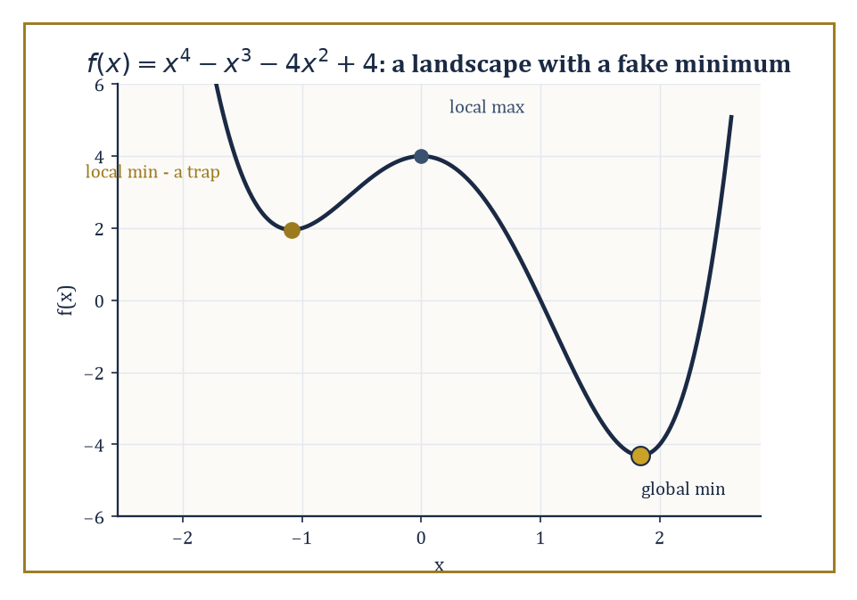
The quartic f(x) = x⁴ − x³ − 4x² + 4, with its local-max decoy at x = 0 and its two local minima — only one of which is telling the truth.
Recall the vocabulary: a point x* is a local minimum if the following holds for all x in some neighbourhood of x*,
f(x*) ≤ f(x)
and x* is a global minimum if that same inequality holds for every x in the whole domain, neighbourhood or not.
Convex functions collapse this distinction: every local minimum is global, so a hillwalker who only ever walks downhill is guaranteed to end up at the best possible place.
Nonconvex functions un-collapse it, and with a vengeance: they can have arbitrarily many local minima, most of them mediocre, plus critical points that are neither minima nor maxima at all — saddle points, where the surface curves up in some directions and down in others, like the seat of a horse.
The task of nonconvex optimization is not merely to find a point where the gradient vanishes (that's easy: sit still) but to find one that is actually good, in a landscape that offers no a priori assurance that 'locally best' means 'best'.
Numeric example — Worked example — a landscape with a fake minimum. Take f(x) = x⁴ − x³ − 4x² + 4, a quartic — so certainly nonconvex, since its second derivative changes sign. Its critical points satisfy
f′(x) = 4x³ − 3x² − 8x = 0
Factor out x:
x(4x² − 3x − 8) = 0
One root is x = 0. The other two solve the quadratic factor, and the quadratic formula gives
4x² − 3x − 8 = 0 ⟹ x = (3 ± √(9 + 128))/8 = (3 ± √137)/8
Since √137 ≈ 11.7047, the roots are x ≈ 1.8381 and x ≈ −1.0881. Classify them with the second derivative,
f″(x) = 12x² − 6x − 8
At x = 0:
f″(0) = −8 < 0
a local maximum, with f(0) = 4. At x ≈ −1.0881:
f″(−1.0881) ≈ 14.21 + 6.53 − 8 = 12.74 > 0
a local minimum; computing the value,
f(−1.0881) ≈ 1.954
At x ≈ 1.8381:
f″(1.8381) ≈ 40.54 − 11.03 − 8 = 21.51 > 0
also a local minimum; here
f(1.8381) ≈ −4.310
So the landscape has two local minima, at heights 1.954 and −4.310 — and only the second one is global. A hillwalker who starts near x = −1.088 and only ever walks downhill will confidently arrive at a point that is, in absolute terms, more than six units worse than the true bottom of the valley next door. This is the entire crisis of nonconvex optimization in miniature: local information certifies nothing about global quality.
The crisis, however, is not universal. Certain nonconvex problems that show up constantly in statistics and machine learning — phase retrieval (recovering a signal from the magnitudes of its measurements, with the phase information thrown away), low-rank matrix recovery, and the training landscapes of many neural networks — turn out to possess what practitioners have taken to calling benign nonconvexity.
The technical content of 'benign' varies by problem, but two flavours recur constantly: either every local minimum is secretly global (so the crisis above simply cannot occur), or every non-minimal critical point is a strict saddle, meaning it has at least one direction of strictly negative curvature that a sufficiently curious algorithm can use to escape.
Both properties are studied under the heading of landscape analysis — quite literally cartography for functions, mapping which regions are safe, which critical points are traps, and whether the good points (the global minima) form a connected set that a continuous path of descent could realistically reach, or scattered islands separated by ridges no local method could cross.
Abstract example — Abstract example — topology taxes the landscape. Landscape geometry is not free to be arranged however we like; the shape of the domain constrains how many critical points a function must have. This is Morse theory's contribution, and a compact instance makes it vivid.
Stand a torus (a doughnut) upright on a table and consider the height function h giving each point on its surface its vertical coordinate. Walking up from the bottom: there is one minimum (the lowest point, where the doughnut touches the table), then a saddle where the surface first curves both up and down as you pass the inner rim, then a second saddle at the inner rim on the opposite side, and finally one maximum at the top. That's 1 minimum, 2 saddles, 1 maximum.
Morse theory insists these counts satisfy the following, where χ is the Euler characteristic of the surface, and for a torus χ = 0:
(#minima) − (#saddles) + (#maxima) = χ
Check:
1 − 2 + 1 = 0
It works. Compare a sphere (χ = 2, like a ball sitting on the table): its height function has exactly 1 minimum and 1 maximum and needs no saddle at all, since
1 − 0 + 1 = 2
The torus is topologically obliged to have a saddle; the sphere is not. This is why the standard warning that 'the number of critical points can grow with dimension' is not superstition — it is a theorem about the shape of the space the function lives on, long before any particular function is chosen.
The upshot, and the thesis of this entire storey, is that nonconvex optimization is no longer a polite synonym for 'we have no idea what to do here.' It is a landscape, and landscapes can be surveyed.
The next room formalises exactly what a critical point looks like up close — first order, second order, and the crucial strict-saddle property that turns 'the gradient vanished' into 'the gradient vanished, but here is the direction that lets you keep going.'

Room 48.2: Critical Points, Saddles, and Landscape Geometry
Or: how to tell a resting place from a trap using nothing but a second derivative
A first-order critical point of a differentiable f is any x with the gradient equal to zero,
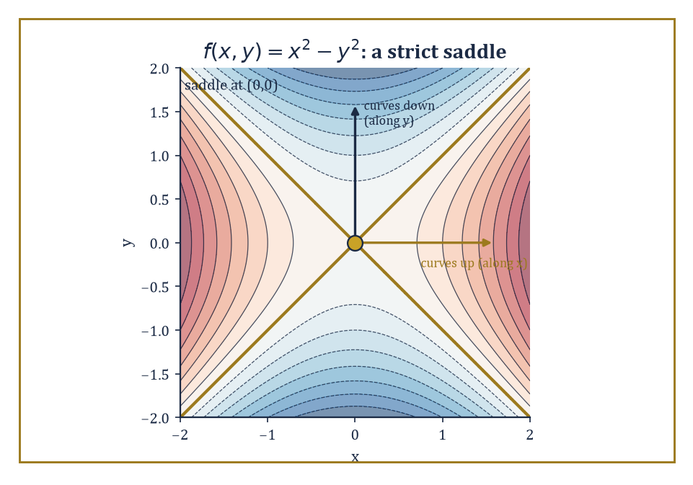
The textbook saddle f(x,y) = x² − y²: curving up along x, down along y, and offering the origin as a resting place only to those who don't look closely.
∇f(x) = 0
the vector of all partial derivatives vanishes entirely, so there is no direction of steepest ascent or descent left to follow. That alone is a weak certificate; it is satisfied by minima, maxima, and saddles alike.
A second-order critical point tightens the net: it additionally requires the Hessian matrix ∇²f(x) (the matrix of second partial derivatives) to be positive semidefinite, meaning every direction curves upward or stays flat — no direction of strictly negative curvature survives.
A strict saddle is a first-order critical point whose Hessian has at least one strictly negative eigenvalue: some direction genuinely curves downward, and a small step along it decreases f.
The strict-saddle property, which a function either has or doesn't, asserts that every critical point of f is either a local minimum or a strict saddle — nothing in between, and in particular no degenerate flat saddles where the Hessian is merely semidefinite with a zero eigenvalue sitting ambiguously on the fence.
Under this property, an algorithm equipped to detect and exploit negative curvature is guaranteed, eventually, to escape every saddle it meets.
Numeric example — Worked example — the textbook saddle. Consider the simplest possible saddle,
f(x, y) = x² − y²
Its gradient is
∇f(x, y) = (2x, −2y)
which vanishes only at the origin (0, 0) — the unique critical point. The Hessian is the constant matrix,
∇²f = [[2, 0], [0, −2]]
already diagonal, so its eigenvalues can be read off directly: 2 (along the x-direction) and −2 (along the y-direction). One positive, one negative — this is a strict saddle with a two-dimensional certificate rather than a one-dimensional guess.
Geometrically: walking along the x-axis from the origin,
f(x, 0) = x²
increases — you're climbing. Walking along the y-axis,
f(0, y) = −y²
decreases — you're descending. A plain gradient-descent step from exactly (0,0) goes nowhere, since the gradient there is the zero vector — but nudge the starting point by even a whisker in the y-direction, say to (0, 10⁻⁶), and the negative curvature along y takes over: subsequent gradient steps accelerate away from the origin and never look back.
This is precisely the mechanism behind perturbed gradient descent — inject a small random perturbation whenever the gradient is nearly zero, and any strict saddle you land near becomes, with high probability, a launching pad rather than a resting place.
The strict-saddle property matters because it converts a purely local guarantee (perturbed gradient descent escapes strict saddles) into something close to a global one: if every critical point in the entire landscape is either a genuine local minimum or an escapable strict saddle, then an algorithm that keeps escaping saddles can only ever converge to a local minimum, full stop — there is no third kind of resting place left to get stuck at.
Establishing that a given nonconvex problem has this property is landscape analysis in its purest form, and it typically proceeds by studying the geometry of sublevel sets,
{x : f(x) ≤ c}
do they stay connected as c grows, or do new disconnected components appear, signalling an isolated spurious minimum? — together with the connectivity of the set of global minimizers itself, and, for statistical estimation problems specifically, a condition called restricted strong convexity: the demand that f behaves like a convex, well-conditioned bowl not everywhere, but merely in a neighbourhood of the true underlying parameter, which is usually all an algorithm initialized sensibly will ever need.
Abstract example — Abstract example — a saddle carved out of symmetry. Many strict saddles arise not from bad luck but from symmetry: whenever a problem has an exact symmetry (swap two variables, flip a sign, rotate a factor), the symmetric point is almost always a saddle. Consider the smallest possible instance of matrix factorization, thinking of it as trying to write the 1×1 number '1' as a product of two scalar factors u and w,
h(u, w) = (uw − 1)²
Its critical points satisfy
∇h = (2w(uw−1), 2u(uw−1)) = 0
Either uw = 1, giving the entire hyperbola of solutions,
{(u, w) : uw = 1}
a connected curve of global minima, exactly the kind of landscape connectivity Room 48.1 flagged as desirable — or else both w(uw−1) = 0 and u(uw−1) = 0 with uw ≠ 1, which forces u = 0 and w = 0 simultaneously. So the origin is the only critical point that is not a global minimum.
Its Hessian, computed directly from the second partial derivatives,
∂²h/∂u² = 2w², ∂²h/∂w² = 2u², ∂²h/∂u∂w = 4uw − 2
evaluates at (0,0) to
[[0, −2], [−2, 0]]
whose eigenvalues are ±2 (the eigenvalues of any matrix of the form [[0, c], [c, 0]] are +c and −c). One positive, one negative: the origin is a strict saddle.
In one clean picture, this is the entire content of the benign-nonconvexity theorems for matrix factorization — a connected continuum of good points, and exactly one bad point, which isn't even dangerous.
Understanding the landscape — where the minima live, whether they're connected, and whether the remaining critical points are escapable — is the geometric prerequisite for everything that follows. It tells you what an algorithm is allowed to hope for before you've committed to running one.
The next room supplies the algorithm most commonly asked to do the hoping: stochastic gradient descent, which trades a perfect gradient for a noisy but cheap one, and somehow still gets the job done.

Room 48.3: Stochastic Gradient Methods
In praise of the gradient that is wrong on purpose, cheaply, and on average correct
Stochastic gradient descent (SGD) is the pragmatist's answer to a genuine computational bind: many objectives of interest are averages over an enormous number of terms,
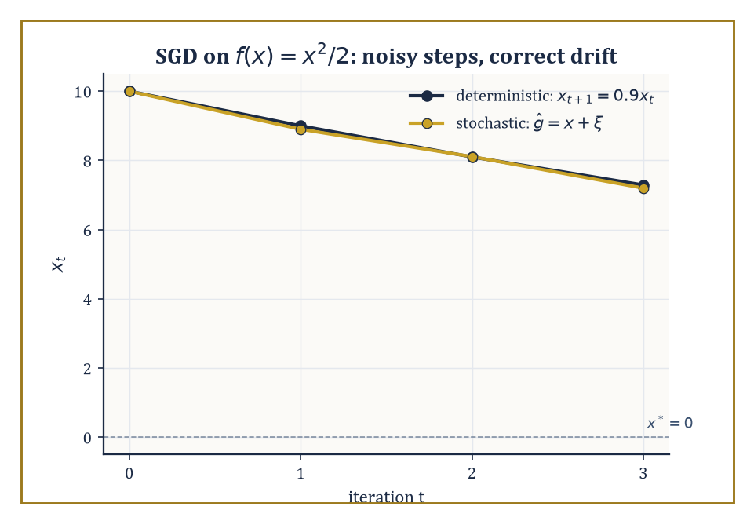
The worked descent on f(x) = x²/2: the stochastic path (10, 8.9, 8.11, 7.199) fluctuates around the deterministic one but tracks its downward drift closely.
f(x) = (1/n) Σᵢ fᵢ(x)
where n might be measured in the millions (one term per data point). Computing the exact gradient ∇f(x) means touching every single fᵢ, which becomes ruinously expensive as n grows.
SGD instead replaces the true gradient by an unbiased estimate ĝ(x) built from a single randomly chosen term, or a small mini-batch of them:
ĝ(x) = ∇fᵢ(x) for a randomly drawn index i
Unbiased means the following holds — on average, across all the randomness, the estimator gets it exactly right, even though on any given step it is almost certainly wrong by some amount:
𝔼[ĝ(x)] = ∇f(x)
The update rule is the familiar
x_{t+1} = x_t − η·ĝ(x_t)
with η the step size, except now the path it traces is a genuinely random walk biased, on average, downhill.
Numeric example — Worked example — a noisy descent, step by step. Let f(x) = x²/2, so the true gradient is ∇f(x) = x and the unique minimizer is x* = 0. Build a stochastic gradient estimator,
ĝ(x) = x + ξ, ξ drawn uniformly from {−1, +1}
This is unbiased since 𝔼[ξ] = 0, so 𝔼[ĝ(x)] = x exactly — but each individual draw is off by a full unit. Start at x₀ = 10 with step size η = 0.1, and suppose the noise realizations happen to come out as ξ₁ = +1, ξ₂ = −1, ξ₃ = +1.
Step 1: x₁ = x₀ − η(x₀ + ξ₁) = 10 − 0.1(11) = 8.9
Step 2: x₂ = x₁ − η(x₁ + ξ₂) = 8.9 − 0.1(7.9) = 8.11
Step 3: x₃ = x₂ − η(x₂ + ξ₃) = 8.11 − 0.1(9.11) = 7.199
Compare this to the deterministic path using the true gradient,
x_{t+1} = (1 − η)x_t = 0.9x_t
which gives 10 → 9 → 8.1 → 7.29. The stochastic path (10, 8.9, 8.11, 7.199) fluctuates around the deterministic one but tracks its overall downward trend closely — this is the entire phenomenon in miniature: individual steps are noisy, but the drift is correct, and over many iterations the noise averages out while the signal accumulates.
In the nonconvex setting SGD's guarantee weakens gracefully rather than collapsing: instead of converging to the global minimum, it converges (in expectation, or almost surely, or with high probability, depending on how careful the analysis wants to be) to a first-order critical point — somewhere the gradient is small.
Left entirely alone, it can and does linger near strict saddles for a while, since the mean update near a saddle is nearly zero and there's no systematic force pushing it off the fence.
But the noise itself is the escape mechanism: because ĝ(x) is random, it very rarely points in exactly the direction of zero curvature, and the negative-curvature component of the noise gets amplified step after step, eventually flinging the iterate away from the saddle — the same mechanism as the deliberate perturbations of Room 48.2, except SGD gets it for free, as a side effect of the very noise that made it cheap in the first place.
Three practical knobs govern how well this works: the mini-batch size (larger batches reduce the variance of ĝ but cost more per step), the learning-rate schedule (constant step sizes converge to a noise-dominated neighbourhood of a critical point; decaying step sizes, roughly η_t ∝ 1/√t, are needed for exact convergence), and momentum (accumulating a running average of past gradients to smooth out the zig-zag that noisy updates otherwise produce).
Numeric example — Worked example — what a bigger batch buys you. Suppose each individual noise term ξ has variance σ² = 1, as in the example above, since ξ ∈ {−1,+1} uniformly gives
Var(ξ) = 𝔼[ξ²] − 𝔼[ξ]² = 1 − 0 = 1
A mini-batch estimator averages m independent draws,
ĝ_batch(x) = x + (1/m)Σⱼ₌₁ᵐ ξⱼ
Since the ξⱼ are independent, the variance of their average is σ²/m. With a batch of m = 4, the variance of the noise term drops to
1/4 = 0.25
i.e. a standard deviation of 0.5 instead of 1 — the estimator is twice as precise, at four times the per-step computational cost. This square-root relationship (halve the noise, quadruple the batch) is the standard economic trade-off practitioners weigh constantly: doubling the batch size buys only a 1/√2 ≈ 29% reduction in noise, which is why, past a certain point, it is usually cheaper to run more noisy steps than fewer clean ones.
SGD's real triumph is not any particular convergence rate but the fact that it made large-scale nonconvex optimization routine at all: its per-iteration cost is independent of n, the dataset size, so a model can be trained on a billion examples using exactly the same per-step arithmetic as one trained on a thousand.
This is the algorithm underneath essentially every modern machine-learning system, and the next room asks how to do better than plain SGD without giving up that scalability — first by reducing the variance directly, and then by letting the step size adapt itself, coordinate by coordinate, to the terrain it happens to be crossing.

Room 48.4: Variance Reduction and Adaptive Methods
Two ways to make a noisy gradient behave itself: subtract the noise, or outsmart it
Variance reduction attacks the noise in SGD head-on for the finite-sum setting,
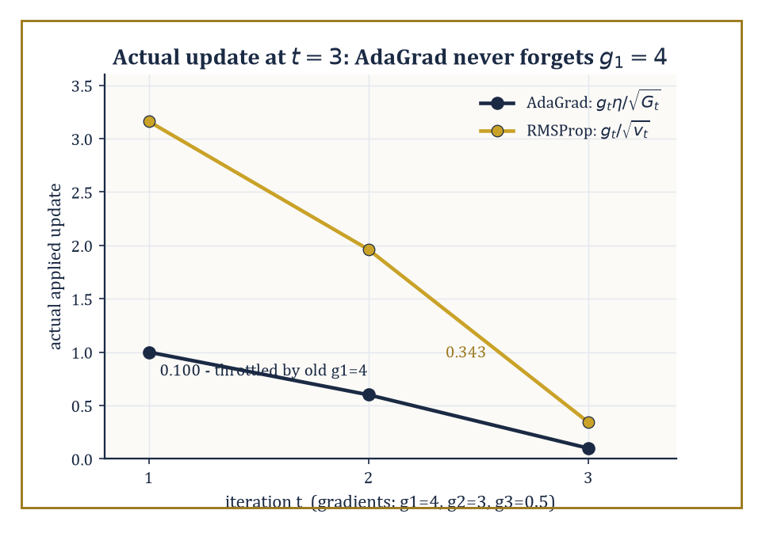
The actual applied update at t = 3 for gradients (4, 3, 0.5): AdaGrad's ever-growing accumulator throttles it to 0.100, while RMSProp's short memory allows 0.343.
f(x) = (1/n)Σᵢ fᵢ(x)
The family of methods — SVRG, SAGA, SARAH, among others — shares a common trick: instead of using a raw stochastic gradient ∇fᵢ(x), construct a control-variate estimator that combines the current sample with a correction computed at some reference point x̃, a periodically refreshed 'snapshot':
ĝ = ∇fᵢ(x) − ∇fᵢ(x̃) + ∇f(x̃)
This is still unbiased, since the snapshot terms cancel in expectation,
𝔼ᵢ[ĝ] = ∇f(x) − ∇f(x̃) + ∇f(x̃) = ∇f(x)
but crucially its variance shrinks to zero as x approaches x̃, because the difference ∇fᵢ(x) − ∇fᵢ(x̃) — the part that still depends on the random index i — itself shrinks to zero.
Under strong convexity, or the weaker Polyak–Łojasiewicz (PL) condition — which demands only the following for some μ > 0, a bound relating gradient size to sub-optimality without requiring convexity at all —
‖∇f(x)‖² ≥ 2μ(f(x) − f*)
this restores the fast linear convergence rate of full gradient descent while still touching only one or a few fᵢ per step. Nonconvex finite-sum problems admit analogous, somewhat weaker, guarantees.
Numeric example — Worked example — variance reduction with the noise removed by hand. Take three component functions with a = (1, 3, 8),
fᵢ(x) = (x − aᵢ)²/2, f(x) = (1/3)Σfᵢ(x)
so f has true gradient ∇f(x) = x − ā where
ā = (1+3+8)/3 = 4
At the current point x = 0, the true gradient is
∇f(0) = 0 − 4 = −4
Check it component-wise:
f₁′(0) = −1, f₂′(0) = −3, f₃′(0) = −8, average = (−1−3−8)/3 = −4
Now fix a snapshot point x̃ = 2, with true gradient
∇f(2) = 2 − 4 = −2
and components
f₁′(2) = 1, f₂′(2) = −1, f₃′(2) = −6, average = −2
as required. Build the SVRG estimator for a randomly sampled index, say i = 3:
ĝ₃ = f₃′(0) − f₃′(2) + ∇f(2) = (−8) − (−6) + (−2) = −4
exactly the true gradient. Try i = 1 instead:
ĝ₁ = (−1) − (1) + (−2) = −4
And i = 2:
ĝ₂ = (−3) − (−1) + (−2) = −4
Every single sample gives exactly the right answer, with zero variance. This isn't a coincidence of these particular numbers — it's because every fᵢ here is a quadratic with the same curvature (coefficient ½ on x²), so
fᵢ′(x) − fᵢ′(x̃) = (x − aᵢ) − (x̃ − aᵢ) = x − x̃
regardless of aᵢ: the sample-dependent part cancels exactly, leaving only the deterministic correction x − x̃ plus the snapshot gradient. In general, with unequal curvatures, some residual variance survives this cancellation — but it shrinks steadily as x moves toward x̃, which is the entire mechanism variance reduction exploits.
Adaptive methods take a different tack entirely: rather than reducing the noise in the gradient estimate, they reshape the step itself, coordinate by coordinate, using the history of gradient magnitudes observed so far.
AdaGrad accumulates the sum of squared past gradients per coordinate,
G_t = Σ_{s≤t} g_s²
and divides the step size by √G_t, so coordinates that have seen large gradients get smaller effective steps and coordinates that have stayed quiet get comparatively larger ones — useful when different parameters naturally live on very different scales.
RMSProp and Adam replace that ever-growing sum with an exponentially decaying moving average of squared gradients,
v_t = β v_{t−1} + (1−β)g_t²
so old gradient information is gradually forgotten rather than accumulated forever; Adam additionally keeps a momentum-style moving average of the gradients themselves.
These are, by a wide margin, the default optimizers used to train deep networks in practice, even though a fully satisfying theoretical account of why they so often outperform plain SGD — and precisely when they don't — remains an active and somewhat contested area of research.
Numeric example — Worked example — AdaGrad never forgets (and that's the problem). Suppose a single coordinate sees gradients g₁ = 4, g₂ = 3, g₃ = 0.5 over three steps — a large early gradient followed by two much smaller ones. AdaGrad's accumulator builds up as:
G₁ = 4² = 16, G₂ = 16 + 3² = 25, G₃ = 25 + 0.5² = 25.25
With base learning rate η = 1, the effective step size at t = 3 is
η/√G₃ = 1/√25.25 ≈ 1/5.025 ≈ 0.199
giving an actual update of
g₃ × 0.199 ≈ 0.0995
tiny, even though the current gradient g₃ = 0.5 isn't itself especially small; the update is being throttled by a large gradient from two steps ago that has long since become irrelevant.
Now compare RMSProp with decay β = 0.9 and v₀ = 0:
v₁ = 0.9(0) + 0.1(16) = 1.6, v₂ = 0.9(1.6) + 0.1(9) = 2.34, v₃ = 0.9(2.34) + 0.1(0.25) = 2.131
The effective step at t = 3 is
g₃/√v₃ = 0.5/√2.131 ≈ 0.5/1.460 ≈ 0.3425
more than three times larger than AdaGrad's, because the exponential average has partly forgotten the old g₁ = 4 and is responding mainly to recent, smaller gradients. This single comparison is the entire historical motivation for RMSProp and Adam over plain AdaGrad: an ever-growing accumulator eventually stalls every coordinate's learning rate to near zero, however irrelevant the gradient that caused it has become.
Variance reduction and adaptation are, in this sense, the two principal refinements available once you've decided plain SGD is too noisy or too poorly scaled to be efficient on its own — one attacks the randomness directly, the other reshapes the geometry the randomness has to navigate, and modern practice frequently reaches for both.
The next room turns to problems where the dimension itself is the enemy: high-dimensional statistical estimation, where the number of unknowns can dwarf the number of observations, and nonconvexity is not a nuisance to be tolerated but the natural, unavoidable formulation of the problem.

Room 48.5: High-Dimensional and Structured Nonconvex Problems
Where the unknowns outnumber the data, and convexity becomes a luxury good
A cluster of high-dimensional statistical estimation problems — sparse regression (recovering a vector with mostly zero entries), low-rank matrix completion (filling in the missing entries of a matrix known to have low rank), phase retrieval (recovering a signal from only the magnitudes, not the signs or phases, of its measurements), and blind deconvolution — share a family resemblance: they are naturally nonconvex the moment you write them down in their own natural parameters.
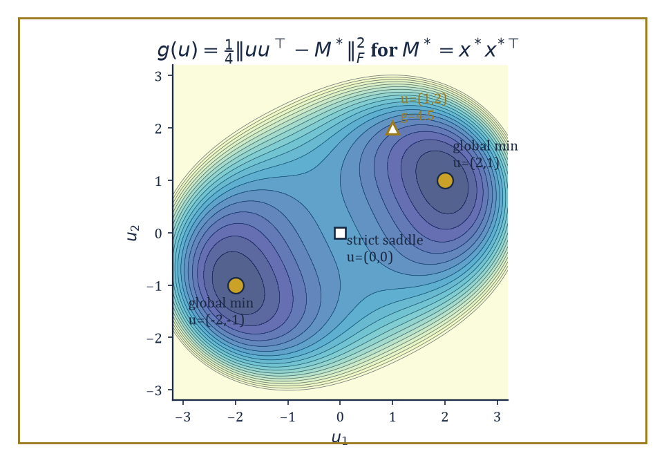
The rank-1 recovery landscape g(u): two symmetric global minima at ±(2,1), one escapable saddle at the origin, and a substantial penalty for the merely plausible-looking (1,2).
Ask directly for a low-rank matrix,
M = UVᵀ
and you are optimizing over factors U and V, and that factorized objective is nonconvex (the map (U,V) ↦ UVᵀ is bilinear, not linear, and the same M has infinitely many factorizations).
One classical fix is convex relaxation: replace 'rank' with the nuclear norm (the sum of singular values, the tightest convex surrogate for rank) or replace 'sparsity' with the ℓ¹ norm, and solve a convex problem instead.
These relaxations provably recover the truth once the measurement operator satisfies a restricted isometry property (RIP) or a restricted eigenvalue condition — roughly, that it doesn't distort the length of any sparse or low-rank vector too badly, so that fitting the data still pins down the truth uniquely.
Numeric example — Worked example — a nonconvex landscape for rank-1 recovery. Suppose the ground truth is a rank-1 matrix M* = x*x*ᵀ for x* = (2, 1), so
M* = [[4, 2], [2, 1]]
Rather than solving a convex nuclear-norm problem, work directly with the nonconvex factorized objective, minimizing over a single factor u ∈ ℝ²,
g(u) = ¼‖uuᵀ − M*‖²_F
At u = x* = (2,1):
uuᵀ = [[4,2],[2,1]] = M*, so g(x*) = 0
the global minimum. By the sign symmetry of the factorization, u = −x* = (−2,−1) is also a global minimum:
(−2)(−2)=4, (−2)(−1)=2, (−1)(−2)=2, (−1)(−1)=1
reproducing M* exactly again. Now evaluate the same objective at a nearby-looking but wrong point, u = (1, 2):
uuᵀ = [[1,2],[2,4]]
The difference from M* is
[[1−4, 2−2],[2−2, 4−1]] = [[−3, 0],[0, 3]]
with squared Frobenius norm
9 + 0 + 0 + 9 = 18, giving g(1,2) = 18/4 = 4.5
a substantial penalty for what looks, at a glance, like a modest perturbation of the truth (same coordinates, swapped). This is the shape of the whole enterprise: the nonconvex objective has exactly the two symmetric global minima ±x* and nothing else pretending to be one, and results in this area (matrix-sensing landscape theorems, in the style of Room 48.2's strict-saddle discussion) establish that every other critical point of g is a strict saddle — so a perturbed gradient method, run directly on the factors, provably finds x* up to the unavoidable sign ambiguity, with no relaxation and no nuclear norm in sight.
The reason nonconvex methods — projected gradient descent (take a gradient step, then project back onto the constraint set, such as the set of sparse or low-rank objects), alternating minimization (optimize over U with V fixed, then over V with U fixed, repeat), and Wirtinger flow (a gradient method tailored to phase retrieval's complex-valued, magnitude-only measurements) — often match or beat their convex relaxation cousins is computational: the convex relaxations frequently require solving a semidefinite program or an ℓ¹-penalized regression over a much larger lifted variable (an n×n matrix instead of a length-n vector, say), whereas the nonconvex method works directly with the natural, small parameterization the whole time.
The price is that the analysis is harder and typically only local: it establishes restricted strong convexity and restricted smoothness in a neighbourhood of the truth, valid once the sample size clears some threshold, and then shows a sensible initialization (often obtained via a cheap spectral method) lands inside that neighbourhood to begin with.
Abstract example — Abstract example — when statistics and computation disagree. Not every high-dimensional problem that is statistically solvable is also efficiently solvable, and the gap between the two is itself a subject of study, the computational–statistical gap. Consider sparse PCA in miniature: a covariance matrix
Σ = θ·vvᵀ + I
where v is an unknown k-sparse unit vector (only k of its n coordinates are nonzero) hidden inside an otherwise featureless identity background, and θ measures how strong the planted signal is.
Information-theoretically — meaning if you were willing to search over every one of the (n choose k) possible support sets by brute force — a signal strength θ on the order of the following (with m the number of samples) suffices to recover v's support with high probability:
θ ≈ √(k log n / m)
But every known polynomial-time algorithm (methods based on the top eigenvector, or on convex relaxations of the sparsity constraint) appears to require a substantially larger θ to succeed, closer to
θ ≈ √(k² log n / m)
a gap of a full factor of √k in the required signal strength (equivalently, a factor of k in the number of samples needed for a fixed signal strength), believed — and in restricted computational models, provable — to be unavoidable for any efficient method.
The moral for structured nonconvex optimization is sobering: 'more data would fix it' and 'a better algorithm would fix it' are not always the same claim, and telling them apart is itself a research programme, one that borrows tools from cryptography and average-case complexity that would look entirely out of place in Storey 30's convex world.
Structured nonconvexity, then, is the precise point at which advanced optimization stops being purely about algorithms and starts being inseparable from high-dimensional statistics: the landscape's good behaviour is a probabilistic fact about random data, established with the tools of concentration of measure, and the algorithm's success is contingent on that fact holding.
The next room leaves single-objective minimization behind altogether, for problems with two competing players and no single number either of them is simply trying to minimize.

Room 48.6: Minimax Optimization and GANs
Two gradients enter a room; only sometimes does either of them leave
A minimax problem asks for
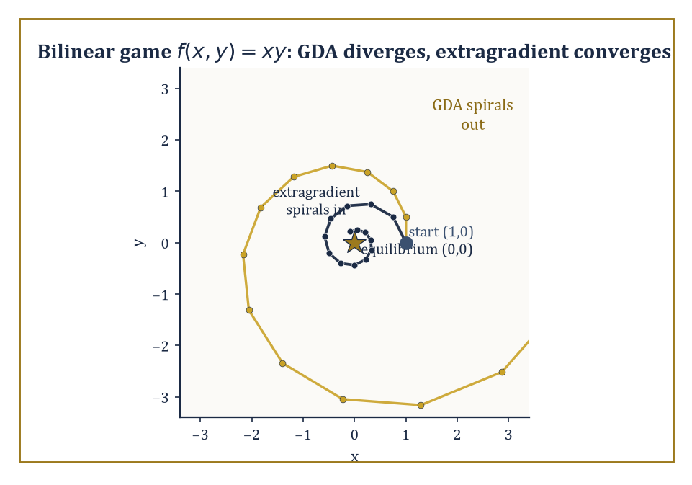
Same bilinear game, same starting point, same step size: gradient descent-ascent spirals away from the equilibrium while extragradient spirals politely into it.
min_x max_y f(x,y)
one variable x tries to minimize the objective while another variable y, adversarially, tries to maximize it, each choosing after seeing the other's move in the idealized sense the notation implies.
These arise wherever there are two opposing forces rather than one — in classical game theory, in robust optimization (x is a decision, y is 'nature' or an adversary choosing the worst-case disturbance), and, in one of the more consequential recent examples, in the training of generative adversarial networks (GANs), where a generator (x) tries to produce fake data indistinguishable from real, while a discriminator (y) tries to tell them apart.
Single-objective optimality (a critical point, a local minimum) no longer makes sense as a target, since improving f for x's sake generally makes it worse for y's; the right notion of a solution is a Nash equilibrium, a pair (x*, y*) at which neither player can improve their own outcome by unilaterally changing their choice — or, in settings with a genuine order of play, a Stackelberg equilibrium, where one player commits first and the other best-responds.
Both can be phrased as variational inequalities, a general framework for 'no direction of unilateral improvement exists' that subsumes ordinary critical points as the special case of a single player.
Numeric example — Worked example — the simplest minimax game diverges. Take the bilinear game
f(x,y) = xy
whose unique equilibrium is (0,0) — the saddle point of the surface, exactly as in Room 48.2's f(x,y)=x²−y² example, except now one variable is minimizing and the other maximizing along the two axes at once. Gradient descent-ascent (GDA) updates both simultaneously:
x_{t+1} = x_t − η·∂f/∂x = x_t − η y_t, y_{t+1} = y_t + η·∂f/∂y = y_t + η x_t
Start at (x₀,y₀) = (1,0) with η = 0.5.
Step 1: x₁ = 1 − 0.5(0) = 1, y₁ = 0 + 0.5(1) = 0.5
Step 2: x₂ = 1 − 0.5(0.5) = 0.75, y₂ = 0.5 + 0.5(1) = 1.0
Step 3: x₃ = 0.75 − 0.5(1.0) = 0.25, y₃ = 1.0 + 0.5(0.75) = 1.375
Track the squared distance from the equilibrium, r²_t = x_t² + y_t²:
r²₀ = 1, r²₁ = 1 + 0.25 = 1.25, r²₂ = 0.5625 + 1 = 1.5625, r²₃ = 0.0625 + 1.890625 ≈ 1.953
It's growing, and in fact growing by a constant factor each step: algebraically,
x_{t+1}² + y_{t+1}² = (x_t − ηy_t)² + (y_t + ηx_t)² = x_t² + y_t² + η²(x_t² + y_t²) = (1+η²)(x_t² + y_t²)
so r²_{t+1} = (1+η²)r²_t exactly. With η = 0.5, that factor is 1.25 — check:
1×1.25=1.25 ✓, 1.25×1.25=1.5625 ✓, 1.5625×1.25≈1.953 ✓
The iterates spiral outward geometrically forever, never converging, despite starting a mere unit away from the correct answer. Naive simultaneous gradient descent-ascent simply does not work on this, the simplest possible minimax problem there is.
This failure is not a defect of the example; it is the central obstruction of the whole subject. Under a convex-concave assumption — f convex in x for every fixed y, and concave in y for every fixed x — extragradient and optimistic-gradient variants (which take a tentative lookahead step before committing to the real update, using the gradient at the lookahead point rather than the current one) do converge, provably.
Once convexity-concavity is abandoned — nonconvex-nonconcave minimax, which is exactly what a GAN's generator-versus-discriminator game actually is — the guarantees mostly evaporate, and the empirical behaviour matches: limit cycles (the iterates orbit the equilibrium forever, neither approaching nor escaping), oscillation, and outright divergence are all commonly observed in practice, which is precisely why GAN training has a well-earned reputation for being finicky, sensitive to hyperparameters, and prone to a failure mode called mode collapse in which the generator gives up on diversity and produces the same handful of outputs regardless of input.
Numeric example — Worked example — the lookahead that saves the day. Apply extragradient to the identical bilinear game and starting point. Each step first computes a lookahead half-move using the current gradients — exactly one GDA step — and then uses the gradient at that lookahead point to update from the original position. Lookahead from (1, 0):
x̄ = 1 − 0.5(0) = 1, ȳ = 0 + 0.5(1) = 0.5
identical to GDA's first step so far. Real update:
x₁ = x₀ − η·ȳ = 1 − 0.5(0.5) = 0.75, y₁ = y₀ + η·x̄ = 0 + 0.5(1) = 0.5
Already
r²₁ = 0.75² + 0.5² = 0.5625 + 0.25 = 0.8125
down from r²₀ = 1 — shrinking, not growing. Second step: lookahead from (0.75, 0.5) gives
x̄ = 0.75 − 0.5(0.5) = 0.5, ȳ = 0.5 + 0.5(0.75) = 0.875
real update
x₂ = 0.75 − 0.5(0.875) = 0.3125, y₂ = 0.5 + 0.5(0.5) = 0.75
Now
r²₂ = 0.3125² + 0.75² = 0.09766 + 0.5625 = 0.66016
smaller again. The sequence of squared distances, 1 → 0.8125 → 0.660, is contracting steadily toward the true equilibrium at the origin — exactly the behaviour GDA failed to produce with the same starting point, same step size, and almost the same arithmetic. The one extra lookahead half-step is the entire difference between divergence and convergence.
Minimax optimization extends the reach of the whole theory from a single objective to a genuinely competitive setting, and the extragradient idea above is only the simplest of a family of correction schemes designed to tame the rotational dynamics that plain gradient descent-ascent cannot handle.
Designing training algorithms for GANs and related adversarial architectures that are provably reliable outside the convex-concave comfort zone remains one of the liveliest open interfaces between optimization theory and machine-learning practice. The next room asks a different, more austere question: forgetting any particular algorithm, how fast could the best possible algorithm ever hope to go?

Room 48.7: Complexity Lower Bounds and Optimal Rates
In which the tower stops asking what's known and starts asking what's knowable
An oracle complexity lower bound is a theorem of a particular, almost paranoid shape: for a stated class of functions (say, all functions that are smooth with a given Lipschitz-continuous gradient, or all such functions that are additionally convex, or strongly convex, or nonconvex with a Lipschitz Hessian), and for any algorithm that is only permitted to query a gradient oracle — hand it a point, it hands back the gradient there, and nothing else — there exists some function in the class on which the algorithm needs at least a certain number of queries to find an approximately optimal point.
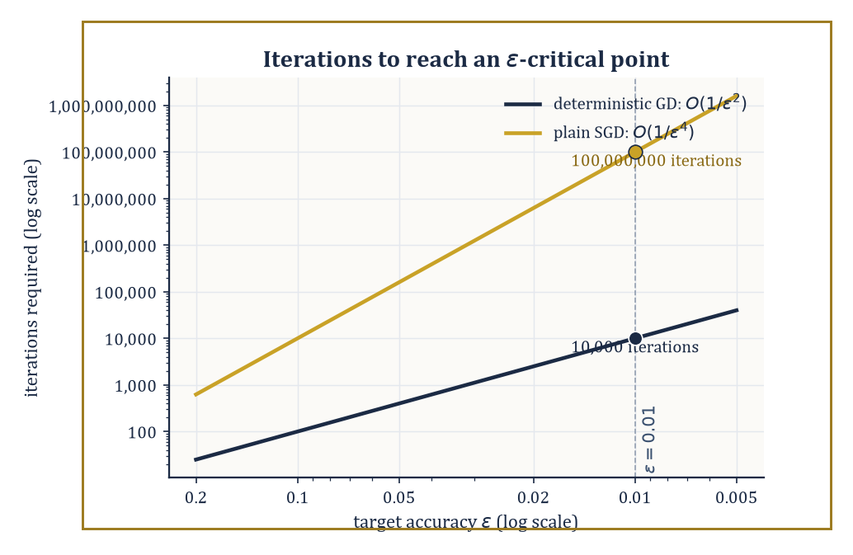
O(1/ε²) versus O(1/ε⁴): at ε = 0.01 the gap between deterministic and stochastic iteration counts is already four orders of magnitude, and it only widens.
It is a statement not about any specific algorithm's failure, but about every conceivable algorithm's failure, on some worst-case adversarially chosen function.
When a matching upper bound exists — an actual algorithm, such as gradient descent or Nesterov's accelerated gradient method from Storey 30, that achieves that same rate — the two bounds sandwich the truth exactly, and the question 'what is the best possible rate' closes for good, at least within that oracle model.
Numeric example — Worked example — why the exponent is the whole story. In the nonconvex setting, the standard target is an ε-critical point: a point x with the gradient small, even if global optimality can't be certified,
‖∇f(x)‖ ≤ ε
Under standard smoothness assumptions, deterministic gradient descent needs O(1/ε²) iterations to find one, while plain SGD, hobbled by the variance of its gradient estimates, needs O(1/ε⁴). Set ε = 0.01 and compare, treating the hidden constants as 1 for illustration.
Deterministic: 1/ε² = 1/(0.01)² = 1/0.0001 = 10,000 iterations
Stochastic: 1/ε⁴ = 1/(0.01)⁴ = 1/(10⁻⁸) = 100,000,000 iterations
That's ten thousand times more. This is not a rounding difference; it is the difference between a computation so short you wouldn't notice it (10,000 iterations, gone in well under a second on anything built this century) and one that, at a million iterations per second, still takes a leisurely hundred seconds — nearly two minutes spent achieving what determinism would have delivered in a blink.
The gap is the price of noise: every doubling of precision (halving ε) costs deterministic GD a factor of 4 in iteration count, but costs SGD a factor of 16 — which is exactly why variance reduction (Room 48.4), which restores something closer to the deterministic rate for finite sums, is not a minor refinement but close to essential once high precision is required.
Structure earns you a better rate, and the theory is precise about how much better: under the Polyak–Łojasiewicz condition introduced in Room 48.4, gradient descent's rate improves from the generic sublinear nonconvex rate to a linear (geometric) one, matching what strong convexity alone would give in the convex world, even though the PL condition says nothing about convexity at all — it only bounds how gradient magnitude relates to sub-optimality.
Under the strict-saddle property of Room 48.2, perturbed gradient methods achieve essentially the same rate as unperturbed gradient descent for finding critical points, plus only a small additional cost, polynomial in the dimension, for the perturbations doing the work of escaping saddles.
These lower bounds are established through what's called information-based complexity: one constructs an explicit worst-case 'resisting' function, engineered so that until an algorithm has made enough queries, no amount of cleverness can distinguish it from several other functions with very different minimizers — so no algorithm, however clever, can have found the right one yet.
Abstract example — Abstract example — a function built to resist you. The canonical resisting construction, due to Nesterov, is a chain function: a quadratic built so information about the objective can only travel one coordinate at a time. A miniature two-coordinate version,
f(x₁,x₂) = ½(x₁ − 1)² + ½(x₁ − x₂)²
is minimized, as direct calculus confirms, at x₁ = x₂ = 1. The point of the construction is structural, not this tiny instance's exact rate: the gradient's second coordinate,
∂f/∂x₂ = x₂ − x₁
is identically zero whenever x₂ has not yet 'heard' about x₁ (for instance, starting from x₁ = x₂ = 0, the first gradient step moves x₁ toward 1 but leaves the x₂-component of the gradient at exactly 0 until x₁ has actually moved).
In the full N-coordinate chain, summed along a chain of N variables,
½(x₁−1)² + ½Σ(xᵢ − x_{i+1})²
a gradient-only algorithm started at the origin can only make coordinate x_k respond after roughly k rounds of these one-step-at-a-time relays, because each coordinate's gradient stays at zero until its neighbour up the chain has already moved. Make N large enough relative to the target accuracy ε, and the number of iterations needed to get information all the way down the chain is forced to scale as claimed by the lower bound — a function that is, by design, exactly as slow to solve as the theorem says any function in its class could be.
Lower bounds convert the informal, slightly embarrassed admission 'we don't currently know a faster algorithm for this' into the considerably more satisfying mathematical statement 'no faster algorithm exists, within this oracle model, full stop' — the gradient-oracle equivalent of a speed limit backed by the laws of physics rather than a suggestion from the council.
The next room asks what all this optimization machinery is actually for, once the objective being minimized is itself an estimate of something statistical rather than a fixed target handed down from on high.

Room 48.8: Optimization for Statistical Learning
In which minimizing the training loss turns out to be doing more work than you asked it to
The interface between optimization and statistical learning asks a question that would have seemed almost impertinent in Storey 30: does it matter how you minimize the loss, not just whether you minimize it? The surprising answer is yes, emphatically — the step size, the amount and kind of regularization, when you stop training, and the batch size all leave fingerprints on the statistical quality of the solution you end up with, quite independently of how low the training loss itself got.
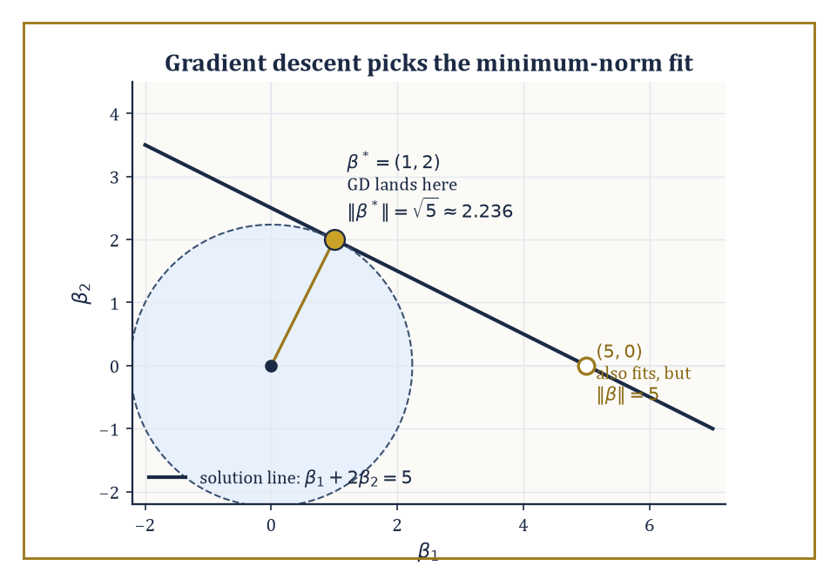
Every point on the line β₁ + 2β₂ = 5 fits the data perfectly; gradient descent from zero quietly picks the one closest to the origin, β* = (1,2), over equally valid alternatives like (5,0).
The clearest instance is implicit regularization: in an overparameterized model (more parameters than data points, so infinitely many settings of the parameters fit the training data exactly), gradient descent started from a particular initialization — typically all-zero, or small random values — does not land on an arbitrary interpolating solution.
It systematically prefers a specific one, and for the simplest overparameterized model, ordinary linear least squares with more unknowns than equations, that preferred solution has an exact, classical description: the minimum-norm interpolant, the one among all data-fitting solutions with the smallest Euclidean length.
Numeric example — Worked example — gradient descent picks the tidiest answer. Take the smallest instructive underdetermined case: one data point, two parameters. The design row is X = [1, 2], the target is y = 5, and any β = (β₁, β₂) with the following fits the data perfectly — a whole line of solutions in the plane:
β₁ + 2β₂ = 5
The minimum-norm one is given by the pseudoinverse formula,
β* = Xᵀ(XXᵀ)⁻¹y
Here XXᵀ = 1² + 2² = 5 (a 1×1 matrix, so just the scalar 5), giving
β* = [1;2]·(1/5)·5 = [1;2]·1 = (1, 2)
Check the fit:
1(1) + 2(2) = 1 + 4 = 5 ✓
Its norm is
‖β*‖ = √(1² + 2²) = √5 ≈ 2.236
Compare another perfectly valid fit, β = (5, 0): also satisfies
1(5) + 2(0) = 5 ✓
but
‖β‖ = √(25+0) = 5
more than twice as large. It is a classical fact (traceable to the geometry of linear least squares: gradient descent from zero never leaves the row space of X, and within that one-dimensional row space here, only β* lies on the solution line) that gradient descent initialized at β₀ = (0,0) on this problem converges exactly to β* = (1,2), the minimum-norm solution — not to (5,0), not to any of the infinitely many other equally data-fitting alternatives. The algorithm, asked only to drive the training loss to zero, quietly also chose the smallest, and typically best-generalizing, way of doing so.
This phenomenon generalizes, with less exact but still substantial force, to the interpolation regime of modern overparameterized models (including, notoriously, large neural networks trained past the point of fitting their training data exactly): the path gradient descent takes, not merely its endpoint, encodes a statistical preference, and understanding that preference is now understood to be part of the statistical procedure itself, not a footnote to it.
A second thread ties optimization to statistics through online learning: a sequential prediction setting where, at each round t, the learner commits to a point x_t before seeing that round's loss function ℓ_t, incurs ℓ_t(x_t), and only then gets to see ℓ_t and update.
The natural performance measure is regret — the learner's total loss compared to the best single fixed point chosen with the benefit of hindsight,
min_x Σ_t ℓ_t(x)
and bounding this regret, achievable with the same online-gradient-descent update as ordinary SGD, is simultaneously an optimization guarantee and (via standard online-to-batch conversion arguments) a statistical generalization guarantee for models trained by SGD on streaming or randomly-ordered data.
Numeric example — Worked example — regret, computed honestly. Run online gradient descent on three rounds of losses ℓ_t(x) = (x − c_t)²/2 with targets c = (1, −1, 1), starting at x₁ = 0 with step size η = 0.5.
Round 1: predict x₁ = 0, incur loss (0−1)²/2 = 0.5; gradient x₁ − c₁ = −1, so x₂ = x₁ − 0.5(−1) = 0.5
Round 2: predict x₂ = 0.5 against c₂ = −1, incur loss (0.5−(−1))²/2 = (1.5)²/2 = 1.125; gradient x₂ − c₂ = 1.5, so x₃ = 0.5 − 0.5(1.5) = −0.25
Round 3: predict x₃ = −0.25 against c₃ = 1, incur loss (−0.25−1)²/2 = (−1.25)²/2 = 0.78125
Total algorithm loss:
0.5 + 1.125 + 0.78125 = 2.40625
Now the benchmark: the single best fixed x in hindsight minimizes Σ(x−c_t)²/2 over all three rounds at once, achieved at
x* = mean(c) = (1 − 1 + 1)/3 = 1/3
Its total loss is
(1/3−1)²/2 + (1/3+1)²/2 + (1/3−1)²/2 = (4/9)/2 + (16/9)/2 + (4/9)/2 = 2/9 + 8/9 + 2/9 = 12/9 = 4/3 ≈ 1.3333
The regret — algorithm loss minus best-in-hindsight loss — is
2.40625 − 1.3333 ≈ 1.073
That the regret is positive is entirely expected: the online learner had to commit to x₂ = 0.5 before knowing c₂ was going to swing all the way to −1, a mistake the hindsight benchmark never has to make. What online-learning theory actually promises is not zero regret but sublinear regret — that this gap, divided by the number of rounds T, shrinks toward zero as T grows, so the learner's per-round disadvantage relative to the best fixed choice vanishes even though it is never told the future.
The lesson of this room, stated as starkly as the evidence allows: optimization, in the context of statistical learning, is not a subroutine bolted onto statistics from outside, minimizing a number handed to it by a separate statistical procedure.
It is part of the statistical procedure — the choice of algorithm, initialization, step size, and stopping time is itself a form of implicit modelling, one that current theory can characterize precisely in simple cases and is still working, with considerable urgency, to characterize in the complicated ones that actually get deployed.

Room 48.9: Looking Ahead: From Advanced Optimization to Deep Learning, Distributed Methods, and Open Problems
The view from the top of a storey built almost entirely out of things that shouldn't have worked
Gather up the tools of this storey and the shape of what's been built becomes clear. Nonconvex landscape geometry (Rooms 48.1–48.2) told us when local search can be trusted despite the absence of global convexity — strict saddles, benign nonconvexity, landscape connectivity.
Stochastic and adaptive methods (Rooms 48.3–48.4) told us how to run that local search cheaply, at scale, with noisy information, and how to reshape the geometry the noise has to cross.
Structured high-dimensional problems (Room 48.5) showed nonconvexity arising not as an obstacle but as the honest formulation of a statistical estimation task, complete with its own gap between what's statistically possible and what's computationally efficient.
Minimax optimization (Room 48.6) extended everything to competitive, two-player settings where a single number to minimize no longer exists. Complexity lower bounds (Room 48.7) told us, with total rigour, exactly how good any of this could ever get. And optimization for statistical learning (Room 48.8) closed the loop by showing the algorithm itself quietly performing statistics whether or not anyone asked it to.
None of this is a finished cathedral; it is scaffolding around several very active construction sites.
The training of deep neural networks specifically raises landscape questions this storey has only gestured at — how the architecture itself (depth, width, skip connections, the normalization layers that rescale activations mid-network, the attention mechanisms that weight which inputs matter to which outputs) reshapes the loss landscape, sometimes making it dramatically more benign than a naive parameter count would suggest and sometimes not.
Distributed and federated optimization asks how to run these same algorithms when the data, and the compute, are scattered across many machines that may disagree with each other's statistics (heterogeneity) and can only communicate occasionally and expensively (communication efficiency) — an entire secondary optimization problem layered on top of the one this storey has been solving.
Second-order and quasi-Newton methods, which use curvature information the way Newton's method did back in Storey 30, are being revisited for problems at a scale where computing, let alone inverting, a full Hessian is unthinkable, forcing clever low-memory approximations.
And a healthy list of open problems remains stubbornly open: sharp, general rates for nonconvex-nonconcave minimax problems (Room 48.6 showed you the easy convex-concave case and the outright pathological bilinear failure; the vast territory in between is still being mapped); a fully satisfying theoretical account of why adaptive methods work as well as they empirically do; and a precise characterization of exactly which modern architectures enjoy benign nonconvexity and which merely got lucky with their initialization.
The deeper lesson of the whole storey, if it has to be compressed into one sentence for the lift ride down, is that nonconvexity is not an obstacle to be apologized for but a landscape to be understood — and that understanding it, structure by structure, has produced algorithms that succeed spectacularly far outside the tidy convex regime where the theory was originally, and modestly, built.
Advanced optimization is the mathematics of hard, high-dimensional, and stochastic decision-making, and the tower continues upward: the next storey, Numerical Methods (Advanced), asks a closely related but distinct question — not merely how to find the minimizer of a function you can only sample noisily, but how to compute, reliably and to guaranteed precision, whatever it is a differential equation, an integral, or a linear system is quietly trying to tell you, when doing so exactly is as hopeless as finding a global minimum by inspection alone.
We have learned, at least, to climb the nonconvex landscape without assuming there's only one valley in it.
So ends Storey 48, four floors short of the roof, having spent its length arguing that the absence of convexity is a research programme rather than a eulogy. What began, storeys ago, as gradient descent politely rolling downhill in a single well-behaved bowl has become gradient descent picking its way across an entire mountain range, occasionally noisy, occasionally adversarial, and only locally trustworthy — and somehow that is enough, more often than pessimism would have predicted, to reach somewhere genuinely good.
Ahead lies Storey 49, Numerical Methods (Advanced), where the question shifts from finding the best point to computing, with certified accuracy, quantities that no closed form will ever hand you directly — differential equations, integrals, linear systems at a scale where 'exact' and 'practical' have long since stopped meaning the same thing. The gradient estimators, the error bounds, and the faint but persistent smell of numerical trouble met in this storey will all be back, wearing slightly different hats.
Take the lift. Mind the saddle points on the way out.

Storey 49: Numerical Methods (Advanced)
High Performance, Structure, and the Art of Computing at Scale
Storey 48 left us having squeezed almost every drop of optimality out of optimization: gradients tamed, constraints herded into line, even the non-convex badlands surveyed with the appropriate degree of terror. Numerical methods proper began much further down the Tower, in Storey 29, where root-finding, interpolation, quadrature, and the discretization of differential equations were introduced as the sensible person's substitute for solving things exactly — exact solutions being, for most equations that matter, a courtesy mathematics declines to extend. This storey resumes that programme exactly where the phrase 'small enough to solve on the back of an envelope, or at worst a patient laptop' stops being true.
It stops being true in three ways, and the whole of what follows is really an extended meditation on each of them. First, scale: the matrices arising from a three-dimensional PDE discretized on a mesh fine enough to be useful have millions or billions of unknowns, at which point storing them densely — the elementary approach — requires more memory than exists. Second, structure: those same matrices are almost entirely zero, because a grid point only feels its immediate neighbours, and an algorithm that fails to notice this is not merely slow but insultingly wasteful. Third, uncertainty: the model itself, and the data feeding it, are rarely known exactly, and a single deterministic number output with no error bar attached is a confidence trick, however sincerely meant. Elementary numerical analysis, admirably, gets the mathematics of consistency, stability, and convergence right; it simply never had to meet a matrix this large, this sparse, or this unsure of itself.
A confession, offered in the spirit of full disclosure rather than self-pity: advanced numerical methods is the subject in which the gap between a textbook algorithm — three elegant lines, a Greek letter or two, a satisfied full stop — and a production code that actually runs on real hardware is at its widest and least forgivable. Rounding error accumulates in ways your convergence proof did not anticipate; cache hierarchies punish an algorithm that reads memory in the wrong order regardless of how few flops it uses; communication between processors costs more than the arithmetic it enables; and reproducibility, that unglamorous virtue, turns out to require real mathematical care once floating-point addition stops being associative. Every algorithm in this storey is therefore, secretly, a software-engineering problem wearing a theorem as a disguise. The mathematics remains the foundation. The implementation is where the art — and a good deal of the swearing — happens.
If elementary numerical methods taught us to discretize, this storey teaches us to discretize at scale, with structure, and without lying to ourselves about how sure we are of the answer. The next storey, the fiftieth and last, turns outward to applied mathematics and modeling proper — the business of deciding what equation to solve in the first place. Before we get there, we still have to learn how to solve the ones we've already chosen, when they are enormous, sparse, high-dimensional, and reluctant to sit still. Let's compute at scale.

Room 49.1: What Advanced Numerical Methods Actually Are
In Which the Matrices Get Big and the Excuses Run Out
Advanced numerical methods address problems whose size, structure, or uncertainty exceeds the reach of the elementary algorithms of Storey 29. The emphasis shifts, almost entirely, away from dense linear algebra and uniform grids and toward sparse matrices, hierarchical bases, adaptive discretizations, and probabilistic models of error and uncertainty.
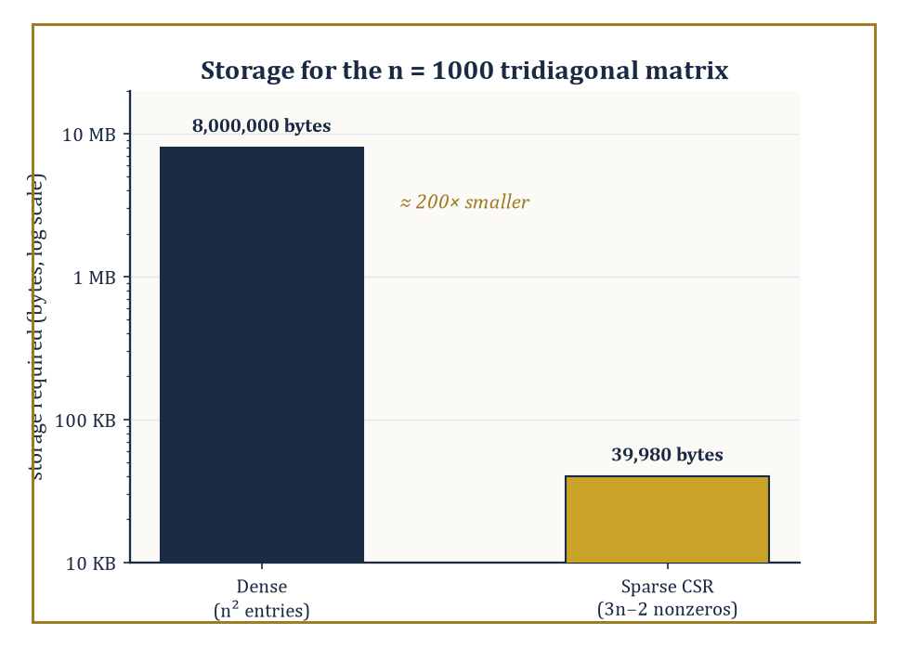
Dense versus compressed-sparse-row storage for the same n = 1000 tridiagonal matrix — roughly two hundred zeros' worth of savings.
The change is not cosmetic. A dense n×n matrix costs n² memory and roughly n³ flops to solve directly by Gaussian elimination; once n reaches even a modest million — entirely ordinary for a three-dimensional PDE mesh — n² already exceeds what any machine can store, and n³ exceeds what any machine will finish computing before the heat death of the universe, or at any rate before your grant runs out.
The subject that follows is, in large part, the discovery that one never actually needs the dense picture: almost every large matrix that arises from a real physical problem is sparse, because physics is local, and locality is a resource waiting to be exploited.
There is a useful, slightly melancholy analogy here with the census: a dense matrix insists on recording the relationship between every pair of unknowns, however irrelevant, in the same way a census that asked each citizen to describe their relationship to every other citizen would generate mostly blank forms and a truly heroic filing problem; a sparse matrix, sensibly, only records the relationships that actually exist.
Numeric example — Worked example: arithmetic intensity and the memory wall. Consider a dense matrix–vector product with A of size n = 1000, stored in double precision (8 bytes per entry):
y = Ax
The flop count is exact: each of the n² = 1,000,000 entries contributes one multiply and (almost) one add.
2n² − n = 1,999,000 flops
The memory traffic is dominated by reading the matrix itself, since the vectors x and y are negligible by comparison at 8 kilobytes each:
n² × 8 bytes = 8,000,000 bytes, i.e. 8 megabytes
The arithmetic intensity — flops performed per byte fetched from memory — is therefore:
AI = 1,999,000 / 8,000,000 ≈ 0.25 flops per byte
A typical modern processor can perform on the order of 10–50 flops for every byte it can move from main memory in the same time (the exact ratio is the machine's 'roofline' balance point); an operation with AI ≈ 0.25 sits nowhere near that ceiling, meaning the processor spends nearly all its time waiting for numbers to arrive, not computing on them. This is why dense matrix–vector multiplication is called memory-bound, and why simply having 'more flops available' — the traditional boast of a new supercomputer — does almost nothing to speed it up.
The entire discipline of exploiting sparsity, discussed next, exists in large part to raise the numerator (or, more precisely, to shrink the denominator by never fetching the zeros in the first place).
Structure — sparsity, low rank, hierarchy, symmetry — is therefore not a nicety but the principal resource that advanced numerical algorithms are designed around. A sparse matrix stores only its nonzero entries, typically in a compressed format such as CSR (compressed sparse row): one array of the nonzero values, one array recording which column each value belongs to, and one short array of row pointers.
For a matrix arising from a one-dimensional finite-difference or finite-element discretization, each row has only two or three nonzero entries regardless of how large n becomes, because each grid point only interacts with its immediate neighbours. The saving compounds: not only does the matrix fit in memory when the dense version would not, but the sparse matrix–vector product touches only the nonzero entries, so its flop count and memory traffic both scale linearly in n rather than quadratically.
Low rank (a matrix well approximated by the product of two much thinner matrices) and hierarchy (a multiscale organization in which coarse features are cheap and fine features are added as corrections) are the same idea one level up, and both reappear repeatedly in this storey — in multigrid, in randomized SVD, and in multilevel Monte Carlo alike.
Numeric example — Worked example: dense versus sparse storage. Take the tridiagonal matrix that arises from a standard one-dimensional discretization (each interior row has entries on the main diagonal and its two neighbours) with n = 1000.
Dense storage requires:
n² = 1,000,000 entries, i.e. 8 megabytes in double precision
The matrix actually has only 3n − 2 nonzero entries, since the two corner rows have one fewer neighbour each:
3n − 2 = 2998 nonzero entries
Stored in CSR format, that is 2998 values, 2998 column indices, and about 1001 row pointers:
2998 values × 8 bytes each = 23,984 bytes
(2998 column indices + 1001 row pointers) × 4 bytes each (32-bit integers) ≈ 15,996 bytes
total ≈ 23,984 + 15,996 = 39,980 bytes, about 39 kilobytes
The ratio of dense to sparse storage is:
8,000,000 / 39,980 ≈ 200
So the sparse representation is roughly two hundred times smaller for this modest n, and the gap widens linearly as n grows, since dense storage scales as n² while sparse storage scales as n. This is not an optimization; below a certain problem size dense storage is merely wasteful, and above it, it is simply impossible.
Everything in this storey is a variation on that single realization: complexity is no longer measured only in flops, but in memory traffic, communication volume between processors, and how gracefully an algorithm scales as more of them are added. The rooms that follow are, in effect, a catalogue of the ways one can be clever about matrices, meshes, spectra, and uncertainty once the naive dense approach has excused itself from the room.

Room 49.2: Iterative Methods for Linear Systems
Approximating Our Way to an Exact Answer, Politely
When a linear system Ax = b is too large to solve directly (recall from Room 49.1 that direct Gaussian elimination costs O(n³) flops and, worse, tends to destroy sparsity by filling in zero entries with nonzero ones as it proceeds), the practical alternative is to build a sequence of increasingly good approximations using only matrix–vector products — never forming A explicitly beyond that.
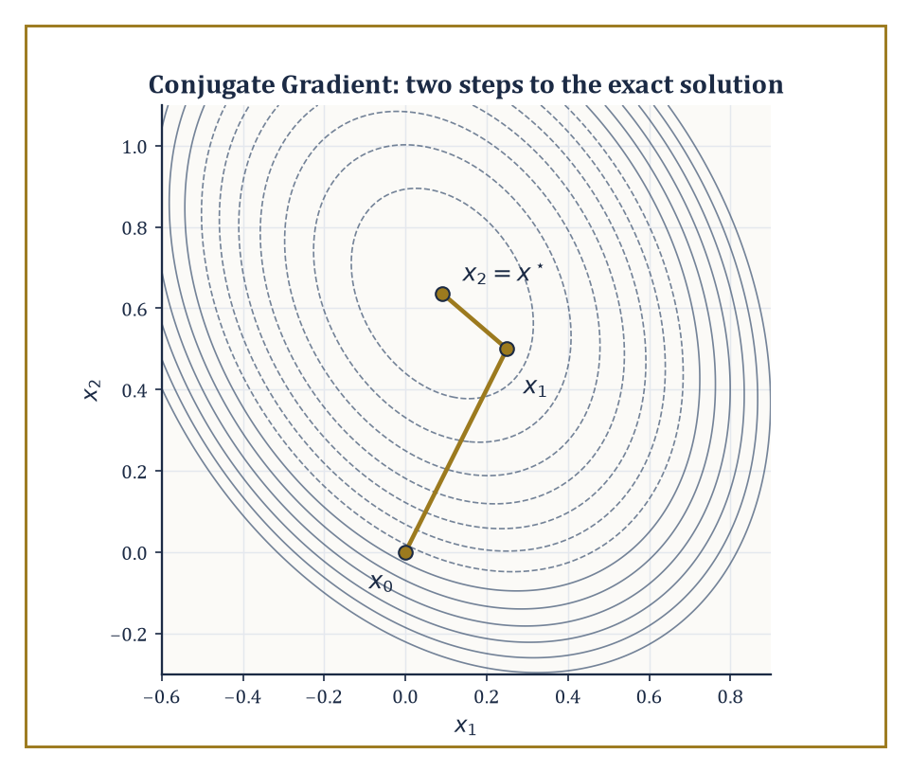
The two Conjugate Gradient steps of the worked example, plotted against the level sets of the quadratic they minimize.
The natural space in which to build such approximations is the Krylov subspace, generated by repeatedly applying A to the initial residual:
K_m(A, r₀) = span{r₀, Ar₀, A²r₀, …, A^(m−1)r₀}, where r₀ = b − Ax₀
Krylov methods — Conjugate Gradient (CG), MINRES, GMRES, BiCGSTAB, and their relatives — construct the m-th approximation x_m by extracting the best available vector from x₀ + K_m(A, r₀) according to some notion of 'best': smallest error in a natural norm for CG, smallest residual for MINRES and GMRES.
Because the only operation required is a matrix–vector product, these methods are matrix-free: A need never be stored explicitly at all, only a subroutine that computes Av for a given v, which is exactly what a sparse or structured matrix offers cheaply.
Numeric example — Worked example: Conjugate Gradient by hand. Solve Ax = b with A = [[4, 1], [1, 3]] and b = [1, 2], starting from x₀ = [0, 0].
This A is symmetric positive-definite: its eigenvalues are found from
λ² − 7λ + 11 = 0
and both roots are positive.
Initialize the residual and search direction:
r₀ = b − Ax₀ = [1, 2], p₀ = r₀ = [1, 2]
Step 1:
Ap₀ = [4·1+1·2, 1·1+3·2] = [6, 7]
α₀ = (r₀ᵀr₀)/(p₀ᵀAp₀) = 5/20 = 1/4
Update:
x₁ = x₀ + α₀p₀ = [1/4, 1/2]
r₁ = r₀ − α₀Ap₀ = [1 − 1.5, 2 − 1.75] = [−1/2, 1/4]
Step 2:
β₀ = (r₁ᵀr₁)/(r₀ᵀr₀) = (5/16)/5 = 1/16
so the new direction is
p₁ = r₁ + β₀p₀ = [−7/16, 3/8]
Then:
Ap₁ = [−11/8, 11/16], p₁ᵀAp₁ = 55/64, α₁ = (5/16)/(55/64) = 4/11
Updating:
x₂ = x₁ + α₁p₁ = [1/4 − 7/44, 1/2 + 3/22] = [1/11, 7/11]
Checking directly against the original equations 4x + y = 1 and x + 3y = 2 gives, by substitution, x = 1/11 and y = 7/11 exactly — CG has found the exact solution in precisely two steps, and one can verify r₂ = [0, 0] outright.
This finite termination in at most n steps (here n = 2) is not a coincidence; it follows from the Cayley–Hamilton theorem, since the Krylov space can grow no larger than the dimension of the ambient space. In practice n is in the millions and one stops long before exhaustion, satisfied with a residual small enough for the application at hand.
For symmetric positive-definite systems, CG is optimal among Krylov methods in a precise sense: among all vectors reachable from x₀ + K_m(A, r₀), it selects the one minimizing the A-norm of the error,
‖x − x_m‖_A = √((x − x_m)ᵀA(x − x_m))
and it does so using only short recurrences that require storing a handful of vectors regardless of m — the reason CG scales to enormous sparse systems where storing all previous search directions explicitly would be impossible.
For nonsymmetric systems, no such short recurrence with an optimality guarantee exists in general (a fact with a precise theoretical pedigree, not merely an engineering inconvenience), and GMRES is the standard fallback: it minimizes the Euclidean residual ‖b − Ax_m‖ over x₀ + K_m(A, r₀) using the Arnoldi process to build an orthonormal basis.
This comes at the cost of having to store all m basis vectors — hence the near-universal practice of restarted GMRES(m), which discards the accumulated basis every m steps and starts afresh, trading some convergence speed for bounded memory.
BiCGSTAB and its relatives sacrifice the strict minimization property in exchange for short recurrences even in the nonsymmetric case, a compromise that works remarkably well in practice and rather less predictably in theory — the sort of arrangement a mathematician tolerates only because the alternative, restarted GMRES with a memory budget too small for the problem, tolerates it rather worse.
The initial guess x₀ deserves a word too, since it is the one ingredient every Krylov method depends on that the theory tends to wave past: a good initial guess (the solution from a previous, nearby time step, say, or from a coarser discretization) shrinks the initial residual r₀ and therefore the entire Krylov space the method has to search through, while a poor one costs nothing beyond wasted iterations — there is no danger in guessing badly, only in not bothering to guess well when a better guess was sitting nearby the whole time.
Abstract example — Abstract example: the residual polynomial viewpoint. Every Krylov method's m-th residual can be written as follows, for some polynomial p_m of degree at most m with p_m(0) = 1:
r_m = p_m(A) r₀
This follows directly from r_m ∈ r₀ + AK_m(A, r₀), unwinding the definition of the Krylov space.
CG and GMRES differ only in which norm they minimize this polynomial's action in:
CG minimizes ‖p_m(A) r₀‖_{A^{-1}} when A is SPD; GMRES minimizes ‖p_m(A) r₀‖ in the ordinary Euclidean norm for general A
This single observation explains why convergence theory for both methods is stated in terms of the spectrum (for symmetric A) or the field of values (for nonsymmetric A): a Krylov method converges quickly precisely when there exists a low-degree polynomial, small at every eigenvalue of A and equal to 1 at the origin, and such a polynomial is easy to construct exactly when the eigenvalues are tightly clustered away from zero — which is precisely the property a good preconditioner, the subject of the next room, is designed to manufacture.

Room 49.3: Preconditioning and Multigrid
Solving a Different, Nicer Problem That Happens to Have the Same Answer
A preconditioner M is an approximation to A that is, crucially, much cheaper to invert than A itself; instead of solving Ax = b directly, one solves the equivalent system:
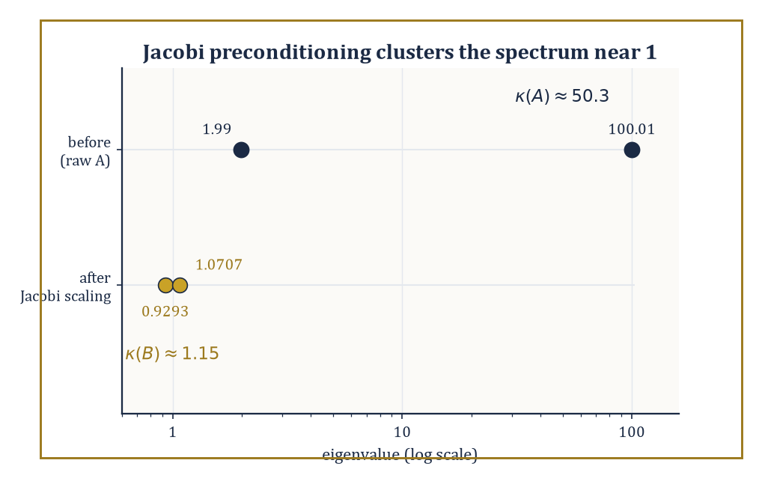
Jacobi scaling herds the worked example's two eigenvalues from a 50-to-1 spread down to a barely-there 1.15.
M⁻¹Ax = M⁻¹b
This system (or a symmetrized variant) has exactly the same solution but — if M has been chosen well — a far more favourable spectrum for a Krylov method to chew through.
The previous room ended on the observation that Krylov convergence is governed by how easily a low-degree polynomial can be made small across the matrix's eigenvalues; preconditioning attacks the problem directly by clustering those eigenvalues near 1, so that a very low-degree polynomial suffices.
Algebraic preconditioners — incomplete LU factorization (ILU), sparse approximate inverses, algebraic multigrid — build M from the matrix entries alone, with no reference to any underlying geometry, which makes them broadly applicable but somewhat blind. Geometric preconditioners, especially multigrid, use the grid the matrix came from and are correspondingly more powerful when that grid exists.
Numeric example — Worked example: Jacobi preconditioning shrinks a condition number. Take the symmetric positive-definite matrix A = [[100, 1], [1, 2]]. Its eigenvalues solve:
λ² − 102λ + 199 = 0
λ = (102 ± √9608)/2 ≈ (102 ± 98.02)/2, i.e. λ₁ ≈ 100.01 and λ₂ ≈ 1.99
The condition number is:
κ(A) = λ₁/λ₂ ≈ 50.3
This is respectable, but CG's error bound worsens with √κ, so this is already an unpleasant system to iterate on. Apply the simplest possible preconditioner, symmetric Jacobi scaling: let D = diag(100, 2) and form B = D^(−1/2) A D^(−1/2).
Direct computation gives:
B₁₁ = 100/100 = 1, B₂₂ = 2/2 = 1, B₁₂ = B₂₁ = 1/√(100·2) = 1/√200 ≈ 0.0707
So:
B = [[1, 0.0707], [0.0707, 1]], whose eigenvalues are 1 ± 0.0707, namely about 1.0707 and 0.9293
The new condition number is:
κ(B) ≈ 1.0707/0.9293 ≈ 1.15
This is down from 50.3 to essentially 1, using nothing more sophisticated than dividing each row and column by the square root of its own diagonal entry. This is the entire content of diagonal (Jacobi) preconditioning: it costs almost nothing and, whenever the poor conditioning comes from wildly differing diagonal magnitudes (as it does here), it does almost all the work.
Multigrid is the more ambitious answer, and for elliptic problems (the class that includes the Poisson equation and most steady-state diffusion problems) it achieves something remarkable: optimal complexity, meaning the total work to solve the system to a fixed accuracy grows only linearly in the number of unknowns, O(n), rather than the worse-than-linear growth every other general-purpose method suffers.
The mechanism rests on a division of labour. Simple iterative smoothers, such as weighted Jacobi or Gauss–Seidel, are hopeless at reducing smooth, long-wavelength error but excellent at annihilating oscillatory, short-wavelength error within just a few sweeps.
Multigrid exploits this asymmetry by smoothing on the fine grid until only smooth error remains, then transferring that residual to a coarser grid — on which the remaining smooth error looks comparatively oscillatory and can itself be smoothed away cheaply, recursing all the way down to a grid small enough to solve directly, before interpolating the correction back up.
Geometric multigrid needs an actual grid hierarchy to do this transferring; algebraic multigrid (AMG) constructs a synthetic coarse 'grid' directly from the matrix's connectivity pattern, extending the idea to unstructured meshes and general sparse matrices where no natural coarsening is visible to the eye.
Abstract example — Abstract example: a two-level cycle on a 1-D problem. Consider a 1-D discretization with a fine grid of 7 interior points (spacing h) and a coarse grid of 3 interior points obtained by keeping every other fine point (spacing H = 2h).
Decompose any error on the fine grid into Fourier modes:
sin(kπx), for k = 1, …, 7
Weighted Jacobi smoothing damps the high-wavenumber modes (k close to 7, oscillating rapidly from one grid point to the next) by a large factor per sweep but barely touches the low-wavenumber modes (k close to 1, varying gently across the domain) — this is precisely the asymmetry the method relies on. After a few smoothing sweeps, only the smooth, low-k error survives on the fine grid.
Crucially, that same low-k mode, when sampled only at the 3 coarse points, is resolved just as accurately as a high-k mode would have been on the fine grid — smooth functions need few points to represent — so the coarse grid can now smooth it away cheaply, or recurse further if the hierarchy continues.
The correction computed on the coarse grid is then interpolated back and added to the fine-grid approximation. No step in this cycle required forming a dense matrix or an explicit polynomial; the entire O(n) complexity comes from the fact that each level does a fixed, small amount of work per unknown, and there are only O(log n) levels.
The upshot, stated plainly: preconditioning is very often the difference between a Krylov method that converges in a dozen iterations and one that has not visibly moved after ten thousand, and multigrid — where it applies — is the gold standard against which every other preconditioner for elliptic problems is measured, precisely because nothing else routinely achieves optimal linear complexity on genuinely large problems.

Room 49.4: Sparse Eigenvalue Problems and SVD
Finding a Handful of Eigenvalues Without Meeting All the Others
For a large sparse matrix, computing the full eigendecomposition — every eigenvalue and eigenvector — is neither affordable nor, usually, wanted; most applications need only a handful of extremal or otherwise interesting eigenvalues (the lowest vibrational frequencies of a structure, the ground-state energy of a quantum system, the dominant modes of a dataset).
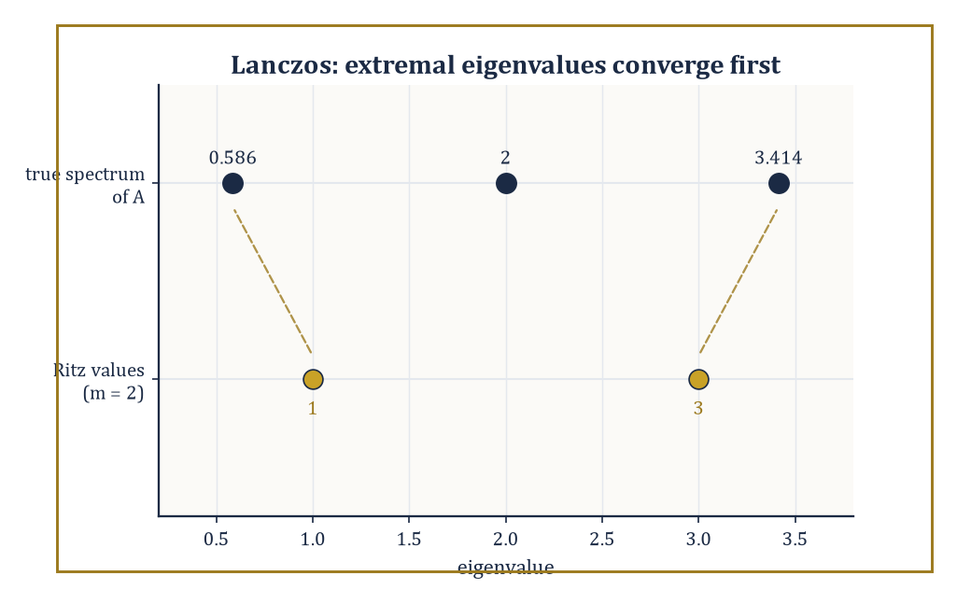
After just two Lanczos steps, the Ritz values 1 and 3 already flank the true extremal eigenvalues 0.586 and 3.414.
Krylov methods once again supply the machinery: the Lanczos algorithm, for symmetric matrices, and its nonsymmetric generalization, Arnoldi, build an orthonormal basis {q₁, …, q_m} of the Krylov space K_m(A, q₁) and simultaneously produce a small m×m matrix — tridiagonal for Lanczos, upper Hessenberg for Arnoldi — that represents A's action restricted to that subspace.
The eigenvalues of this small matrix, called Ritz values, are the algorithm's best available approximations to eigenvalues of A, and they typically converge to the extremal eigenvalues astonishingly fast, often within a number of steps far smaller than n.
Shift-and-invert redirects the method toward interior eigenvalues that would otherwise be ignored in favour of the extremes: it replaces A by (A − σI)⁻¹ for a shift σ near the eigenvalues of interest, since:
(A − σI)⁻¹ has eigenvalues 1/(λᵢ − σ)
An eigenvalue λᵢ close to σ becomes enormous in the transformed spectrum and is therefore the one a Krylov method, which always chases the extremes first, finds fastest — a pleasing bit of judo in which the very bias that makes Lanczos indifferent to interior eigenvalues is turned around and used to hunt them down deliberately.
The one price is that each Krylov step now requires solving a linear system with A − σI rather than a single matrix–vector product, so shift-and-invert is only as cheap as the sparse factorization (or preconditioned solve, courtesy of Room 49.3) behind it.
The Jacobi–Davidson method sidesteps some of that cost by expanding the search space with a correction equation rather than a fixed shift, and contour-integral techniques (the FEAST-type family) count and extract every eigenvalue enclosed by a chosen contour in the complex plane via a handful of resolvent evaluations — both are the methods of choice when the spectrum is clustered, defective, or otherwise unkind to a straightforward Krylov approach.
Numeric example — Worked example: two steps of Lanczos. Let A = [[2, 1, 0], [1, 2, 1], [0, 1, 2]], a standard discrete-Laplacian-type matrix whose exact eigenvalues are 2 − √2 ≈ 0.586, 2, and 2 + √2 ≈ 3.414. Start Lanczos from q₁ = [1, 0, 0].
Compute:
Aq₁ = [2, 1, 0], α₁ = q₁ᵀ(Aq₁) = 2
The residual has norm β₁ = 1:
w₁ = Aq₁ − α₁q₁ = [0, 1, 0], β₁ = 1, q₂ = [0, 1, 0]
Next:
Aq₂ = [1, 2, 1], α₂ = q₂ᵀ(Aq₂) = 2
w₂ = Aq₂ − α₂q₂ − β₁q₁ = [1, 2, 1] − [0, 2, 0] − [1, 0, 0] = [0, 0, 1]
After only two steps, the projected tridiagonal matrix is:
T₂ = [[2, 1], [1, 2]], whose eigenvalues are 2 ± 1, i.e. 1 and 3
Compare with the true extremal eigenvalues 0.586 and 3.414: after just two matrix–vector products — no factorization of A, no dense eigensolver, nothing beyond Aq for two vectors q — the Ritz values 1 and 3 already sit within about 0.41 of the true extremes, and the gap closes further, typically very fast, with each additional step.
This is the entire appeal of Krylov eigensolvers: they extract the dominant spectral information first, cheaply, without ever needing the rest of the spectrum.
The singular value decomposition of a large matrix is computed by close relatives of the same machinery — either Lanczos-type methods applied to AᵀA (or, more stably, to the augmented matrix [[0, A], [Aᵀ, 0]]) or, increasingly, by randomized algorithms that multiply A by a small number of random test vectors and exploit concentration-of-measure phenomena to capture its dominant range with high probability at a fraction of the cost of a deterministic method.
Whichever route is taken, the outcome is a low-rank approximation keeping only the r largest singular values:
A ≈ Σᵣ σᵢ uᵢ vᵢᵀ
The Eckart–Young theorem guarantees this truncation is the best possible rank-r approximation in both the spectral and Frobenius norms — not merely a convenient one.
This makes the SVD simultaneously a numerical tool (for solving ill-conditioned or rank-deficient least-squares problems) and a model-reduction device (for compressing a large dataset or a large simulation down to its dominant modes), which is why it underlies both classical numerical analysis and principal component analysis in equal measure — the same decomposition, wearing different hats depending on whether the room down the corridor calls itself Numerical Linear Algebra or Statistics.
Randomized SVD algorithms deserve a further word, since they can feel like a magic trick the first time one meets them: multiply A by a small random matrix Ω with, say, r + 10 columns, orthonormalize the result to get a matrix Q whose columns approximately span A's dominant range, and then work with the tiny matrix QᵀA instead of A itself.
That this crude-sounding procedure works reliably is a consequence of measure concentration in high dimension — a random subspace of modest dimension almost never misses a matrix's dominant directions by more than a small, controllable amount — and the practical upshot is a dominant-mode extraction algorithm that touches A only a handful of times, making it competitive with, and often faster than, deterministic Krylov methods on genuinely enormous matrices.
Numeric example — Worked example: best rank-1 approximation and the Eckart–Young theorem. Let M = [[1, 2], [2, 1]], symmetric with eigenvalues 3 and −1, from trace 2 and determinant −3.
Its eigenvectors are:
v₁ = [1, 1]/√2 (for eigenvalue 3), v₂ = [1, −1]/√2 (for eigenvalue −1)
Since a negative eigenvalue corresponds to a singular value with a sign flip absorbed into the left singular vector, the SVD is:
M = 3·u₁v₁ᵀ + 1·u₂v₂ᵀ, with σ₁ = 3, σ₂ = 1, u₁ = v₁ = [1,1]/√2, u₂ = −v₂ = [−1,1]/√2
Checking:
3·u₁v₁ᵀ = (3/2)[[1,1],[1,1]] = [[1.5,1.5],[1.5,1.5]]
1·u₂v₂ᵀ = (1/2)[[−1,1],[1,−1]] = [[−0.5,0.5],[0.5,−0.5]]
summing recovers exactly [[1,2],[2,1]] = M
The best rank-1 approximation, by Eckart–Young, is:
M₁ = 3u₁v₁ᵀ = [[1.5,1.5],[1.5,1.5]]
and the approximation error is:
M − M₁ = [[−0.5,0.5],[0.5,−0.5]], with Frobenius norm √(4×0.25) = 1
This is exactly σ₂, precisely as the theorem promises — the discarded singular value is, itself, the size of the error one is forced to accept.

Room 49.5: Spectral and High-Order Methods
When the Answer Is Smooth, Ask a Smooth Question
Spectral methods represent the solution not in a piecewise-polynomial basis local to each grid cell (as low-order finite differences and finite elements do) but in a global basis of functions spanning the whole domain at once — trigonometric polynomials (Fourier) for periodic problems, or Chebyshev and Legendre polynomials for problems on an interval.
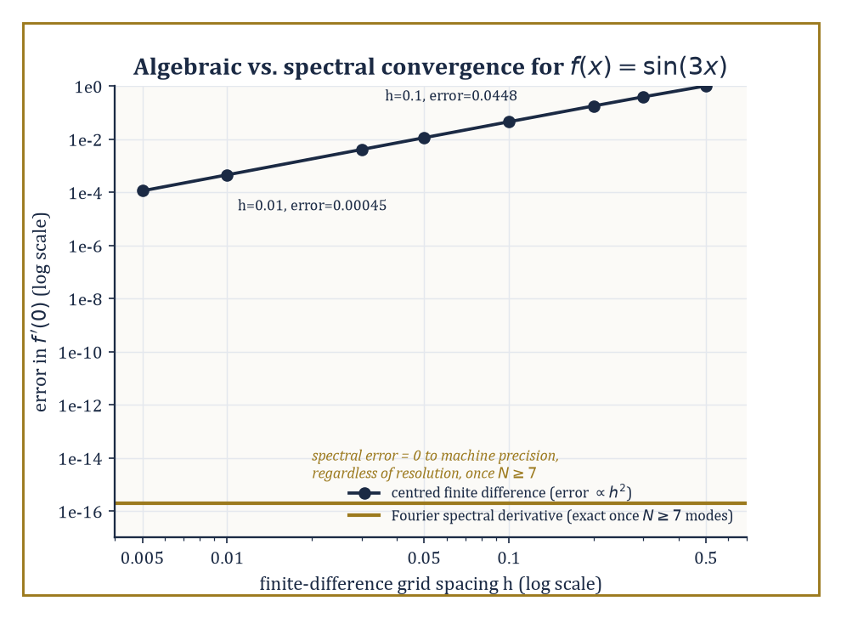
Finite differences chip away at the error one power of h at a time; the Fourier spectral derivative simply gets sin(3x) exactly right.
The payoff, when the true solution is analytic (infinitely differentiable and locally equal to its own Taylor series), is exponential convergence: the error shrinks not like h^p for some fixed order p, as it does for finite differences, but like e^(−cN) in the number of basis functions N, so that doubling the resolution doesn't merely improve the answer, it can add several new correct digits outright.
Collocation methods enforce the governing equation exactly at a set of chosen points; Galerkin and tau formulations enforce it weakly, in an inner-product sense, against the same basis.
All three produce linear systems that are dense (every basis function typically overlaps with every other) but very small, which is an entirely acceptable trade against the near-perfect accuracy on offer. Domain decomposition and spectral elements extend the idea to geometries too complicated for a single global basis to handle gracefully, by gluing many small spectral patches together.
It is worth pausing on why the basis choice matters so much: a global polynomial or trigonometric function 'sees' the whole domain at once, so a single coefficient can encode information that a local, piecewise basis would need many degrees of freedom, spread across many elements, to represent — the price is that every basis function typically interacts with every other, so the resulting linear system, though small, is dense rather than sparse, a trade this room's earlier obsession with sparsity (Room 49.1) is happy to accept once the dimension involved is small enough.
Numeric example — Worked example: spectral accuracy versus finite-difference accuracy. Let f(x) = sin(3x), whose exact derivative at x = 0 is:
f'(0) = 3cos(0) = 3
A standard centred finite-difference estimate uses:
(f(h) − f(−h))/(2h) = sin(3h)/h
With h = 0.1:
sin(0.3)/0.1 = 0.29552/0.1 = 2.9552 (error 0.0448)
With h = 0.01:
sin(0.03)/0.01 = 0.029996/0.01 = 2.9996 (error 0.00045)
The error shrunk by a factor of about 99.6 when h shrank by a factor of 10, consistent with the theoretical second-order rate:
error ∝ h², (0.1/0.01)² = 100
Now consider the Fourier spectral derivative. Because f(x) = sin(3x) is exactly a single Fourier mode of wavenumber 3, any Fourier discretization resolving that wavenumber — which requires only N ≥ 7 grid points, by the Nyquist criterion for wavenumber 3 — computes the derivative exactly:
ik·f̂(k) with k = 3, giving precisely 3cos(x)
This has no truncation error whatsoever, regardless of how the finite-difference error would have continued shrinking. This is the essence of spectral accuracy: a band-limited (or, more generally, analytic) function is captured to machine precision by a finite, often small, number of modes, whereas an algebraically convergent method must keep refining forever to catch up, and even then never quite arrives.
High-order finite elements and discontinuous Galerkin (DG) methods aim to have both virtues at once: the geometric flexibility of finite elements, which handle complicated domains and non-smooth material properties that a single global spectral basis cannot, combined with the high-order accuracy of a spectral method, achieved by raising the polynomial degree p used within each element rather than (or in addition to) shrinking the element size h.
This gives the practitioner two independent dials — h-refinement (more, smaller elements, at fixed low order) and p-refinement (fewer, larger elements, at higher order) — and the central practical design question of the whole field is how to turn them.
Where the solution is genuinely smooth within an element, increasing p is far more cost-effective than decreasing h; where the solution has a kink, a boundary layer, or worse, increasing p buys little and refining h (or, better, doing both adaptively, the subject of the next room) is unavoidable.
Discontinuous Galerkin methods add one further freedom by permitting the numerical solution to be genuinely discontinuous across element boundaries, patched together only weakly through numerical fluxes borrowed from the finite-volume tradition; this makes DG unusually well suited to hyperbolic problems — advection, wave propagation, shocks — where the true solution may itself be discontinuous, and where forcing continuity, as ordinary finite elements do, would mean fighting the physics rather than representing it.
Abstract example — Abstract example: the h-version versus the p-version. Standard finite-element error theory gives, for a solution u with s bounded derivatives, an h-version error bound at fixed polynomial degree p:
‖u − u_h‖ ≤ C h^(min(p,s−1)) ‖u‖
Refining the mesh buys a fixed algebraic rate that saturates once p exceeds the solution's smoothness.
For the p-version at fixed mesh, when u is analytic on each element, the corresponding bound takes the exponential form:
‖u − u_p‖ ≤ C e^(−bp)
Here b > 0 depends on how far u's singularities lie from the real axis — informally, on the size of its region of analyticity.
The qualitative content, worked through on a smooth model problem such as:
−u'' = π²sin(πx) on [0,1], with u(0) = u(1) = 0 (exact solution u(x) = sin(πx), certainly analytic)
is that a fixed-order h-refinement sequence needs its element count to keep growing forever to add each further correct digit, while a p-refinement sequence on a single element adds roughly a fixed number of correct digits for every unit increase in p — the discrete-Fourier-mode phenomenon of the previous example, transplanted into the finite-element setting.
This is precisely why spectral-element codes, which combine a modest h with an aggressive p, dominate applications — turbulence simulation, seismic wave propagation — where the solution is smooth almost everywhere and only occasionally, locally, is not.

Room 49.6: Adaptive Finite Elements and Multilevel Methods
Spending Your Computational Budget Where the Trouble Is
Adaptive finite-element methods refine the mesh — or raise the local polynomial degree — precisely where the error is estimated to be large, rather than everywhere uniformly, and are driven by an iterative loop usually summarized as SOLVE, ESTIMATE, MARK, REFINE: solve the problem on the current mesh, estimate the local error contributed by each element using only computable quantities (never the unknown exact solution, which rather defeats the purpose), mark a subset of elements whose estimated error is largest, and refine only those.
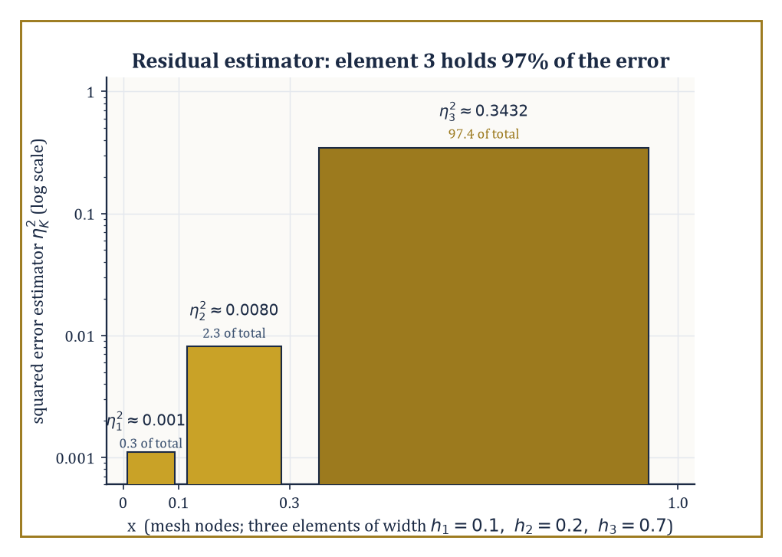
On the three-element mesh of the worked example, the large coarse element on the right carries nearly all the estimated error — and gets marked for refinement alone.
A posteriori error estimators come in several families — residual-based estimators, which measure how badly the computed solution fails to satisfy the governing equation locally; hierarchical estimators, which compare the solution on two nested approximation spaces; and recovery-based estimators, which compare a computed gradient against a smoothed, post-processed version of itself.
Convergence of the resulting adaptive algorithm — that it actually drives the true error to zero, and does so at an optimal rate — has been proved rigorously for a wide class of elliptic problems, which is more than can be said for most heuristics in numerical computing, and it is the practical method of choice whenever a solution has a singularity, a sharp boundary layer, or any other feature confined to a small part of the domain.
The classic illustration, repeated in every course on the subject for good reason, is a re-entrant corner: near a sharp, non-convex corner in an otherwise ordinary elliptic problem, the true solution's derivatives blow up, and a uniform mesh refined everywhere would need an impractical number of elements globally just to control the error near that one corner — adaptivity, by contrast, piles elements up exactly there, geometrically, while leaving the smooth interior of the domain coarse, and recovers the optimal convergence rate that a uniform mesh could never achieve no matter how much it was refined.
Numeric example — Worked example: a residual-based estimator and Dörfler marking. Solve −u'' = 1 on [0,1] with u(0) = u(1) = 0, using piecewise-linear finite elements on a non-uniform three-element mesh with nodes at 0, 0.1, 0.3, 1.0, giving element sizes h₁ = 0.1, h₂ = 0.2, h₃ = 0.7.
Because the computed solution is piecewise linear, u_h'' = 0 exactly within each element, so the interior residual on element K is simply f = 1, and the standard estimator is:
η_K = h_K‖f‖_{L²(K)} = h_K√(h_K) = h_K^(3/2), since ‖f‖²_{L²(K)} = ∫_K 1² dx = h_K for constant f = 1
Computing:
η₁ = 0.1^1.5 ≈ 0.0316, η₂ = 0.2^1.5 ≈ 0.0894, η₃ = 0.7^1.5 ≈ 0.5857
The squared estimators are:
η₁² ≈ 0.0010, η₂² ≈ 0.0080, η₃² ≈ 0.3432, summing to about 0.3522
Element 3 alone contributes:
0.3432/0.3522 ≈ 97.4%
of the total squared error estimate. Dörfler marking with a bulk parameter θ = 0.5 (mark the smallest set of elements whose combined squared estimator exceeds half the total) therefore marks element 3 alone for refinement, leaving elements 1 and 2 untouched — even though the underlying forcing f = 1 is perfectly smooth everywhere, the estimator correctly identifies that the large, coarse element 3 is contributing almost all the discretization error, purely because of its size, and directs the computational budget there first.
Multilevel methods generalize the two-grid idea from Room 49.3 into a full hierarchy of discretizations — multigrid, multilevel Monte Carlo (taken up properly in the next room), and hierarchical bases — and exploit a single underlying fact: solutions of elliptic problems, and more generally smooth quantities of interest, look smoother and smoother as one coarsens the discretization, so that the bulk of the answer can be captured cheaply on a coarse level, leaving only a small correction — a 'detail' or 'surplus' — to be resolved at each successively finer level.
This is the algorithmic expression of an idea familiar from wavelets and multiresolution analysis: represent a function not by its raw fine-grid values but by a coarse approximation plus a sequence of ever-smaller corrections.
Numeric example — Worked example: a hierarchical (multilevel) decomposition. Take the smooth function u(x) = x² sampled on a fine grid of 5 equally spaced points, indices 0–4, giving values [0, 1, 4, 9, 16]. Let the coarse grid keep only the even-indexed points, 0, 2, 4, with values [0, 4, 16].
Linear interpolation from the coarse grid predicts the odd-indexed fine values as the midpoint of their coarse neighbours:
index 1: predicted value = (0 + 4)/2 = 2; index 3: predicted value = (4 + 16)/2 = 10
The hierarchical surpluses — the corrections the fine grid must add on top of the coarse interpolant — are therefore:
d₁ = 1 − 2 = −1, d₃ = 9 − 10 = −1
The original fine-grid vector is recovered exactly as the coarse values, linearly interpolated, plus the surpluses at the odd nodes:
index 1 = 2 + (−1) = 1 ✓, index 3 = 10 + (−1) = 9 ✓
Notice how small and uniform the surpluses are (both exactly −1) compared with the coarse values themselves (0, 4, 16): the coarse grid has captured almost all of the function's variation, because x² is smooth, and only a small, structured residual remains to be resolved at the fine scale.
This is exactly the phenomenon multigrid's coarse-grid correction exploits: smooth error is nearly free to represent coarsely, so a hierarchy of grids, each doing a small fixed amount of work, suffices to resolve the whole problem — the mechanism behind the O(n) complexity claimed back in Room 49.3.
Adaptivity and multilevel structure are, in a real sense, the two principal routes to efficiency whenever a problem has localized features (adaptivity chases them) or multiple interacting scales (multilevel methods span them), and a great many state-of-the-art large-scale solvers are, on inspection, simply disciplined combinations of both ideas at once.

Room 49.7: Uncertainty Quantification
Putting Honest Error Bars on an Answer You Weren't Sure Of Anyway
Uncertainty quantification (UQ) takes seriously the fact that a computational model's inputs — physical parameters, boundary data, even the choice of model itself — are rarely known exactly, and asks how that input uncertainty propagates through the (possibly very expensive) computation to produce uncertainty in the output.
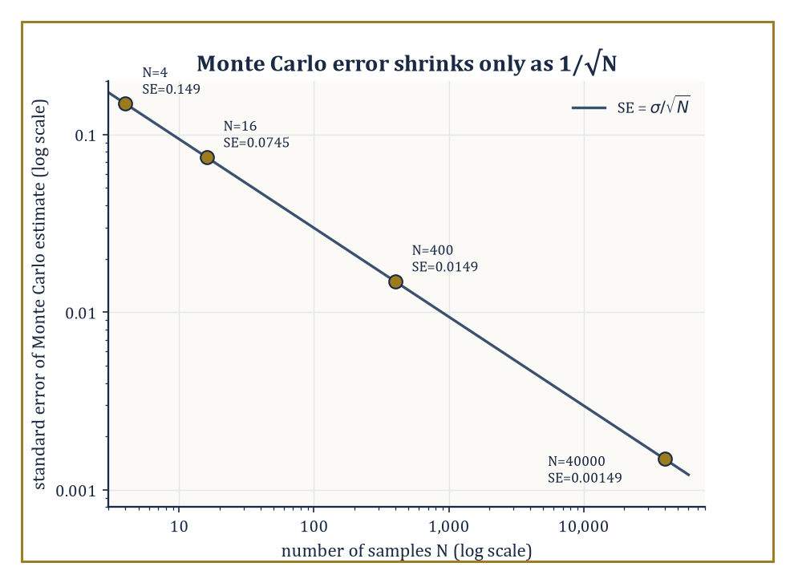
The worked example's four sample sizes sit exactly on the 1/√N line — one more correct digit costs a hundredfold more samples.
Forward UQ starts from a known or assumed distribution over the inputs and asks what distribution results for a quantity of interest; the crudest and most robust tool is plain Monte Carlo sampling: draw many independent input samples, run the model on each, and average.
Its great virtue is that it makes no assumption whatsoever about the model's smoothness; its great vice is that its error decreases only as 1/√N in the number of samples N, so that reducing the error by a factor of ten costs a hundred times as many (expensive) model evaluations.
Numeric example — Worked example: the 1/√N Monte Carlo rate. Let X ~ Uniform(0,1) and the quantity of interest be g(X) = X². The true mean is:
E[X²] = ∫₀¹ x² dx = 1/3 ≈ 0.3333
The variance of g(X) is:
Var(X²) = E[X⁴] − E[X²]² = ∫₀¹ x⁴ dx − (1/3)² = 1/5 − 1/9 = 9/45 − 5/45 = 4/45 ≈ 0.0889
so the standard deviation is σ ≈ 0.2981. The standard error of a Monte Carlo estimate from N samples is σ/√N.
At N = 4 samples:
SE ≈ 0.2981/2 ≈ 0.149
This is a genuinely large uncertainty relative to the answer being estimated. Quadrupling the effort to N = 16 only halves the error, to about 0.0745; reaching a modest SE of about 0.0149 requires N = 400 samples, and squeezing out one further correct decimal digit (SE ≈ 0.00149) requires N = 40,000.
This relentless square-root law is the single fact that motivates almost everything else in this room: quasi-Monte Carlo (which replaces random sampling with more evenly spread deterministic point sets to improve the rate for smooth integrands), multilevel Monte Carlo (which, exactly as in Room 49.6's hierarchy, does most of the sampling cheaply on a coarse model and corrects with a few expensive fine-model samples), and surrogate models, discussed next, which try to avoid repeated expensive model evaluations altogether.
Where plain sampling is too expensive, surrogate models replace the true computational model with a cheap approximation built from a modest number of evaluations: polynomial chaos expansions (PCE) represent the output as a series in orthogonal polynomials of the random inputs, while Gaussian process surrogates fit a probabilistic interpolant with its own built-in uncertainty estimate.
Stochastic Galerkin and stochastic collocation methods discretize the parameter space directly (much as a spatial PDE is discretized), and inherit the same curse of dimensionality that plagues any grid-based method in high dimension — the number of points needed grows exponentially with the number of uncertain parameters — which motivates sparse grids (which retain accuracy while including far fewer points than a full tensor grid) and reduced-basis techniques.
Inverse UQ runs the whole process backwards: given noisy data, it calibrates the model's parameters and reports a posterior distribution over them (typically via Bayesian inference), while honestly confronting model discrepancy — the uncomfortable but unavoidable fact that even a perfectly calibrated model is still not nature, only a structured guess about it.
Bayesian model calibration turns this discomfort into arithmetic rather than despair: it treats the gap between model and reality as an additional random term to be estimated alongside the physical parameters, so that a calibrated model reports not a single best-fit answer but a posterior distribution honestly wide enough to admit that the model itself might be part of the problem — a discipline every applied mathematician could stand to practise rather more often than they do.
Worked example — Worked example: polynomial chaos reads off the mean and variance. Let X ~ Uniform(−1,1) and the quantity of interest be g(X) = X². The Legendre polynomials, orthogonal with respect to this distribution, begin:
P₀(x) = 1, P₁(x) = x, P₂(x) = (3x² − 1)/2
Since g is itself a degree-2 polynomial, it has an exact, finite chaos expansion. Writing x² = a·P₀(x) + b·P₂(x) and matching coefficients:
3b/2 = 1, so b = 2/3; a − b/2 = 0, so a = 1/3
That is, exactly:
x² = (1/3)P₀(x) + (2/3)P₂(x)
Direct substitution confirms this:
(1/3) + (2/3)·(3x²−1)/2 = 1/3 + x² − 1/3 = x²
Because E[P₀] = 1 and E[Pₖ] = 0 for k ≥ 1 under this normalization, the mean of g(X) is simply the leading coefficient:
E[X²] = a = 1/3
This matches the direct calculation:
∫₋₁¹ x²·(1/2) dx = 1/3
The variance is read off just as directly, as a sum of squared coefficients weighted by ‖Pₖ‖² = 1/(2k+1); here only the k = 2 term contributes:
Var(X²) = b²·(1/5) = (2/3)²·(1/5) = 4/45 ≈ 0.0889
which matches:
E[X⁴] − E[X²]² = 1/5 − 1/9 = 4/45
computed directly. This is the entire practical payoff of polynomial chaos: once the expansion coefficients are known (from a handful of model evaluations, not millions), every statistic of interest — mean, variance, and more — falls out of them algebraically, with no further sampling required.
The overall effect of this room's machinery is to turn a deterministic simulation, which reports one number and implicitly claims to be sure of it, into a genuinely probabilistic prediction — a distribution, or at least an honest error bar — and that conversion is not an optional refinement but an essential component of any computational science that intends to be believed.

Room 49.8: Structure-Preserving and Geometric Integration
Respecting the Physics Enough Not to Let the Energy Wander Off
Geometric numerical integration designs time-stepping methods that deliberately preserve structural properties of the continuous system being simulated, rather than merely minimizing the local truncation error the way a generic Runge–Kutta method does.
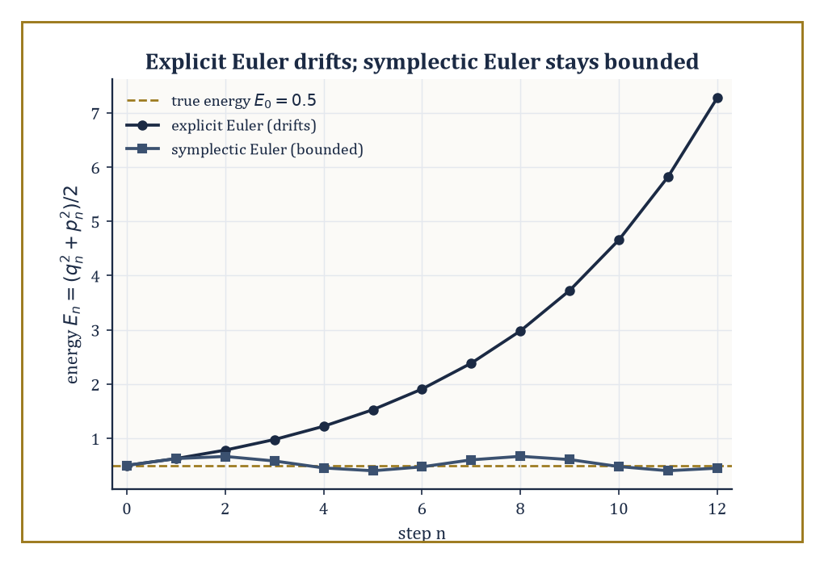
The worked example's twelve steps: explicit Euler's energy climbs without limit, symplectic Euler's just wobbles politely around the truth.
A Hamiltonian system is one governed by the equations:
dq/dt = ∂H/∂p, dp/dt = −∂H/∂q, for some energy function H(q,p)
For such a system, the relevant structure is symplecticity, a precise geometric statement about how the flow distorts phase-space volume and orientation, and symplectic Runge–Kutta methods, variational integrators (derived by discretizing the underlying action principle rather than the differential equation directly), and discrete gradient methods are the principal families built to respect it.
The payoff is not better short-term accuracy — a symplectic method is not, in general, more accurate at any single step than a good non-symplectic one of the same order — but qualitatively superior long-time behaviour: a backward error analysis shows that a symplectic method exactly solves a nearby Hamiltonian system, which forces its energy error to stay bounded and oscillate near the true value indefinitely, rather than drifting away as a generic method's error does.
Numeric example — Worked example: explicit Euler drifts, symplectic Euler doesn't. Take the simple harmonic oscillator with:
H(q,p) = (p² + q²)/2, dq/dt = p, dp/dt = −q
The true energy is conserved exactly along any real trajectory. Start from q₀ = 1, p₀ = 0 (energy E₀ = 0.5) and step with h = 0.5.
Explicit Euler updates both variables from old values:
q_{n+1} = q_n + h p_n, p_{n+1} = p_n − h q_n
Step 1:
q₁ = 1 + 0 = 1, p₁ = 0 − 0.5 = −0.5, E₁ = (1 + 0.25)/2 = 0.625
Step 2:
q₂ = 1 + 0.5(−0.5) = 0.75, p₂ = −0.5 − 0.5(1) = −1.0, E₂ = (0.5625 + 1)/2 = 0.78125
Step 3:
q₃ = 0.75 + 0.5(−1.0) = 0.25, p₃ = −1.0 − 0.5(0.75) = −1.375, E₃ = (0.0625 + 1.890625)/2 ≈ 0.9766
The energy climbs steadily — 0.5, 0.625, 0.781, 0.977 — a clear, unbounded drift; explicit Euler spirals outward.
Now use symplectic Euler, which updates q first and then uses the new q in the p update:
q_{n+1} = q_n + h p_n, p_{n+1} = p_n − h q_{n+1}
Step 1 is identical, since p₀ = 0 makes no difference yet:
q₁ = 1, p₁ = 0 − 0.5(1) = −0.5, E₁ = 0.625
Step 2:
q₂ = 1 + 0.5(−0.5) = 0.75, p₂ = −0.5 − 0.5(0.75) = −0.875, E₂ = (0.5625 + 0.765625)/2 ≈ 0.6641
Step 3:
q₃ = 0.75 + 0.5(−0.875) = 0.3125, p₃ = −0.875 − 0.5(0.3125) = −1.03125, E₃ = (0.09766 + 1.06348)/2 ≈ 0.5806
The symplectic energies — 0.5, 0.625, 0.664, 0.581 — fluctuate rather than climb, staying much closer to the true value of 0.5 instead of drifting ever upward; this bounded oscillation, not monotone growth, is exactly the qualitative signature backward error analysis predicts, and it is the entire reason symplectic integrators are preferred for long-time simulation even though, step for step, they are no more locally accurate than the method that got it so visibly wrong.
Discrete gradient methods take a different but related route to structure preservation, aiming for exact conservation rather than merely bounded oscillation: a discrete gradient ∇̄H(q, q′) is constructed to satisfy, exactly by design:
∇̄H(q,q′)·(q′ − q) = H(q′) − H(q)
This forces the resulting scheme to conserve the Hamiltonian to machine precision at every single step, not merely on average over long times.
Variational integrators, meanwhile, are derived by discretizing Hamilton's action principle itself and only then deriving the resulting difference equations, which guarantees the discrete scheme inherits a discrete version of Noether's theorem — conserved quantities tied to the system's symmetries, such as angular momentum for a rotationally invariant system, survive the discretization exactly, not approximately.
These methods are the tools of choice wherever long-time fidelity genuinely matters and cannot be fudged: molecular dynamics simulations that must run for billions of steps without the temperature quietly drifting, and celestial mechanics calculations that must track planetary orbits over millions of years without the solar system numerically disintegrating — a standard one would not care to be blamed for, however honest the small-print disclaimer in the paper's methods section.
Numeric example — Worked example: the implicit midpoint rule conserves energy exactly here. The implicit midpoint rule is:
q_{n+1} = q_n + h·(p_n+p_{n+1})/2, p_{n+1} = p_n − h·(q_n+q_{n+1})/2
It is both symplectic and, for exactly quadratic Hamiltonians such as this oscillator, a discrete-gradient method — so it should conserve energy exactly, not merely approximately.
Taking one step with h = 0.5 from q₀ = 1, p₀ = 0 requires solving the coupled linear system simultaneously:
q₁ = 1 + 0.25(0 + p₁), p₁ = 0 − 0.25(1 + q₁)
Substituting the first into the second:
p₁ = −0.25 − 0.25(1 + 0.25p₁) = −0.5 − 0.0625p₁, so 1.0625p₁ = −0.5, giving p₁ = −0.470588…
q₁ = 1 + 0.25(−0.470588) = 0.882353
The new energy is:
E₁ = (q₁² + p₁²)/2 = (0.778547 + 0.221453)/2 = 1.0/2 = 0.5
This is exactly the starting energy, to the precision of this hand calculation, confirming the theoretical guarantee directly rather than merely citing it.

Room 49.9: Looking Ahead: From Advanced Numerics to Exascale, Machine Learning, and Verified Computation
The View From the Top of This Particular Staircase
We have now acquired the core of advanced numerical methods: iterative linear algebra and Krylov subspaces, preconditioning and multigrid, sparse eigenproblems and the SVD, spectral and high-order methods, adaptivity and multilevel structure, uncertainty quantification, and structure-preserving integration.
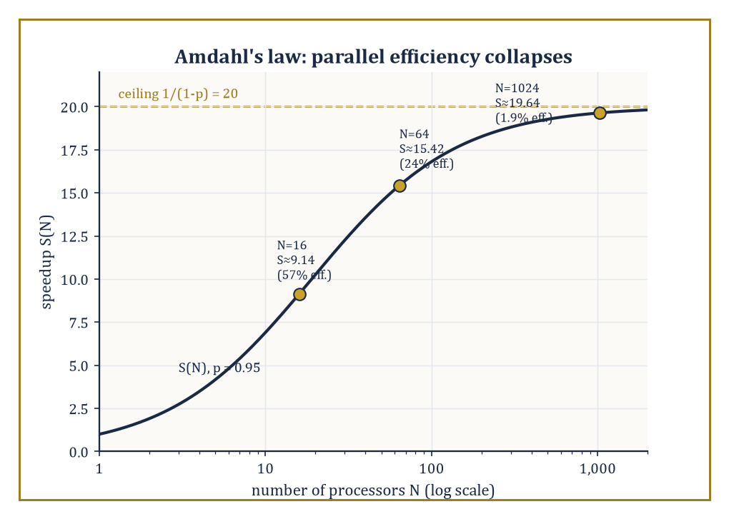
Amdahl's law at p = 0.95: speedup keeps climbing toward its ceiling of 20, but efficiency has already collapsed to under 2% by N = 1024 processors.
Three frontiers lie immediately beyond this material, and each deserves at least a glance before we leave the room. The first is exascale computing: as machines grow not by getting individually faster but by acquiring ever more processing cores, the bottleneck shifts decisively from arithmetic to communication and synchronization, and the algorithms that win are the ones redesigned to minimize how much data must move between processors and how often those processors must wait for each other, even at the cost of doing somewhat more arithmetic overall.
Numeric example — Worked example: Amdahl's law and the collapse of parallel efficiency. Suppose a computation has a parallel fraction p = 0.95 — 95% of the work can be split across processors, 5% is stubbornly sequential, an optimistic figure for most real codes. Amdahl's law gives the speedup on N processors as:
S(N) = 1/((1−p) + p/N)
At N = 16:
p/N = 0.059375, denominator = 0.05 + 0.059375 = 0.109375, S(16) = 1/0.109375 ≈ 9.14
This is an efficiency of S(16)/16 ≈ 57%, already leaking almost half the theoretical benefit.
At N = 64:
p/N = 0.014844, S(64) = 1/0.064844 ≈ 15.42 (efficiency ≈ 24%)
At N = 1024:
p/N ≈ 0.000928, S(1024) = 1/0.050928 ≈ 19.64 (efficiency ≈ 1.9%)
Barely one part in fifty of the processors' work is actually contributing net speedup, even though the speedup itself is still (slowly) climbing toward its ceiling of:
1/(1−p) = 20
This is precisely the phenomenon that makes exascale computing hard in a way that simply buying more cores cannot fix: unless the sequential fraction and the communication overhead are attacked directly — the entire point of communication-avoiding algorithm redesign — adding processors past a certain point buys almost nothing, a sobering fact that no amount of enthusiastic press-release language about 'a billion billion calculations per second' will alter.
The second frontier is the increasingly porous boundary with machine learning: learned discretizations that replace a hand-derived stencil with one fitted to data, neural preconditioners trained to approximate the action of an expensive inverse operator, and data-driven model reduction that learns a low-dimensional surrogate directly from simulation output rather than deriving one analytically.
It is tempting, and not entirely wrong, to read this as machine learning quietly annexing numerical analysis's territory; the more accurate reading is that every one of these techniques still leans on the mathematics of this storey to be trustworthy at all — a neural preconditioner is only useful if it is cheap to apply and reliably clusters the spectrum, exactly the criteria Room 49.3 set out, and a learned surrogate is only useful if someone can bound how far it might be wrong, which returns us directly to Room 49.7's uncertainty quantification and to the third frontier below.
The third, and in some ways the most conservative, is verified computation — interval arithmetic and residual-based a posteriori bounds that supply not just an approximate answer but a rigorous, mathematically guaranteed enclosure of the true one, at the cost of some pessimism in how tight that enclosure can be made.
Numeric example — Worked example: interval arithmetic is sound but pessimistic. Let f(x) = x² − 2x = (x−1)² − 1, and evaluate it rigorously over X = [1,3] using naive interval arithmetic.
Since 0 ∉ X:
X² = [1²,3²] = [1,9]
2X = [2,6]
X² − 2X = [1−6, 9−2] = [−5,7]
Compare with the true range: since (x−1)² − 1 has its minimum at x = 1, the left endpoint of the interval, and increases monotonically thereafter, the exact range is:
f(1) = −1, f(3) = 9−6 = 3, so the exact range of f on [1,3] is [−1,3]
The naive interval bound [−5,7] does contain the true range [−1,3], as the theory guarantees it must — interval arithmetic is sound by construction, never wrong, only ever conservative — but it is considerably wider than necessary.
The looseness arises from the 'dependency problem': naive interval arithmetic treats the two occurrences of x in x² and −2x as if they were independent unknowns ranging freely over [1,3], rather than remembering they are the same quantity, and this loss of correlation is exactly what more refined verified-computation techniques (mean-value forms, Taylor models, and their relatives) are built to recover, tightening the enclosure without ever sacrificing the underlying guarantee.
The same ideas explored across this storey — sparse and iterative linear algebra, hierarchy, adaptivity, uncertainty, structure — reappear, essentially unchanged in spirit, in computational fluid dynamics, climate modelling, computational electromagnetics, and across the numerical solution of the partial differential equations of mathematical physics generally.
The deeper lesson, if the storey has one, is that the discretization of continuous problems, once it must be done at scale and with structure, stops being a subfield of analysis and becomes a discipline in its own right — one that fuses analysis, linear algebra, probability, and computer architecture into a single computational science, in which a wrong answer delivered instantly is no better than a right one delivered never, and the entire art lies in the space between.
Advanced numerical methods are, in the end, the mathematics of reliable computation at a scale no single mind can check by hand — which is either a humbling thought or a liberating one, depending on how the tenure review went that year. We have learned to exploit sparsity instead of drowning in zeros, to precondition instead of merely waiting, to go where the error actually is instead of refining everywhere out of politeness, to quantify what we don't know instead of pretending otherwise, and to respect the physics enough to let a planet keep its orbit for a few million years without numerical assistance in going somewhere it shouldn't.
The Tower continues upward, and it turns now, for its fiftieth and final storey, from method to purpose: applied mathematics and modelling — the rather more philosophical question, postponed throughout this storey by cheerful necessity, of which equation one ought to be solving in the first place, and what the answer is actually for. Everything computed here has assumed the model was already given; the next storey asks where models come from, and how one decides whether they deserve to be trusted at all. We have learned to compute at scale. It remains, at last, to ask what for.

Storey 50: Where the Tower Meets the World
From Phenomenon to Equation, and the Art of Making Mathematics Speak About the World
Fifty storeys. If you have climbed them all in order — and if you have not, no matter, the lift still runs, though the buttons above thirty or so require a certain faith — you began at Storey 1 with the proposition that three apples and two apples make five apples, and you now stand somewhere considerably higher, having lately passed through the numerical-methods storey below: the grim, necessary business of persuading a machine to approximate what cannot be solved by hand, and of knowing, to several decimal places, exactly how wrong one is prepared to be. That storey ended, as such storeys do, with error bounds and a faint smell of solder.
This, the fiftieth and last, is not about a new piece of mathematics at all. Every tool the Tower has forged — algebra to sharpen the pencil, calculus to track the change, probability to hedge the ignorance, analysis to keep the whole enterprise honest, numerical method to compute what refuses to be solved in closed form — has been built, if we are honest, for use. This storey is that use. It is called modeling, a word with a slightly apologetic ring to it, as though the mathematics knows it is about to be asked to say something about the actual, muddy, non-Platonic world, and would rather not.
A model, we shall see, is not a small imitation of the universe; it is a lie, told carefully, in the hope that it turns out to be a useful one. Every equation in this storey describes something that does not, strictly, exist — a frictionless pendulum, a population with no immigrants, a market with no fools — and every one of them is nonetheless indispensable, because the alternative to a useful lie is not the whole unmanageable truth; it is silence. Nine rooms lie ahead: what modeling is, how it is done, how to measure a system before daring to write an equation for it, the discrete-versus-continuous choice, the honest admission of randomness, three case studies drawn from mechanics, biology, and epidemiology, the arrival of data as a modeling ingredient in its own right, the business of finding out whether any of it was true, and, last, a turn to look back down the whole climb and ask what it was all for.
Then the Tower ends — not with a flourish but with the mathematics turning, at last, to face outward, toward the phenomenon it was built to describe. Do mind the draught at the top; the view is rather good.

Room 50.1: What Mathematical Modeling Actually Is
In Which the World Is Asked Politely to Hold Still
A mathematical model is a mathematical structure built to represent selected features of a real system, for the purpose of understanding it, predicting it, or controlling it. Four ingredients make it up.
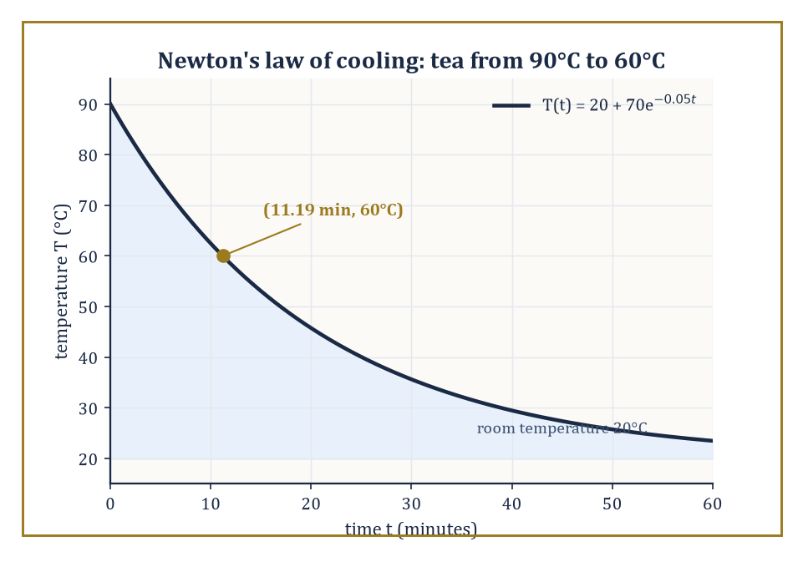
The tea's temperature decays exponentially toward room temperature, hitting a drinkable 60°C at t ≈ 11.19 minutes — exactly where the model, and not a moment sooner, says it must.
Variables are the quantities that change within the model — a population size, a temperature, a stock price.
Parameters are the quantities held fixed for a given run of the model but that could, in principle, be different for a different system — a growth rate, a reaction constant, an interest rate; the same equation with a different parameter describes a different rabbit warren, a different chemical, a different bank.
Equations (or, for a computational model, algorithms) relate the variables and parameters to one another and to time.
And — the ingredient every over-eager modeler forgets to state out loud, usually to their later embarrassment — a domain of validity: the range of conditions over which the model's claims may actually be trusted, outside of which it is simply the wrong tool, however elegant the algebra inside it.
The word 'selected' in the first sentence is doing the real work. A model does not represent a system; it represents the handful of features of that system the modeler has decided matter for the question at hand, and quietly, deliberately discards the rest.
The discarding is not laziness, it is the entire craft, since a structure that tried to represent every feature of the real system would be exactly as hard to understand as the real system itself, and would have earned the modeler nothing at all for the effort of building it.
Numeric example — Worked example — Newton's law of cooling, and where it stops being true. A cup of tea is poured at 90°C into a room held at a constant 20°C. Empirically, for a cooling liquid well above room temperature and not too close to it, the rate of heat loss is roughly proportional to the temperature difference — Newton's law of cooling — giving the model
T(t) = T_env + (T0 − T_env)e^(−kt)
with T0 = 90, T_env = 20, and a cooling constant k = 0.05 per minute (a parameter one would measure for this particular mug, this particular room, this particular draught). Question: how long until the tea reaches a drinkable 60°C? Set T(t) = 60:
60 − 20 = (90 − 20)e^(−0.05t)
40 = 70·e^(−0.05t)
e^(−0.05t) = 40/70 = 0.5714
Taking logarithms,
−0.05t = ln(0.5714) = −0.5596
t = 0.5596/0.05 ≈ 11.19 minutes
Notice what the domain of validity is quietly assuming: that k stays constant (it will not, if someone opens a window at minute six), that T_env stays constant (it will not, in a small kitchen with the kettle still going), and that the mechanism itself — heat loss dominated by a temperature-difference-proportional process — remains the right description as T approaches T_env, where in reality measurement noise and slow convective effects start to dominate the signal entirely. The equation does not know any of this; only the modeler does.
Models are judged along three axes that pull in different directions.
Fidelity is agreement with observation — how faithfully the model's output matches what is actually measured.
Tractability is amenability to analysis or computation — can anyone actually solve the thing, or simulate it in a lifetime, on a budget?
Usefulness is relevance to the question being asked — a model that predicts a protein's fold to the nearest ångström is a triumph of fidelity and utterly useless for forecasting next week's rainfall.
No model optimizes all three simultaneously; that is not a failure of imagination but close to a theorem. A model detailed enough to have high fidelity to every microscopic feature of a real system is, very often, exactly the model too complicated for anyone to analyze or even simulate at the scale the question requires.
The modeler's entire craft is the navigation of that trade-off — deciding, deliberately, what to sacrifice.
Abstract example — Abstract example — two models of the same traffic jam. Consider modeling congestion on a motorway. One approach treats the stream of cars as a continuous fluid: a density ρ(x,t) (cars per kilometre) obeying a conservation-law partial differential equation,
∂ρ/∂t + ∂(ρv(ρ))/∂x = 0
where the speed v is assumed to be some decreasing function of local density — the Lighthill–Whitham–Richards model. This buys enormous tractability: wave speeds for a growing jam can be extracted in closed form, and the PDE machinery of an earlier storey applies wholesale. It sacrifices fidelity at the level of any individual driver — there is no 'car' in the model, only a density, so questions like 'does this following distance cause a rear-end collision' cannot even be posed.
A second approach — a cellular-automaton or agent-based model such as Nagel–Schreckenberg — places discrete cars on a discretized road, each obeying a simple local rule (accelerate if clear ahead, brake if too close, occasionally and randomly slow down for no good reason, exactly as real drivers do). This sacrifices tractability — there is no closed-form solution, only simulation — in exchange for fidelity at the individual-vehicle scale, including the emergence of stop-and-go waves from nothing but local rules and a bit of randomness, a genuinely surprising phenomenon the fluid model can only put in by hand.
Neither model is 'more correct'; each is useful for a different question, which is precisely the point of the three-way trade-off above.
Modeling, then, is the applied face of mathematics, and it is the reason the preceding forty-nine storeys of this Tower were built at all — every tool sharpened on the way up exists, ultimately, to be pointed at something.
Everything from here on is an exercise in choosing, wisely and with open eyes about the cost of the choice, what to keep and what to throw away.

Room 50.2: The Modeling Process: From Phenomenon to Equation
Nine Tidy Stages, Taken in No Particular Order
The modeling process, laid out as a list, looks reassuringly linear: observation and question formulation; identification of the relevant quantities and mechanisms; choice of mathematical framework — ordinary differential equation, partial differential equation, stochastic process, discrete structure; derivation or postulation of the governing equations; nondimensionalization and simplification (the subject of the next room); analysis or simulation; confrontation with data; and revision.
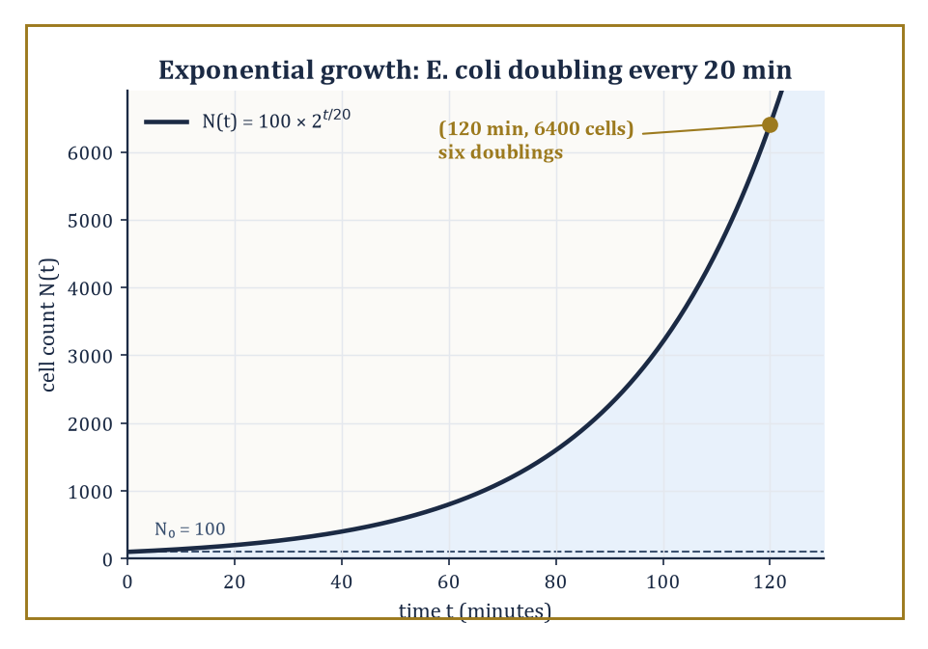
Six doublings, no curve-fitting: the bacterial count derived straight from the mechanism lands on 6,400 cells at the two-hour mark, precisely as the equation demands.
Note that 'question formulation' comes before everything else, and deliberately so: the same rabbit population might be modeled as a smooth continuum if the question is 'how many rabbits, roughly, in five years', or as an explicitly discrete, individual-tracking stochastic process if the question is instead 'what is the probability this particular reintroduced colony of eleven rabbits dies out by winter' — same animal, same field, a completely different answer to stage three because the question asked was different.
In practice the list is a loop, entered at any point and traversed in whatever order the phenomenon demands — a modeler frequently discovers, three stages in, that the chosen framework cannot capture the mechanism at all, and returns to stage three having learned something valuable from the failed attempt.
No textbook diagram of this process, this one included, has ever survived contact with an actual research problem without a great many arrows pointing backwards.
Numeric example — Worked example — walking the process for bacterial growth. Observation: a culture of E. coli, 100 cells at time zero, is left to grow in nutrient-rich broth. Mechanism, identified from first principles of cell biology: each cell, roughly every 20 minutes (its doubling time T_d, a measured parameter of this organism under these conditions), splits into two daughter cells. Framework: this mechanism is naturally discrete-in-generation, but because doublings happen asynchronously across a large population it is well approximated by continuous exponential growth,
N(t) = N0·2^(t/T_d)
Derivation is done — the equation follows directly from the mechanism, no curve-fitting involved. Analysis: after 2 hours (120 minutes),
t/T_d = 120/20 = 6
N(120) = 100 × 2^6 = 100 × 64 = 6400 cells
Confrontation with data: a real culture, sampled at 2 hours, might show something close to 6400 — or, if nutrients are running low, noticeably less. Revision: the discrepancy is not a failure of the model so much as a signal that a new mechanism (nutrient depletion) has entered the regime of validity, motivating the next paragraph.
Models built the way the bacterial example was built — from conservation laws, constitutive relations, or force balances, i.e. from a claim about mechanism — are called mechanistic.
Models built instead from an observed pattern, with no claim about the underlying mechanism, are called phenomenological: fit a curve that looks like the data and use it to interpolate or extrapolate, without asserting why the data has that shape.
Both styles are entirely legitimate mathematics; the choice depends on how much is actually known about the mechanism and on what the model needs to do — a modeler faced with a genuinely novel system, with no established theory to lean on, has no honest choice but to start phenomenologically, and to treat any claim of mechanism drawn from the curve alone with deep suspicion until independent evidence for it turns up.
A mechanistic model can be trusted to extrapolate into regimes never observed, because it encodes a claim about cause; a phenomenological model can only be trusted to interpolate within the range it was fitted to, because it encodes nothing but the shape of what was already seen, and shapes have an unpleasant habit of changing the moment one looks just past the edge of the data.
Numeric example — Worked example — a mechanistic model, Michaelis–Menten enzyme kinetics. An enzyme E binds a substrate S to form a complex ES, which then releases product P and free enzyme: E + S ⇌ ES → E + P. Applying the law of mass action to this mechanism (a genuine chemical claim, not a curve fit) and assuming the ES complex reaches a quasi-steady concentration, one derives the reaction velocity
v = V_max·[S] / (K_m + [S])
where V_max and K_m are combinations of the underlying rate constants. Given V_max = 100 μM/min and K_m = 20 μM, at a substrate concentration [S] = 30 μM:
v = 100 × 30 / (20 + 30) = 3000/50 = 60 μM/min
Because this is mechanistic, it licenses a further, testable prediction with no new curve-fitting: a competitive inhibitor is known, from the same mechanism, to increase the apparent K_m without changing V_max — so doubling the apparent K_m to 40 while holding [S] = 30 predicts
v = 100 × 30/(40+30) = 3000/70 ≈ 42.9 μM/min
a specific number a purely phenomenological sigmoidal fit to the uninhibited data alone would have no principled way to produce.
The process is as much a craft as a science, and experience and judgement matter more than any flowchart suggests.
Modelers switch frameworks mid-derivation more often than textbooks admit — an epidemiologist might begin writing a smooth ordinary differential equation for an outbreak, realize the case count is still in single figures where chance dominates trend, and abandon the ODE in favour of a stochastic branching process (Room 50.5) purely because the early numbers are too small for the continuum framework to mean anything yet.
That switch is not a failure of planning; it is stage nine — revision — arriving earlier than the list implies it should, and a modeler who never has to backtrack has almost certainly not yet asked a hard enough question.

Room 50.3: Scaling, Dimensional Analysis, and Dimensionless Models
How to Learn a Great Deal About an Equation Before Writing It Down
Dimensional analysis extracts constraints on the form of a physical relation purely from the dimensions — length, time, mass, and so on — of the quantities involved, without needing to know the underlying physics at all.
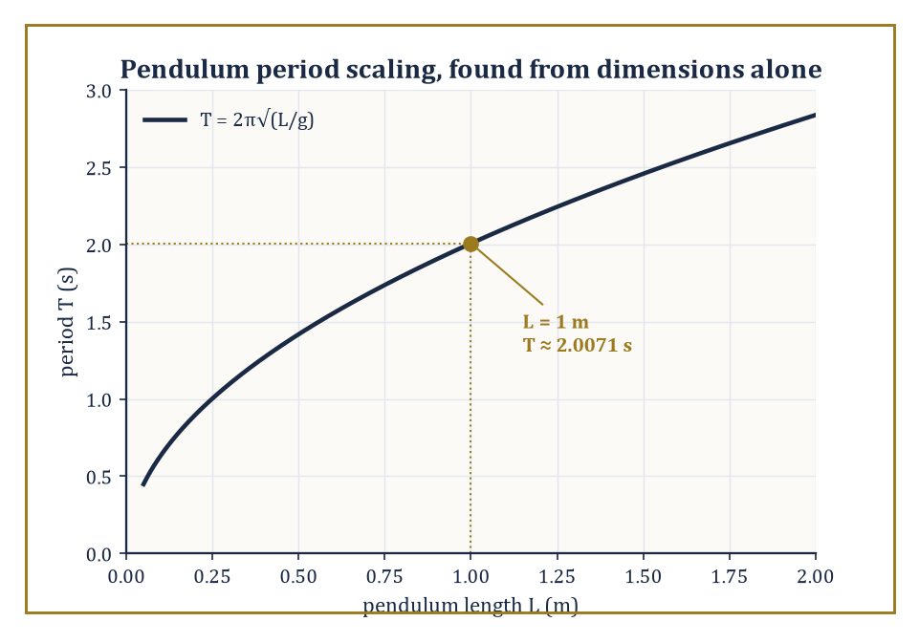
Dimensional analysis alone fixes the shape of the curve, T = C√(L/g); only the constant C = 2π still awaits the physics Room 50.6 will supply.
Its central tool is Buckingham's Pi theorem: if a relation involves n physical quantities built from k independent fundamental dimensions, then the relation can be rewritten in terms of exactly n − k independent dimensionless groups (traditionally called Π groups), and every dimensionally consistent relation among the original quantities must, in fact, be expressible purely as a relation among these groups.
This is a remarkable piece of mathematics doing the work of physics for free, before a single experiment has been run or a single law of motion invoked — it will not tell you the constant in front of an equation (that genuinely does require physics, or at least one measurement), but it will tell you, correctly and for nothing, exactly what variables the equation is and is not allowed to depend on, which is very often most of the battle.
Numeric example — Worked example — the pendulum period, derived without doing any physics. Suppose the period T of a simple pendulum's small swing depends only on its length L, the gravitational acceleration g, and its mass m. Dimensions:
[T] = time, [L] = length, [g] = length/time², [m] = mass
Since mass appears in none of the other quantities, it cannot combine with them to cancel out and must drop from the relation entirely — dimensional analysis has just told us, correctly, that a heavier pendulum bob swings no slower or faster than a lighter one, with zero physics invoked. That leaves three quantities, T, L, g, built from two fundamental dimensions, length and time, so
n − k = 3 − 2 = 1
exactly one dimensionless group. By inspection,
Π = T·√(g/L)
is dimensionless (check:
[T]·√([L/T²]/[L]) = time · √(1/time²) = time · (1/time) = 1
dimensionless, correct). The Pi theorem says any valid relation must take the form Π = C, a pure number — so
T = C·√(L/g)
for some constant C that dimensional analysis alone cannot supply. Plugging in L = 1 m, g = 9.8 m/s², and the value C = 2π (which Room 50.6 will actually derive from the physics, not merely assume):
T = 2π·√(1/9.8) = 2π × 0.31944 ≈ 2.0071 seconds
matching the textbook value for a one-metre pendulum to four figures.
Nondimensionalization is the practical use of this idea inside a working model: rescale every variable in the governing equations by a characteristic value (a characteristic length, time, or concentration) so that the resulting equation contains no dimensional quantities at all, only dimensionless parameters — pure numbers.
These dimensionless parameters have names because they recur constantly and classify the qualitative regime a system is in: the Reynolds number for fluid flows, the Froude number for surface-wave-dominated flows, the Damköhler number for reaction-versus-transport competition, and — met again in Room 50.6 — the basic reproduction number for epidemics.
A crucial payoff: two physically very different systems with the same dimensionless parameter behave, in the relevant respect, identically, which is precisely how a scale model in a wind tunnel can say anything true about a full-size aircraft.
Numeric example — Worked example — Reynolds number for pipe flow. Water flows through a pipe of diameter D = 0.02 m at average speed v = 0.5 m/s; the kinematic viscosity of water is ν ≈ 1.0 × 10⁻⁶ m²/s. The Reynolds number is
Re = vD/ν = (0.5 × 0.02)/(1.0 × 10⁻⁶) = 0.01/0.000001 = 10,000
Since pipe flow typically transitions from laminar to turbulent somewhere around Re ≈ 2,300–4,000, a value of 10,000 says the flow is comfortably turbulent. Note the payoff mentioned above directly: a pipe eight times wider carrying water eight times slower would have exactly the same Re = 10,000 and therefore the same qualitative (turbulent) behaviour, despite being a completely different physical size — the dimensionless number, not the raw numbers, is what governs the regime.
Scaling is the companion skill of estimating the relative size of the different terms in an equation, in order to work out which of them may be safely discarded in a given regime — the single most cost-effective act of simplification available to a modeler, because it is arithmetic, not analysis, and it can be done on the back of an envelope before any serious work begins.
Numeric example — Worked example — does gravity or surface tension shape a droplet?. The Bond number
Bo = Δρ·g·L²/σ
compares gravitational to surface-tension forces at length scale L, where Δρ is the density difference across the surface, g is gravitational acceleration, and σ is surface tension. For a small water droplet of radius L = 1 mm = 10⁻³ m, with Δρ ≈ 1000 kg/m³ and σ ≈ 0.072 N/m for water:
Bo = 1000 × 9.8 × (10⁻³)² / 0.072 = 1000 × 9.8 × 10⁻⁶ / 0.072 = 9.8 × 10⁻³ / 0.072 ≈ 0.136
Since Bo is well below 1, surface tension dominates gravity at this scale — the gravitational term in the governing equation may be dropped, and indeed small droplets are very nearly spherical, exactly as surface tension alone would produce. For a bucket of water, L ≈ 0.3 m:
Bo = 1000 × 9.8 × (0.3)² / 0.072 = 1000 × 9.8 × 0.09/0.072 ≈ 12,250
vastly greater than 1, so now it is the surface-tension term that is negligible, and buckets of water are, correctly, not spherical.
Scaling and dimensional analysis are the first and often the most powerful tools a modeler reaches for, because they cost almost nothing — a page of algebra, no simulation, no data — and because they catch a large fraction of would-be modeling errors before a single differential equation is written down.
A term with the wrong dimensions in a proposed equation is not a subtle mistake to be caught by careful simulation weeks later; it is an immediate, mechanical contradiction, visible on inspection, and a surprising number of published errors in applied mathematics would never have survived five minutes of this particular, unglamorous kind of checking.

Room 50.4: Discrete and Continuous Models
Or: Should Time Tick, or Should It Flow?
Discrete models — difference equations, cellular automata, agent-based models, graph-based models — evolve a finite or countable state through discrete steps of time.
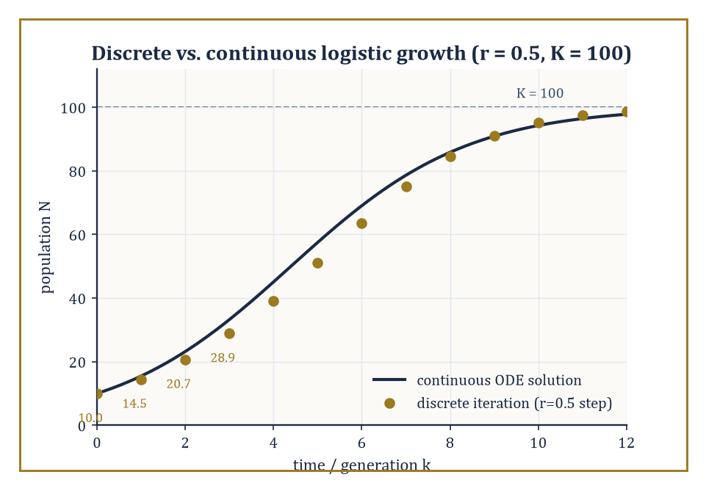
For a modest growth rate the discrete iterates sit right on the continuous S-curve — the agreement that quietly stops holding once r climbs past about 2.
Continuous models — ordinary differential equations, partial differential equations, delay equations, integral equations — evolve a continuum-valued state through continuous time.
Which framework a phenomenon demands is decided by its natural scale (does the system genuinely change in indivisible jumps, like a cell dividing or a molecule reacting, or does it change smoothly, like a temperature field diffusing through a metal bar?) and by which mathematics is actually available to analyse it once chosen.
A cellular automaton, for instance, is simply a discrete model taken to its logical extreme: a grid of cells, each in one of a finite number of states, updated in lockstep according to a fixed local rule depending only on a cell's own state and its neighbours' — no equation in the traditional sense at all, and yet, as Room 50.1's traffic example already hinted, capable of producing rich, unpredictable, genuinely emergent large-scale behaviour from nothing but simple local arithmetic repeated many times.
The choice between discrete and continuous is not always innocent: the 'same' model, written discretely versus continuously, can behave qualitatively differently, as the very next example shows.
Numeric example — Worked example — a discrete population that overshoots its own ceiling. The discrete logistic difference equation
N_(k+1) = N_k + r·N_k·(1 − N_k/K)
with growth-rate parameter r = 0.5, carrying capacity K = 100, and initial population N0 = 10, is iterated by hand:
N1 = 10 + 0.5×10×(1 − 10/100) = 10 + 5×0.9 = 10 + 4.5 = 14.5
N2 = 14.5 + 0.5×14.5×(1 − 14.5/100) = 14.5 + 7.25×0.855 = 14.5 + 6.19875 = 20.69875
N3 = 20.69875 + 0.5×20.69875×(1 − 0.2069875) = 20.69875 + 10.349375×0.7930125 ≈ 20.69875 + 8.20718 ≈ 28.906
The population climbs steadily toward K = 100, as expected — but for this same difference equation, larger values of r (roughly r > 2) are known to make N_k overshoot K, undershoot back, and settle into sustained oscillation or outright chaos, a qualitative behaviour with no counterpart at all in the continuous logistic ODE
dN/dt = rN(1 − N/K)
whose solution is a smooth S-curve that approaches K monotonically for every positive r. The discretization is not a mere numerical detail; for large r it is a different dynamical system.
Continuum limits of discrete models, and discretizations of continuum models, are the rigorous bridges connecting the two worlds, and they run in both directions.
Mean-field limits of interacting particle systems let an enormous number of discrete, randomly interacting individuals collapse, as their number grows without bound, onto a single smooth deterministic equation for their average behaviour — this is exactly how the individual, stochastic collisions of billions of gas molecules give rise to the smooth, continuous, entirely deterministic equations of fluid dynamics, and it is why the SIR equations of Room 50.6 can be trusted once an epidemic's case count is large, even though the true underlying process is really the discrete, stochastic one of Room 50.5.
Hydrodynamic limits and homogenization (replacing a finely structured discrete medium — a lattice of individual atoms, a composite material's microscopic weave — with an equivalent smooth one) run the same trick in materials science and statistical mechanics.
The clearest and most elementary instance of such a bridge, however, requires no lattice, no gas, and no advanced theorem at all — only a bank account.
Numeric example — Worked example — compound interest becomes e. A sum grows by a total annual rate of r = 1 (a deliberately dramatic 100%, chosen to make the arithmetic vivid), compounded n times per year, by the discrete growth factor (1 + r/n)^n. Computing this factor for increasing n:
n = 1: (1+1)^1 = 2.0
n = 2: (1.5)^2 = 2.25
n = 4: (1.25)^4 = 1.5625² = 2.44140625
n = 12: (1 + 1/12)^12 ≈ 2.61303
n = 365: (1 + 1/365)^365 ≈ 2.71457
As n → ∞ — compounding continuously — the factor converges to Euler's number, e ≈ 2.71828. This is, quite literally, the discrete difference-equation model of growth ('add a bit of interest every 1/n of a year') converging, as the time step shrinks to zero, onto the continuous exponential ODE
dy/dt = y
whose solution is
y = y0·e^t
Every mean-field or hydrodynamic limit in the paragraph above is the same trick — discrete steps shrinking to a continuum — dressed up in more elaborate clothing.
Hybrid models combine discrete and continuous components in a single system, used when different parts of the phenomenon genuinely demand different descriptions and no single framework serves the whole.
Abstract example — Abstract example — a tumour that is discrete at the edge and continuous in the middle. A model of an invasive tumour might treat individual cells at the tumour's growing edge as discrete agents, each making a discrete decision every time step — divide, migrate, or die — based on the local nutrient concentration it senses.
Meanwhile the oxygen and nutrient concentration diffusing through the surrounding tissue is modelled as a continuous reaction–diffusion partial differential equation, since tracking every individual diffusing molecule discretely would be computationally hopeless and scientifically pointless.
The two components are coupled: the PDE supplies each discrete cell with the local nutrient value driving its decision rule, and the discrete cells' consumption of nutrient feeds back into the PDE as a sink term.
Neither a fully discrete model (infeasible at the molecular scale) nor a fully continuous one (which erases the individual cell-to-cell variability that actually determines whether the tumour invades along one path or another) would serve alone; the hybrid keeps exactly the granularity that matters at each scale.
The discrete–continuous dichotomy is one of the fundamental choices a modeler makes, and — as the overshooting population above should make clear — it is rarely a choice without consequences for what the model can and cannot do.
It is worth saying plainly that neither side of the dichotomy is the 'more realistic' one in general: the world is not secretly discrete with continuity as a convenient fiction, nor secretly continuous with discreteness as a computational nuisance; which description is apt depends entirely on the scale at which the question is being asked, and a competent modeler must be equally fluent in both, ready to cross the bridge in either direction as the question demands.

Room 50.5: Stochastic Models and Uncertainty
The World Declines to Be Deterministic, and Is Quite Right To
Stochastic models build randomness into the mathematics explicitly, as a first-class ingredient of the equations themselves, rather than treating it as an embarrassing residual noise to be averaged away at the end: birth–death processes, stochastic differential equations, random walks, branching processes, Markov chains all belong to this family.
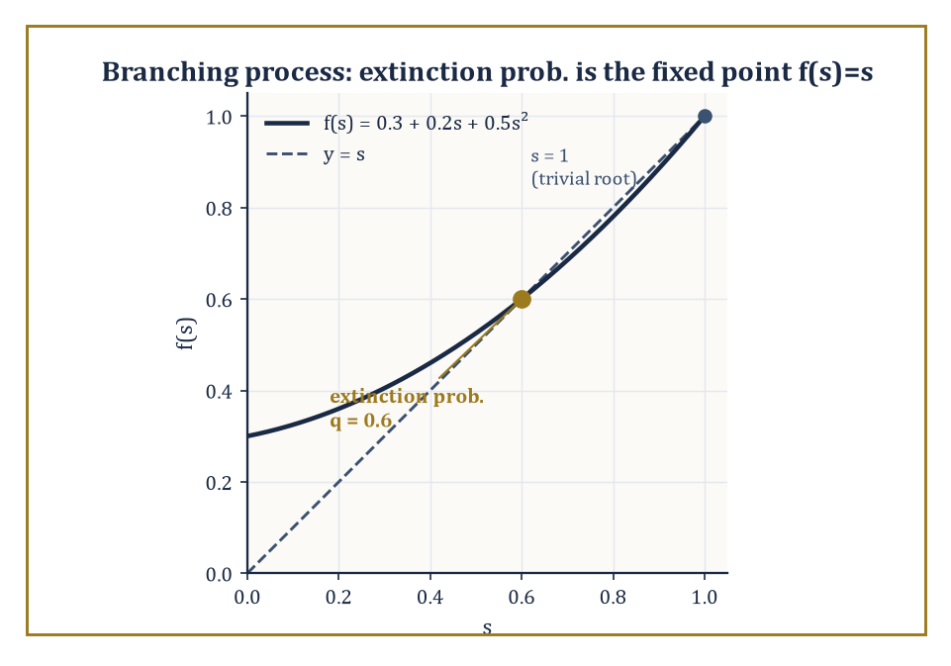
Where the offspring-generating curve crosses the line y = s below 1 is the extinction probability — 0.6, even though the mean-field model insists the population only ever grows.
They earn their keep whenever fluctuations actually matter — in small populations, in noisy environments, wherever the modeler's knowledge of initial conditions or mechanism is genuinely incomplete — and above all whenever a system is small enough that 'the average behaviour', the thing a deterministic model reports, and 'what actually happens on this particular occasion' can come apart in a way that matters to the question being asked.
A Markov chain generalizes the idea to any system that moves between a set of states with probabilities depending only on its current state, not its history — a useful working definition of 'memorylessness' that recurs across the whole family.
A branching process is the simplest serious example of the genuinely dynamical kind: starting from one individual, each individual in every generation independently produces a random number of offspring according to some fixed probability distribution, and the population either dies out or grows forever — there is no other long-run option, a dichotomy sharp enough to be worth computing exactly.
Numeric example — Worked example — a growing population that dies out 60% of the time. Suppose each individual has 0 offspring with probability p0 = 0.3, exactly 1 offspring with probability p1 = 0.2, and exactly 2 offspring with probability p2 = 0.5. The mean number of offspring per individual is
μ = 0×0.3 + 1×0.2 + 2×0.5 = 0.2 + 1.0 = 1.2
Since μ > 1, a deterministic (mean-field) model of the same process —
dN/dt or N_(k+1) = 1.2·N_k
— would predict, with complete confidence, unbounded growth forever. The true stochastic process disagrees. The extinction probability q is the smallest root in [0,1] of f(s) = s, where f(s) = p0 + p1s + p2s² is the offspring probability-generating function:
0.3 + 0.2s + 0.5s² = s ⟹ 0.5s² − 0.8s + 0.3 = 0 ⟹ s² − 1.6s + 0.6 = 0
(multiplying by 2). The discriminant is
1.6² − 4×0.6 = 2.56 − 2.4 = 0.16
so √0.16 = 0.4, and the roots are
s = (1.6 ± 0.4)/2, giving s = 1.0 or s = 0.6
The smallest root in [0,1) is q = 0.6. So even with a healthy 20% average growth per generation, the line founded by a single individual dies out completely 60% of the time — extinction and explosive growth are both entirely normal outcomes of the identical stochastic process, a fact the mean alone hides completely.
Uncertainty quantification — treated at length in its own right earlier in the Tower — extends this same idea to a model's parameters, and even to its structure, treating them as uncertain quantities to be propagated through to the predictions rather than fixed numbers plugged in once and then quietly forgotten about.
This matters because a model is often far more sensitive to some parameters than others; propagating the uncertainty properly, rather than reporting a single confident number, tells the modeler which unmeasured quantity is actually worth the expense of measuring more precisely, and which is safe to leave vague.
Bayesian calibration is the standard mechanism for doing the propagating: begin with a prior probability distribution over an unknown parameter, encoding what is believed before seeing the data at hand, and update it into a posterior distribution once data arrives, via Bayes's rule.
Model discrepancy, a further refinement, explicitly accounts for the systematic gap between even the best-calibrated model and reality — the honest admission that no amount of data will make a structurally wrong mechanism right, only a well-fitted one, and that the two failures look deceptively similar from the outside until this distinction is drawn.
Numeric example — Worked example — updating a belief about an infection probability. Let p be the probability that an individual exposed to a pathogen becomes infected — an unknown parameter of an epidemic model. A weak, symmetric prior belief is encoded as a Beta(2,2) distribution, centred on 0.5 but not dogmatic about it. A small challenge study observes 7 infections out of 10 exposures. Because the Beta distribution is conjugate to the binomial likelihood, the posterior is exactly
Beta(2+7, 2+3) = Beta(9,5), with posterior mean 9/(9+5) = 9/14 ≈ 0.643
— pulled from the prior's 0.5 toward the raw observed frequency of 7/10 = 0.7, but not all the way, because the weak prior still has some say with only ten data points behind it. Now suppose, instead, the same 70% infection rate had been observed over 100 exposures (70 infections): the posterior becomes
Beta(2+70, 2+30) = Beta(72,32), with mean 72/104 ≈ 0.692
— much closer to the raw frequency, because a hundred data points overwhelm a weak prior far more thoroughly than ten do. This is uncertainty quantification in miniature: the parameter is never a bare number but a distribution, one that narrows and shifts, in a mathematically precise and reproducible way, as evidence accumulates.
Stochasticity and uncertainty, then, are not defects in a model to be regretted and eliminated with a bigger computer; they are features of the world, and of our knowledge of it, that a good model represents honestly rather than papers over.
Numeric example — Worked example — why noise matters more when the numbers are small. A simple symmetric random walk of N independent ±1 steps has variance N and standard deviation √N, so the size of the fluctuation relative to N itself scales as
√N/N = 1/√N
For N = 100, the relative fluctuation is
1/√100 = 1/10 = 10%
for N = 10,000, it drops to
1/√10,000 = 1/100 = 1%
This single scaling law is exactly why the branching-process calculation above had teeth: with only a handful of infected individuals at an outbreak's start, the 'noise' is comparable in size to the 'signal', so a supercritical process (mean growth rate above 1, μ = 1.2 in the earlier example) can still fizzle out by sheer chance — the 60% extinction probability computed there. Once case counts reach the thousands, this same 1/√N law says the relative noise has shrunk to the point of irrelevance, and the smooth, deterministic compartmental models of Room 50.6 become trustworthy again. Stochastic and deterministic models are not rivals; they are the correct description of the identical phenomenon at two different scales.

Room 50.6: Case Studies: Mechanics, Biology, and Epidemiology
Where the Abstract Process Finally Gets Its Hands Dirty
Classical mechanics supplies the template every other applied field imitates, whether or not it advertises the fact.
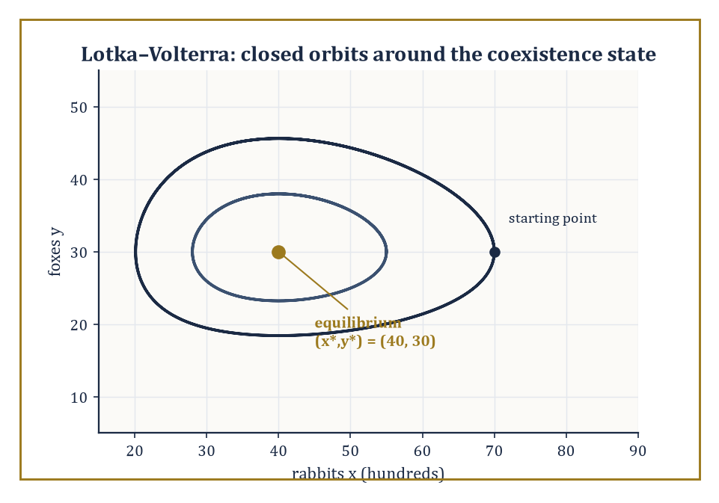
Rabbits and foxes never settle at (40, 30) — they orbit it forever, a centre rather than an attractor, exactly as the purely imaginary eigenvalues predict.
Newton's laws give forces directly, coordinate by coordinate, which is straightforward for a free particle and rapidly becomes a bookkeeping nightmare once constraints enter — a bead on a wire, a pendulum's string, a piston in a cylinder.
The Lagrangian formulation gives an equivalent, often far more convenient, route via a single scalar function, kinetic energy minus potential energy:
L = T − V
from which the equations of motion follow automatically via the Euler–Lagrange equation
d/dt(∂L/∂θ̇) − ∂L/∂θ = 0
for each generalized coordinate θ — no need to resolve the awkward constraint forces (the tension in that pendulum's string, precisely) by hand at all, since a well-chosen coordinate builds the constraint in from the start and the tension simply never has to be computed.
The same template — a conservation law, dressed in a constitutive relation tailored to the specific material at hand — reappears, essentially unchanged in its logical structure, in elasticity, fluid dynamics, and plasticity; only the constitutive law linking stress to strain (or strain rate) changes from one to the next, which is why a mechanical engineer and a fluid dynamicist, for all their apparent differences, are doing recognizably the same kind of mathematics.
Numeric example — Worked example — deriving the pendulum equation, properly this time. For a simple pendulum of mass m and length L, angle θ from vertical, position
(x,y) = (L sinθ, −L cosθ)
so speed² = L²θ̇², kinetic energy
T = ½mL²θ̇²
and potential energy
V = −mgL cosθ
(taking the pivot as the reference height). The Lagrangian is
L = T − V = ½mL²θ̇² + mgL cosθ
Then
∂L/∂θ̇ = mL²θ̇, so d/dt(∂L/∂θ̇) = mL²θ̈
and
∂L/∂θ = −mgL sinθ
The Euler–Lagrange equation gives
mL²θ̈ − (−mgL sinθ) = 0, i.e. mL²θ̈ + mgL sinθ = 0
and dividing through by mL²:
θ̈ + (g/L) sinθ = 0
The mass m cancels completely — Galileo's observation about pendulums, re-derived here from Lagrangian mechanics rather than an inclined plane. With L = 1 m and g = 9.8 m/s²:
θ̈ = −9.8 sinθ
For small oscillations, sinθ ≈ θ, giving simple harmonic motion
θ̈ ≈ −9.8θ
angular frequency
ω = √9.8 ≈ 3.1305 rad/s
and period
T = 2π/ω = 2π/3.1305 ≈ 2.0071 seconds
exactly the value Room 50.3 obtained by dimensional analysis alone, this time with the constant C = 2π derived rather than assumed, as promised.
Biological modeling ranges across scales from enzyme kinetics and ion channels up through population dynamics, pattern formation (the Turing mechanism, by which a uniform field of two diffusing, reacting chemicals can spontaneously organize into spots or stripes), to physiological control systems.
The models here are characteristically nonlinear, often spatially structured, and stubbornly parameterized by quantities that are difficult or expensive to measure directly — which is precisely why the data-driven and Bayesian techniques of the last two rooms find so much of their natural habitat here.
Numeric example — Worked example — where predator and prey settle, and why they don't stay there. The classical Lotka–Volterra predator–prey model is
dx/dt = αx − βxy (prey, say rabbits)
dy/dt = δxy − γy (predator, say foxes)
with α the rabbits' intrinsic growth rate, β the predation-encounter rate, δ the foxes' reproduction efficiency per rabbit eaten, and γ the foxes' death rate in the absence of food. The nontrivial (coexistence) equilibrium is found by setting both derivatives to zero with x,y ≠ 0: from dx/dt = 0,
α = βy, so y* = α/β
from dy/dt = 0,
δx = γ, so x* = γ/δ
With α = 1.5/yr, β = 0.05, δ = 0.02, γ = 0.8/yr:
x* = 0.8/0.02 = 40 (hundreds of rabbits, say)
y* = 1.5/0.05 = 30 (foxes)
Linearizing the equations about this point produces a pair of purely imaginary eigenvalues — meaning the equilibrium is a centre, not an attractor: real trajectories orbit around (40,30) in closed loops rather than settling onto it, a famous feature of the model. This qualitative prediction — sustained cycles, never damping — is both confirmed by real predator–prey data (the classic lynx–hare fur-trapping records) and gently embarrassed by it, since real cycles typically do damp somewhat, a discrepancy that points, correctly, to a missing ingredient (commonly, a resource limitation on the prey population itself) that the bare model has left out.
Epidemiological models — the SIR model (Susceptible, Infected, Recovered) and its many descendants — illustrate the entire modeling cycle in one compact package: compartmental structure derived from the first-principles mechanism of transmission and recovery, a basic reproduction number obtained by linearizing about the disease-free state, intervention scenarios explored by simulation, and confrontation with real incidence data.
The COVID-19 pandemic put both the genuine power and the real limitations of this modeling family in front of a very wide, and often very critical, public audience.
Numeric example — Worked example — computing R0 and the herd-immunity threshold. In the SIR model,
dS/dt = −βSI/N, dI/dt = βSI/N − γI, dR/dt = γI
with transmission rate β = 0.3 per day and recovery rate γ = 0.1 per day (so the mean infectious period is 1/γ = 10 days). Near the start of an outbreak, S ≈ N, so
dI/dt ≈ (β − γ)I
the infected compartment grows exactly when β > γ, i.e. when the basic reproduction number
R0 = β/γ = 0.3/0.1 = 3
exceeds 1 — a threshold condition obtained purely by linearizing about the disease-free equilibrium and checking the sign of a single eigenvalue, the same technique used to classify the pendulum and the logistic equilibria elsewhere in this storey. R0 = 3 means each infected individual, in an otherwise fully susceptible population, infects three others on average before recovering. The herd-immunity threshold — the immune fraction needed to push the effective reproduction number below 1 — is
1 − 1/R0 = 1 − 1/3 = 2/3 ≈ 66.7%
Case studies are where the nine tidy stages of Room 50.2 stop being tidy and start being real; they are, in the fullest sense, the modeler's apprenticeship.

Room 50.7: Data-Driven and Hybrid Modeling
Letting the Data Do Some of the Thinking
Data-driven models infer structure directly from observations rather than from a stated mechanism: statistical regression, machine-learning surrogates, sparse identification of nonlinear dynamics (SINDy), dynamic mode decomposition, and physics-informed neural networks all belong to this family.
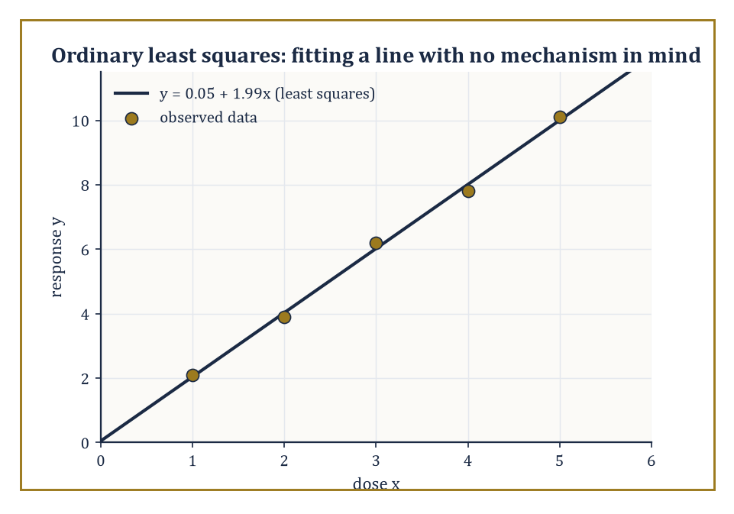
The least-squares line y ≈ 0.05 + 1.99x hugs all five points without asserting a single word about why dose and response should be related at all.
They come into their own precisely where mechanistic modeling struggles — when the underlying mechanism is genuinely unknown, or is known in principle but too complex, too coupled, or too poorly characterized to write down and solve in any useful closed form, as is routinely the case in climate science, neuroscience, and economics, three fields where nobody seriously claims to have the exact governing equations in hand.
The simplest and oldest member of the family, and still the workhorse underneath a great many of the fancier ones, is ordinary least-squares regression: given data, find the line (or curve, for the nonlinear generalizations) that minimizes the sum of squared vertical distances between the observed points and the fitted curve — a single, elegant optimization criterion from which an enormous amount of applied statistics ultimately descends.
Numeric example — Worked example — fitting a line with no mechanism in mind. Five measurements of a response y to a stimulus dose x, with no theory available for why the relationship should take any particular form: (1, 2.1), (2, 3.9), (3, 6.2), (4, 7.8), (5, 10.1). The means are
x̄ = (1+2+3+4+5)/5 = 3
ȳ = (2.1+3.9+6.2+7.8+10.1)/5 = 30.1/5 = 6.02
Deviations from the mean: x − x̄ gives −2, −1, 0, 1, 2; y − ȳ gives −3.92, −2.12, 0.18, 1.78, 4.08. The sum of products,
Sxy = (−2)(−3.92) + (−1)(−2.12) + (0)(0.18) + (1)(1.78) + (2)(4.08) = 7.84 + 2.12 + 0 + 1.78 + 8.16 = 19.9
The sum of squared x-deviations,
Sxx = 4 + 1 + 0 + 1 + 4 = 10
The least-squares slope is
Sxy/Sxx = 19.9/10 = 1.99
and the intercept is
ȳ − slope×x̄ = 6.02 − 1.99×3 = 6.02 − 5.97 = 0.05
The fitted model y ≈ 0.05 + 1.99x asserts nothing whatsoever about why the response is very nearly twice the dose; it only asserts that, within the observed range of doses one to five, it reliably is.
Sparse identification of nonlinear dynamics (SINDy) pushes the same regression idea much further, toward genuine equation discovery rather than mere curve-fitting: build a library of candidate terms that might plausibly appear in a governing equation — constants, x, x², x³, sinx, and so on, as many as the modeler's physical intuition suggests including — regress the observed rate of change dx/dt against this whole library at once, and apply a sparsity penalty that discards any candidate whose fitted coefficient is too small to be distinguished from noise.
The philosophical bet underneath the method is essentially Occam's razor again, imported wholesale from Room 50.8: of all the terms that could in principle appear, only a genuine physical law's worth of them actually will, and the rest are decorative.
What survives the thresholding is, if the method has worked, the true differential equation, recovered without the modeler ever having assumed its functional form in advance — a much stronger claim than an ordinary regression fit ever makes.
Numeric example — Worked example — recovering dx/dt = −2x from noisy data. Suppose the true, unknown-to-the-modeler dynamics are simple exponential decay,
dx/dt = −2x
and noisy trajectory data is regressed against the candidate library {1, x, x², x³}. The unconstrained least-squares fit returns coefficients (0.01, −1.98, 0.003, −0.001) for the four terms respectively — every coefficient except the one on x is small, consistent with measurement noise rather than genuine signal. Applying a sparsity threshold of 0.1 (discard any coefficient smaller in magnitude than that) zeroes out the constant, x², and x³ terms, leaving the sparse recovered model
dx/dt ≈ −1.98x
a close match to the true law dx/dt = −2x, and, crucially, an actual differential equation carrying a mechanistic claim (linear decay, proportional to current state), not merely a curve valid only over the range of the observed data, as the pure regression example above was.
Hybrid models combine a mechanistic backbone with a data-driven component filling in exactly the part that is genuinely unknown: a differential equation whose right-hand side is partly a known conservation law and partly a learned function, a stochastic model whose structural form is fixed but whose rates are estimated from data.
The aim is the best of both worlds — the interpretability and extrapolation-safety of mechanism, combined with the flexibility of a method that does not require the unknown part to be known in advance.
Abstract example — Abstract example — a reactor model that cannot lie about mass balance. Consider a chemical reactor of volume V, with flow rate Q_in of fresh reagent in and Q_out of product out, and an unknown, genuinely messy catalytic reaction consuming the reagent at some rate r([C]) nobody has fully characterized. Mass conservation — a non-negotiable physical law — fixes the overall structure:
d[C]/dt = Q_in/V − (Q_out/V)[C] − r([C])
The first two terms come from exact bookkeeping of flow and cannot be argued with; only the reaction-rate term r([C]) is replaced by a small neural network trained against observed concentration measurements. Whatever the network learns, the conservation structure surrounding it guarantees the overall model cannot violate mass balance — the mechanistic backbone constrains the data-driven component to only ever supply the one piece of genuine ignorance, the reaction kinetics, and nothing more.
The rise of data-driven methods does not abolish mechanistic modeling; it enlarges the toolkit, and shifts the division of labour between what is asserted from principle and what is learned from observation — a shift the next room will show how to police.

Room 50.8: Validation, Falsification, and Model Selection
In Which Every Model Is Guilty Until Proven Useful
A model is validated — never 'proven', only validated, a weaker and more honest claim — by comparing its predictions against observations that played no part in building it.
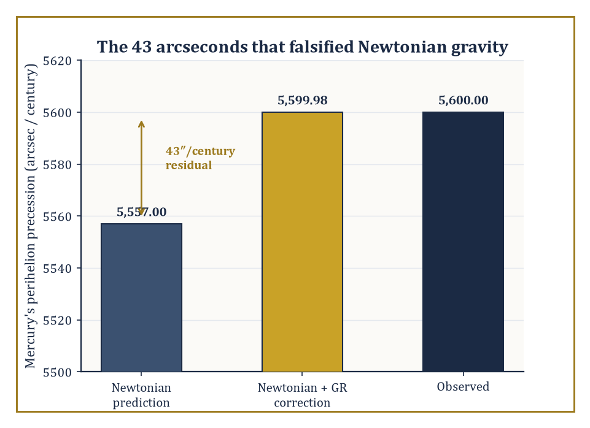
A 43-arcsecond gap sat in plain view for decades until general relativity closed it, uninvited and to the arcsecond, with no parameter tuned after the fact.
This restriction is not pedantry. A model fitted and then tested only on the very data used to fit it will always look better than it deserves to, for the same reason a tailor's suit fits the tailor's own mannequin perfectly: the two were made for each other.
Holding back data breaks that collusion by construction, since the model was never shown the answer it is now being asked to predict.
Cross-validation (holding back part of the data during fitting, then checking against the held-back portion, often repeated across several different held-back subsets and averaged), out-of-sample testing, and genuine prospective prediction (forecasting something that has not happened yet, so that not even the modeler could have peeked) are the standard tools, in roughly increasing order of how hard they are to fake — it is disconcertingly easy to fool oneself with cross-validation if the held-back data secretly resembles the training data too closely, but almost impossible to fool oneself with a prediction about next month that next month has not yet had the chance to contradict.
Falsification — a decisive, reproducible disagreement between prediction and observation — is the sharpest instrument of progress available to a modeler: it does not merely criticize a model, it forces its revision or its abandonment, with no room for face-saving.
Numeric example — Worked example — the 43 arcseconds that broke Newtonian gravity. Mercury's elliptical orbit precesses — its perihelion, the point of closest approach to the Sun, slowly rotates around the Sun over time. The total observed precession is about 5,600 arcseconds per century relative to the fixed stars. Newtonian mechanics, accounting for the gravitational perturbations of all the other known planets, predicts about 5,557 arcseconds per century. The residual is
5,600 − 5,557 = 43 arcseconds per century
This resisted every attempt, for decades, to explain it with an undiscovered planet, a ring of unseen dust, or an oblate Sun consistent with every other observation available. That 43-arcsecond gap was a falsification sitting in plain view: an otherwise spectacularly successful theory was quietly, measurably, stubbornly wrong. When general relativity arrived, it predicted an additional perihelion precession of 42.98 arcseconds per century directly from first principles, with no free parameter tuned after the fact to match — very possibly the single most persuasive piece of evidence for the theory at the moment of its proposal, precisely because it resolved a number the reigning model had already, demonstrably, got wrong.
Model selection is the more everyday cousin of falsification: choosing among several competing, non-falsified models by explicitly balancing goodness of fit against complexity, using criteria such as the Akaike Information Criterion (AIC), the Bayesian Information Criterion (BIC), cross-validation error, or Bayesian evidence.
In its simplified least-squares form,
AIC ≈ n·ln(RSS/n) + 2k
where n is the number of data points, RSS the residual sum of squares, and k the number of fitted parameters — lower AIC is preferred.
The two terms are in open conflict by design: ln(RSS/n) can only fall, or at worst stay flat, as more parameters are added and the fit improves (a model with more knobs to turn can always match the training data at least as well), while the 2k term rises steadily to punish exactly that temptation.
BIC replaces the 2k penalty with k·ln(n), a heavier tax on complexity once n is reasonably large, reflecting a slightly different philosophical commitment — AIC is built to find the model that predicts best, BIC to find the model that is, in a Bayesian sense, most probably the true one, and the two do not always agree.
This machinery is Occam's razor made computable: a formal, arithmetic preference for the model that achieves adequate fit with fewer parameters, rather than a vague philosophical injunction toward simplicity that everyone quotes and nobody quite knows how to apply.
Numeric example — Worked example — does the extra parameter earn its keep?. Two models are fitted to n = 20 data points. Model A, a straight line, has k = 2 parameters and residual sum of squares RSS_A = 50. Model B, a quadratic, has k = 3 parameters and RSS_B = 42.
AIC_A = 20·ln(50/20) + 2×2 = 20·ln(2.5) + 4 = 20×0.9163 + 4 = 18.326 + 4 = 22.326
AIC_B = 20·ln(42/20) + 2×3 = 20·ln(2.1) + 6 = 20×0.7419 + 6 = 14.839 + 6 = 20.839
Since AIC_B < AIC_A, the quadratic is preferred: its improved fit (RSS falling from 50 to 42) outweighs the two-point penalty charged for its extra parameter. Had the quadratic instead only reduced RSS to 48, the arithmetic runs
AIC_B = 20·ln(48/20)+6 = 20×0.8755+6 = 17.51+6 = 23.51
which exceeds AIC_A = 22.326 — so the simpler line would then be preferred, the extra parameter judged not to have earned its keep. This is Occam's razor doing arithmetic rather than moralising, and it can, as shown, go either way depending on exactly how much the extra complexity actually buys.
Validation and selection close the modeling loop opened in Room 50.2: they convert the output of analysis, simulation, and data-fitting back into an honest, checkable judgement about the model's actual relation to the world it was built to describe — which, after all, was the entire point of the exercise.
Every earlier room in this storey built the machinery to construct a model; this room, deliberately placed last, exists to keep that machinery honest, and a modeler who skips it has not finished the job, however elegant the equation left sitting on the page.

Room 50.9: Looking Back and Looking Ahead: The Tower and What Lies Beyond
The View From the Top Floor
We have reached the top storey.
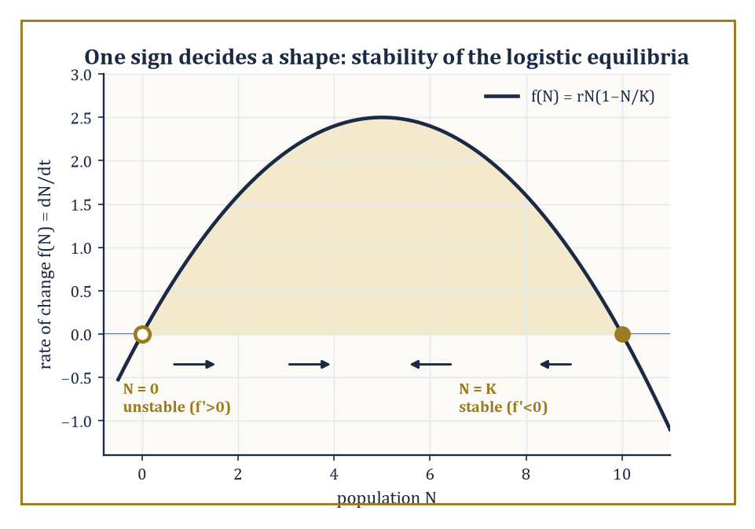
Two signs, one open circle and one filled: the whole S-shaped fate of the logistic population is decided by nothing more than which way the arrows point at N = 0 and N = K.
The Tower that began, fifty storeys below, with the counting of apples has risen through algebra, geometry, calculus, analysis, probability, computation, and the great structural theories of modern mathematics, each storey adding tools the ones above would eventually need, very often without the storey doing the adding having any idea what the tool would one day be used for.
This storey has been about use: about taking that entire accumulated apparatus and turning it, deliberately, toward phenomena that do not know or care that they are being modeled — tea cooling, bacteria dividing, pendulums swinging, epidemics spreading, reactors reacting.
None of those phenomena has read this Tower, or any other; they simply go on doing what they do, and the equations are our attempt, always partial and always provisional, to keep up.
Looking back, the whole climb has aimed at three things at once: technical competence in the core subjects of pure and applied mathematics; a sense of the unity of the subject — the discovery, over and over, that the same structure reappears in wildly different guises; and a style of thought that combines genuine precision with a willingness to approximate, to simplify, and to confront the mathematics honestly with the world, exactly as this storey's nine rooms have tried to do.
Worked example — Synthesis example — one equation, four unrelated jobs. Four numbers were computed in the rooms behind us: tea cooling from 90°C to 60°C in about 11.19 minutes (Room 50.1); a bacterial culture reaching 6,400 cells after six doublings (Room 50.2); the discrete-compounding growth factor climbing, step by step, toward e ≈ 2.71828 as the compounding interval shrank to nothing (Room 50.4); and an epidemic with basic reproduction number R0 = 3 (Room 50.6).
Underneath four entirely unrelated vocabularies — temperature, cell counts, currency, infections — all four are governed by the identical linear differential equation
dy/dt = k·y
(or its discrete difference-equation twin), and by the single eigenvalue k that decides, in every case, whether the quantity in question grows, decays, or sits at a threshold. This is what 'the same structure reappearing in different guises' means in practice: not a philosophical flourish, but the literally identical piece of algebra, learned once, doing four unrelated jobs across four unrelated rooms of this storey alone — let alone across the other forty-nine.
Numeric example — Worked example — one sign decides a shape. The logistic equation
dN/dt = rN(1 − N/K)
has two equilibria, N = 0 and N = K. Writing
f(N) = rN − rN²/K
its derivative is
f'(N) = r − 2rN/K
At N = 0:
f'(0) = r > 0
— a positive eigenvalue, meaning the equilibrium is unstable, so any tiny founding population grows away from extinction rather than settling back into it. At N = K:
f'(K) = r − 2r = −r < 0
— a negative eigenvalue, meaning this equilibrium is stable, so any small perturbation away from carrying capacity decays back toward it. The entire qualitative shape of the logistic S-curve — climbing away from zero, levelling off at K, with nothing else it is permitted to do — is contained in nothing more than the signs of these two numbers, which is exactly the eigenvalue machinery of linear algebra, forged many storeys below this one for entirely abstract reasons, doing quiet and indispensable service in an applied setting.
Looking ahead, the tools will not stop evolving: new physical regimes (quantum devices at room temperature, climates outside any historical envelope), new sources of data (sensors on everything, cheaply, all the time), new computational architectures, and new mathematical structures not yet invented will all demand extensions of everything built in this storey.
Specific techniques will age; the Reynolds number will still be computed, but perhaps alongside dimensionless groups for phenomena not yet named.
What will not need replacing is the modeling process itself — observation, mechanism, framework, derivation, simplification, analysis, confrontation, revision, in whatever order the phenomenon demands — because that disciplined translation between world and mathematics is the one permanently useful skill underneath every specific technique this storey has taught, and it will outlive every one of them.
The deeper lesson of the climb is that mathematics is, at once, a pure creation of the mind and the most effective language yet found for describing the structure of the world — and that these two faces are not in tension but reinforce each other.
Pure structures become useful because they turn out, unexpectedly and without having been designed for the purpose, to capture something real; real phenomena become intelligible because they turn out to be organized by pure structures all along.
Abstract example — Abstract example — an idea invented for no reason at all. Complex numbers were introduced, centuries ago, purely to let the algebra of polynomial root-finding close up neatly — a bookkeeping convenience for a problem entirely internal to mathematics, with no physical motivation whatsoever at the time.
Centuries later, the identical structure turned out to be the indispensable language of alternating-current circuit analysis, of quantum mechanics's wavefunctions, and — directly relevant to this very storey — of the Fourier techniques underlying much of the signal-processing machinery behind the data-driven methods of Room 50.7.
Nobody arranged this. The structure was invented for its own internal elegance, and reality, apparently, had been waiting for it the whole time.
Applied mathematics and modeling, then, are the place where the Tower meets the world — the storey, fittingly the last one, where everything built for its own sake finally has to answer for itself.
And so the Tower, begun fifty storeys below with three apples and two apples, is finished. Below us: the numerical-methods storey, still faintly warm from the last simulation left running; below that, forty-eight further storeys of algebra, geometry, calculus, analysis, probability, and structure, patiently waiting to be needed again, as they periodically will be, by anyone who climbs back down to borrow them.
It has been a long climb, and if it has occasionally felt like a meditation on infinity, on the slow accretion of tenure-track certainty, and on the specific existential dread of a professor watching an integral fail to converge in front of a lecture hall — well, that was rather the point. Mathematics does not flinch from any of that; it merely insists on writing it down correctly, checking the arithmetic twice, and moving on regardless. That, as much as any theorem in these fifty storeys, is the actual lesson.
The tower is built. The world, as it always was, is waiting — and now, at least, we have the equations to go and ask it some proper questions. End of Storey 50. The lift, mercifully, also goes back down.

